Descriptive statistics and inferential statistics

Descriptive statistics and inferential statistics, along with exploratory statistics, are the main areas of statistics. Descriptive statistics provides tools to describe a sample. Starting from the sample, inferential statistics can now be used to make a statement about the population.

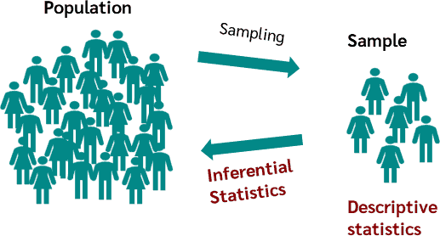

Descriptive statistics vs inferential statistics

One main area of statistics is to make a statement about a population. In most cases it is not possible to get all data of the population, so a sample is taken. This sample can now be described using descriptive statistics, e.g. what the mean value is and how strongly the sample scatters.

But this is not yet a statement about the population, that is the task of the inferential statistics. The inferential statistics takes a sample from the population, in order to make inferences about the population with this sample. So, the goal of inferential statistics is to infer the unknown parameters of the population from the known parameters of a sample.

Therefore, inferential statistics try to infer conclusions that go beyond the immediate data, unlike descriptive statistics. To achieve this, [hypothesis tests](https://datatab.net/tutorial/hypothesis-testing) such as the [t-test](https://datatab.net/tutorial/t-test) or [analysis of variance](https://datatab.net/tutorial/anova) are used in inferential statistics.

Descriptive statistics

After collecting data, one of the first things to do is to graph the data, calculate the mean and get an overview of the distributions of the data. This is the task of descriptive statistics.

Thus, the goal of descriptive statistics is to gain an overview of the distribution of data sets. Descriptive statistics helps to describe and illustrate data sets.

Definition

The term **descriptive statistics** covers statistical methods for describing data using statistical characteristics, charts, graphics or tables.

It is important here that only the properties of the respective sample are described and evaluated. However, no conclusions are drawn about other points in time or the population. This is the task of inferential statistics or concluding statistics.

The various sub-areas of descriptive statistics can be summarised as follows:

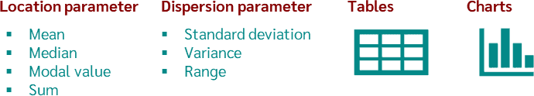

Depending on which question and which [measurement scale](https://datatab.net/tutorial/level-of-measurement) is available, different key figures, tables and graphics are used for evaluation. The best known of these are:

* [Location parameter:](https://datatab.net/tutorial/location-parameter) Mean value, median, mode, sum
* [Dispersion parameter:](https://datatab.net/tutorial/dispersion-parameter) Standard deviation, variance, range
* [Tables:](https://datatab.net/tutorial/frequency-table) Absolute, relative and cumulative frequencies
* [Charts:](https://datatab.net/statistics-calculator/charts) Histograms, bar charts, box plots, scatter charts, matrix plots

The first group of Descriptive Statistics are **location parameter** like the mean and mode. They are used to express a central tendency of the data set. They therefore describe where the center of a sample is located or where a large part of the sample is located.

The second group are [measures of dispersion](https://datatab.net/tutorial/dispersion-parameter). They provide information about how much the values of a variable in a sample differ from each other. Measures of dispersion can therefore describe how strongly the values of a variable deviate from the mean value: Are the values rather close together, i.e. are they similar, or are they far apart and thus differ greatly? A classic example is the [standard deviation](https://datatab.net/tutorial/dispersion-parameter).

Which measures of location or dispersion are suitable for describing the data depends on the respective [scales of measurement](https://datatab.net/tutorial/level-of-measurement) of the variable. Here, a distinction can be made between **metric**, **ordinal** and **nominal** scales of measurement.

Finally, a large area of descriptive statistics is [diagrams](https://datatab.net/tutorial/charts) such as the bar chart, the pie chart, or the histogram.

Tip

On DATAtab you can create charts directly in your browser, e.g. you can [create a bar chart](https://datatab.net/statistics-calculator/charts/create-bar-chart) or [a boxplot online](https://datatab.net/statistics-calculator/charts/create-boxplot). Of course, DATAtab also provides you with many other descriptive statistics.

Descriptive Statistics Example

A random sample of 10 male basketball players will be drawn, whose height will be measured in meters.

| **Player** | **Body height** |
| --- | --- |
| **1** | 1.62 |
| **2** | 1.72 |
| **3** | 1.55 |
| **4** | 1.7 |
| **5** | 1.78 |
| **6** | 1.65 |
| **7** | 1.64 |
| **8** | 1.64 |
| **9** | 1.66 |
| **10** | 1.74 |

[Load example data](https://datatab.net/statistics-calculator/descriptive-statistics?example=descriptive_statistics)

Once you have copied the data into the table of the [Online Statistics Software](https://datatab.net/statistics-calculator/descriptive-statistics), click on descriptive statistics in the calculator and select the variable "height".

DATAtab will now give you the following table of descriptive statistics (relevant dispersion measures and location measures) on the height of the players.

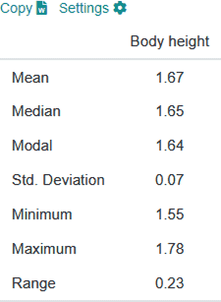

Inferential statistics

What's inferential statistics? In contrast to descriptive statistics, **inferential statistics** want to make a statement about the **population**. However, since it is almost impossible in most cases to survey the entire population, a sample is used, i.e. a small data set originating from the population. With this sample a statement about the population can be made. An example would be if a sample of 1,000 citizens is taken from the population of all Canadian citizens.

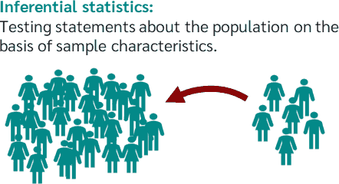

Depending on which statement is to be made about the population or which question is to be answered about the population, different statistical methods or hypothesis tests are used. The best known are the hypothesis tests with which a group difference can be tested, such as the [t-test](https://datatab.net/tutorial/t-test), the [chi-square test](https://datatab.net/tutorial/chi-square-test) or the analysis of variance. Then there are the hypothesis tests with which a correlation of variables can be tested, such as correlation analysis and [regression](https://datatab.net/tutorial/linear-regression).

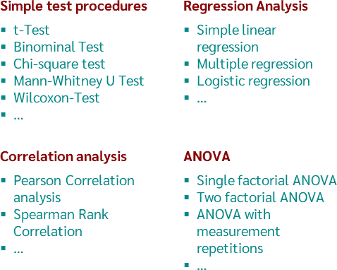

In the [Hypothesis Test Calculator](https://datatab.net/statistics-calculator/hypothesis-test) on DATAtab you can easily calculate these tests from the inference statistics directly online in your browser.

Inferential statistics definition

Inferential statistics is a branch of statistics that uses various analytical tools to draw conclusions about the population from sample data. For a given hypothesis about the population, inferential statistics uses a sample and gives an indication of the validity of the hypothesis based on the sample collected.

Example inferential statistics

In the example above, a sample of 10 basketball players was drawn and then exactly this sample was described, this is the task of descriptive statistics. If you want to make a statement about the **population** you need the **inferential statistics**. For example, it could be of interest if basketball players are larger than the average male population. To test this hypothesis a [t-Test](https://datatab.net/tutorial/t-test) is calculated, the t-test compares the sample mean with the mean of the population.

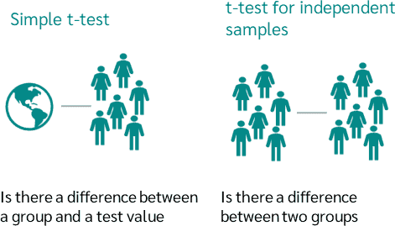

Furthermore, the question could arise whether basketball players are larger than football players. For this purpose, a sample of football players is drawn, and then the mean value of the basketball players can be compared with the mean value of the football players using an [independent t-test](https://datatab.net/tutorial/unpaired-t-test). Now a statement can be made, for example, whether basketball players are larger than football players in the population or not.

Since this statement is only made based on the samples and it can also be pure coincidence that the basketball players are larger in exactly this sample, the statement can only be confirmed or re-submitted with a certain probability.