LAB Logbook
Repo Link
Lab 1 (22 January 2026)
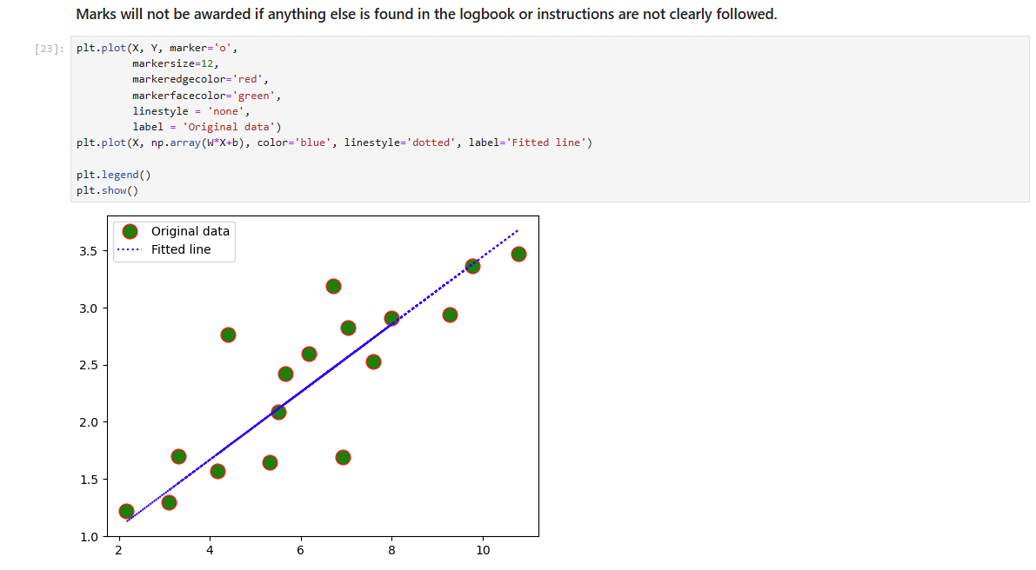

Lab 2 (29 January 2026)

Task 1:
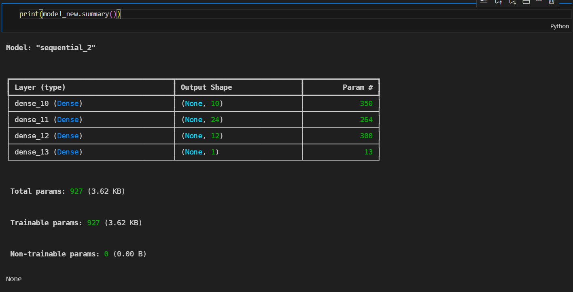
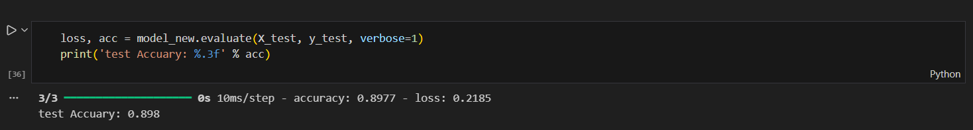
Task 2:
Output 1: 0.8287369366
Output 2: 0.8287369366

Lab 3(05 February 2026)
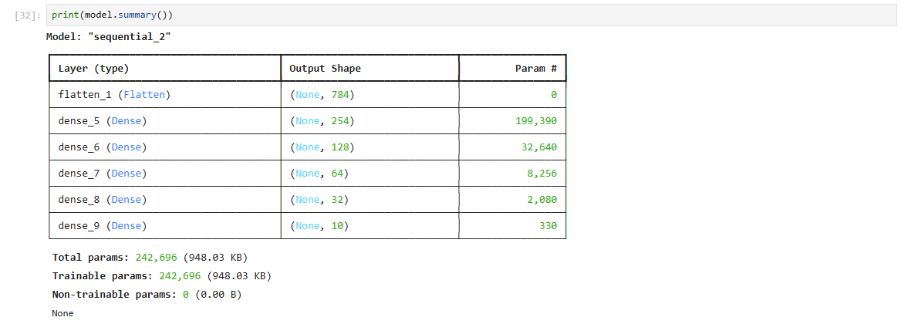
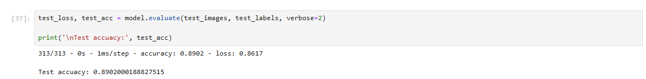

Lab 4(12 February 2026)
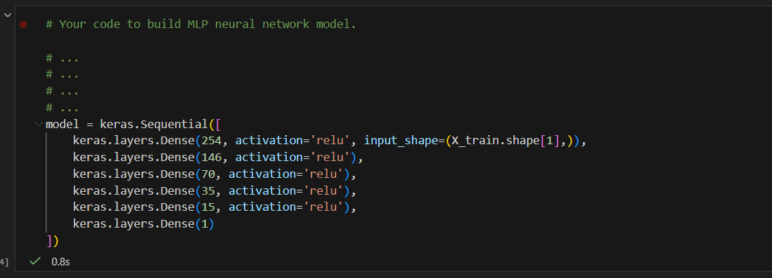
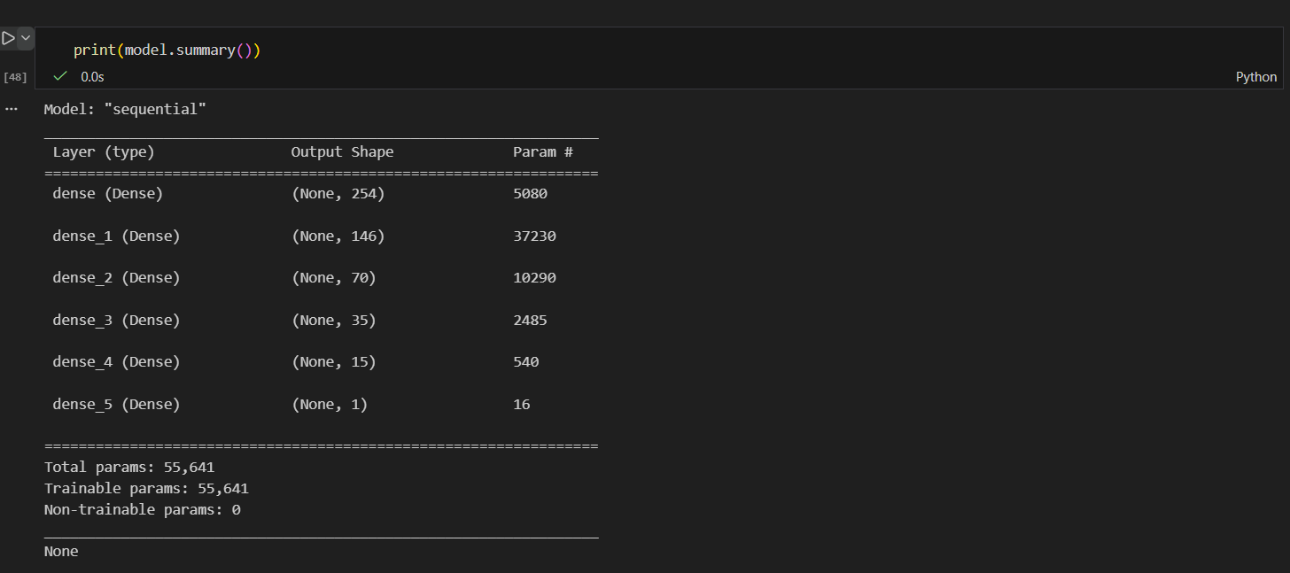
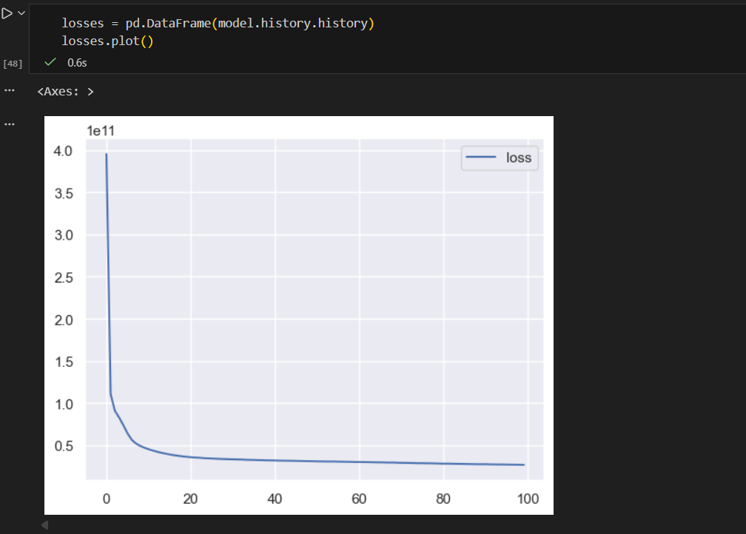
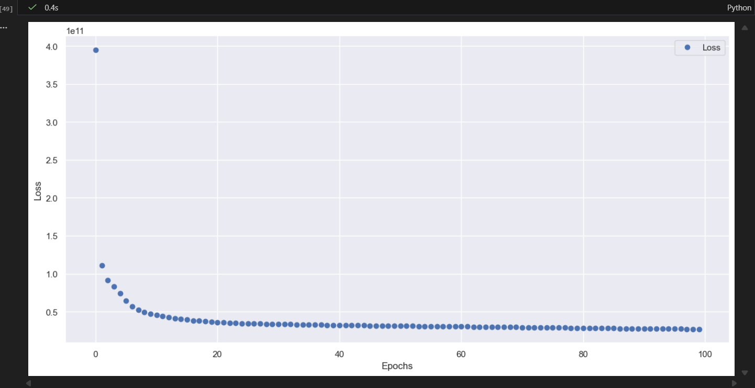
Lab 5

Lab 6

Lab 7

Lab 8

Lab 9

Lab 10

Lab 11

Lab 12

