What is Virtualization?

**Virtualization** is a creation of logical object version in place of an actual version.

Few examples are virtual computer hardware platform, virtual storage, and virtual LANs.

**Hardware virtualization** means creating virtual machine that acts like a real physical computer with an OS.

For example, a virtual machine (VM) hosted on a computer with Microsoft Windows may behave like Ubuntu and Ubuntu supported software may run on the VM.

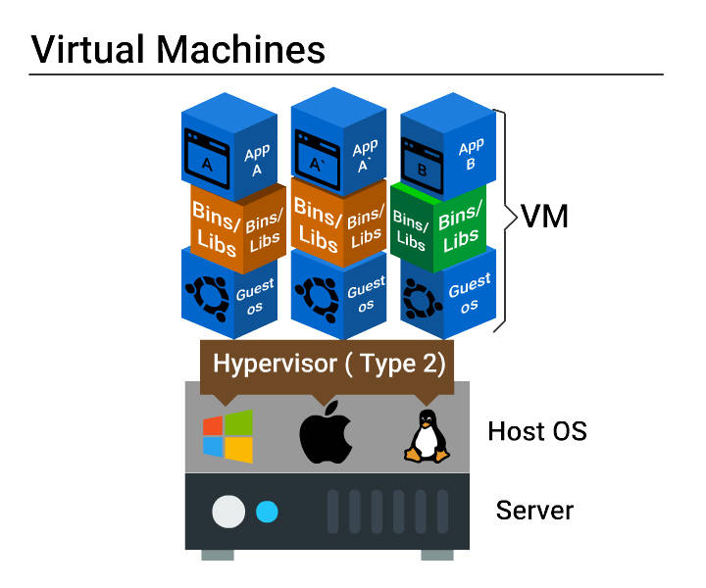

This block diagram explains virtual machine configuration and how applications are deployed on VMs.

##### Need for a Virtual Machine

Virtual machine setup has the following benefits.

* **Multiple operating systems** can be hosted on the same machine simultaneously with complete isolation.
* **Multiple VMs** can be deployed on the same physical box. This reduces the total number of physical machines.
* **Easy maintenance**, app provisioning, and quick recovery.

Problems with Virtual Machine

* A lot of **wastage of resources** like ram, processor, disk space due to fixed space slicing for every application deployed. Hence this is not ideal for a large scale application developed using micro services.
* **Inconsistent computing environment** across the software delivery life cycle (Prod/Dev/QA).
* **Hardware failures** like malfunctioning and power supply loss will stop all working servers since many servers run on a single physical server.

##### What are Containers?

**Containers are multiple isolated services** that are run on a single control host (underlying infrastructure) and they access a single kernel.

**Container based virtualization is an OS-level virtualization** method for deploying and running distributed applications without launching an entire VM for each application.

**They isolate applications from one another.**

##### Virtual Machines vs Containers

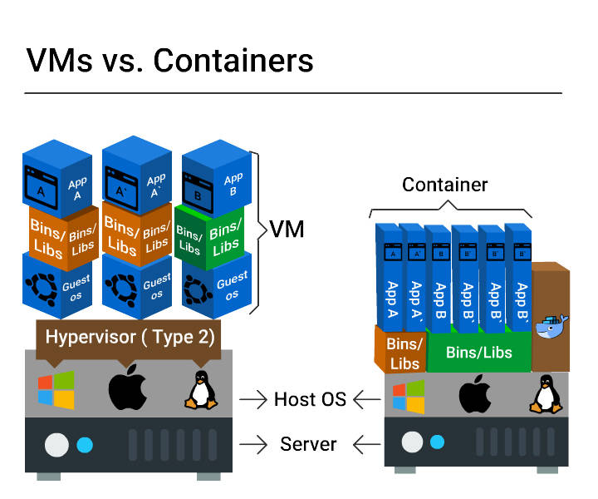

This block diagram clearly depicts the difference between VMs and Containers on how an application is deployed.

Size:

**VMs** - **Resource wastage** is high

**Containers** - **No wastage**

Start up:

**VMs** - Starts **slow**

**Containers** - Starts **really quick**

Integration with DevOps tools:

**VMs** - **Complex** (infrastructure wastage, repetitive configuration and minimal scalability)

**Containers** - **Very simple**

Container - Benefits

* Improved portability
* Better performance
* Optimum RAM/disk space/cloud utilization
* Suited for agile environment
* Facilitates approaches such as micro services, continuous integration, and delivery.
* Eliminates environment inconsistancies

##### Benefits from Container Orchestration Tools

Container Orchestration tools like Docker Swarm, Amazon ECS, and Azure Container Service:

* Facilitate auto deployment
* Scale application easily
* Quickly push application from one environment to another
* Enable automated rollbacks and backups
* Support load balancing and service healing

##### Docker - Introduction

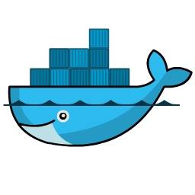

Docker is a tool intended to make the process of creating, deploying and running applications easier by using **container based virtualization technology**.

Docker is an open source container technology that provisions far more apps running on the same old servers compared to traditional VMs.

##### Docker Engine

Docker engine is the Docker core component that is responsible for creating Docker Images and running them as services.

Let us learn in detail about Docker Images in the next topic.

Docker Core Components

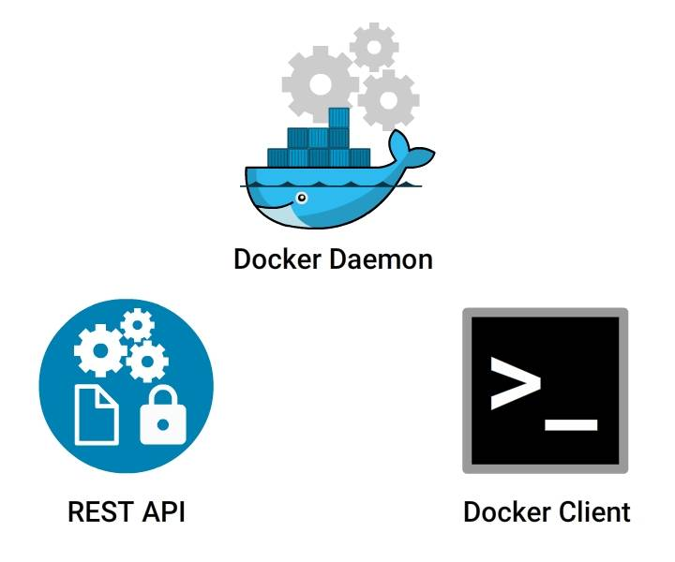

Docker Engine Core Components:

* **Docker Daemon**

Continuous running program (daemon process) that manages the service and other docker objects tied to it.

* **REST API**

Specifies **interfaces**, that programs can utilize to speak to the daemon and direct it what to do.

* **Docker Client**

**CLI** is utilized to interact with the daemon (docker command).

##### Docker on Linux and non-Linux Kernel

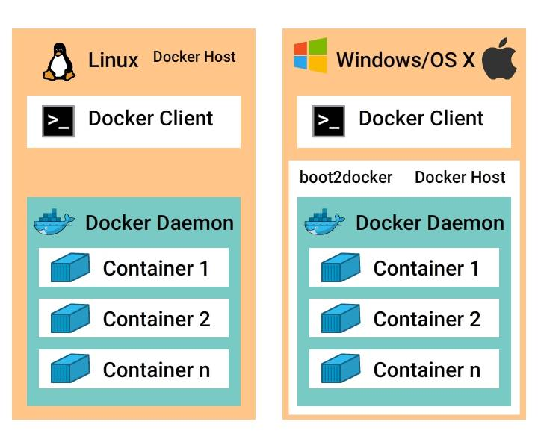

**Docker hosted on Linux:**

This requires just a Docker client and Docker daemon.

**Docker hosted on non-Linux:**

We need to install an **additional Virtual box** and then an extra layer **boot2docker** that will spin up Linux virtual environment on top of non-Linux kernel.

##### Docker Architecture

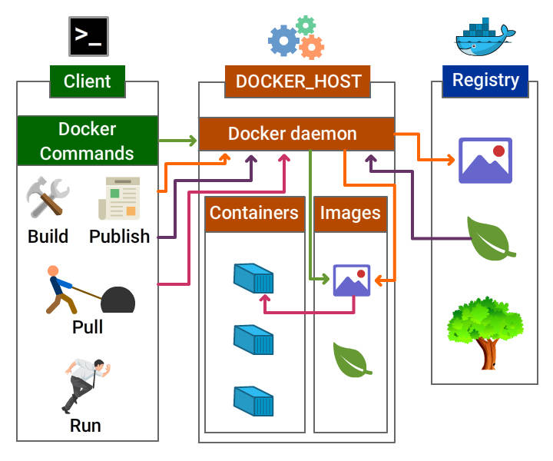

##### Docker Components

Docker components include

* Docker daemon
* Docker client
* Docker Objects
  + Images
  + Containers / Services
  + Network
  + Volumes
* Docker Registry

##### Docker Daemon and Docker Client

**Docker Daemon**

Docker daemon is the docker process that receives requests from docker client and is responsible for **managing docker objects** such as containers, images, networks, and volumes.

**Docker Client**

Docker client **communicates with the docker daemon** through Rest API calls. A docker client can send a request to many docker daemons.

##### Docker Image

Docker image is the collection of **all files, libraries, binaries and other dependencies** forming an executable software application, which can run everywhere without glitches.

An image is an inert, immutable file.

##### Docker Image...

Here are the points to be noted about Docker Image:

* Docker image is read-only, i.e., the image and **its content cannot be altered.**
* Although the alteration is not allowed in Docker, we are allowed to **add the new layer with the changes.**
* After having many alterations, a docker image may be visualized as **several layers one above another.**

### **Parent and Child Images**

The layering concept in docker images leads to the addition of required capabilities efficiently by adding a new layer to the existing one resulting in a new image.

Hence, **the image has the parent-child relationship where the original image is termed as the** base image **upon which several child images are added.**

##### Docker Service / Container

**Containers are** run-time instances **of Docker images that can be run using the Docker run command.**

The fundamental purpose of Docker is to run containers.

You can run a docker image to create as many docker containers as you want.

**Docker Container Lifecycle**

This example explains the container life cycle stages and traversal from one stage to another.

##### Docker Network

The concept of networking in Docker comes into account when working with Docker in a real time scenario at a large scale.

Docker Networking helps us to share data across various containers.

Host and containers in Docker are tied with **1:N relationship**, which means one host can command multiple containers.

**Modes of Networking**

Various modes for networking is all about how we manage connections between containers.

* Bridge mode Networking
* Host Mode Networking
* Container Mode Networking
* No Networking

##### Docker File

Dockerfile is a **script**, formed of different **arguments** and **commands**(instructions) listed successively to automatically execute actions on a base image to form or create a new one.

A Docker File is a simple text file with instructions on how to build your images.

##### Docker Registry

Docker Registry (Docker Repository) is **a storage house** for the Docker Images. It can be accessed publicly or privately by developers across the world.

* Docker images can be **sent to registry** by using docker push subcommand.
* Docker images can be **downloaded** from the registry using docker pull subcommand.

Following are the places where Docker registry can be hosted:

1. **Docker Hub**
2. **AWS Container Registry**
3. **Google Container Registry** and lot more

##### Docker Hub

**Docker hub is one of the repositories of images which can be accessed at**index.docker.io.

Docker Hub is the official repository by Docker development community. Any third party images can be pulled from the repository.

e.g.:

docker pull thedockerbook/helloworld

##### Docker Storage

**Storage drivers**

Container layer contains a **very thin writable layer**, unlike images that have read only layers.

Each container has its storage layer whereas they **share the read only image layer** across containers in the same host.

Docker uses **storage drivers** that will manage the data using copy-on-write mechanism.

**Copy-on-write mechanism**

Docker engine does not copy the whole image when we try to launch it. Instead, it uses Copy-on-write mechanism by which it uses a single copy of shared data until the data within the image is modified.

This saves a lot of disk volume, and the startup process is quick.

**Volumes**

Volume is a directory mounted in the container that is created using docker command.

They are used to share data between containers by using the same volume across various containers.

Video

Image –OS+software+application code all bundled up in a file.

Dockerfile is a text file which contains steps to perform to create image.

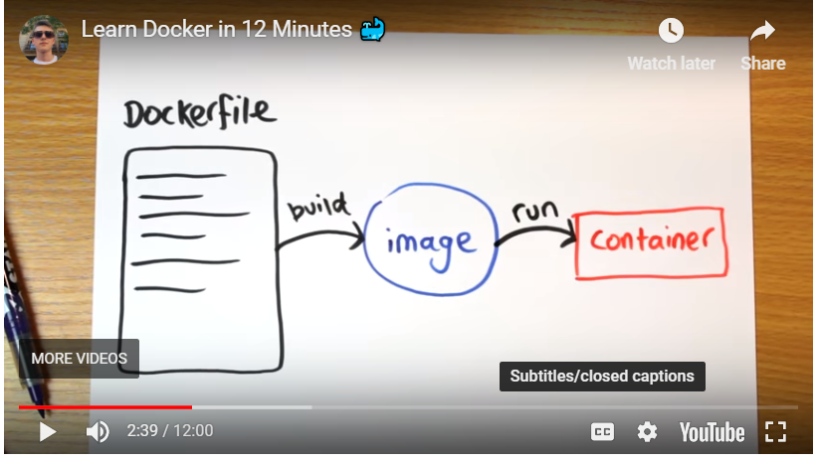

1)Write a dockerfile . Instructions

FROM,COPY,EXPOSE etc

2)On docker bash move to the directory where you want to put the image

give the command –

docker build –t hello-world .

where . means current directory.

3)docker run-p 80:80 hello-world

-p is used to forward a port port 80 from the host to port 80 in the container, so that means when a request gets the host the host is your computer when a request gets there docker is going to forward that to the container and when it gets to the container “that expose line we have got in docker file” that will let the container accept the request and allow apache to handle it.

There are 2 types of containers

* One- ot persists and share data between containers.
* Other lets you share folder between host and container.you can mount a local directory on your computer as a volume inside the container then the container when its running, we will be able to see the files that we were working on

To mount a volume, add another option to docker run command.

Docker run –p 80:80 –v /Users/jake/Desktop/docker/src :/var/www/html/ hello-world.

So we want a local folder to be mounted inside a container

Volume just give running container,the ability to see files on host machine filesystem. They donot change the image.

##### Docker Workflow

Docker workflow includes the following components:

* Docker Image - Read only template that stores the application and environment.
* Docker Container - Runtime instance of a docker image
* Docker registry - Public and private repositories to store images
* Docker File - Automates Image construction
* Docker file Compose - Compose is a tool that can be used to manage multiple containers containing the same different applications.

##### Docker Workflow - In Detail

**Part 1**

* Create a docker file that includes details on the base and child images to be built.
* Build the docker file using docker build command and tag a name to the image.
* Verify if the image is built successfully using docker images command and Run docker inspect command to view the complete details of the image.
* Now the image is ready, push the same to the image repository using docker pushcommand.

**Part 2**

* Pull the newly created image from the repository using docker pull command.
* Run the image using docker run command or using Dockerfile compose.
* Now you can verify the running container using docker ps command.

##### Docker Basic Commands

Here are few **basic docker commands**.

Check the version of Docker:

docker version

Check the detailed information on the running/stopped containers:

docker info

Docker images can be downloaded from **Docker hub using docker commands**.

Lets **pull an image from docker hub** using pull command.

Download a image from docker hub

docker pull <<image name>>

e.g. docker pull nginx

##### Docker Commands - Images

Verify the downloaded docker images:

docker images ↵

View all the commands that were run with an image via a container.

docker history <<Image Name>> ↵

e.g. docker history nginx

Remove Docker Images

docker rmi <<Image Name>> ↵

e.g. docker rmi nginx

Download and run an image in docker container using run command

docker run <<Image Name>> ↵

e.g. docker run --name nginxservice -d nginx

*--name --> to specify a name for the running service. In this example, it is nginxservice*

*-d --> to run the service in the background*

##### Docker Version Tag

You must have noticed that on pulling the image from the Registry, the tagged version of the image is displayed:

https://docs-cdn.fresco.me/system/attachments/files/000/103/273/large/2813b357e1c1cc064e2ec6e8c7ff4c83a0844c6c/tag.jpeg

For example, docker pull busybox:1.24 will download the corresponding version:

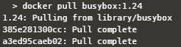

##### Docker Search

We can also search for the images in the Docker Hub registry by using docker searchsubcommand. Let us search for ubuntu images in the Docker Hub, and limit the search result only to 20 because we have more than 2000 images on Ubuntu:

docker search ubuntu | head -20

##### Docker Commands - Container

Now lets run list of commands on the service/ container

List running containers

docker ps

Know the IP address of the running container:

docker inspect <Container Name>

e.g. docker inspect nginxservice

Print the stats for a running Container

docker stats <<Container Name>> ↵

e.g. docker stats nginxservice

Pause the processes in a running container

docker pause <<Container Name >> ↵

e.g. docker pause nginxservice

Unpause the processes in a running container

docker unpause <<Container Name >> ↵

e.g. docker unpause nginxservice

##### Docker Commands - Container (Contd 1...)

Kill the processes in a running container

docker kill <<Container Name >> ↵

e.g. docker kill nginxservice

Start the same container:

docker start <<Container Name>> ↵

e.g. docker start nginxservice

Stop the running container

docker stop <<Container Name >> ↵

e.g. docker stop nginxservice

List all containers (This includes containers in a all states):

We will be able to see the container we just stopped listed here.

docker ps -a

Delete a container:

docker rm <<Container Name >> ↵

e.g. docker rm nginxservice

To remove all stopped containers:

docker container prune

Note: Instead of using the Container Name, all the above commands can be executed with the container id as well.

##### Docker Commands - Container (Contd 2...)

Export a container

docker export <<Container Name>> <<file_Name>>.tar ↵

e.g.

Lets run a service using docker run command.

docker run --name newnginxservice -d nginx

docker export newnginxservice > test.tar

Import a container

docker import <<Remote URL/Image Name.tar>> ↵

e.g. docker import test.tar

##### Docker daemon Commands

Stop Docker daemon process

service docker stop

Start Docker daemon process

service docker start

You may not be able to try these 2 commands since you would not have access to root on Katacoda playground.

Diagnose Run Issues

In case you are having a problem with downloading the images and running them, please follow these steps to check whether the docker service is running on your system or not:

* Check the running status of docker:

service docker status

* Restart Docker service in your system:

service docker restart

Docker Installation

Prerequisite for installation of Docker on Linux are:

* 64-bit architecture Linux
* Linux kernel must be 3.10 or later

**Here are the steps for installing the community edition in Ubuntu 16.04:**

* Add the GPG key for the official Docker repository to the system:

$ curl -fsSL https://download.docker.com/linux/ubuntu/gpg | sudo apt-key add -

* Now add the Docker repository to APT sources:

$ sudo add-apt-repository "deb [arch=amd64] https://download.docker.com/linux/ubuntu $(lsb_release -cs) stable"

Docker Installation...

1. Now update the package database with the Docker packages:

$ sudo apt-get update

1. Check for the policy:
2. $ apt-cache policy docker-ce
3. Install Docker:

```sh

$ sudo apt-get install -y docker-ce

```

1. Check the installed version of Docker:

$ sudo docker --version

**Congratulations!** You have successfully installed Docker version 17.03.0 community edition.

Installation Using Automated Script

**Are you feeling this procedure lengthy? There is a shortcut to this process.**

Just run the below command to install Docker

* curl command

>$ sudo curl -sSL https://get.docker.io/ | sh

##### Uninstall Docker CE

This command is used to uninstall Docker CE package in Ubuntu machine.

$ sudo apt-get purge docker-ce

Step 1 - Create a Dockerfile

1. Create a new directory DockerExample

mkdir DockerExample.

1. Move the newly created directory

cd DockerExample.

1. Add a file named Dockerfile

vi Dockerfile.

**Dockerfile**

FROM tomcat:jre8-alpine

# For wget to work

RUN apk update \

&& apk add ca-certificates wget \

&& update-ca-certificates

# Copy tomcat server.xml

WORKDIR /usr/local/tomcat

# Start tomcat

CMD ["catalina.sh", "run"]

##### Step 2 - Build a Docker Image

Build a docker image using below command.

All the four steps in the docker file will be executed one by one. You will see a message Successfully Built "Image Id".

docker build -t tomcatimage .

-t --> Tags the name 'tomcatimage' to the newly created image.

**Note**: Do not forget to add a '.' dot at the end of the build command.

You can run the below command to view the complete details of the image.

docker inspect tomcatimage

##### Step 3 - Verify Image

Verify the image retrieved by running command. This should list the newly created image.

*docker images*

Step 4 - Push to Registry

Let us push the created image to Docker hub.

Set up a Docker Hub account. Fill your profile details on the main Docker Hub website and click Sign Up. Activate your account from the email sent.

Go back to Katacoda page and continue with the commands to push the image to docker hub.

1. Login to docker hub using the below command

docker login --username <username>

key in the password once prompted.

1. Command to tag the image with the repository image name

docker tag tomcat01 <username>/tomcatimage

1. Now let us push the image to the hub

docker push <username>/tomcatimage

Now the image 'tomcat01' is available in the docker hub.

Step 5 - Pull from Registry

Now lets learn to pull an image from the docker hub.

Open a new Katacoda session and type the following command.

1. Login to docker hub using the same docker login command
2. Type the below command to pull the added image

docker pull <username>/tomcatimage

1. Verify if the image is available by running docker command

docker images

##### Step 6 - Run Image

To run the tomcat image, type the below command

*docker run --name tomcatRunner -p 8080:80 -d tomcatimage*

tomcatRunner - container name

8080 - port of host machine

80 - port of container

-d - Run the daemon process in the background

##### Step 7 - Verify Container

Now let us verify if the new container created is running. Type in command

*docker ps*

This will list the newly created container.