# Overview

The design of the Mu2e detector is driven by the need to reject backgrounds to a level consistent with a single event sensitivity for ** → *e* conversion of the order of 5x10-17. The calorimeter system is a vital link in the chain of background defenses. A background of particular concern is false tracks arising from pattern recognition errors that result from high rates of hits in the tracker. The accidental hits could combine with, or obscure, hits from lower energy particles, to create a trajectory consistent with a higher energy conversion electron. Thus a primary purpose of the Mu2e calorimeter is to provide a second set of measurements that complement the information from the tracker and enable us to reject background due to reconstruction error. Another source of background is cosmic ray muons that are not vetoed by the CRV system which stop in the calorimeter and produce a backward-going electron track within the 105 MeV acceptance window. A calorimeter with excellent time resolution can reject such tracks.

The energy resolution of a crystal calorimeter complements, but is not competitive with, a tracking detector. Even a coarse confirmation of track energy by the calorimeter will, however, help reject backgrounds from spurious combinations of hits from lower energy particles. The Mu2e simulation is not yet at the stage where this can be explicitly demonstrated, but 5% energy resolution has been achieved by other experiments operating in a similar energy regime [2].

For real tracks, activity in the tracker and in the calorimeter will be correlated in time. The time resolution of the calorimeter should be comparable to the time resolution of extrapolated tracks from the tracker, estimated to be a few ns [1]. A calorimeter timing resolution of ~1 ns is consistent with the tracker and can be easily achieved.

## Design

In the 100 MeV energy regime, a total absorption calorimeter employing a homogeneous continuous medium is required to meet the resolution requirement. This could be either a liquid such as xenon, or a scintillating crystal; we have chosen the latter. Two types of crystals have been considered for the Mu2e calorimeter: lutetium-yttrium oxyorthosilicate (LYSO) and barium fluoride (BaF2). The design selected for the Mu2e calorimeter uses an array of BaF2 crystals arranged in two annular disks. Electrons following helical trajectories spiral into the front faces of the crystals, as shown in **Figure 0.2**. Photodetectors, electronics and services are all arranged on the rear face of the disks. The crystals are of hexagonal shape, 3.2 cm across flats and are 21 cm long; there are a total of XXXX crystals. Each crystal is read out by two large area APDs; solid state photo detectors are required because the calorimeter resides in a 1 T magnetic field. Front end electronics resides on the detector, voltage distribution, slow controls and are behind each disk. A laser flasher system provides light to each crystal for relative calibration and monitoring purposes. A source system provides absolute calibration and an energy scale. The crystals are supported by a lightweight carbon fiber support structure. Each of these components is discussed in the sections that follow.

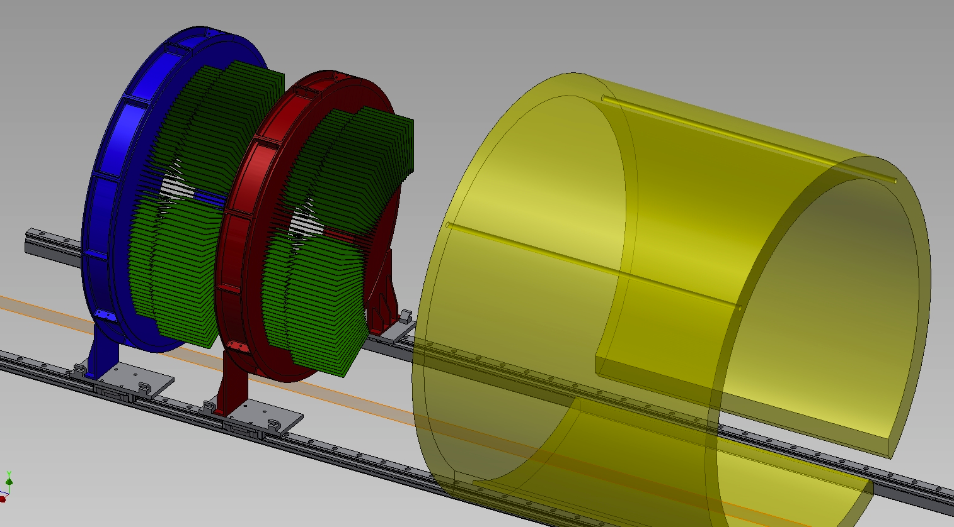

**Figure 0.2**. PLACEHOLDER FIGURE The Mu2e calorimeter, consisting of an array of BaF2 crystals arranged in two annular disks. Electrons spiral into the red faces.

### Crystals

**Baseline design**

At the start of the Mu2e project, the crystal considered for the calorimeter was lead tungstate (PbWO4). The low light output required running the calorimeter at -25oC with very tight tolerances on the temperature stability, and the radiation dose dependence of the light output made for a difficult calibration problem. By the time of the Mu2e CDR, we had replaced the PbWO4 with lutetium-yttrium oxyorthosilicate (LYSO) crystals. LYSO is an excellent match to the problem at hand: it has a very high light output, a small Molière radius, a fast scintillation decay time, excellent radiation hardness, and a scintillation spectrum that is well-matched to readout by large area avalanche photodiodes (APDs) of the type employed in the CMS and PANDA experiments. LYSO is also the preferred option for the KLOE-2 upgrade. The only downside of LYSO is the cost. This is driven by the cost of the Lu2O3 salt. Manipulation of the price of rare earths by the Chinese government has over the past several years resulted in an increase of the price Lu2O3 of by a factor of more than three. China has recently lost a WTO case concerning rare earths, so over time, prices are likely to subside. However, at current prices we have concluded that an LYSO calorimeter in unaffordable. We have therefore chosen barium fluoride crystals for the calorimeter

Table 0.1 shows a comparison of the properties of BaF2, LYSO and PbWO4. Several points are worth discussing. It is clear that LYSO is the superior alternative, based on radiation length, Molière radius and light output. BaF2 has much less light than LYSO, but much more than PbWO4. It also has a substantially larger Molière radius and radiation length, which are disadvantages.

**Table 0.1**. Comparison of crystal properties for BaF2, LYSO and PbWO4.

|  |  |  |  |  |
| --- | --- | --- | --- | --- |
| **Crystal** | **BaF2** | **LYSO** | **PbWO4** |  |
| Density (g/cm3)  Radiation length (cm) *X*0 | 4.89 | 7.28 1.14 | 8.28  0.9 |  |
| 2.03 |
| Molière radius (cm) Rm | 3.10 | 2.07 | 2.0 |  |
| Interaction length (cm) | 30.7 | 20.9 | 20.7 |  |
| *dE/dx* (MeV/cm) | 6.5 | 10.0 | 13.0 |  |
| Refractive Index at max | 1.50 | 1.82 | 2.20 |  |
| Peak luminescence (nm) | 220, 300 | 402 | 420 |  |
| Decay time *τ*  (ns) | 0.9, 650 | 40 | 30, 10 |  |
| Light yield (compared to NaI(Tl)) (%) | 4.1, 36 | 85 | 0.3, 0.1 |  |
| Light yield variation with temperature(% / °C) | 0.1, -1.9 | -0.2 | -2.5 |  |
| Hygroscopicity | None | None | None |  |

The light emission spectrum of LYSO peaks at 402 nm, compatible with APD readout. LYSO has a scintillation decay time of *τ* = 40 ns; the optimal integration time of 200 ns is compatible with the expected signal and background rate.

The greatest advantage of LYSO crystals is the excellent light yield, which provides excellent energy resolution at room temperature. This greatly simplifies the calorimeter design. Temperature stability requirements are also substantially less stringent.

The much larger LYSO signals provides greater flexibility in the choice of photo sensors and front end electronics (FEE). There are several alternatives possible: (a) the use of a simple voltage amplifier in place of a charge sensitive amplifier and shaper. Our tests show that even a single APD/crystal can provide an ENC of 100 keV, b) using the FEE together with a large size APD can reduce the ENC due primarily to the APD leakage noise to ~30-40 keV, (c) retaining the FEE developed for PWO-2 and reduce the APD size from 10×10 mm2 to 5×5 mm2, keeping the ENC at the level of ~150 keV. For any of these options the overall noise for a group of 25 crystals will be below 1 MeV, allowing us to push the energy resolution close to the intrinsic photoelectron statistics limit of 1%.

A third advantage of LYSO is the excellent radiation hardness, which has been measured for both *’*s and neutrons. Negligible deterioration of signals (10% loss in light yield) is observed with* * exposures of 10000 Gy (*i.e.* 15 years of Mu2e running). Therefore, with LYSO we expect not to need any stimulated recovery mechanism and there will be no reduction of running time.

**Figure 0.3** shows the response of a LYSO crystal read out by a conventional PMT to a 22Na source. The energy resolution is excellent. The same technique is used to measure the LRU (Longitudinal Response Uniformity) by scanning the crystal along its axis [3]. Control of the cerium concentration in the growing process has brought the longitudinal response uniformity in current production LYSO crystals to better than 2-3%.

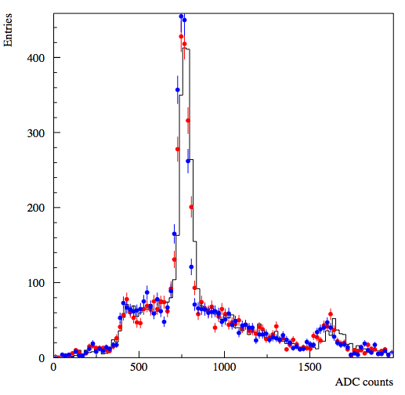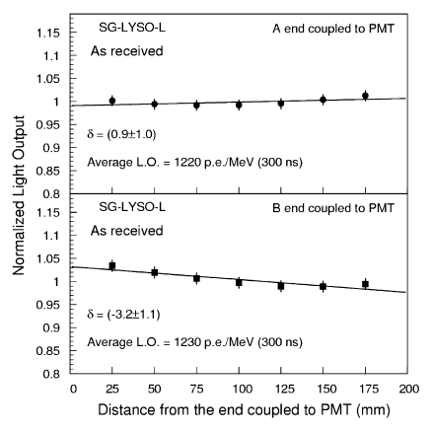

**Figure 0.4**. *(left)* Charge response to a 22Na source for a LYSO crystal readout by a PMT. *(right)* Longitudinal response uniformity measurement for a Saint-Gobain crystal.

The main disadvantage of LYSO is the cost. LYSO crystals are commercially available from Saint-Gobain, SICCAS (Shanghai Institute of Ceramics), SIPAT (Sichuan Institute of Piezoelectric and Acousto-optic Technology) and other producers. Despite an active R&D program at Caltech, in cooperation with SICCAS and SIPAT, aiming to reduce the commercial price of LYSO, the large increase in Lu2O3 salt price over the past two years has made the cost of a LYSO calorimeter unaffordable. The LYSO crystal cost at the time of the CDR was of the order of a factor 2.5-3 more than PWO-2. There were, however, compensating cost reductions, in that the -25°C cooling system is not required, no provision for radiation damage recovery had be provided, and that performance was improved, and

**Figure 0.5.** Market price of Lu2O3 as a function of time.

the running of the experiment would be more efficient. Figure 0.5 shows the history of the spot price of Lu2O3. This increase, due entirely to market manipulation on the part of the Chinese government, has increased the price of LYSO crystals by more than a factor of two, making them too expensive for use in Mu2e. While China lost a recent Word Trade Organization case concerning rare earth market manipulation, the case has been appealed; it is unlikely that the salt price will return to normal levels on a short time scale.

We have therefore been forced to seek alternatives, and have decided upon barium fluoride as the scintillating crystal. Table 0.1 compares the basic properties of BaF2, LYSO and PbWO4 crystals. The larger radiation length and Molière radius of BaF2 are clearly a disadvantage. The light yield is much greater than PbWO4, although smaller than that of LYSO. The presence of a very fast scintillation decay time component at 220 nm (<1 ns) is very useful in background rejection, providing compensation for the larger shower size. If rates are not too high, it may be possible to make use of the larger slow component (650 ns) at 300m nm as well.

The emission spectrum of BaF2 is shown in Figure 0.6. The short wavelength of both the fast and slow scintillation components presents a difficult readout problem. Photomultiplier tubes with quartz windows and perhaps solar-blind photocathodes are well matched to the BaF2 spectrum, but will not work in the field of the Detector Solenoid. Channel plate PMTs are at present far too expensive. We are closely monitoring the LAPPD project, which may be able to produce suitable devices. Out main thrust, however, is to use solid state photosensors, either APDs, SiPMs or MPPCs, with extended UV response.

**Figure 0.6.** BaF2 emission spectrum. The fast component (900 ps) peaks at 220 nm. The slow component (650 ns) peaks at ~300 nm.

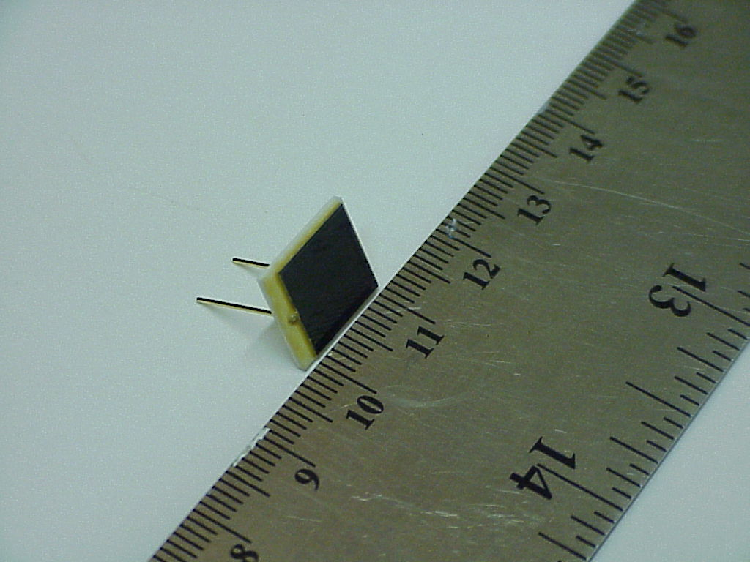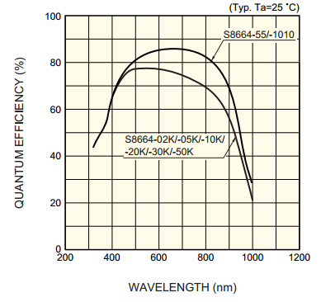

**Figure 0.8.** A photograph of a packaged RMD 9 x 9 mm2 APD.

**Figure 0.7** The spectral response of a conventional Hamamatsu APD

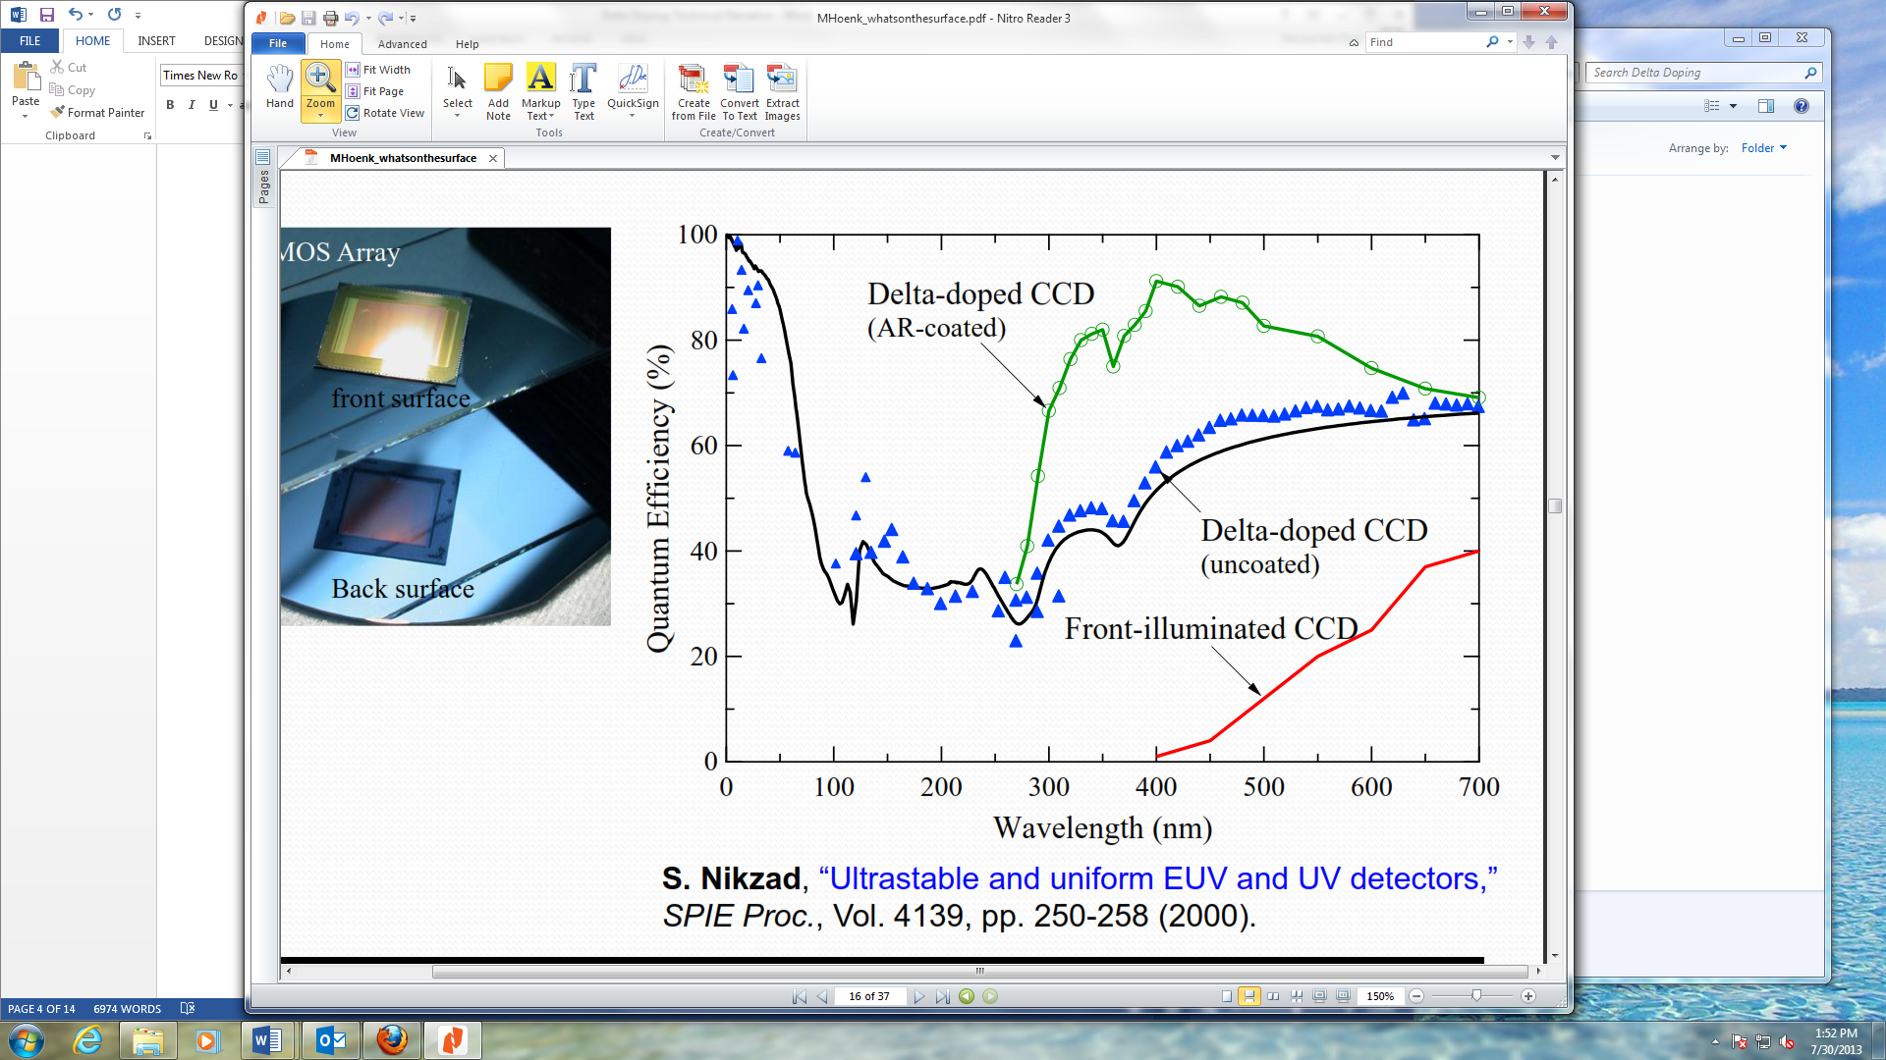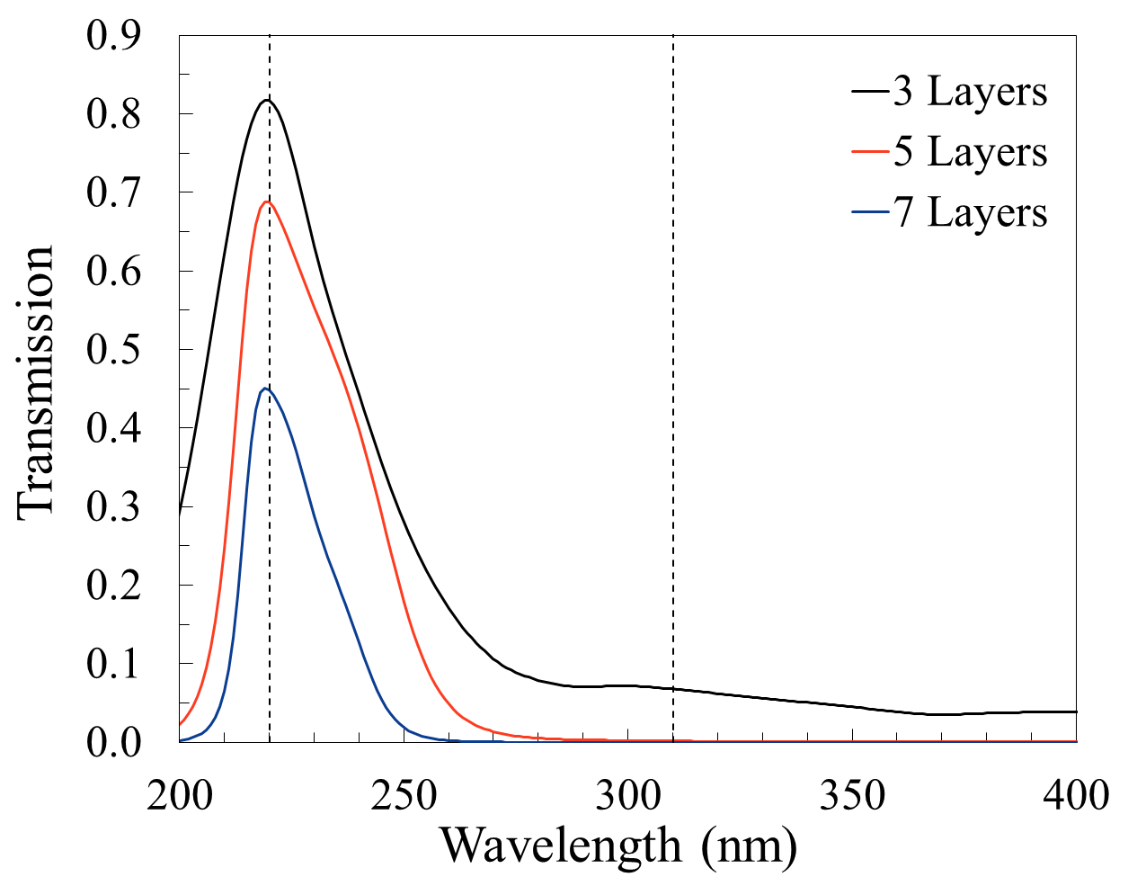

**Figure 0.11.** The rise times from two APDs, directly measured on a digital oscilloscope, while illuminated with a pulsed 405 nm laser. The red trace is the thinned APD (FWHM ~ 1.5 ns) while the orange trace is a standard APD (FWHM ~ 150 ns).

**Figure 0.10.** QE versus wavelength for a CCD before and after delta-doping [12]. The black line is the QE theoretical (1-R) limit.

**Figure 0.9.**  Calculated response of 3, 5 and 7 layer combination Al2O3/Al interference filters on a Si substrate. The blocking ratios for 220 vs. 310 nm are 12:1, 400:1 and 15,000:1.