## Requirements

The requirements for the calorimeter have been documented by the Mu2e collaboration [X]. The primary functions are to provide energy, position and timing information to confirm that events reconstructed by the tracker are well measured and are not the result of a spurious combination of hits. Moreover, the calorimeter should also provide the experiment’s trigger. This leads to the following requirements:

* An energy resolution of O (4%) at 100 MeV is desirable to confirm the much more precise energy measurement from the tracker.
* A timing resolution better than ~ 0.5 ns is required to ensure that energy deposits in the calorimeter are in time with events reconstructed in the tracker.
* Position resolution better than 1 cm to allow a fair comparison of the position of the energy deposit to the extrapolated trajectory of a reconstructed track.
* The calorimeter should provide additional information that can be combined with information from the tracker to distinguish muons from electrons.
* The calorimeter must provide a trigger, either in hardware, software, or firmware that can be used to identify events with significant energy deposits.
* The calorimeter must operate in the unique, high-rate Mu2e environment and must maintain its functionality for radiation exposures up to XX Gy/crystal/year and for a neutron flux equivalent to 10XX n_1MeVeq /cm2.

The energy resolution of a crystal calorimeter complements, but is not competitive with, that of the tracking detector. Even a coarse confirmation of track energy by the calorimeter will, however, help reject backgrounds from spurious combinations of hits from lower energy particles. Energy resolution at a level of 5%, at 100 MeV, has been achieved by the Mu2e calorimeter group [NIMs] as well as other experiments [PANDA] operating in a similar energy regime.

To provide a guide for this discussion, we have simulated a large sample (25 x 106) of DIO events in the momentum range of 100-105 MeV/c. The DIO sample has been produced with the proper energy spectrum and normalized to the expected rate for 3 years running. We have also produced 105 conversion electron, CE, and normalized it to the number of events expected for a BR (μ- N 🡪 e- N) of 10-16. For each simulated event, we have reconstructed tracks and clusters with the official Mu2e framework and estimated their momenta, P, and deposited energy, E. For the purpose of this test, we assume perfect reconstruction so that background hits, in pileup to track and cluster reconstruction, have not been added.

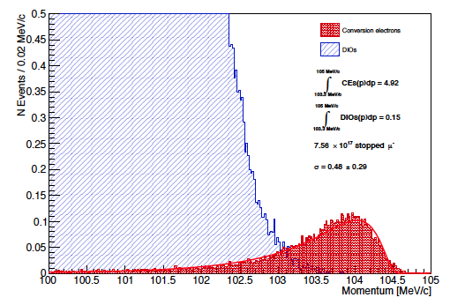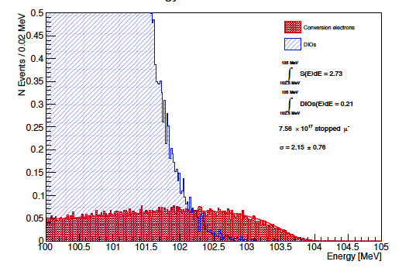

In Fig.1.1, the distribution of energy and momentum are shown for DIO and CE events with the best estimate of event sensitivity for each single detector. To use both information, we have built a pseudo-chi2 variable, ξ = signed((P-μp)/σp)2 + signed((E-μE)/σE), where μ is the most probable value and σ represents the FWHM/2.35 respectively, the sign +(-) is assigned to events above (below) the most probable values. In Fig.1.2.left the distributions of ξ is shown for the DIO and CE events. Cutting at ξ < 3.5, as indicated in the picture, we count NDIO=0.23 and NCE=4.11, respectively. These results have to be compared with NDIO=0.15 and NCE=4.9 estimated by using tracker only information. In Figure 1.2.right, the scatter plot of P_trk vs E is shown after the application of this cut. It is evident that the request of energy information does not improve the S/N while reduces the efficiency of a 20%. The situation slightly deteriorates for increasing energy resolution. A summary of these results are reported in Tab.1 where additional Gaussian smearing has been add to the simulated calorimeter resolution.

Figure . *Energy and Momentum distribution for DIO and CE events. Assume perfect reconstruction and no addition hits in overlap from the background.*

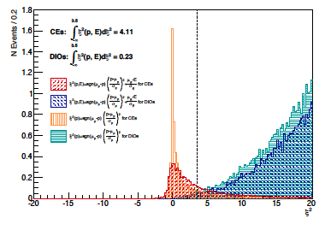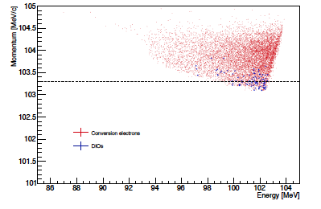

Figure . *(Left) Distribution of the ξ variable described in the text, (right) scatter plot of P vs E for events with ξ < 3.5.*

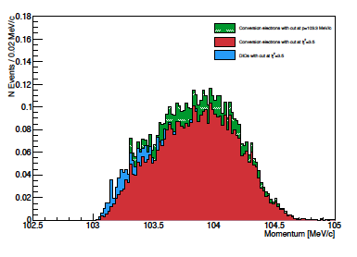In Fig.1.3, the momentum distribution for CE, DIO events selected by the tracker are compared with the ones obtained with the combined information; the left (right) plot displays the case for an energy resolution of 2.1%, 3.1% respectively. We conclude that the combined information does not improve the signal over noise ratio and slightly reduces the reconstruction efficiency tracker based. However it adds a confirmation to the CE candidate in case of a wrong track reconstruction. A detailed report of such a study can be found in ref.[XX].

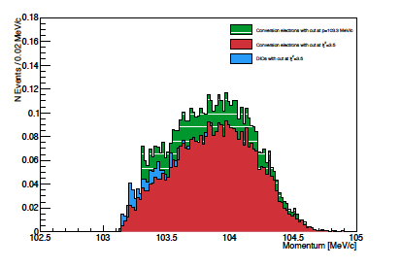

Figure 1.3 *Momentum distributions for the CE candidate and DIO background for selections with the* ξ *variable (red histogram), additional track only candidate (green stacked histogram). DIO events are displayed in blue: left plot is for calorimeter resolution of 2.1%, right plot for 3.1%.*

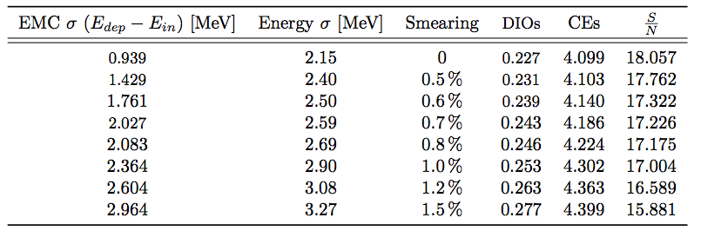

Table : *Number of CE and DIO candidates after the application of a ξ cut at 3.5 as a function of the calorimeter energy resolution*

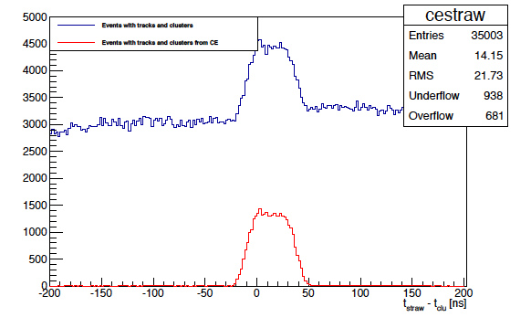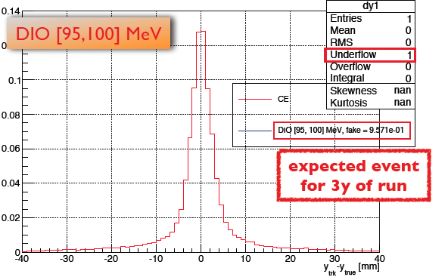

Figure1.4 (Left) *Distribution of the difference between the real impact point of the CE track on the calorimeter surface and the extrapolated value from the tracker.* *The tracks were fitted with a Kalman filter and extrapolated to the calorimeter using the full covariance matrix. (Right) distribution of ΔTHITS = Tstraw – Tcalo (ns), blue are all hits, red hits connected to CE tracks.*

The tracker and the calorimeter hits produced by the same particle should be close in time. The calorimeter timing resolution should be comparable to the time resolution of extrapolated tracks from the tracker, estimated to be ~ 0.5 ns. The calorimeter timing resolution of about 0.5 ns is consistent with the tracker and will not spoil the joint calorimeter track performances. The requirement on the calorimeter’s position resolution is based on the error associated with extrapolating a track from the tracker to the calorimeter, Fig.1.4. There is no need for the calorimeter position resolution to be better than the extrapolation error, driven by multiple scattering in the tracker. Based on this study, a position resolution of 0.5 cm is sufficient.

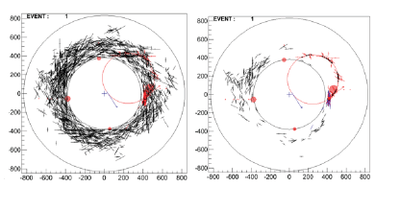

Figure .5 *Distribution of the hits in the tracker before (left) and after (right) the application of a cut on the DT variable described in the text. The situation for the pattern recognition is dramatically improved.*

The calorimeter timing information can be used by the reconstruction in many different ways. For the clustering reconstruction itself, a good timing resolution helps in the connection/rejection of cells to the cluster and in the cluster merging. This is however a

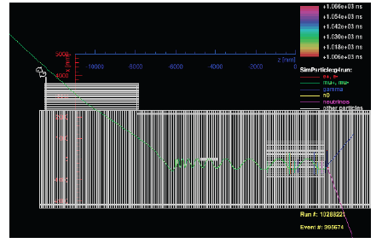

Figure .6 *Event display of the “RALF” event, a simulated cosmic ray muon surviving CRV cuts and reconstructed by the tracker system as a CE candidate. Simulated statistics of the cosmic sample equivalent to ~ 10% of experiment live time.*

technical point and strongly depends on the geometry and granularity choice, it will be discussed further in Sect. XX after presenting the baseline detector layout. Timing is instead essential for: (i) improving the pattern recognition in the tracker and (ii) adding discriminating power to the particle identification of muons with respect to the electrons.

1. **Improvement on the tracking pattern recognition capability**

This is shown by the ΔT distribution of Fig.1.4.right, where ΔTHITS = Tstraw-Tcalo is the time difference between the timing of the tracker hits and the calorimeter cluster timing. Retaining only the hits in time in a region large enough to take care of the drift in the straw, as for instance |ΔTHITS| < 50 ns, reduces dramatically the combinatorial background. This is clearly shown by the comparison of the tracking event display before (Fig.1.5.left) and after (Fig.1.5.right) the application of this cut.

1. **Particle Identification and Muon Rejection**

Cosmic rays can generate two distinct categories of background events: muons trapped in the magnetic field of the detector solenoid and electrons, produced in the cosmic muon interaction with the detector material. We concentrate on the first category. Discussion of rejection of the second

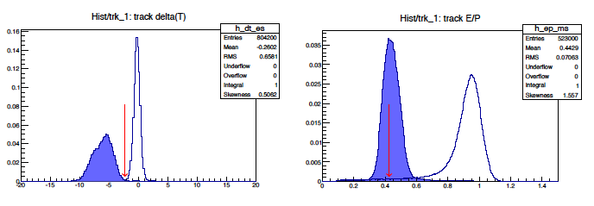

Figure .7 *Distribution of DT_e (left-plot) and energy (right-plot) variables for electrons (white) and muon (blue) of same momentum (104.4 MeV).*

category can be found in ref. [Pezzullo]. In Fig. 1.6 the simulated cosmic muon (named Ralf Event) that has survived the CRV is shown. This event has been reconstructed as a CE candidate, since it has a momentum of 104.4 MeV/c. The simulation sample done [REF-ralf] corresponds to a 10% of the experiment data taking time so that we expect O(10) events of this kind in the final sample. Our physics requirement is to keep the contribution due to cosmic background at a level of 0.05 events (cfr.xxx) thus translating in a muon rejection requirement of ~ 200 while keeping a high signal efficiency

(~ 99% on CE)

The tracker alone is unable to make such a powerful discrimination. In note [refpasha] the tracker timing and DE/DX information were combined in a Log Likelihood ratio function that provided a rejection of 8 with an efficiency of 90%. Rejecting the offending Ralf event corresponds to a 30% inefficiency on the CE signal.

The tracker-calorimeter PID can be based on energy reconstruction, shower shape and time difference between calorimeter timing and extrapolated arrival time of the track on the calorimeter surface in the electron hypothesis, ΔT_e. In the following calculation, we do not consider the shower shape since this is really detector specific. In Fig.1.7, the ΔT_e and energy distributions are shown for muons and electron candidates. Rejection of the offending Ralf event is straightforward since it has energy deposition in the calorimeter of 44.4 MeV and a DT variable of -1.5 ns as shown by the red arrows in Fig.1.7.

Study of rejection and efficiency has been done as a function of different values of the energy and timing resolution. Results of these studies are reported in ref [ToBeDone] and in Fig.1.8. We conclude that the timing resolution of ~0.5 ns and an energy resolution of O(5%) are necessary to keep high efficiency and a 3-σ μ-e separation. In chapt. [Simulation], we will also show how this result is stable with respect to the background occupancy.



Figure 1.8 *Distribution of the μ-e rejection factor as a function of reconstruction efficiency. The results are parametrized as a function of energy and timing resolution.*

Another relevant characteristics provided by the calorimeter system is the one of generating a fast, efficient and tracking independent trigger for the experiment. For trigger we mean an offline filter, HLT/L3 like, that can be used after streaming the events from the DS to the online computing farm but before storing data on disk. The DAQ [cfr chapt.xx] will read events from the tracking and EMC digitizer at a maximum throughput of XX Gb/sec and the foreseen online farm will not be able to process with full reconstruction more than 1/20 of the streamed data. The calorimeter “trigger” should be able to help the processing in the online farm by reducing the input of a factor XXX while preserving the writing on disk to a max storage of 10 pB/year. The most important aspect for this trigger is to be independent from the tracker for two reasons: (i) it will allow a measurement of the tracking and of the Track Trigger efficiency if done in OR with the calorimeter one, (ii) it will suffer of a completely different systematics due to the presence of the environmental background. The second point is particularly important for a smooth start-up of the experiment where the running conditions will not precisely known. Indeed, while the overlapping hits in the tracker make the pattern recognition difficult a calorimeter based trigger, that looks only to the energy threshold, will see the additional hits only as incremental energy. This might translate in a higher throughput for the background but will not reduce substantially the trigger efficiency. Moreover, the offline application of the DThits cut will speed up also the tracker reconstruction. In ref [DocDbTrigger], we have revised the study of the DIO rejection and signal efficiency for a simple calorimeter cluster based trigger. In Fig.xx, we report the DIO surviving rate as a function of efficiency for different value of energy resolution. It is clear that the requirement to bring down the rate to 4 kHz and efficiency to > 90% suggests a calorimeter with an energy resolution of O(7-8)%.

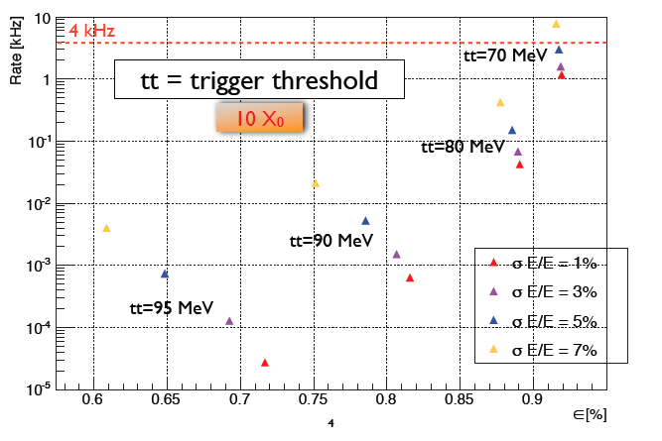

Figure 1.9 TRIGGER EFFICIENCY vs Resolution

Calorimeter improvement of CALMAN Filter ??

The calorimeter system should also be radiation hard and have an occupancy at a level of 10-20 % not to impact the data throughput.

Summarizing, whatever resolution around 5% will be reasonable for the calorimeter. A timing better than 500 ps is favored for PID as well as a 0.5 cm position resolution for track matching.