## Simulation

**1.3.1 Calorimeter optimization**

The baseline calorimeter geometry design (henceforth disk geometry) for Mu2e consists of two annular disks separated by approximately half a wavelength. This configuration presents minimal area for the interception of backgrounds to particles entering the Detector Solenoid and originating in the muon-stopping target or the beam dump while keeping excellent signal efficiency. We selected hexagonal faced crystals to tessellate the annular disk, as they provide a more natural tiling and offer a better coverage than square crystals. Hexagonal crystals also offer superior light collection efficiency and better approximate the shape of electromagnetic showers. In optimizing the disk design, we considered the inner and outer radii of the disks, their placement and relative separation, and the dimensions of the crystals.

The dimensions of the disks are the first to be addressed. Figure XX shows the efficiency for detecting in the calorimeter a good signal electron found by the tracker as a function of the disk inner and outer radii. We consider only cluster with a deposited energy above 60 MeV. The separation between the disks is set to 70 cm, corresponding approximately to half a wavelength, and the crystal size is taken to be 32 mm across flats. The efficiency reaches a maximum at an outer radius close to 67 cm for both an inner radius of 35 cm and 36 cm. A similar conclusion holds for considering disks with different outer radii. We refine the optimization by minimizing the empty space between the crystals and the disk boundaries as a function of the crystal size and the disk radii. Figure XX shows for example the empty space as a function of the disk inner radius for a crystal dimension of 33 mm across flats. Several possible configurations are detailed in Table XX. We selected a crystal size of 33 mm across flats with disk radii of 351 mm and 660 mm, respectively. This choice ensures sufficient space to mount the readout at the back of the crystal while maintaining efficiency and limiting the number of readout channels. The crystal layout is shown in Figure xx.

We finally optimize the separation between the disks. As shown in Figure XX, a separation of 70 cm is optimal, independent of the energy deposited in the calorimeter. The position of the disk w.r.t the tracker has a negligible impact on the efficiency, as expected from translational invariance.

|  |  |  |  |  |  |
| --- | --- | --- | --- | --- | --- |
| Crystal size  (mm) | Disk Radii  in / out (cm) | # crystals | Empty volume  in / out (mm3) | Crystal  volume (cm3) | Efficiency  (%) |
| 31 | 359.1 / 643 | 966 | 28772.2 / 54288.1 | 168830 | 90.5 ± 0.6 |
| 31 | 359.1 / 672.3 | 1110 | 28772.2 / 54508.3 | 193998 | 90.4 ± 0.6 |
| 32 | 340.1 / 663.5 | 1044 | 29098.3 / 57184.3 | 194424 | 92.2 ± 0.6 |
| 32 | 371 / 663.5 | 966 | 29801.2 / 57184.3 | 179898 | 90.2 ± 0.6 |
| 33 | 351 / 660 | 930 | 30243.4 / 67178.5 | 184188 | 92.2 ± 0.6 |
| 34 | 361.2 / 647.3 | 798 | 32992.5 / 68438.1 | 167769 | 90.4 ± 0.6 |

Table xx.xx: Characteristics of the disks and crystals for some of the configurations optimizing the empty volume between the crystal and the disk boundaries.

Figure Left: The cumulative efficiency for detection in the calorimeter of good signal tracks first found in the tracker, as a function of the disk outer radius for different values of inner radius. Right: Empty space between the crystals and the disk inner bo

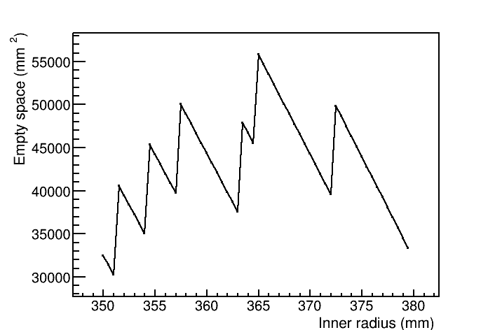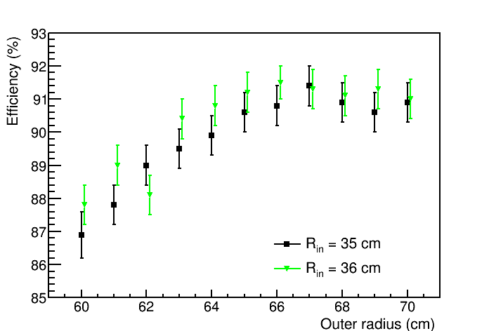

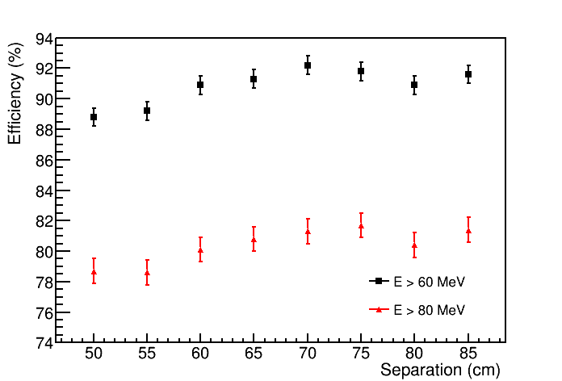

Figure The cumulative efficiency for detection in the calorimeter of good signal tracks first found in the tracker, as a function of the separation between the disks, for two thresholds of the energy deposited in the calorimeter.

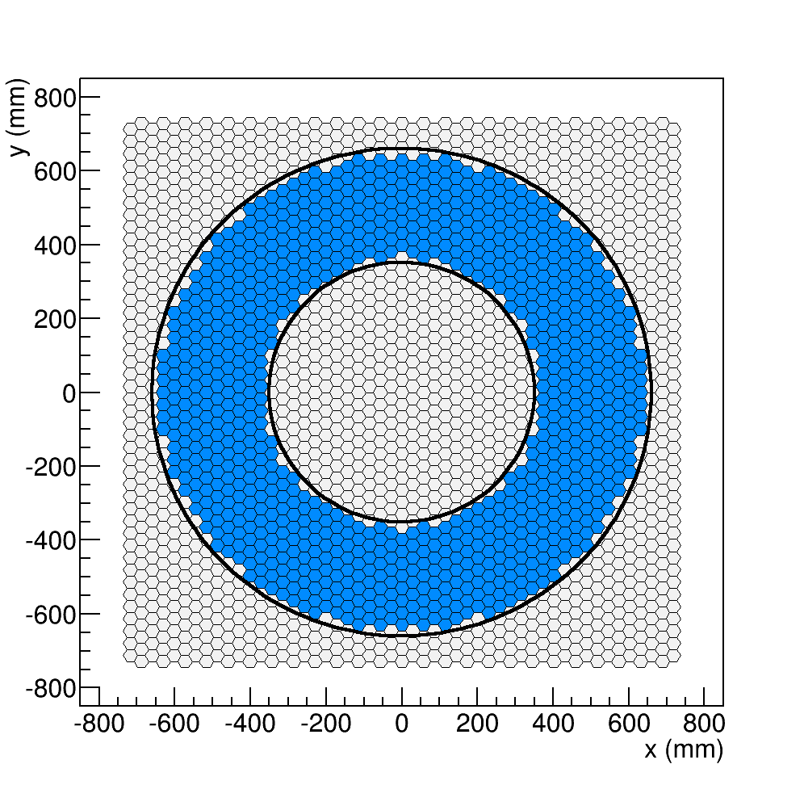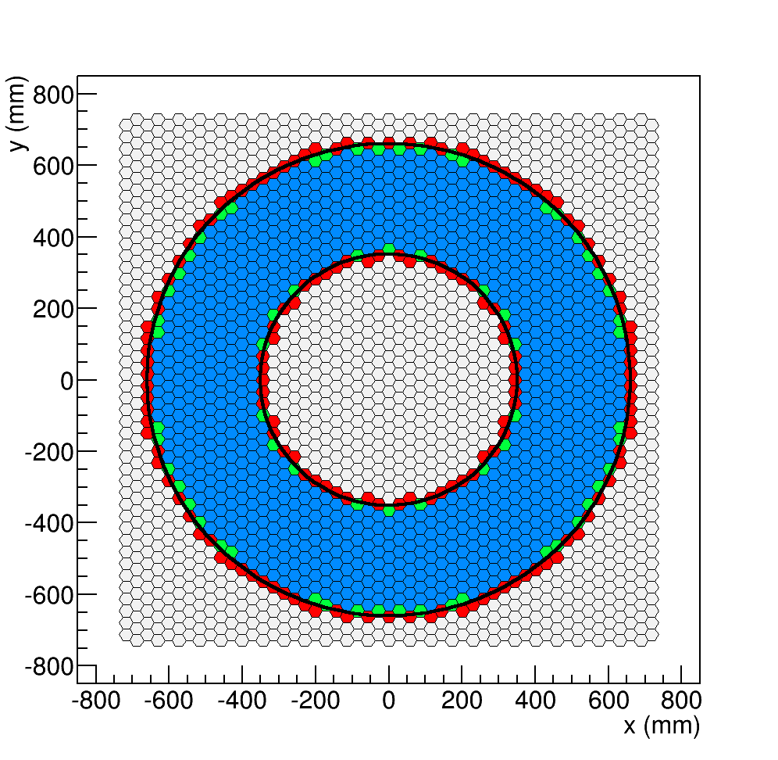

Figure 3. Left:: Crystal layout for a crystal size of 33 mm across flats with disk radii of 351 mm and 660 mm. The crystals in the disk are colored in blue. Right: Similar layout, together with crystal intersecting the disk boundaries colored in green (blue) if their center lie inside (outside ) the disk boundaries.