Collection ----automatically growable and shrinkable class

these are broadly categoriezed into 3 type

|  |  |  |  |
| --- | --- | --- | --- |
| List | Set | Queue | Map |
| Duplicates are allowed | Unique values | Duplicate allowed | Key, value |
| Ordered list | unordered | Ordered | Searching is faster based keys |
|  |  | Data can be retrieved from both sides |  |

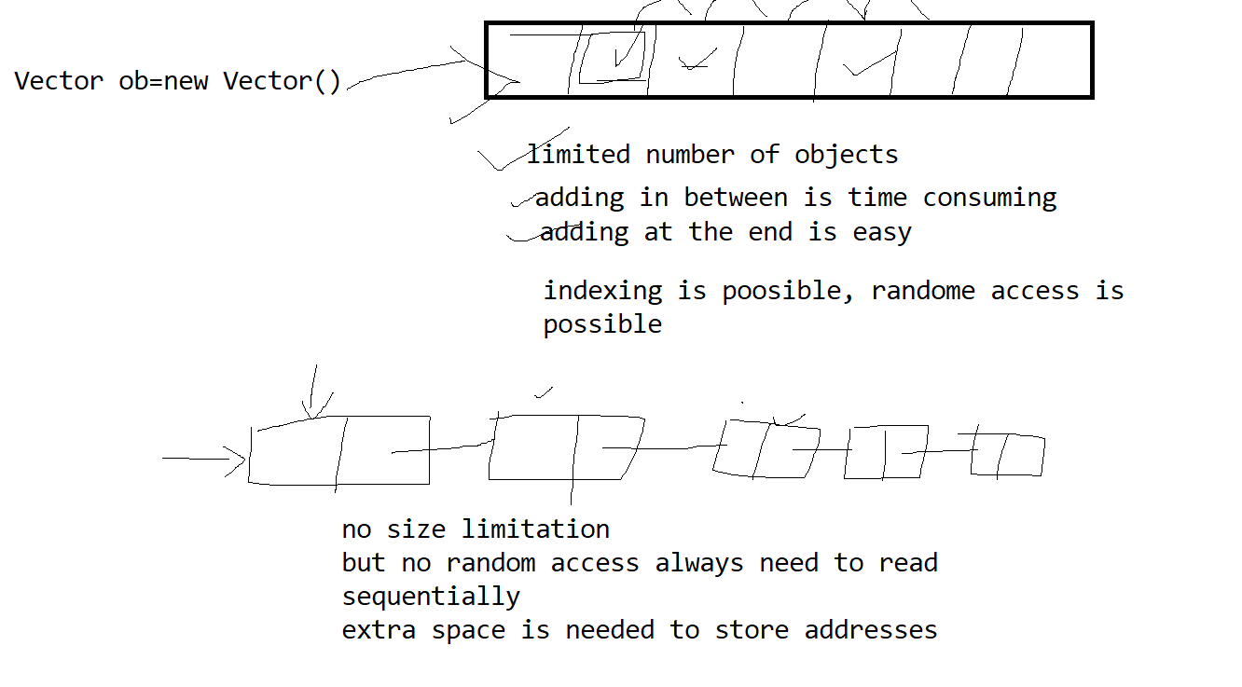

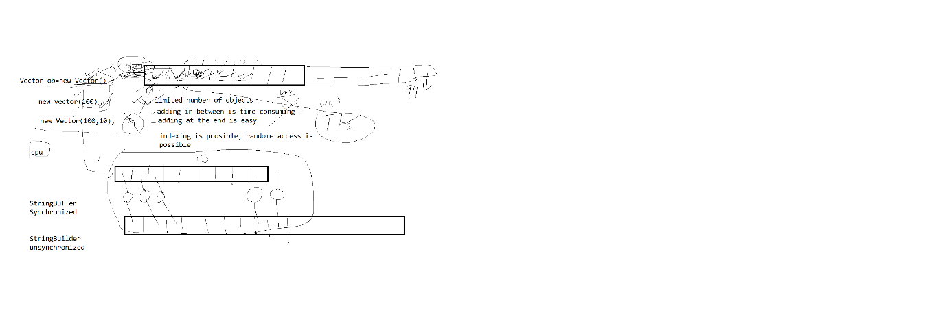

converting String to Java Date using Java.util.Date and SimpleDateFormat

SimpleDateformat class has function parse to convert String into Date

has a function format to convert date to string

SimpleDateFormat sdt=new SimpleDateFormat("dd-MM-yyyy");

System.out.println("enter date(dd-MM-yyyy)");

String dt=sc.next();

try {

Date bdate=sdt.parse(dt);

} catch (ParseException e) {

// TODO Auto-generated catch block

e.printStackTrace();

}

-----Java 1.8 convert String to LocalDate

LocalDate ldt=LocalDate.now(); ///Joda API

System.out.println("enter date dd/MM/yyyy");

String dt1=sc.next();

ldt=LocalDate.parse(dt1, DateTimeFormatter.ofPattern("dd/MM/yyyy"));