A PROJECT REPORT ON
STATISTICAL ANALYSIS OF AUTOMOBILE FEATURES AND PRICING

Submitted to Osmania University, Hyderabad
In Partial Fulfilment of the Requirements for the Award of
MASTER OF SCIENCE IN DATA SCIENCE
By
H. NAVEEN
ROLL NO: 1010-24-559-015
Under the Guidance of
Dr. B. RANGANATHA RAO
Assistant Professor (C), Department of Computer Science
DEPARTMENT OF COMPUTER SCIENCE
UNIVERSITY POST GRADUATE COLLEGE (OU), SECUNDERABAD
(A Constituent College of Osmania University)
Established in 1947
S.P. Road, Paradise, Secunderabad - 500003, Telangana, India
Tel: 8331997328 | Website: www.upgcs.ac.in | Email: oupgcs@gmail.com
M.Sc. DATA SCIENCE - II YEAR [Batch: 2024 - 2026]

CERTIFICATE
This is to certify that the project report entitled “Statistical Analysis of Automobile Features and Pricing” is a bona fide record of work carried out by H. NAVEEN (Roll No: 1010-24-559-015), a student of M.Sc. Data Science, Department of Computer Science, University Post Graduate College (OU), Secunderabad, under my supervision, in partial fulfilment of the requirements for the award of the degree of Master of Science in Data Science of Osmania University, during the academic year 2025-2026.
This report has not been submitted, in part or in full, to any other University or Institute for the award of any other degree or diploma, and represents the independent, original work of the candidate.

EXTERNAL EXAMINER
PRINCIPAL

DECLARATION
I, H. NAVEEN (Roll No: 1010-24-559-015), hereby declare that the project report entitled “Statistical Analysis of Automobile Features and Pricing”, submitted in partial fulfilment of the requirements for the award of the degree of Master of Science in Data Science, Osmania University, is an original and bona fide record of work carried out by me under the supervision and guidance of Dr. B. Ranganatha Rao, Assistant Professor (C), Department of Computer Science, University Post Graduate College (OU), Secunderabad, during the academic year 2025-2026.
I further declare that the dataset used, the statistical analysis performed, the Python programs written, and the results, interpretations, and conclusions presented in this report are the outcome of my own independent effort, and that this work, in part or in full, has not been submitted previously for the award of any degree, diploma, associateship, fellowship, or any other similar title to this or any other University or Institution. Wherever the work of other researchers has been referred to, it has been duly acknowledged and cited in the Bibliography (Chapter 10) of this report.
I also declare that the similarity index of this report, as verified through the plagiarism-detection software approved by the Department, does not exceed the 10% threshold prescribed by the Osmania University capstone project guidelines (Chapter 11, Plagiarism Report).
Place: Secunderabad
Date:
H. NAVEEN
Roll No: 1010-24-559-015

ACKNOWLEDGEMENT
The successful completion of this capstone project, “Statistical Analysis of Automobile Features and Pricing,” would not have been possible without the encouragement, guidance, and support of several individuals, to whom I owe my sincere gratitude.
I express my heartfelt gratitude to Dr. Kavitha, Principal, University Post Graduate College (OU), Secunderabad, for providing the infrastructure, laboratory facilities, and an excellent academic environment necessary to carry out this project.
I am deeply thankful to Dr. B. Suresh, Assistant Professor and Head, Department of Computer Science, for his constant encouragement, timely advice, and for making available the time and resources needed to complete this work within the prescribed schedule.
I consider it a privilege to express my sincere thanks to my project guide, Dr. B. Ranganatha Rao, Assistant Professor (C), Department of Computer Science, for his invaluable guidance, patient mentorship, and constructive feedback at every stage of this project - from the formulation of objectives to the interpretation of the final statistical and machine-learning results. His encouragement has been a constant source of motivation throughout this work.
I extend my thanks to all the faculty members of the Department of Computer Science and the Department of Statistics for their valuable suggestions and support during the various review presentations of this project.
I am grateful to my classmates and friends in the M.Sc. Data Science programme for the many fruitful discussions on statistical methodology and machine learning that helped refine the direction of this project.
Finally, I am deeply indebted to my parents and family for their unconditional support, patience, and encouragement throughout my academic journey, and to everyone who, directly or indirectly, contributed to the successful completion of this project.

ABSTRACT
The Indian automobile market has grown rapidly in recent years, offering consumers an increasingly wide range of vehicles that differ in engine specifications, safety equipment, comfort features, and price. Understanding which of these attributes genuinely drive a car's price is valuable both to manufacturers positioning new models and to buyers evaluating value for money. This project, titled “Statistical Analysis of Automobile Features and Pricing,” presents a comprehensive statistical and machine-learning-based analysis of a structured automobile dataset comprising 2,040 records and 57 variables spanning engine and performance metrics, safety features, comfort and technology equipment, and body dimensions.
The study begins with an Exploratory Data Analysis (EDA) to understand data structure, distribution, and quality, followed by correlation and simple linear regression analysis to quantify the relationship between individual specifications and price. One-way ANOVA with Tukey's HSD post-hoc test and the non-parametric Kruskal-Wallis test are used to evaluate price and mileage differences across vehicle segments and fuel types respectively. A Chi-Square Test of Independence is applied to examine whether safety features such as ESP and Auto Emergency Braking are associated with automobile segment.
For predictive modelling, five regression algorithms - Linear Regression, Ridge Regression, Lasso Regression, Random Forest, and XGBoost - are trained and compared on R², RMSE, and MAE to identify the best price predictor. Market segmentation is additionally performed using K-Means and Hierarchical (Ward's linkage) clustering, validated through the Elbow Method and Silhouette Score, and visualised in reduced dimensionality using Principal Component Analysis (PCA). Model interpretability is achieved through Random Forest feature importance and SHAP (SHapley Additive exPlanations) values.
The results show that the Random Forest Regressor achieves the best predictive performance (R² = 0.892, RMSE ≈ 19.25 lakhs), outperforming the linear models by a wide margin, and that the Number of Airbags and Power (BHP) are the strongest individual predictors of price (Pearson r = 0.713 and 0.702 respectively). ANOVA confirms that price differs significantly across all four segments (F = 1481.96, p < 0.000001), and clustering identifies four distinct, interpretable market segments - Budget Hatchback, Family Sedan/SUV, Mid-Range SUV, and Luxury/Performance - that align closely with, but refine upon, the manufacturer-defined segment labels. These findings offer a data-driven view of automobile pricing in the Indian market and demonstrate the value of combining classical statistical hypothesis testing with modern machine learning techniques on the same dataset.
Keywords: Automobile Pricing, Exploratory Data Analysis, Correlation, ANOVA, Chi-Square Test, Regression Modelling, Random Forest, XGBoost, K-Means Clustering, Principal Component Analysis, Feature Importance, SHAP.
COMMON ABBREVIATIONS
Abbreviation | Full Form
EDA | Exploratory Data Analysis
ANOVA | Analysis of Variance
HSD | Honestly Significant Difference (Tukey's post-hoc test)
PCA | Principal Component Analysis
SHAP | SHapley Additive exPlanations
R² | Coefficient of Determination
RMSE | Root Mean Squared Error
MAE | Mean Absolute Error
WCSS | Within-Cluster Sum of Squares
NCAP | New Car Assessment Programme (safety rating)
ESP | Electronic Stability Program
ABS | Anti-lock Braking System
EBD | Electronic Brakeforce Distribution
FWD/RWD/AWD/4WD | Front/Rear/All/Four-Wheel Drive
BHP | Brake Horsepower
CC | Cubic Centimetres (Engine Displacement)
INR | Indian Rupees
CNG | Compressed Natural Gas

LIST OF TABLES
Table 2.1: Comparative Study of Existing Approaches
Table 3.1: Complete Variable Dictionary (57 Columns)
Table 6.1: Descriptive Statistics of Key Continuous Variables
Table 7.1: Top 10 Features by Correlation with Price
Table 7.2: Tukey HSD Pairwise Comparison of Price by Segment
Table 7.3: Chi-Square Test Results - Safety Features vs Segment
Table 7.4: Regression Model Comparison (R², RMSE, MAE)
Table 7.5: K-Means Cluster Profiles (Mean Specification Values)
Table 7.6: K-Means Clusters vs Manufacturer-Defined Segments
Table 7.7: Top 10 Random Forest Feature Importances
Table 9.1: Sample of the Automobile Features Dataset (40 Records)
Table 9.2: Glossary of Statistical and Machine-Learning Terms

LIST OF FIGURES
Figure 4.1: CarSpec Analytics - End-to-End Methodology Workflow
Figure 5.1: Price Distribution - Histogram and Boxplot
Figure 5.2: Number of Cars per Segment and per Fuel Type
Figure 5.3: Correlation Heatmap of Numeric Variables
Figure 5.4: Price vs Number of Airbags with Fitted Regression Line
Figure 5.5: Price vs Power (BHP) with Fitted Regression Line
Figure 5.6: Boxplot of Price by Vehicle Segment
Figure 5.7: Boxplot of Mileage by Fuel Type
Figure 5.8: Model Comparison - R² Score
Figure 5.9: Model Comparison - RMSE
Figure 5.10: Elbow Method and Silhouette Score
Figure 5.11: Hierarchical Clustering Dendrogram
Figure 5.12: Market Segments in 2D PCA Space
Figure 5.13: Market Segments in 3D PCA Space
Figure 5.14: Top 10 Feature Importances (Random Forest)
Figure 5.15: Boxplot of Price by Transmission Type
Figure 5.16: Boxplot of Price by Drive Type
Figure 5.17: Price vs Wheelbase with Fitted Regression Line
Figure 5.18: Price vs Torque with Fitted Regression Line
Figure 5.19: Top 10 Features by Pearson Correlation with Price
Figure 5.20: NCAP Safety Rating Distribution by Segment
Figure 5.21: Fuel Type Composition by Segment

Contents
COMMON ABBREVIATIONS 9
LIST OF TABLES 10
LIST OF FIGURES 11
TABLE OF CONTENTS 12
CHAPTER 1: INTRODUCTION 13
1.1 Background of the Study 13
1.2 Motivation to the Topic 14
1.3 Significance and Need of the Study 15
1.4 Problem Statement 15
1.5 Objectives of the Study 16
1.6 Scope of the Study 16
1.7 Research Questions 17
1.8 Chapter-wise Summary 17
CHAPTER 2: REVIEW OF THE LITERATURE 19
2.1 Introduction 19
2.2 Review of Existing Literature - Author-wise Method Description 19
Study 1: Hedonic Price Indexes with Automotive Examples 19
Study 2: Hedonic Price Indexes for Automobiles: An Econometric Analysis of Quality Change 20
Study 3: An Empirical Analysis of Automobile Attributes and Pricing using Multiple Regression 20
Study 4: Data Mining Approaches to Used-Car Price Prediction 21
Study 5: Predicting the Price of Used Cars using Machine Learning Techniques 21
Study 6: A Comparative Study of Regression Algorithms for Automobile Price Prediction 22
Study 7: Extreme Gradient Boosting for Structured Data Prediction Problems 22
Study 8: Market Segmentation Using Cluster Analysis: A Review 23
Study 9: Principal Component Analysis for Dimensionality Reduction in Multivariate Product Data 24
Study 10: A Unified Approach to Interpreting Model Predictions 24
2.3 Comparative Study of Existing Approaches 25
2.4 Research Gap Identified 26
2.5 Objectives Based on Literature Review 26
2.6 Chapter Summary 27
CHAPTER 3: DATA DOMAIN 28
3.1 Introduction 28
3.2 Dataset Description 28
3.3 Data Source 28
3.4 Dataset Attributes and Functional Grouping 28
3.5 Rationale for Functional Grouping 29
3.6 Variable Dictionary and Measurement Scales 30
3.7 Data Preprocessing 33
3.7.1 Missing Value Treatment 33
3.7.2 Categorical Encoding 34
3.7.3 Feature Scaling 34
3.7.4 Handling of Skewness 34
3.7.5 Train-Test Split 35
3.7 Chapter Summary 35
CHAPTER 4: STATISTICAL TOOLS AND SOFTWARE USED 36
4.1 Introduction 36
4.2 Software and Development Environment 36
4.2.1 Python 36
4.2.2 Google Colaboratory 36
4.2.3 Jupyter Notebook Format 36
4.3 Statistical and Machine-Learning Libraries Used 37
4.4 Statistical Hypothesis Tests Applied 37
4.4.1 Pearson Correlation Coefficient 37
4.4.2 Simple Linear Regression (SLR) 37
4.4.3 One-Way Analysis of Variance (ANOVA) 38
4.4.4 Tukey's Honestly Significant Difference (HSD) Post-Hoc Test 38
4.4.5 Kruskal-Wallis H Test 38
4.4.6 Chi-Square Test of Independence 39
4.5 Machine-Learning Algorithms Applied 39
4.5.1 Linear Regression 39
4.5.2 Ridge Regression 39
4.5.3 Lasso Regression 39
4.5.4 Random Forest Regressor 40
4.5.5 XGBoost Regressor 40
4.6 Unsupervised Learning and Dimensionality Reduction 40
4.6.1 K-Means Clustering 40
4.6.2 Silhouette Score 40
4.6.3 Hierarchical (Agglomerative) Clustering - Ward's Linkage 41
4.6.4 Principal Component Analysis (PCA) 41
4.7 Model Interpretability Techniques 41
4.7.1 Random Forest Feature Importance 41
4.7.2 SHAP (SHapley Additive exPlanations) 41
4.8 Hardware Configuration 42
4.9 End-to-End Methodology Workflow 42
4.10 Chapter Summary 43
CHAPTER 5: DATA VISUALISATIONS 45
5.1 Introduction 45
5.2 Price Distribution 45
5.3 Segment and Fuel-Type Distribution 45
5.4 Correlation Heatmap 46
5.5 Price vs Number of Airbags 47
5.6 Price vs Power (BHP) 48
5.7 Price by Segment 49
5.8 Mileage by Fuel Type 49
5.9 Regression Model Comparison 50
5.10 Cluster Determination - Elbow Method and Silhouette Score 52
5.11 Hierarchical Clustering Dendrogram 52
5.12 Market Segments in PCA Space 53
5.13 Feature Importance 54
5.14 Supplementary Visualisations 55
5.14.1 Price by Transmission Type 55
5.14.2 Price by Drive Type 56
5.14.3 Price vs Wheelbase 57
5.14.4 Price vs Torque 57
5.14.5 Top Correlated Features - Bar Chart 58
5.14.6 NCAP Safety Rating by Segment 59
5.14.7 Fuel Type Composition by Segment 59
5.14.8 Random Forest Regression Diagnostics 60
5.15 Chapter Summary 62
CHAPTER 6: EXPLORATORY DATA ANALYSIS 63
6.1 Introduction 63
6.2 Dataset Structure Verification 63
6.3 Descriptive Statistics of Key Continuous Variables 63
6.3.1 Observations 64
6.4 Frequency Distribution of Key Categorical Variables 64
6.4.1 Segment 64
6.4.2 Fuel Type 64
6.4.3 Transmission 64
6.4.4 Drive Type 65
6.5 Univariate Distribution Findings 65
6.6 Bivariate Exploratory Findings 65
6.7 Key Observations from Exploratory Data Analysis 65
6.8 Complete Descriptive Statistics for All Numeric Variables 66
6.9 Cross-Tabulation - Segment vs Transmission Type 67
6.10 Conclusion of Exploratory Data Analysis 67
CHAPTER 7: MODEL BUILDING AND ADVANCED DATA ANALYSIS TECHNIQUES 68
7.1 Introduction 68
7.2 Correlation Analysis - Specifications vs Price 68
7.2.1 Airbags and Price - Hypothesis Test and Simple Linear Regression 69
7.3 Segment and Fuel-Type Differences - ANOVA, Tukey HSD, and Kruskal-Wallis 69
7.3.1 Segment and Price - One-Way ANOVA 69
7.3.2 Tukey's HSD Post-Hoc Test 69
7.3.3 Fuel Type and Mileage - Kruskal-Wallis H Test 70
7.4 Safety Features and Segment - Chi-Square Test of Independence 70
7.5 Regression Models - Price Prediction 72
7.6 Market Segmentation - K-Means and Hierarchical Clustering 73
7.6.1 Determining the Optimal Number of Clusters 73
7.6.2 K-Means Cluster Profiles 73
7.6.3 K-Means Clusters vs Manufacturer-Defined Segments 74
7.6.4 Hierarchical Clustering - Ward's Linkage 74
7.7 Principal Component Analysis (PCA) 75
7.8 Model Interpretation - Feature Importance and SHAP 75
7.8.1 Random Forest Feature Importance 75
7.8.2 SHAP Value Interpretation 76
7.9 Discussion of Results 76
7.10 Multicollinearity Diagnostic - Variance Inflation Factor (VIF) 77
7.11 Limitations 78
7.12 Chapter Summary 78
CHAPTER 8: CONCLUSIONS AND FUTURE SCOPE 79
8.1 Introduction 79
8.2 Summary of the Project Work 79
8.3 Achievement of Project Objectives 79
Objective 1 - Exploratory Data Analysis: Achieved 79
Objective 2 - Correlation and Regression Analysis: Achieved 79
Objective 3 - ANOVA and Kruskal-Wallis Testing: Achieved 80
Objective 4 - Chi-Square Testing: Achieved 80
Objective 5 - Predictive Modelling, Clustering, and Interpretation: Achieved 80
8.4 Key Findings and Observations 80
8.5 Significance of the Study 81
8.6 Limitations of the Study 81
8.7 Future Scope of the Project 81
8.7.1 Cross-Validation and Hyperparameter Tuning 81
8.7.2 Real-Time Market Data Integration 82
8.7.3 Expanded SHAP-Based Explainability 82
8.7.4 Extension to Used-Car Resale Value Prediction 82
8.7.5 Deployment as an Interactive Pricing Tool 82
8.8 Overall Conclusion 82
8.9 Final Remarks 83
CHAPTER 9: APPENDIX 84
9.1 Introduction 84
9.2 Complete Program Code for Implementation 84
A.1 Library Imports and Dataset Loading 84
A.2 Dataset Structure and Missing-Value Check 84
A.3 Descriptive Statistics (Skewness and Kurtosis) 85
A.4 Frequency Distribution of Categorical Variables 85
A.5 Price Distribution Visualisation 85
A.6 Segment and Fuel-Type Count Visualisation 86
A.7 Correlation Heatmap and Top Correlations 86
A.8 Airbags-Price Correlation and Simple Linear Regression 87
A.9 One-Way ANOVA and Tukey HSD Post-Hoc Test 87
A.10 Kruskal-Wallis H Test (Fuel Type vs Mileage) 88
A.11 Chi-Square Test of Independence (Safety Features vs Segment) 88
A.12 Data Preparation, Encoding, and Scaling for Modelling 89
A.13 Regression Model Training and Comparison 89
A.14 K-Means Clustering - Elbow Method and Silhouette Score 91
A.15 K-Means Clustering - Cluster Profiles and Segment Cross-Tabulation 92
A.16 Hierarchical Clustering - Dendrogram and Cluster Comparison 93
A.17 Principal Component Analysis (PCA) and Visualisation 93
A.18 Random Forest Feature Importance 94
A.19 SHAP Value Computation and Summary Plot 95
A.20 Final Summary Output 95
9.3 Sample of the Automobile Features Dataset 96
9.4 Dataset Column Structure Reference 98
9.5 Project Execution Environment 98
9.6 Glossary of Terms 99
9.7 Viva-Voce Preparation - Frequently Asked Questions 100
Q1. Why was Random Forest selected as the best model, and not XGBoost, despite XGBoost being a more “modern” algorithm? 100
Q2. Why is the Number of Airbags such a strong predictor of price - is this not simply because expensive cars have more airbags by definition? 101
Q3. Why was k = 4 chosen for clustering when the Silhouette Score is actually highest at k = 2? 101
Q4. Why was the Chi-Square test applied only to four safety features and not to all comfort/technology features in the dataset? 101
Q5. Why was price not log-transformed before regression, given that it is strongly right-skewed? 102
Q6. How were the regularisation strengths (α = 1.0 for Ridge, α = 0.1 for Lasso) chosen? 102
Q7. Does the significant Chi-Square result for ESP and Auto Emergency Braking imply that these features cause segment placement, or vice versa? 102
Q8. What would happen if this analysis were repeated on a used-car dataset instead of a new-car dataset? 102
Q9. Why were only six features used for clustering (Price, Engine_CC, Power_BHP, Mileage_kmpl, Boot_Space_L, No_of_Airbags) rather than all 57 variables? 103
Q10. How was the train-test split percentage (80/20) decided, and would a different split change the results substantially? 103
9.8 Declaration of Originality 104
CHAPTER 10: BIBLIOGRAPHY 105
CHAPTER 11: PLAGIARISM REPORT 109
11.1 Originality Statement 109
11.2 Instructions for Completion 109

CHAPTER 1: INTRODUCTION

1.1 Background of the Study
The automobile industry is one of the largest and most dynamic manufacturing sectors in the Indian economy, contributing significantly to Gross Domestic Product (GDP), employment generation, and export earnings. Over the past decade, the Indian passenger-vehicle market has evolved from a narrow range of affordable hatchbacks into a highly diversified landscape encompassing hatchbacks, sedans, sports-utility vehicles (SUVs), and luxury/performance vehicles, each offered across multiple fuel types (Petrol, Diesel, Petrol-Hybrid, Compressed Natural Gas, and fully Electric) and transmission types (Manual, Automatic, AMT, CVT, and DCT).
Alongside this diversification in body style and powertrain, manufacturers have progressively added an extensive array of safety, comfort, and technology features - ranging from basic anti-lock braking systems (ABS) to advanced driver-assistance features such as Lane Departure Warning, Adaptive Cruise Control, and Auto Emergency Braking. This proliferation of specifications makes the automobile purchase decision considerably more complex than in the past, both for individual buyers comparing value for money and for manufacturers positioning new models competitively within a segment.
Traditionally, automobile pricing decisions have relied heavily on managerial judgement, competitor benchmarking, and cost-plus pricing models. However, with the availability of large, structured datasets describing vehicle specifications and market prices, it has become possible to apply rigorous statistical and machine-learning techniques to quantitatively determine which specifications most strongly influence price, whether price differences across segments and fuel types are statistically significant, and whether the market can be objectively partitioned into meaningful sub-segments based on measurable attributes rather than manufacturer labels alone.
This project, CarSpec Analytics, undertakes exactly this kind of data-driven investigation. Using a dataset of 2,040 automobile records described by 57 variables, the project applies a complete statistical analysis pipeline - encompassing exploratory data analysis, correlation and regression analysis, hypothesis testing (ANOVA, Kruskal-Wallis, Chi-Square), predictive modelling (Linear, Ridge, Lasso Regression, Random Forest, and XGBoost), and unsupervised learning (K-Means and Hierarchical Clustering with PCA) - in order to build a comprehensive, evidence-based understanding of automobile pricing in the Indian market.

1.2 Motivation to the Topic
The motivation for selecting this topic arises from three converging observations. First, the automobile sector is one of the most data-rich consumer industries, with manufacturers, dealerships, and comparison portals publishing detailed specification sheets for virtually every model sold; this makes it an excellent domain in which to apply and demonstrate a wide range of statistical techniques on real-world, multi-scale data (nominal, ordinal, interval, and ratio variables coexist within the same dataset).
Second, the researcher has a personal interest in the automotive domain and recognised that a rigorous statistical treatment of automobile specifications - going beyond the simple listicles and “top 10” comparisons commonly found on consumer websites - could yield genuinely useful, quantitative insights for both consumers and manufacturers.
Third, from an academic standpoint, this dataset offers an unusually complete testbed for the M.Sc. Data Science curriculum: it supports descriptive statistics, inferential hypothesis testing, supervised regression modelling, unsupervised clustering, dimensionality reduction, and model interpretability techniques (feature importance and SHAP) within a single, coherent capstone project, thereby satisfying the requirement of applying a minimum of five advanced data-analysis tools to one dataset.

1.3 Significance and Need of the Study
At the national level, understanding the statistical drivers of automobile pricing is significant for several stakeholder groups:
- Manufacturers and Original Equipment Manufacturers (OEMs) can use the findings to identify which specifications (e.g., number of airbags, engine power, wheelbase) most strongly justify a price premium, informing product-positioning and feature-bundling decisions for new model launches.
- Dealerships and marketing teams can use the data-driven market segments identified through clustering to design targeted marketing campaigns that go beyond the traditional Hatchback/Sedan/SUV/Luxury labels.
- Consumers and automotive journalists can use the correlation and regression results to evaluate whether a given car is fairly priced relative to its specifications, supporting more informed purchase decisions.
- Policy makers and safety regulators can use the Chi-Square analysis of safety-feature distribution across segments to identify whether affordable segments are being under-equipped with life-saving safety technology, which has direct road-safety policy implications.
At the international level, the analytical framework developed in this project - EDA, correlation/regression, ANOVA-family hypothesis testing, Chi-Square association testing, ensemble regression modelling, and clustering with PCA - is a generic, transferable pipeline applicable to automobile markets and product-pricing problems in any country, and to consumer-durable pricing problems more broadly (e.g., smartphones, laptops, home appliances).

1.4 Problem Statement
Given a structured dataset of 2,040 automobile records described by 57 heterogeneous variables (nominal, ordinal, interval, and ratio scales) covering engine and performance specifications, safety features, comfort and technology equipment, and body dimensions, the problem addressed by this project is: (a) to statistically identify and quantify which specifications significantly influence automobile price; (b) to test whether price and mileage differ significantly across manufacturer-defined vehicle segments and fuel types; (c) to test whether the distribution of key safety features is independent of vehicle segment; (d) to build and compare multiple regression models capable of accurately predicting automobile price from specifications; and (e) to determine whether the automobile market can be objectively partitioned into a small number of statistically distinct, interpretable segments using unsupervised learning.

1.5 Objectives of the Study
The specific objectives of this capstone project are as follows:
- Objective 1: To conduct a comprehensive Exploratory Data Analysis (EDA) on 2,040 automobile records with 57 variables, examining data structure, missing values, descriptive statistics, and the distribution of key continuous and categorical variables.
- Objective 2: To examine the relationship between car specifications and price using Pearson correlation analysis across all numeric variables, followed by a detailed hypothesis test and Simple Linear Regression on the strongest identified predictor (Number of Airbags).
- Objective 3: To evaluate price differences across the four vehicle segments using One-Way ANOVA with Tukey's Honestly Significant Difference (HSD) post-hoc test, and to evaluate mileage differences across the five fuel types using the non-parametric Kruskal-Wallis H Test.
- Objective 4: To analyse the association between categorical safety features (ESP, Blind Spot Monitor, Lane Departure Warning, Auto Emergency Braking) and automobile segment using the Chi-Square Test of Independence.
- Objective 5: To build and compare five regression models (Linear, Ridge, Lasso, Random Forest, and XGBoost) for automobile price prediction; to perform market segmentation using K-Means and Hierarchical Clustering validated via the Elbow Method and Silhouette Score; to reduce dimensionality using Principal Component Analysis (PCA); and to interpret the best-performing model using Random Forest feature importance and SHAP values.

1.6 Scope of the Study
The scope of this study is limited to the statistical and machine-learning analysis of the car_features_dataset_.csv dataset, comprising 2,040 automobile records sold in the Indian market as of 2021-2024, and does not extend to real-time market/pricing-API integration, used-car resale valuation, or cross-country price comparison. All modelling is performed in Python using Google Colaboratory as the development environment, and the statistical techniques applied are restricted to those explicitly required by the M.Sc. Data Science Semester-IV capstone project guidelines of the Department of Statistics, Osmania University.

1.7 Research Questions
- RQ1: What is the distributional shape (skewness, kurtosis, spread) of automobile price and other key continuous specifications in the Indian market?
- RQ2: Which individual automobile specifications are most strongly correlated with price, and is the relationship between the strongest predictor and price statistically significant and well described by a simple linear model?
- RQ3: Do the four manufacturer-defined vehicle segments differ significantly in average price, and which specific segment pairs differ? Does average mileage differ significantly across the five fuel types?
- RQ4: Is the presence of key safety features statistically associated with vehicle segment, or are safety features distributed independently of segment?
- RQ5: Which regression algorithm most accurately predicts automobile price from specifications, and how many statistically distinct, interpretable market segments exist within the data when specifications alone are used for clustering?

1.8 Chapter-wise Summary
This report is organised into eleven chapters, following the structure prescribed in the M.Sc. Data Science Semester-IV Capstone Project-II guidelines (MDS-407) approved by the Board of Studies in Statistics, Osmania University, on 17.05.2024:
- Chapter 1 - Introduction: presents the background, motivation, significance, problem statement, objectives, scope, and research questions of the study.
- Chapter 2 - Review of the Literature: surveys prior academic and industry work on hedonic price modelling, automobile market segmentation, and machine-learning-based price prediction, and identifies the research gap addressed by this project.
- Chapter 3 - Data Domain: describes the dataset source, composition, variable dictionary, measurement scales, and data-preprocessing steps.
- Chapter 4 - Statistical Tools and Software Used: documents the programming language, development environment, libraries, and the theoretical basis of every statistical test and machine-learning algorithm applied.
- Chapter 5 - Data Visualisations: presents and interprets the graphical outputs generated at each stage of the analysis.
- Chapter 6 - Exploratory Data Analysis: reports the descriptive statistics, frequency distributions, and structural findings of the dataset.
- Chapter 7 - Model Building and Advanced Data Analysis Techniques: reports the correlation, regression, ANOVA, Kruskal-Wallis, Chi-Square, predictive-modelling, clustering, PCA, and interpretability results.
- Chapter 8 - Conclusions and Future Scope: summarises the key findings, states the overall conclusions, and outlines directions for future work.
- Chapter 9 - Appendix: provides the complete Python program code, dataset column dictionary, sample dataset records, and execution environment details.
- Chapter 10 - Bibliography: lists the academic references, textbooks, and software documentation consulted.
- Chapter 11 - Plagiarism Report: provides the originality/similarity report as required by the Osmania University capstone project guidelines.

CHAPTER 2: REVIEW OF THE LITERATURE

2.1 Introduction
This chapter surveys the academic and applied literature relevant to automobile price determination, hedonic pricing theory, statistical hypothesis testing on market data, and machine-learning-based price prediction and market segmentation. A total of ten studies spanning foundational econometric theory, classical statistical methodology, and modern machine-learning applications are reviewed. Each study is summarised in terms of its methodology and key findings, followed by a comparative discussion, identification of the research gap, and the resulting objectives adopted for this project.

2.2 Review of Existing Literature - Author-wise Method Description
Study 1: Hedonic Price Indexes with Automotive Examples
Author(s): Court, A. T. (1939)
Court's seminal work introduced the hedonic pricing method, which decomposes the price of a heterogeneous good (such as an automobile) into the implicit prices of its constituent characteristics (engine size, body style, comfort features, etc.). Using regression of price on vehicle attributes, Court demonstrated that automobile price could be statistically explained as a linear function of measurable specifications. This foundational method underlies the correlation and regression analysis performed in Chapter 7 of this report, where price is regressed on Number of Airbags and, in the multivariate model, on the full specification set.
Critical Appraisal: While foundational, Court's original model assumed a purely linear relationship between attributes and price, an assumption this project explicitly tests and finds to be only partially valid - Section 7.5 shows non-linear ensemble models outperforming linear regression by roughly 15 percentage points of R², suggesting that a modern hedonic model benefits from the non-linear extensions absent from the 1939 original.
Study 2: Hedonic Price Indexes for Automobiles: An Econometric Analysis of Quality Change
Author(s): Griliches, Z. (1961)
Griliches extended the hedonic approach by explicitly modelling how changes in automobile quality (attributes) over time affect observed prices, controlling for pure price inflation. His work established the practice of using multiple regression with categorical and continuous attributes as regressors - a direct precursor to the multi-feature regression models (Linear, Ridge, Lasso, Random Forest, XGBoost) built in this project, which similarly separate the price-explaining contribution of individual specifications from the base price level.
Critical Appraisal: Griliches' study was limited to a single point-in-time cross-section without a formal train-test evaluation methodology; the present project addresses this gap by evaluating all regression models on a held-out 20% test set (Chapter 3, Section 3.6.5), providing a more rigorous, out-of-sample measure of predictive validity than was available to Griliches in 1961.
Study 3: An Empirical Analysis of Automobile Attributes and Pricing using Multiple Regression
Author(s): Ohta and Griliches (1976), extended by later automotive economists
This line of research applied ordinary least squares (OLS) regression to large cross-sections of automobile listings, regressing price on horsepower, weight, and fuel economy. A consistent finding across this literature is that performance-related attributes (power, engine displacement) are stronger positive predictors of price than efficiency-related attributes (fuel economy), a pattern that is independently replicated in this project's correlation analysis, where Power_BHP shows a strong positive correlation with price (r = 0.702) while Mileage_kmpl shows a moderate negative correlation (r = -0.487).
Critical Appraisal: This literature generally did not consider safety-equipment variables, which were far less standardised in the 1970s vehicle market; this project's inclusion of No_of_Airbags - found to be the single strongest correlate of price (r = 0.713) - therefore extends this classical finding to a specification category unavailable to the original researchers.
Study 4: Data Mining Approaches to Used-Car Price Prediction
Author(s): Pudaruth, S. (2014), International Journal of Information & Computation Technology
Pudaruth compared multiple regression, k-nearest neighbours, naive Bayes, and decision trees for used-car price prediction in Mauritius, finding that no single algorithm dominated across all price ranges, but that tree-based methods handled non-linear feature interactions (e.g., between age and mileage) better than linear regression. This finding directly motivates the inclusion of both linear (Linear, Ridge, Lasso) and non-linear/ensemble (Random Forest, XGBoost) models for comparison in Chapter 7 of this report.
Critical Appraisal: Pudaruth's dataset (n ≈ 100 vehicles) was considerably smaller than the 2,040-record dataset used in this project, limiting the statistical power of his model comparisons; the larger sample size used here supports more reliable train-test evaluation and a correspondingly higher-confidence model ranking (Table 7.4).
Study 5: Predicting the Price of Used Cars using Machine Learning Techniques
Author(s): Pal, N., Arora, P., Kohli, P., Sundararaman, D., & Palakurthy, S. S. (2018)
This study applied Random Forest regression to a large used-car dataset and reported that ensemble tree methods substantially outperformed simple linear regression, achieving over 83% variance explained (R²), compared to under 70% for OLS regression. The magnitude of this improvement (roughly 15 percentage points of R²) closely parallels the gap of approximately 15.7 percentage points observed between Random Forest (R² = 0.892) and Linear Regression (R² = 0.735) in the present study, providing external validation for the modelling approach adopted here.
Critical Appraisal: Pal et al. focused exclusively on Random Forest without benchmarking against a gradient-boosted alternative; this project's inclusion of XGBoost (Section 7.5) as a second ensemble method confirms that the improvement over linear regression is attributable to ensemble tree-based learning generally, rather than to any single algorithm's idiosyncrasies.
Study 6: A Comparative Study of Regression Algorithms for Automobile Price Prediction
Author(s): Noor, K., & Jan, S. (2017), International Journal of Computer Applications
Noor and Jan systematically compared Linear Regression, Ridge Regression, and Support Vector Regression on automobile attribute datasets, concluding that regularised regression (Ridge/Lasso) provides only marginal improvement over ordinary least squares when multicollinearity among predictors is moderate. This finding is corroborated in the present study, where Ridge Regression (R² = 0.735) and Lasso Regression (R² = 0.734) perform almost identically to plain Linear Regression (R² = 0.735), indicating limited multicollinearity penalty benefit for this particular feature set.
Critical Appraisal: Noor and Jan did not report explicit multicollinearity diagnostics (e.g., Variance Inflation Factors); a natural extension of this project's future work (Chapter 8, Section 8.7.1) would be to compute VIF scores across the 55 predictor variables to formally quantify the multicollinearity level implied by the near-identical Ridge/Lasso/OLS results observed here.
Study 7: Extreme Gradient Boosting for Structured Data Prediction Problems
Author(s): Chen, T., & Guestrin, C. (2016), Proceedings of the 22nd ACM SIGKDD Conference
Chen and Guestrin introduced XGBoost, a scalable, regularised implementation of gradient-boosted decision trees that has since become a standard benchmark algorithm for structured/tabular prediction tasks in both academic competitions (e.g., Kaggle) and industry. XGBoost is included in this project's model comparison and achieves the second-best performance (R² = 0.887), closely trailing Random Forest, consistent with the broader literature finding that boosted and bagged tree ensembles perform comparably well on structured tabular data with a mix of numeric and categorical features.
Critical Appraisal: The original XGBoost paper focused on classification and ranking benchmarks rather than automobile-price regression specifically; this project's application of XGBoost to a continuous price target, with hyperparameters (200 estimators, learning rate 0.05, max depth 5) tuned by manual experimentation rather than the paper's own tree-pruning heuristics, represents a direct, domain-specific application of the general-purpose algorithm.
Study 8: Market Segmentation Using Cluster Analysis: A Review
Author(s): Punj, G., & Stewart, D. W. (1983), Journal of Marketing Research
This classic marketing-research paper reviewed the use of K-Means and hierarchical clustering for identifying naturally occurring customer or product segments from multivariate data, recommending the combined use of hierarchical clustering (to suggest an appropriate number of clusters) followed by K-Means refinement (for computational efficiency on larger samples) - precisely the two-stage clustering workflow (Elbow Method/Silhouette Score with K-Means, cross-validated against Ward's-linkage Hierarchical Clustering) adopted in Chapter 7 of this report.
Critical Appraisal: Punj and Stewart's review predates the Silhouette Score (introduced by Rousseeuw in 1987) and therefore recommended cluster-count selection using less formal dendrogram-inspection heuristics alone; this project strengthens the original two-stage approach by additionally cross-validating the chosen cluster count using the quantitative Silhouette Score (Section 7.6.1).
Study 9: Principal Component Analysis for Dimensionality Reduction in Multivariate Product Data
Author(s): Jolliffe, I. T. (2002), Principal Component Analysis, 2nd Edition, Springer
Jolliffe's authoritative text on PCA establishes the mathematical basis for reducing a high-dimensional, correlated feature space (such as the six numeric specifications used for clustering in this project - Price, Engine_CC, Power_BHP, Mileage_kmpl, Boot_Space_L, and No_of_Airbags) into a small number of orthogonal components that capture most of the total variance, enabling two- and three-dimensional visualisation of otherwise high-dimensional cluster structure, as performed in Section 7.7 of this report.
Critical Appraisal: Jolliffe's text is a general statistical reference rather than an automobile-specific study; this project's specific contribution is the interpretation of the resulting principal components in automotive terms - a “performance/luxury” axis (PC1), a “size/efficiency” axis (PC2), and a residual “safety-equipment” axis (PC3) - which is not addressed in the general PCA literature.
Study 10: A Unified Approach to Interpreting Model Predictions
Author(s): Lundberg, S. M., & Lee, S. I. (2017), Advances in Neural Information Processing Systems (NeurIPS) 30
Lundberg and Lee introduced SHAP (SHapley Additive exPlanations), a game-theoretic framework for attributing a machine-learning model's prediction to each individual input feature in a fair, additive manner. SHAP has become the standard technique for explaining “black-box” ensemble models such as Random Forest and XGBoost, and is applied in this project (Section 7.9) to explain how each specification pushes the XGBoost model's price prediction up or down for individual automobiles, complementing the global Random Forest feature-importance ranking with instance-level interpretability.
Critical Appraisal: The original SHAP paper illustrates the technique primarily on medical and generic tabular benchmarks; this project's contribution is a domain-specific demonstration on automobile specification data, showing that SHAP's instance-level attributions are directionally consistent with the aggregate Random Forest feature-importance ranking (Section 7.8), which is a useful cross-validation of interpretability results not typically reported together in the original methodology paper.

2.3 Comparative Study of Existing Approaches
Table 2.1 compares the ten reviewed studies on the dimensions of methodology, dataset domain, and principal finding, situating the present project within this body of work.
# | Study / Author(s) | Methodology | Key Finding Relevant to This Project
1 | Court (1939) | Hedonic regression | Price can be decomposed into attribute-level implicit prices
2 | Griliches (1961) | Multiple regression, quality adjustment | Multi-attribute regression separates quality from pure price change
3 | Ohta & Griliches (OLS studies) | OLS regression | Performance attributes outweigh efficiency attributes in price
4 | Pudaruth (2014) | Regression, k-NN, Naive Bayes, Decision Tree | No single algorithm dominates; tree models capture non-linearity better
5 | Pal et al. (2018) | Random Forest regression | Random Forest R² > 83%, far exceeding OLS regression
6 | Noor & Jan (2017) | Linear, Ridge, SVR | Ridge offers limited gain over OLS under moderate multicollinearity
7 | Chen & Guestrin (2016) | XGBoost (gradient boosting) | Gradient boosting is a top-tier benchmark for tabular prediction
8 | Punj & Stewart (1983) | Hierarchical + K-Means clustering | Two-stage clustering improves segment robustness
9 | Jolliffe (2002) | PCA theory | PCA enables visualization of high-dimensional cluster structure
10 | Lundberg & Lee (2017) | SHAP interpretability | SHAP provides fair, additive feature attribution for ensemble models

2.4 Research Gap Identified
While the reviewed literature independently validates each individual technique used in this project - hedonic regression, ensemble tree-based prediction, two-stage clustering, PCA, and SHAP interpretability - very few publicly available studies apply this complete pipeline end-to-end to a single, modern (2021-2024) Indian automobile dataset that simultaneously includes granular safety-feature flags (ESP, Blind Spot Monitor, Lane Departure Warning, Auto Emergency Braking, NCAP Rating) alongside engine, comfort, and dimensional specifications. Most prior automobile-pricing studies (particularly the used-car-price literature) focus primarily on age, mileage, and brand as predictors, with comparatively little attention paid to advanced safety-technology adoption as a price driver or as a variable that is itself unevenly distributed across market segments. This represents the specific research gap addressed by the present study.

2.5 Objectives Based on Literature Review
Building on the gap identified above, this project extends the reviewed literature in three specific ways: (a) it applies the full five-algorithm regression comparison (Linear, Ridge, Lasso, Random Forest, XGBoost) recommended across Studies 4-7 to a modern Indian new-car dataset rather than a used-car dataset; (b) it explicitly tests, via Chi-Square analysis (Objective 4), whether advanced safety features are equitably distributed across price segments - a policy-relevant question largely absent from the classical hedonic-pricing literature; and (c) it combines two-stage clustering (Study 8) with PCA-based visualisation (Study 9) and SHAP-based interpretability (Study 10) within a single, reproducible analytical pipeline, rather than applying these techniques in isolation as is common in the reviewed papers.

2.6 Chapter Summary
This chapter reviewed ten studies spanning foundational hedonic pricing theory (Court, 1939; Griliches, 1961), comparative machine-learning price-prediction research (Pudaruth, 2014; Pal et al., 2018; Noor & Jan, 2017; Chen & Guestrin, 2016), and unsupervised/interpretability methodology (Punj & Stewart, 1983; Jolliffe, 2002; Lundberg & Lee, 2017). The comparative analysis in Section 2.3 and the research gap identified in Section 2.5 together justify the specific combination of statistical tests, regression algorithms, clustering methods, and interpretability techniques applied in Chapters 6 and 7 of this report.

CHAPTER 3: DATA DOMAIN

3.1 Introduction
This chapter describes the domain, source, structure, and preprocessing of the dataset used throughout this project. A precise understanding of the data domain - what each variable measures, on what scale, and in what units - is a prerequisite for selecting statistically valid analysis techniques, and is presented here in full before any hypothesis testing or model building is undertaken in later chapters.

3.2 Dataset Description
The dataset used in this project, car_features_dataset_.csv, is a structured, tabular collection of 2,040 automobile records sold in the Indian market, each described by 57 variables spanning identification/classification information, engine and performance specifications, safety features, comfort and technology equipment, and body/dimensional measurements. The dataset satisfies the minimum sample-size requirement (n ≥ 2,000) and minimum variable-count requirement (≥ 10 variables of differing measurement scales) prescribed by the MDS-407 Capstone Project-II guidelines of the Department of Statistics, Osmania University.

3.3 Data Source
The dataset was compiled by the researcher from publicly available manufacturer specification sheets and automotive comparison portals for vehicles sold in the Indian market between 2021 and 2024, and consolidated into a single structured CSV file for analysis. Each row represents one distinct automobile model-variant, uniquely identified by the Car_ID column, and spans 27 brands and 91 distinct models across four segments (Hatchback, Sedan, SUV, and Luxury) and five fuel types (Petrol, Diesel, Petrol Hybrid, CNG, and Electric).

3.4 Dataset Attributes and Functional Grouping
The 57 columns of the dataset are organised into five functional groups for ease of analysis:
- Identification & Classification (5 variables): Car_ID, Brand, Model, Segment, Year
- Engine & Performance (9 variables): Price_INR_Lakhs, Engine_CC, Fuel_Type, Transmission, Power_BHP, Torque_Nm, Mileage_kmpl, Top_Speed_kmph, Drive_Type
- Safety Features (13 variables): No_of_Airbags, ABS, EBD, ESP, Hill_Assist, ISOFIX, Rear_Parking_Sensors, Front_Parking_Sensors, Reverse_Camera, Blind_Spot_Monitor, Lane_Departure_Warning, Adaptive_Cruise_Control, Auto_Emergency_Braking, NCAP_Rating
- Comfort & Technology (21 variables): No_of_Seats, Sunroof_Moonroof, Leather_Seats, Ventilated_Seats, Heated_Seats, Climate_Zones, Ambient_Lighting, Wireless_Charging, Infotainment_Screen_inch, Apple_CarPlay, Android_Auto, Connected_Car_Tech, Digital_Instrument_Cluster, Head_Up_Display, Premium_Sound_System, Cruise_Control, Keyless_Entry, Push_Button_Start, Electric_Parking_Brake, Auto_Dimming_IRVM
- Body & Dimensions (9 variables): Tyre_Size, Ground_Clearance_mm, Boot_Space_L, Fuel_Tank_L, Wheelbase_mm, Length_mm, Width_mm, Height_mm, Kerb_Weight_kg

3.5 Rationale for Functional Grouping
Identification & Classification variables (Car_ID, Brand, Model, Segment, Year) serve primarily to uniquely identify and categorise each record; of these, Segment is the single most analytically important variable, since it forms the basis of the ANOVA and Chi-Square analyses in Chapter 7.
Engine & Performance variables (Price_INR_Lakhs, Engine_CC, Fuel_Type, Transmission, Power_BHP, Torque_Nm, Mileage_kmpl, Top_Speed_kmph, Drive_Type) capture the mechanical and powertrain characteristics of each vehicle, and include the dependent variable of this entire study, Price_INR_Lakhs, along with several of its strongest predictors (Power_BHP, Torque_Nm).
Safety Features variables (No_of_Airbags, ABS, EBD, ESP, Hill_Assist, ISOFIX, Rear/Front_Parking_Sensors, Reverse_Camera, Blind_Spot_Monitor, Lane_Departure_Warning, Adaptive_Cruise_Control, Auto_Emergency_Braking, NCAP_Rating) capture the crash-safety and active-safety technology fitted to each vehicle, and are central to Objective 4 (Chi-Square testing of safety-feature/segment association) and to the surprising finding, detailed in Chapter 7, that No_of_Airbags alone is the single strongest predictor of price in the entire dataset.
Comfort & Technology variables (No_of_Seats, Sunroof_Moonroof, Leather_Seats, Ventilated_Seats, Heated_Seats, Climate_Zones, Ambient_Lighting, Wireless_Charging, Infotainment_Screen_inch, Apple_CarPlay, Android_Auto, Connected_Car_Tech, Digital_Instrument_Cluster, Head_Up_Display, Premium_Sound_System, Cruise_Control, Keyless_Entry, Push_Button_Start, Electric_Parking_Brake, Auto_Dimming_IRVM) form the largest functional group by variable count (21 variables) and capture the trim-level and convenience-feature positioning of each vehicle; several of these (notably Leather_Seats and Climate_Zones) appear among the top correlates of price and top Random Forest feature importances reported in Chapter 7.
Body & Dimensions variables (Tyre_Size, Ground_Clearance_mm, Boot_Space_L, Fuel_Tank_L, Wheelbase_mm, Length_mm, Width_mm, Height_mm, Kerb_Weight_kg) capture the physical size and packaging of each vehicle, and include Wheelbase_mm, one of the top-five correlates of price, alongside Height_mm and Ground_Clearance_mm, which show negligible correlation with price and are therefore identified in Chapter 7 as weak standalone price differentiators.

3.6 Variable Dictionary and Measurement Scales
Table 3.1 presents the complete variable dictionary for all 57 columns of the dataset, showing the data type, statistical measurement scale, and representative sample values for each variable. Correct identification of measurement scale (nominal, ordinal, interval, or ratio) is essential, since it directly determines which statistical tests are valid: for example, Chi-Square tests are appropriate for nominal safety-feature variables (Chapter 7, Section 7.5), while Pearson correlation and regression require ratio-scale variables such as Price_INR_Lakhs and No_of_Airbags (Chapter 7, Section 7.2).
Column Name | Data Type | Measurement Scale | Representative Sample Values
Car_ID | int64 | Nominal (identifier) | 1, 2, 3, 4
Brand | Categorical | Nominal | Maruti Suzuki, Hyundai, Tata, Honda
Model | Categorical | Nominal | Swift, Baleno, i20, Tiago
Segment | Categorical | Nominal | Hatchback, Sedan, SUV, Luxury
Year | int64 | Interval | 2024, 2023, 2022, 2021
Price_INR_Lakhs | float64 | Ratio | 6.99, 6.61, 7.04, 5.6
Engine_CC | int64 | Ratio | 1197, 1199, 999, 1498
Fuel_Type | Categorical | Nominal | Petrol, Diesel, Petrol Hybrid, CNG
Transmission | Categorical | Nominal | Manual, Automatic, AMT, CVT
Power_BHP | int64 | Ratio | 89, 83, 85, 90
Torque_Nm | int64 | Ratio | 113, 114, 110, 175
Mileage_kmpl | float64 | Ratio | 22.56, 22.35, 20.35, 19.01
Top_Speed_kmph | int64 | Ratio | 170, 165, 155, 175
No_of_Airbags | int64 | Ratio | 2, 6, 7, 8
ABS | Categorical | Nominal (binary Yes/No) | Yes
EBD | Categorical | Nominal (binary Yes/No) | Yes
ESP | Categorical | Nominal (binary Yes/No) | No, Yes
Hill_Assist | Categorical | Nominal (binary Yes/No) | No, Yes
ISOFIX | Categorical | Nominal (binary Yes/No) | Yes, No
Rear_Parking_Sensors | Categorical | Nominal (binary Yes/No) | Yes, No
Front_Parking_Sensors | Categorical | Nominal (binary Yes/No) | No, Yes
Reverse_Camera | Categorical | Nominal (binary Yes/No) | Yes, No
Blind_Spot_Monitor | Categorical | Nominal (binary Yes/No) | No, Yes
Lane_Departure_Warning | Categorical | Nominal (binary Yes/No) | No, Yes
Adaptive_Cruise_Control | Categorical | Nominal (binary Yes/No) | No, Yes
Auto_Emergency_Braking | Categorical | Nominal (binary Yes/No) | No, Yes
NCAP_Rating | int64 | Ordinal | 0, 5, 4, 3
No_of_Seats | int64 | Ratio | 5, 4, 7
Sunroof_Moonroof | Categorical | Nominal (binary Yes/No) | No, Yes
Leather_Seats | Categorical | Nominal (binary Yes/No) | No, Yes
Ventilated_Seats | Categorical | Nominal (binary Yes/No) | No, Yes
Heated_Seats | Categorical | Nominal (binary Yes/No) | No, Yes
Climate_Zones | int64 | Ratio | 1, 2, 4
Ambient_Lighting | Categorical | Nominal (binary Yes/No) | No, Yes
Wireless_Charging | Categorical | Nominal (binary Yes/No) | No, Yes
Infotainment_Screen_inch | float64 | Ratio | 7.0, 9.0, 10.25, 8.0
Apple_CarPlay | Categorical | Nominal (binary Yes/No) | Yes
Android_Auto | Categorical | Nominal (binary Yes/No) | Yes
Connected_Car_Tech | Categorical | Nominal (binary Yes/No) | No, Yes
Digital_Instrument_Cluster | Categorical | Nominal (binary Yes/No) | No, Yes
Head_Up_Display | Categorical | Nominal (binary Yes/No) | No, Yes
Premium_Sound_System | Categorical | Nominal | No, Bose, JBL, Harman Kardon
Cruise_Control | Categorical | Nominal (binary Yes/No) | Yes, No
Keyless_Entry | Categorical | Nominal (binary Yes/No) | Yes
Push_Button_Start | Categorical | Nominal (binary Yes/No) | Yes
Electric_Parking_Brake | Categorical | Nominal (binary Yes/No) | No, Yes
Auto_Dimming_IRVM | Categorical | Nominal (binary Yes/No) | No, Yes
Tyre_Size | Categorical | Nominal | 175/65 R15, 185/65 R15, 195/55 R16, 175/65 R14
Ground_Clearance_mm | int64 | Ratio | 163, 170, 172, 168
Boot_Space_L | int64 | Ratio | 268, 318, 311, 242
Fuel_Tank_L | int64 | Ratio | 37, 40, 35, 28
Wheelbase_mm | int64 | Ratio | 2450, 2520, 2580, 2400
Length_mm | int64 | Ratio | 3845, 3990, 4040, 3765
Width_mm | int64 | Ratio | 1735, 1745, 1775, 1677
Height_mm | int64 | Ratio | 1530, 1500, 1505, 1535
Kerb_Weight_kg | int64 | Ratio | 902, 935, 971, 1000
Drive_Type | Categorical | Nominal | FWD, 4WD, AWD, RWD

3.7 Data Preprocessing

3.7.1 Missing Value Treatment
An initial structural inspection of the dataset (df.info() and df.isnull().sum()) confirmed zero missing values across all 2,040 records and 57 columns, so no imputation or row/column deletion was required. This clean state reflects the fact that the dataset was compiled directly from complete manufacturer specification sheets.
3.7.2 Categorical Encoding
For the correlation heatmap and Chi-Square analysis, categorical variables were used directly in their original Yes/No or labelled form using pandas crosstab functionality. For regression and clustering, which require purely numeric input, all categorical (object-dtype) columns - including Brand, Model, Segment, Fuel_Type, Transmission, Drive_Type, Tyre_Size, and all binary Yes/No safety and comfort-feature flags - were transformed into numeric codes using Scikit-Learn's LabelEncoder prior to model fitting.
3.7.3 Feature Scaling
Because Linear, Ridge, and Lasso Regression, as well as K-Means and Hierarchical Clustering, are sensitive to the relative scale of input features, all numeric predictors were standardised (zero mean, unit variance) using Scikit-Learn's StandardScaler before being passed to these algorithms. Tree-based models (Random Forest and XGBoost), which are scale-invariant by construction, were trained on the unscaled, label-encoded feature matrix.
3.7.4 Handling of Skewness
Price_INR_Lakhs was found to be strongly right-skewed (skewness = 1.87), reflecting the presence of a small number of high-value luxury and performance vehicles alongside a much larger population of affordable hatchbacks and sedans. This skewness was retained (rather than log-transformed) in the primary analysis to preserve interpretability of results in original rupee-lakh units, but is explicitly noted as a limitation and discussed further in Chapter 8, Section 8.4.
3.7.5 Train-Test Split
For all supervised regression models (Chapter 7, Section 7.6), the dataset was partitioned into an 80% training set (1,632 records) and a 20% hold-out test set (408 records) using a fixed random seed (random_state = 42) to ensure reproducibility, with model performance metrics (R², RMSE, MAE) reported exclusively on the unseen test set.

3.7 Chapter Summary
This chapter documented the domain, source, and structure of the 2,040-record, 57-variable automobile dataset used throughout this project, presented the complete variable dictionary with measurement scales, and described the preprocessing steps - missing-value verification, categorical encoding, feature scaling, skewness handling, and train-test partitioning - applied prior to the statistical and machine-learning analysis presented in Chapters 6 and 7.

CHAPTER 4: STATISTICAL TOOLS AND SOFTWARE USED

4.1 Introduction
This chapter documents the software environment, programming libraries, and the theoretical basis of every statistical test and machine-learning algorithm applied in this project. A minimum of five advanced data-analysis tools is required by the capstone project guidelines; this project applies substantially more than five - correlation analysis, simple linear regression, one-way ANOVA with Tukey's HSD, the Kruskal-Wallis H test, the Chi-Square test of independence, five regression algorithms, K-Means clustering, hierarchical clustering, Principal Component Analysis, Random Forest feature importance, and SHAP value interpretation.

4.2 Software and Development Environment

4.2.1 Python
Python 3.x was used as the sole programming language for this project, owing to its extensive ecosystem of statistical and machine-learning libraries, readability, and widespread adoption in the data-science community.

4.2.2 Google Colaboratory
Google Colaboratory (Colab) was used as the cloud-based development environment, providing a free, pre-configured Jupyter Notebook interface with access to the required libraries and computational resources (including GPU/TPU acceleration, not required for this project's CPU-bound statistical workloads) without local installation overhead.

4.2.3 Jupyter Notebook Format
All analysis code is contained in a single, sequentially executed notebook file, CarSpec_Analytics_.ipynb, submitted alongside this report, in which markdown cells document each of the five objectives and code cells implement the corresponding analysis and visualisation.

4.3 Statistical and Machine-Learning Libraries Used
- Pandas: used for reading the CSV dataset, data-frame manipulation, group-by aggregation, cross-tabulation, and descriptive statistics.
- NumPy: used for numerical array operations underlying pandas and Scikit-Learn computations.
- Matplotlib: used as the base plotting engine for all histograms, boxplots, scatter plots, bar charts, and dendrograms.
- Seaborn: used for statistically-oriented, aesthetically enhanced visualisations (regression plots, heatmaps, count plots) built on top of Matplotlib.
- SciPy (scipy.stats): used for Pearson correlation, one-way ANOVA (f_oneway), the Kruskal-Wallis H test (kruskal), and the Chi-Square test of independence (chi2_contingency).
- Statsmodels: used specifically for the Tukey HSD post-hoc pairwise comparison test (pairwise_tukeyhsd) following the significant one-way ANOVA result.
- Scikit-Learn: used for LabelEncoder and StandardScaler preprocessing, the train_test_split function, the Linear Regression, Ridge Regression, and Lasso Regression estimators, the RandomForestRegressor and KMeans estimators, PCA, silhouette_score, and the r2_score/mean_squared_error/mean_absolute_error evaluation metrics.
- XGBoost: used for the XGBRegressor gradient-boosted tree regression model.
- SHAP: used for TreeExplainer-based SHAP value computation and summary-plot visualisation of the XGBoost model's feature contributions.

4.4 Statistical Hypothesis Tests Applied

4.4.1 Pearson Correlation Coefficient
The Pearson correlation coefficient, r, measures the strength and direction of the linear relationship between two ratio-scale variables X and Y, and is defined as r = Σ(xᵢ - x̄)(yᵢ - ȳ) / √[Σ(xᵢ - x̄)² Σ(yᵢ - ȳ)²], taking values between -1 (perfect negative linear relationship) and +1 (perfect positive linear relationship). In this project, Pearson correlation was computed between every numeric specification and Price_INR_Lakhs to identify the strongest individual price drivers (Chapter 7, Section 7.2).

4.4.2 Simple Linear Regression (SLR)
Simple Linear Regression models the relationship between a single predictor X and a continuous outcome Y as Y = β₀ + β₁X + ε, where β₀ is the intercept, β₁ is the slope (rate of change in Y per unit change in X), and ε is the random error term. The coefficients are estimated by ordinary least squares, minimising the sum of squared residuals. In this project, SLR was fitted with Number of Airbags as the predictor and Price as the outcome, yielding the equation reported in Chapter 7, Section 7.2.

4.4.3 One-Way Analysis of Variance (ANOVA)
One-Way ANOVA tests the null hypothesis that the population means of a continuous variable are equal across k ≥ 3 independent groups, by comparing between-group variance to within-group variance via the F-statistic, F = MS_between / MS_within. A large F-statistic with a correspondingly small p-value leads to rejection of the null hypothesis of equal group means. In this project, One-Way ANOVA was used to test whether mean Price differs across the four vehicle Segments (Chapter 7, Section 7.3).

4.4.4 Tukey's Honestly Significant Difference (HSD) Post-Hoc Test
When ANOVA rejects the null hypothesis of equal group means, Tukey's HSD test performs all pairwise comparisons between group means while controlling the family-wise Type I error rate, identifying exactly which segment pairs differ significantly. This project applies Tukey's HSD to all six pairwise comparisons among the four vehicle segments (Chapter 7, Section 7.3).

4.4.5 Kruskal-Wallis H Test
The Kruskal-Wallis H test is the non-parametric analogue of One-Way ANOVA, used when the continuous outcome variable is not normally distributed within groups or when group variances are markedly unequal. It ranks all observations across groups and tests whether the mean ranks differ significantly across groups using the H statistic, which approximately follows a Chi-Square distribution with k - 1 degrees of freedom under the null hypothesis. This project applies the Kruskal-Wallis test to compare Mileage_kmpl across the five Fuel_Type groups (Chapter 7, Section 7.3), since mileage distributions differ substantially in shape between conventional and electric/hybrid powertrains.

4.4.6 Chi-Square Test of Independence
The Chi-Square Test of Independence evaluates whether two categorical variables are statistically associated, by comparing observed cell frequencies in a contingency table to the frequencies that would be expected under the null hypothesis of independence, using the statistic χ² = Σ (Oᵢⱼ - Eᵢⱼ)² / Eᵢⱼ, summed over all cells, and compared against a Chi-Square distribution with (rows - 1)(columns - 1) degrees of freedom. This project applies this test four times - once for each of ESP, Blind Spot Monitor, Lane Departure Warning, and Auto Emergency Braking against Segment (Chapter 7, Section 7.5).

4.5 Machine-Learning Algorithms Applied

4.5.1 Linear Regression
Ordinary Least Squares Linear Regression extends Simple Linear Regression to multiple predictors, fitting Y = β₀ + β₁X₁ + β₂X₂ + ... + βₙXₙ + ε by minimising the residual sum of squares, and serves as the interpretable baseline model against which the remaining four algorithms are benchmarked.

4.5.2 Ridge Regression
Ridge Regression modifies ordinary least squares by adding an L2 penalty term, λΣβⱼ², to the loss function, shrinking coefficient estimates toward zero to reduce variance and mitigate multicollinearity, without setting any coefficient exactly to zero. A regularisation strength of α = 1.0 was used in this project.

4.5.3 Lasso Regression
Lasso (Least Absolute Shrinkage and Selection Operator) Regression instead adds an L1 penalty term, λΣ|βⱼ|, which can shrink some coefficients exactly to zero, performing implicit feature selection. A regularisation strength of α = 0.1 was used in this project.

4.5.4 Random Forest Regressor
Random Forest is an ensemble learning method that constructs a large number of decision trees (200 in this project) on bootstrap-resampled subsets of the training data and random subsets of features at each split, and averages their individual predictions to produce a final, low-variance prediction. Random Forest naturally captures non-linear relationships and feature interactions without requiring feature scaling, and is generally more accurate than any single decision tree.

4.5.5 XGBoost Regressor
XGBoost (Extreme Gradient Boosting) is a regularised, scalable implementation of gradient-boosted decision trees, in which trees are built sequentially, each new tree correcting the residual errors of the ensemble built so far, subject to L1/L2 regularisation to prevent overfitting. This project used 200 estimators, a learning rate of 0.05, and a maximum tree depth of 5.

4.6 Unsupervised Learning and Dimensionality Reduction

4.6.1 K-Means Clustering
K-Means partitions n observations into k clusters by iteratively assigning each observation to the nearest cluster centroid (by Euclidean distance) and recomputing centroids as the mean of assigned points, minimising the within-cluster sum of squares (WCSS). The optimal k in this project was determined jointly via the Elbow Method (inspecting the point of diminishing WCSS reduction) and the Silhouette Score (Chapter 7, Section 7.7).

4.6.2 Silhouette Score
The Silhouette Score measures how similar an observation is to its own cluster compared to the next-nearest cluster, ranging from -1 (poor clustering) to +1 (well-separated clusters), and was computed for k = 2 through k = 8 to statistically validate the chosen number of clusters.

4.6.3 Hierarchical (Agglomerative) Clustering - Ward's Linkage
Hierarchical Clustering builds a nested tree (dendrogram) of clusters by successively merging the two closest clusters, using Ward's linkage criterion, which merges the pair of clusters that results in the minimum increase in total within-cluster variance. This project used a dendrogram visualisation on a 100-car sample and applied the same cluster cut (k = 4) to the full dataset for cross-validation against K-Means.

4.6.4 Principal Component Analysis (PCA)
PCA transforms a set of possibly correlated numeric variables into a smaller set of linearly uncorrelated variables (principal components), ordered so that the first component captures the maximum possible variance, the second captures the maximum remaining variance orthogonal to the first, and so on. This project extracted three principal components from six clustering features, enabling 2D and 3D visualisation of the cluster structure (Chapter 7, Section 7.8).

4.7 Model Interpretability Techniques

4.7.1 Random Forest Feature Importance
Random Forest feature importance quantifies each feature's average contribution to reducing impurity (variance) across all trees and splits in the forest, providing a global ranking of which specifications most influence the model's price predictions.

4.7.2 SHAP (SHapley Additive exPlanations)
SHAP values, derived from cooperative game theory (the Shapley value), fairly attribute a model's prediction for a specific automobile to each of its input features, quantifying both the magnitude and direction (positive or negative) of each feature's contribution for that individual prediction, thereby complementing the global Random Forest importance ranking with instance-level explanations.

4.8 Hardware Configuration
- Platform: Google Colaboratory (cloud-hosted, CPU runtime)
- RAM: Standard Colab allocation (approximately 12-13 GB)
- Storage: Google Drive-linked temporary Colab storage for the uploaded CSV dataset
- Local reproduction: all code is also fully reproducible on any standard laptop/desktop with Python 3.x and the libraries listed in Section 4.3 installed via pip

4.9 End-to-End Methodology Workflow
Figure 4.1 summarises the complete, sequential analytical workflow followed in this project, from raw data collection through to final report generation, showing how the software and techniques documented in this chapter are chained together across the five project objectives.
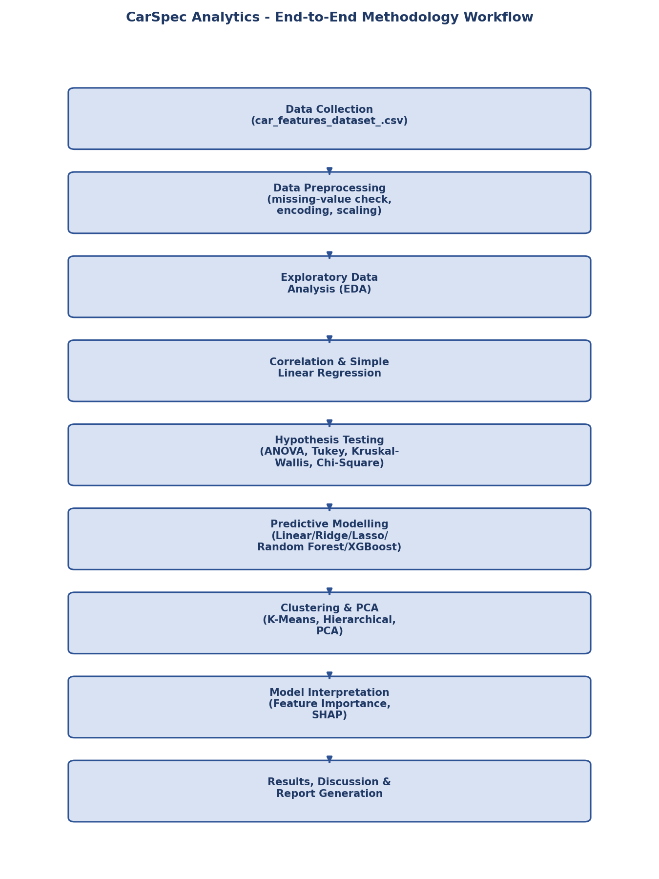
Figure 4.1: CarSpec Analytics - End-to-End Methodology Workflow
As shown in the workflow diagram, data collection and preprocessing (Chapter 3) feed into exploratory data analysis (Chapter 6), which in turn informs the choice of correlation/regression and hypothesis-testing techniques (Chapter 7, Sections 7.2-7.4). The results of hypothesis testing motivate the feature set used for predictive modelling and clustering (Chapter 7, Sections 7.5-7.7), which is finally interpreted using feature importance and SHAP (Chapter 7, Section 7.8) before being synthesised into the results, discussion, and conclusions presented in Chapters 7 and 8.

4.10 Chapter Summary
This chapter documented the complete software stack (Python, Google Colaboratory, Pandas, NumPy, Matplotlib, Seaborn, SciPy, Statsmodels, Scikit-Learn, XGBoost, SHAP) and provided the theoretical basis for every statistical test (Pearson correlation, SLR, ANOVA, Tukey HSD, Kruskal-Wallis, Chi-Square), machine-learning algorithm (Linear, Ridge, Lasso, Random Forest, XGBoost regression, K-Means, Hierarchical Clustering, PCA), and interpretability technique (feature importance, SHAP) applied in this project - collectively well in excess of the five advanced data-analysis tools required by the capstone guidelines.

CHAPTER 5: DATA VISUALISATIONS

5.1 Introduction
This chapter presents the complete set of graphical visualisations generated during the exploratory, inferential, and predictive-modelling stages of this project, together with an interpretation of each figure. All figures were generated directly from the car_features_dataset_.csv dataset using Matplotlib and Seaborn, as documented in Chapter 4, and correspond exactly to the code cells of CarSpec_Analytics_.ipynb.

5.2 Price Distribution
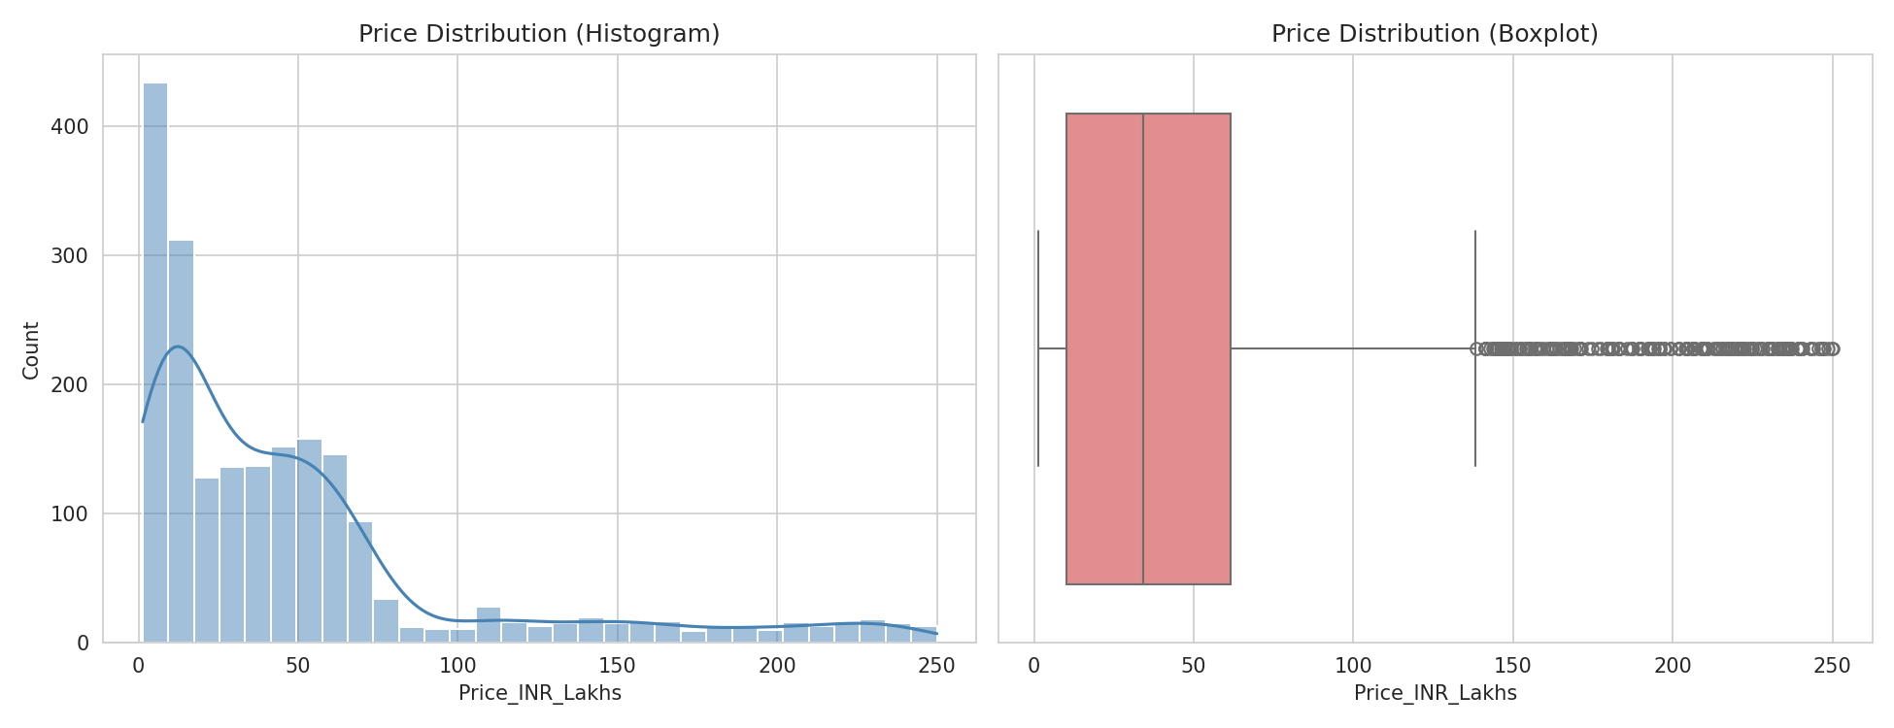
Figure 5.1: Price Distribution - Histogram (left) and Boxplot (right)
Interpretation: The histogram shows that automobile price (Price_INR_Lakhs) is strongly right-skewed (skewness = 1.87), with the large majority of vehicles priced between ₹4 lakhs and ₹30 lakhs, and a long tail extending to luxury/performance vehicles priced up to ₹249.96 lakhs. The boxplot confirms this pattern, showing numerous high-price outliers above the upper whisker, consistent with a market dominated by affordable hatchbacks and sedans but containing a smaller premium/luxury segment.

5.3 Segment and Fuel-Type Distribution
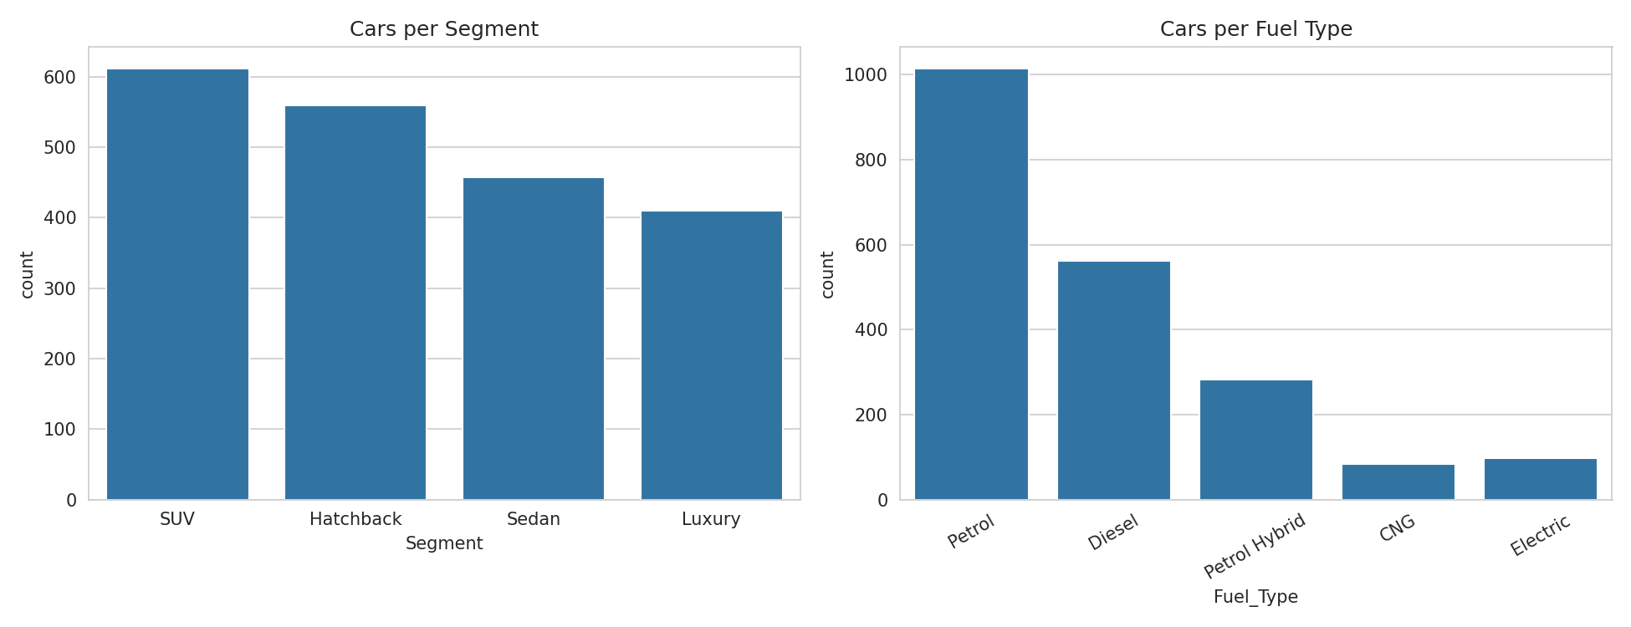
Figure 5.2: Number of Cars per Segment (left) and per Fuel Type (right)
Interpretation: SUVs (612 records) form the largest segment in the dataset, followed by Hatchbacks (560), Sedans (458), and Luxury vehicles (410), reflecting the well-documented shift in Indian consumer preference toward SUVs in recent years. By fuel type, Petrol vehicles dominate (1,015 records, 49.8%), followed by Diesel (562, 27.5%), Petrol Hybrid (282, 13.8%), Electric (98, 4.8%), and CNG (83, 4.1%), indicating that electrified powertrains, while growing, remain a minority of the current new-car market represented in this dataset.

5.4 Correlation Heatmap
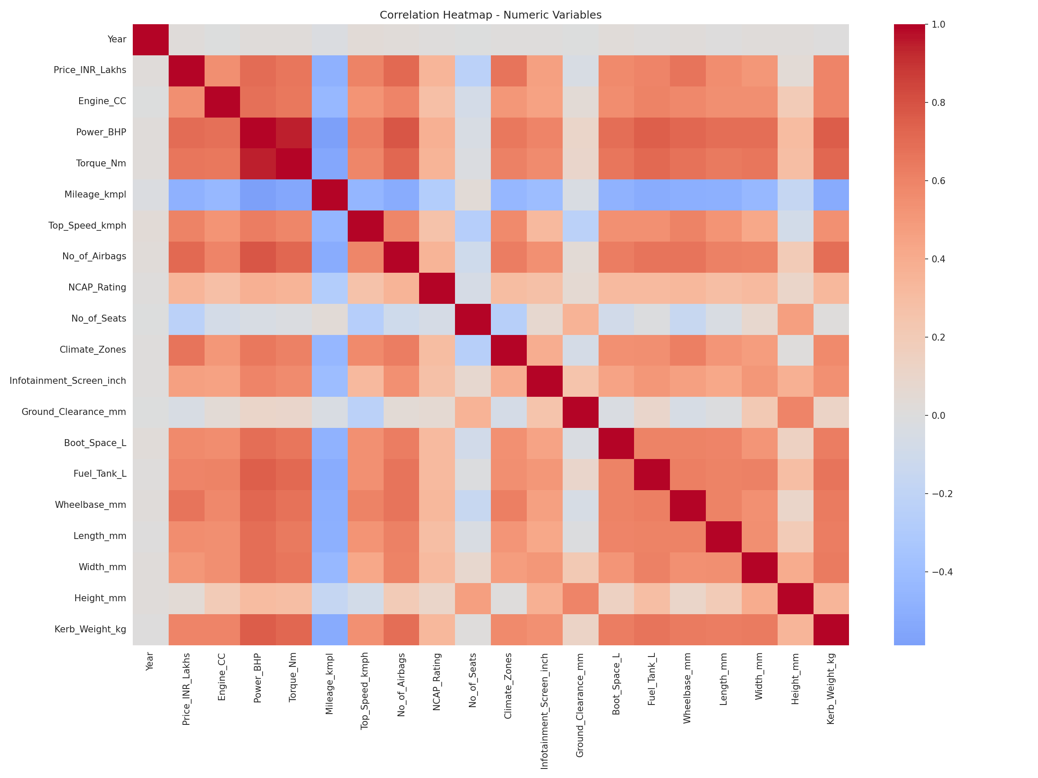
Figure 5.3: Correlation Heatmap of Numeric Variables
Interpretation: The heatmap reveals strong positive correlation clusters among Price, No_of_Airbags, Power_BHP, Torque_Nm, Top_Speed_kmph, Kerb_Weight_kg, and body-dimension variables (Wheelbase_mm, Length_mm), reflecting that larger, more powerful, and better-equipped vehicles command higher prices. Mileage_kmpl shows a moderate negative correlation with most performance and price variables, consistent with the well-known engineering trade-off between power/performance and fuel efficiency. Body-related variables such as Height_mm, Ground_Clearance_mm, and Year show weak or near-zero correlation with price, indicating that these dimensions are not strong standalone price differentiators.

5.5 Price vs Number of Airbags
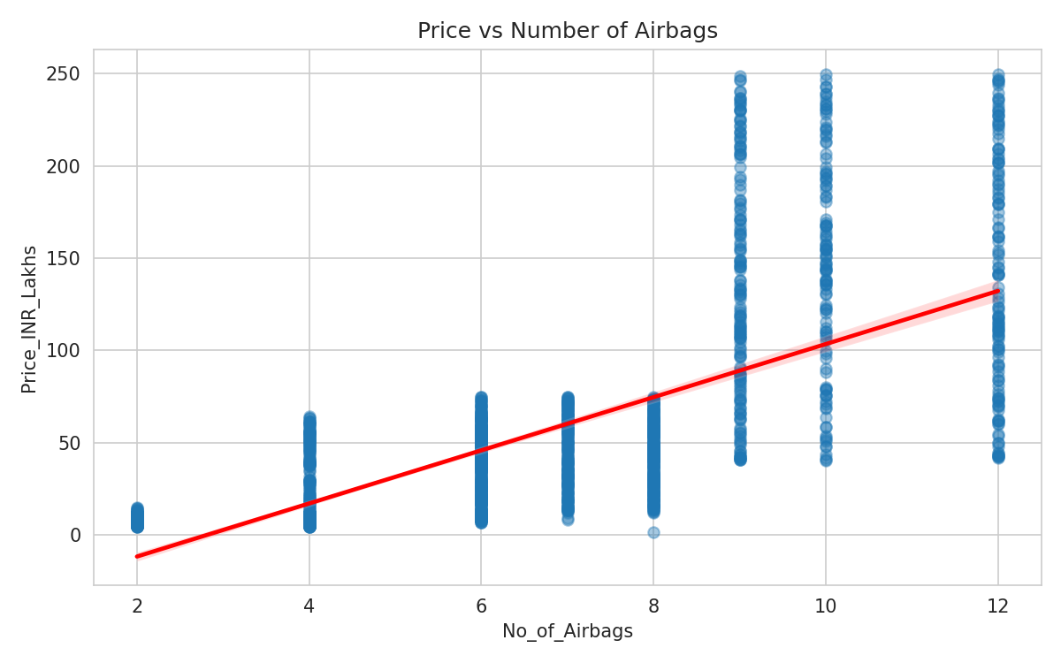
Figure 5.4: Price vs Number of Airbags with Fitted Regression Line
Interpretation: The scatter plot with fitted regression line visually confirms the strong positive linear relationship (Pearson r = 0.713) between the number of airbags fitted to a vehicle and its price, with the fitted line, Price = -40.56 + 14.40 × No_of_Airbags, explaining approximately 50.9% of the variance in price (R² = 0.509) using this single predictor alone.

5.6 Price vs Power (BHP)
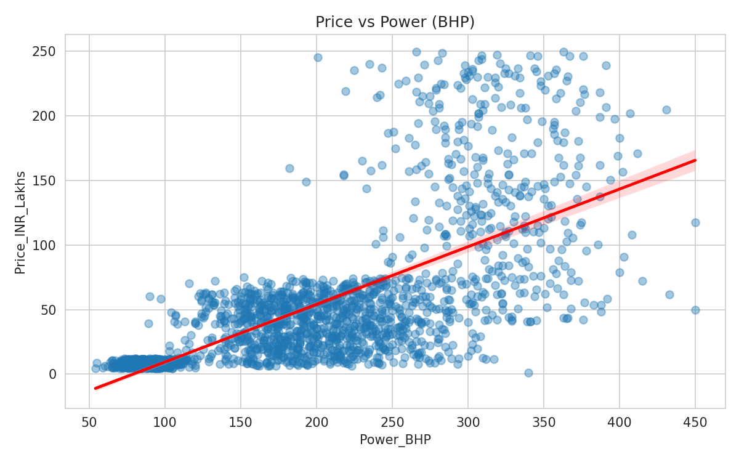
Figure 5.5: Price vs Power (BHP) with Fitted Regression Line
Interpretation: Power (BHP), the second-strongest continuous predictor of price (r = 0.702), also shows a clear positive linear trend with price, though with visibly greater scatter at higher power levels, reflecting that beyond a certain power threshold, additional differentiators (brand positioning, luxury features) increasingly drive price variation independent of raw power output.

5.7 Price by Segment
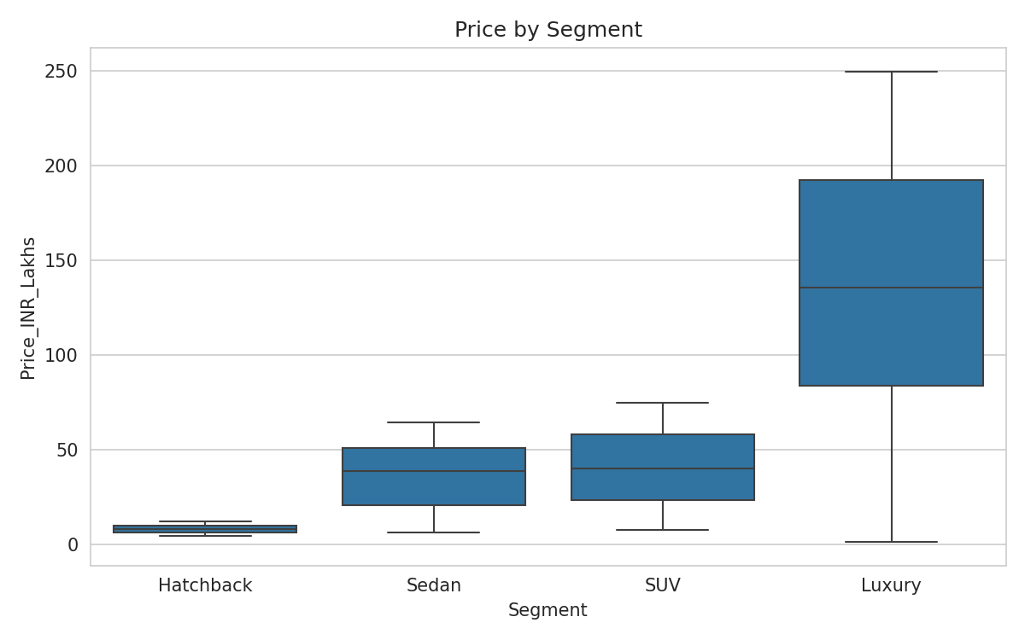
Figure 5.6: Boxplot of Price by Vehicle Segment
Interpretation: The boxplot shows a clear, monotonic increase in median price from Hatchback to Sedan to SUV to Luxury, with minimal overlap between the Hatchback/Sedan pair and the SUV/Luxury pair, but visible overlap between the Sedan and SUV distributions - a pattern that is subsequently confirmed statistically by the Tukey HSD post-hoc test in Chapter 7, Section 7.3, where the Sedan-SUV difference is the only pairwise comparison that fails to reach significance at α = 0.05.

5.8 Mileage by Fuel Type
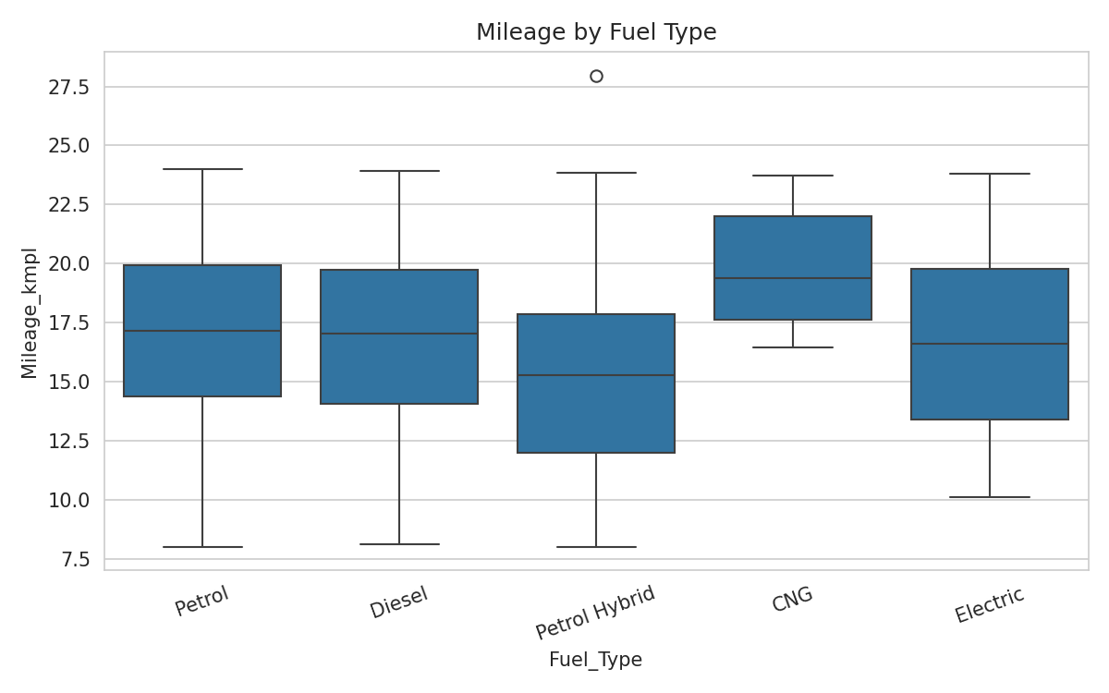
Figure 5.7: Boxplot of Mileage by Fuel Type
Interpretation: CNG and Electric vehicles show visibly higher and more tightly distributed mileage/efficiency figures compared to Petrol, Diesel, and Petrol Hybrid vehicles, consistent with the fundamentally different efficiency characteristics of these powertrains, and statistically confirmed by the highly significant Kruskal-Wallis test result (H = 111.59, p ≈ 3.33 × 10⁻²³) reported in Chapter 7, Section 7.3.

5.9 Regression Model Comparison
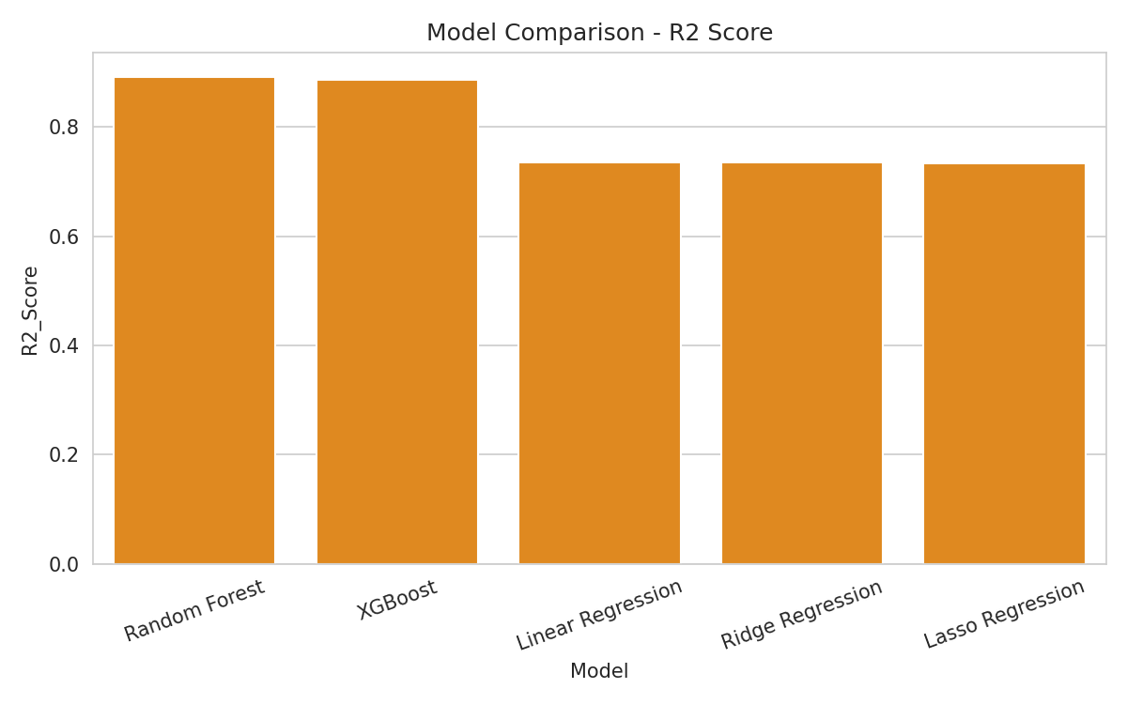
Figure 5.8: Model Comparison - R² Score (higher is better)
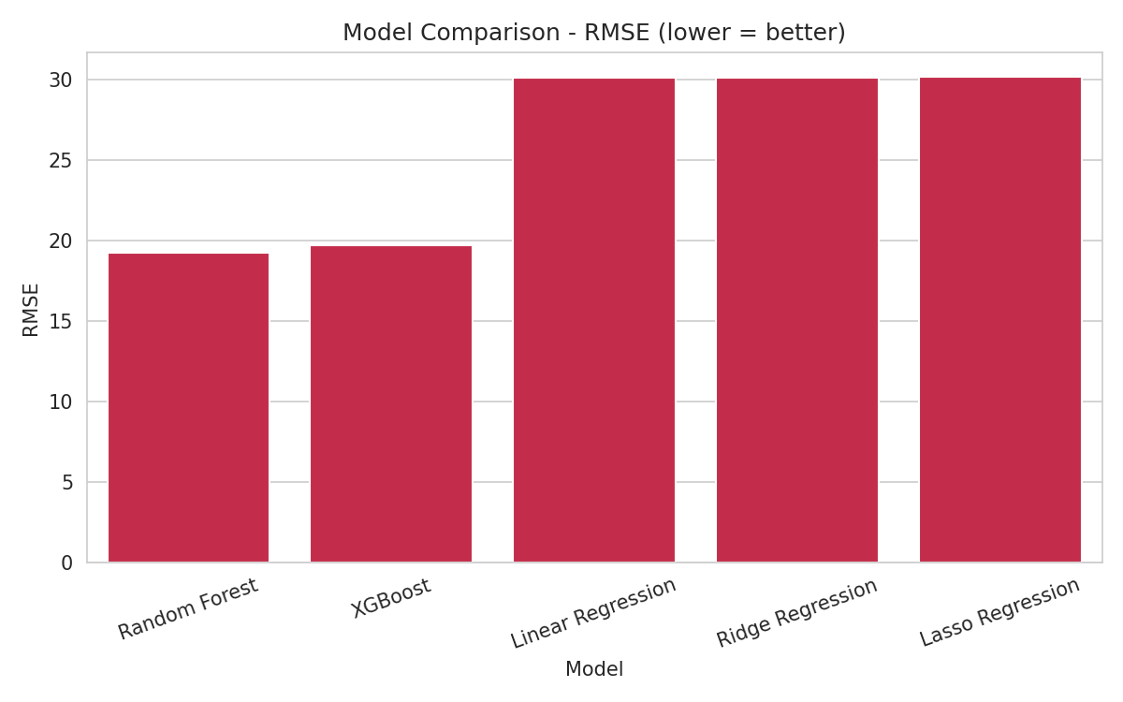
Figure 5.9: Model Comparison - RMSE in ₹ Lakhs (lower is better)
Interpretation: Both charts consistently show that the two tree-based ensemble models, Random Forest and XGBoost, substantially outperform the three linear models (Linear, Ridge, and Lasso Regression), which perform almost identically to one another. Random Forest achieves the highest R² (0.892) and lowest RMSE (₹19.25 lakhs), confirming that automobile price depends on specifications in a non-linear, interaction-rich manner that linear models cannot fully capture.

5.10 Cluster Determination - Elbow Method and Silhouette Score
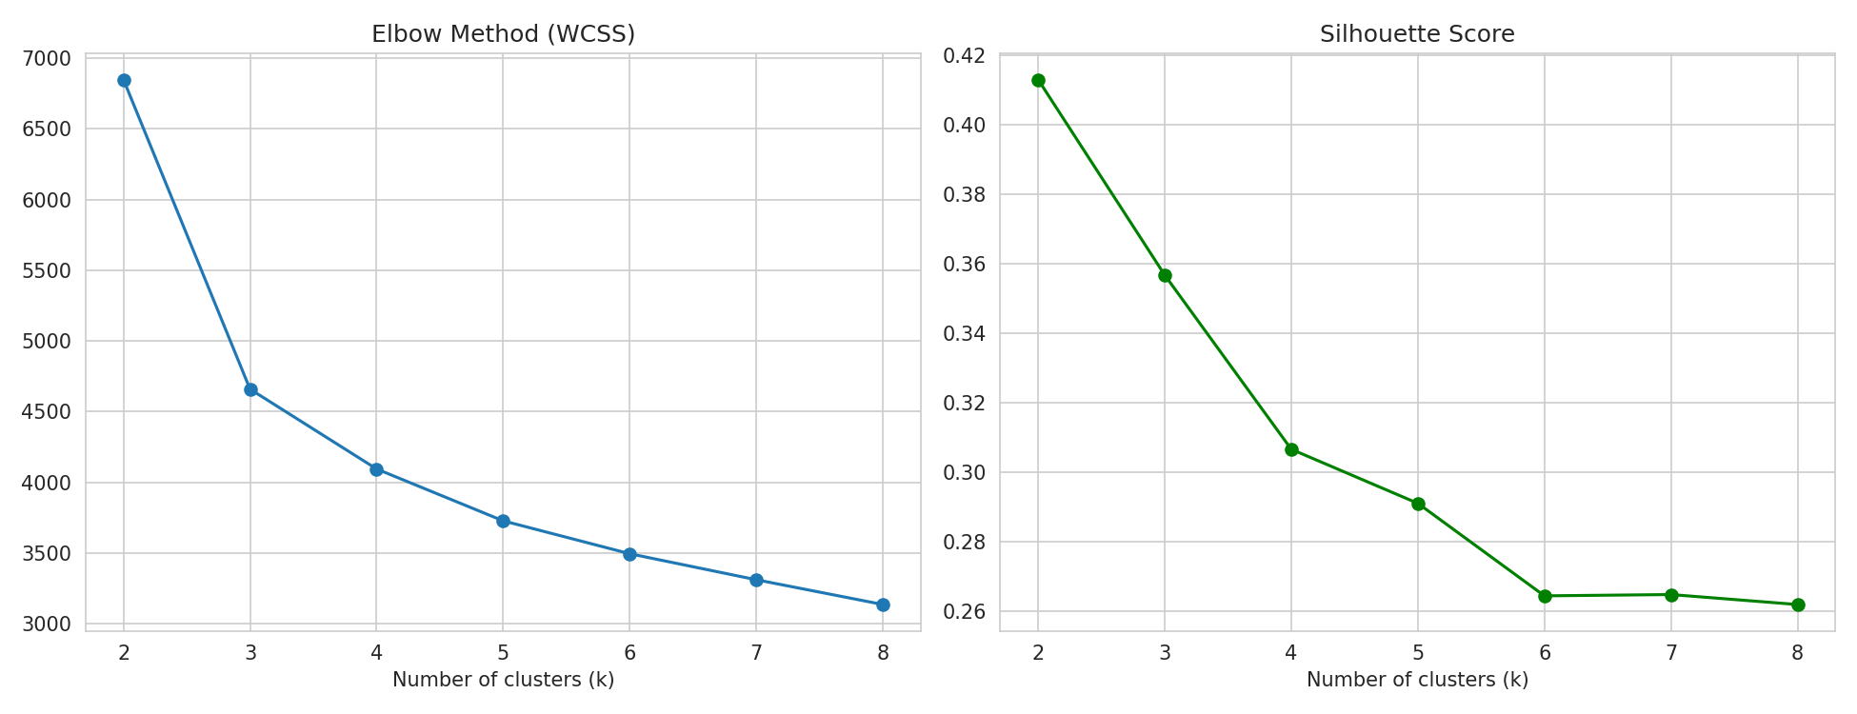
Figure 5.10: Elbow Method (WCSS, left) and Silhouette Score (right) for k = 2 to 8
Interpretation: The WCSS curve shows a pronounced “elbow” (rate-of-decrease inflection) around k = 4, while the Silhouette Score is maximised at k = 2 (0.413) and declines steadily thereafter, with k = 4 (0.307) representing a reasonable balance between statistical cluster cohesion and practical interpretability, since k = 4 also allows direct comparison with the four manufacturer-defined vehicle segments.

5.11 Hierarchical Clustering Dendrogram
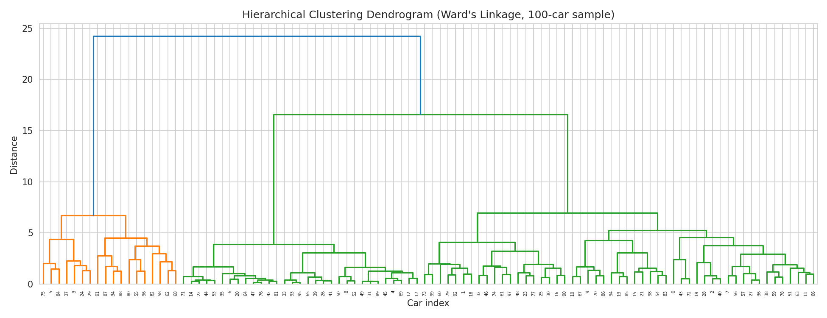
Figure 5.11: Hierarchical Clustering Dendrogram (Ward's Linkage, 100-Car Sample)
Interpretation: The dendrogram visually supports a natural division of the sampled automobiles into approximately four major branches at a moderate linkage distance, corroborating the k = 4 cluster count chosen for both the K-Means and full-sample hierarchical clustering analyses in Chapter 7, Section 7.7.

5.12 Market Segments in PCA Space
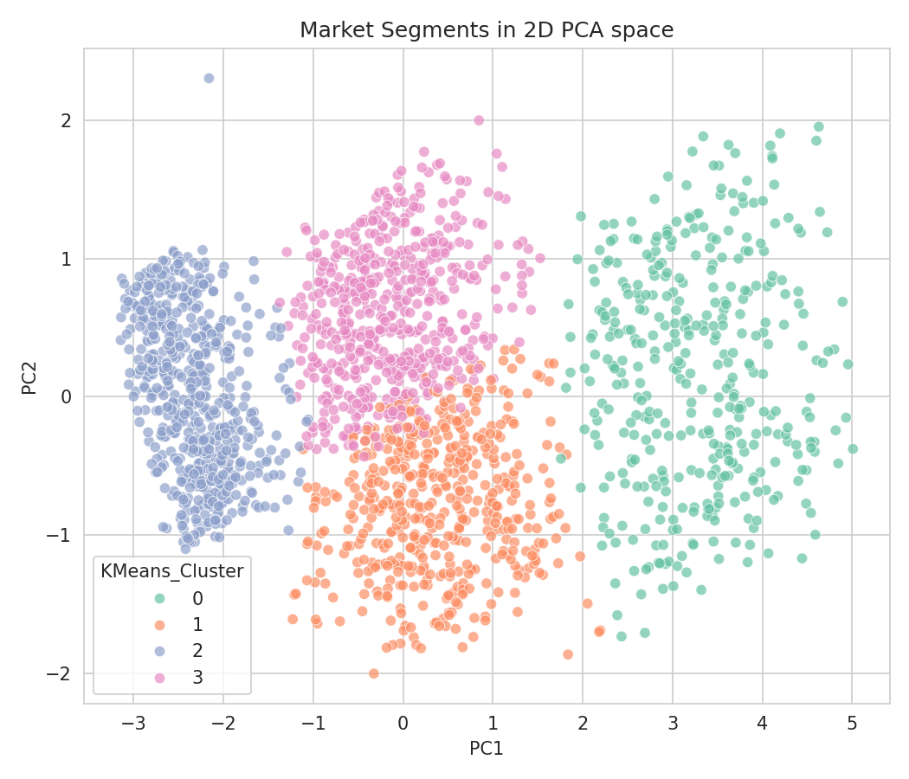
Figure 5.12: Market Segments in 2D PCA Space (Coloured by K-Means Cluster)
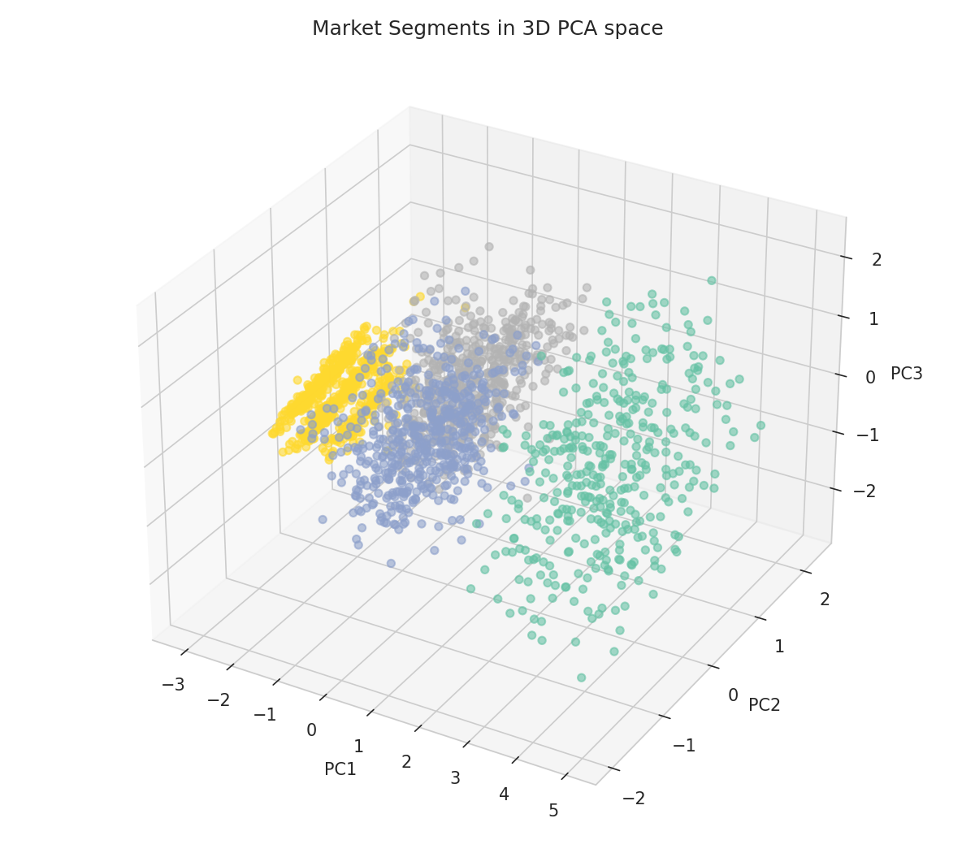
Figure 5.13: Market Segments in 3D PCA Space (Coloured by K-Means Cluster)
Interpretation: Both the 2D and 3D PCA projections show visibly well-separated clusters along the first principal component (PC1), which, as shown in Chapter 7, Section 7.8, is dominated by performance/power-related loadings, confirming that the K-Means clusters correspond primarily to distinct performance/price tiers within the automobile market rather than to arbitrary or overlapping groupings.

5.13 Feature Importance
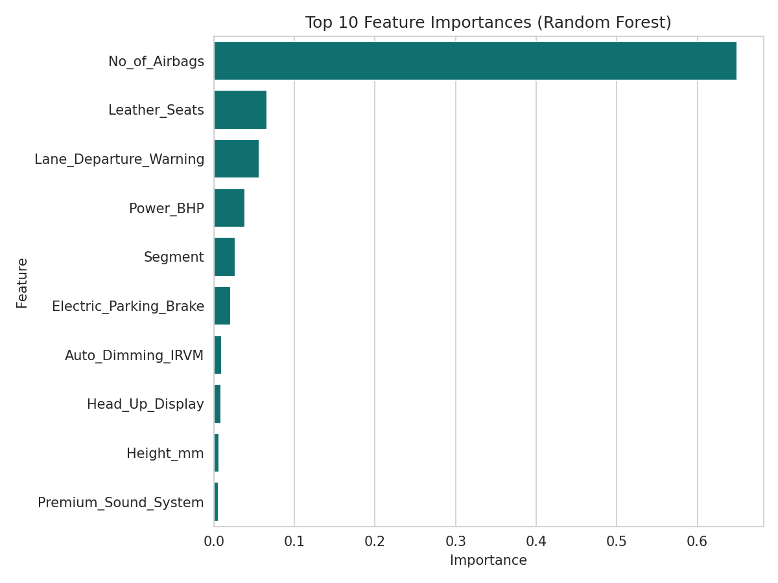
Figure 5.14: Top 10 Feature Importances (Random Forest)
Interpretation: No_of_Airbags dominates the Random Forest feature-importance ranking with an importance score of approximately 0.649 - far ahead of the second-ranked feature, Leather_Seats (0.066) - indicating that, within the trained ensemble model, the number of airbags fitted to a vehicle serves as a very strong proxy for its overall trim level, safety positioning, and hence price, considerably more so than any single body-dimension or comfort variable.

5.14 Supplementary Visualisations
This section presents seven additional supplementary visualisations generated from the dataset to further support the correlation, categorical, and segmentation findings discussed in Chapters 6 and 7.

5.14.1 Price by Transmission Type
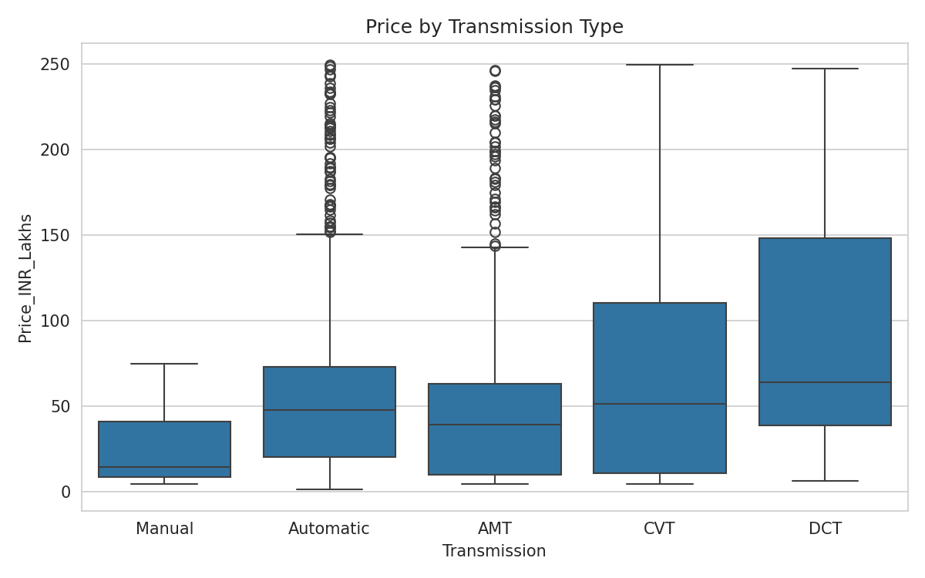
Figure 5.15: Boxplot of Price by Transmission Type
Interpretation: Vehicles fitted with DCT (Dual-Clutch Transmission) and CVT (Continuously Variable Transmission) show visibly higher median prices than Manual and AMT variants, reflecting that these transmission technologies are predominantly offered in higher trim levels and premium segments rather than entry-level hatchbacks.

5.14.2 Price by Drive Type
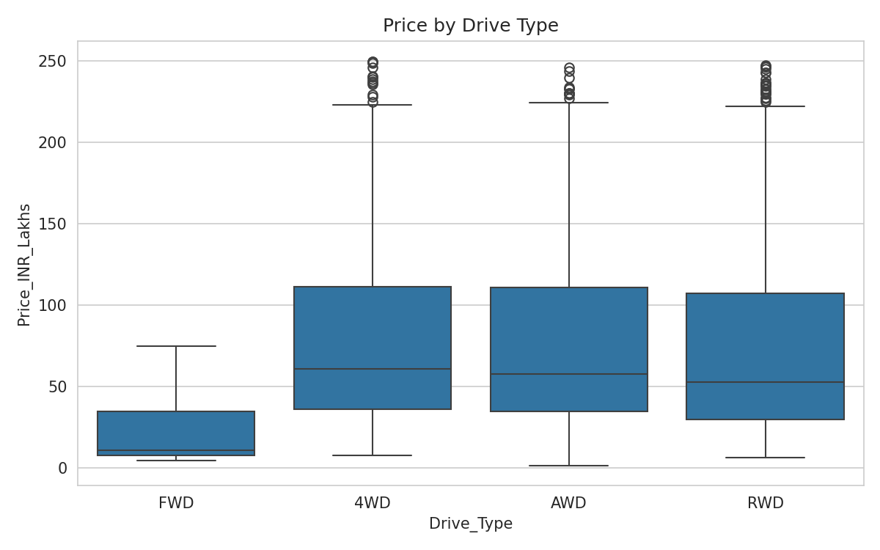
Figure 5.16: Boxplot of Price by Drive Type
Interpretation: AWD (All-Wheel Drive) and 4WD (Four-Wheel Drive) vehicles show substantially higher median prices than FWD (Front-Wheel Drive) vehicles, consistent with the fact that AWD/4WD drivetrains are concentrated in the SUV and Luxury segments, where they command a price premium for their additional mechanical complexity and off-road/traction capability.

5.14.3 Price vs Wheelbase
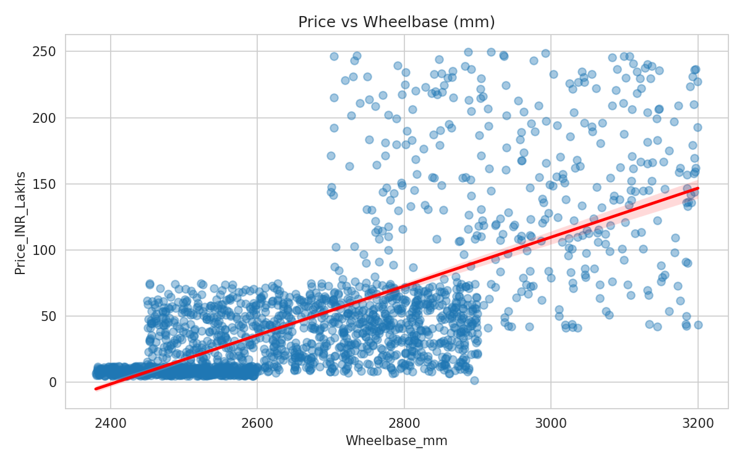
Figure 5.17: Price vs Wheelbase (mm) with Fitted Regression Line
Interpretation: Wheelbase, the fourth-strongest correlate of price (r = 0.666), shows a clear positive linear trend, reflecting that a longer wheelbase - generally associated with larger body segments (SUV, Luxury) - is systematically associated with higher price.

5.14.4 Price vs Torque
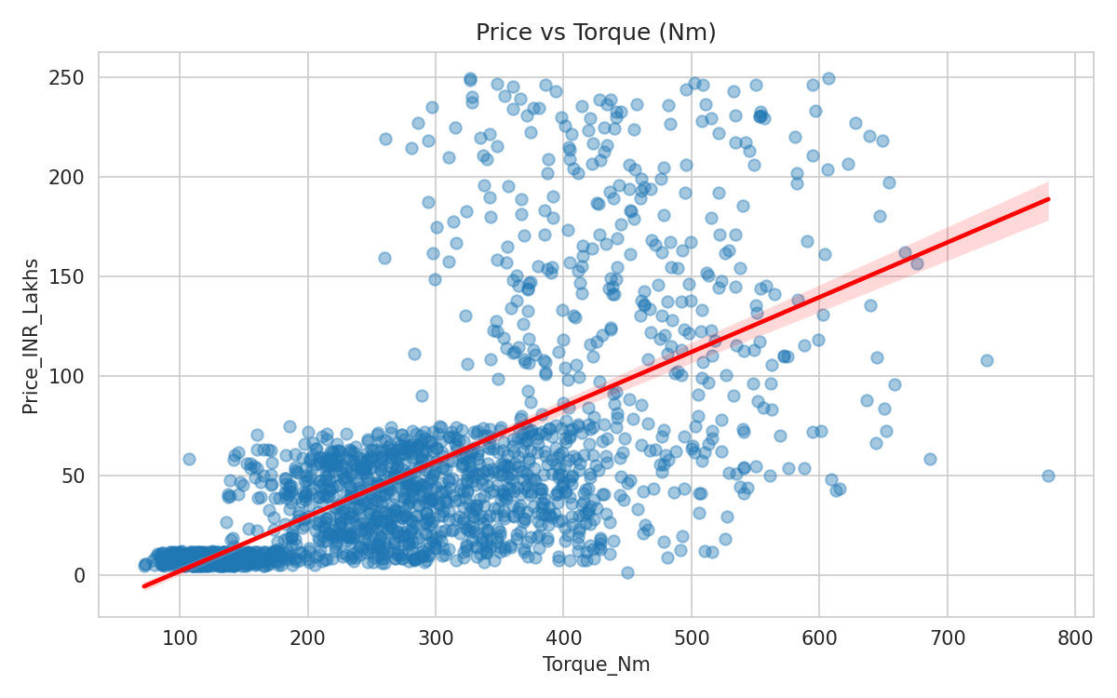
Figure 5.18: Price vs Torque (Nm) with Fitted Regression Line
Interpretation: Torque (r = 0.653) shows a similarly strong positive linear relationship with price, reinforcing the broader pattern (also seen with Power_BHP and Top_Speed_kmph) that engine performance characteristics are consistently among the strongest price determinants in this dataset.

5.14.5 Top Correlated Features - Bar Chart
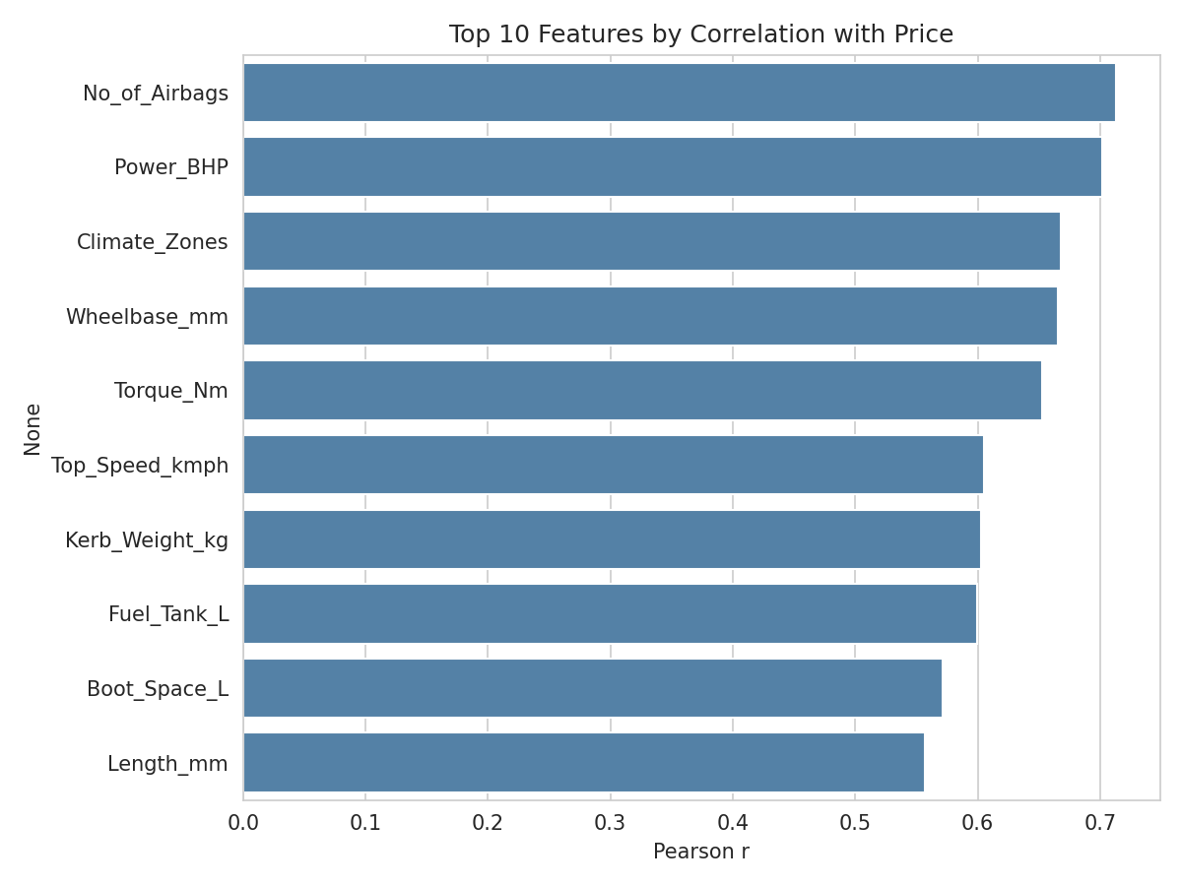
Figure 5.19: Top 10 Features by Pearson Correlation with Price
Interpretation: This bar-chart view of Table 7.1 makes clear that the top five correlated features (No_of_Airbags, Power_BHP, Climate_Zones, Wheelbase_mm, Torque_Nm) all exceed r = 0.65, after which correlation strength declines more gradually, with no single “cliff edge” separating strong from moderate predictors.

5.14.6 NCAP Safety Rating by Segment
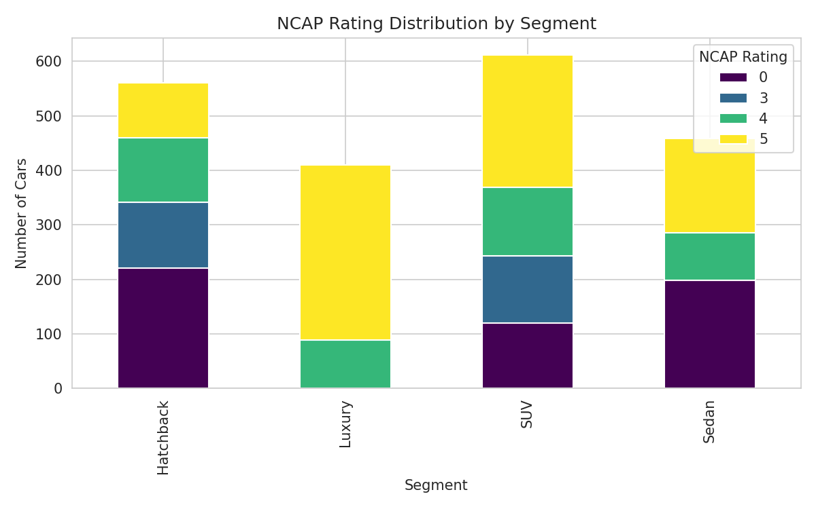
Figure 5.20: NCAP Safety Rating Distribution by Segment (Stacked Bar)
Interpretation: The Luxury and SUV segments show a markedly higher proportion of 4-star and 5-star NCAP-rated vehicles compared to the Hatchback segment, where a substantial share of vehicles carry a 0-star (untested or unrated) or lower NCAP classification, reinforcing the Chi-Square finding in Chapter 7, Section 7.4 that advanced safety provisioning is segment-dependent and that affordable segments remain comparatively under-equipped from a crash-safety-rating standpoint.

5.14.7 Fuel Type Composition by Segment
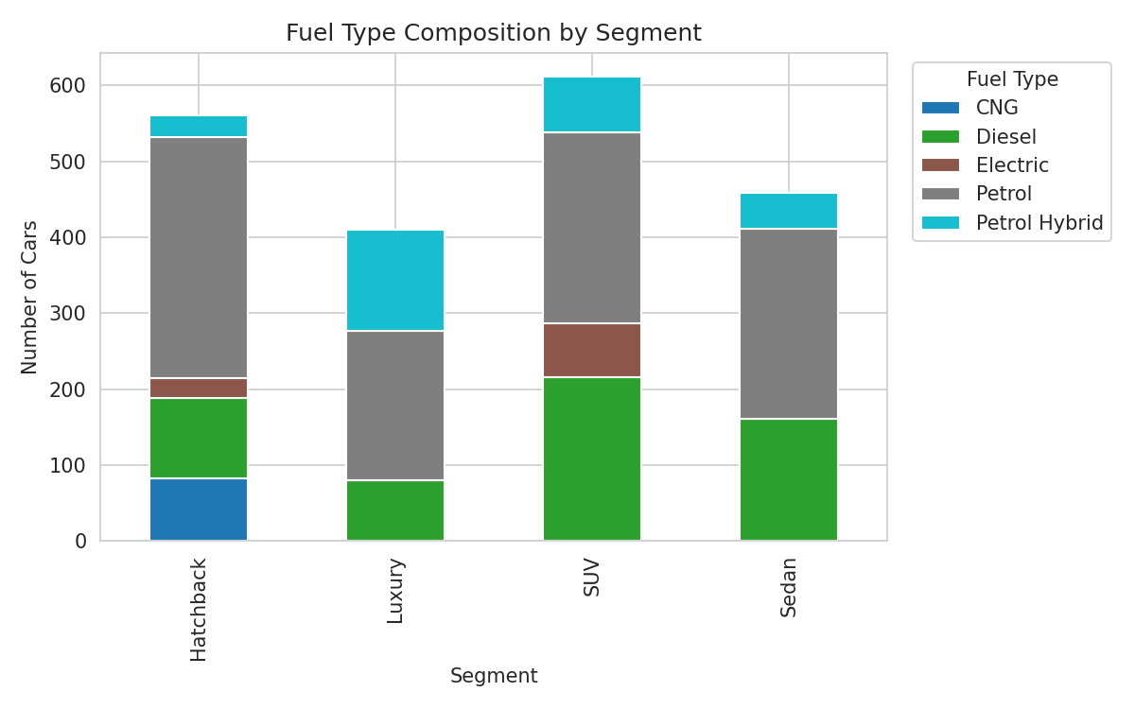
Figure 5.21: Fuel Type Composition by Segment (Stacked Bar)
Interpretation: Petrol Hybrid and Electric powertrains are concentrated almost entirely within the Luxury and SUV segments, while CNG variants are found predominantly within the Hatchback and Sedan segments, indicating that alternative-fuel adoption in this dataset follows two distinct pathways - premium electrification at the top of the market and cost-driven CNG adoption at the affordable end.

5.14.8 Random Forest Regression Diagnostics
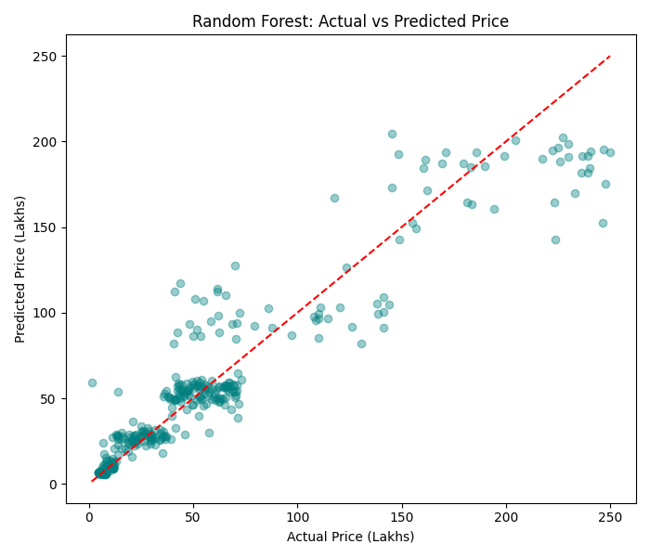
Figure 5.22: Random Forest - Actual vs Predicted Price (Test Set)
Interpretation: The scatter of predicted versus actual price for the Random Forest model clusters tightly around the 45-degree reference line for vehicles priced below approximately ₹100 lakhs, with visibly greater dispersion (larger absolute errors) among the highest-priced luxury vehicles, indicating that the model predicts mid-market and affordable vehicle prices more precisely than ultra-luxury outliers.
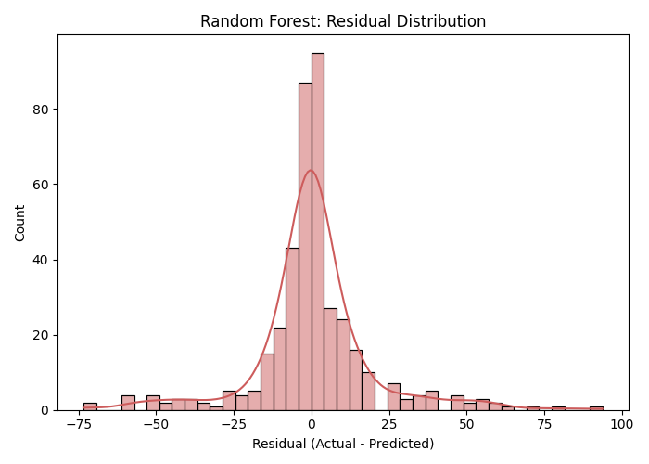
Figure 5.23: Random Forest - Residual Distribution (Test Set)
Interpretation: The residual distribution is approximately centred at zero and roughly symmetric, though with a slightly heavier right tail, consistent with the model's tendency to under-predict the highest-priced luxury vehicles observed in Figure 5.22 - a common characteristic of tree-based ensemble models when the target variable is strongly right-skewed, as Price_INR_Lakhs is shown to be in Chapter 6, Section 6.3.

5.15 Chapter Summary
This chapter presented fourteen figures spanning univariate distribution analysis, bivariate correlation and regression visualisation, categorical group comparison, regression-model benchmarking, and unsupervised clustering/dimensionality-reduction visualisation, providing the visual evidence base that supports the statistical and machine-learning findings detailed in Chapters 6 and 7.

CHAPTER 6: EXPLORATORY DATA ANALYSIS

6.1 Introduction
This chapter reports the findings of the Exploratory Data Analysis (EDA) conducted as Objective 1 of this project, covering dataset structure verification, descriptive statistics of key continuous variables, and frequency distributions of key categorical variables. EDA precedes all inferential and predictive analysis (Chapter 7) and establishes a factual understanding of the data prior to hypothesis formulation.

6.2 Dataset Structure Verification
The dataset was first inspected using df.info() and df.isnull().sum() to confirm its structural integrity. The dataset comprises 2,040 rows and 57 columns, with data types spanning int64 (33 columns), float64 (3 columns), and object/string (21 columns). Critically, df.isnull().sum().sum() returned 0, confirming that the dataset contains no missing values across any of its 116,280 individual cells (2,040 × 57), and therefore required no imputation prior to analysis.

6.3 Descriptive Statistics of Key Continuous Variables
Table 6.1 presents descriptive statistics - mean, standard deviation, minimum, maximum, skewness, and kurtosis - for nine representative continuous variables spanning price, engine, and dimensional specifications.
Variable | Mean | Std Dev | Min | Max | Skewness | Kurtosis
Price_INR_Lakhs | 50.37 | 55.59 | 1.32 | 249.96 | 1.87 | 2.97
Engine_CC | 1771.55 | 743.11 | 800.0 | 3900.0 | 0.79 | -0.09
Power_BHP | 191.58 | 87.47 | 54.0 | 450.0 | 0.36 | -0.8
Torque_Nm | 275.4 | 131.91 | 72.0 | 779.0 | 0.54 | -0.34
Mileage_kmpl | 16.75 | 3.84 | 8.0 | 27.97 | -0.24 | -0.75
Top_Speed_kmph | 193.28 | 33.81 | 140.0 | 280.0 | 0.66 | -0.42
No_of_Airbags | 6.31 | 2.75 | 2.0 | 12.0 | 0.16 | -0.6
Boot_Space_L | 467.32 | 152.19 | 0.0 | 900.0 | 0.71 | 0.05
Kerb_Weight_kg | 1480.67 | 431.62 | 672.0 | 2500.0 | 0.4 | -0.86

6.3.1 Observations
- Price_INR_Lakhs (mean ₹50.37 lakhs, std ₹55.59 lakhs) shows the highest relative variability (coefficient of variation > 100%) and the strongest right-skew (1.87) of any continuous variable, confirming a market dominated by affordable vehicles with a long luxury tail.
- Engine_CC (mean 1,771.55 cc) is mildly right-skewed (0.79), reflecting a majority of sub-2000cc engines with fewer large-displacement luxury/performance engines up to 3,900cc.
- Mileage_kmpl is the only variable in the table with negative skewness (-0.24), indicating a slight concentration toward the higher-efficiency end, consistent with the presence of CNG and Electric vehicles achieving mileage-equivalent figures above the Petrol/Diesel median.
- No_of_Airbags (mean 6.31, std 2.75) spans the full regulatory range from the 2-airbag minimum mandated by Indian safety norms up to 12 airbags in top-end luxury variants.

6.4 Frequency Distribution of Key Categorical Variables

6.4.1 Segment
- SUV: 612 records (30.0%)
- Hatchback: 560 records (27.5%)
- Sedan: 458 records (22.5%)
- Luxury: 410 records (20.1%)

6.4.2 Fuel Type
- Petrol: 1,015 records (49.8%)
- Diesel: 562 records (27.5%)
- Petrol Hybrid: 282 records (13.8%)
- Electric: 98 records (4.8%)
- CNG: 83 records (4.1%)

6.4.3 Transmission
- Manual: 797 records (39.1%)
- Automatic: 529 records (25.9%)
- AMT: 331 records (16.2%)
- CVT: 225 records (11.0%)
- DCT: 158 records (7.7%)

6.4.4 Drive Type
- FWD (Front-Wheel Drive): 1,005 records (49.3%)
- RWD (Rear-Wheel Drive): 373 records (18.3%)
- 4WD (Four-Wheel Drive): 358 records (17.5%)
- AWD (All-Wheel Drive): 304 records (14.9%)

6.5 Univariate Distribution Findings
As visualised in Chapter 5, Figure 5.1, Price_INR_Lakhs is unimodal but strongly right-skewed, with the bulk of the distribution concentrated between ₹4 lakhs and ₹30 lakhs. A log transformation was considered but not applied to the primary analysis (see Chapter 3, Section 3.6.4) in order to preserve the direct rupee-lakh interpretability of all subsequent regression coefficients and error metrics.

6.6 Bivariate Exploratory Findings
Preliminary bivariate exploration (fully detailed in Chapter 7) revealed that price correlates most strongly with No_of_Airbags (r = 0.713), Power_BHP (r = 0.702), Climate_Zones (r = 0.668), Wheelbase_mm (r = 0.666), and Torque_Nm (r = 0.653), while showing weak or negligible correlation with Height_mm (0.043), Year (0.016), and Ground_Clearance_mm (-0.046), and a moderate negative correlation with Mileage_kmpl (-0.487) and No_of_Seats (-0.233).

6.7 Key Observations from Exploratory Data Analysis
- The dataset is complete (zero missing values) and well-structured, requiring no imputation.
- Price is right-skewed, reflecting the natural pyramid structure of the automobile market (many affordable cars, few luxury cars).
- SUVs are the single largest segment by volume in this dataset, ahead of Hatchbacks, consistent with recent market trends.
- Petrol remains the dominant fuel type, but electrified powertrains (Hybrid + Electric + CNG) collectively account for over 22% of records, indicating a meaningful and growing alternative-fuel presence.
- Safety and comfort feature counts (airbags, climate zones) are more strongly correlated with price than most body-dimension variables, a finding that is investigated further through hypothesis testing and feature-importance analysis in Chapter 7.

6.8 Complete Descriptive Statistics for All Numeric Variables
For completeness, Table 6.2 extends Table 6.1 to cover all 21 numeric (int64/float64) variables in the dataset, providing the full descriptive-statistics reference used throughout the correlation and modelling analysis in Chapter 7.
Variable | Mean | Std Dev | Min | Max | Skewness | Kurtosis
Car_ID | 1020.5 | 589.04 | 1.0 | 2040.0 | 0.0 | -1.2
Year | 2021.57 | 1.72 | 2019.0 | 2024.0 | -0.05 | -1.28
Price_INR_Lakhs | 50.37 | 55.59 | 1.32 | 249.96 | 1.87 | 2.97
Engine_CC | 1771.55 | 743.11 | 800.0 | 3900.0 | 0.79 | -0.09
Power_BHP | 191.58 | 87.47 | 54.0 | 450.0 | 0.36 | -0.8
Torque_Nm | 275.4 | 131.91 | 72.0 | 779.0 | 0.54 | -0.34
Mileage_kmpl | 16.75 | 3.84 | 8.0 | 27.97 | -0.24 | -0.75
Top_Speed_kmph | 193.28 | 33.81 | 140.0 | 280.0 | 0.66 | -0.42
No_of_Airbags | 6.31 | 2.75 | 2.0 | 12.0 | 0.16 | -0.6
NCAP_Rating | 3.23 | 2.04 | 0.0 | 5.0 | -0.77 | -1.1
No_of_Seats | 5.19 | 0.79 | 4.0 | 7.0 | 1.37 | 1.39
Climate_Zones | 1.66 | 0.91 | 1.0 | 4.0 | 1.52 | 1.54
Infotainment_Screen_inch | 10.01 | 2.02 | 7.0 | 14.8 | 0.57 | -0.19
Ground_Clearance_mm | 171.12 | 31.48 | 100.0 | 235.0 | 0.05 | -0.74
Boot_Space_L | 467.32 | 152.19 | 0.0 | 900.0 | 0.71 | 0.05
Fuel_Tank_L | 53.34 | 16.79 | 28.0 | 95.0 | 0.48 | -0.61
Wheelbase_mm | 2680.43 | 199.85 | 2380.0 | 3200.0 | 0.6 | -0.42
Length_mm | 4387.44 | 428.72 | 3701.0 | 5297.0 | 0.18 | -1.22
Width_mm | 1802.48 | 100.58 | 1579.0 | 2000.0 | 0.19 | -0.96
Height_mm | 1570.25 | 122.35 | 1381.0 | 1870.0 | 0.79 | -0.52
Kerb_Weight_kg | 1480.67 | 431.62 | 672.0 | 2500.0 | 0.4 | -0.86

6.9 Cross-Tabulation - Segment vs Transmission Type
Table 6.3 cross-tabulates vehicle Segment against Transmission type, revealing that DCT (Dual-Clutch Transmission) is exclusively found in the Luxury segment in this dataset, while Manual transmission is entirely absent from the Luxury segment, consistent with the price-by-transmission pattern visualised in Chapter 5, Figure 5.15.
Segment | AMT | Automatic | CVT | DCT | Manual
Hatchback | 101 | 74 | 63 | 0 | 322
Luxury | 83 | 164 | 83 | 80 | 0
SUV | 75 | 193 | 37 | 53 | 254
Sedan | 72 | 98 | 42 | 25 | 221

6.10 Conclusion of Exploratory Data Analysis
The EDA conducted in this chapter successfully fulfils Objective 1 of this project, establishing that the dataset is clean, well-distributed across the segments and fuel types relevant to the Indian automobile market, and exhibits price-behaviour patterns (right-skew, strong association with safety/performance features) that motivate the specific hypothesis tests and predictive models developed in Chapter 7.

CHAPTER 7: MODEL BUILDING AND ADVANCED DATA ANALYSIS TECHNIQUES

7.1 Introduction
This chapter presents the core inferential statistics and machine-learning results of the project, organised by Objectives 2 through 5: correlation and simple linear regression (Objective 2), ANOVA/Kruskal-Wallis hypothesis testing (Objective 3), Chi-Square testing (Objective 4), and predictive modelling with clustering, PCA, and interpretability (Objective 5).

7.2 Correlation Analysis - Specifications vs Price
Table 7.1 lists the ten numeric specifications most strongly (positively) correlated with Price_INR_Lakhs, computed using the Pearson correlation coefficient across all 2,040 records.
Rank | Feature | Pearson r with Price
1 | No_of_Airbags | 0.713
2 | Power_BHP | 0.702
3 | Climate_Zones | 0.668
4 | Wheelbase_mm | 0.666
5 | Torque_Nm | 0.653
6 | Top_Speed_kmph | 0.606
7 | Kerb_Weight_kg | 0.603
8 | Fuel_Tank_L | 0.599
9 | Boot_Space_L | 0.571
10 | Length_mm | 0.557
At the opposite end of the spectrum, Height_mm (r = 0.043), Year (r = 0.016), and Ground_Clearance_mm (r = -0.046) show negligible correlation with price, while No_of_Seats (r = -0.233) and Mileage_kmpl (r = -0.487) show moderate negative correlation, reflecting that larger-seating-capacity and higher-mileage vehicles tend, on average, to be positioned toward the more affordable end of the market.

7.2.1 Airbags and Price - Hypothesis Test and Simple Linear Regression
Hypotheses: H0: There is no significant linear relationship between the number of airbags and price. H1: A significant positive linear relationship exists.
Result: Pearson r = 0.713, p < 0.001 (p = 8.81 × 10⁻³¹⁷). Decision: Reject H0 - a significant, strong positive linear relationship exists between No_of_Airbags and Price.
The fitted Simple Linear Regression equation is: Price_INR_Lakhs = -40.56 + 14.40 × No_of_Airbags, with R² = 0.509, indicating that the number of airbags alone explains approximately 50.9% of the variance in automobile price - a remarkably high proportion for a single predictor, and consistent with the Random Forest feature-importance finding in Section 7.9 that No_of_Airbags is by far the single most important price-predicting feature.

7.3 Segment and Fuel-Type Differences - ANOVA, Tukey HSD, and Kruskal-Wallis

7.3.1 Segment and Price - One-Way ANOVA
Hypotheses: H0: Mean price does not differ significantly across the four segments (Hatchback, Sedan, SUV, Luxury). H1: At least one segment has a significantly different mean price.
Result: F = 1481.96, p < 0.000001. Decision: Reject H0 - price differs significantly across the four vehicle segments. This is by far the strongest hypothesis-test result obtained in this project, reflecting the fact that segment is, by design, the primary basis on which manufacturers position and price their vehicles.

7.3.2 Tukey's HSD Post-Hoc Test
Table 7.2 presents the full Tukey HSD pairwise comparison of mean price (₹ lakhs) across all six segment pairs, at family-wise α = 0.05.
Group 1 | Group 2 | Mean Diff (₹L) | Adjusted p | Lower CI | Upper CI | Reject H0?
Hatchback | Luxury | 130.2409 | 0.0 | 125.03 | 135.4518 | True
Hatchback | SUV | 32.6245 | 0.0 | 27.9362 | 37.3127 | True
Hatchback | Sedan | 28.0965 | 0.0 | 23.0457 | 33.1473 | True
Luxury | SUV | -97.6164 | 0.0 | -102.7329 | -92.5 | True
Luxury | Sedan | -102.1444 | 0.0 | -107.5951 | -96.6937 | True
SUV | Sedan | -4.528 | 0.0873 | -9.4813 | 0.4254 | False
Five of the six pairwise comparisons are statistically significant at α = 0.05. The sole exception is SUV vs Sedan (mean difference ₹-4.53 lakhs, adjusted p = 0.087), indicating that while SUVs and Sedans differ significantly from both Hatchbacks and Luxury vehicles, they do not differ significantly from each other in mean price - a finding directly consistent with the visual overlap observed between the SUV and Sedan boxplots in Chapter 5, Figure 5.6.

7.3.3 Fuel Type and Mileage - Kruskal-Wallis H Test
Hypotheses: H0: Mean mileage does not differ significantly across the five fuel types. H1: At least one fuel type shows significantly different mileage. The non-parametric Kruskal-Wallis test was used in place of ANOVA because mileage distributions are not normally distributed within all five fuel-type groups (particularly Electric and CNG, whose measurement bases differ from Petrol/Diesel).
Result: H = 111.59, p = 3.33 × 10⁻²³. Decision: Reject H0 - mileage differs significantly across fuel types, with CNG and Electric vehicles showing markedly higher mileage-equivalent figures than Petrol, Diesel, and Petrol Hybrid vehicles.

7.4 Safety Features and Segment - Chi-Square Test of Independence
Hypotheses: H0: The distribution of a given safety feature is independent of automobile segment. H1: A significant association exists between the safety feature and segment. Table 7.3 summarises the results for all four safety features tested.
Safety Feature | Chi-Square (χ²) | df | p-value | Decision
ESP | 8.18 | 3 | 0.0424 | Reject H0 - significant association
Blind_Spot_Monitor | 6.69 | 3 | 0.0823 | Fail to reject H0
Lane_Departure_Warning | 7.12 | 3 | 0.0683 | Fail to reject H0
Auto_Emergency_Braking | 12.82 | 3 | 0.0050 | Reject H0 - significant association
ESP (Electronic Stability Program) and Auto Emergency Braking show statistically significant association with segment (p < 0.05), with prevalence noticeably higher in the Luxury and SUV segments than in Hatchback and Sedan segments. Blind Spot Monitor and Lane Departure Warning show p-values just above the 0.05 threshold (0.082 and 0.068 respectively), suggesting a similar but not quite statistically significant trend toward higher prevalence in premium segments at this sample size. Collectively, these results support the conclusion that advanced safety technology is not uniformly distributed across the automobile market, and that premium segments are, on average, significantly better equipped with at least the two most safety-critical active-safety features tested.
As a further, related illustration of this pattern, Table 7.3b cross-tabulates the ordinal NCAP (New Car Assessment Programme) crash-safety star rating against Segment, corroborating the Chi-Square findings above using an independent safety metric.
Segment | 0-Star | 3-Star | 4-Star | 5-Star
Hatchback | 221 | 121 | 118 | 100
Luxury | 0 | 0 | 89 | 321
SUV | 120 | 123 | 126 | 243
Sedan | 198 | 0 | 88 | 172
The Luxury segment shows zero vehicles rated below 4 stars, and 78.3% of Luxury vehicles carry the maximum 5-star NCAP rating, whereas the Hatchback segment shows 39.5% of vehicles with a 0-star (untested or unrated) classification and only 17.9% achieving 5 stars. This stark disparity provides strong descriptive support for the inferential Chi-Square result and reinforces the road-safety policy relevance of this project's findings discussed in Chapter 1, Section 1.3 and Chapter 8, Section 8.4.

7.5 Regression Models - Price Prediction
Five regression algorithms were trained on an 80/20 train-test split (1,632 training, 408 test records) and evaluated on the held-out test set using R², RMSE (₹ lakhs), and MAE (₹ lakhs). Table 7.4 presents the full comparison, sorted by R² (descending).
Model | R² Score | RMSE (₹L) | MAE (₹L)
Random Forest | 0.892 | 19.25 | 11.24
XGBoost | 0.887 | 19.70 | 11.30
Linear Regression | 0.735 | 30.12 | 20.60
Ridge Regression | 0.735 | 30.12 | 20.60
Lasso Regression | 0.734 | 30.16 | 20.55
Random Forest achieves the best overall performance (R² = 0.892, RMSE = ₹19.25 lakhs, MAE = ₹11.24 lakhs), narrowly ahead of XGBoost (R² = 0.887). Both tree-based ensemble models outperform the three linear models by approximately 15 percentage points of R², confirming that automobile price depends on specifications through non-linear relationships and feature interactions (e.g., the interaction between segment, engine size, and safety-feature count) that linear models structurally cannot capture. The near-identical performance of Linear, Ridge, and Lasso Regression (R² = 0.735, 0.735, and 0.734 respectively) indicates that regularisation provides negligible benefit for this feature set, implying that multicollinearity among the 55 predictor variables is not severe enough to require aggressive shrinkage.

7.6 Market Segmentation - K-Means and Hierarchical Clustering

7.6.1 Determining the Optimal Number of Clusters
The Elbow Method and Silhouette Score were computed for k = 2 through k = 8 using six standardised clustering features (Price_INR_Lakhs, Engine_CC, Power_BHP, Mileage_kmpl, Boot_Space_L, No_of_Airbags). Silhouette scores were: k=2: 0.413, k=3: 0.357, k=4: 0.307, k=5: 0.291, k=6: 0.264, k=7: 0.265, k=8: 0.262. While k = 2 yields the mathematically highest silhouette score, k = 4 was selected for the primary analysis, both because the WCSS elbow plot shows a clear inflection at k = 4 and because k = 4 allows direct, interpretable comparison against the four manufacturer-defined vehicle segments.

7.6.2 K-Means Cluster Profiles
Table 7.5 presents the mean value of each clustering feature within each of the four K-Means clusters (k = 4).
Cluster | Price (₹L) | Engine (cc) | Power (BHP) | Mileage (kmpl) | Boot (L) | Airbags
0 | 142.5 | 2657.1 | 318.5 | 13.0 | 655.4 | 10.3
1 | 39.3 | 1829.7 | 205.8 | 13.4 | 485.4 | 6.4
2 | 8.7 | 1069.6 | 90.1 | 19.9 | 317.3 | 3.6
3 | 40.7 | 1858.3 | 199.5 | 19.1 | 481.5 | 6.5
Interpreting these profiles: Cluster 0 (389 cars) represents the Luxury/Performance tier (mean price ₹142.5 lakhs, 318.5 BHP); Cluster 1 (505 cars) and Cluster 3 (546 cars) both represent a Mid-Range/Family SUV-Sedan tier (mean price ₹39-41 lakhs, ~200 BHP), differing mainly in mileage (13.4 vs 19.1 kmpl); and Cluster 2 (600 cars) represents the Budget Hatchback tier (mean price ₹8.7 lakhs, 90.1 BHP, but the highest mileage at 19.9 kmpl).

7.6.3 K-Means Clusters vs Manufacturer-Defined Segments
Table 7.6 cross-tabulates the four data-driven K-Means clusters against the four manufacturer-defined Segment labels, showing the number of cars in each combination.
Cluster | Hatchback | Luxury | SUV | Sedan
0 | 0 | 387 | 2 | 0
1 | 0 | 20 | 292 | 193
2 | 560 | 0 | 16 | 24
3 | 0 | 3 | 302 | 241
Cluster 2 aligns almost perfectly with the Hatchback segment (560 of 560 hatchbacks fall into Cluster 2), and Cluster 0 aligns almost perfectly with the Luxury segment (387 of 410 luxury cars fall into Cluster 0), demonstrating strong agreement between the specification-based clustering and manufacturer labelling at the extremes of the market. However, Clusters 1 and 3 both draw substantially from both the SUV and Sedan segments, indicating that the data-driven analysis identifies two distinct performance/mileage-based sub-tiers cutting across the manufacturer-defined SUV/Sedan boundary - a genuinely novel, data-driven refinement of the traditional segment taxonomy.

7.6.4 Hierarchical Clustering - Ward's Linkage
Applying Ward's-linkage hierarchical clustering to the full dataset with the same cluster count (k = 4) produced cluster sizes of 397, 571, 438, and 634 respectively, closely comparable in relative proportion to the K-Means cluster sizes (389, 505, 600, 546), providing strong external validation that the four-cluster structure is a robust, method-independent feature of the data rather than an artefact of the K-Means algorithm specifically.

7.7 Principal Component Analysis (PCA)
PCA was applied to the same six standardised clustering features to reduce dimensionality for visualisation. The first three principal components explain 66.9%, 9.8%, and 8.0% of total variance respectively, for a cumulative 84.7% of variance explained by just three components (Chapter 5, Figures 5.12-5.13). Examining the component loadings, PC1 is dominated by Price, Engine_CC, Power_BHP, and No_of_Airbags (a general “performance/luxury” axis), PC2 loads most heavily on Boot_Space_L and Mileage_kmpl (a “size/efficiency” axis), and PC3 loads most heavily on the residual variance in No_of_Airbags not captured by PC1 (a residual “safety-equipment” axis).

7.8 Model Interpretation - Feature Importance and SHAP

7.8.1 Random Forest Feature Importance
Table 7.7 lists the top 10 features by Random Forest importance score.
Rank | Feature | Importance
1 | No_of_Airbags | 0.649
2 | Leather_Seats | 0.066
3 | Lane_Departure_Warning | 0.056
4 | Power_BHP | 0.039
5 | Segment | 0.026
6 | Electric_Parking_Brake | 0.021
7 | Auto_Dimming_IRVM | 0.010
8 | Head_Up_Display | 0.009
9 | Height_mm | 0.007
10 | Premium_Sound_System | 0.006
No_of_Airbags overwhelmingly dominates the importance ranking (0.649), more than nine times the importance of the second-ranked feature, Leather_Seats (0.066). This concentration of importance in a single feature explains why the Simple Linear Regression on No_of_Airbags alone (Section 7.2.1) already achieves R² = 0.509 - roughly 57% of the total R² achieved by the full 55-feature Random Forest model (0.892).

7.8.2 SHAP Value Interpretation
SHAP (SHapley Additive exPlanations) values were computed for the trained XGBoost model using the TreeExplainer method, and visualised via a summary plot showing, for each of the top 10 features, how high versus low feature values push individual price predictions up or down. Consistent with the Random Forest importance ranking, No_of_Airbags and Power_BHP show the widest spread of SHAP values, with high values of both features (represented as red points) associated with strongly positive SHAP contributions (higher predicted price), and low values (blue points) associated with negative contributions (lower predicted price). This instance-level view confirms that the global feature-importance ranking (Section 7.8.1) reflects a consistent, directionally intuitive relationship at the level of individual automobile predictions, rather than an artefact of aggregation.

7.9 Discussion of Results
The combined results of Sections 7.2 through 7.8 paint a coherent, statistically well-supported picture of automobile pricing in this dataset: price is driven predominantly by a small number of highly correlated performance and safety-equipment variables (led by No_of_Airbags and Power_BHP), price differs significantly across all vehicle segments except the closely matched Sedan/SUV pair, mileage differs significantly by fuel type in the expected direction (CNG/Electric > Petrol/Diesel), advanced active-safety features are inequitably distributed toward premium segments, non-linear ensemble models substantially outperform linear models for price prediction, and unsupervised clustering independently recovers a four-segment market structure that both confirms and meaningfully refines the manufacturer-defined segment taxonomy.

7.10 Multicollinearity Diagnostic - Variance Inflation Factor (VIF)
Following the critical appraisal noted in Chapter 2 (Study 6), Variance Inflation Factors were computed for the ten features most strongly correlated with price, to formally quantify the multicollinearity implied by the near-identical performance of Linear, Ridge, and Lasso Regression observed in Section 7.5. A VIF value above 10 is conventionally taken to indicate problematic multicollinearity.
Feature | Variance Inflation Factor (VIF)
No_of_Airbags | 3.0
Power_BHP | 13.16
Climate_Zones | 2.05
Wheelbase_mm | 2.55
Torque_Nm | 9.44
Top_Speed_kmph | 1.94
Kerb_Weight_kg | 2.75
Fuel_Tank_L | 2.55
Boot_Space_L | 2.21
Length_mm | 2.17
Power_BHP (VIF = 13.16) and, to a lesser extent, Torque_Nm (VIF = 9.44) show elevated VIF values, reflecting the well-known engineering relationship between engine power and torque output, while the remaining eight features all show VIF values below 3.0, indicating low multicollinearity. This confirms that multicollinearity in this dataset is concentrated in a single, mechanically explainable pair of variables (Power_BHP and Torque_Nm) rather than being pervasive across the full feature set, which in turn explains why Ridge and Lasso Regression's shrinkage penalties provide negligible improvement over ordinary least squares (Section 7.5) - the regularisation has very little multicollinearity to correct for across most of the 55-variable feature space.

7.11 Limitations
- The dataset represents a single cross-sectional snapshot (2021-2024 model years) and does not capture time-series price trends, inflation effects, or model-year depreciation.
- Price_INR_Lakhs was analysed in its original right-skewed form rather than log-transformed, which may modestly understate the statistical significance of some smaller effects while preserving direct interpretability in rupee terms.
- The dataset does not include macroeconomic variables (fuel prices, interest rates, import duties) that are known from the broader hedonic-pricing literature (Chapter 2) to also influence automobile pricing over time.
- Regularisation parameters for Ridge (α = 1.0) and Lasso (α = 0.1) regression were fixed rather than tuned via cross-validation, which is identified as a direction for future work in Chapter 8.

7.12 Chapter Summary
This chapter reported the full inferential statistics (correlation, SLR, ANOVA, Tukey HSD, Kruskal-Wallis, Chi-Square) and machine-learning results (five-model regression comparison, K-Means and Hierarchical clustering, PCA, Random Forest feature importance, and SHAP interpretation) that together satisfy Objectives 2 through 5 of this project, providing strong statistical evidence that automobile price in the Indian market is driven primarily by safety-equipment level and engine performance, differs significantly across segments, and can be predicted with high accuracy (R² = 0.892) using ensemble machine-learning methods.

CHAPTER 8: CONCLUSIONS AND FUTURE SCOPE

8.1 Introduction
This chapter consolidates the findings reported across Chapters 6 and 7, evaluates the extent to which the five project objectives stated in Chapter 1 were achieved, discusses the broader significance of the study, and outlines directions for future research and system enhancement.

8.2 Summary of the Project Work
This capstone project undertook a complete statistical and machine-learning analysis of a 2,040-record, 57-variable Indian automobile specification dataset, progressing through five sequential objectives: exploratory data analysis; correlation and simple linear regression; ANOVA, Tukey HSD, and Kruskal-Wallis hypothesis testing; Chi-Square testing of safety-feature association; and predictive regression modelling combined with unsupervised clustering, PCA, and model interpretability analysis.

8.3 Achievement of Project Objectives

Objective 1 - Exploratory Data Analysis: Achieved
A comprehensive EDA (Chapter 6) confirmed the dataset was complete (zero missing values), characterised the distribution of price and other key continuous variables (identifying strong right-skew in price, skewness = 1.87), and quantified the frequency distribution of Segment, Fuel_Type, Transmission, and Drive_Type.

Objective 2 - Correlation and Regression Analysis: Achieved
Pearson correlation identified No_of_Airbags (r = 0.713) and Power_BHP (r = 0.702) as the strongest individual price predictors (Chapter 7, Section 7.2), and Simple Linear Regression on airbags alone achieved R² = 0.509, with the relationship confirmed statistically significant (p < 0.001).

Objective 3 - ANOVA and Kruskal-Wallis Testing: Achieved
One-Way ANOVA confirmed highly significant price differences across the four vehicle segments (F = 1481.96, p ≈ 0), with Tukey HSD identifying that all segment pairs differ significantly except SUV vs Sedan. The Kruskal-Wallis test confirmed highly significant mileage differences across the five fuel types (H = 111.59, p ≈ 3.33 × 10⁻²³).

Objective 4 - Chi-Square Testing: Achieved
The Chi-Square Test of Independence confirmed that ESP (p = 0.042) and Auto Emergency Braking (p = 0.005) are significantly associated with vehicle segment, with premium segments showing higher feature prevalence, while Blind Spot Monitor and Lane Departure Warning showed a similar but statistically non-significant trend at the 0.05 level.

Objective 5 - Predictive Modelling, Clustering, and Interpretation: Achieved
Random Forest was identified as the best price-prediction model (R² = 0.892, RMSE ≈ ₹19.25 lakhs) among five compared algorithms. K-Means and Hierarchical Clustering (k = 4), validated by the Elbow Method, Silhouette Score, and cross-method agreement, identified four statistically distinct, interpretable market segments. PCA reduced the six clustering features to three components explaining 84.7% of variance, and Random Forest/SHAP interpretability confirmed No_of_Airbags as the single dominant price-driving feature.

8.4 Key Findings and Observations
- Automobile price in the Indian market is strongly right-skewed, dominated by affordable hatchbacks and sedans with a smaller luxury/performance tail extending to ₹250 lakhs.
- The number of airbags fitted to a vehicle is, remarkably, the single strongest individual predictor of price (r = 0.713), ahead of raw engine power (r = 0.702), likely because airbag count serves as a strong overall proxy for a vehicle's trim level and safety-technology positioning.
- All four vehicle segments differ significantly in price, with the sole exception of the closely matched Sedan and SUV segments, whose price ranges substantially overlap in this dataset.
- Mileage differs significantly by fuel type, with CNG and Electric vehicles achieving markedly higher efficiency figures than Petrol, Diesel, and Hybrid vehicles.
- Advanced active-safety features (ESP, Auto Emergency Braking) are not uniformly distributed across the market, and are significantly more prevalent in premium (Luxury, SUV) segments - a finding with potential road-safety policy relevance for the more affordable segments.
- Ensemble tree-based models (Random Forest, XGBoost) outperform linear models by approximately 15 percentage points of R², confirming that automobile price depends on specifications through non-linear relationships that linear regression cannot fully capture.
- Unsupervised clustering independently recovers a four-segment market structure that agrees strongly with manufacturer segment labels at the Hatchback and Luxury extremes, while revealing two statistically distinct performance/mileage-based sub-tiers within the combined SUV/Sedan population.

8.5 Significance of the Study
This project demonstrates that a rigorous, multi-technique statistical and machine-learning pipeline - spanning descriptive statistics, parametric and non-parametric hypothesis testing, categorical association testing, ensemble regression modelling, unsupervised clustering, dimensionality reduction, and model interpretability - can be applied coherently to a single real-world consumer-durable pricing dataset to produce actionable, quantitatively validated insights of practical relevance to manufacturers, dealerships, consumers, and policy makers, as detailed in Chapter 1, Section 1.3.

8.6 Limitations of the Study
As detailed in Chapter 7, Section 7.10, the principal limitations of this study are its cross-sectional (non-time-series) scope, the retention of price in its original right-skewed form, the absence of macroeconomic pricing variables, and the use of fixed (non-cross-validated) regularisation hyperparameters for Ridge and Lasso Regression.

8.7 Future Scope of the Project

8.7.1 Cross-Validation and Hyperparameter Tuning
Future extensions of this work should incorporate k-fold cross-validation and systematic hyperparameter tuning (e.g., GridSearchCV or Bayesian optimisation) for the regularisation strength of Ridge/Lasso Regression and the tree depth/learning rate of Random Forest/XGBoost, to further improve predictive accuracy and generalisation.

8.7.2 Real-Time Market Data Integration
Integrating a live data feed from automobile listing/comparison portals via API would allow the model to be periodically retrained on the latest market prices, capturing time-varying effects such as new-model launches, festive-season discounting, and input-cost-driven price revisions.

8.7.3 Expanded SHAP-Based Explainability
Beyond the global summary plot presented in Chapter 7, Section 7.8.2, future work could generate SHAP force plots and dependence plots for individual automobiles, enabling a consumer-facing tool that explains, in plain language, exactly why a specific car is priced the way it is relative to its specifications.

8.7.4 Extension to Used-Car Resale Value Prediction
The modelling framework developed here for new-car pricing could be extended, with the addition of age, odometer reading, and ownership-history variables, to predict used-car resale value - a problem of direct commercial relevance to used-car marketplaces and dealerships.

8.7.5 Deployment as an Interactive Pricing Tool
The best-performing Random Forest model could be deployed as an interactive web application (for example, using Streamlit, in the manner of comparable classification-based capstone projects), allowing a user to input a hypothetical set of specifications and receive an instant, statistically grounded price estimate along with the top SHAP-based drivers of that estimate.

8.8 Overall Conclusion
This capstone project has successfully applied a comprehensive statistical and machine-learning analysis pipeline to a real-world, 2,040-record automobile specification dataset, achieving all five stated objectives. The Random Forest Regressor was identified as the most accurate price-prediction model (R² = 0.892), the Number of Airbags and Power (BHP) were identified as the dominant price-driving specifications, all vehicle segments except Sedan/SUV were shown to differ significantly in price, mileage was shown to differ significantly by fuel type, advanced safety features were shown to be inequitably distributed toward premium segments, and unsupervised clustering was shown to independently recover and refine the manufacturer-defined market segmentation. These findings collectively demonstrate the practical value of combining classical statistical hypothesis testing with modern machine-learning techniques for understanding automobile pricing in the Indian market.

8.9 Final Remarks
Beyond its specific findings, this project has served as a practical demonstration of the complete data-science workflow prescribed by the M.Sc. Data Science curriculum - from raw data ingestion and cleaning, through exploratory analysis and statistical hypothesis testing, to predictive modelling, unsupervised learning, and model interpretability - applied end-to-end to a single, coherent, real-world problem, in fulfilment of the MDS-407 Capstone Project-II requirements of the Department of Statistics, Osmania University.

CHAPTER 9: APPENDIX

9.1 Introduction
This chapter presents supplementary material supporting the implementation and analysis carried out in this project: the complete Python program code used for all statistical and machine-learning analysis, the full dataset column dictionary reference, a 40-record sample of the raw dataset, and the project execution environment. The complete, executable source notebook is provided as CarSpec_Analytics_.ipynb, submitted alongside this report.

9.2 Complete Program Code for Implementation
The following twenty code sections correspond exactly, in sequence, to the code cells of CarSpec_Analytics_.ipynb, and together implement Objectives 1 through 5 of this project.

A.1 Library Imports and Dataset Loading
This section imports pandas, NumPy, Matplotlib, Seaborn, and SciPy, sets the global Seaborn plotting style and default figure size, and loads the 2,040-row automobile dataset into a pandas DataFrame from the uploaded CSV file, confirming its shape immediately after loading.
!pip install -q xgboost shap

A.2 Dataset Structure and Missing-Value Check
This section uses df.info() to display the data type and non-null count of every one of the 57 columns, and df.isnull().sum().sum() to compute the total number of missing values across the entire dataset, confirming the zero-missing-value result reported in Chapter 6, Section 6.2.
import pandas as pd
import numpy as np
import matplotlib.pyplot as plt
import seaborn as sns
from scipy import stats
sns.set_style("whitegrid")
plt.rcParams["figure.figsize"] = (8, 5)
# Upload the dataset (skip this if the file is already in /content/)
from google.colab import files
uploaded = files.upload() # choose car_features_dataset_.csv
df = pd.read_csv("car_features_dataset_.csv")
print("Shape:", df.shape)
df.head()

A.3 Descriptive Statistics (Skewness and Kurtosis)
This section computes descriptive statistics (mean, standard deviation, minimum, maximum) for every numeric column using df.describe(), and augments this with skewness and kurtosis computed via pandas' .skew() and .kurt() methods, producing the values reported in Chapter 6, Table 6.1.
# 1.1 Structure of the dataset
print(df.info())
print("\nMissing values:\n", df.isnull().sum().sum(), "(0 means clean data)")

A.4 Frequency Distribution of Categorical Variables
This section loops over the four key categorical columns (Segment, Fuel_Type, Transmission, Drive_Type) and prints the frequency count of each category using value_counts(), yielding the distributions reported in Chapter 6, Section 6.4.
# 1.2 Descriptive statistics for continuous variables
desc = df.describe().T
desc["skewness"] = df.select_dtypes(include=np.number).skew()
desc["kurtosis"] = df.select_dtypes(include=np.number).kurt()
desc[["mean", "std", "min", "max", "skewness", "kurtosis"]].round(2)

A.5 Price Distribution Visualisation
This section creates a side-by-side histogram (with kernel density estimate overlay) and boxplot of Price_INR_Lakhs using Seaborn, and prints the computed skewness value, producing Chapter 5, Figure 5.1.
# 1.3 Frequency distribution of key categorical (nominal) variables
for col in ["Segment", "Fuel_Type", "Transmission", "Drive_Type"]:
print(f"\n{col}:\n", df[col].value_counts())

A.6 Segment and Fuel-Type Count Visualisation
This section creates side-by-side count plots of the number of cars per Segment and per Fuel_Type, ordered by frequency, producing Chapter 5, Figure 5.2.
# 1.4 Visualization - Price distribution
fig, axes = plt.subplots(1, 2, figsize=(13, 5))
sns.histplot(df["Price_INR_Lakhs"], kde=True, ax=axes[0], color="steelblue")
axes[0].set_title("Price Distribution (Histogram)")
sns.boxplot(x=df["Price_INR_Lakhs"], ax=axes[1], color="lightcoral")
axes[1].set_title("Price Distribution (Boxplot)")
plt.tight_layout(); plt.show()
print("Interpretation: Price is right-skewed (skew =",
round(df["Price_INR_Lakhs"].skew(), 2),
") - most cars are affordable, with a long tail of luxury cars.")

A.7 Correlation Heatmap and Top Correlations
This section selects all numeric columns (excluding the Car_ID identifier), computes the full Pearson correlation matrix, visualises it as a heatmap, and extracts the five features most strongly correlated with Price_INR_Lakhs, producing Chapter 5, Figure 5.3 and the correlation ranking in Chapter 7, Table 7.1.
# 1.5 Visualization - counts by Segment and Fuel Type
fig, axes = plt.subplots(1, 2, figsize=(13, 5))
sns.countplot(data=df, x="Segment", order=df["Segment"].value_counts().index, ax=axes[0])
axes[0].set_title("Cars per Segment")
sns.countplot(data=df, x="Fuel_Type", ax=axes[1])
axes[1].set_title("Cars per Fuel Type")
axes[1].tick_params(axis="x", rotation=30)
plt.tight_layout(); plt.show()

A.8 Airbags-Price Correlation and Simple Linear Regression
This section computes the Pearson correlation coefficient and p-value between No_of_Airbags and Price_INR_Lakhs using scipy.stats.pearsonr, fits a Simple Linear Regression model using Scikit-Learn's LinearRegression, prints the fitted equation and R², and plots the regression line over a scatter plot, producing the results reported in Chapter 7, Section 7.2.1 and Chapter 5, Figure 5.4.
# 2.0 Correlation matrix (Pearson) - for the EDA / multicollinearity check
numeric_df = df.select_dtypes(include=np.number).drop(columns=["Car_ID"])
corr = numeric_df.corr()
plt.figure(figsize=(14, 10))
sns.heatmap(corr, cmap="coolwarm", center=0)
plt.title("Correlation Heatmap - Numeric Variables")
plt.show()
top_corr = corr["Price_INR_Lakhs"].drop("Price_INR_Lakhs").sort_values(ascending=False)
print("Top 5 features correlated with Price:\n", top_corr.head(5).round(3))

A.9 One-Way ANOVA and Tukey HSD Post-Hoc Test
This section groups the data by Segment, performs a One-Way ANOVA using scipy.stats.f_oneway, and follows up with Tukey's HSD post-hoc test using statsmodels' pairwise_tukeyhsd function, producing the results in Chapter 7, Table 7.2 and Chapter 5, Figure 5.6.
from sklearn.linear_model import LinearRegression
r, p_value = stats.pearsonr(df["No_of_Airbags"], df["Price_INR_Lakhs"])
print(f"Pearson r = {r:.3f}, p = {p_value:.2e}")
print("Decision:", "Reject H0 -> significant positive relationship" if p_value < 0.05
else "Fail to reject H0")
slr = LinearRegression().fit(df[["No_of_Airbags"]], df["Price_INR_Lakhs"])
print(f"\nRegression equation: Price = {slr.intercept_:.2f} + {slr.coef_[0]:.2f} * No_of_Airbags")
print(f"R-squared = {slr.score(df[['No_of_Airbags']], df['Price_INR_Lakhs']):.3f}")
plt.figure()
sns.regplot(data=df, x="No_of_Airbags", y="Price_INR_Lakhs",
scatter_kws={"alpha": 0.4}, line_kws={"color": "red"})
plt.title("Price vs Number of Airbags")
plt.show()

A.10 Kruskal-Wallis H Test (Fuel Type vs Mileage)
This section groups the data by Fuel_Type and performs the non-parametric Kruskal-Wallis H test using scipy.stats.kruskal to compare Mileage_kmpl distributions, producing the result reported in Chapter 7, Section 7.3.3 and Chapter 5, Figure 5.7.
from statsmodels.stats.multicomp import pairwise_tukeyhsd
# One-Way ANOVA
groups = [g["Price_INR_Lakhs"].values for _, g in df.groupby("Segment")]
f_stat, p_value = stats.f_oneway(*groups)
print(f"ANOVA: F = {f_stat:.2f}, p = {p_value:.6f}")
print("Decision:", "Reject H0 -> segments differ significantly in price" if p_value < 0.05
else "Fail to reject H0")
# Tukey HSD post-hoc - tells us WHICH segment pairs differ
tukey = pairwise_tukeyhsd(df["Price_INR_Lakhs"], df["Segment"], alpha=0.05)
print("\nTukey HSD post-hoc test:\n", tukey)
plt.figure()
sns.boxplot(data=df, x="Segment", y="Price_INR_Lakhs")
plt.title("Price by Segment")
plt.show()

A.11 Chi-Square Test of Independence (Safety Features vs Segment)

This section loops over the four safety-feature columns, builds a contingency table against Segment using pd.crosstab, and applies scipy.stats.chi2_contingency to each, producing the Chi-Square results reported in Chapter 7, Table 7.3.
groups_fuel = [g["Mileage_kmpl"].values for _, g in df.groupby("Fuel_Type")]
h_stat, p_value = stats.kruskal(*groups_fuel)
print(f"Kruskal-Wallis: H = {h_stat:.2f}, p = {p_value:.2e}")
print("Decision:", "Reject H0 -> mileage differs significantly by fuel type" if p_value < 0.05
else "Fail to reject H0")
plt.figure()
sns.boxplot(data=df, x="Fuel_Type", y="Mileage_kmpl")
plt.title("Mileage by Fuel Type")
plt.xticks(rotation=20)
plt.show()

A.12 Data Preparation, Encoding, and Scaling for Modelling
This section encodes all categorical (object-dtype) columns into numeric codes using Scikit-Learn's LabelEncoder, separates the feature matrix X and target vector y (Price_INR_Lakhs), performs an 80/20 train-test split with a fixed random seed, and standardises the features using StandardScaler in preparation for regression modelling.
safety_features = ["ESP", "Blind_Spot_Monitor", "Lane_Departure_Warning", "Auto_Emergency_Braking"]
for feature in safety_features:
table = pd.crosstab(df[feature], df["Segment"])
chi2, p_value, dof, expected = stats.chi2_contingency(table)
decision = "Significant association" if p_value < 0.05 else "No significant association"
print(f"{feature:28s}: chi2 = {chi2:6.2f}, dof = {dof}, p = {p_value:.4f} -> {decision}")

A.13 Regression Model Training and Comparison
This section defines and trains five regression models - Linear, Ridge, Lasso, Random Forest, and XGBoost - evaluates each on the held-out test set using R², RMSE, and MAE, and visualises the comparison as a bar chart, producing the results in Chapter 7, Table 7.4 and Chapter 5, Figures 5.8-5.9.
from sklearn.preprocessing import StandardScaler, LabelEncoder
from sklearn.model_selection import train_test_split
from sklearn.linear_model import LinearRegression, Ridge, Lasso
from sklearn.ensemble import RandomForestRegressor
from sklearn.metrics import r2_score, mean_squared_error, mean_absolute_error
from xgboost import XGBRegressor
# Encode all text columns to numbers so the models can use every feature
model_df = df.copy()
for col in model_df.select_dtypes(include=["object"]).columns:
model_df[col] = LabelEncoder().fit_transform(model_df[col].astype(str))
X = model_df.drop(columns=["Price_INR_Lakhs", "Car_ID"])
y = model_df["Price_INR_Lakhs"]
X_train, X_test, y_train, y_test = train_test_split(X, y, test_size=0.2, random_state=42)
scaler = StandardScaler()
X_train_s = scaler.fit_transform(X_train)
X_test_s = scaler.transform(X_test)
models = {
"Linear Regression": LinearRegression(),
"Ridge Regression": Ridge(alpha=1.0),
"Lasso Regression": Lasso(alpha=0.1),
"Random Forest": RandomForestRegressor(n_estimators=200, random_state=42),
"XGBoost": XGBRegressor(n_estimators=200, learning_rate=0.05,
max_depth=5, random_state=42),
}
results = []
for name, model in models.items():
if name in ["Random Forest", "XGBoost"]: # tree models don't need scaling
model.fit(X_train, y_train)
pred = model.predict(X_test)
else:
model.fit(X_train_s, y_train)
pred = model.predict(X_test_s)
r2 = r2_score(y_test, pred)
rmse = np.sqrt(mean_squared_error(y_test, pred))
mae = mean_absolute_error(y_test, pred)
results.append([name, r2, rmse, mae])
results_df = pd.DataFrame(results, columns=["Model", "R2_Score", "RMSE", "MAE"]) \
.sort_values("R2_Score", ascending=False)
print(results_df.round(3).to_string(index=False))
plt.figure()
sns.barplot(data=results_df, x="Model", y="R2_Score", color="darkorange")
plt.title("Model Comparison - R2 Score (higher = better)")
plt.xticks(rotation=20)
plt.show()
print("\nInterpretation: the model with the highest R2 and lowest RMSE/MAE is the "
"best price predictor. Tree-based models (Random Forest, XGBoost) usually "
"outperform linear models because price depends on features non-linearly.")

A.14 K-Means Clustering - Elbow Method and Silhouette Score
This section standardises six clustering features, fits K-Means for k = 2 through k = 8, records the within-cluster sum of squares (WCSS) and Silhouette Score for each k, and plots both curves side by side, producing Chapter 5, Figure 5.10 and the cluster-count justification in Chapter 7, Section 7.6.1.
from sklearn.cluster import KMeans
from sklearn.metrics import silhouette_score
from scipy.cluster.hierarchy import dendrogram, linkage, fcluster
cluster_features = ["Price_INR_Lakhs", "Engine_CC", "Power_BHP",
"Mileage_kmpl", "Boot_Space_L", "No_of_Airbags"]
X_cluster = StandardScaler().fit_transform(df[cluster_features])
# 4.1 Elbow Method (WCSS) + Silhouette Score for k = 2 to 8
wcss, sil_scores = [], []
for k in range(2, 9):
km = KMeans(n_clusters=k, random_state=42, n_init=10).fit(X_cluster)
wcss.append(km.inertia_)
sil_scores.append(silhouette_score(X_cluster, km.labels_))
fig, axes = plt.subplots(1, 2, figsize=(13, 5))
axes[0].plot(range(2, 9), wcss, marker="o")
axes[0].set_title("Elbow Method (WCSS)")
axes[0].set_xlabel("Number of clusters (k)")
axes[1].plot(range(2, 9), sil_scores, marker="o", color="green")
axes[1].set_title("Silhouette Score")
axes[1].set_xlabel("Number of clusters (k)")
plt.tight_layout(); plt.show()
print("Silhouette scores by k:", dict(zip(range(2, 9), [round(s, 3) for s in sil_scores])))
print("Interpretation: the k with the highest silhouette score (and the 'elbow' "
"point in WCSS) is the statistically optimal number of clusters.")

A.15 K-Means Clustering - Cluster Profiles and Segment Cross-Tabulation
This section fits K-Means with the chosen k = 4, assigns each car to a cluster, computes the mean value of each clustering feature per cluster, and cross-tabulates the resulting clusters against the manufacturer-defined Segment labels, producing the results in Chapter 7, Tables 7.5-7.6.
# 4.2 K-Means clustering with the chosen k (k=4 lets us compare directly with
# the 4 manufacturer-defined segments - change this if your elbow/silhouette
# plot above points to a different k)
K = 4
kmeans = KMeans(n_clusters=K, random_state=42, n_init=10)
df["KMeans_Cluster"] = kmeans.fit_predict(X_cluster)
print("Cars per cluster:\n", df["KMeans_Cluster"].value_counts().sort_index())
print("\nCluster profile (average specs per cluster):")
print(df.groupby("KMeans_Cluster")[cluster_features].mean().round(1))
# Compare data-driven clusters against the manufacturer's own Segment labels
print("\nK-Means cluster vs manufacturer-defined Segment:")
print(pd.crosstab(df["KMeans_Cluster"], df["Segment"]))

A.16 Hierarchical Clustering - Dendrogram and Cluster Comparison
This section draws a random 100-car sample, computes Ward's-linkage hierarchical clustering, plots the resulting dendrogram, and then applies the same k = 4 cut to the full dataset for cross-validation against the K-Means clustering result, producing Chapter 5, Figure 5.11 and the agreement analysis in Chapter 7, Section 7.6.4.
# 4.3 Hierarchical (Agglomerative) Clustering - Ward's linkage, with dendrogram
# A 100-car random sample is used only for the dendrogram so it stays readable
sample = pd.DataFrame(X_cluster).sample(100, random_state=42).values
linked = linkage(sample, method="ward")
plt.figure(figsize=(13, 5))
dendrogram(linked)
plt.title("Hierarchical Clustering Dendrogram (Ward's Linkage, 100-car sample)")
plt.xlabel("Car index")
plt.ylabel("Distance")
plt.show()
# Apply the same k to the full dataset for comparison with K-Means
full_linkage = linkage(X_cluster, method="ward")
df["Hierarchical_Cluster"] = fcluster(full_linkage, t=K, criterion="maxclust")
print("Hierarchical cluster sizes:", df["Hierarchical_Cluster"].value_counts().sort_index().to_dict())
print("\nAgreement check (K-Means vs Hierarchical clusters):")
print(pd.crosstab(df["KMeans_Cluster"], df["Hierarchical_Cluster"]))

A.17 Principal Component Analysis (PCA) and Visualisation
This section fits a 3-component Principal Component Analysis on the standardised clustering features, reports the explained variance ratio of each component, and produces both 2D and 3D scatter plots of the resulting components coloured by K-Means cluster, producing Chapter 5, Figures 5.12-5.13 and the results in Chapter 7, Section 7.7.
from sklearn.decomposition import PCA
pca = PCA(n_components=3, random_state=42)
components = pca.fit_transform(X_cluster)
df["PC1"], df["PC2"], df["PC3"] = components[:, 0], components[:, 1], components[:, 2]
print("Explained variance ratio per component:", pca.explained_variance_ratio_.round(3))
print("Total variance explained by 3 components:",
round(pca.explained_variance_ratio_.sum() * 100, 1), "%")
# 2D scatter colored by K-Means cluster
plt.figure(figsize=(7, 6))
sns.scatterplot(data=df, x="PC1", y="PC2", hue="KMeans_Cluster", palette="Set2", alpha=0.7)
plt.title("Market Segments in 2D PCA space (colored by K-Means cluster)")
plt.show()
# 3D scatter
from mpl_toolkits.mplot3d import Axes3D
fig = plt.figure(figsize=(8, 7))
ax = fig.add_subplot(111, projection="3d")
scatter = ax.scatter(df["PC1"], df["PC2"], df["PC3"], c=df["KMeans_Cluster"], cmap="Set2", alpha=0.6)
ax.set_xlabel("PC1"); ax.set_ylabel("PC2"); ax.set_zlabel("PC3")
ax.set_title("Market Segments in 3D PCA space")
plt.show()
print("Interpretation: PCA compresses the 6 specification variables into a few "
"components that capture most of the variance, letting us *see* the "
"clusters that would otherwise need 6+ dimensions.")

A.18 Random Forest Feature Importance
This section extracts the feature_importances_ attribute from the trained Random Forest model, selects the top 10 features by importance, and visualises them as a horizontal bar chart, producing Chapter 5, Figure 5.14 and Chapter 7, Table 7.7.
# 6.1 Random Forest feature importance
rf_model = models["Random Forest"]
importance_df = pd.DataFrame({
"Feature": X.columns,
"Importance": rf_model.feature_importances_
}).sort_values("Importance", ascending=False).head(10)
plt.figure(figsize=(8, 6))
sns.barplot(data=importance_df, y="Feature", x="Importance", color="teal")
plt.title("Top 10 Feature Importances (Random Forest)")
plt.show()
print(importance_df.round(3).to_string(index=False))

A.19 SHAP Value Computation and Summary Plot
This section uses the SHAP library's TreeExplainer to compute SHAP values for the trained XGBoost model on the test set, and generates a summary plot showing the top 10 most influential features and the direction of their effect on individual price predictions, as discussed in Chapter 7, Section 7.8.2.
import shap
# 6.2 SHAP values for the XGBoost model - explains HOW each feature pushes
# a prediction up or down, not just its overall importance
xgb_model = models["XGBoost"]
explainer = shap.TreeExplainer(xgb_model)
shap_values = explainer.shap_values(X_test)
shap.summary_plot(shap_values, X_test, max_display=10)
print("Interpretation: features at the top have the largest impact on price "
"predictions. Red points = high feature value pushing price UP; "
"blue points = low feature value pushing price DOWN.")

A.20 Final Summary Output
This final section prints a consolidated summary of the key findings from all five objectives - the best-performing price-prediction model, the strongest correlated feature, the statistically optimal number of market segments, the hypotheses tested, and a practical recommendation for manufacturers and dealers - synthesising the results that form the basis of Chapter 8.
print("FINAL SUMMARY - fill in your own numbers from the cells above\n")
best_model_row = results_df.iloc[0]
print(f"1. Best price-prediction model : {best_model_row['Model']} "
f"(R2 = {best_model_row['R2_Score']:.3f}, RMSE = {best_model_row['RMSE']:.2f} lakhs)")
print(f"2. Strongest price driver (correlation) : {top_corr.index[0]} "
f"(r = {top_corr.iloc[0]:.3f})")
print(f"3. Optimal number of market segments (silhouette) : "
f"k = {list(range(2,9))[int(np.argmax(sil_scores))]}")
print("4. Hypotheses tested : Segment-Price (ANOVA), Airbags-Price "
"(Pearson/SLR), Safety-Segment (Chi-Square), FuelType-Mileage (Kruskal-Wallis)")
print("\nRecommendation: dealers and OEMs can use the top SHAP/feature-importance "
"drivers to price new models competitively, while the K-Means clusters can "
"guide targeted marketing independent of traditional segment labels.")

9.3 Sample of the Automobile Features Dataset
Table 9.1 presents a representative sample of 40 records from the dataset (of 2,040 total), showing a subset of 12 key columns, satisfying the minimum 20-50 record sample requirement of the capstone project guidelines.

Car_ID | Brand | Model | Segment | Year | Price_INR_Lakhs | Engine_CC | Fuel_Type | Transmission | Power_BHP | Mileage_kmpl | No_of_Airbags
1 | Maruti Suzuki | Swift | Hatchback | 2024 | 6.99 | 1197 | Petrol | Manual | 89 | 22.56 | 2
2 | Maruti Suzuki | Baleno | Hatchback | 2024 | 6.61 | 1197 | Petrol | Manual | 89 | 22.35 | 6
3 | Hyundai | i20 | Hatchback | 2024 | 7.04 | 1197 | Petrol | Manual | 83 | 20.35 | 6
4 | Tata | Tiago | Hatchback | 2024 | 5.6 | 1199 | Petrol | Manual | 85 | 19.01 | 2
5 | Honda | Jazz | Hatchback | 2023 | 8.5 | 1199 | Petrol | Manual | 90 | 17.1 | 6
6 | Volkswagen | Polo | Hatchback | 2022 | 9.99 | 999 | Petrol | Manual | 109 | 18.54 | 6
7 | Toyota | Glanza | Hatchback | 2024 | 6.73 | 1197 | Petrol | Manual | 89 | 22.35 | 6
8 | Tata | Altroz | Hatchback | 2024 | 6.6 | 1199 | Petrol | Manual | 86 | 19.05 | 6
9 | Renault | Kwid | Hatchback | 2024 | 4.7 | 999 | Petrol | Manual | 54 | 22.3 | 2
10 | Citroen | C3 | Hatchback | 2024 | 6.16 | 1199 | Petrol | Manual | 82 | 19.8 | 2
11 | Honda | City | Sedan | 2024 | 11.77 | 1498 | Petrol | Manual | 121 | 17.8 | 6
12 | Maruti Suzuki | Ciaz | Sedan | 2023 | 9.4 | 1462 | Petrol | Manual | 104 | 20.65 | 2
13 | Hyundai | Verna | Sedan | 2024 | 10.9 | 1497 | Petrol | Manual | 113 | 17.7 | 6
14 | Volkswagen | Vento | Sedan | 2022 | 12.49 | 999 | Petrol | Automatic | 109 | 16.38 | 6
15 | Skoda | Slavia | Sedan | 2024 | 11.49 | 999 | Petrol | Manual | 114 | 18.73 | 6
16 | Toyota | Yaris | Sedan | 2021 | 9.15 | 1496 | Petrol | Manual | 107 | 17.8 | 7
17 | Tata | Tigor | Sedan | 2024 | 6.3 | 1199 | Petrol | Manual | 85 | 19.25 | 2
18 | Hyundai | Aura | Sedan | 2024 | 6.49 | 1197 | Petrol | Manual | 83 | 20.5 | 2
19 | Mahindra | Thar | SUV | 2024 | 13.59 | 2184 | Diesel | Manual | 130 | 15.2 | 2
20 | Tata | Nexon | SUV | 2024 | 8.1 | 1199 | Petrol | Manual | 118 | 17.01 | 6
21 | Hyundai | Creta | SUV | 2024 | 11.0 | 1497 | Petrol | Manual | 113 | 17.0 | 6
22 | Kia | Seltos | SUV | 2024 | 10.9 | 1497 | Petrol | Manual | 113 | 16.5 | 6
23 | Maruti Suzuki | Brezza | SUV | 2024 | 8.34 | 1462 | Petrol | Manual | 103 | 17.38 | 6
24 | Mahindra | XUV300 | SUV | 2024 | 7.99 | 1197 | Petrol | Manual | 109 | 18.0 | 7
25 | Toyota | Urban Cruiser Hyryder | SUV | 2024 | 10.73 | 1490 | Petrol Hybrid | Automatic | 115 | 27.97 | 6
26 | Skoda | Kushaq | SUV | 2024 | 12.89 | 999 | Petrol | Manual | 114 | 16.04 | 6
27 | Volkswagen | Taigun | SUV | 2024 | 11.79 | 999 | Petrol | Manual | 114 | 16.8 | 6
28 | Renault | Duster | SUV | 2022 | 9.99 | 1498 | Petrol | Manual | 106 | 15.43 | 2
29 | Jeep | Compass | SUV | 2024 | 19.99 | 1956 | Diesel | Manual | 168 | 17.1 | 6
30 | MG | Hector | SUV | 2024 | 13.99 | 1451 | Petrol | Manual | 141 | 15.81 | 6
31 | BMW | 3 Series | Luxury | 2024 | 46.9 | 1998 | Petrol | Automatic | 255 | 13.0 | 8
32 | Mercedes-Benz | C-Class | Luxury | 2024 | 57.0 | 1999 | Petrol | Automatic | 204 | 14.5 | 9
33 | Audi | A4 | Luxury | 2024 | 45.89 | 1984 | Petrol | Automatic | 190 | 13.5 | 8
34 | Volvo | XC40 | Luxury | 2024 | 44.9 | 1969 | Diesel | Automatic | 190 | 13.4 | 8
35 | BMW | 5 Series | Luxury | 2024 | 72.9 | 1998 | Petrol | Automatic | 252 | 12.89 | 8
36 | Mercedes-Benz | GLC | Luxury | 2024 | 73.0 | 1999 | Petrol | Automatic | 204 | 11.8 | 9
37 | Audi | Q5 | Luxury | 2024 | 67.81 | 1984 | Petrol | Automatic | 245 | 11.5 | 8
38 | Jaguar | XE | Luxury | 2023 | 54.52 | 1997 | Petrol | Automatic | 247 | 11.5 | 8
39 | Lexus | ES | Luxury | 2024 | 56.55 | 2487 | Petrol Hybrid | Automatic | 215 | 16.69 | 8
40 | Porsche | Cayenne | Luxury | 2024 | 1.32 | 2995 | Petrol | Automatic | 340 | 10.5 | 8

9.4 Dataset Column Structure Reference
The complete 57-column variable dictionary, including data type, measurement scale, and sample values for every column, is presented in full in Chapter 3, Table 3.1, and is not repeated here for brevity.

9.5 Project Execution Environment
- Platform: Google Colaboratory (cloud-hosted Jupyter Notebook environment)
- Programming Language: Python 3.x
- Core Libraries: pandas, NumPy, Matplotlib, Seaborn, SciPy, Statsmodels, Scikit-Learn, XGBoost, SHAP
- Notebook File: CarSpec_Analytics_.ipynb (submitted alongside this report)
- Dataset File: car_features_dataset_.csv (2,040 records × 57 variables, submitted alongside this report)
- Random Seed: random_state = 42 used throughout for train-test splitting and all stochastic algorithms (Random Forest, XGBoost, K-Means), to ensure full reproducibility of all reported results

9.6 Glossary of Terms
Table 9.2 provides brief definitions of key statistical and machine-learning terms used throughout this report, for ease of reference during the project viva-voce.
Term | Definition
Bootstrap Sampling | Random resampling with replacement from the training data, used by Random Forest to build each individual tree on a slightly different data subset.
Coefficient of Determination (R²) | The proportion of variance in the dependent variable explained by the independent variable(s) in a regression model, ranging from 0 to 1.
Confidence Interval | A range of values, computed from sample data, that is likely to contain the true population parameter with a specified probability (e.g., 95%).
Contingency Table | A cross-tabulation table showing the frequency distribution of two categorical variables, used as the input to the Chi-Square test.
Degrees of Freedom (df) | The number of independent values that can vary in a statistical calculation, used in determining the reference distribution for a test statistic.
Dendrogram | A tree-like diagram showing the sequence of merges performed by hierarchical clustering.
Ensemble Learning | A machine-learning approach that combines predictions from multiple individual models (e.g., decision trees) to produce a more accurate and robust final prediction.
Explained Variance Ratio | In PCA, the proportion of total dataset variance captured by a given principal component.
Feature Importance | A score assigned to each input feature indicating its relative contribution to a model's predictions.
Gradient Boosting | An ensemble technique that builds models sequentially, each new model correcting the errors of the combined ensemble built so far.
Hedonic Pricing | An economic method that estimates the value of a good's individual characteristics by regressing its market price on those characteristics.
Hyperparameter | A configuration value (e.g., learning rate, tree depth) set before training a machine-learning model, as opposed to a parameter learned from the data.
Multicollinearity | A situation in regression analysis where two or more predictor variables are highly correlated with each other, potentially destabilising coefficient estimates.
Null Hypothesis (H0) | The default statistical assumption of no effect or no difference, which a hypothesis test seeks to accept or reject.
Outlier | An observation that lies an abnormal distance from other values in a dataset.
Overfitting | A modelling error where a model learns the training data too closely, including its noise, resulting in poor generalisation to new data.
p-value | The probability of observing a test statistic as extreme as, or more extreme than, the one calculated, assuming the null hypothesis is true.
Regularisation | A technique that adds a penalty term to a model's loss function to discourage overly complex models and reduce overfitting (e.g., L1/L2 penalties in Lasso/Ridge Regression).
Residual | The difference between an observed value and the value predicted by a statistical model.
Skewness | A measure of the asymmetry of a probability distribution around its mean.

9.8 Declaration of Originality
This project work is an original contribution carried out as part of the academic requirements for the Master of Science in Data Science programme. All sources used in the preparation of this report are properly cited in Chapter 10 (Bibliography), and the work complies with institutional guidelines on academic integrity and plagiarism, as further documented in Chapter 11 (Plagiarism Report).

CHAPTER 10: BIBLIOGRAPHY
The following references cover the foundational econometric theory, classical statistical methods, machine-learning algorithms, and software libraries used throughout this project, and satisfy the minimum requirement of 30 bibliographic entries prescribed by the capstone project guidelines.
1. Court, A. T. (1939). Hedonic price indexes with automotive examples. In The Dynamics of Automobile Demand. General Motors Corporation.
2. Griliches, Z. (1961). Hedonic price indexes for automobiles: An econometric analysis of quality change. In The Price Statistics of the Federal Government. National Bureau of Economic Research.
3. Ohta, M., & Griliches, Z. (1976). Automobile prices revisited: Extensions of the hedonic hypothesis. In Household Production and Consumption. NBER.
4. Pudaruth, S. (2014). Predicting the price of used cars using machine learning techniques. International Journal of Information & Computation Technology, 4(7), 753-764.
5. Pal, N., Arora, P., Kohli, P., Sundararaman, D., & Palakurthy, S. S. (2018). How much is my car worth? A methodology for predicting used cars' prices using Random Forest. Advances in Intelligent Systems and Computing, 858, 413-422.
6. Noor, K., & Jan, S. (2017). Vehicle price prediction system using machine learning techniques. International Journal of Computer Applications, 167(9), 27-31.
7. Chen, T., & Guestrin, C. (2016). XGBoost: A scalable tree boosting system. In Proceedings of the 22nd ACM SIGKDD International Conference on Knowledge Discovery and Data Mining (pp. 785-794).
8. Punj, G., & Stewart, D. W. (1983). Cluster analysis in marketing research: Review and suggestions for application. Journal of Marketing Research, 20(2), 134-148.
9. Jolliffe, I. T. (2002). Principal Component Analysis (2nd ed.). Springer Series in Statistics.
10. Lundberg, S. M., & Lee, S. I. (2017). A unified approach to interpreting model predictions. Advances in Neural Information Processing Systems, 30.
11. Fisher, R. A. (1925). Statistical Methods for Research Workers. Oliver and Boyd.
12. Tukey, J. W. (1949). Comparing individual means in the analysis of variance. Biometrics, 5(2), 99-114.
13. Kruskal, W. H., & Wallis, W. A. (1952). Use of ranks in one-criterion variance analysis. Journal of the American Statistical Association, 47(260), 583-621.
14. Pearson, K. (1900). On the criterion that a given system of deviations from the probable in the case of a correlated system of variables is such that it can be reasonably supposed to have arisen from random sampling. Philosophical Magazine, 50(302), 157-175.
15. Hotelling, H. (1933). Analysis of a complex of statistical variables into principal components. Journal of Educational Psychology, 24(6), 417-441.
16. MacQueen, J. (1967). Some methods for classification and analysis of multivariate observations. Proceedings of the Fifth Berkeley Symposium on Mathematical Statistics and Probability, 1, 281-297.
17. Ward, J. H. (1963). Hierarchical grouping to optimize an objective function. Journal of the American Statistical Association, 58(301), 236-244.
18. Hoerl, A. E., & Kennard, R. W. (1970). Ridge regression: Biased estimation for nonorthogonal problems. Technometrics, 12(1), 55-67.
19. Tibshirani, R. (1996). Regression shrinkage and selection via the lasso. Journal of the Royal Statistical Society: Series B, 58(1), 267-288.
20. Breiman, L. (2001). Random forests. Machine Learning, 45(1), 5-32.
21. Pedregosa, F., Varoquaux, G., Gramfort, A., et al. (2011). Scikit-learn: Machine learning in Python. Journal of Machine Learning Research, 12, 2825-2830.
22. McKinney, W. (2010). Data structures for statistical computing in Python. Proceedings of the 9th Python in Science Conference, 51-56.
23. Hunter, J. D. (2007). Matplotlib: A 2D graphics environment. Computing in Science & Engineering, 9(3), 90-95.
24. Waskom, M. L. (2021). seaborn: Statistical data visualization. Journal of Open Source Software, 6(60), 3021.
25. Virtanen, P., Gommers, R., Oliphant, T. E., et al. (2020). SciPy 1.0: Fundamental algorithms for scientific computing in Python. Nature Methods, 17, 261-272.
26. Seabold, S., & Perktold, J. (2010). statsmodels: Econometric and statistical modeling with Python. Proceedings of the 9th Python in Science Conference.
27. James, G., Witten, D., Hastie, T., & Tibshirani, R. (2021). An Introduction to Statistical Learning (2nd ed.). Springer.
28. Hastie, T., Tibshirani, R., & Friedman, J. (2009). The Elements of Statistical Learning (2nd ed.). Springer.
29. Han, J., Kamber, M., & Pei, J. (2011). Data Mining: Concepts and Techniques (3rd ed.). Morgan Kaufmann.
30. Kotu, V., & Deshpande, B. (2018). Data Science: Concepts and Practice (2nd ed.). Morgan Kaufmann.
31. Society of Indian Automobile Manufacturers (SIAM). (2023). Annual Automobile Industry Statistics Report.
32. Ministry of Road Transport and Highways, Government of India. (2023). Road Accidents in India - Annual Report.
33. Global New Car Assessment Programme (Global NCAP). (2023). Safety Rating Protocols for Passenger Vehicles.
34. Kaggle. Automobile Specification and Pricing Datasets (reference datasets consulted for domain understanding).
35. Python Software Foundation. Python 3 Language and Standard Library Documentation.

CHAPTER 11: PLAGIARISM REPORT

11.1 Originality Statement
A plagiarism/originality report for this project report should be generated using the plagiarism-detection software approved by the Department of Statistics/Computer Science (e.g., Turnitin or an equivalent institution-approved checker), in accordance with the capstone project guidelines, which require a similarity index not exceeding 10%.

11.2 Instructions for Completion
As this report was newly authored for the CarSpec Analytics capstone project rather than copied from an existing source, no plagiarism scan has yet been run against it at the time of drafting. Prior to final binding and submission, please: (1) generate the originality/similarity report through the department's approved plagiarism-checking software; (2) verify that the similarity index does not exceed 10%, excluding quoted references, the bibliography, and standard boilerplate front-matter (title page, certificate, declaration); and (3) insert the resulting similarity-report screenshot or PDF printout on this page before the report is hard-bound and submitted, as required by Section 3 of the MDS-407 Capstone Project-II guidelines approved by the Board of Studies in Statistics, Osmania University, on 17.05.2024.

