Dear Brothers and Sisters:

Praise the Lord!

We are so glad to have received your registration. Please continue to pray that the Lord will richly bless this college training with His presence and speaking.

We have prepared some detailed information in the attached document which will help you to prepare for your visit to Central Taiwan Blending Center (CTBC). We pray that the saints will have a fruitful time in CTBC. If there is any lack in our service, we sincerely ask that you forgive us in love.

**The grace of the Lord Jesus Christ and the love of God and the fellowship of the Holy**

**Spirit be with you all!**

Serving Ones

**Important Information before your arrival to**

**2016 International College Training in Asia**

**1) Flight Information**

a) When you arrive at the airport, you will be met by saints holding “ΕΝ ΧΡΙΣΤΩ” sign or “2016 International College Training in Asia” signboard. The pick-up service will start from July 13th. If you plan to arrive before July 13th, please email us at [2016collegetraininginasia@gmail.com](mailto:2016collegetraininginasia@gmail.com) for an alternative arrangement.

b) When you check-in at CTBC, please reconfirm your blending tour group and departure flight from Taiwan. This is essential for the airport drop-off service on 20th July. Please hand-in a Xerox copy of your passport. This document is for the insurance of the blending tour.

c) For urgent assistance, please contact Brother Kao at this number: +886-956-507120.

**2) Training Material and Schedule**

Each trainee will receive one copy of the English message outlines at registration. The subject of this training is The Crystallization-study of Exodus (4). The trainees must bring an English Recovery Version Bible and an English Hymnal. The following is the training meeting schedule.

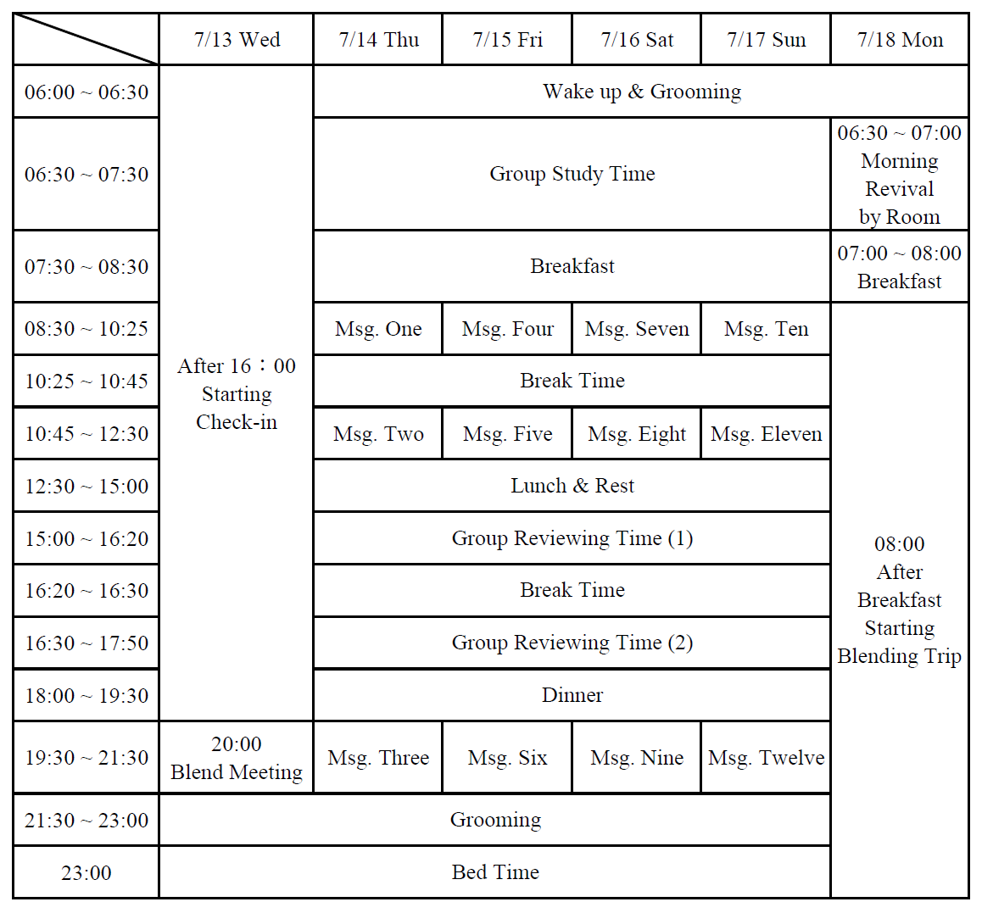

**3) Weather/ Power plug**

The temperature in Taiwan in July can range from 33° Celsius during day time and 24° Celsius at night. The weather is mostly sunny, but could be cloudy with occasional rain. The electrical voltage in Taiwan is 110V. Taiwan uses type A plugs as in the following picture:

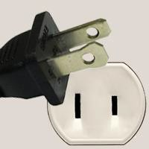

It is advisable to bring an international plug adapter and a transformer for your electrical devices.

**4) Payment**

The 2016 ICTA registration fee is US$250, which covers the expenses from July14th to 20th, without dinner on 13th and 20th. Your registration fee must be wired before June 15th.

**5) CTBC information**

Address 地址: 南投市學藝路 35 號

No.35, Xueyi Rd., Nantou City, Nantou County 540, Taiwan (R.O.C.)

Phone Number 電話: 049-2392552

Hours of operation : 6:00am to 10:30pm.

**6) Medical Service**

A first aid station will be set up at CTBC with common medications for headaches, upset stomachs, cold/ flu, etc. You may contact Brother Wang at +886-921-244241 if you require medical help. For saints on special or long-term medications (for high blood pressure, hypertension, diabetes, etc.), be sure to bring your own medication in sufficient quantity.

**7) Dress Code**

Trainees should be dressed in proper meeting attire during the period of the training from July 14th to 17th. Bring casual clothes for the blending tour.