**CS132: Software Engineering**

**HW1: UML Practice**

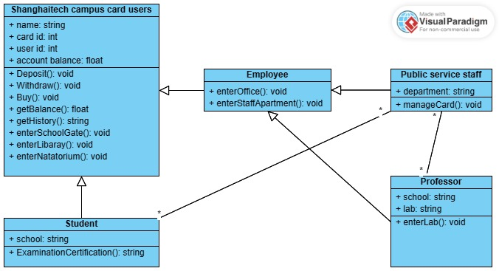**Task1: Class diagram**

**Task2: Use case diagram**

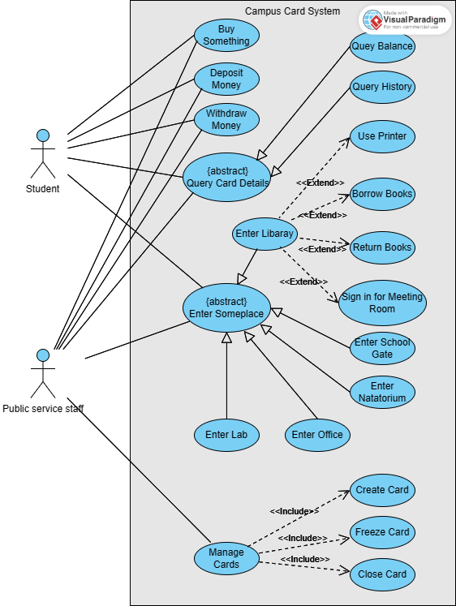

**Task3: Activity diagram**

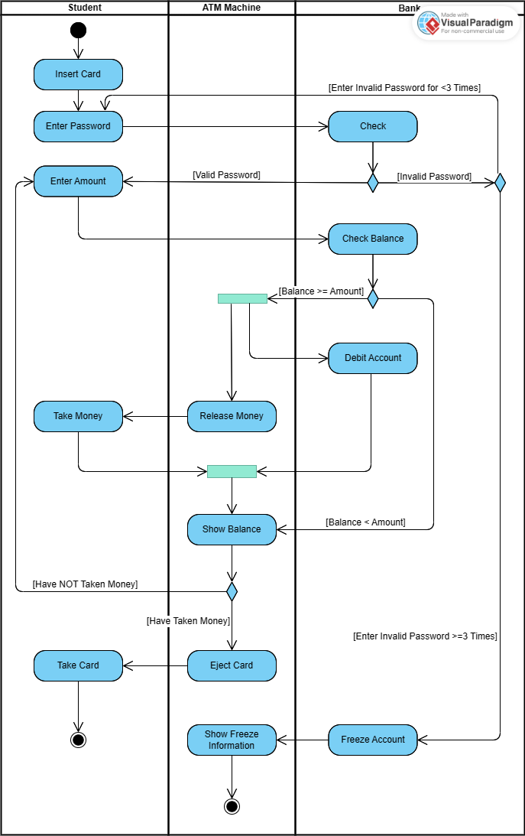

**Task4: Sequence diagram**

