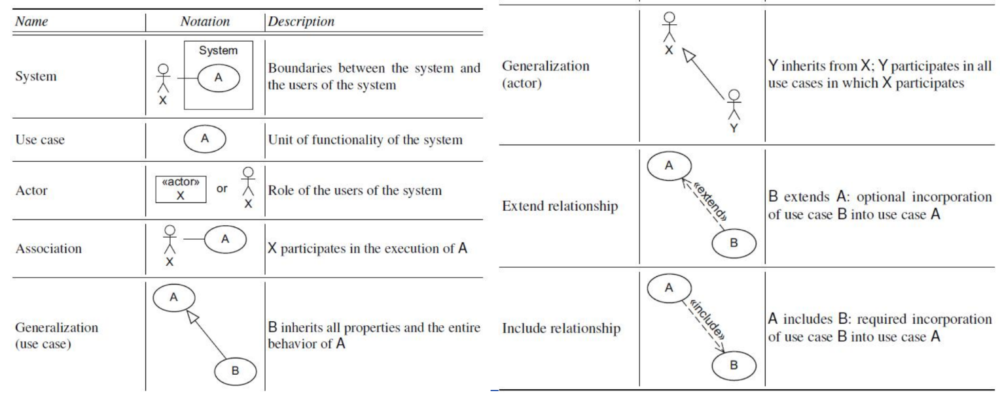**Use Case Diagram** 描述基本功能(核心的、对角色有益的)+角色 Use Cases → The customer’s requirements of the system (**Functional**) **Verb + Noun** Use case needs to benefit the actor. ① **Include**: - The included use case is part of the base use case. – Like a subroutine. – The included use case can be executed individually. ② **Extend**: - Optional. – The extending use case and the base use case both can execute individually. – The extending use case is triggered by a condition at an extension point.

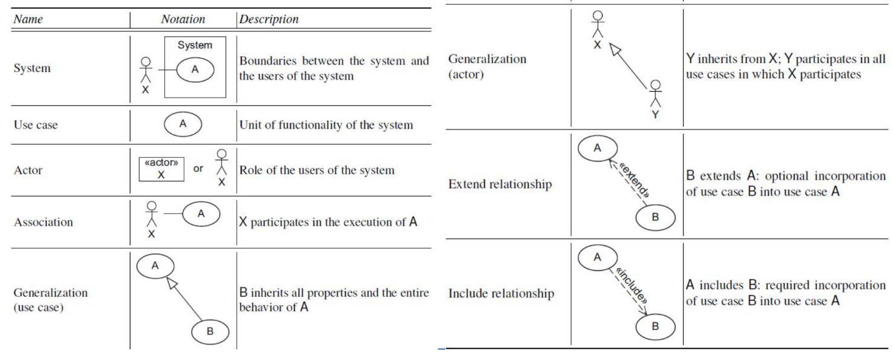**Class Diagram** 描述关系与系统组成 Class: The basic component of object-oriented approaches. Each class has a list of attributes (静态) and operations (动态). Objects are instances of classes.

**+ global**, **- private**, **# protected**

**Sequence Diagram** 描述信息交互的流程 Message among interaction partners.

**Activity Diagram** 是纯流程的

**A[] p** “Always globally p”: For each (all) execution path p holds for all the states of the path.

**A<> p** “Always eventually p”: For each (all) execution path p holds for at least one state of the path.

**E[] p** “Exists globally p” meaning there is an execution path in which p holds for all the states of the path.

**E<> p** “Exists eventually p” meaning there is an execution path in which p eventually (in some state of the path) holds.

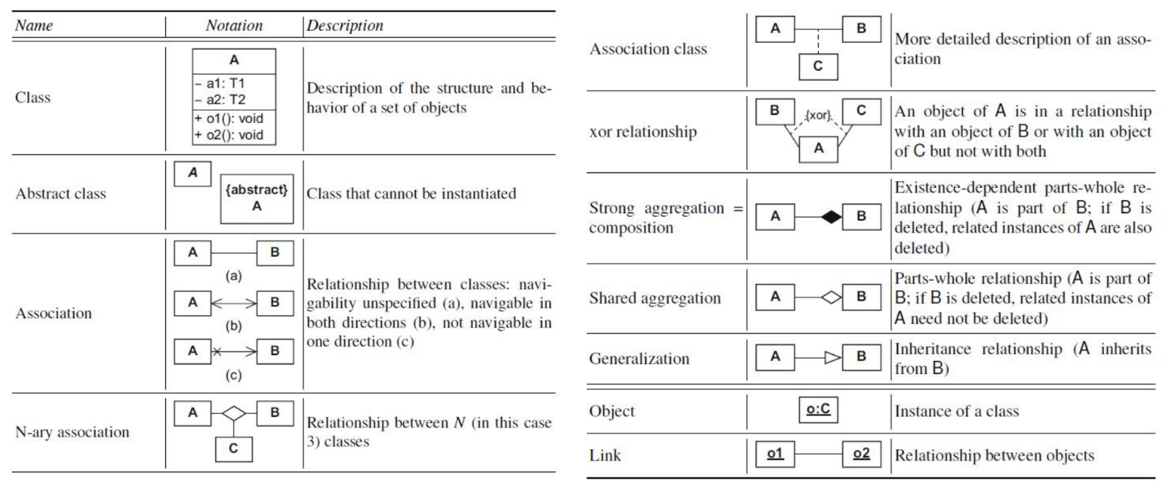**p -->** **p’ (p imply p’)**

**Statement coverage** methodology: Design test cases so that every statement in a program is executed at least once.

**Branch Coverage**: Test cases are designed such that different *branch conditions* given true and false values in turn.

**Condition Coverage**: Test cases are designed such that each component of a composite conditional expression given both true and false values.

Condition testing > Branch testing > Statement testing

