**C Sc 335 Analysis and Design Artifacts for Final Project**

**1. Team Name:**  _____PokemonAsian______________________

**2. Project: ______Pokemon Safari Zone______________________**

**3. Team Members**: _ ___Long Chen________________________ ______Hang Chen_______________

_Thai Pham_________Yang Yang Lu_____________________________

**4. Candidate Objects or Class Hierarchies**

List the most important objects, or an inheritance hierarchy name, and the single responsibility of each.

|  |  |
| --- | --- |
| **Candidate Object** | **Single Responsibility in 1 or 2 sentences** |
| Map View | show the map and the player, pokemons captured by the player. |
| Battle View | show Red and pokemon, Throw a [Safari Ball](http://bulbapedia.bulbagarden.net/wiki/Pok%C3%A9_Ball#Safari_Ball), throw Bait, throw a Rock, and run away. Animation for in and out of battle for pokemon. |
| 2nd Map View | show the map with different config and the player, pokemons captured by the player. |
| Pokémon | an abstract class of pokemon and three diff pokemon implement it(10 for total) |
| Items | 3 diff abstract class of items, Ball, Restore HP, Bait |
| DecisionMaker | This class enforce all the rule in the game. Such as: condition for the game to win,  When the trainer has exhausted their steps, …. |
| SoundCloud | contain all the sound tracks which are needed for the game. Such as: when trainer run: SoundClound.run() will be played, throwing a rock, |
| Trainer | Is the user. Giving action through the GUI such as: catch, throw ball, run away |
| GameController | control all the behavior of the game. It include all the objects(except the GUI) |

**5. Sequence Diagram 1:** Your team UML Sequence Diagram should show the most important scenario you can think of. Your sequence diagram should show most of your objects from above and how they communicate with each other.

*This Sequence Diagram must be created with the sequence diagram editor* [https://www.websequencediagrams.com/#](https://www.websequencediagrams.com/)

*Export and Image and copy and paste it here*

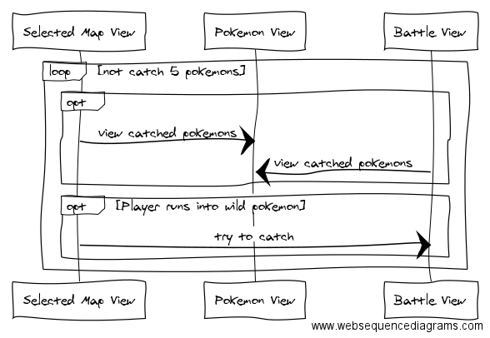

**6. Sequence Diagram 2:** Your team UML Sequence Diagram should show the seconf most important scenario you can think of. Your sequence diagram should show most of your objects from above and how they communicate with each other.

*This Sequence Diagram must be created with the sequence diagram editor* [https://www.websequencediagrams.com/#](https://www.websequencediagrams.com/)

*Export and Image and copy and paste it here*

