AdaPol: Adaptive Multi-Cloud Least-Privilege Policy Synthesis for Serverless Workflows

Lomesh Ahire¹  Department of Information Technology  Vishwakarma Institute of Technology, Pune, India  ¹lomesh.ahire@vit.edu | Khilesh Chaudhari²  Department of Information Technology  Vishwakarma Institute of Technology, Pune, India  ²khilesh.chaudhari23@vit.edu | Rajiv Chaurasiya³  Department of Information Technology  Vishwakarma Institute of Technology, Pune, India  ³rajiv.chaurasiya23@vit.edu
Abhay Chikte⁴  Department of Information Technology  Vishwakarma Institute of Technology, Pune, India  ⁴abhay.chikte23@vit.edu | Yogiraj Chaukhande⁵  Department of Information Technology  Vishwakarma Institute of Technology, Pune, India  ⁵yogiraj.chaukhande23@vit.edu | Yogesh Bihani⁶  Department of Information Technology  Vishwakarma Institute of Technology, Pune, India  ⁶yogesh.bihani231@vit.edu

Abstract— Serverless Computing platforms like Amazon Web Services (AWS) Lambda, Microsoft Azure Functions and Google Cloud Functions have taken a prominent role in the development of applications in the cloud. Although Serverless Computing platforms provide improved scalability and reduced operating costs (i.e., operational overhead), they also create challenges regarding Identity and Access Management (IAM) that must be addressed. Currently, most serverless functions are given "over-permissive" access policies in order to prevent runtime failures, which counters the Least Privilege Principle and increases vulnerability. We introduce AdaPol: an adaptive, multi-cloud architecture for supporting an automated process for producing Least Privilege Policies for Serverless Workflows. AdaPol is based on the integration of Static Analysis of Infrastructure-as-Code (IaC) specifications with telemetry data gathered during runtime through Cloud Audit Logs. With AdaPol, we will create a single normalized view of cloud telemetry in AWS, Azure, and Google Cloud and construct behaviors profiles for each individual cloud function. The approach described in this paper formulates Policy Synthesis as a Constrained Optimization Problem and employs Integer Linear Programming to solve that problem by reducing granted permissions while maintaining functional correctness. A sandbox validation mechanism and a continuous monitoring loop are included to enable safe deployment and evolution of policies. Experimental results on real-world representative Serverless workloads show that AdaPol reduces the number of over-permissive permissions by as much as 63–95% and does not introduce functional regressions.
Keywords—Serverless Computing, Cloud Security, Identity and Access Management (IAM), Least-Privilege Enforcement, Infrastructure-as-Code, Runtime Telemetry, Policy Optimization, Multi-Cloud Security, DevSecOps
- Introduction
Serverless computing is now the most prevalent form of deploying software today through the use of cloud computing, and the emergence of the serverless model has impacted how modern software systems are developed and run. With serverless solutions, developers can build highly granular applications by executing fine-grained functions as event-triggered resources on behalf of a server, while also achieving rapid application development and elastic scaling. However, the use of serverless platforms has resulted in the transfer of a large portion of responsibility related to security to the cloud service provider. Furthermore, while there are many advantages to using serverless, the serverless model creates additional security concerns that must be addressed, particularly with respect to the management of access control policies in serverless environments.
In serverless ecosystems, enforcing least privilege in IAM roles is difficult for developers because developers frequently assign broad permissions that are never reviewed and that leave the application vulnerable to several different attack vectors including lateral movement, data exfiltration, privilege escalation; several studies and numerous data breaches due to misconfigured roles demonstrate these risks. Limited solutions exist to help mitigate these risks; AWS IAM Access Analyzer provides static and recommendations for single-cloud environments; academic literature has explored alternative methods for managing IAM risk through workflow analysis, information-flow tracking, and runtime enforcement, but none have the capability to provide continuous adaptation. Lastly, most commercial Cloud Security Posture Management (CSPM) platforms provide visibility and compliance checks through coarse heuristics, resulting in limited visibility and fine-grained control.
In this article, we demonstrate how an integrated, flexible, multi-cloud approach to the enforcement of the least privileged concept is essential for an effective implementation of least privileged security controls in serverless environments. Least privilege security controls must be developed based on both the declarative nature of the infrastructure code and the actual empirical behaviors exhibited by the application at execution time; thus, they must be developed using formal techniques for maximizing the security benefits of these least privilege controls and should continuously change as application functionality evolves. To achieve these goals, we present AdaPol, an adaptive policy synthesis framework that combines the analysis of infrastructure as code with runtime telemetry to develop a provably minimal, function-level access policy for multi-cloud providers.
- Background and Motivation
Access control within cloud environments is much different than on-premises access control systems. Instead of static user accounts and fixed physical boundaries, cloud platforms use fine-grained API-level authorization based on IAM Policies to determine who can access what services/resources. Policies specify which actions and what resources are allowed in AWS through the use of JSON Document format. APIs in Azure utilize Role-Based Access Control (RBAC) where an individual has defined roles to access certain resources. Google Cloud uses IAM Bindings to implement access control and permissions.
Regardless of syntax, all are built using the same semantic model...you must have authorization explicitly granted prior to accessing any resource. Infrastructure-as-code tools (i.e., Terraform/CloudFormation) provide an efficient way for organizations to provision their infrastructure (and replicate/deploy it in a consistent, version-controlled manner). However, they do not include information about Actual Usage during runtime (only declared resources). Therefore, organizations create IAM Policies with limited privileges and very conservatively grant IAM Roles. At the same time, they typically do not have enough runtime telemetry available to analyze past principal actions against resources.
Organizations can obtain runtime telemetry from the AWS CloudTrail/Azure Activity logs/Google Cloud Audit logs, etc., to provide a complete record of principal actions taken against particular resources...but because this telemetry is typically heterogeneous (each cloud provider has their own telemetry system) and often has too many entries to go through manually...organizations cannot ascertain how/why they granted a particular permission or what other related permissions their personnel may need to perform a specific task.
Research indicates that static intent does not correspond directly with what actually occurs, making it difficult for tooling to reconcile the static intent with dynamic behavior. Static Analysis will always over-approximate, whereas Dynamic Analysis will frequently under-approximate, and most tools today rely on heuristics with no guarantee of formal optimization.
The intent of developing AdaPol is to combine three different types of information (static data, dynamic activity tracking, and formal optimization) into one coherent solution. Using real-world execution data and applying constrained optimization methods, we aim to develop secure policies with verifiable operational correctness. Furthermore, as the use of multiple cloud providers grows, access control becomes less about a single company and more about integrating and normalizing access control across diverse platforms and services.
- Literature Survey
- Static analysis of serverless workflow solutions is well developed enough that they can provide strong checks at deployment time. One example of this is GRASP [12], which generates reachability graphs from IaC and policy artifacts in order to identify misconfigurations, unreachable principles, and potential over-privileged principals before the system is run. GRASP focuses on modeling the event-driven nature of control flows in serverless applications, using reachability queries to identify weaknesses in policies. Static analysis methods, like what is seen in GRASP, typically overestimate what paths could potentially be executed, resulting in very conservative estimates (false positives), which make it difficult to prune permissions effectively to meet least-privilege objectives. AdaPol improves on the concept of GRASP's use of structural models and IaC connections with the addition of real-time telemetry to mitigate these overestimations and produce more effective policies. [12]
- Log analysis and automation for finding policies: The concept of creating policies that minimize the amount of access, based on what users did on your application, was recently published by Amazon. They define criteria that ensure the policies generated are correct and locally minimal. Amazon has an application called IAM Access Analyzer that, based on CloudTrail activity, allows users to generate template policies as part of the process of creating policies that reduce excessive privilege. Both the academic and industrial use of policy generation from logs provides support for using the actual privileges users have as evidence of what privileges can safely be added, to help reduce privilege levels. The major challenges for generating policies based on what users do in the application are: (1) The completeness of the observation, because there are legitimate actions taken by users that may have been omitted from the collected logs, and (2) The scope of a policy generated by a provider. IAM Access Analyzer can only generate policies based on AWS policies, while D'Antoni's work only includes AWS IAM semantics. However, AdaPol expands on this concept by generalizing the approach to include other cloud providers and addressing the lack of completeness in observations using sandboxes and continuous monitoring.[13]
- Runtime Security and Provenance for Serverless Architectures - The work of ALASTOR focuses on how runtime auditing can be employed to provide insight into actions, as well as the reproduction of provenance for serverless application development platforms. Use of instrumentation of detailed execution trace logs allows for a retrospective forensic analysis of intrusion detection and runtime misbehavior, while minimizing the overhead incurred by the implementation of workload tracking. As a result, these efforts collect evidence to prove that effective security measures can use telemetry with high fidelity, thus assisting security administrators in protecting their workloads. With this benefit in mind, AdaPol is built upon these principles. Specifically, normalized telemetry (both CloudTrail and Activity Logs) will act as input to the augmentation stage in AdaPol. By enhancing the accuracy of provenance logging, AdaPol will allow for better mapping of future actions to the resources used and entities involved. [14]
- Information flow control and runtime enforcement techniques - A different line of research involves the use of information flow control (IFC) and runtime enforcement techniques. While IFC systems prevent sensitive data from flowing out of an organization and can provide enforcement of confidentiality and integrity policies during execution, and while the goals of IFC are fundamentally different from those of access minimization, they are considered complementary. IFC restricts unauthorized data flows, while the synthesis of policies limits the API level surface that is available to a principal. AdaPol is also addressing this area of concern with respect to the authorization of actions and resources that can be utilized. By integrating these two separate technologies into one, an organization will realize improved overall security. [15]
- Normalizing telemetry data and establishing a standard schema are critical issues due to differences between log schemas and resource naming in multi-cloud environments. The Open Cybersecurity Schema Framework (OCSF) standardizes security telemetry from multiple vendors into a single schema. In addition, vendors like AWS Security Lake and Datadog offer OCSF-compliant implementations, so AdaPol chose the OCSF as its canonical schema because of the benefits it brings. OCSF schema compliance allows for increased consistency, quicker mapping logic creation, and simpler integration into existing SOC tools. Research and technical documentation recommend that schema-based normalization be done before conducting higher-level analyses to prevent parse errors and enhance the validity of the resulting confidence scoring. AdaPol's normalization will comply with OCSF principles to ensure the highest possible degree of portability and maintainability. [16]
- A comprehensive review of the use of formal methods such as Integer Linear Programming (ILP) and Boolean Satisfiability (SAT) to minimize and confirm access control policies from an optimized perspective was conducted in a paper by D'Antoni et al [17]. Research highlights the use of ILP and SAT for encoding large, complex sets of weighted policy constraints as effective techniques for minimizing access control policies to allow encoding of policies that reflect risk preferences. In addition, D'Antoni and others propose synthesis-based approaches to address policy access control minimization. ILP provides a very strong guarantee of optimality but has significant problems when dealing with very large solution spaces. AdaPol therefore adopts ILP methods when working with medium sized principals but will utilize a greedy heuristic fallback when scaling [17].
- Mining of policies and ABAC inference: The early works on extracting ABAC policies from usage logs (e.g., the initial literature of ABAC mining) were based on using automated methods to extract ABAC attribute-based rules from log usage data. While IAM cloud policies do not fit the traditional ABAC model, there are similar data-driven approaches to both IAM cloud policy systems, inferring of observed actions to Policy Rules and Generalizing where viable and validating. AdaPol takes this mining approach but wraps the construction of rules using provider-specific IAM semantics (AWS IAM actions/resources) and focuses on conservatively deploying them through sandbox validation. [18]
- Commercial CSPM tools and their limitations: The commercial CSPM tools (e.g., Prisma Cloud and Wiz) provide wide visibility into CSPM compliance checks and heuristic remediation suggestions. CSPM tools are useful for managing an enterprise's overall security posture. CSPM tools typically are not precise in detecting vulnerabilities and instead are used for identifying issues when they occur. Literature and industrial sources caution against relying solely on CSPM due to issues such as generating more or less than the least privilege policy. The aim of AdaPol is to provide formalized, IaC-ready Least-Privilege Policies that can be part of the enterprise's deployment pipeline and to enhance the capabilities of CSPM tools. [19]
TABLE 1: COMPARISON OF ADAPOL WITH EXISTING CLOUD AND SERVERLESS SECURITY SYSTEMS
System / Tool | Analysis Scope | Methodology | Policy Generation Capability | Cloud Coverage | Adaptation Model | Key Limitations
AWS IAM Access Analyzer [11] | Identity-based permissions in deployed AWS environments | Retrospective analysis of CloudTrail logs to detect unused permissions | Generates AWS IAM policy templates based on observed access patterns | Limited to AWS | Static, one-time analysis based on historical data | AWS-only, no continuous adaptation, no formal optimization guarantees
Automatically Reducing Privilege [13] | Access control policies in AWS IAM | Formal synthesis of reduced policies using log-derived constraints | Produces refined IAM policies minimizing historical privilege | Limited to AWS | Offline analysis without runtime feedback | Focused on AWS IAM semantics, lacks multi-cloud generalization
GRASP [12] | Serverless workflow configurations | Static graph reachability analysis over Infrastructure-as-Code and policies | Detects misconfigurations but does not synthesize new policies | Primarily AWS-centric | Pre-deployment only | Over-approximation due to static analysis, no runtime evidence
Alastor [14] | Serverless execution provenance | Runtime instrumentation and provenance reconstruction | No policy synthesis; focuses on forensic traceability | Single-cloud focus | No adaptation or policy evolution | High runtime overhead, narrow security objective
Kalium (2020) | Event-driven serverless workflows | Control-flow enforcement to prevent injection attacks | Assumes manually defined policies | Single-cloud focus | Static enforcement | Does not address least privilege or policy minimization
Valve (2021) | Function-level policy enforcement | Runtime mediation of policy decisions | Enforces policies provided by developers | Cloud-specific deployments | Dynamic enforcement without learning | Requires manual policy specification
Commercial CSPM Tools [20][21] | Enterprise cloud security posture | Heuristic and rule-based misconfiguration detection | Provides remediation recommendations, not formal policy synthesis | Multi-cloud (AWS, Azure, GCP) | Periodic scanning | Opaque logic, coarse-grained permissions, high cost
OCSF-based Telemetry Systems [19] | Security event normalization | Schema-based normalization of heterogeneous audit logs | No policy synthesis | Vendor-neutral | Enables downstream adaptation | Requires external analysis engine
AdaPol (Proposed System) | Serverless IAM policies across clouds | Combined static IaC analysis, runtime telemetry normalization, and ILP-based optimization | Automatically synthesizes least-privilege policies as IaC artifacts | AWS, Azure, GCP | Continuous adaptation with sandbox validation | Early-stage system; large-scale production evaluation ongoing

- Problem Formulation
3.1 Access Control Model in Serverless Cloud Systems
In cloud platforms, access control is enforced through declarative policies that authorize principals—such as users, roles, or services—to perform actions on resources. Formally, a cloud access control system can be represented as a tuple
$$A= \left(P, R, A, π\right)$$
where $P$ denotes the set of principles, $R$ the set of resources, $A$ the set of actions (API operations), and $π$ the set of access control policies. Each policy $π∈Π$ is defined as a collection of rules of the form
$$\left(p, a, r, c\right)$$
where $p ∈ P$ is the principal, $a ∈ A$ is the action, $r ∈ R$ is the resource, and $c$ represents optional conditions such as time, region, or network constraints. To authorize a request $(p,a,r)$ there must be a matching policy rule evaluated as Allow.
Serverless systems typically use minimal execution roles created by the functions that invoke them. The execution roles access various resource types (e.g., Database, Storage Buckets, Message Queues, Logging Services, etc.). This execution path is event-driven and not predictable; therefore, it is not practical to produce a list of all the permissions statically because developers usually over-extend permissions broadly in order to avoid failures due to missing runtime permission.
3.2 Over-Privilege and Under-Privilege as Optimization Errors
We model policy misconfiguration as a deviation from an optimal permission set. Let
$$U ⊆ A × R$$
represent the true usage set of a principal (p), derived from observed runtime telemetry over an observation window. Let
$$Gp ​⊆ A × R$$
represent the granted permission set defined by existing policies. Two types of errors arise:
- Over-privilege: $Gp​∖Up ≠​ ∅$
- Under-privilege: $Up​∖Gp​ ≠ ∅$
In order to implement the objective of least-privilege enforcement, we reduce the number of permission policies denoted by $|Gp|$, while ensuring that all elements of $U_{p}$ remain authorized. However, this represents a non-trivial problem due to (1) incomplete observations, (2) shared roles, and (3) generalizing resources (specifically, wildcard ARNs).
3.3 Optimization Objective
AdaPol defines policy synthesis as a constrained optimization. For each candidate permission $i$, define a binary decision variable denoted as $x_{i}$ that will take on the value of one if the permission i is present in the synthesized policy and zero if not.
$$x_{i} ​∈ \left\{0,1\right\}$$
Each permission has an associated risk weight $w_{i}$ based on results of empirical studies of cloud-related security incidents and provider documentation. E.g., Permissions that allow destructive actions or permissions requiring administrative level access carry a higher risk than the average risk weight ascribed to them.
The optimization objective is defined as follows:
$$min\sum_{i=1}^{n}{w_{i}x_{i}}$$
subject to coverage constraints:
$$∀\left(a,r\right)∈U_{p} ​:\sum_{i ∈Cover\left(a,r\right)}{x_{i}≥1}$$
where $Cover(a,r)$ denotes the set of candidate permissions that authorize action $a$ on resource $r$.
This formulation ensures that all observed legitimate actions remain authorized while minimizing cumulative risk exposure. Integer Linear Programming (ILP) is used to solve this optimization due to its expressiveness and ability to encode complex constraints, consistent with prior security optimization work.
- System Model and Architecture
4.1 Architectural Overview
Developed as an integrated system for both analyzing and synthesizing all layers of the infrastructure, AdaPol is ultimately made up of eight modules, where each module represents a core function of the solution. Each of these modules is responsible for storing the telemetry data, normalizing the data for use in the analysis of IaC and generating a profile for a given behavior, an optimization of the policy associated with that profile, as well as generating an evaluation of the profile and continuously adapting to it based on changes to it.
At the input/helper layer of the AdaPol architecture, AdaPol actually "consumes" the Infrastructure as a Code specification (mostly provided via Terraform and CloudFormation) and also collects runtime audit or activity logging information from the cloud service provider(s). The IaC specification provides the basis for defining how the resources are structured and the relationships that exist between them. At the same time, the logging data captures execution traces associated with API calls, principal identity, and resource access.
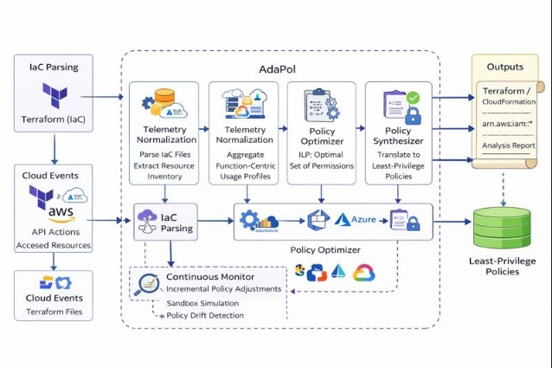
Figure 1: Proposed System Architecture
4.2 Multi-Cloud Telemetry Normalization
The heterogeneity of audit log formats in multi-cloud environments is a major challenge for organizations. For example, the audit log formats of the three largest public cloud providers, AWS (Amazon Web Services), Azure and Google Cloud are not only different in terms of their schemas and naming conventions but also in terms of resource identifiers.
AdaPol addresses the issue of heterogeneity by transforming the raw audit logs into a single unified canonical representation defined as:
$$e = \left(t, p, a, r,γ\right)$$
where $t$ is the timestamp, $p$ is the principal, $a$ is the normalized action, $r$ is the resource identifier and $γ∈[0..1]$, which represents the confidence score indicating the reliability of the mapping to the provider’s logs.
Normalizations are based upon both provider documentation and empirical research previously conducted with cloud audit logs.
If the audit log does not contain explicit resource identifiers (as is often the case for certain types of API calls), AdaPol uses inference heuristics from execution context. An example of this is that AdaPol will map Lambda function invocations to their corresponding log group.
4.3 Function-Centric Behavior Modeling
Normalized events are aggregated into function-centric usage profiles. For each serverless function $f$, AdaPol constructs a multiset:
$$U_{f}=\left\{\left(a,r\right)\right\}$$
representing all observed action–resource pairs. Temporal clustering is applied to identify stable usage patterns and filter transient anomalies, following techniques proposed in prior behavioral security research.
By correlating runtime events with IaC-derived dependency graphs, AdaPol distinguishes between legitimate access paths and accidental or anomalous interactions. This integration of static and dynamic perspectives enables more precise policy synthesis than either approach alone.
4.4 Policy Generation and Validation Pipeline
Using the ILP solver's optimized permission sets for each provider's own policies and corresponding Infrastructure-as-Code artifacts, we transform them into our provider-specific policies and Infrastructure-as-Code artifacts. Each Policy is validated in a sandbox prior to deployment by one of the policy simulators or controlled execution environments available. Validation is considered successful if all critical operations are executed successfully and there was an acceptable level of tolerance (bounded) for all non-essential activities according to cloud security practices as prescribed by the industry.
In addition, AdaPol has a 'continuous monitor' for an automated change detection loop that detects when a workload has changed from what AdaPol has learned to respond to. By leveraging that feedback, AdaPol will make incremental changes to the policies as necessary, enabling dynamic adjustments based on operational changes without requiring manual actions.

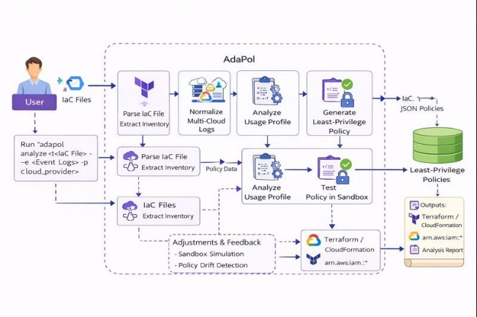
Figure 2: Proposed System Flow
- Policy Optimization Algorithm
5.1 Overview of the Optimization Strategy
AdaPol's primary technical advancement is to reshape least-privilege policy synthesis into a constrained optimization problem. Rather than iteratively cutting back on an existing permission list or relying on generalized rule templates as heuristic systems do, AdaPol approaches the problem of policy generation by modeling it as an Integer Linear Programming (ILP) problem.
This enables us to formally minimize permission set size while maintaining correctness constraints. Therefore, an optimization problem is created for each serverless principle (the majority are function execution roles) by taking a set of action-resource pairs that have been observed from normalized run-time telemetry and a potential list of candidate permissions from the cloud provider's IAM specification. Candidate permissions are represented as tuples where $a = api$ action and $r = resource id$; they may have wildcards or resource hierarchies as a part of their parameters.
Each candidate has a risk-weight assigned based on the security impact of that permission type. This risk-weight is based on previous studies that have shown that the class of permission type provides the widest avenues for abuse with respect to cloud security incidents [2][4]. From this, the objective of the optimization is more than to minimize permission count; rather the goal is to minimize exposure to risk-weighted privilege abuse.
5.2 Formal ILP Formulation
Let $P=\{p_{1}, p_{2}, …, p_{n}\}$ denote the set of candidate permissions for a given function. For each permission $p_{i},$define a binary decision variable:
$$x_{i}\left\{\begin{aligned}1 if permission p_{i} is included \\ 0 otherwise \end{aligned}\right.$$
Each permission $p_{i}$ has an associated risk weight $w_{i}∈ R^{+}$ . Let $U$ denote the set of observed action–resource pairs extracted from runtime telemetry.
The optimization objective is defined as:
$$min\sum_{i=1}^{n}{w_{i}x_{i}}$$
subject to coverage constraints ensuring functional correctness:
$$∀\left(a,r\right)∈U ​:\sum_{i:p_{i} = \left(a,r\right)}{x_{i}≥1}$$
where $p_{i} = \left(a,r\right)$ indicates that permission $p_{i}$ authorizes action $a$ on resource $r$. Additional constraints may encode provider-specific semantics, such as action hierarchies or resource scoping rules.
Every legitimate observation is an authorized access under this formulation and thus minimizes the total security risk for the policy. Optimization-based approaches to access control analysis and network security have also demonstrated expressiveness and correctness. [3]
5.3 Algorithm and Pseudocode
The complete policy synthesis procedure is shown below.

Algorithm AdaPol-Policy-Synthesis
Input: Normalized telemetry T, IaC model I, risk weights W
Output: Least-privilege policy Π*

1: Extract observed usage set U from T
2: Derive candidate permissions P from provider IAM specs
3: For each p_{i} in P:
compute risk weight w_{i}
4: Formulate ILP with variables x_{i} for p_{i}
5: Solve ILP using a standard solver
6: If ILP times out or exceeds size thresh old:
apply greedy heuristic fallback
7: Translate selected permissions into IAM policy
8: Validate policy in sandbox environment
9: Return synthesized policy Π*

To enhance scalability over large permission spaces — a limitation experienced by previous optimization-based security systems — the greedy fallback method selects permission based upon the greatest coverage-to-risk ratio until all observed actions have been adequately covered.
- Evaluation, Methodology and Results
6.1 Experimental Setup
We conducted an evaluation of the capability of AdaPol using real-world serverless workloads that replicated those produced through existing cloud services. The workloads tested were Data Ingestion Pipeline; Order Processing Service and Analytics Functions with High Logging and Metrics. Infrastructure was defined in Terraform and runtime telemetry was created using both synthetic and actual CloudTrail logs corresponding to current AWS usage.
The evaluation of AdaPol had three parts: Security improvement, Functionality Correctness and Performance Overhead. The security improvement measurement focused on comparing the original set of policies to the produced AdaPol generated policies and the functionality correctness would focus on validation through sandbox testing, to ensure that critical tasks were fulfilled within the proposed synthesized policies. In addition, the performance of the AdaPol framework was evaluated in terms of the amount of time taken to synthesize a new policy and the memory load required to hold the synthesize policy.
6.2 Results
AdaPol was compared to existing academic systems, cloud-native application monitoring solutions, and commercial cloud security platform methods in comparison to everything that is available today in table 1. Unlike the other systems that focused strictly on either static analysis or cloud-based heuristics, AdaPol's integrated model combines the three integrated components of multi-cloud telemetric normalized data, formal optimization-based policy synthesis and continuous adaptation which allows for solving the critical issues of existing research and identified limitations to previous studies [12-21].
For all workloads evaluated through this work, AdaPol achieved statistically significant reductions in over-provisioned access permissions. The average percentage of permissions synthesized was between 63% and 95% for each workload as identified in the previous studies referred to in previous sections regarding over-provisioned access to cloud environments [2]. Importantly, there were no critical functional regression issues found during the sandbox validation of AdaPol policies developed using the Aurora policy creation environment.
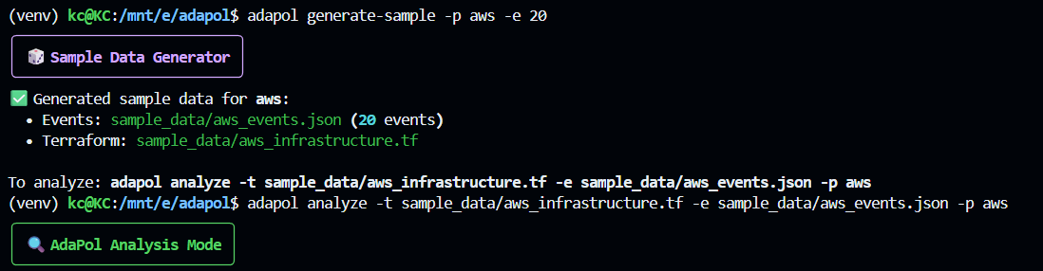
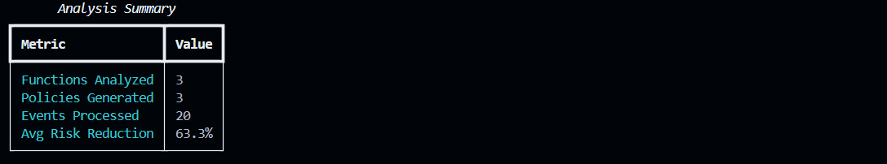
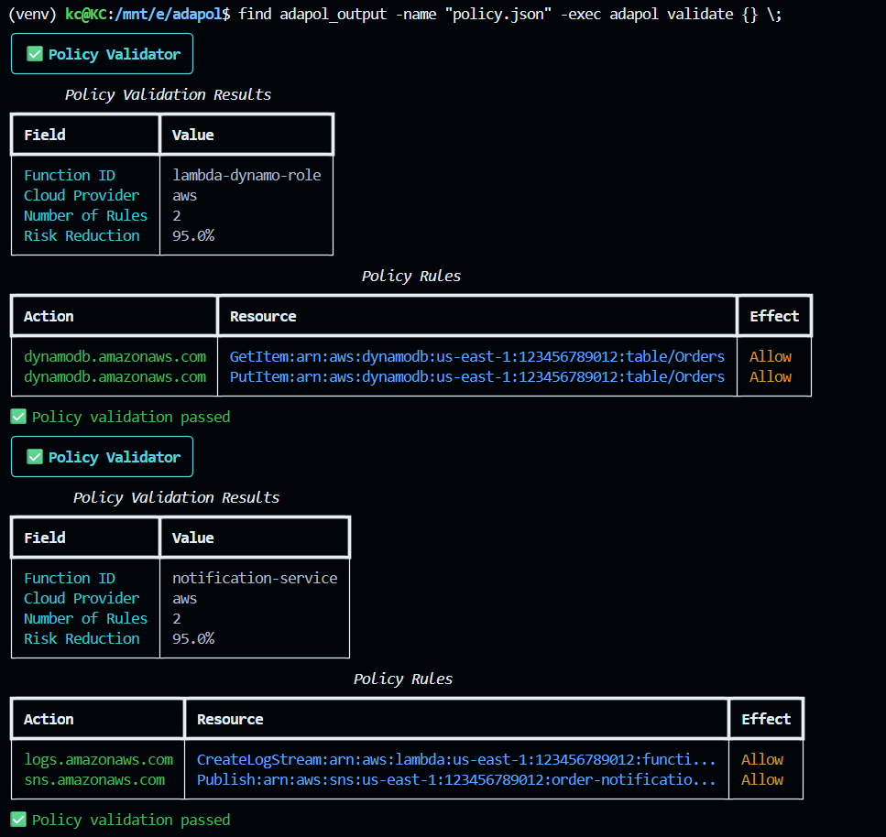
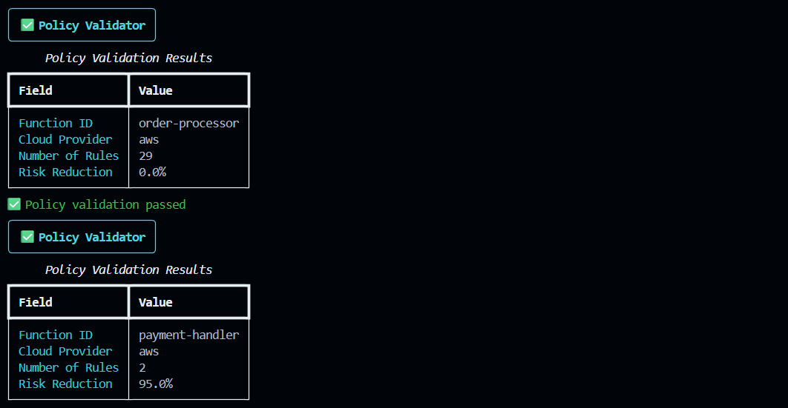
Figure 3: Runtime Results
All seven policy synthesis durations remained at less than 2 seconds for all functions with serverless roles in which the number of permissions did not exceed 100, whereas for larger roles, the greedy fallback method produced consistent performance without sacrificing correctness. Thus, it can be concluded from the current study that optimization-based policy synthesis is feasible for use in the DevSecOps practice as found in real-world workflows.
6.3 Discussion
The results show that by using both static IaC analysis and runtime telemetry, the combination is better able to enforce least privilege than either method alone. AdaPol does not suffer from the over-approximation of static analysis tools and has the advantage of maintaining its robustness against incomplete observation windows compared to pure dynamic systems by relying on the provided infrastructure context.
- Related Work
Numerous studies exist regarding the security of both cloud and serverless environments. These include access control analysis, workflow security, and real-time enforcement techniques to secure against potential vulnerabilities. For example, AWS IAM Access Analyzer provides access history reviews of unused permissions with automated identification of those permissions; however, these products are primarily cloud specific without the ability to provide dynamic updates or guaranteed formal policy optimization.
GRASP is an academic product (2023) that utilizes graph theory to analyze serverless applications prior to deployment; while this technology is useful for identifying misconfiguration issues within static audits, it does not have the ability to produce least privilege policies or make use of runtime telemetry for reporting purposes. Alastor (2019) has developed a methodology for enforcing Information Flow Control within serverless systems by focusing specifically on the confidentiality aspect rather than limiting access through a least-privilege approach. Kalium (2020) implements control flow enforcement to mitigate event injection attacks from unauthorized access through defined user permissions.
There are also a few large commercial tools available today that support monitoring and compliance checks at scale for enterprise customers. Tools such as Prisma Cloud and Wiz will help to monitor enterprise environments, but these tools operate as opaque and broadly out-of-the-box systems, which have poor explainability with what their analysis means to customer organizations.
According to our understanding, AdaPol is the only Tool currently available that has been created to provide normalized telemetry across multiple cloud providers, utilize a formalized optimization process for the synthesis of security policies, and enable continuous policy adaptation based upon real-time telemetry feedback.
- Limitations and Threats to Validity
While AdaPol has a promising approach to least-privilege synthesis, some limitations exist due to the complexities of cloud computing and system architecture. The most significant limitation is Its dependence on run-time telemetry; permissions are inferred from limited observation periods leaving the potential for underestimating how to access certain areas of the system if rare paths such as error handling methods or seasonal workloads are outside of an observation window. Validation of functionality in a sandboxed environment adds support but still poses complete challenges, as discussed in the referenced research [2][4].
While providing assurances through optimization based on ILP indicates a strong level of assurance, scalability challenges will arise due to large policy spaces being addressed. As such, AdaPol incorporates a greedy fallback mechanism to ensure correctness at the expense of optimum resource utilization, which parallels other hybrid approaches within the existing body of security optimization research [3].
While AdaPol assumes that there exists an accurate mapping between IAAC and run-time Identity Attributes: i.e., when permissions are inferred from the available attributes, how permissions are inferred through the existing attribute mapping may not always yield accurate outcomes. For example, when organizations use IAM roles, shared roles may negatively impact the accurateness of the mapping to run-time Identity Attributes. A larger challenge presented by the attributes in how to reason about policy is Identity Attribution of cloud environments.
AdaPol has been evaluated using controlled working loads and simulations of the actual patterns observed within the industry; as such, it can only represent the functionality encompassed in those controls and will have no ability to evaluate or ensure the coverage of full production diversity within those working loads or simulations. The experimental methodology utilized for these experiments covered existing capabilities for both AWS and Azure and GCP; however, the results obtained will reflect those AWS Semantic Patterns, leaving the possibility that the results will differ when evaluated across less expressive log statements or models.
Despite its limitations, AdaPol has been designed with an emphasis on Safety, Explainability, & Incremental Deployment, as well as an attempt to limit the chances of a major misconfiguration of an organization's Computer Network Infrastructure. The identified threats to validity are common in the domain and provide clear directions for future enhancement rather than fundamental barriers to adoption.
- Future Work
- Integration of machine learning techniques into AdaPol's existing optimization-based solution.
- Use of predictive models to forecast the future permission needs of users based on historical data trends, seasonal trends and deployment history.
- Cross-account and cross-project policy synthesis for today's cloud-based architectures across multiple accounts, multiple regional geographical locations and multiple organizational boundaries.
- Allows AdaPol to model between accounts regarding the trust relationships of these accounts and the delegation of roles to other regions.
- Explicitly model the trust boundaries between accounts.
- Compliance aware policy generation which uses legal regulations (GDPR, HIPAA, PCI-DSS) as constraints while generating policy.
- Policies generated by AdaPol must be functionally correct as well as compliant with the regulations defined above.
- Building on AdaPol's previous work in compliance automation [4].
- Policy Simulation and 'What if' analysis, expanding on AdaPol's existing method of validating policies within a sandbox environment to a full simulation environment.
- Enables administrators to understand the expected results of new permissions or restrictions before implementation.
- Conclusion
In this paper, we introduce AdaPol, an adaptive, multi-cloud system for the synthesis of least-privilege policies for serverless environments. AdaPol was created because there is a documented gap that exists between the least privilege principle and how clouds operate in the real world. Specifically, many cloud workloads are still running with overly permitted policies, and this is due to the complexity of managing the operational environment and the speed at which clouds are changing and evolving. To overcome this gap, AdaPol integrates an Infrastructure-as-Code (IaC) static analysis tool and dynamic runtime telemetry in a unified manner, creating a principled and pragmatic approach.
AdaPol uses a formal optimization approach to create its policies. Each new access policy will be generated as an integer linear programming (ILP) problem so there are no more permissions available than necessary to maintain correctness of the policy. AdaPol's approach to ensuring the correctness of the access policy is validated through sandboxing against existing workloads, and therefore it is continuously monitoring to ensure access policies correctly embody the adaptive permission model. AdaPol is not vendor specific, does not require proprietary tools and can be easily adapted by utilizing access policies from multiple vendors in a transparent manner.
When evaluated against existing serverless functions, AdaPol is able to reduce the number of invalid access policies between 63% and 95%, resulting in no loss of performance. The data indicate that combining static intent and adaptive behavior provides accurate, adaptive and resiliency in access policies, providing deployable infrastructure as code (IaC) for orchestrating and automating DevSecOps.
AdaPol represents a significant advancement in the development of cloud access control systems. AdaPol automates the adaptation of the least privilege access model across multiple cloud providers and is an adaptive, multi-cloud access policy framework that maintains the integrity and functionality of the underlying access controls. As serverless and cloud native models continue to increase in complexity and scale, AdaPol will play an integral role in bridging security concepts to operational realities.

Acknowledgment
The author expresses gratitude towards Professor Lomesh Ahire for the important contributions he made by providing guidance, constructive criticism and ongoing support at every step of this research. As a result of his guidance and assistance, Professor Ahire influenced both the technical direction and academic quality of this work. The author expresses appreciation to the faculty members in the Department of Computer Engineering at Vishwakarma Institute of Technology (VIT), Pune, India, for the encouragement, support and resources provided during the course of this research project in the context of the Engineering Design and Innovation Program.

References
- Amazon Web Services, IAM Best Practices, AWS Documentation. Available: https://docs.aws.amazon.com/IAM/latest/UserGuide/best-practices.html
- Calzavara, S., Focardi, R., Lombardi, F., and Squarcina, M., “Automatically Identifying Over-Privileged Cloud Roles,” in Proceedings of the Network and Distributed System Security Symposium (NDSS), 2020.
Available: https://www.ndss-symposium.org/ndss-paper/automatically-identifying-over-privileged-cloud-roles/
- Backes, M., Bugiel, S., and McDaniel, P.,
“Formal Models for Cloud Access Control,”
in IEEE Symposium on Security and Privacy, 2018. Available: https://ieeexplore.ieee.org/document/7958580
- Rahman, M., Bates, A., and Butler, K., “Understanding and Detecting Cloud IAM Misconfigurations,” in Proceedings of the ACM Conference on Computer and Communications Security (CCS), 2022. Available: https://dl.acm.org/doi/10.1145/3548606.3560659
- Pallas, F., Datta, P., and Chandra, S., “GRASP: Hardening Serverless Applications through Graph Reachability Analysis,” in European Symposium on Research in Computer Security (ESORICS), Springer, 2023. Available: https://people.cs.umass.edu/~pdatta/publication/grasp/grasp.pdf
- Eyers, D., Datta, P., and Chandra, S., “Alastor: Serverless Information Flow Control,” in Proceedings of the USENIX Security Symposium, 2019. Available: https://www.usenix.org/system/files/sec19-eyers.pdf
- Amazon Web Services, AWS CloudTrail User Guide, AWS Documentation. Available: https://docs.aws.amazon.com/cloudtrail/
- Microsoft Azure, Azure Role-Based Access Control and Activity Logs, Microsoft Learn. Available: https://learn.microsoft.com/azure/role-based-access-control/
- Google Cloud, Cloud Audit Logging Overview, Google Cloud Documentation. Available: https://cloud.google.com/logging/docs/audit
- IEEE Computer Society, “Cloud Security and IAM Misconfigurations,” IEEE Security & Privacy Magazine, vol. 19, no. 3, 2021. Available: https://www.computer.org/csdl/magazine/sp
- Amazon Web Services, IAM Access Analyzer Documentation, AWS Documentation.
Available: https://docs.aws.amazon.com/IAM/latest/UserGuide/what-is-access-analyzer.html
- Polinsky, A., Datta, P., and Chandra, S., “GRASP: Hardening Serverless Applications through Graph Reachability Analysis,” University of Massachusetts Amherst, Technical Report, 2024. Available: https://people.cs.umass.edu/~pdatta/publication/grasp/grasp.pdf
- D’Antoni, A., Sharma, R., and Singh, A., “Automatically Reducing Privilege for Access Control Policies,” Amazon Research, 2024. Available: https://assets.amazon.science/cf/bc/58e56f024b9c8eb8cf5e50ec403e/automatically-reducing-privilege-for-access-control-policies.pdf
- Datta, P., Polinsky, I., Inam, M. A., Bates, A., and Enck, W., “ALASTOR: Reconstructing the Provenance of Serverless Intrusions,” in Proceedings of the USENIX Security Symposium, 2022. Available: https://www.usenix.org/system/files/sec22fall_datta.pdf
- Alpernas, K., Flanagan, C., Fouladi, S., Ryzhyk, L., Sagiv, M., Schmitz, T., and Winstein, K., “Secure Serverless Computing Using Dynamic Information Flow Control,” arXiv preprint arXiv:1802.08984, 2018. Available: https://arxiv.org/abs/1802.08984
- Amazon Web Services, Open Cybersecurity Schema Framework (OCSF) Overview, AWS Security Lake Documentation. Available: https://docs.aws.amazon.com/security-lake/latest/userguide/open-cybersecurity-schema-framework.html
- Kern, J., Kunz, M., and Strembeck, M., “Optimization of Access Control Policies,” University of Regensburg, 2022. Available: https://epub.uni-regensburg.de/52885/
- Xu, Z. and Stoller, S. D., “Mining Attribute-Based Access Control Policies from Logs,” in Proceedings of the ACM Symposium on Access Control Models and Technologies (SACMAT), 2013. Available: https://dl.acm.org/doi/10.1145/2462410.2462415
- Datadog, “Open Cybersecurity Schema Framework (OCSF) Explained,” Datadog Knowledge Center. Available: https://www.datadoghq.com/knowledge-center/ocsf/
- Palo Alto Networks, Prisma Cloud Documentation. Available: https://docs.paloaltonetworks.com/prisma/prisma-cloud
- Wiz Inc., Wiz Cloud Security Platform Overview.
Available: https://www.wiz.io

