MaterializeCSS

<https://materializecss.com/grid.html>

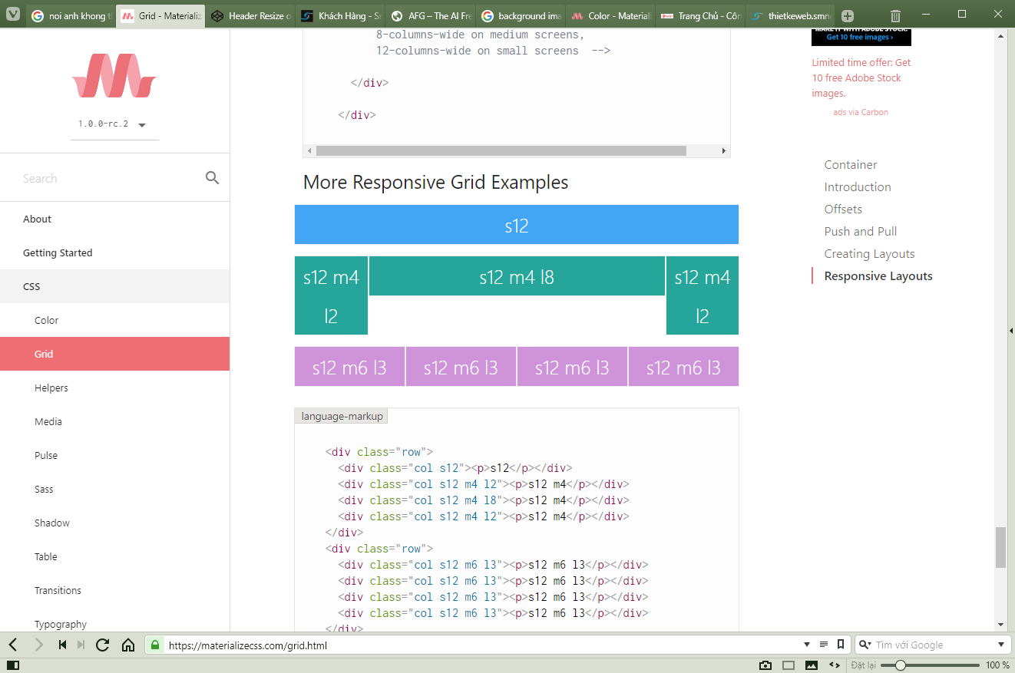

s12 : Full màn hình nếu mở web trên mobile

m6: sẽ xảy ra nếu trên màn hình nhỏ

l3: kích cỡ hiện tại

---------------------------------------------------------------------------------------------------------

Skeleton

<http://atmarkcafe.org/tieng-viet-viet-responsive-web-voi-skeleton/?lang=vi>

<https://webdesign.tutsplus.com/tutorials/building-html-page-structure-with-skeleton--cms-23253>

--------------------------

CSS:

<https://www.cssmatic.com/box-shadow>

Multilevel menu:

<http://seorave.com/style-wordpress-menus-dropdowns/> (good)

<http://w3bits.com/css-responsive-nav-menu/> (good)

<https://codepen.io/markhillard/pen/Deqio>

--------------------------------------------  
Menu example responsive:

<https://medium.com/level-up-web/20-responsive-navigation-solutions-examples-codes-21644390afeb>

--------------------

CSS learning:

<https://medium.com/level-up-web/the-ultimate-guide-to-css-103b0f883de3>

-------------------------------

# [Zoom on image inside div without div moving](https://stackoverflow.com/questions/40319228/zoom-on-image-inside-div-without-div-moving):

<https://stackoverflow.com/questions/40319228/zoom-on-image-inside-div-without-div-moving>