ASSIGNMENT-1

OUTPUT:
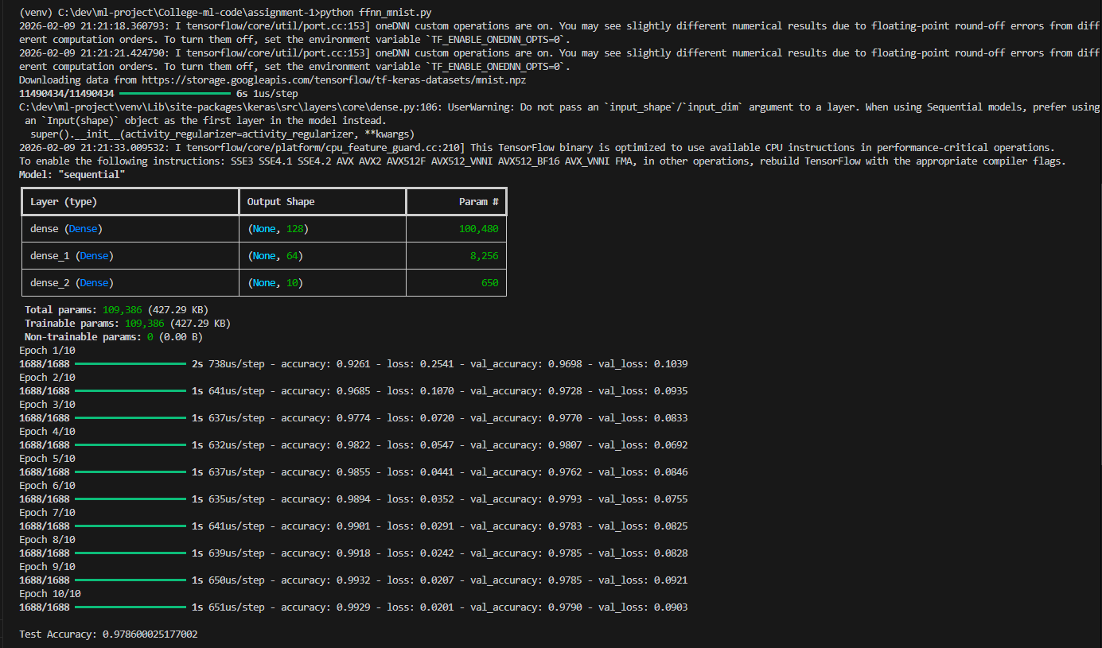
CONCLUSION: This experiment compared Batch Gradient Descent, Stochastic Gradient Descent, and Mini Batch Gradient Descent on the same neural network model. The difference in training behavior was clear. Batch GD was stable but slow, SGD was noisy but faster, and Mini Batch gave the best balance between speed and convergence. From this, Mini Batch Gradient Descent proved to be the most practical method for real world training.

ASSIGNMENT-2
OUTPUT:
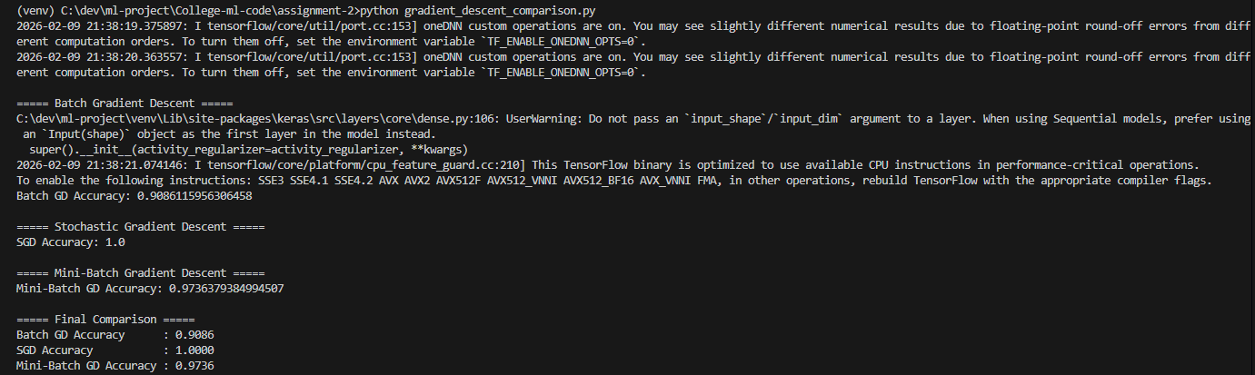

CONCLUSION: In this assignment a feed forward neural network was implemented and trained on the MNIST handwritten digit dataset. The model was able to learn digit patterns effectively and achieved high classification accuracy. This demonstrated how multilayer perceptrons can solve image classification problems when proper preprocessing and architecture design are applied.

ASSIGNMENT-3
OUTPUT:
alexnet
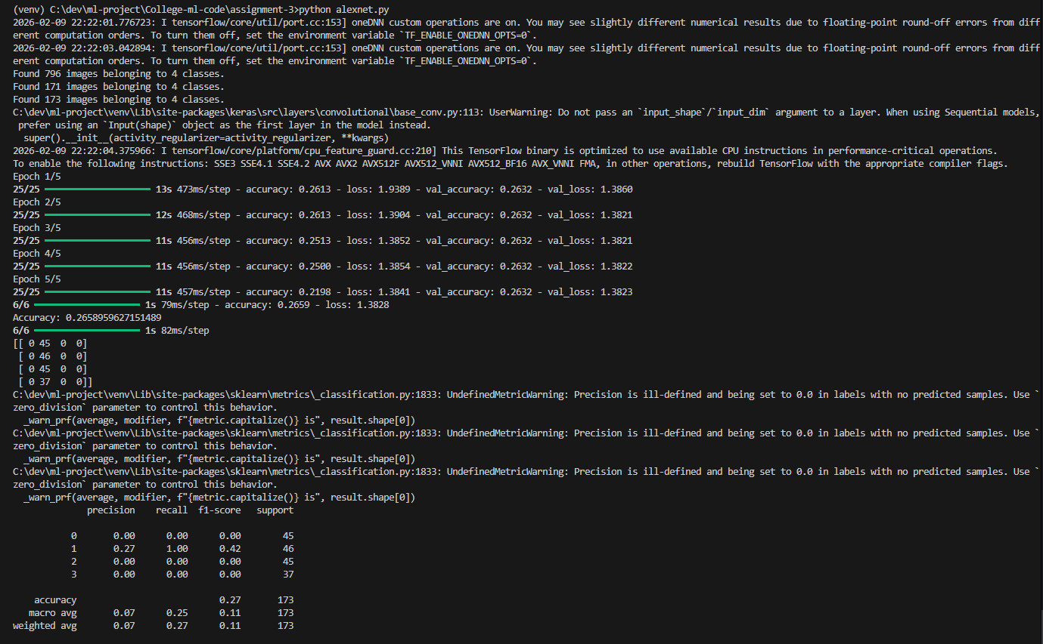
mobilenet
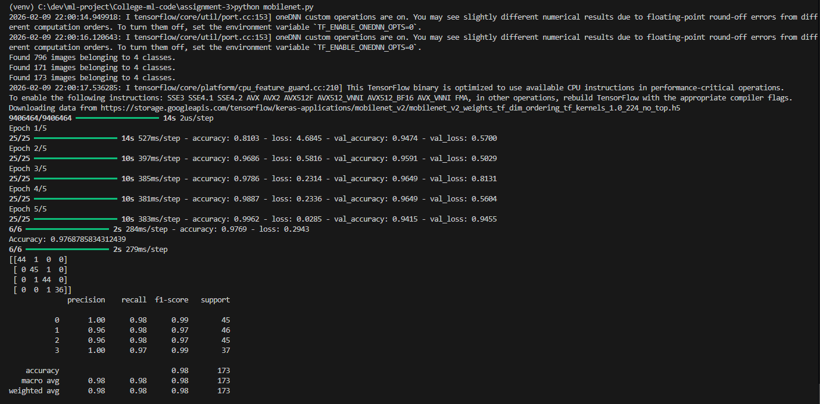

resnet152
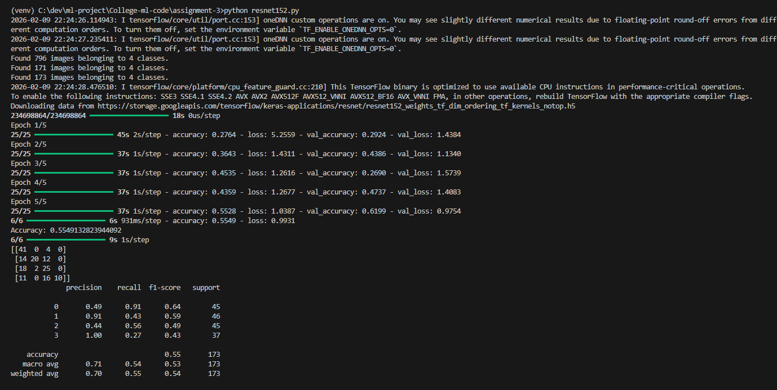

Vgg16
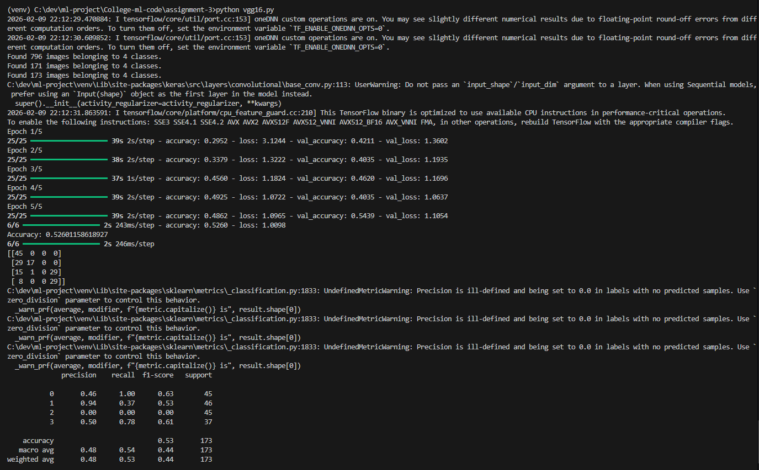

CONCLUSION: This work focused on classifying microplastic images using multiple deep learning architectures. The dataset was preprocessed and split into training, validation, and testing sets before model training. Different architectures showed variation in accuracy and performance metrics, highlighting the impact of model depth and transfer learning. The evaluation using confusion matrix, precision, recall, and F1 score provided a complete view of model effectiveness.

