

Foundations of Programming

Assignment No.: 17
PROBLEM STATEMENT: To accept the number of terms and find the sum of the sine series.

OBJECTIVE:

- To understand the concept of mathematical series in programming.
- To implement sine series using C programming.
- To practice loops and arithmetic operations.
- To learn the use of factorial and power calculations in C.

THEORY:
In mathematics, the sine function can be expressed as an infinite series called the Taylor series expansion. The sine series is represented as:
sin(x) = x − x^3/3! + x^5/5! − x^7/7! + ...

In this program, the user enters the value of x and the number of terms. The program calculates the sum of the sine series up to the specified number of terms using loops. Factorial and power operations are used to compute each term of the series.
PLATFORM: Linux
ALGORITHM:
Step 1: Start
Step 2: Input value of x (in radians) and number of terms n
Step 3: Initialize sum = 0
Step 4: For i from 0 to n-1:
a. Compute power = x^(2i+1)
b. Compute factorial = (2i+1)!
c. Compute term = power / factorial
d. If i is even: sum = sum + term
e. Else: sum = sum - term
Step 5: Display sum
Step 6: Stop

FLOWCHART:
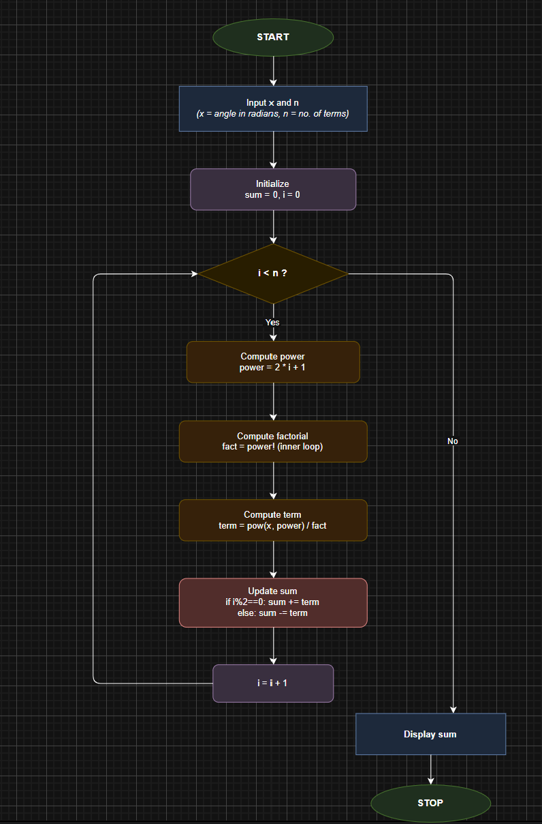

CODE:
#include <stdio.h>
#include <math.h>

double factorial(int n) {
double fact = 1;
for (int i = 1; i <= n; i++)
fact *= i;
return fact;
}

double power(double x, int n) {
double result = 1;
for (int i = 0; i < n; i++)
result *= x;
return result;
}

int main() {
double x, sum = 0;
int n;
printf("Enter value of x (in radians): ");
scanf("%lf", &x);
printf("Enter number of terms: ");
scanf("%d", &n);
for (int i = 0; i < n; i++) {
double term = power(x, 2*i+1) / factorial(2*i+1);
if (i % 2 == 0)
sum += term;
else
sum -= term;
}
printf("Sum of sine series = %lf\n", sum);
return 0;
}

INPUT: Value of x and number of terms.

OUTPUT: Displays the sum of the sine series.
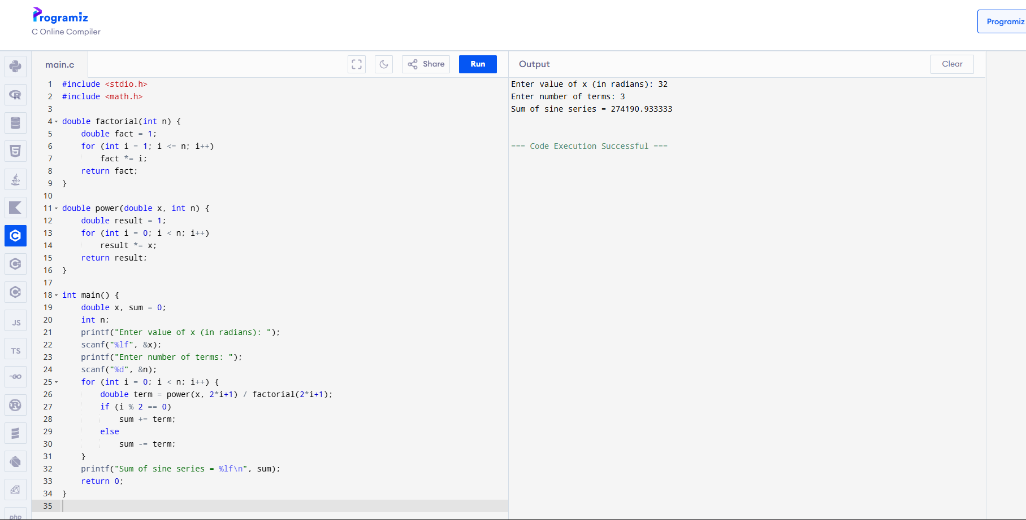

CONCLUSION: Thus, the C program successfully calculates the sum of the sine series for the given number of terms.

