|  |
| --- |
| Software design |

|  |
| --- |
| Shop System |

|  |
| --- |
| SE1617-Group 4  Lê Đức Hiếu - HE150703 - Leader  Phí Minh Tiến - HE151480  Nguyễn Khải Hoàn - HE150635  Hoàng Đông Quang - HE151457 |

# **Document description**

This document describes for Shop system. It is divided into the following sections:

* In section 2 an overview of the Shopsystem’s requirements will be provided, including a list of system users, use cases, use case diagrams, and activity diagrams that describe the most important use case scenarios.
* In section 3 an E-R diagram and all tables of the Library system in detail will be presented.
* In section 4 all classes organized in the layers and their behaviors (sequence diagrams) for the most important use cases will be presented.

# **SRS overview**

## **2.1. List of system users**

1. Manager: The person is manage in Shop System

2. Staff: The person uses services of the Shop system

## **2.2. Use case diagram**

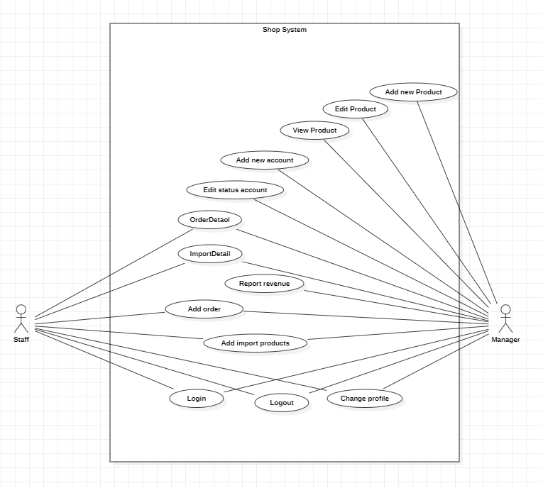

## **2.3. Activity diagram**

* Add orders

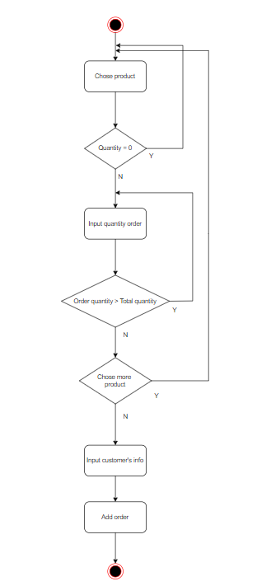

# **Data model**

## **3.1. Entity Relationship Diagram**

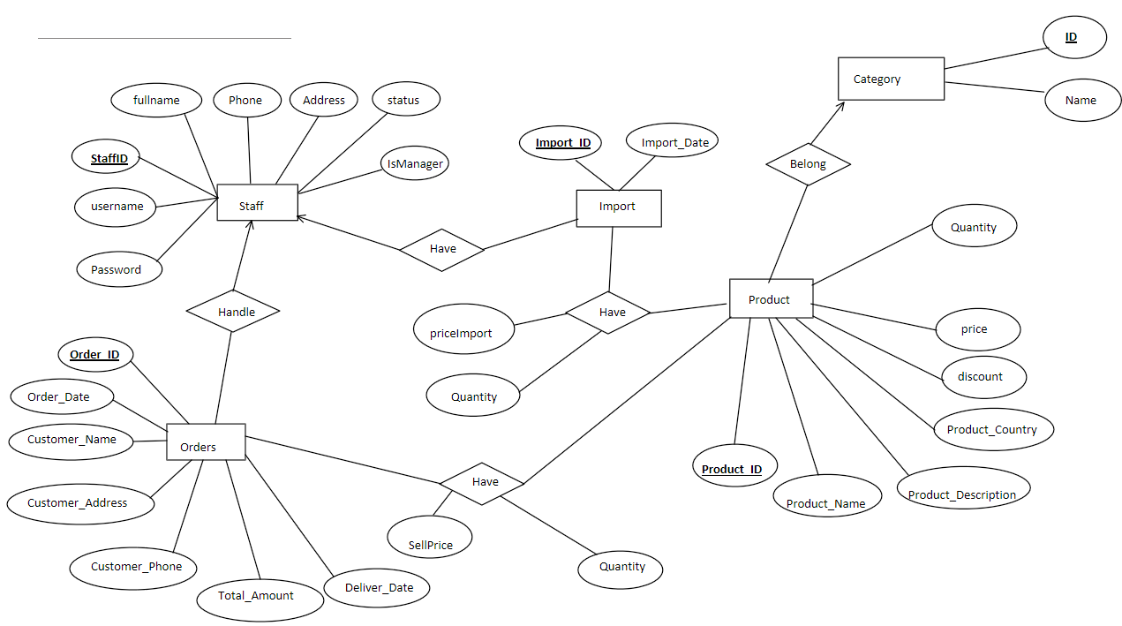

## **3.2. Table details/Chi tiết các bảng**

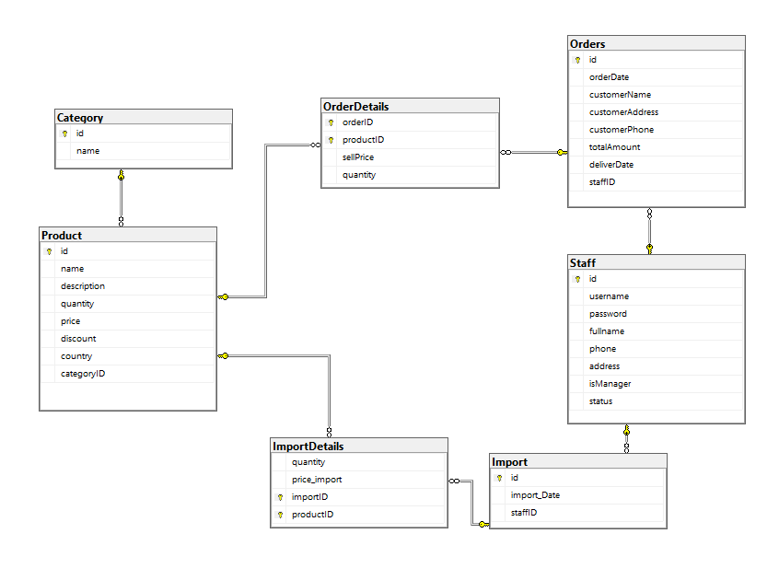

## 

3.2.1. Table name: Product

|  |  |  |  |
| --- | --- | --- | --- |
| **Field name** | **Type** | **Size** | **Note** |
| id | Integer |  | Primary key |
| name | String | 50 | Not null |
| description | String | MAX | Not null |
| quantity | Integer |  | Not null |
| price | Double |  | Not null |
| discount | Integer |  | Not null |
| country | String | MAX | Not null |
| categoryID | Integer |  | Not null, Foreign key, refers to Category table |

## 

3.2.2. Table name: Category

|  |  |  |  |
| --- | --- | --- | --- |
| **Field name** | **Type** | **Size** | **Note** |
| id | Integer |  | Primary key |
| name | String | 50 | Not null |

### 

## 

3.2.3. Table name: OrderDetails

|  |  |  |  |
| --- | --- | --- | --- |
| **Field name** | **Type** | **Size** | **Note** |
| OrderID | Integer |  | Not null, Foreign key, refers to Order table, Primary key |
| ProductID | Integer |  | Not null, Foreign key, refers to Product table, Primary key |
| Quantity | Integer |  | Not null |
| SellPrice | Double |  | Not null |

## 

3.2.4. Table name: Order

|  |  |  |  |
| --- | --- | --- | --- |
| **Field name** | **Type** | **Size** | **Note** |
| ID | int |  | Primary key, not null |
| orderDate | datetime |  | Not null |
| customerName | nvarchar | 150 | Not null |
| customerAddress | nvarchar | MAX | Not null |
| customerPhone | nvarchar | 50 | Not null |
| totalAmount | float |  | Not null |
| deliverDate | datetime |  | Not null |
| staffID | int |  | Not null, Foreign key, refers to Staff  table |

## 

3.2.5. Table name: ImportDetails

|  |  |  |  |
| --- | --- | --- | --- |
| **Field name** | **Type** | **Size** | **Note** |
| quantity | Integer |  | Not null |
| priceImport | Double |  | Not null |
| importID | Integer |  | Not null, Foreign key, refers to Import table, Primary key |
| productID | Integer |  | Not null, Foreign key, refers to Product table, Primary key |

## 

3.2.6. Table name: Import

|  |  |  |  |
| --- | --- | --- | --- |
| **Field name** | **Type** | **Size** | **Note** |
| id | Integer |  | Primary key |
| importDate | Date |  |  |
| staffID | Integer |  | Not null, Foreign key, refers to Staff table |

3.2.7. Table name: Staff

|  |  |  |  |
| --- | --- | --- | --- |
| **Field name** | **Type** | **Size** | **Note** |
| id | Integer |  | Primary key |
| username | String | 50 | Not null |
| password | String | 50 | Not null |
| fullname | String | 150 | Not null |
| phone | String | 50 | Not null |
| address | String | MAX | Not null |
| isManager | Boolean |  | Not null |
| status | Boolean |  | Not null |

# **Class diagram**

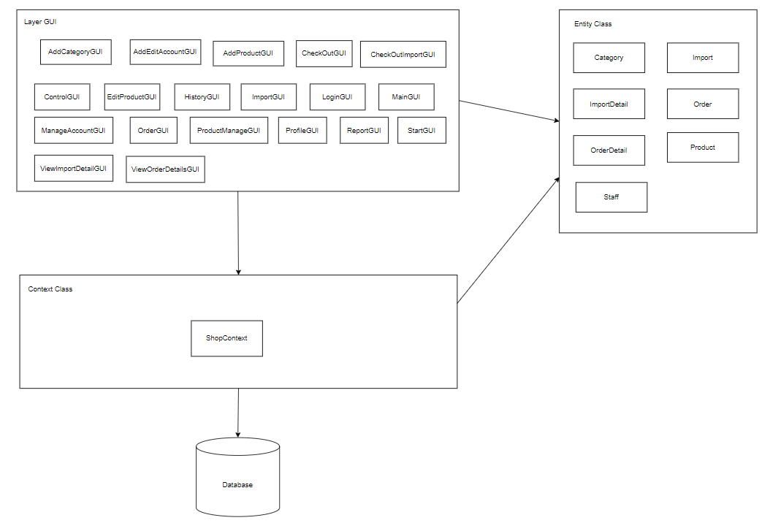

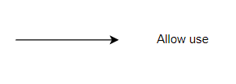

# **User Interface Model Design**

## **5.1. Interface Flow Diagrams**

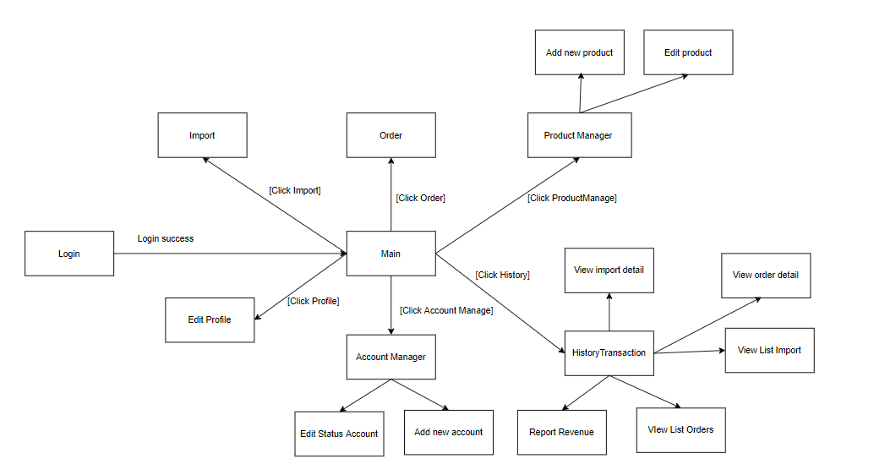

## **5.2. User interface model design**

5.2.1.Login screen

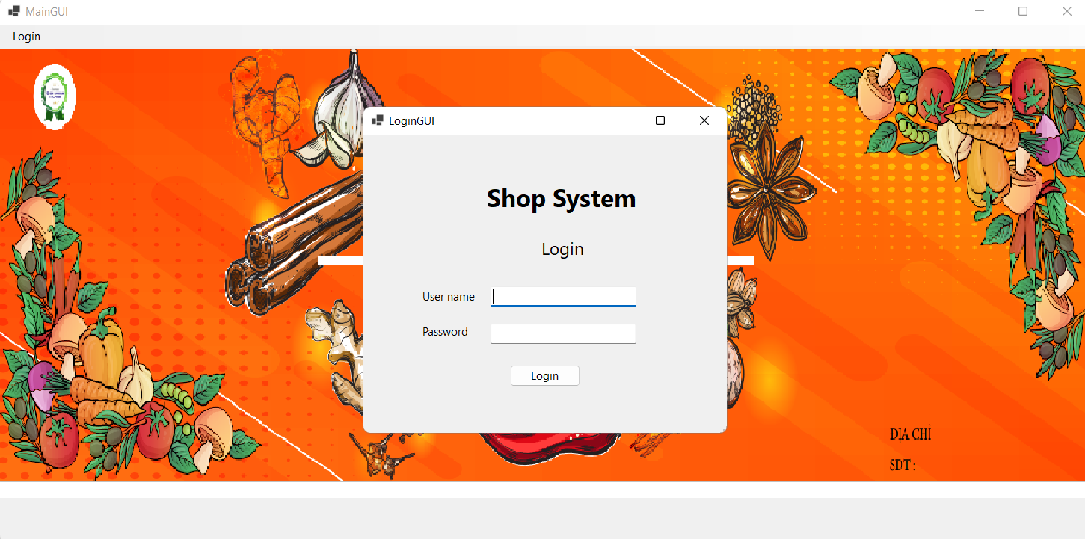

5.2.2.Main screen

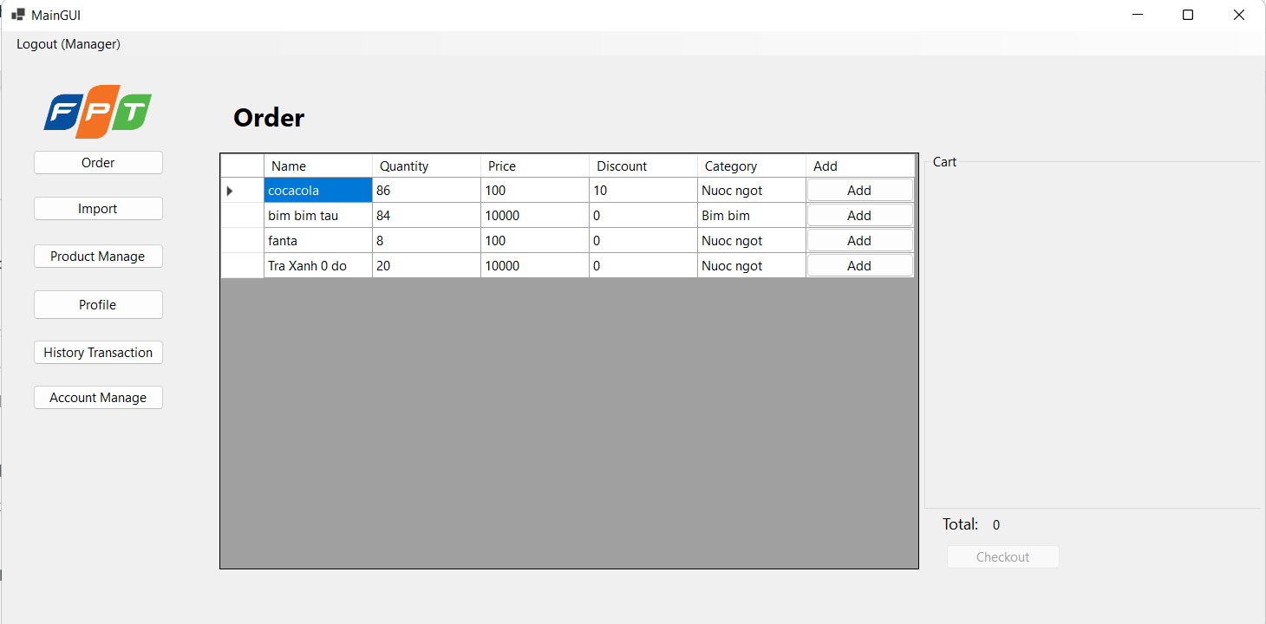

5.2.3.Import screen

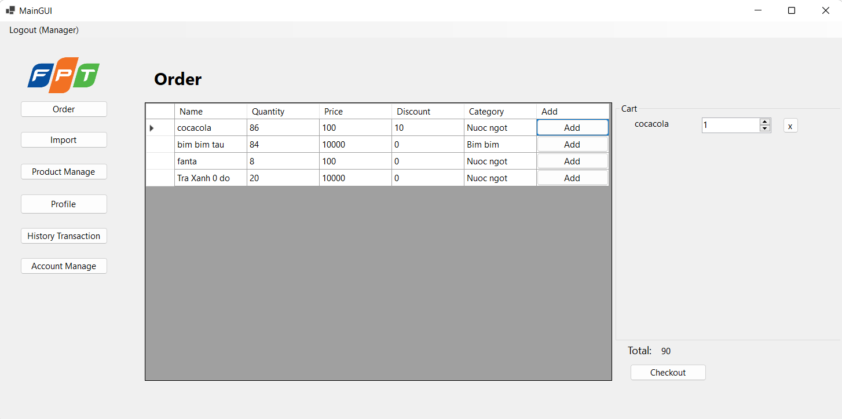

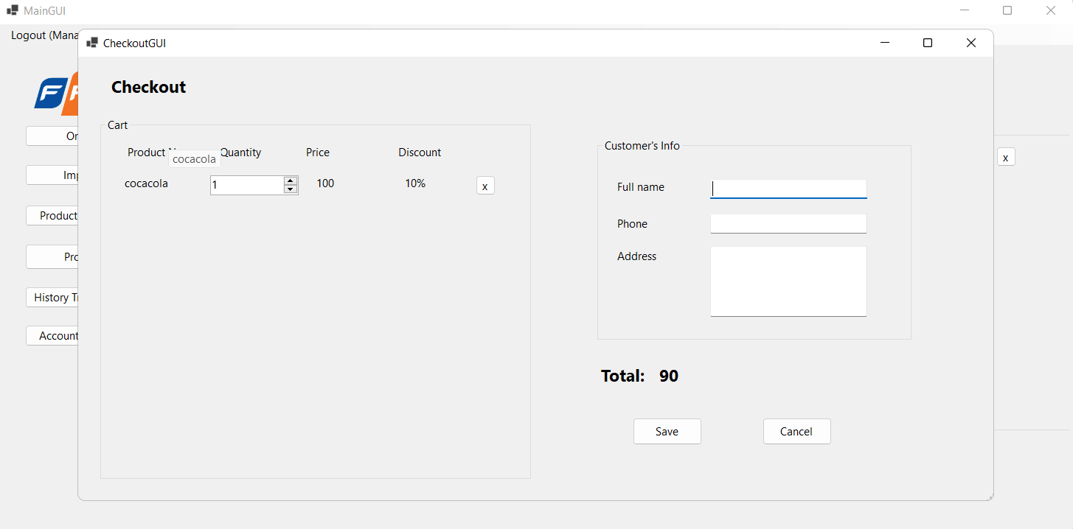

5.2.4.Order screen

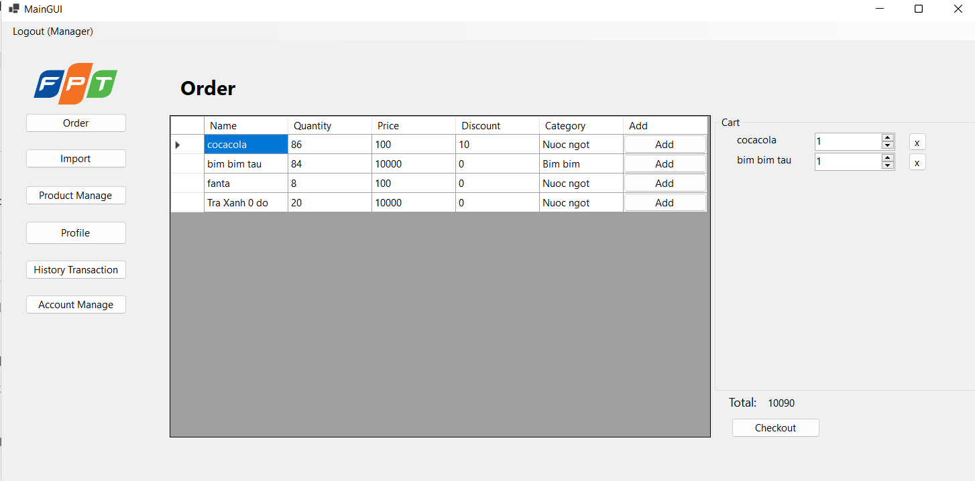

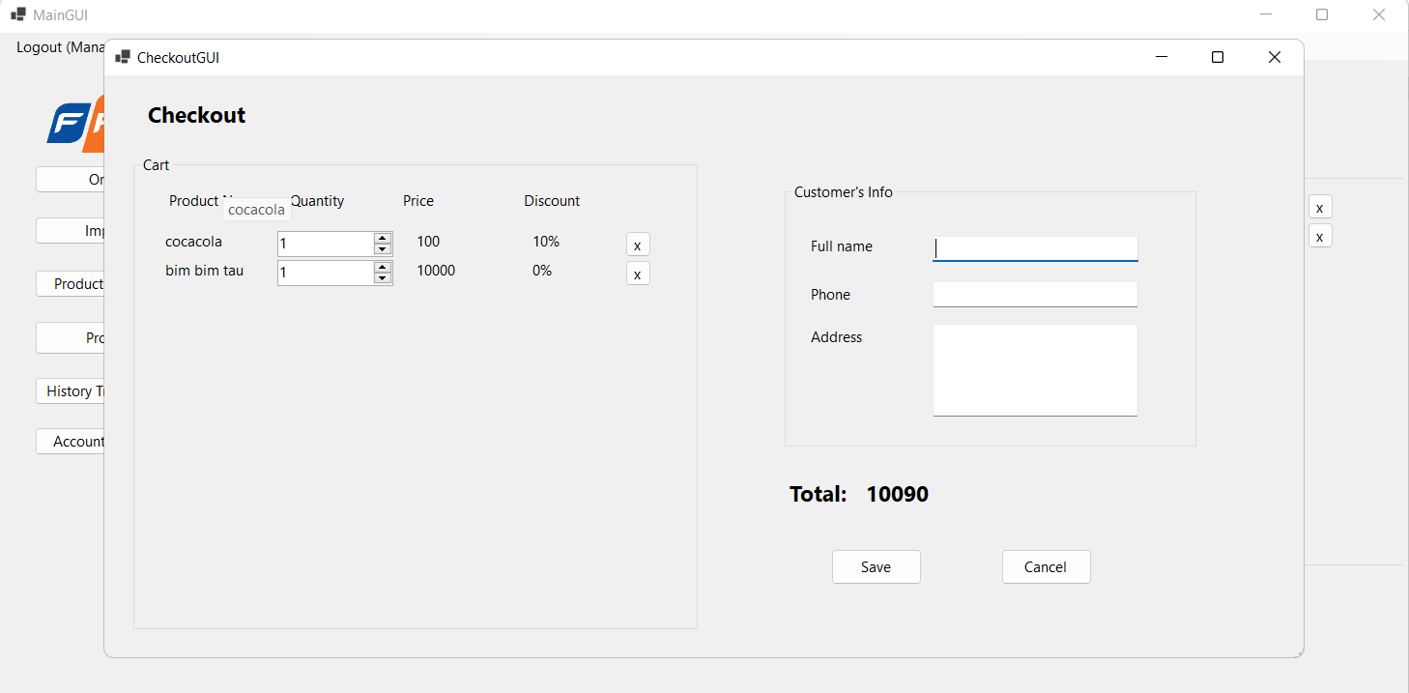

5.2.5.Product manage screen

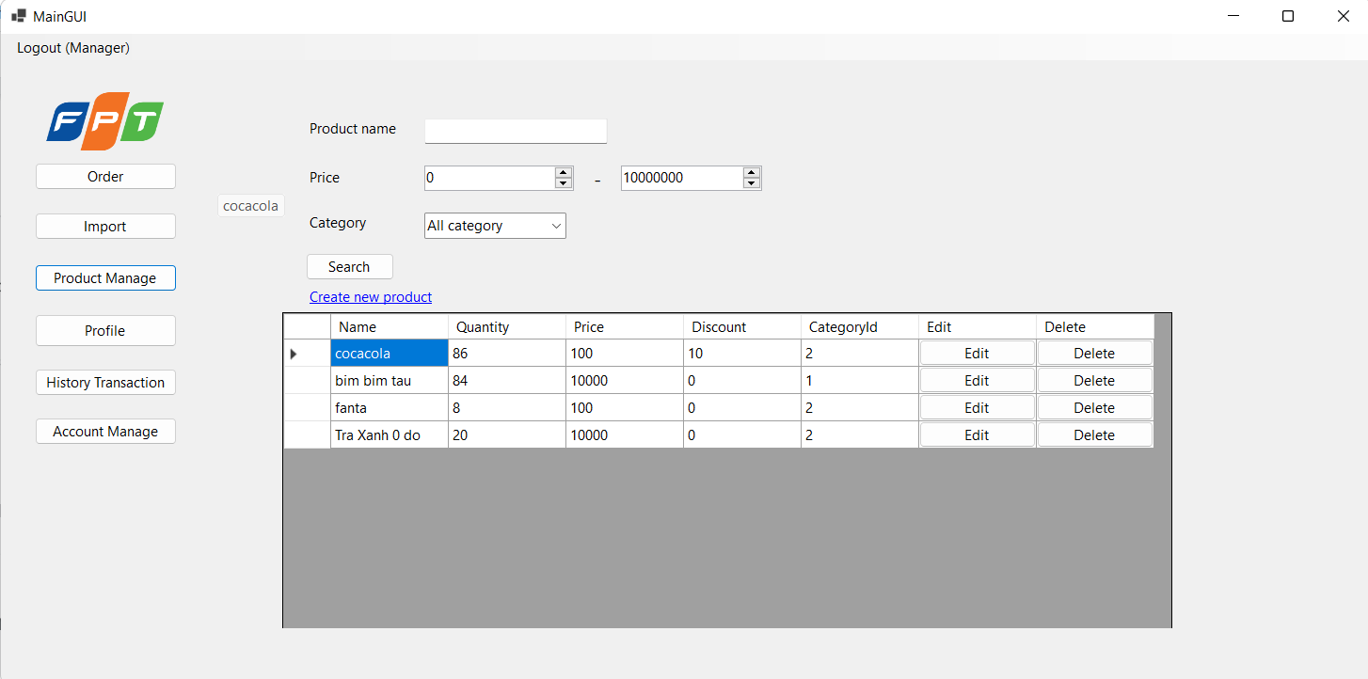

5.2.6.Create new product screen

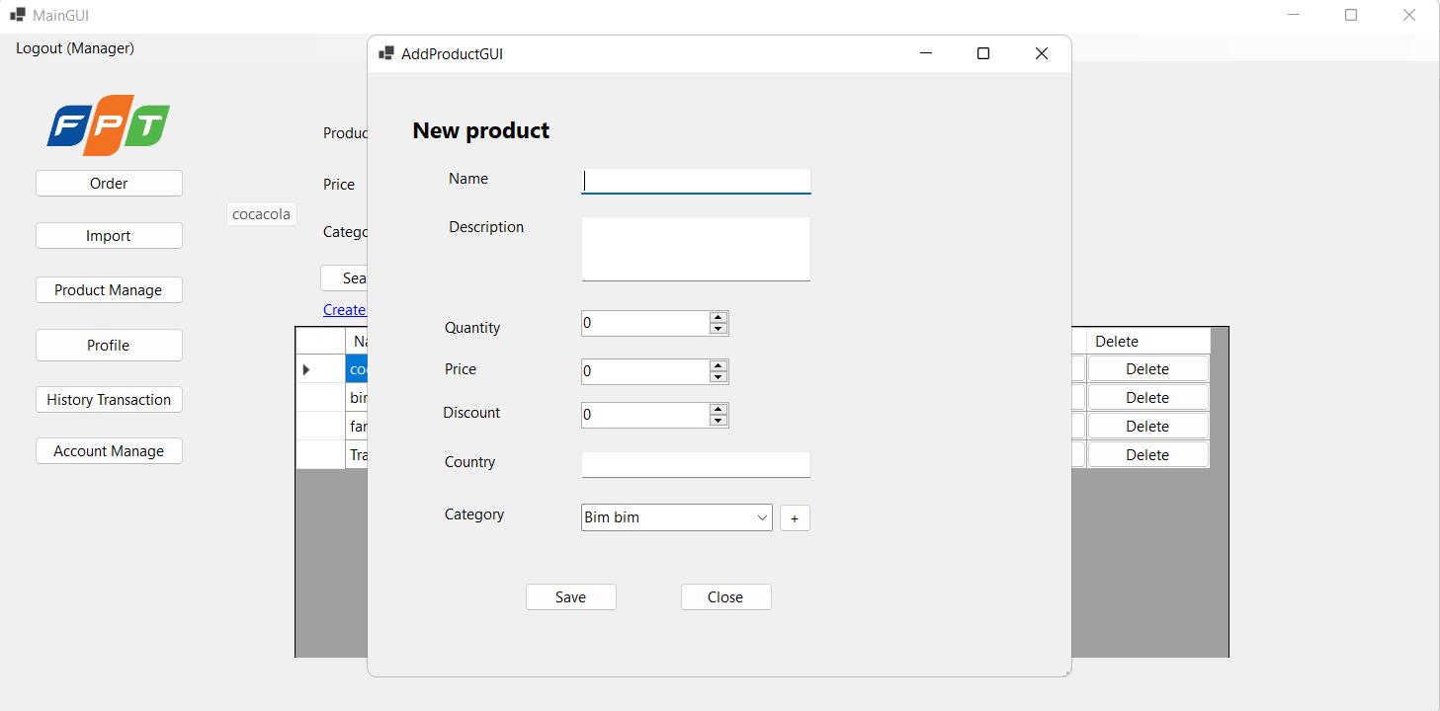

5.2.7.Edit product screen

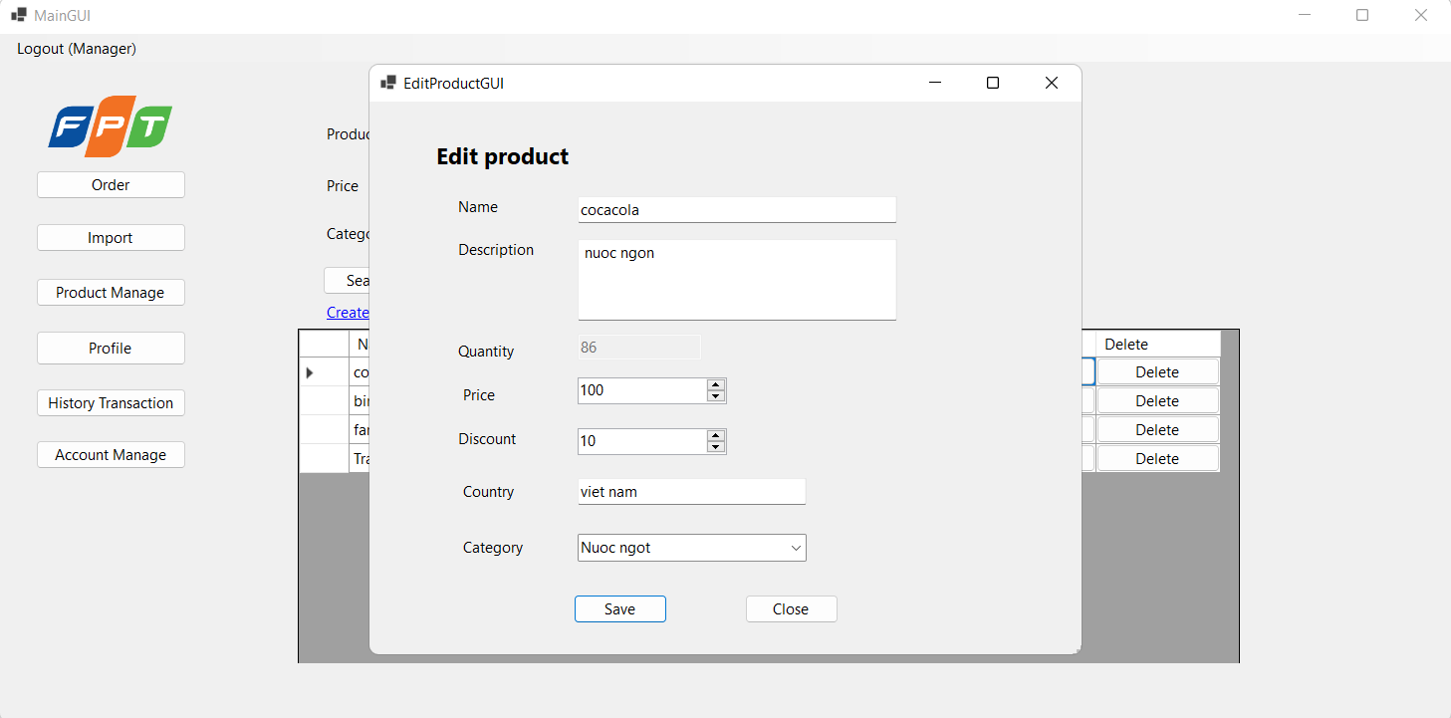

5.2.8.Edit profile screen

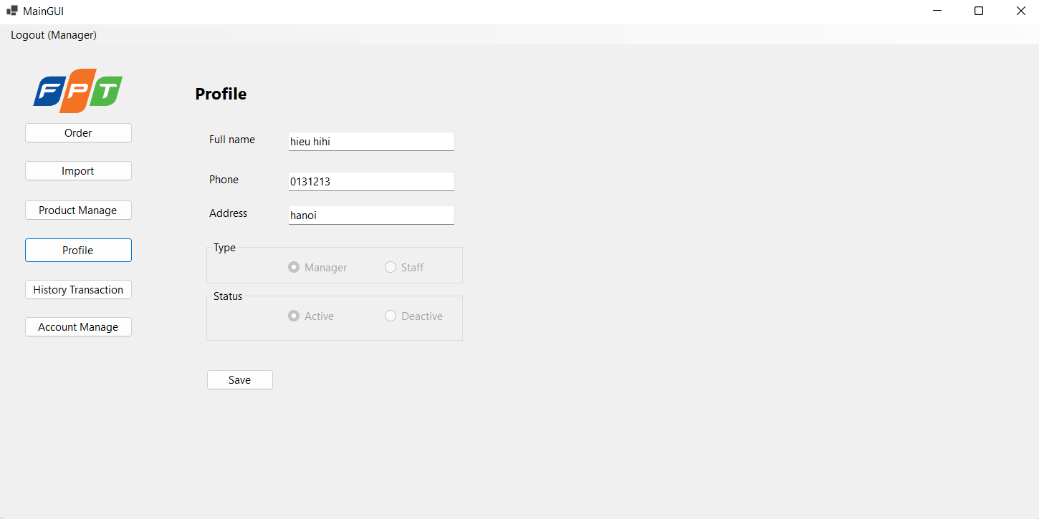

5.2.9.Account manage screen

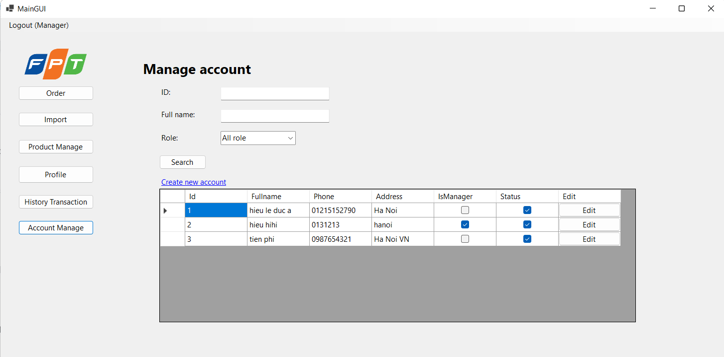

5.2.10.Edit account screen

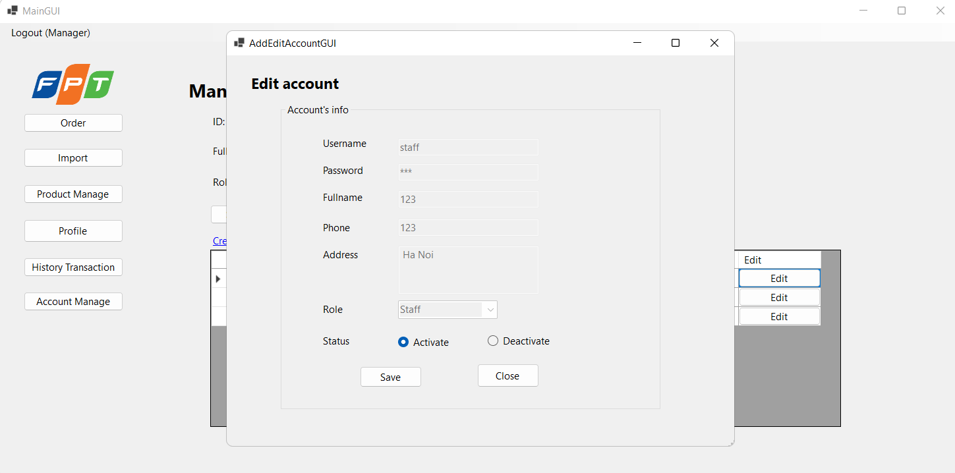

5.2.11.Add new account screen

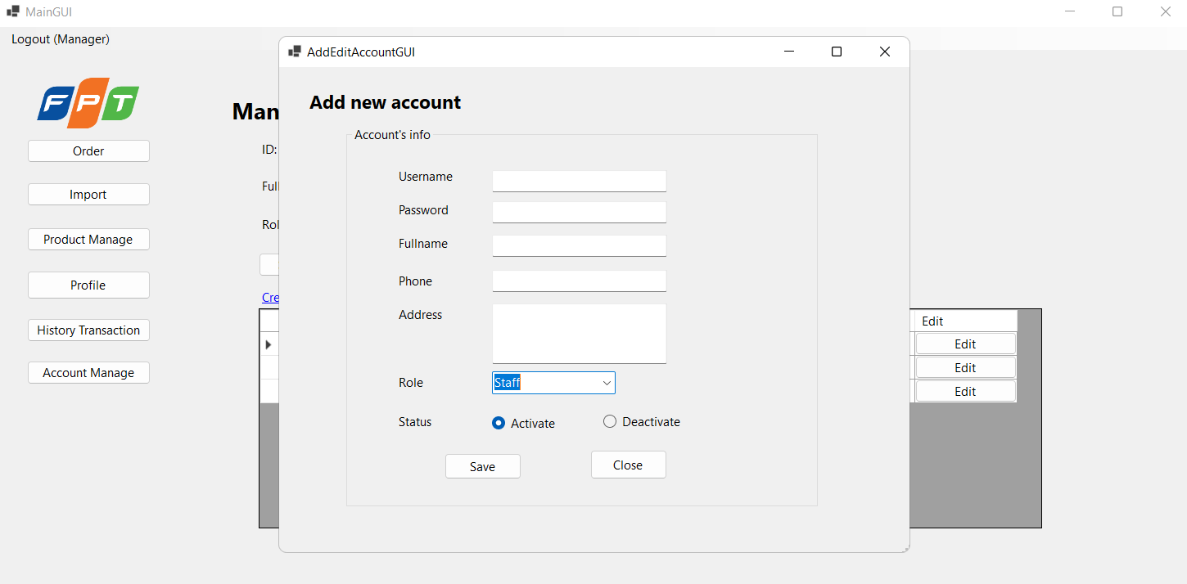

5.2.12.History transaction screen

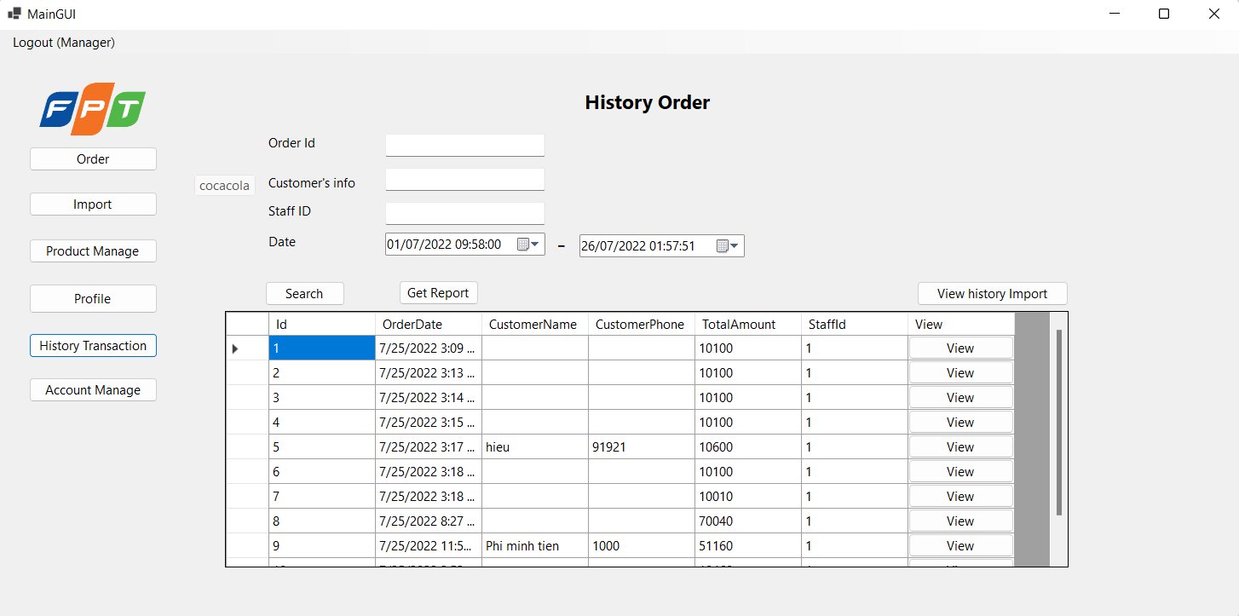

5.2.13.View List import screen

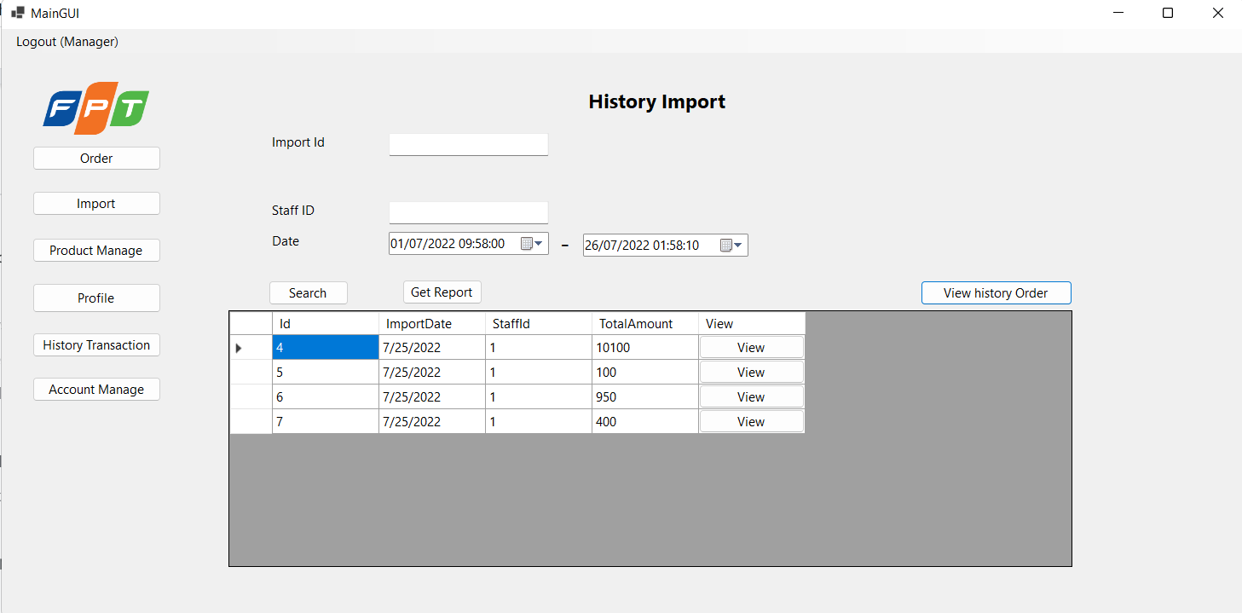

5.2.14.View List order screen



5.2.15.View order detail screen

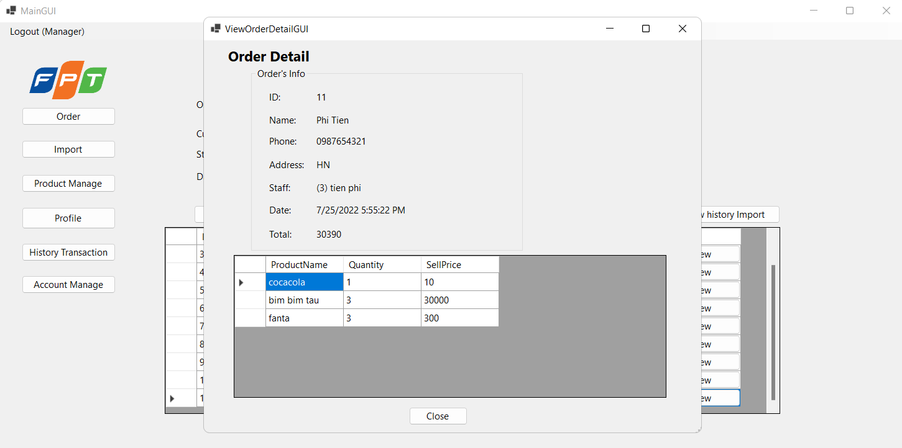

5.2.16.View import detail screen

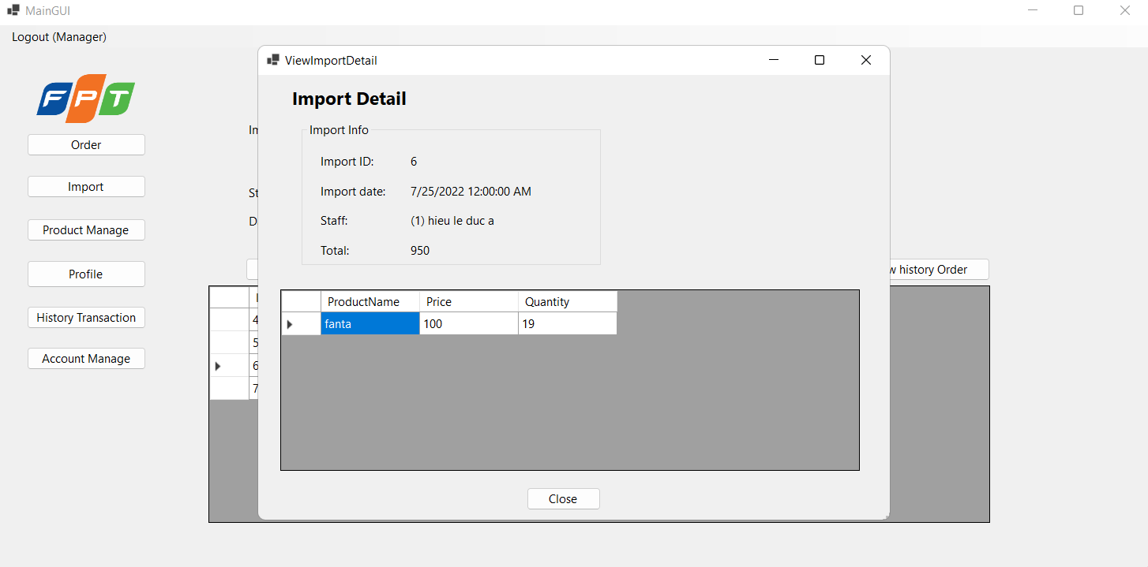

5.2.3. Screen “Product Manage”

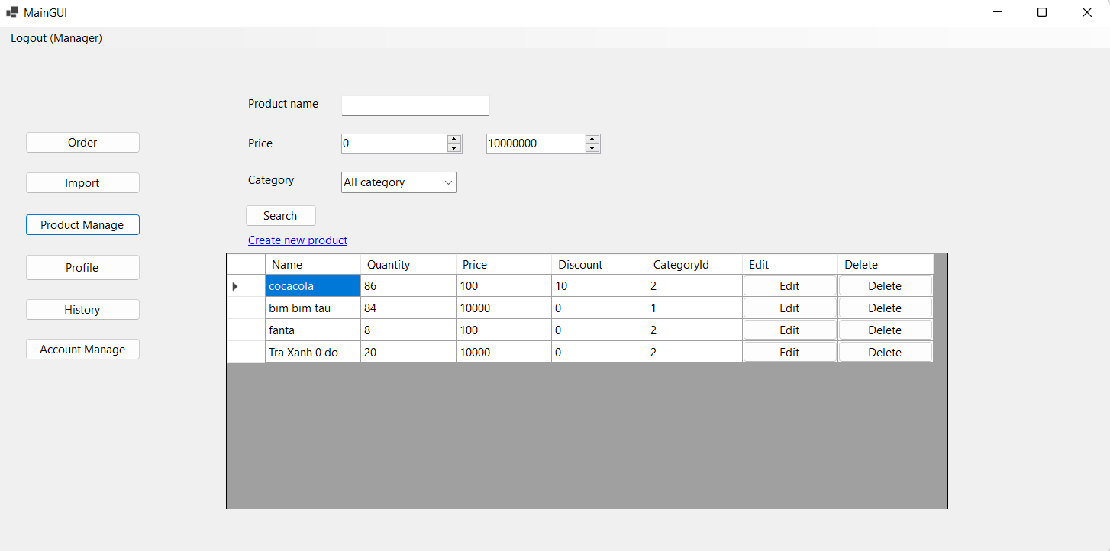

5.2.4. Screen “Profile”

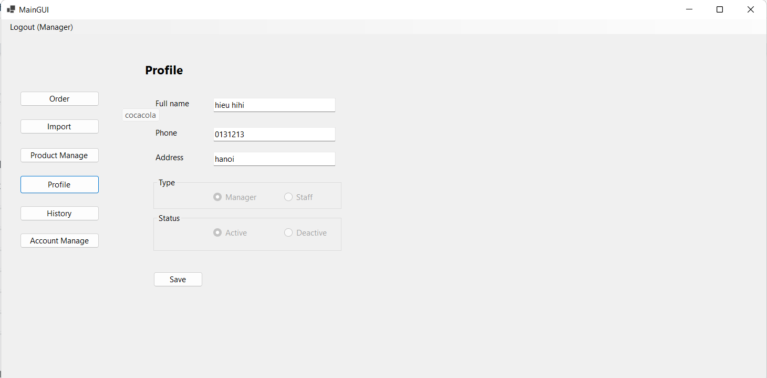

5.2.5. Screen “Account Manage”

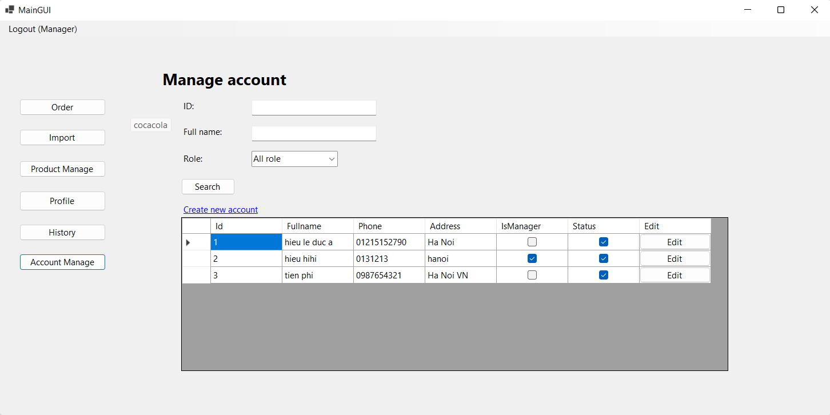

5.2.6. Screen “History Transaction”

