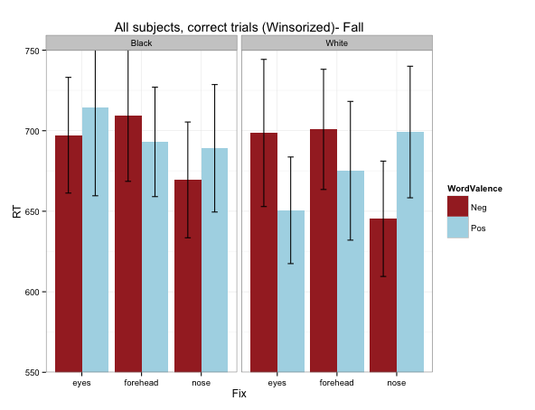Fix x FaceRace x WordValence

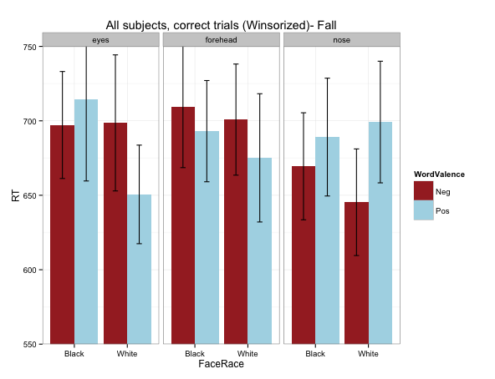

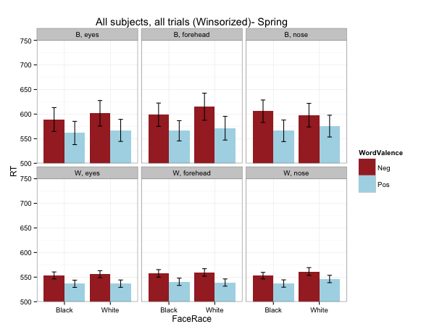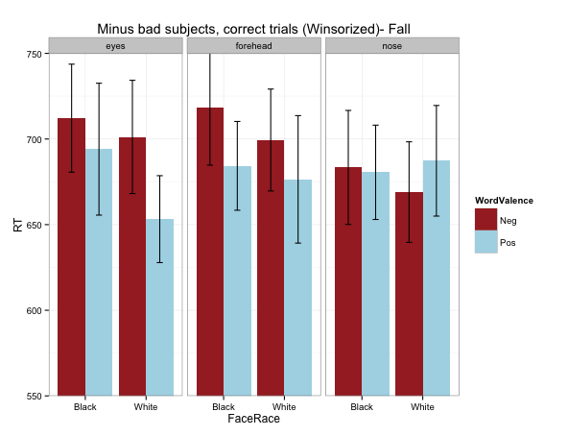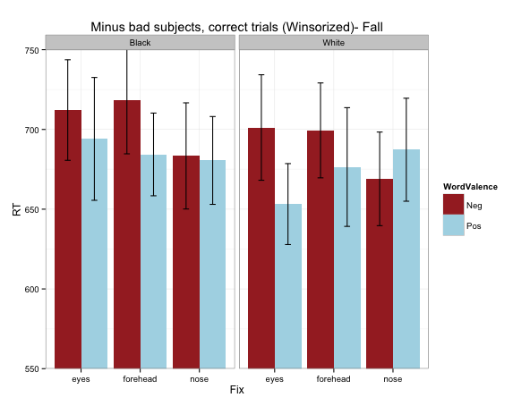

Fall: 27 subjects, 2 thrown out because of fast RT (<400ms) and high error rate

Spring: 54 subjects (44 White, 10 Black), none thrown out

Lambert & Payne (and others), *JPSP* (2003), WIT study

* Difference between WIT and my task might be response deadline? Makes people more nervous, makes people do worse with WIT when someone is in the room?
* do log transformed data instead of winsorized