What we did:
- We first performed a section-aware chunking of the full-text markdown versions of all 150 test papers. Each chunk had chunk_size=1800 characters, and one-paragraph overlap between adjacent chunks.
- We implemented two retrieval variants: BM25 lexical retrieval (k1 = 1.5, b = 0.75) and semantic retrieval using OpenAI text-embedding-3-small embeddings with cosine similarity. Both operate over the same per-paper chunk inventory and retrieve top 5 chunks for each query by default.
- Retrieval was first done separately for each of the 16 questions, but the final prompt does not repeat 16 separate evidence blocks. Instead, we merged the per-question hits into one shared deduplicated evidence pool per paper, ranked passages by how often they were retrieved across questions, and capped the pool so the final RAG prompt stayed comparable to or smaller than the full-paper base prompt.
- We then ran the same downstream pipeline as the other methods: collect model responses, parse them into PMID/QID rows, merge them into the master workbook, and evaluate them with the shared normalization and scoring logic. This let us compare BM25 RAG and Semantic RAG directly against base, FT, QSP, and FT+QSP for GPT-4o-mini and Llama 3.1 70B/8B on new30, original120, and full150.
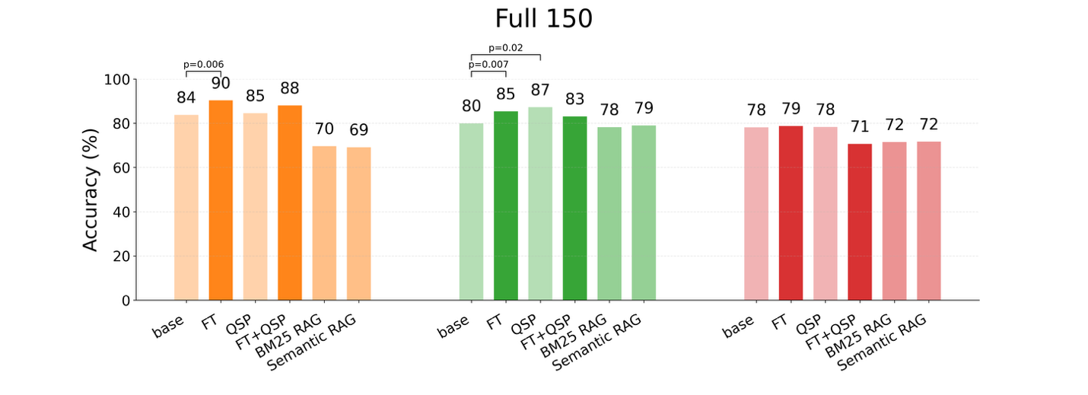
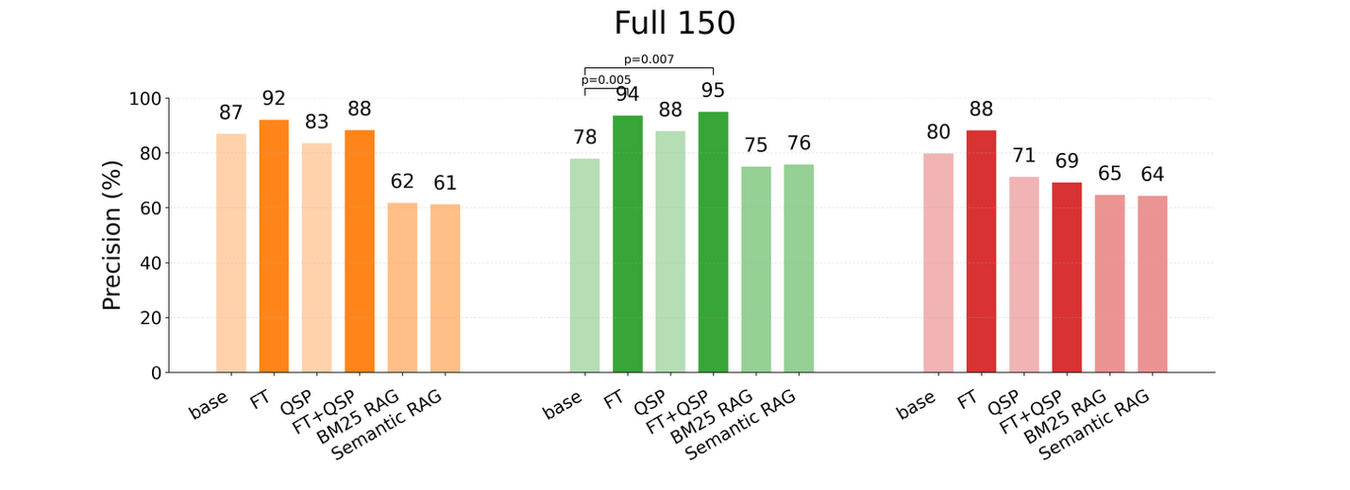
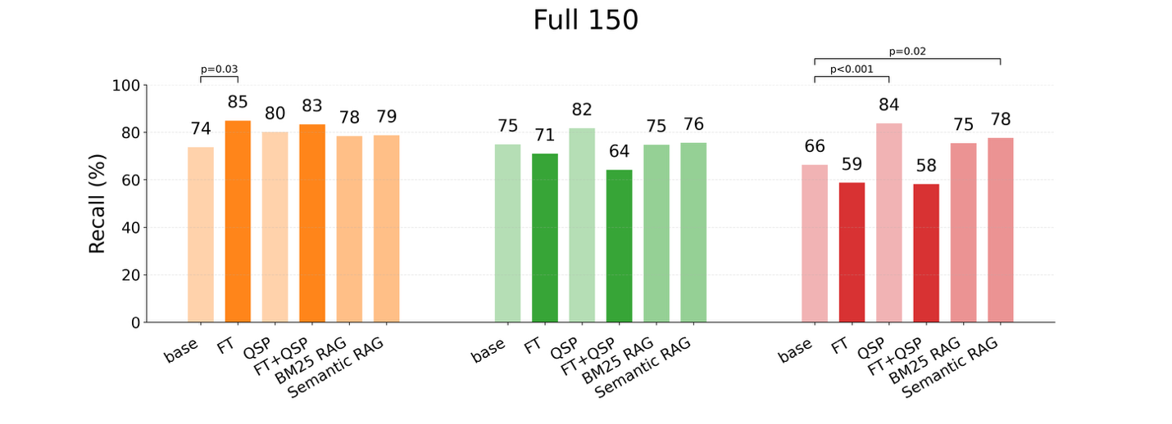
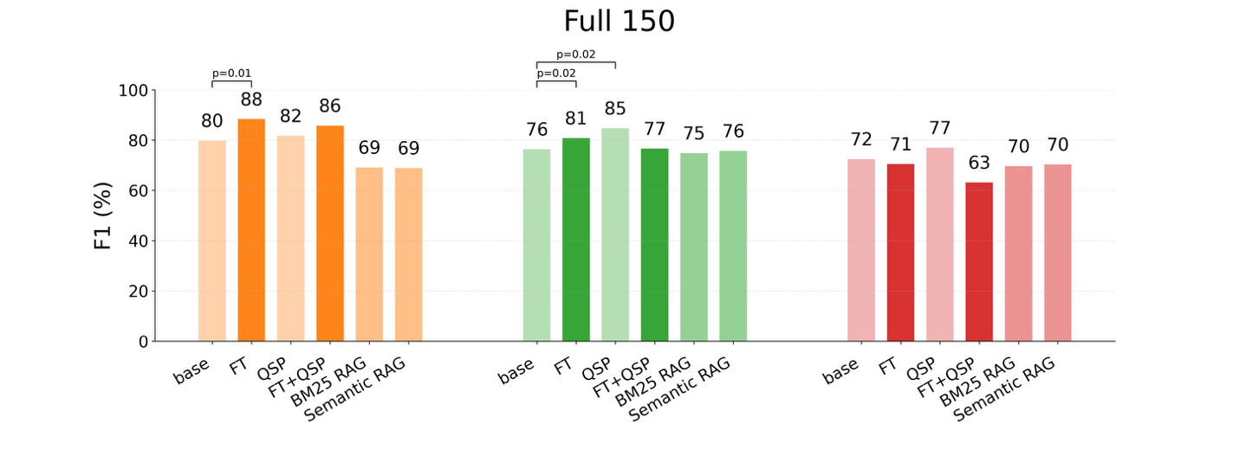

Where RAG works well:
- PMID 21115794, Q9 (Which HIV genes were reported to have been sequenced?): the human answer was IN. All six RAG variants were correct, whereas 11 of 12 non-RAG methods missed the answer. This is a clean example where retrieval surfaced the explicit integrase-region passage and converted a hard gene-identification problem into straightforward evidence extraction.
- PMID 36659824, Q14 (Does the paper report HIV sequences from individuals who had previously received ARV drugs?): the human answer was Yes. Five of six RAG variants were correct, while 11 of 12 non-RAG methods said No. Here the retrieved evidence pool made the prior-treatment context explicit, which helped the RAG models recover a clinically important Yes/No distinction that most non-RAG models missed.
- PMID 35913500, Q7 (From what years were the sequenced samples obtained?): the human answer was 2021-2022. Four of six RAG variants were correct, while 11 of 12 non-RAG methods failed. This is a useful example because it is not a gene or drug-name extraction task; retrieval helped by surfacing a precise temporal statement that the non-RAG models often failed to locate or normalize.

Where RAG fails:
- PMID 26246578, Q13 (Were the patients in the study in a clinical trial?): the human answer was No. All six RAG variants were wrong, while all 12 non-RAG methods were correct. Inspection of the retrieved evidence pool shows why: high-ranked Discussion passages mention the external P1093 dolutegravir dose-ranging study and other trial-related examples, which contaminates the prompt with clinically adjacent but study-external evidence and pushes the model toward a false Yes.
- PMID 23749954, Q16 (Which drugs were received by individuals in the study before sample sequencing?): the human answer was Not applicable. Five of six RAG variants incorrectly produced concrete drug names, whereas most non-RAG methods abstained correctly. In the retrieved pool, assay and selection-pressure drugs such as tenofovir, didanosine, stavudine, apricitabine, and abacavir were highly salient, so the RAG models treated experimental reagents as if they were participant treatment histories.
- PMID 19104010, Q1 (Does the paper report HIV sequences from patient samples?): the human answer was No. All six RAG variants answered incorrectly, while 11 of 12 non-RAG methods were correct. This shows a second recurring failure pattern: once retrieval surfaces sequencing-related text about viral passages or infected cells, the RAG models often over-call patient-sample evidence rather than recognizing that the study is non-patient or in vitro in nature.

Explanation of failure modes:
RAG works best when the correct answer is an explicit positive fact stated directly in the paper, but it underperforms when the answer depends on absence, non-applicability, or study scope.

The current retrieval setup is simple, but its shared evidence pool can still propagate misleading passages across multiple questions: Discussion sections may mention external clinical trials, background case reports, or previously published patient cohorts, and in vitro papers may contain drug-selection passages that look superficially like treatment histories.

That means some errors are probably retriever-fixable with more study-local and question-aware ranking, for example by down-weighting Discussion text for clinical-trial and treatment-history questions or distinguishing assay drugs from participant drugs. However, retrieval is not the whole story.

Even when the evidence pool is reasonable, the RAG models often fail to abstain and instead convert related biomedical context into a concrete Yes answer, a specific list, or a sample type.

In other words, the dominant failure mode is false concretization: RAG improves grounding for explicit positives, but it is still weak at recognizing No, Not reported, and Not applicable cases that require broader document interpretation rather than pure passage extraction.

