**HIVEBANKS** **Use the tutorial for digital currency agents**

**1: log on to the home page of the digital bank (the domain name /h5 of the server configuration, for example, when I configured the server domain as www.baidu.com, then the front-end access domain is www.baidu.com/h5 and the back-end access page is** [www.baidu.com/api](http://www.baidu.com/api)**).**

**2：registered**

1. If the following page is displayed, please wait for the administrator to open the registration authority, or contact the administrator (you can directly login to the existing account).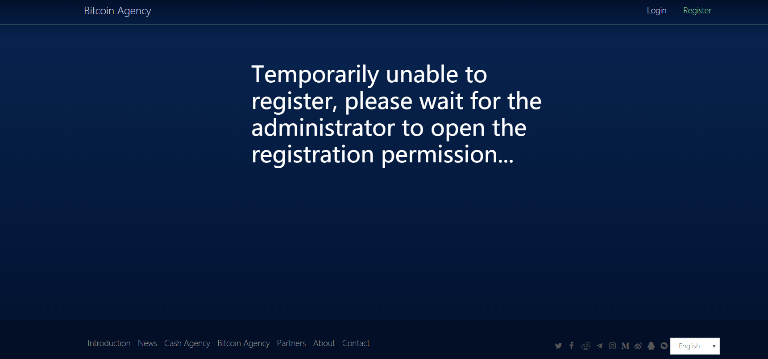

2.1 email registration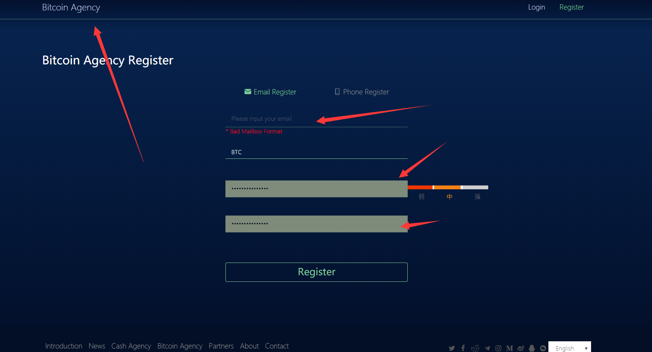

After filling in the information, click the registration button to send a confirmation email link to the registered email account. Click the link to complete the registration. Then please wait patiently for the administrator to review.

2.2 mobile phone registration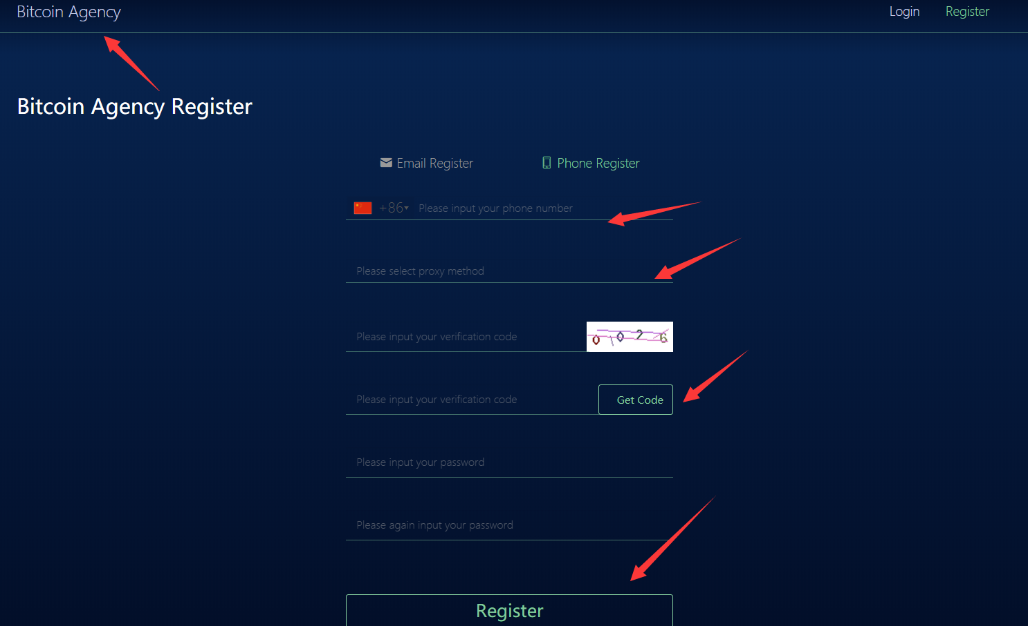

Mobile phone registration needs to select the country code, click to obtain the verification code will be sent to registered mobile phone SMS. Then fill in the information to complete the registration and login, and please wait patiently for the administrator's review.

3 the login

3.1 email account login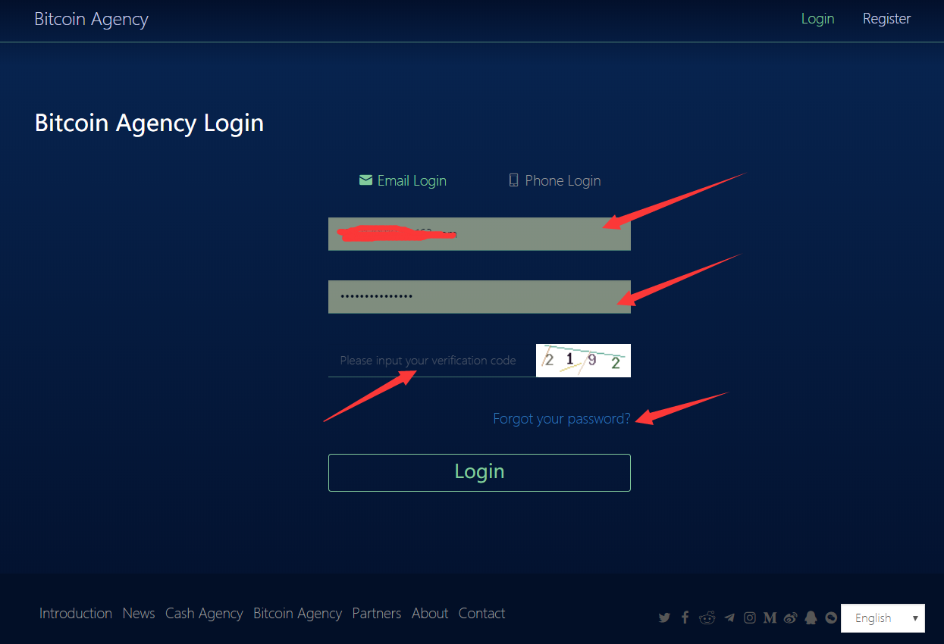

Enter the account, password and verification code for login. (if you forget the password, you can forget the password and reset it)

3.2 mobile phone account login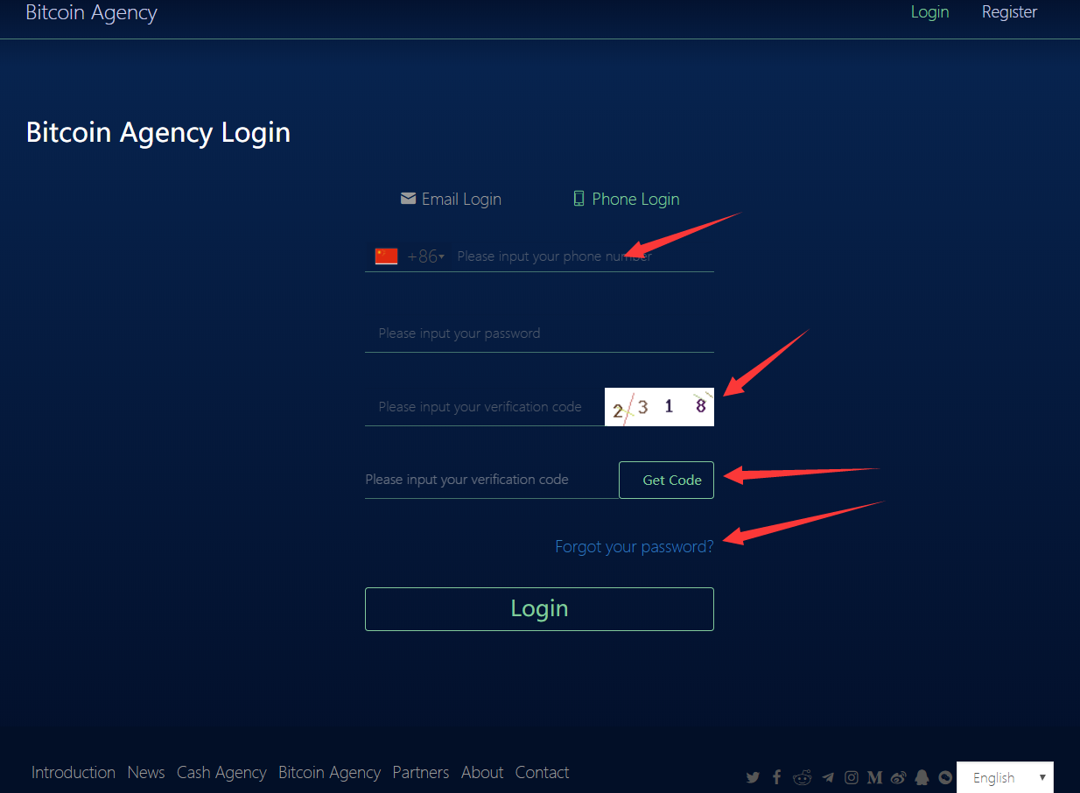

Fill in the login information and require the phone verification code to log in.

**3：Interface management**

3.1 Account home page

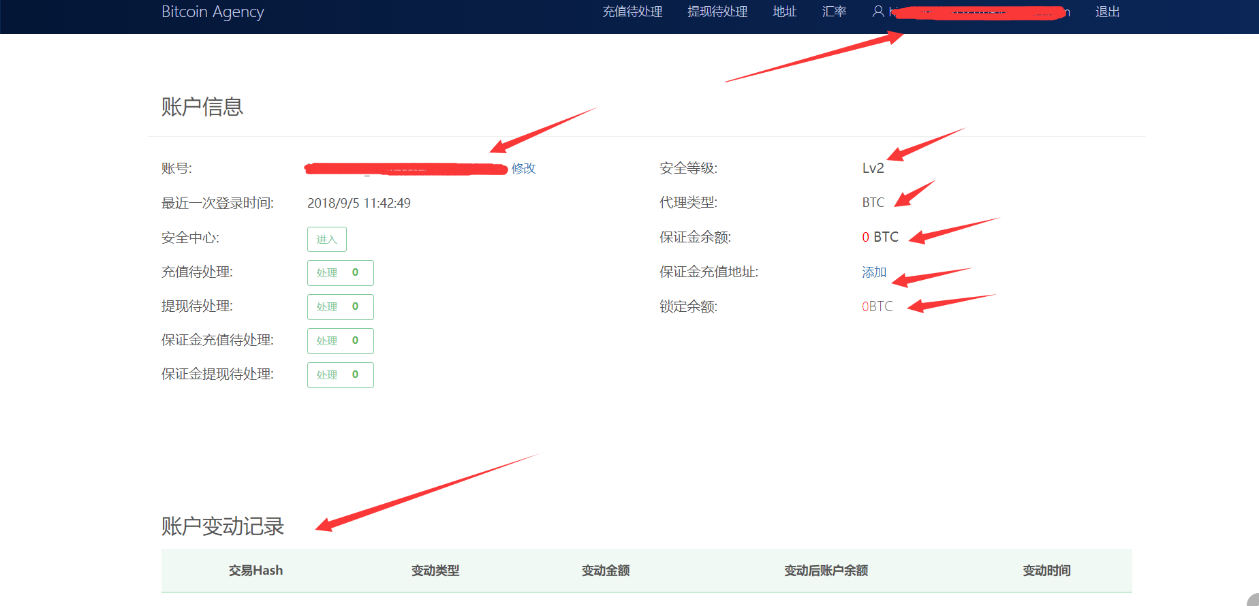

This page is user basic information interface (general ba)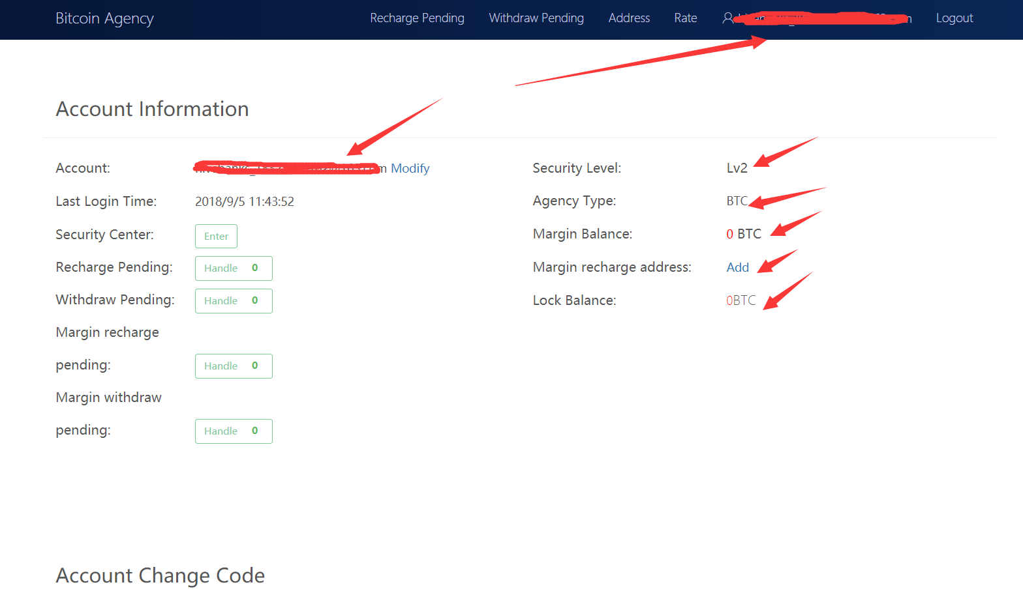

This page is the user basic information interface (benchmark ba)

Note: the benchmark ba is the same but differentiated agent as the general ba. It will be more experienced in use.

3.2 Security center

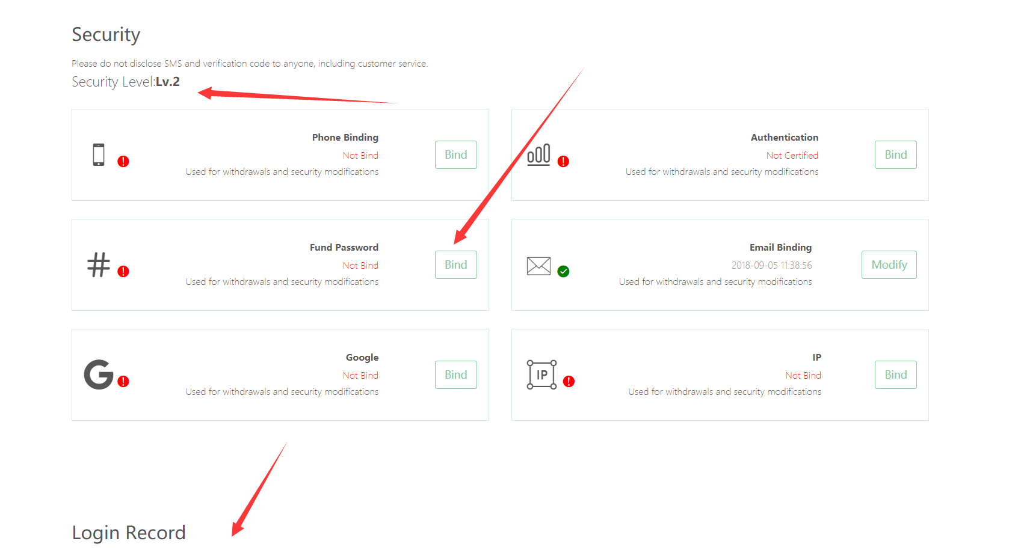

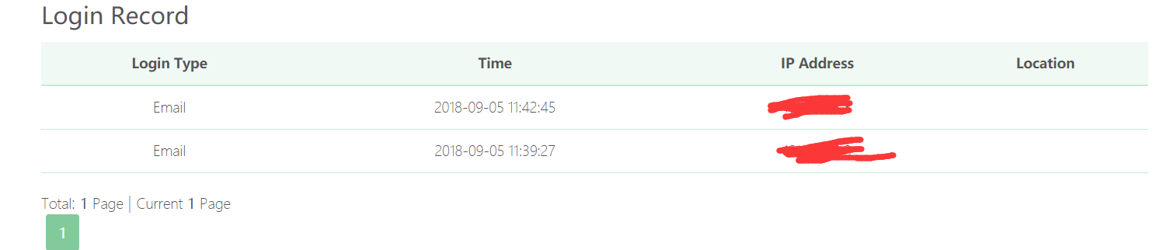

This page displays a summary of the binding information currently used, and a user level display, where user login records can be viewed.

3. 3 Margin recharge

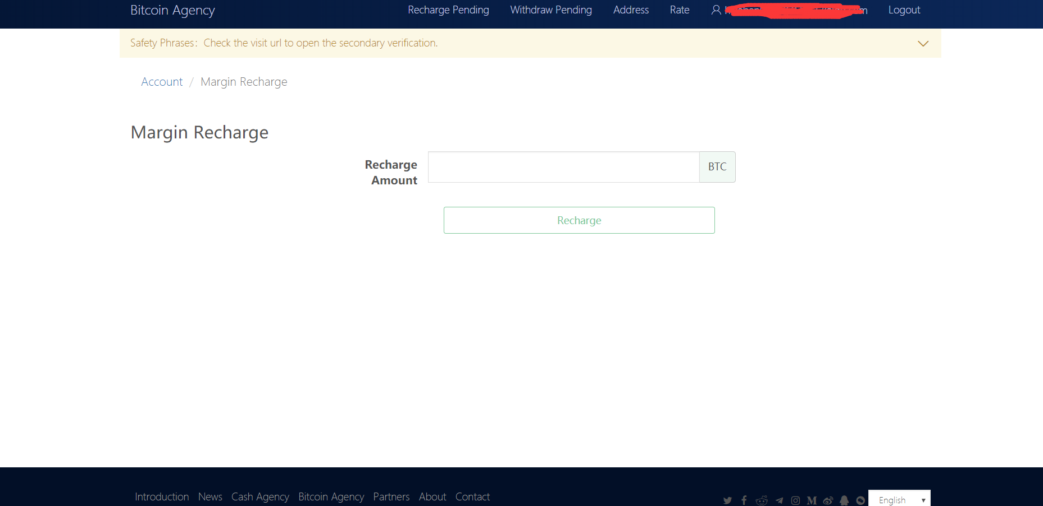

图一

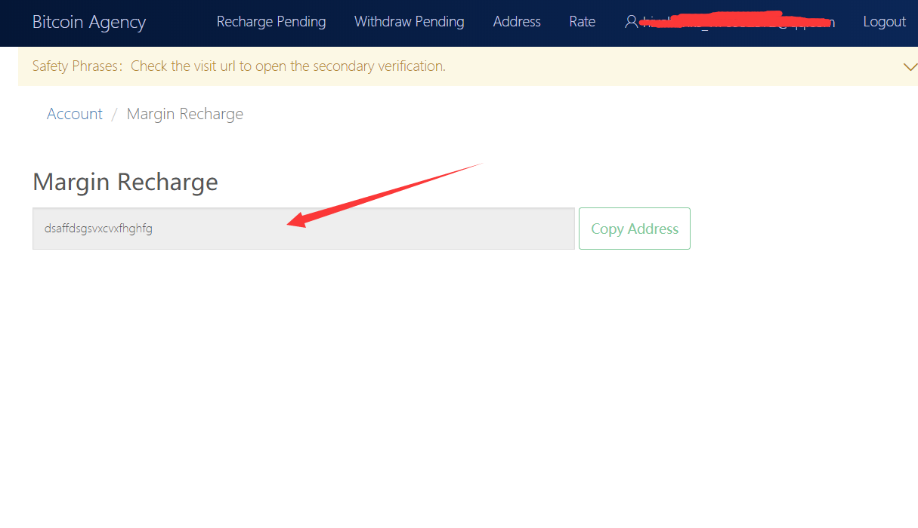

图二

Click recharge to fill the amount, and the user will skip to the deposit recharge address interface as shown in figure 2. Users recharge the amount offline or online

3.4 Margin withdrawal

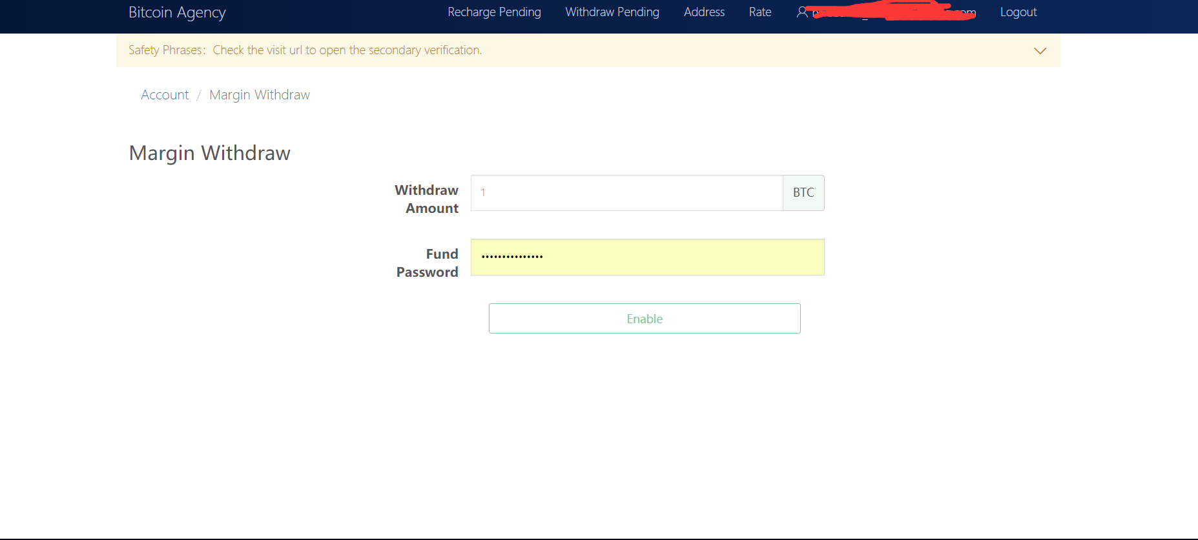

Input the amount and fund password, and the withdrawal can be completed after the audit. Note: the fund password needs to be tied

3.5 Exchange rate setting (general BA rate setting. Benchmark BA has no exchange rate setting)

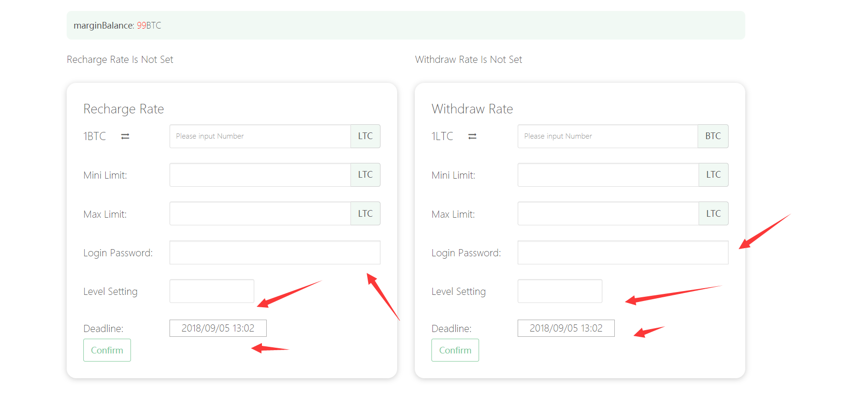

The exchange rate set by the benchmark BA needs to meet the requirements of la. Generally, BA can be customized.

3.6 add of address

3.6.1 withdrawal address.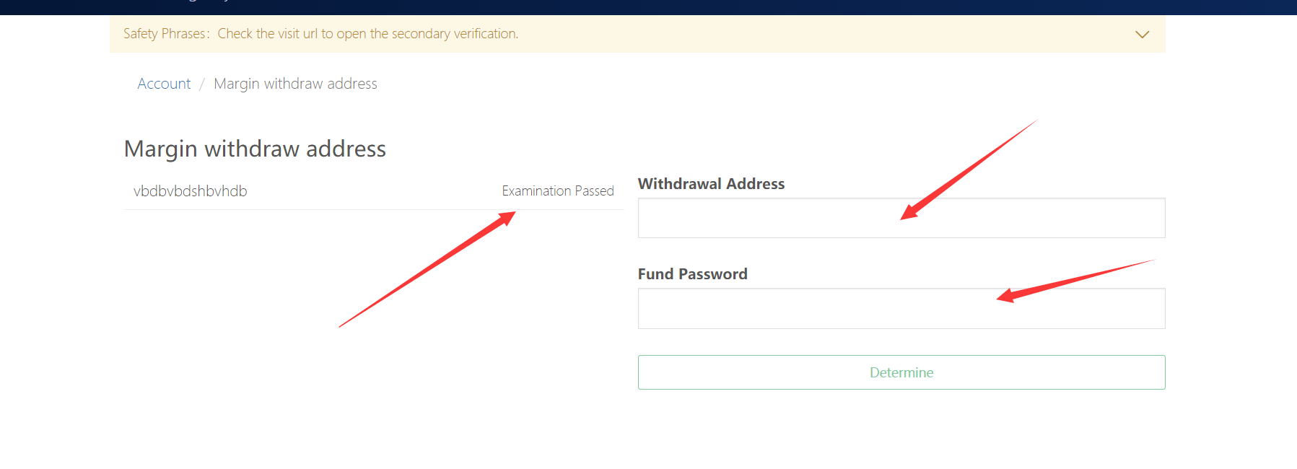

3.6.2 Add BA address

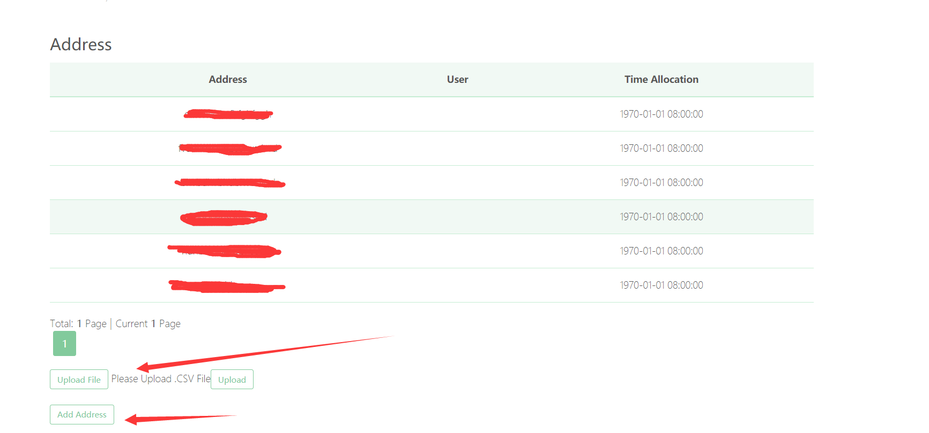

**The introduction of digital agent management interface in banking system ends here. Thank you for your use!**