**HIVEBANKS** **Legal currency agent use tutorial**

**1: log on to the home page of the digital bank (the domain name /h5 of the server configuration, for example, when I configured the server domain as www.baidu.com, then the front-end access domain is www.baidu.com/h5 and the back-end access page is** [www.baidu.com/api](http://www.baidu.com/api)**).**

**2：registered**

1. If the following page is displayed, please wait for the administrator to open the registration authority, or contact the administrator (you can directly login to the existing account).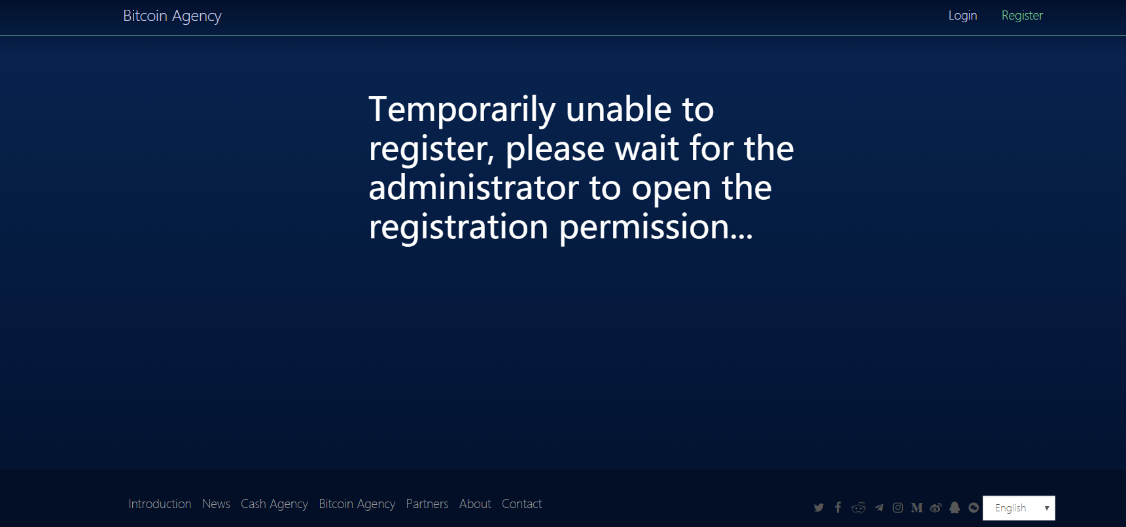

2 registered

2.1 email registration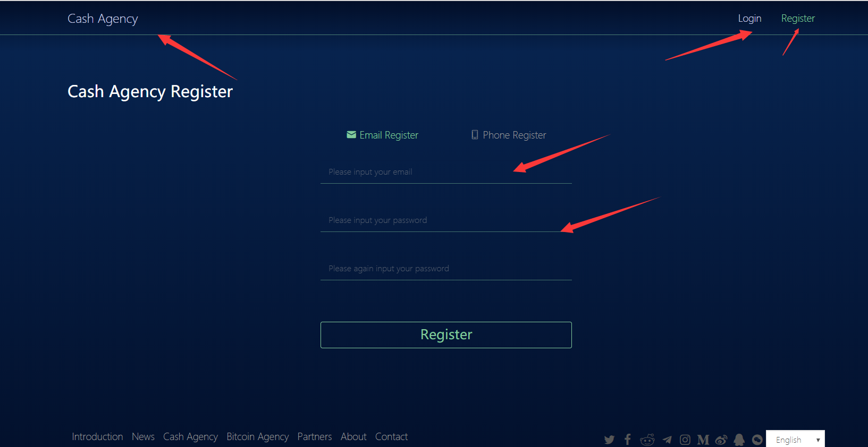

After filling in the information, click the registration button to send a confirmation email link to the registered email account. Click the link to complete the registration. Then please wait patiently for the administrator to review.

2.2 mobile phone registration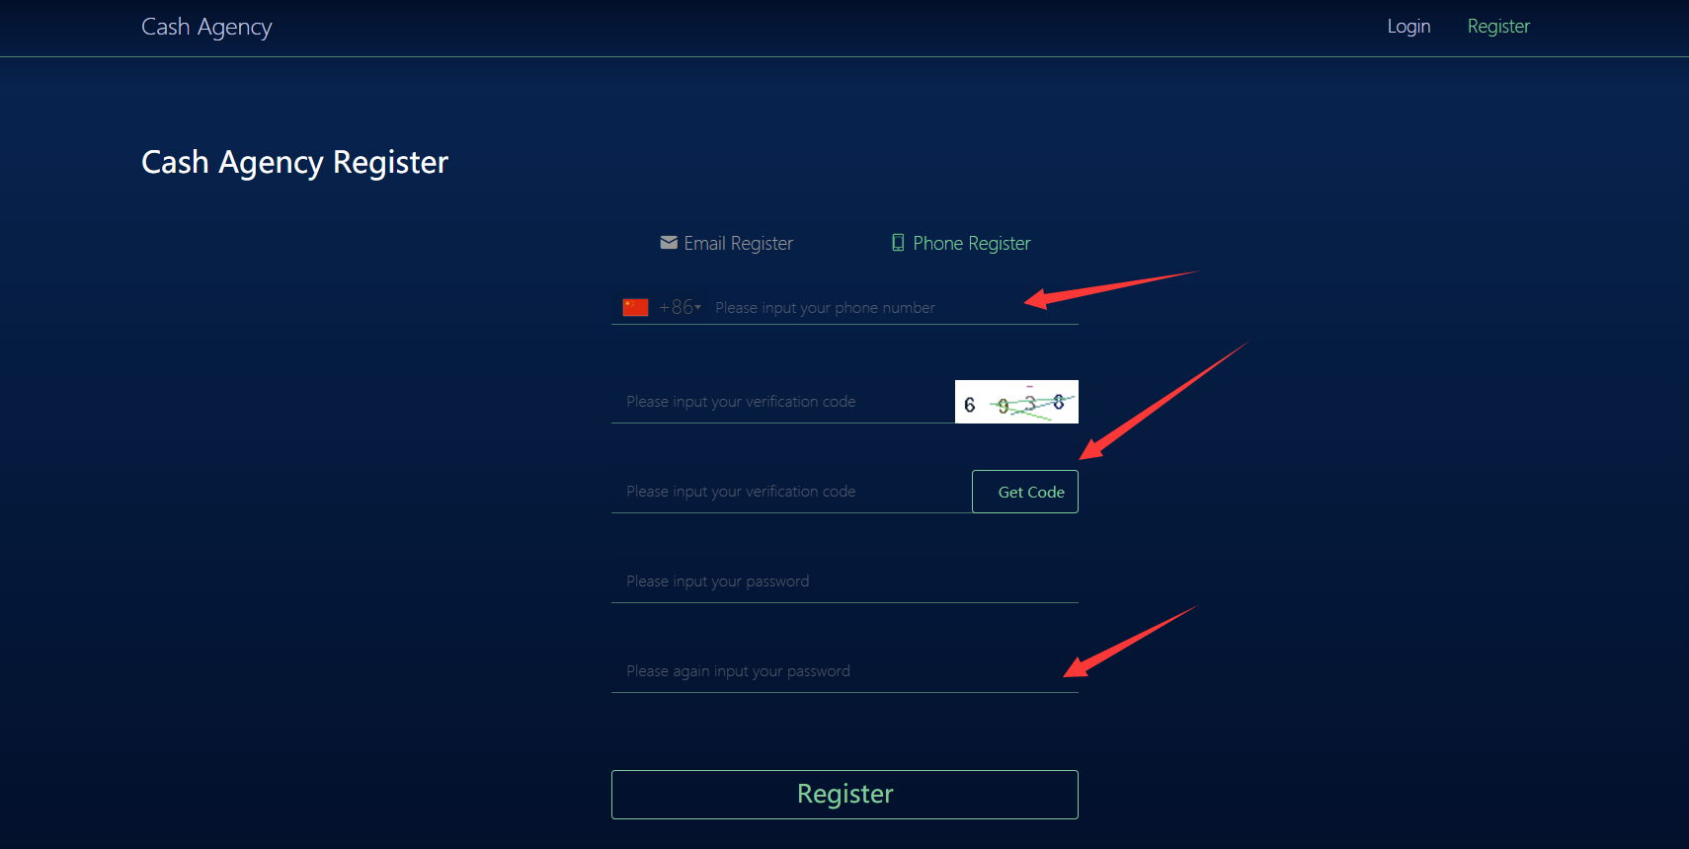

Mobile phone registration needs to select the country code, click to obtain the verification code will be sent to registered mobile phone SMS. Then fill in the information to complete the registration and login, and please wait patiently for the administrator's review.

3 the login

3.1 email account login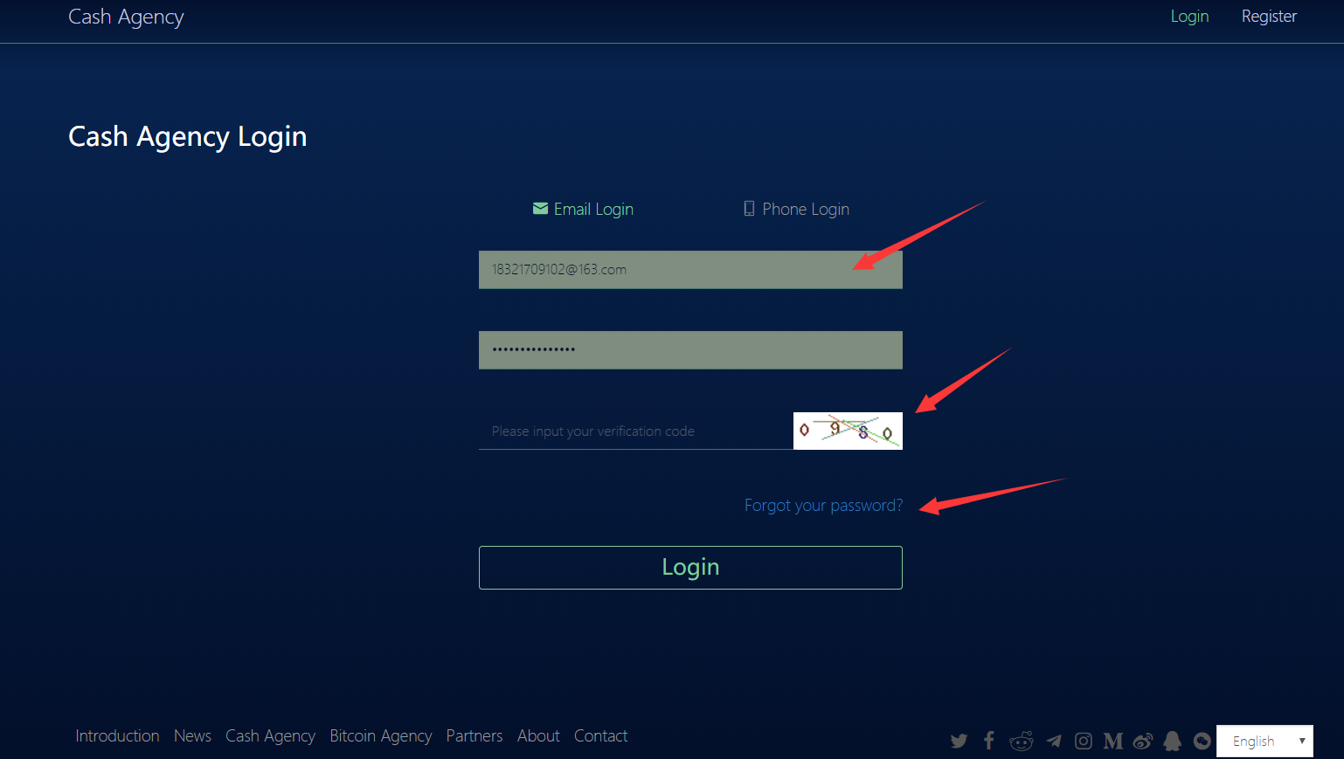

Enter the account, password and verification code for login. (if you forget the password, you can forget the password and reset it)

3.2 mobile phone account login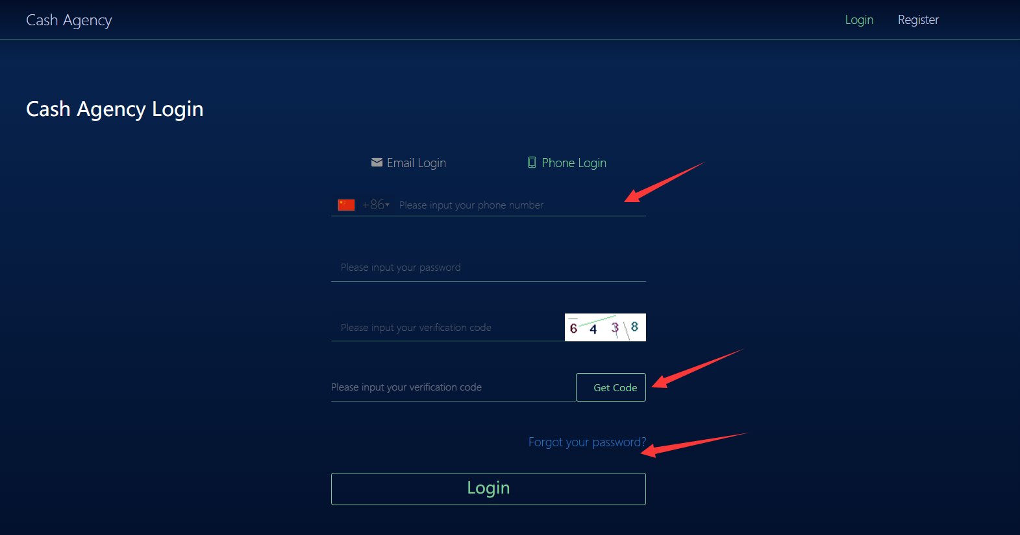

Fill in the login information and require the phone verification code to log in. (if you forget the password, you can forget the password and reset it)

**3：Interface management**

3.1 account homepage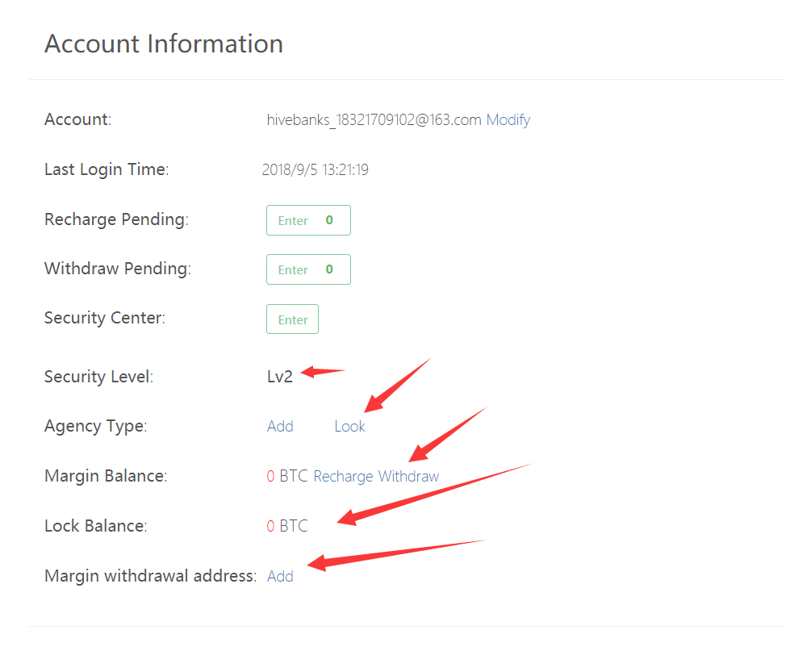

3.2 safety center

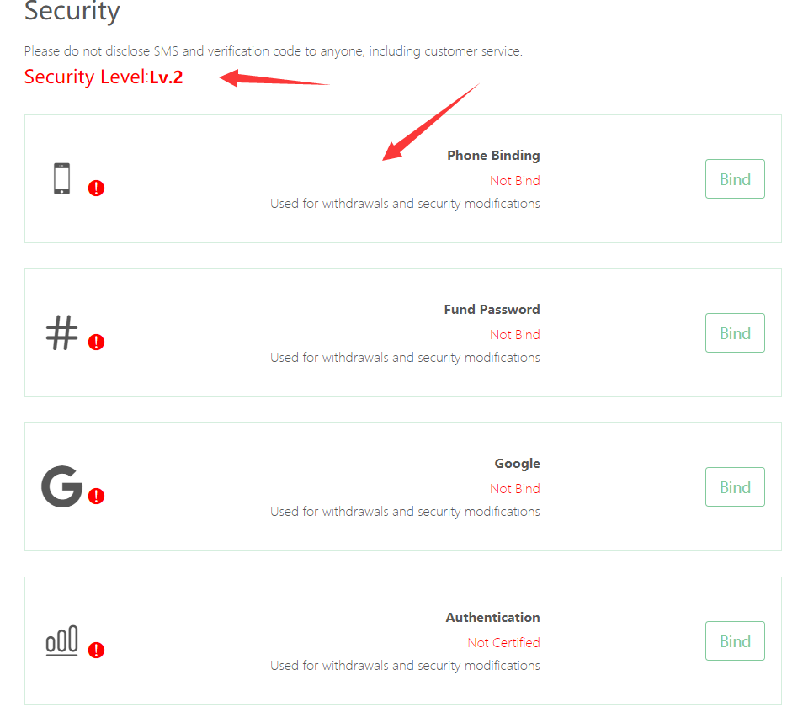

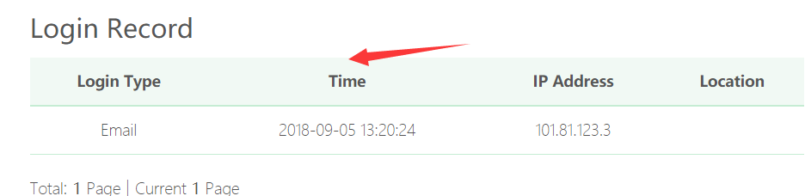

This page displays a summary of the binding information currently used, and a user level display, where user login records can be viewed.

3.3 deposit recharge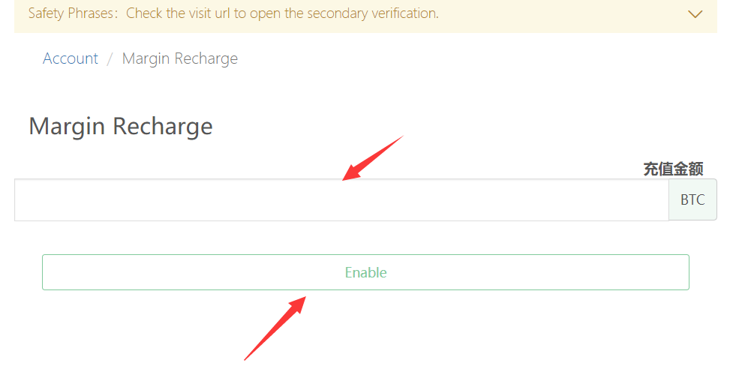

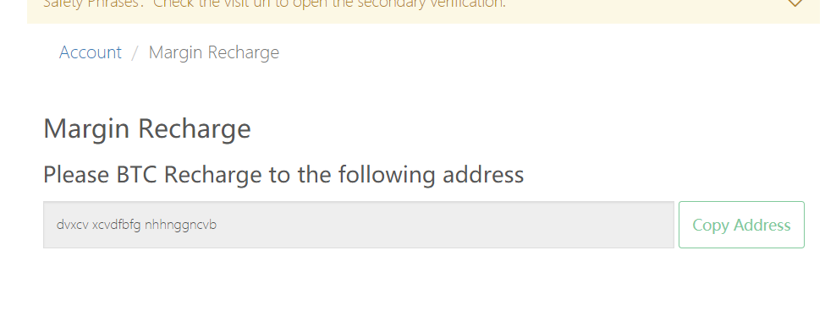

Enter the recharge amount, click ok, and then recharge to the given address through the channel

3.4 margin withdrawal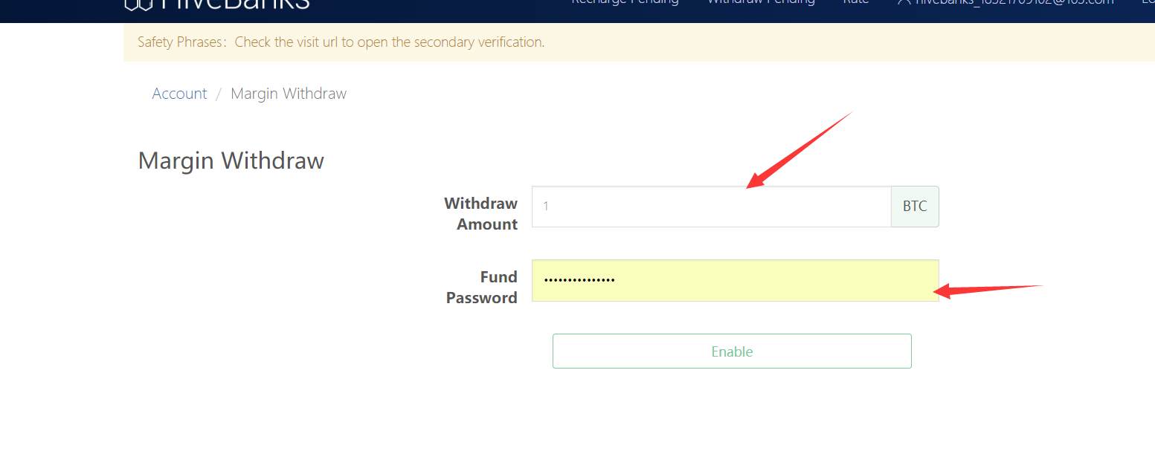

Please wait patiently after clicking withdraw, the amount will be transferred to your personal account.

**The bank system legal currency agent management interface introduced to this end. Thank you for your use!**