**HIVEBANKS** **Banking system setup configuration**

**1：Download the bank software package and unzip it into the directory specified by the domain name**

**2：Open the browser and enter the create directory domain name（For example：**<http://hbapi.fnying.com/api/la/la_setting_setp_one.php> **The domain name is the name written to the script when the server is configured. This example access is not guaranteed to be valid）**

The following page is displayed: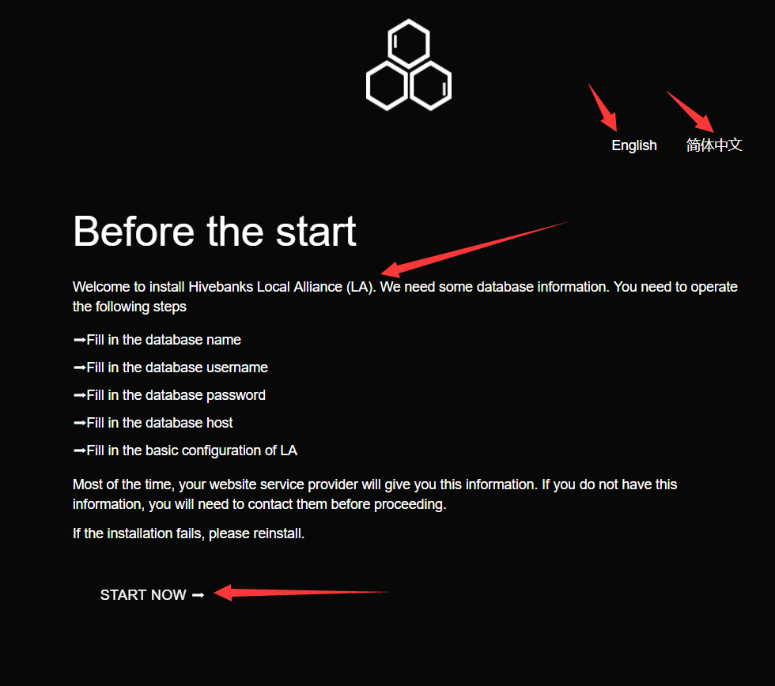

Click now to start the installation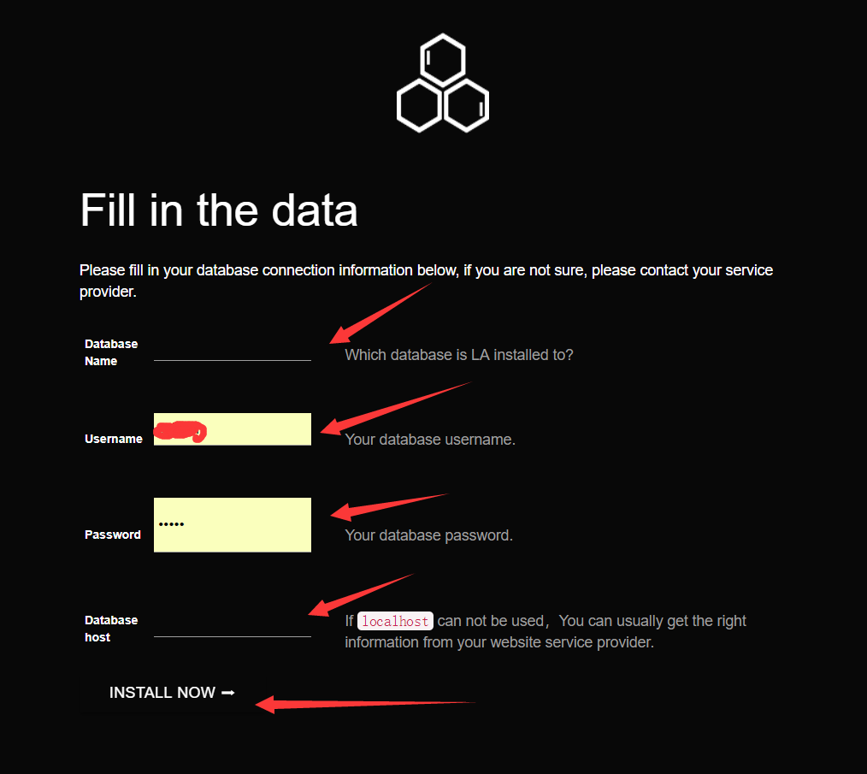

The database user name here is the database name (root by default) and password entered when the server is configured. The database host is the IP of the server. The database name is the host name you want, so feel free to fill it out.

Click the install now to continue

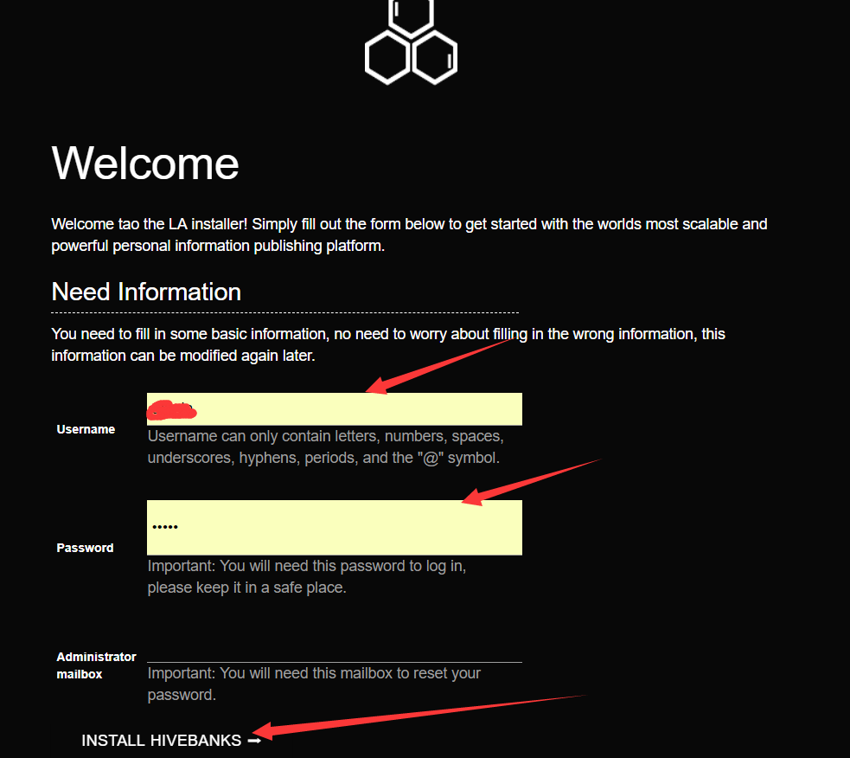

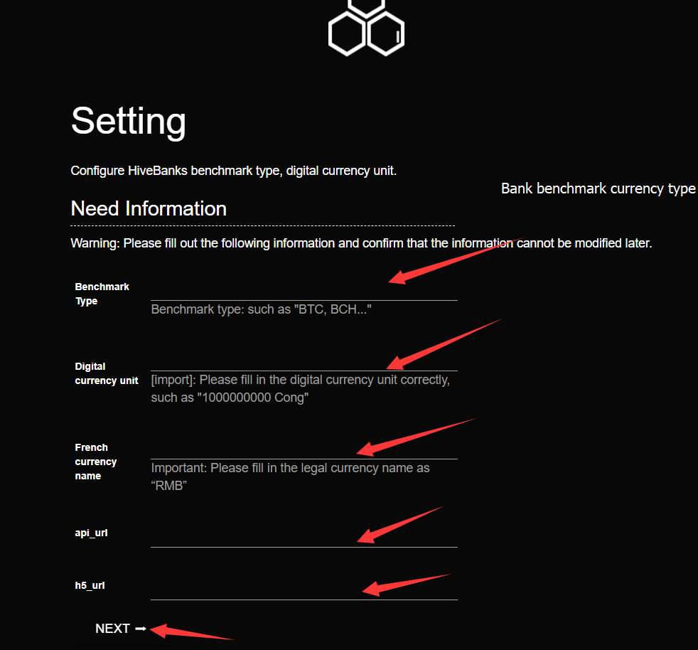

The above information is a sample, which may not be accessible now. The configuration of the front-end background address of the server refers to the server configuration. The domain name of the server is the domain name that is filled in when the server is configured. Note that there is no backslash at the end.

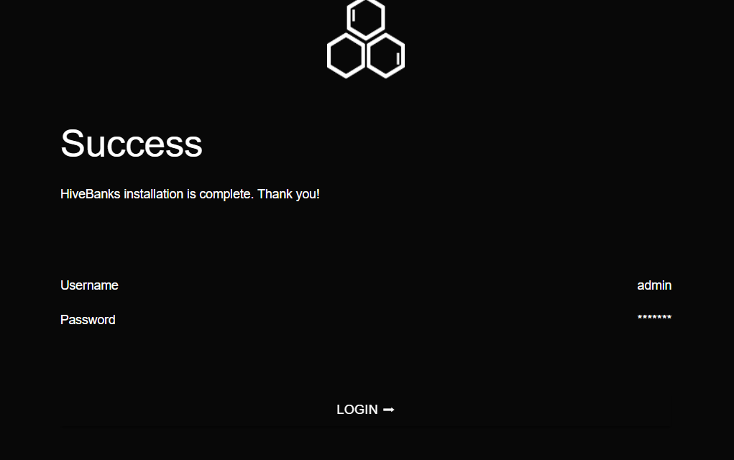

Click login to jump to the login interface, and fill in the information accurately, then you can use it normally (the user name and password are the contents filled in in step 3).

**3：After completing the above steps, enter the configured front-end page in the browser to log in**

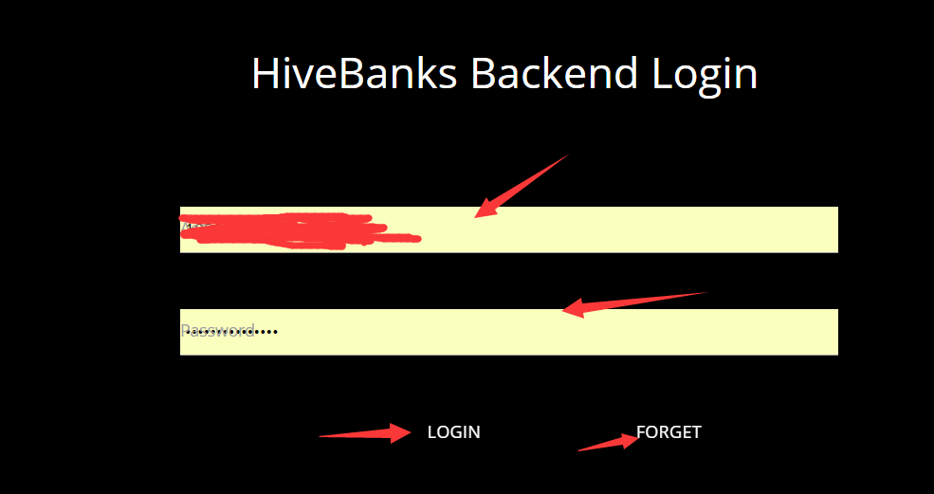

You can click login. If you forget your password, you can reset it by using the "forget password" button. Remember the email account of Scorpio when you created la.

Note: if mail account is lost, it may be completely lost

**4：After the completion of la login, the basic configuration is made. The default configuration may fail to realize the function, and the configuration is made according to the prompt**

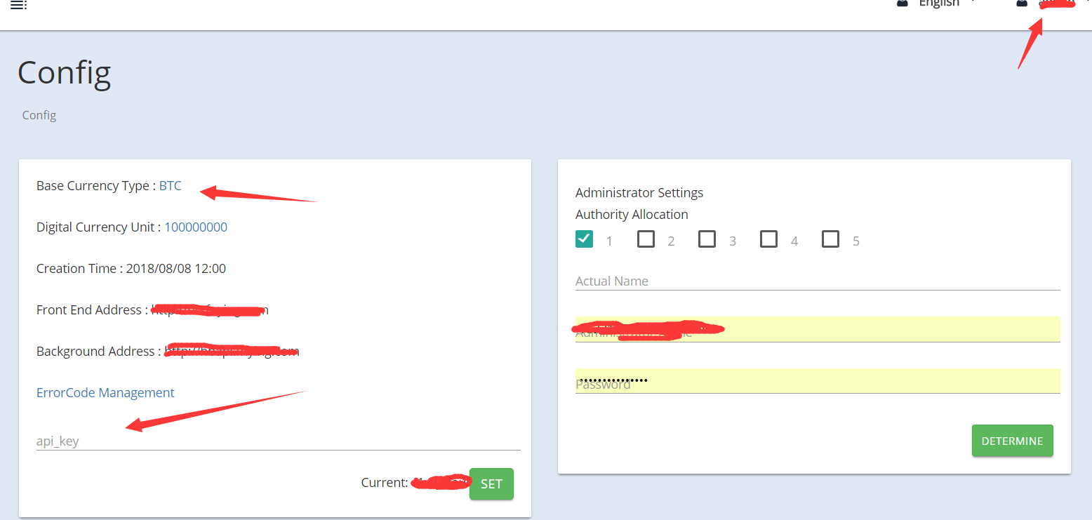

The front-end address and background address are the configuration when the system is created, and the administrator's add is the super administrator's permission (the default is super administrator when the first login is set up).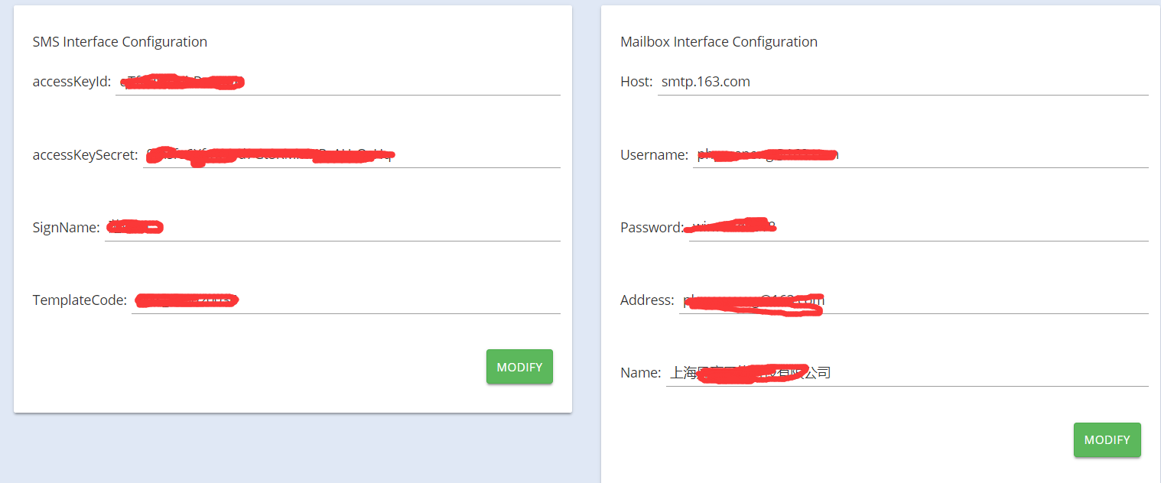

**Note: the email authorization code is not the email password. It is the permission code that the mail service allows third parties to call the email. (there are authorization code tutorials on the website, but I won't elaborate here.)**

**The server of mailbox is different according to mailbox type**

**For example: 163 email: SMTP server: smtp.163.com**

**Qq mailbox: SMTP server: smtp.qq.com**

**Common port number: 465**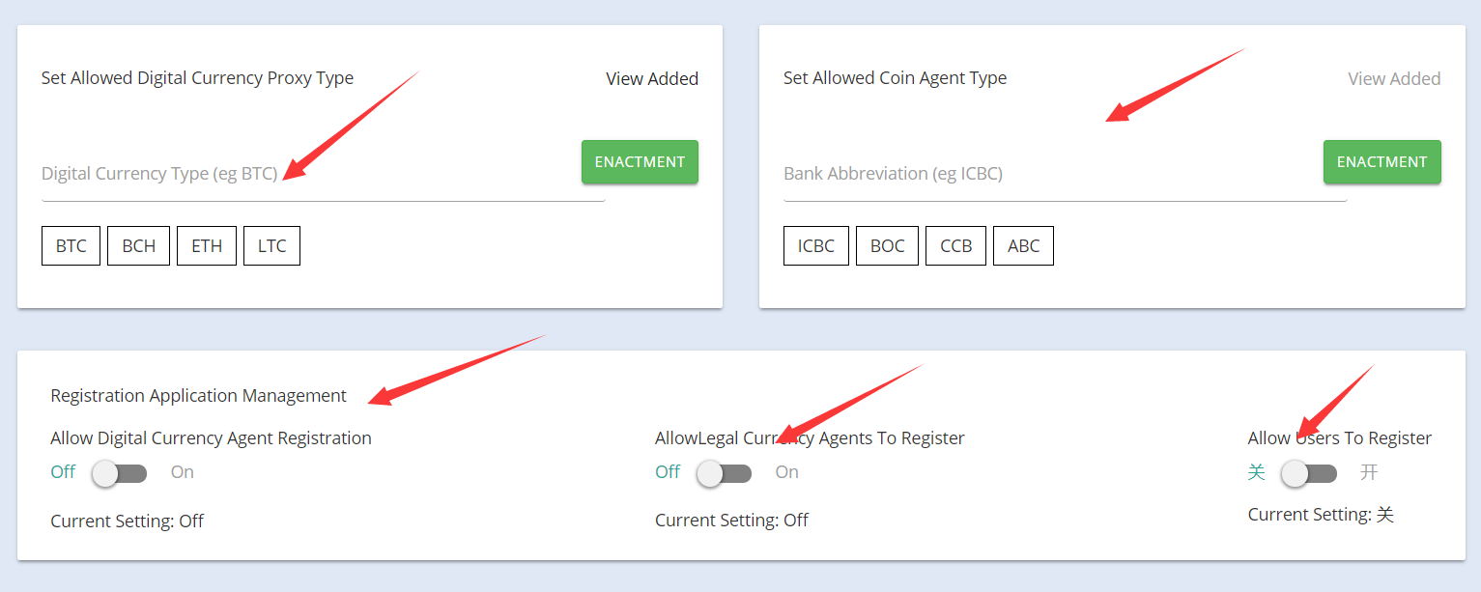

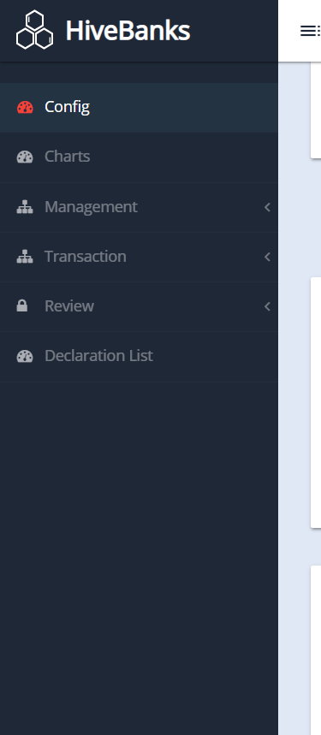

**This page is the administrator's administration page that displays administrative information within the allowed scope.**

**The banking system installation and la management interface are introduced to this basic end. Thank you for your use!**