**HIVEBANKS users use tutorials**

**1: log on to the home page of the digital bank (the domain name /h5 of the server configuration, for example, when I configured the server domain as www.baidu.com, then the front-end access domain is www.baidu.com/h5 and the back-end access page is** [www.baidu.com/api](http://www.baidu.com/api)**).**

Existing accounts are directly logged in, new users can register and create new accounts, and digital currency agents and legal currency agents are agents registered

**2：registered**

1 If the following page is displayed, please wait for the administrator to open the registration authority, or contact the administrator (you can directly login to the existing account).

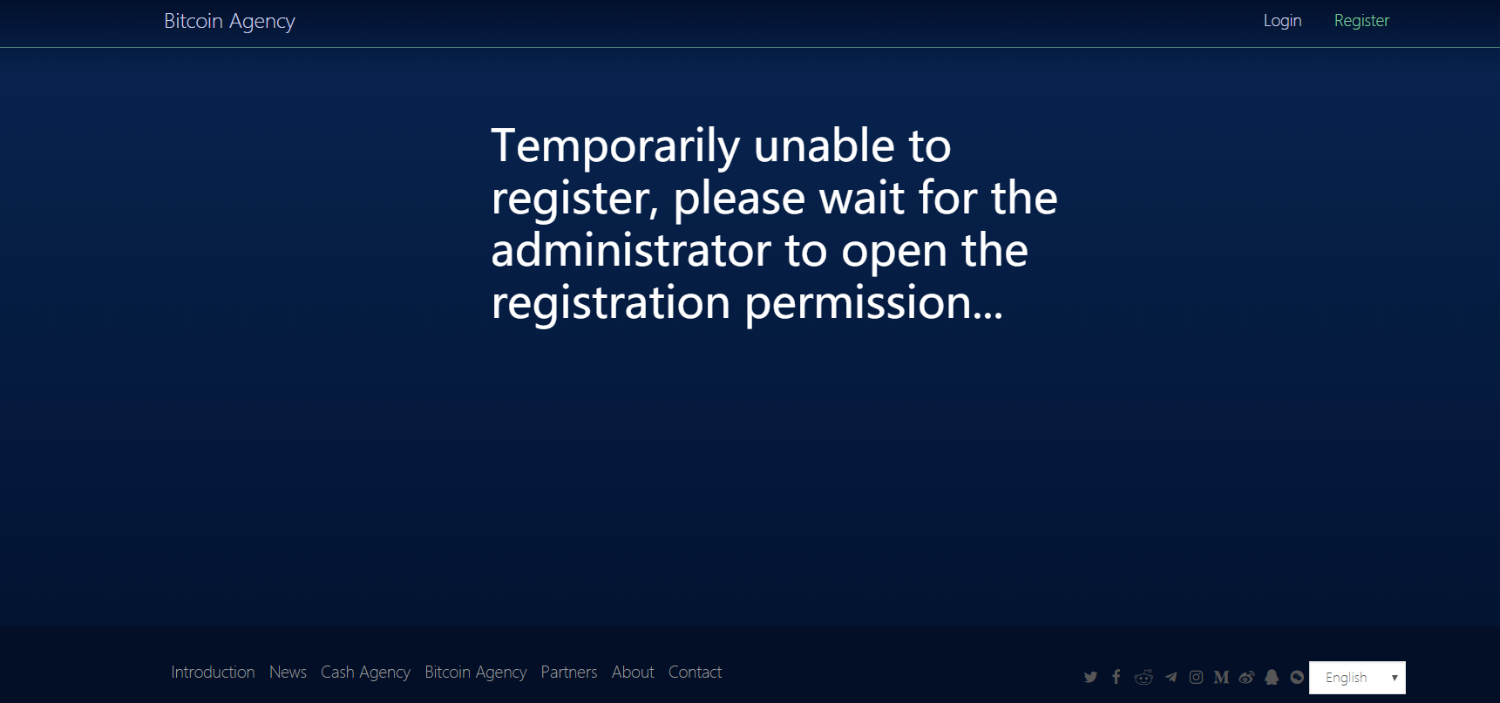

2 registered

2.1 email registration (invitation code optional)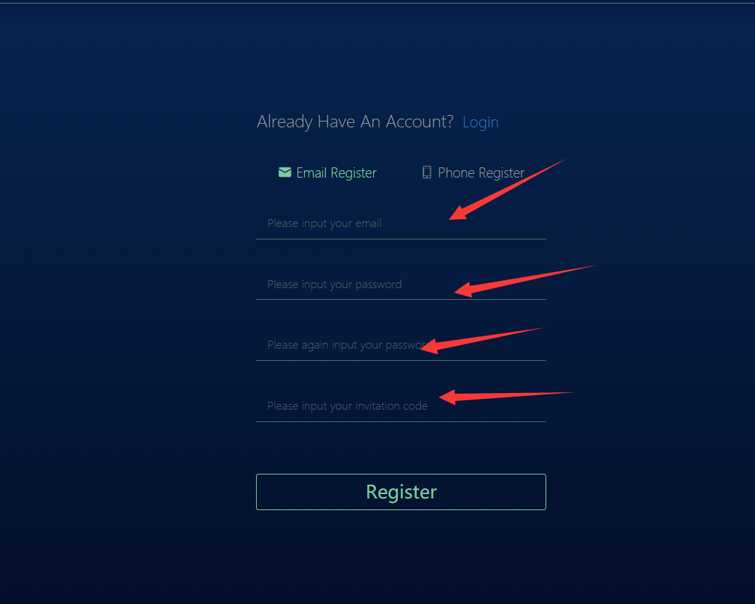

After filling in the information, click registration to send a confirmation email link to the registered email account. Click the link to complete the registration.

2.2 mobile phone registration (optional invitation)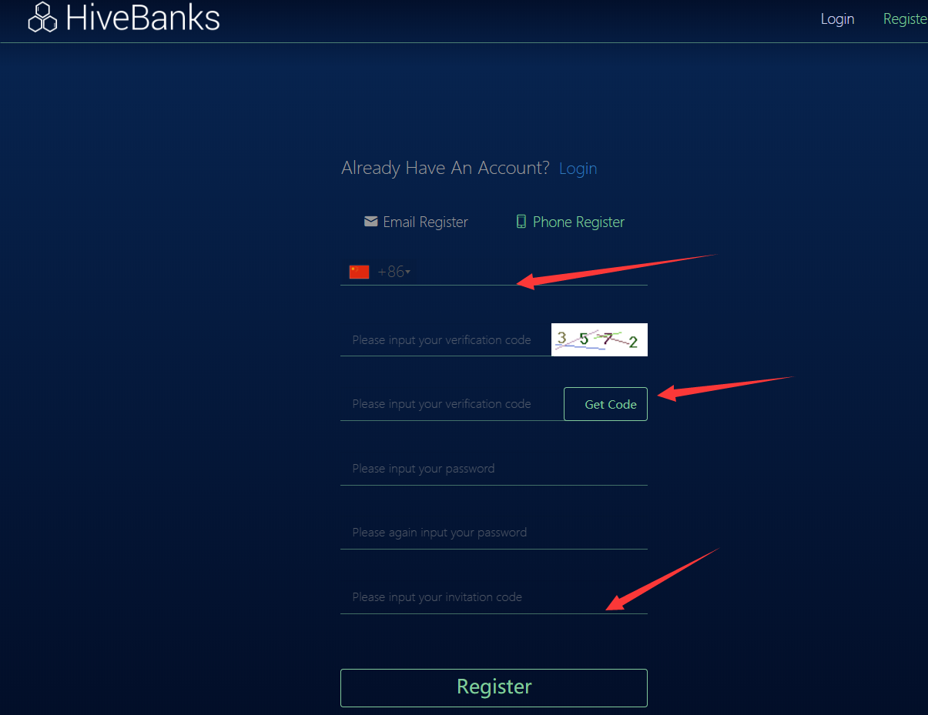

Mobile phone registration needs to select the country code, click to obtain the verification code will be sent to registered mobile phone SMS. Then fill in the information to complete the registration and login.

3 the login

3.1 email account login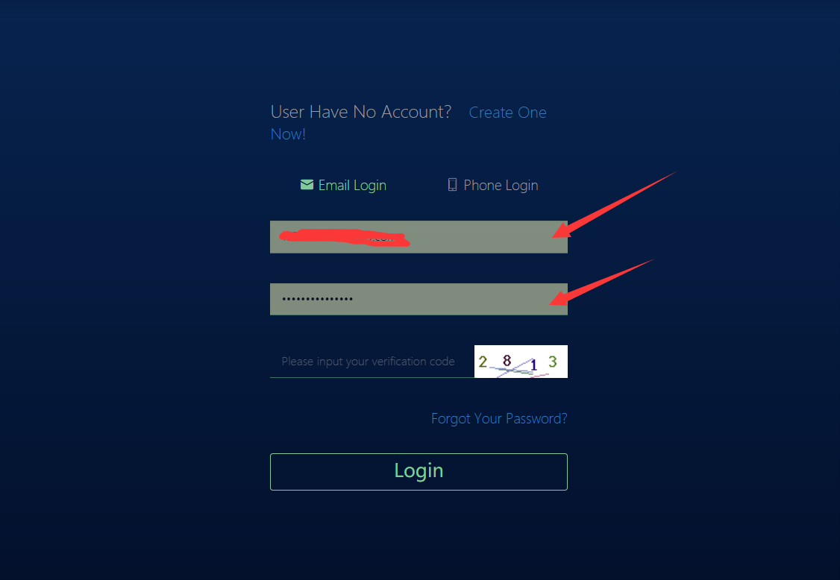

Enter the account, password and verification code for login. (if you forget the password, you can forget the password and reset it)

3.2 mobile phone account login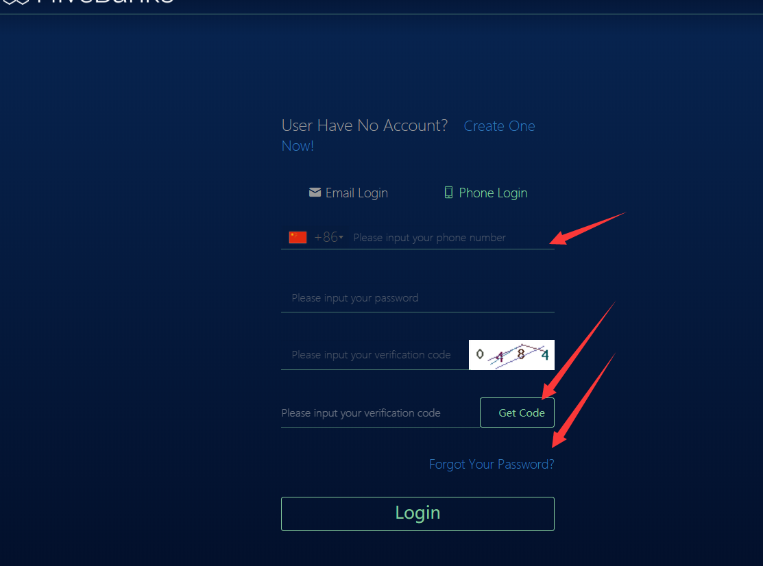

Fill in the login information and require the phone verification code to log in.

**3：Interface management**

3.1 The first page of the account, the following page shows the user's basic information, as well as the user's withdrawal recharge and account change record viewing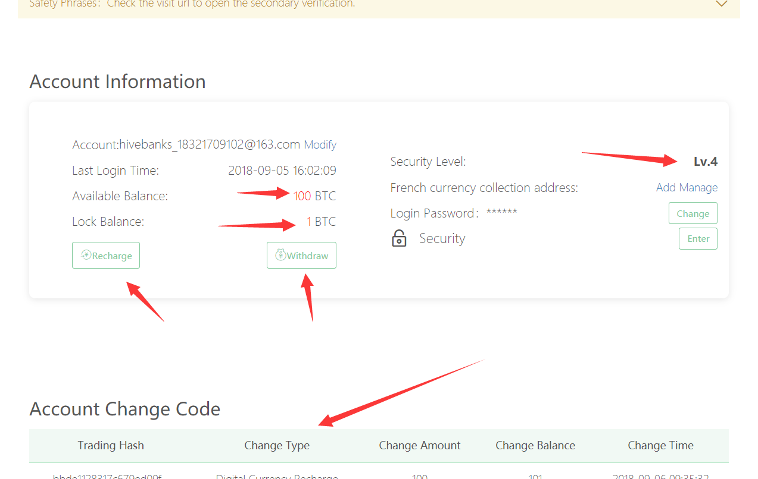

3.2 Security center

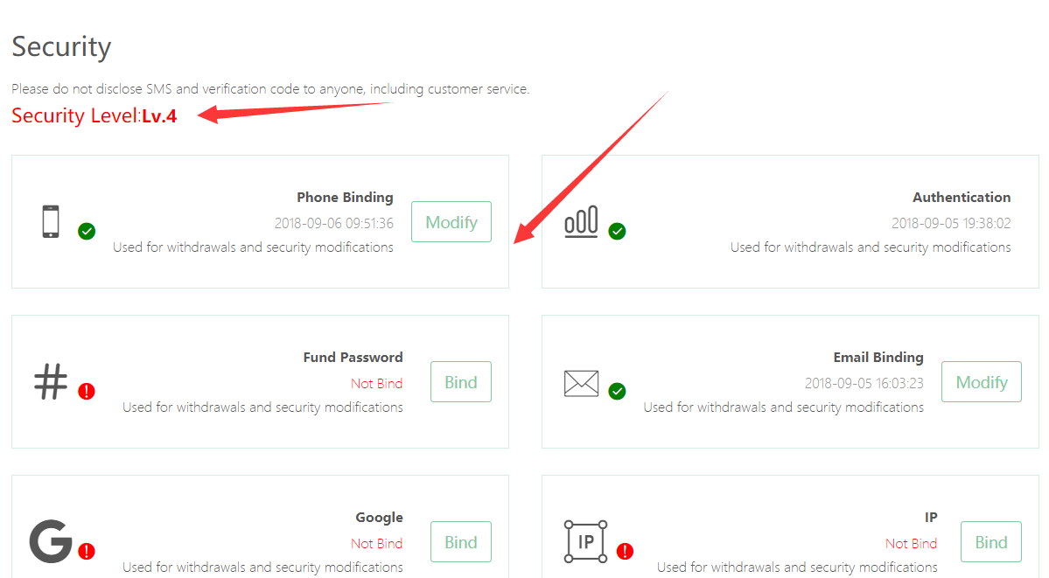

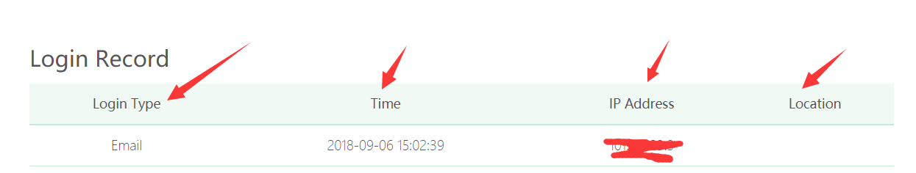

**This page shows the user level and whether the information is bound, and the account level affects the use of the user's withdrawal and recharge authority. User login records can be queried on this page.**

**3.3 account top-up**

**3.3.1 digital currency recharge**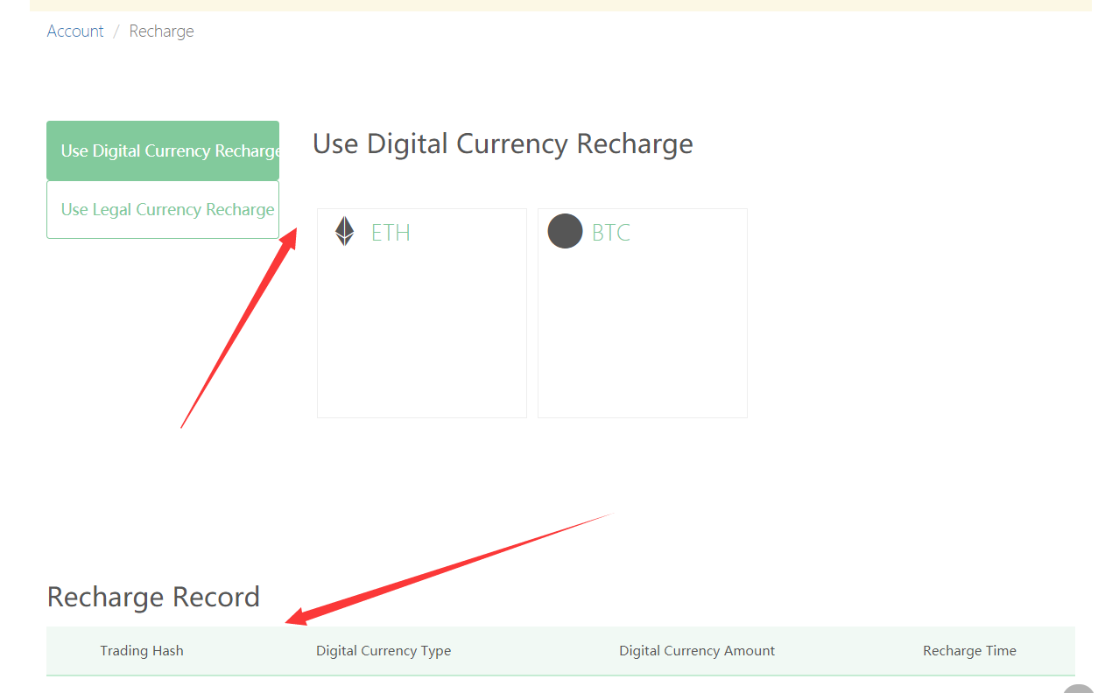

**This page views the current bank opened and available ba account type, mouse over to view the exchange rate, the current page can also view the recharge record. Selection of recharge type (legal currency/digital currency)。**

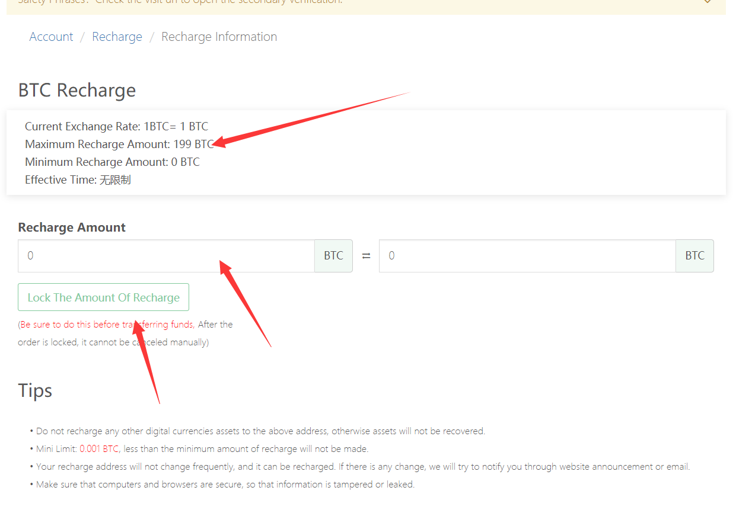

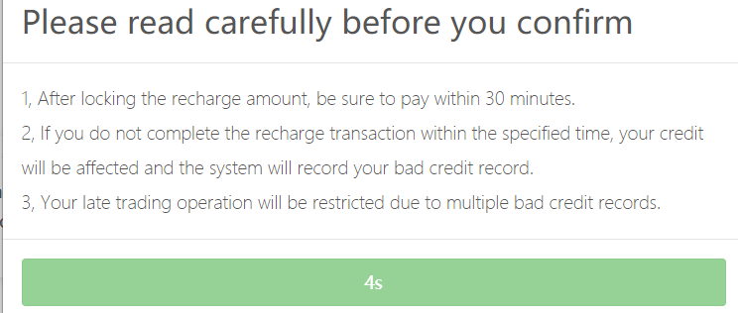

**The current page is the recharge details page, view the exchange rate, input the amount to recharge.** **Please read the tips carefully.**

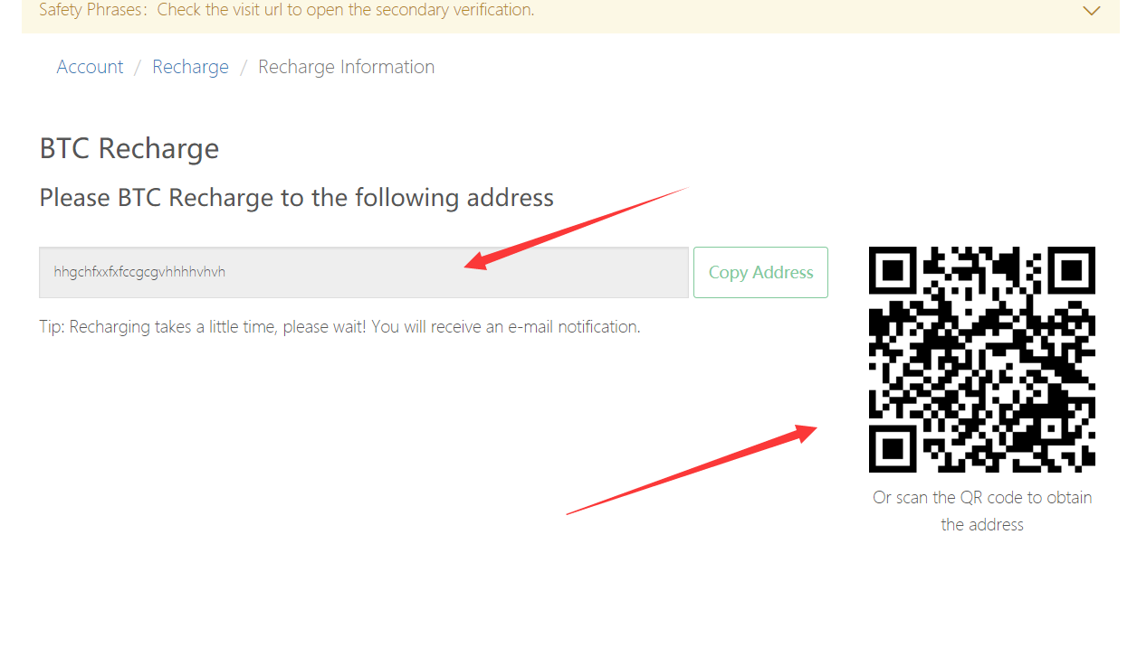

**On this page, users can pay by scanning the code or entering the address on the app.**

**3.3.2 legal currency recharge**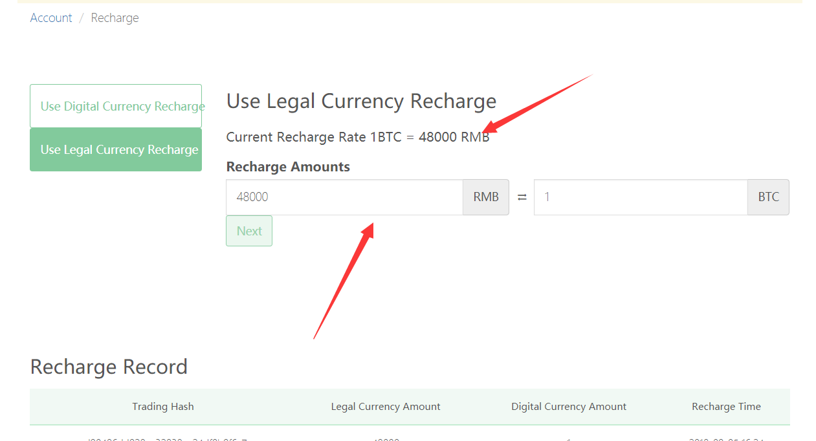

**This page looks at the current bank-opened and available ca account type, and the current page also looks at the recharge record. Select recharge type (legal currency/digital currency).**

**3.3.3 select recharge channel**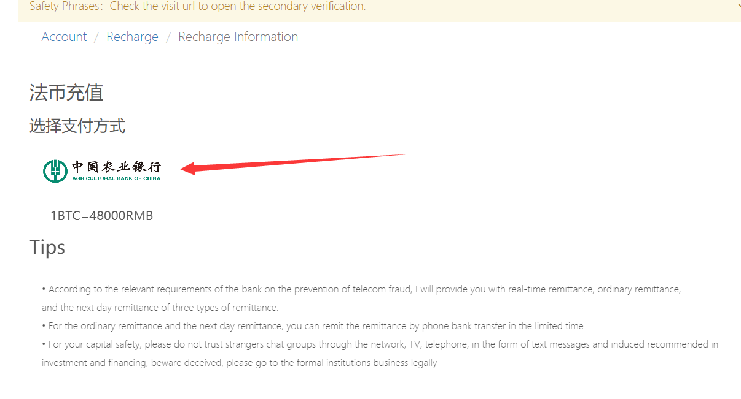

**Check the recharge mode on this page, check whether the exchange rate has not changed, and select good recharge mode**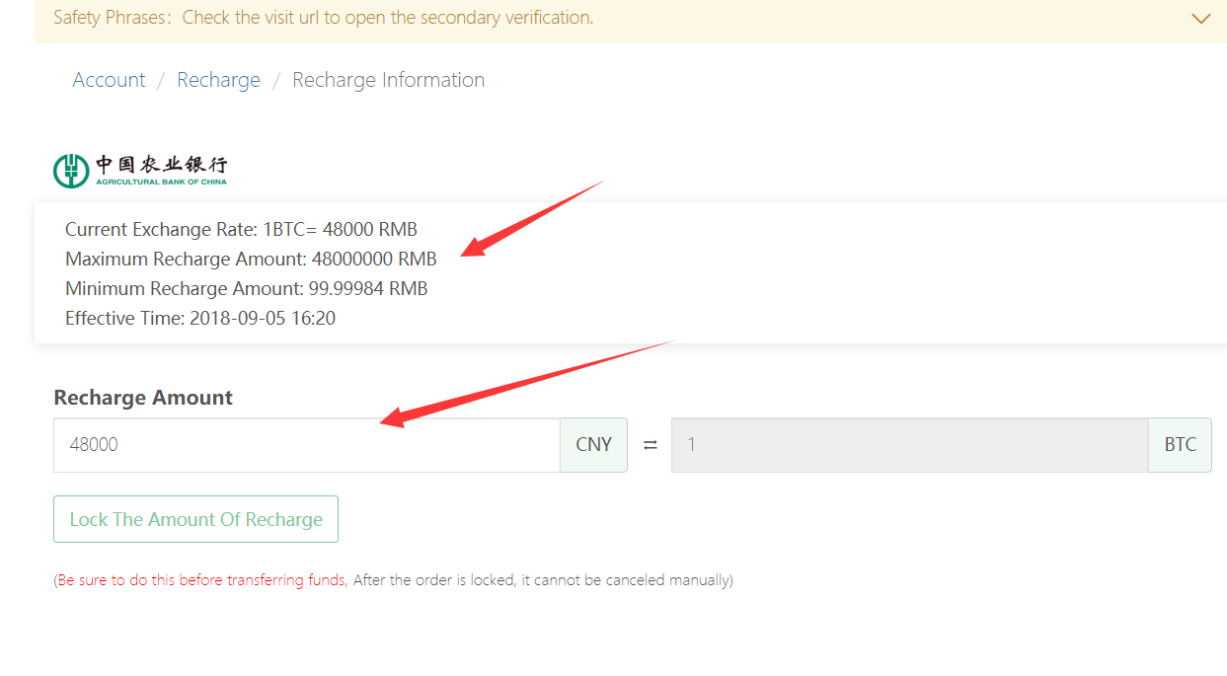

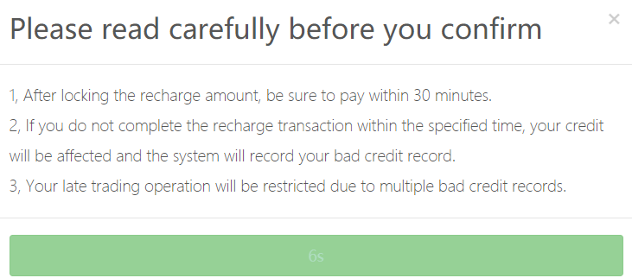

**The current page is the confirmation page. Please pay attention to exchange rate changes and operation confirmation information.**

**Recharge details:**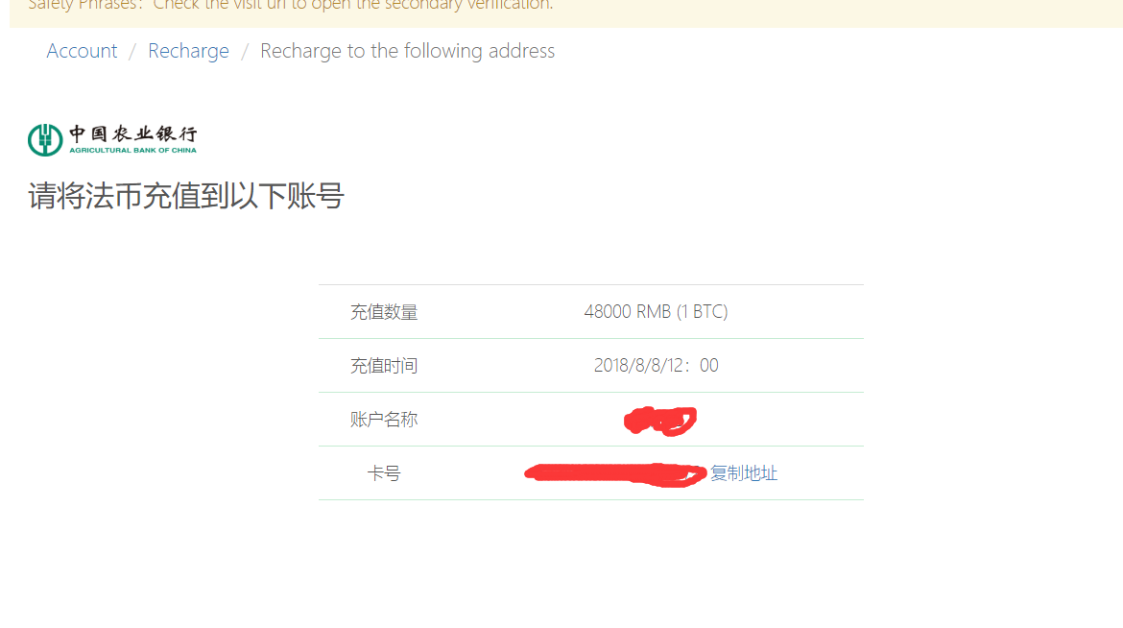

**To verify the recharge information, click "lock" to display the information details page.**

**3.4 account withdrawal**

**3.4.1 digital currency withdrawal**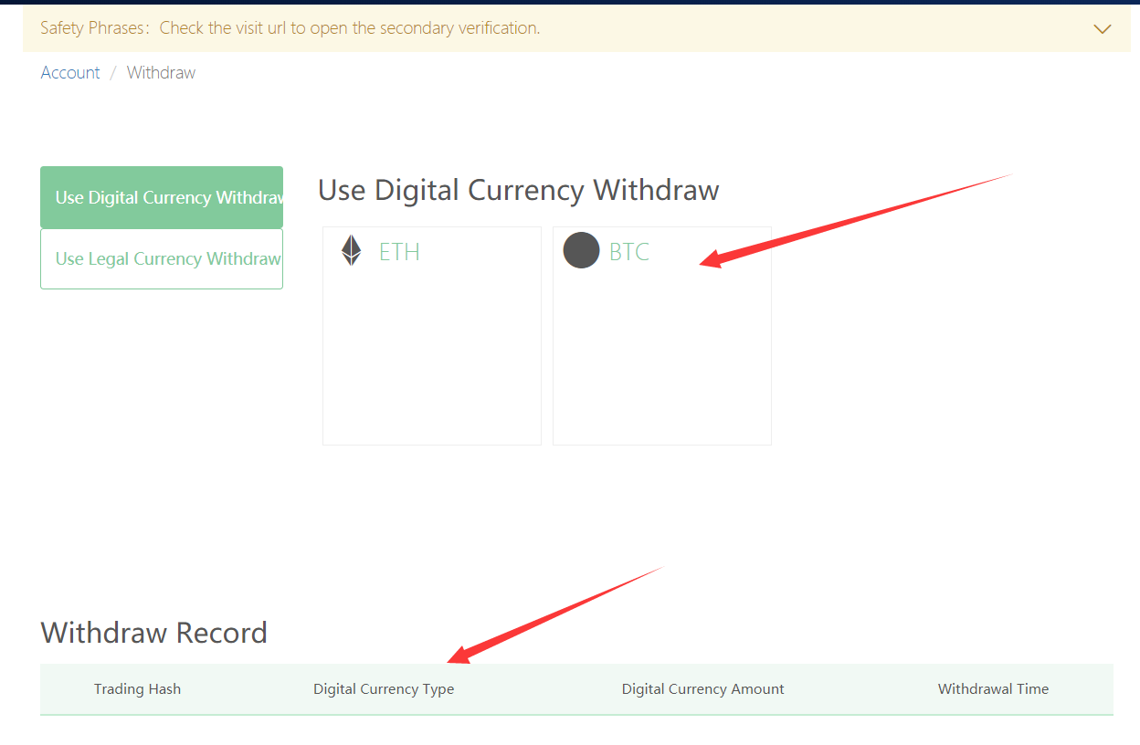

**The page displays the selection of digital currency agents and withdrawal options, with the account's transaction records displayed at the bottom of the page.**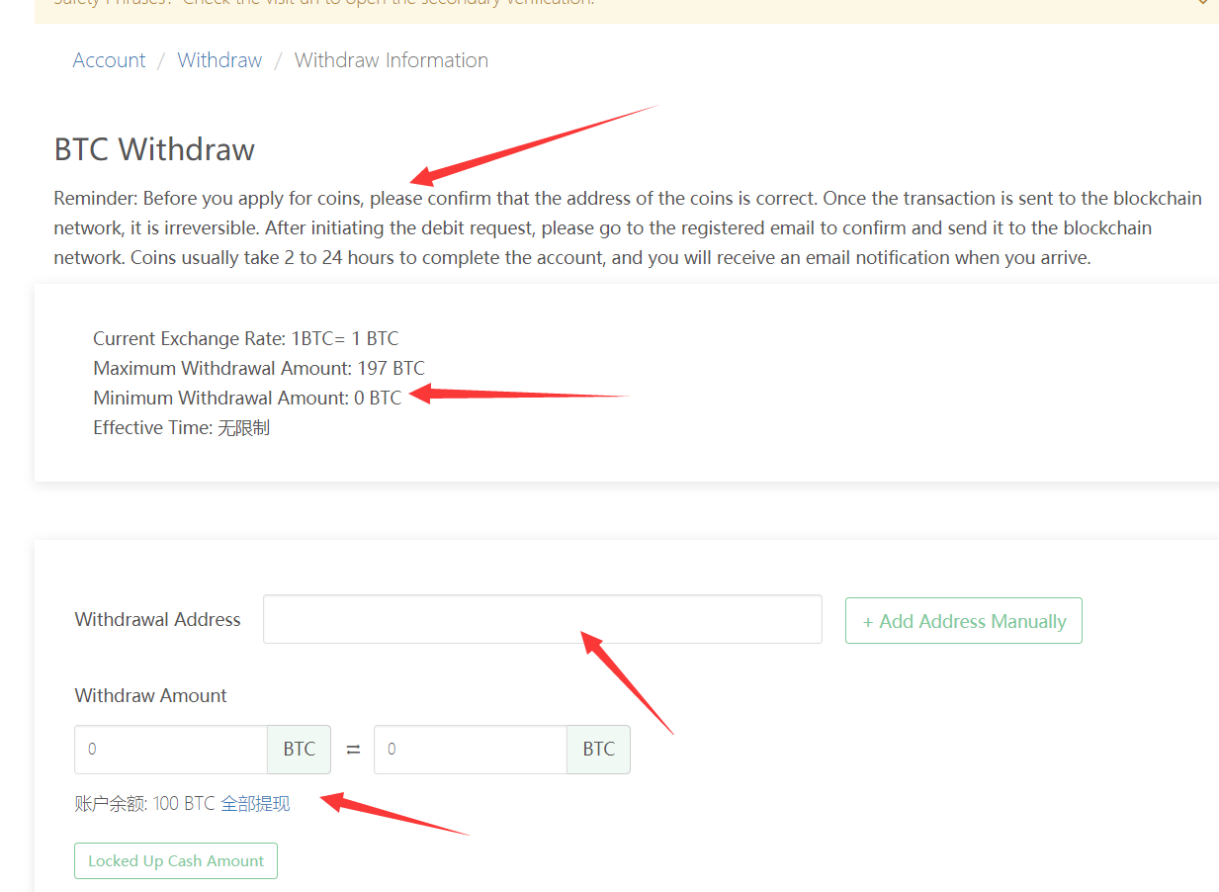

**Enter the withdrawal amount and withdrawal address on the current page, and lock the amount after confirmation, waiting for the completion of remittance to complete the withdrawal**

**3.4.2 withdrawal of legal currency**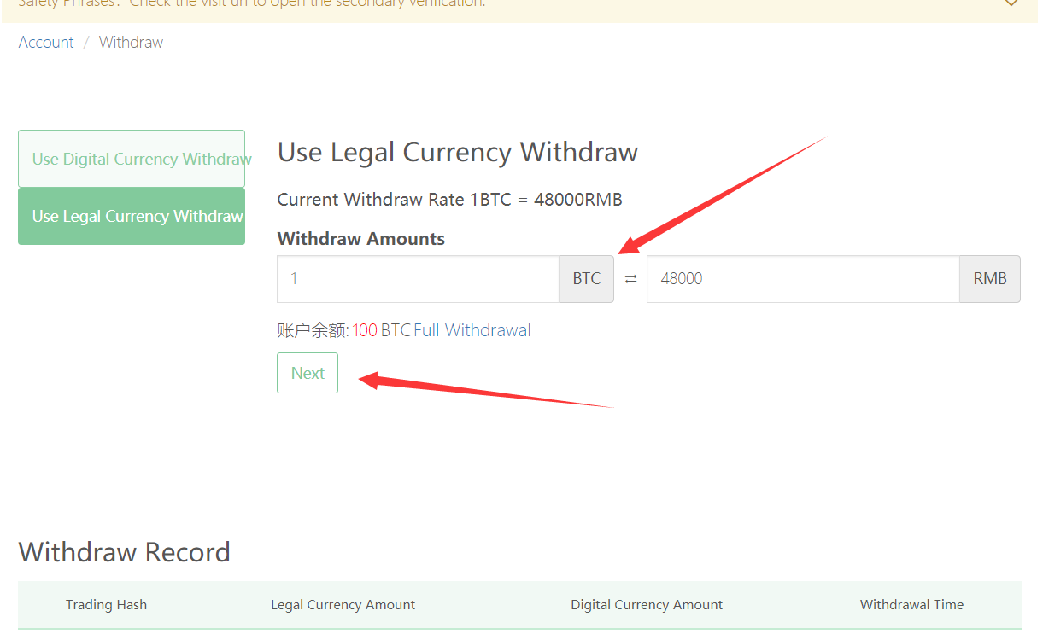

**In this page, we fill in the amount we need to withdraw for the first time (this is to assign your legal currency agent and choose a more reasonable payment method).**

**Going forward we can see the ca list of compliance and its exchange rate options.**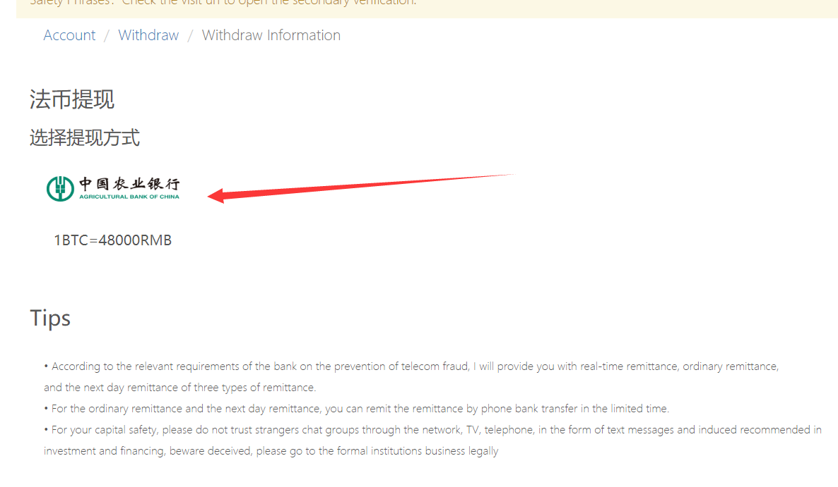

**Click again to enter the final step of the confirmation page, and select the account that has been bound to withdraw. Finally, the order information is displayed.**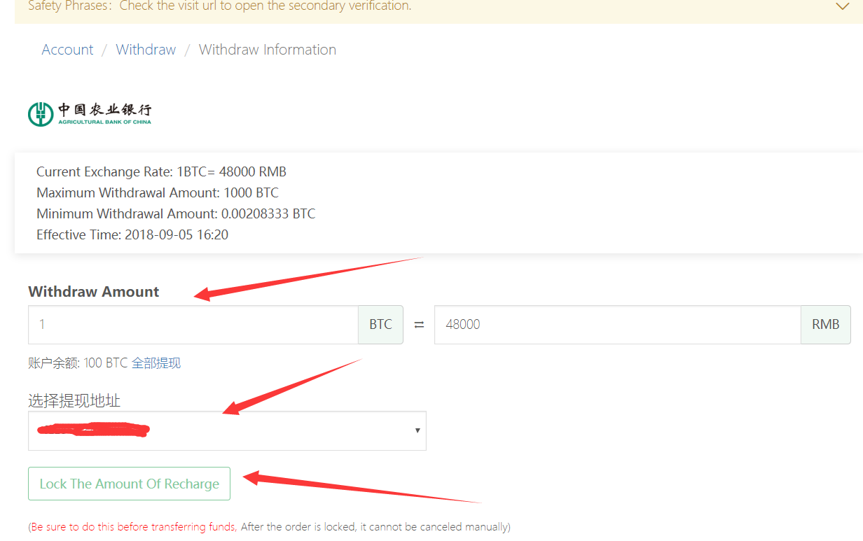

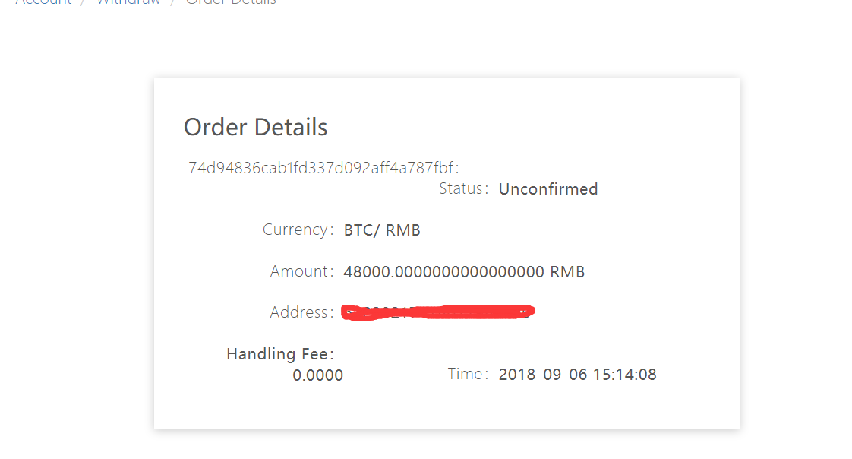

**Banking system user management interface introduced to end. Thank you for your use!**