**Ali cloud server configuration tutorial**

**1: connect to the server remotely through the tool or the official website of the server and switch to root**

**2: download the script and run the following command**

Run the SSH server username @server IP and enter the server username password to log in

Sudo su (get root authority)

wget -O /hivebanks.tar http://doc.fnying.com/environment/hivebanks.tar && tar xvf /hivebanks.tar -C /（Download and unzip the script）

. /loading_system.sh（Run the script）

**3: configuration script information is as follows**

#!/bin/bash

apt-get -y update

# installation nginx

apt-get -y install nginx

# installation php

apt-get -y update

apt-get -y install software-properties-common

add-apt-repository --yes ppa:ondrej/php

apt-get -y update

apt-get -y install php5.6 php5.6-mcrypt php5.6-mbstring php5.6-curl php5.6-cli php5.6-mysql php5.6-gd php5.6-xml php5.6-fpm

# installation mysql

DEBIAN_FRONTEND=noninteractive apt install -y mysql-server

# installation git

apt-get -y install git

# installation jq

apt-get -y install jq

#change mysqld.cnf

sed -i "s/bind-address/#bind-address/g" /etc/mysql/mysql.conf.d/mysqld.cnf

#restart mysql

service mysql restart

# change on session

sed -i "s/session.auto_start = 0/session.auto_start = 1/g" /etc/php/5.6/fpm/php.ini

#restartphp-fpm

service php5.6-fpm restart

# Create a file

mkdir /alidata

mkdir /alidata/www

mkdir /alidata/log

mkdir /alidata/log/nginx

mkdir /alidata/log/hivebanks

mkdir /alidata/www/hivebanks

mkdir /alidata/www/h5_hivebanks

sudo git clone https://github.com/ly-iOSer/hivebanks.git /alidata/www/hivebanks/

sudo git clone https://github.com/ly-iOSer/h5_hivebanks.git /alidata/www/h5_hivebanks/

#phpCreate profile

php /create_hivebanks_conf.php

php /create_h5_hivebanks_conf.php

# The domain name configuration

#api_url=`cat config_url.txt | jq -r '.api_url'`

#sed -i "s/example.com/$api_url/g" /create_hivebanks_conf.php

#h5_url=`cat config_url.txt | jq -r '.h5_url'`

#sed -i "s/example.com/$h5_url/g" /create_h5_hivebanks_conf.php

read -t 300 -p " Please enter the interface address (no http://):" api_url

sed -i "s/example.com/$api_url/g" /etc/nginx/conf.d/hivebanks.conf

read -t 300 -p " Please enter the front-end address (no http://):" h5_url

sed -i "s/example.com/$h5_url/g" /etc/nginx/conf.d/h5_hivebanks.conf

# Restart the nginx

service nginx restart

# Execute mysql to grant remote connections

read -t 300 -p " Please enter the database password (root):" mysqlpassword

sed -i "s/123456/$mysqlpassword/g" /set_mysql.php

php /set_mysql.php

# Give file permissions

chown -R www-data:www-data /alidata

chown -R www-data:www-data /alidata/www/hivebanks

chown -R www-data:www-data /alidata/www/h5_hivebanks

# Delete the file

rm -rf /t.tar

rm -r /loading_system.sh

rm -r /create_hivebanks_conf.php

rm -r /create_h5_hivebanks_conf.php

rm -r /set_mysql.php

echo " Congratulations, installed successfully..."

echo " Address of the interface:"$api_url

echo " The front-end address:"$h5_url

echo " Database user name:"root

echo " Database password:"$mysqlpassword

You can also download the [server configuration](http://doc.fnying.com/environment/t.tar) script and run it.。

The configuration process will show the following fragment, and fill in the interface address and database password according to the prompt. Configuration is done.

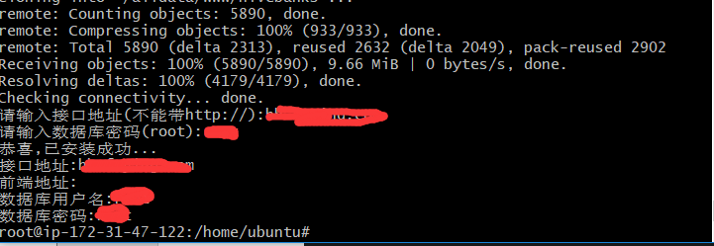

Note: the interface address here must be filled in otherwise the LA creation may fail. The database password may not be required, but it can be filled in correctly at the time of LA creation. Domain names are also available and the steps to resolve to the current server are not detailed.

**End of the ali cloud server configuration tutorial. Thank you for your use!**