**Ali cloud server purchase tutorial**

1. Click [ali cloud purchase process](http://www.acloudbest.com/goumai.asp) to learn about the detailed registration and purchase process

2. Login to ali home page and click the product to find the cloud server ECS, as shown below

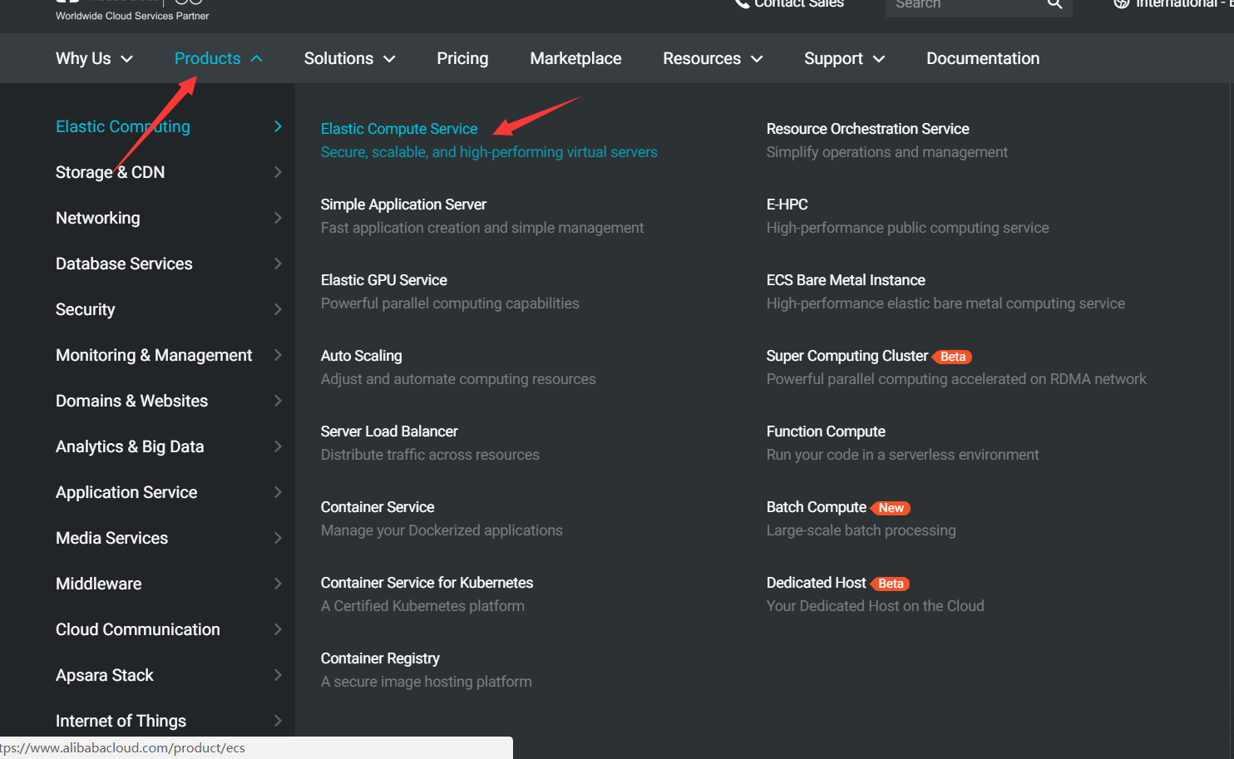

You can see that there are one-click purchases with custom purchases

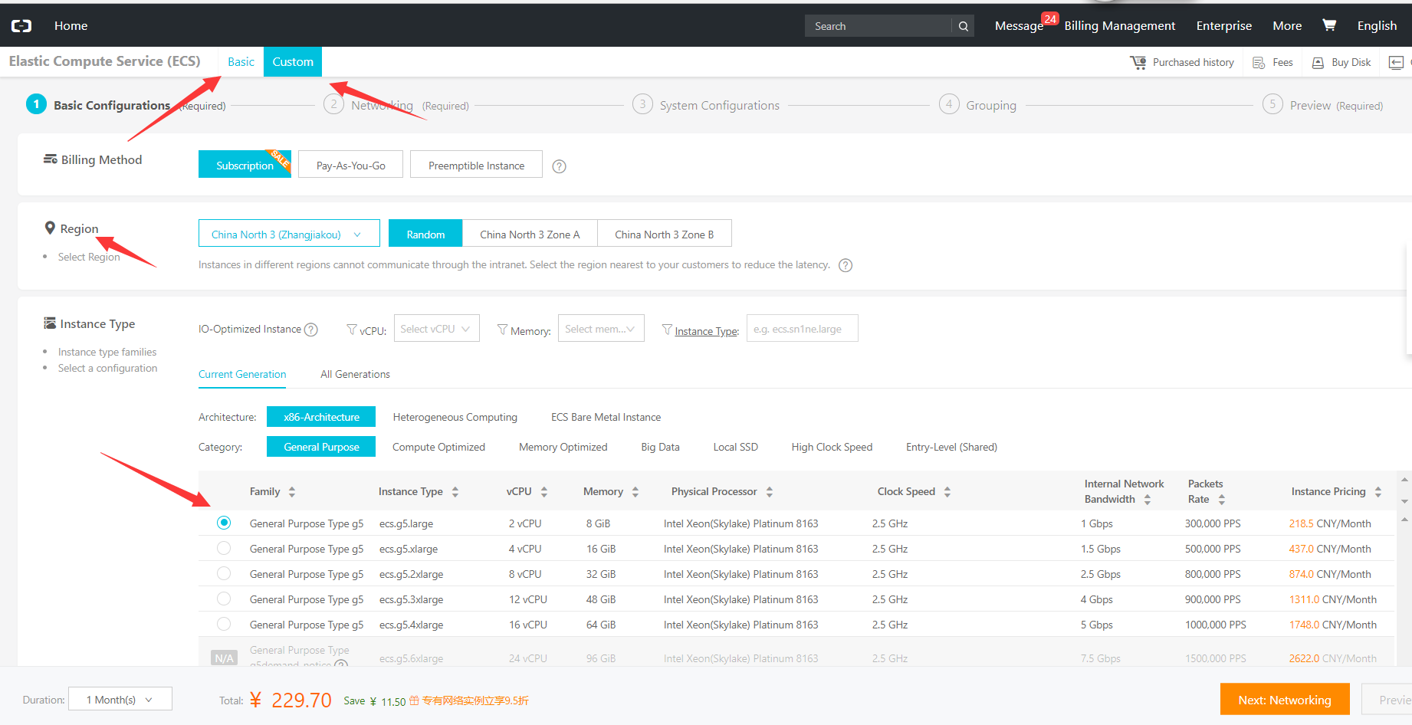

The following is the one-click purchase page, which gives the default location and instance information mirroring and version still needs to be selected by default. Multiple optional information is given by default. The installation system image recommends ubuntu 16.04 version and above

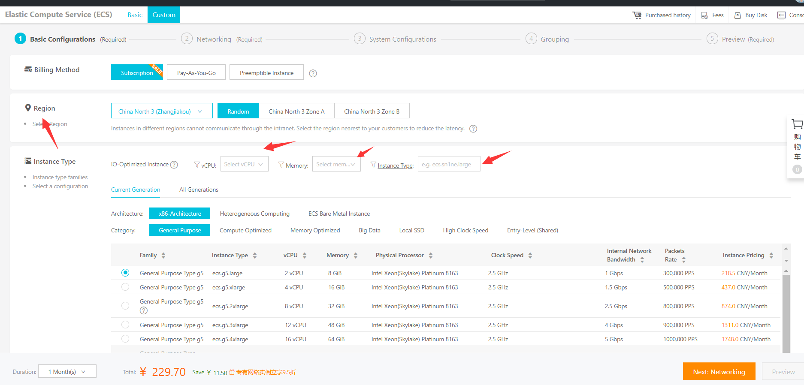

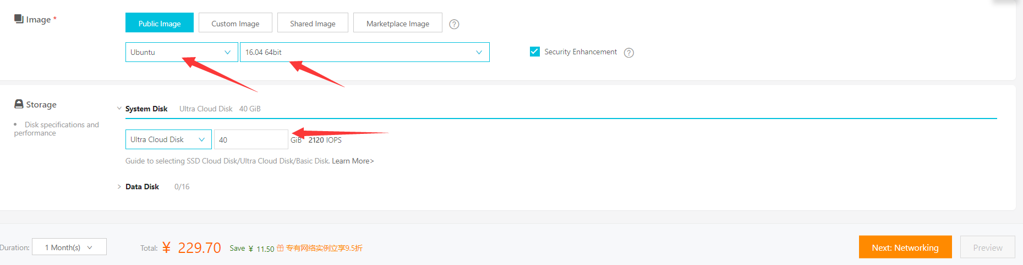

The following is the customized purchase page, which requires 5 steps to complete the operation. The logo is shown in the following figure. The customization purchase is highly optional



The second step in the network and security groups is to configure the selection or creation of the network and security groups

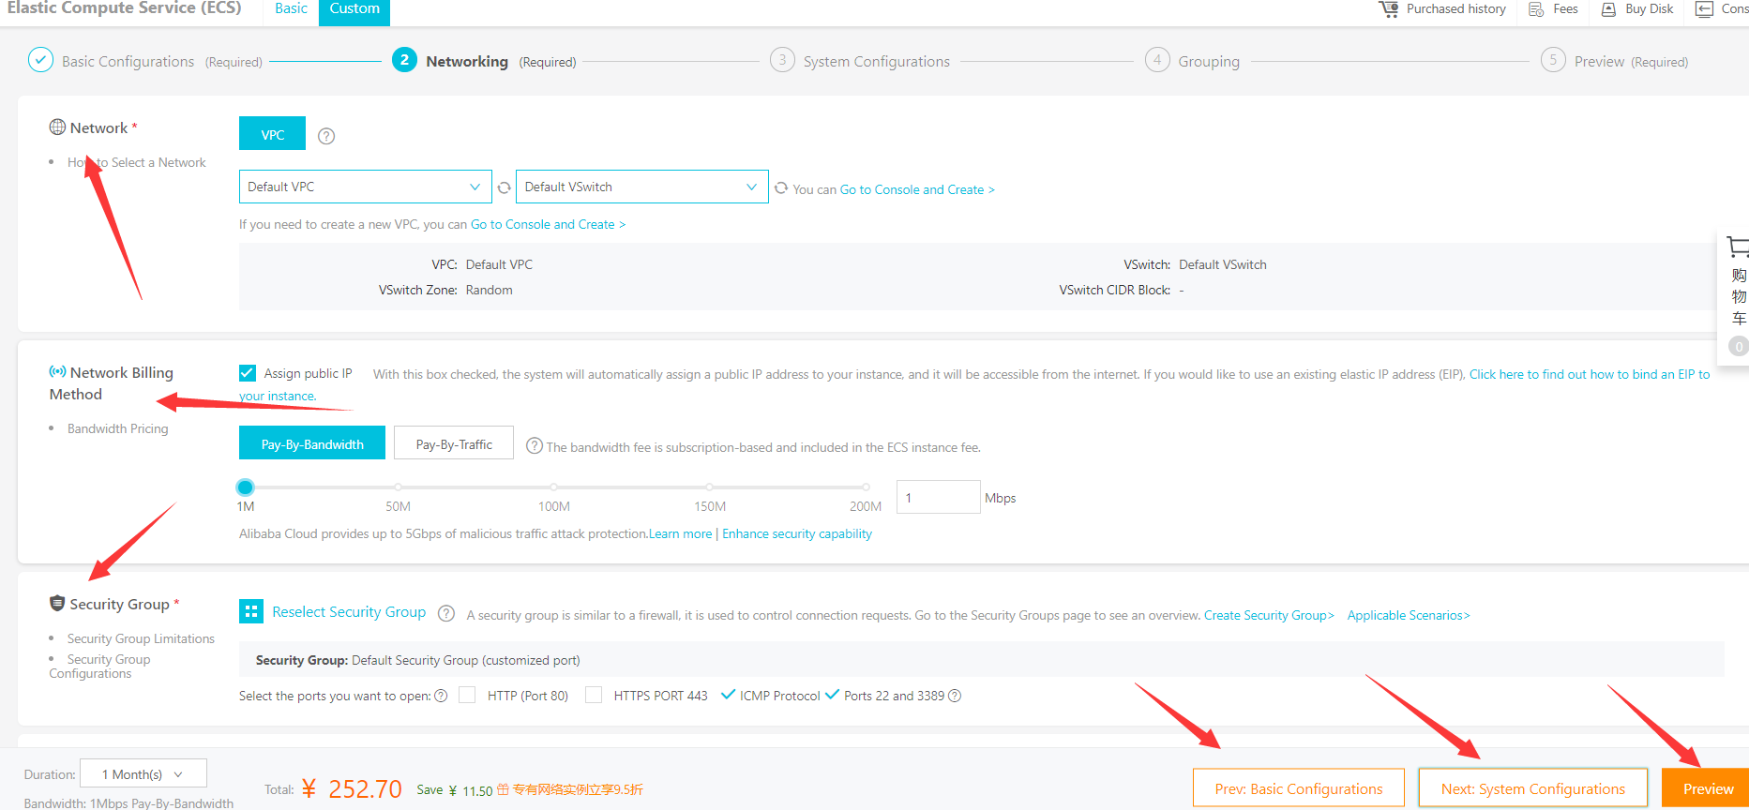

Step 3 in system configuration, the configuration of key pairs is the main one (remember or download to save)

Step 4 select resource group (skip)

Step 5 confirm the purchase information and make the order payment

3: security group configuration and new

Administrative console -> cloud server ecs-> security group, where the creation of security group as well as the establishment of security restrictions and rules

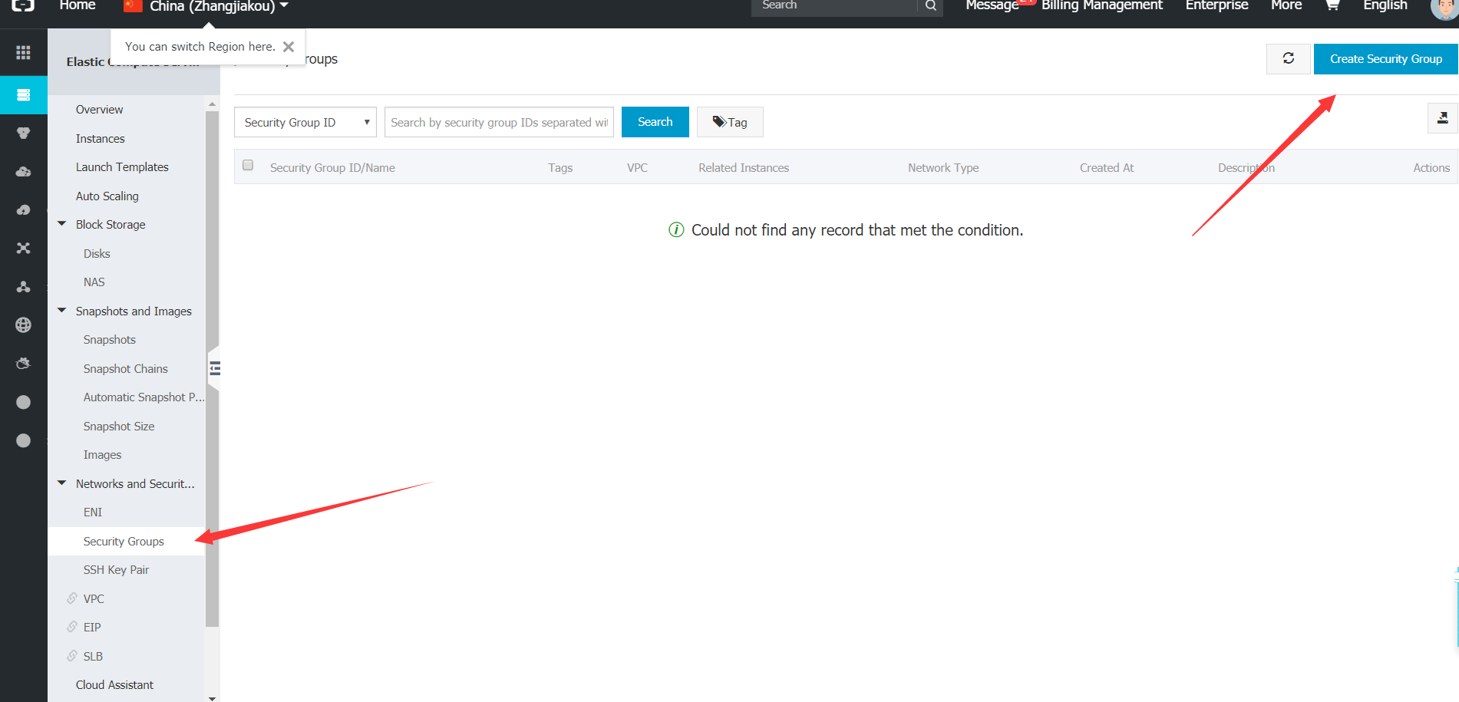

How to create a security group

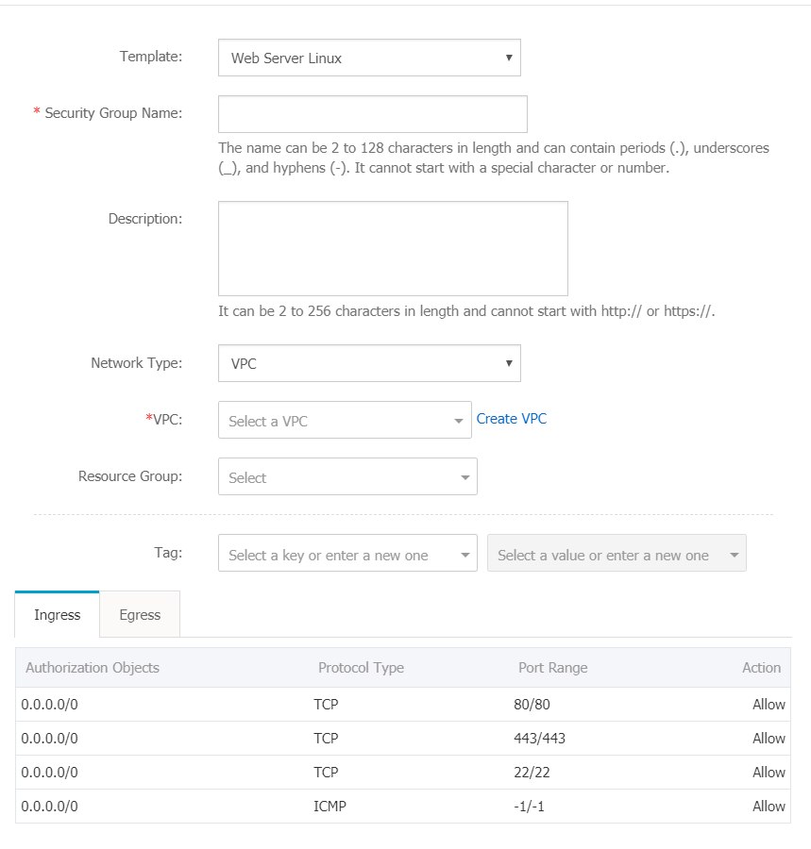

Note: to create a security group, you need to first open the resource management service, and generally only need to configure the direction

Edit and add the security group rules in the security group list -> configuration rules.

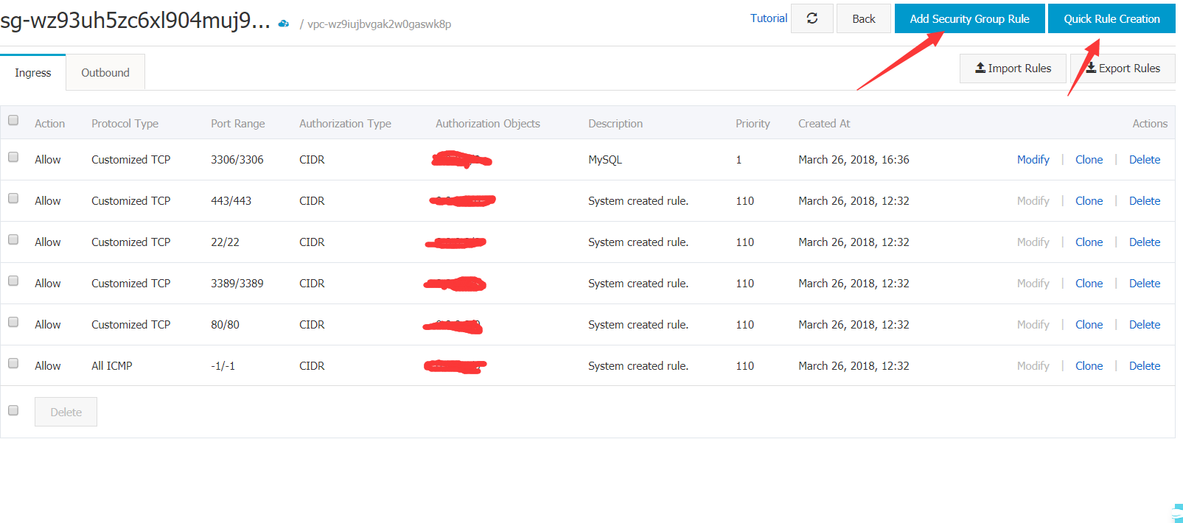

Domain name resolution and binding are not detailed. Click on the [Aliyun domain name resolution](https://jingyan.baidu.com/article/ca2d939d6d9befeb6c31cee4.html) Learn.

**Ali cloud server presentation ends here. Thank you for your use!**