**Amazon server purchase configuration tutorial**

**1：Click on the** [The amazon purchase process](The%20amazon%20purchase%20process) **Understand the detailed registration and purchase process**

**2：Log on to the amazon home page**

The AWS->EC2-> instance -> startup instance enters the server resource configuration interface

Step 1 select a suitable mirror or go into the community to make the purchase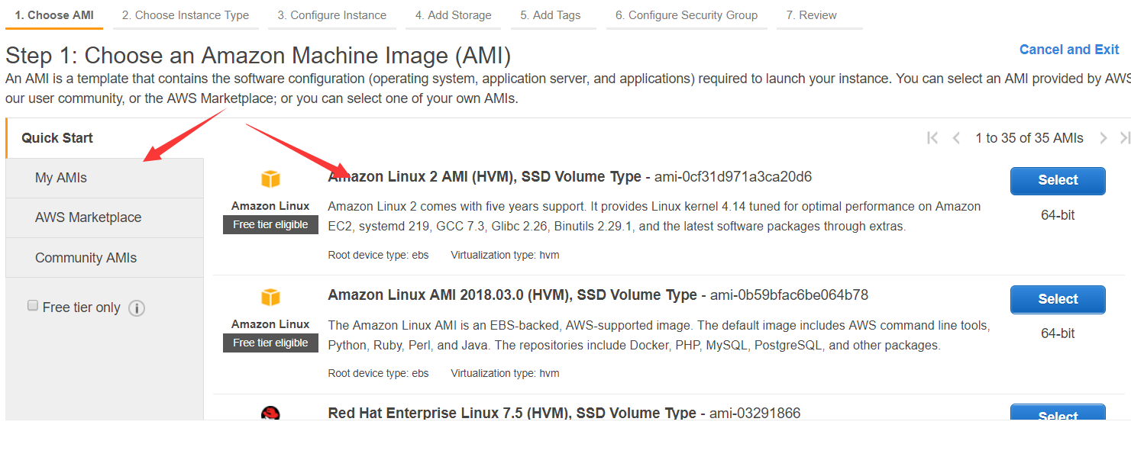

Step 2 select an appropriate instance type (after this step is completed, you can either start the audit directly or continue the configuration)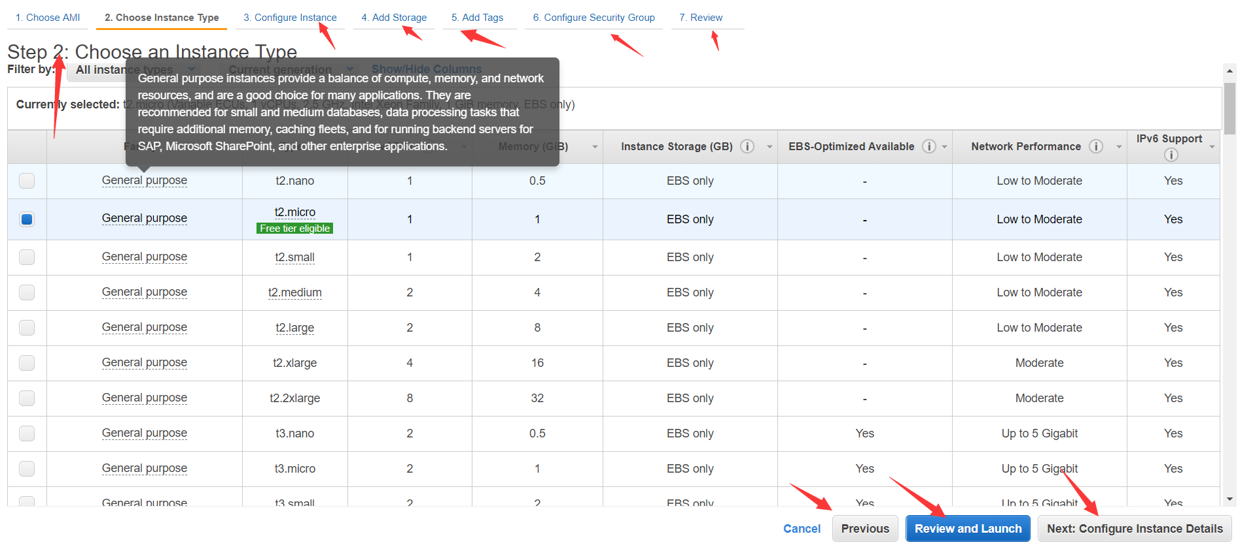

Step 3: configure the instance information (after this step is completed, you can directly start auditing or continue to configure)

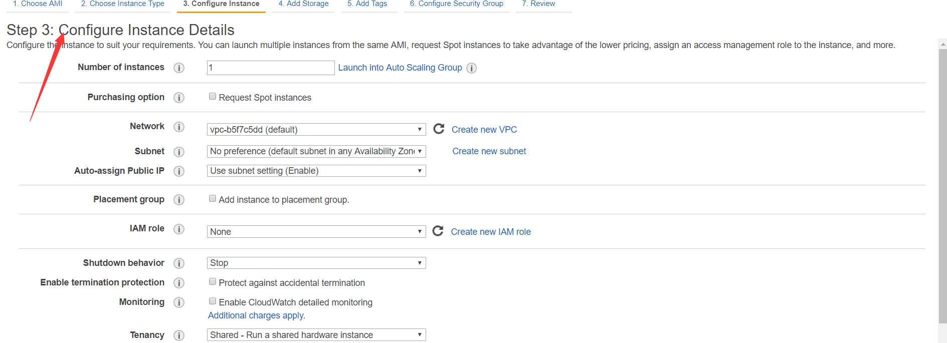

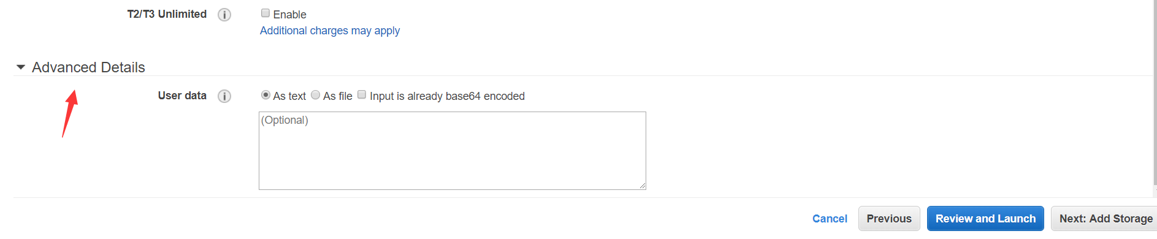

Step 4 store add and configure (after this step is completed, you can directly start auditing, or continue to configure)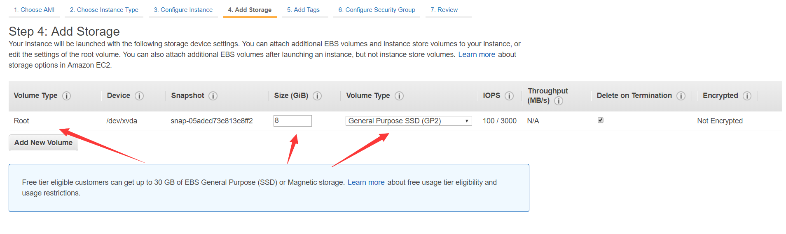

Step 5 tag added, details can be viewed by clicking for more information (after this step is completed, you can directly review and start, or continue to configure).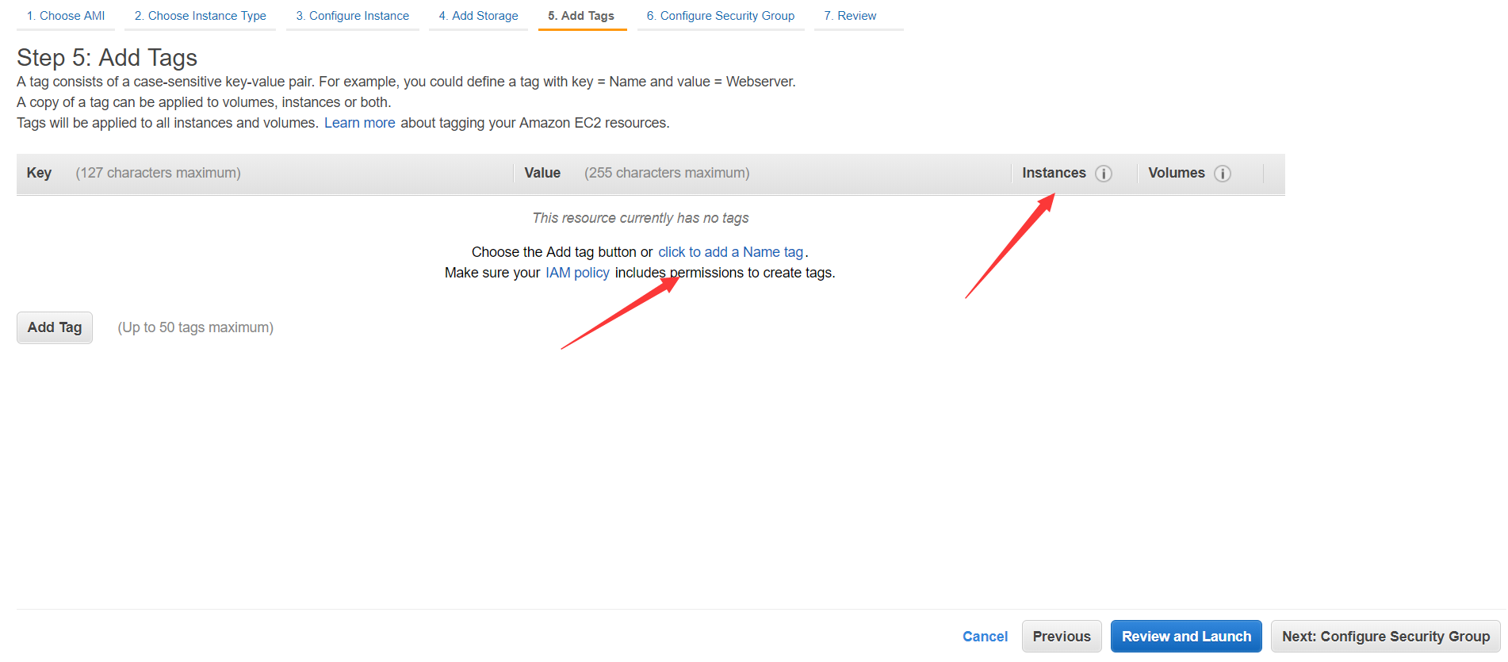

Step 6 configure the security group. The configuration information is as follows.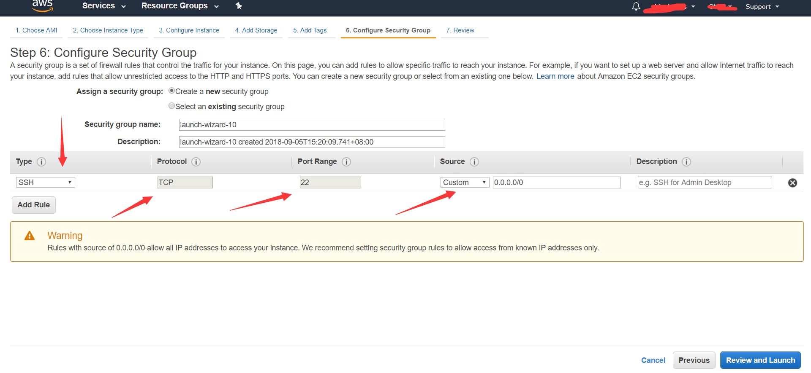

Step 7 review start to see if the configuration information is correct. Click ok to start

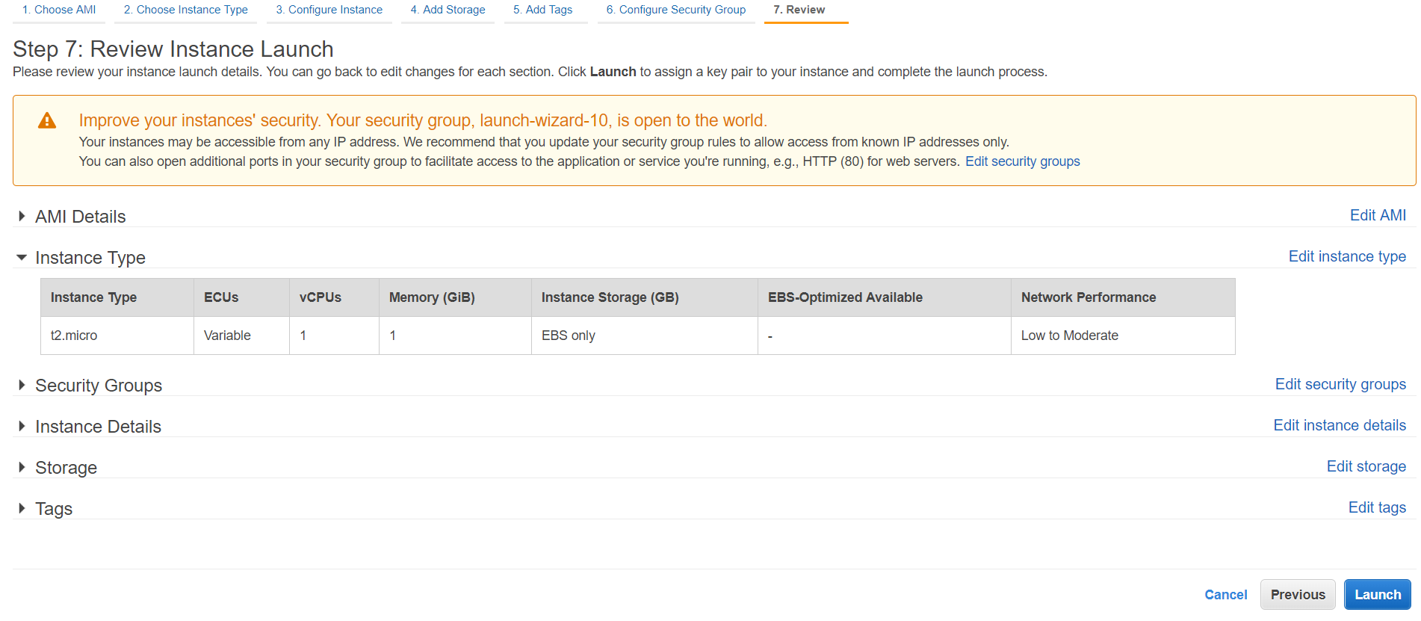

Note: each step can be skipped. If manual configuration is done, check the minimum configuration requirements of the server before configuration, otherwise the instance may not meet the system requirements. (if the default is not met, manually configure it)

**3：Configuration and creation of security groups**

The AWS->EC2-> security group enters the server security group information interface to view all security group information and create a new security group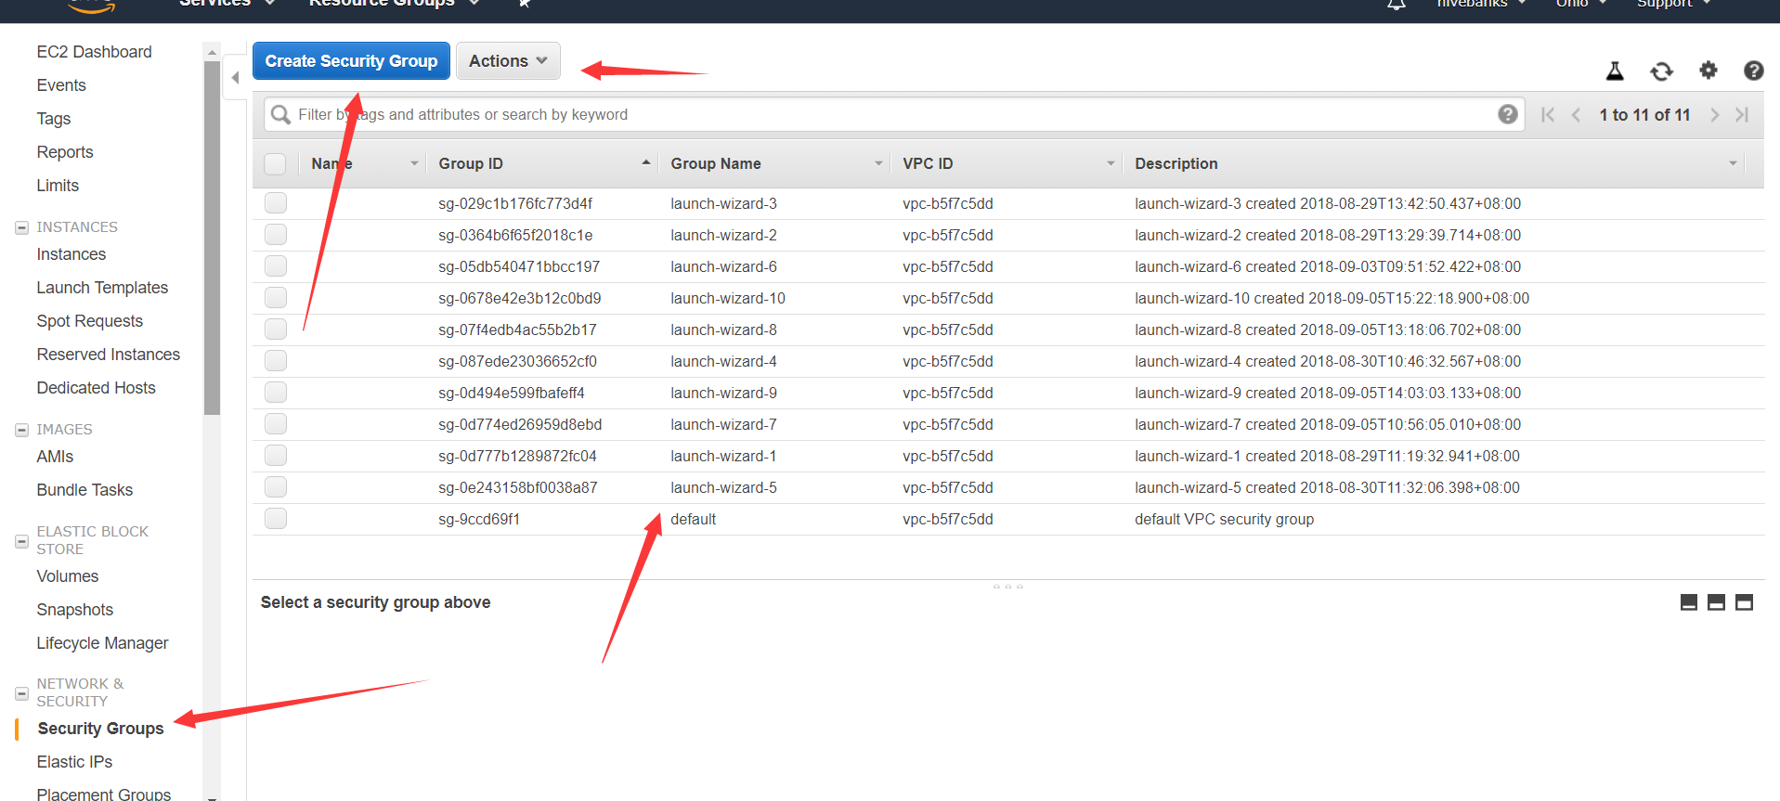

Creating a new security group is mainly about configuring the rules for the security group.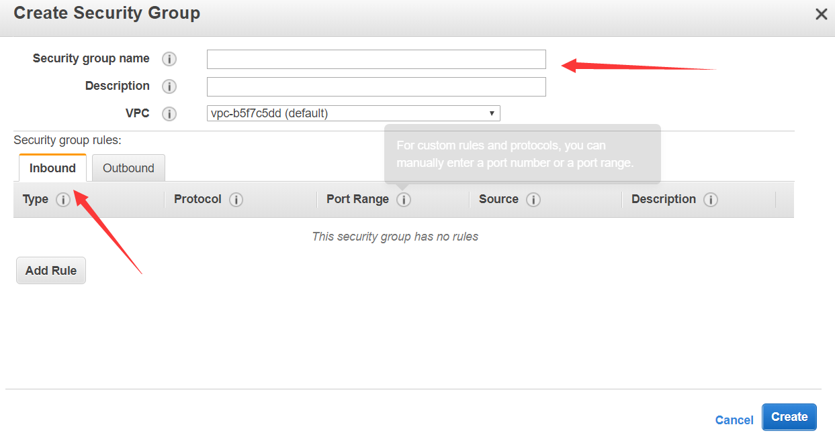

Note: in general, only outbound information needs to be configured.

**End of the amazon server purchase configuration tutorial. Thank you for your use!**