**The HIVEBANKS banking system Godaddy server creates usage tutorials**

**1：Click on the** [godaddy](https://sg.godaddy.com/zh) **Enter the login page**

**2：The following figure prompts you to log in to the user's home page.**

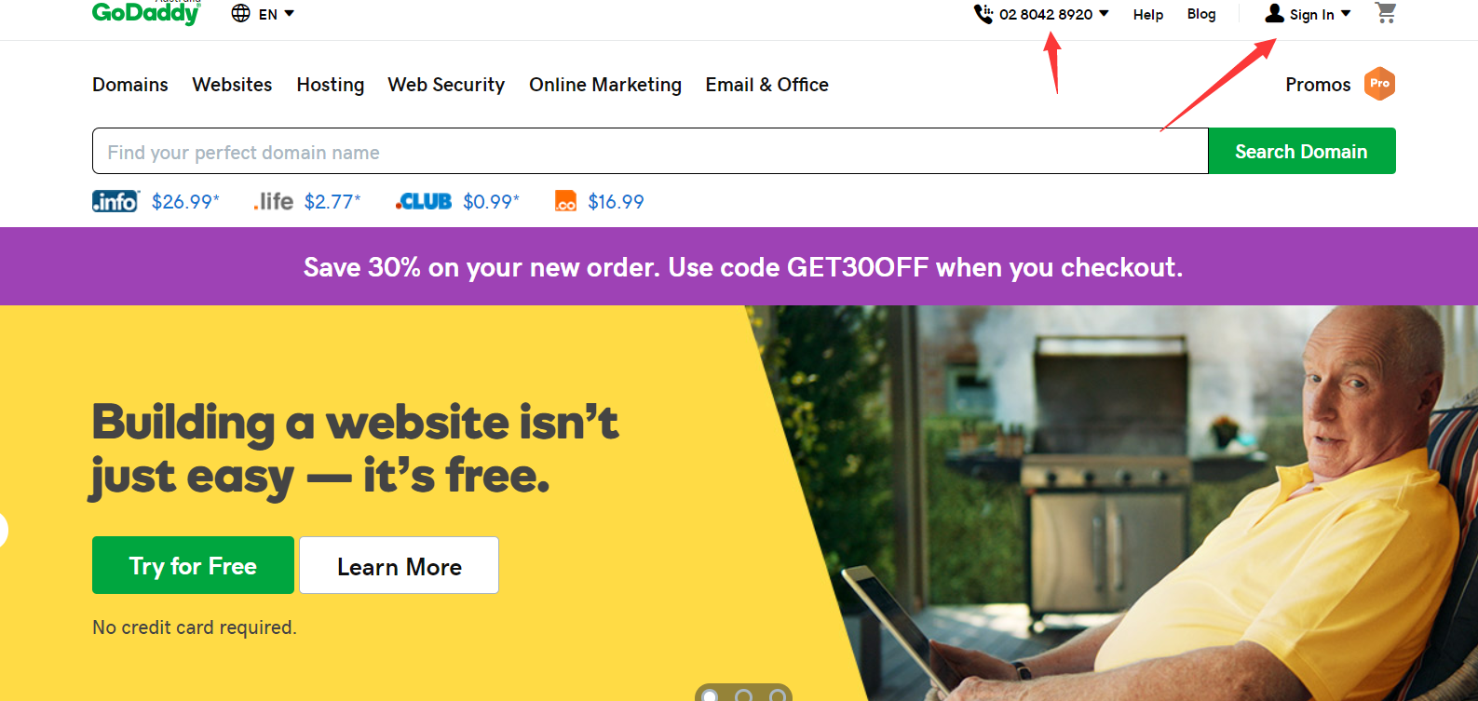

Log in and enter the personal homepage to display the account product management interface.

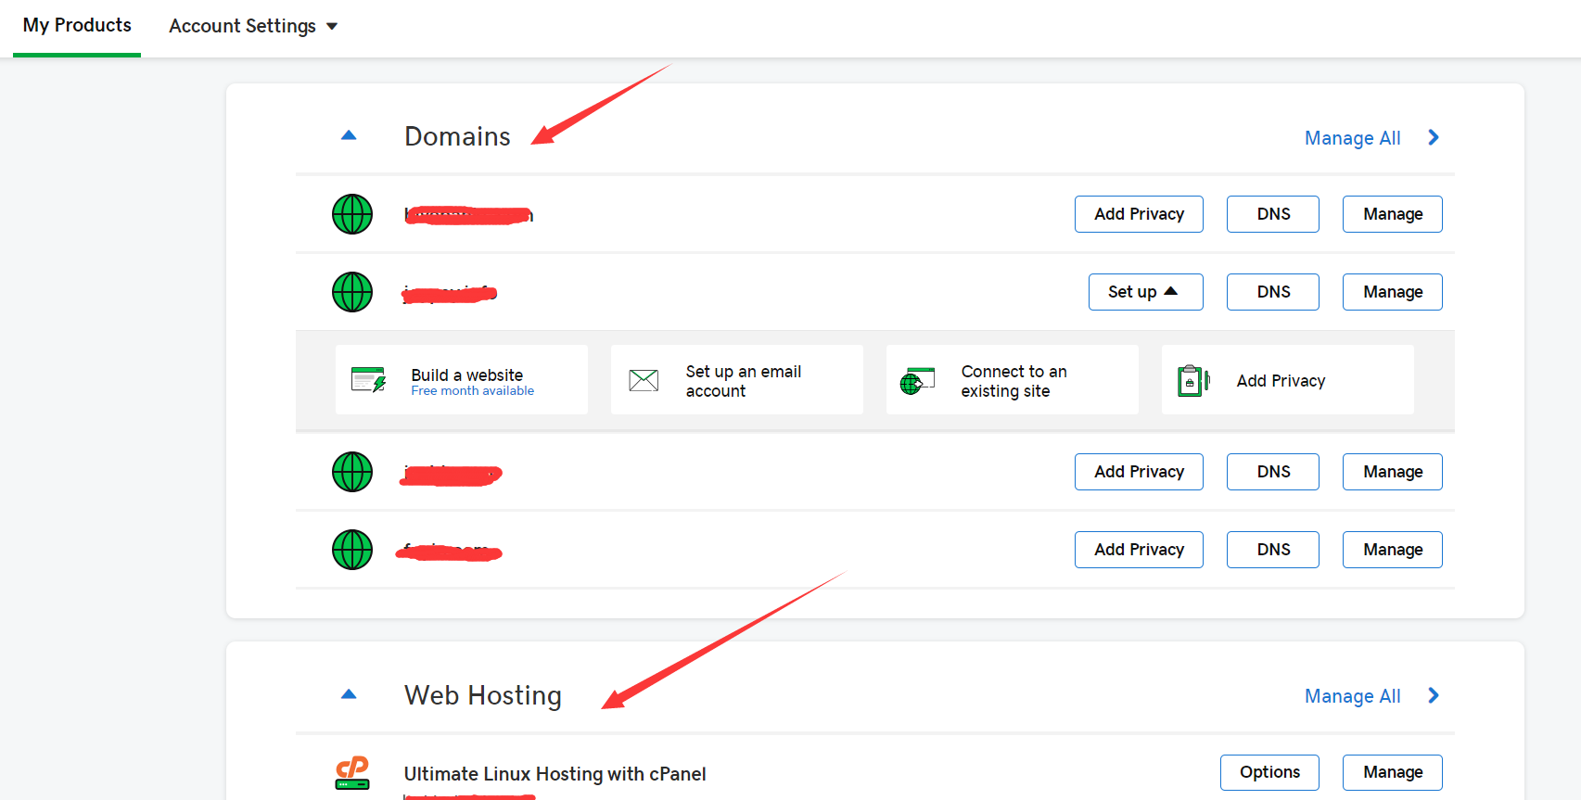

**3：Click into virtual host management to view the domain name and IP address of the server**

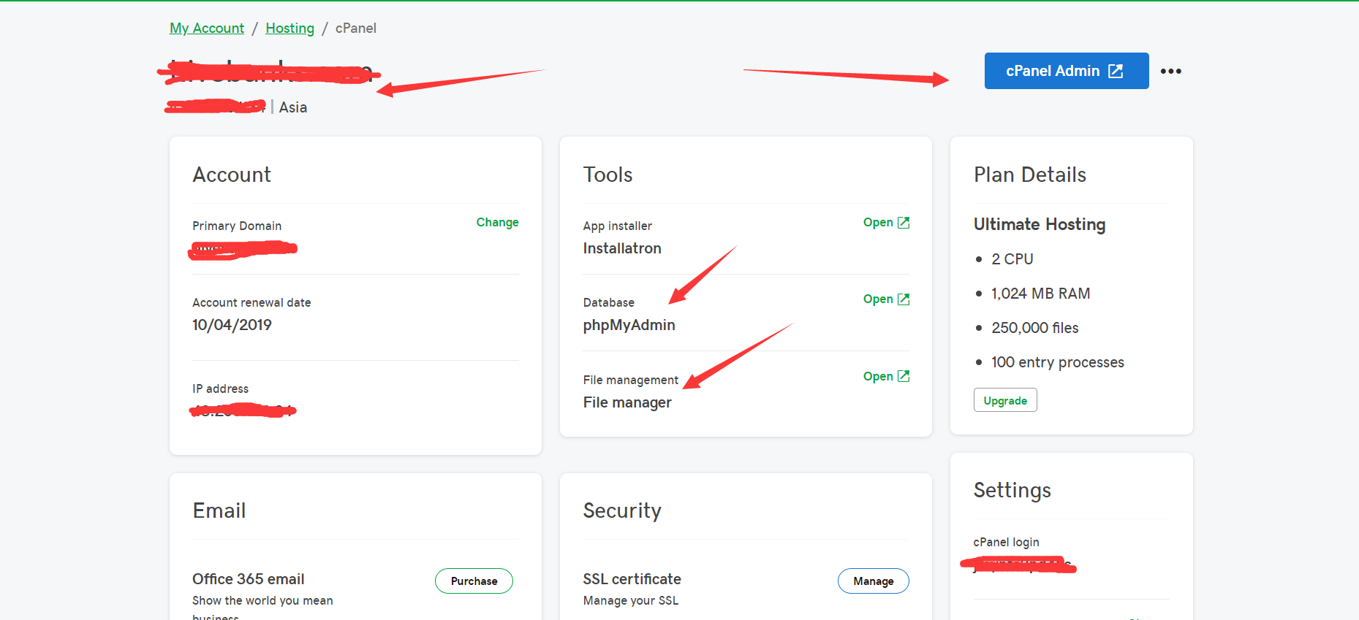

In the administrative interface mainly look at the IP address, as well as the master domain name. The main management is database and file management and cPanel administrator.

3.1 file manager

Click file manager and select public_html to upload the compressed file of the front-end file of the system.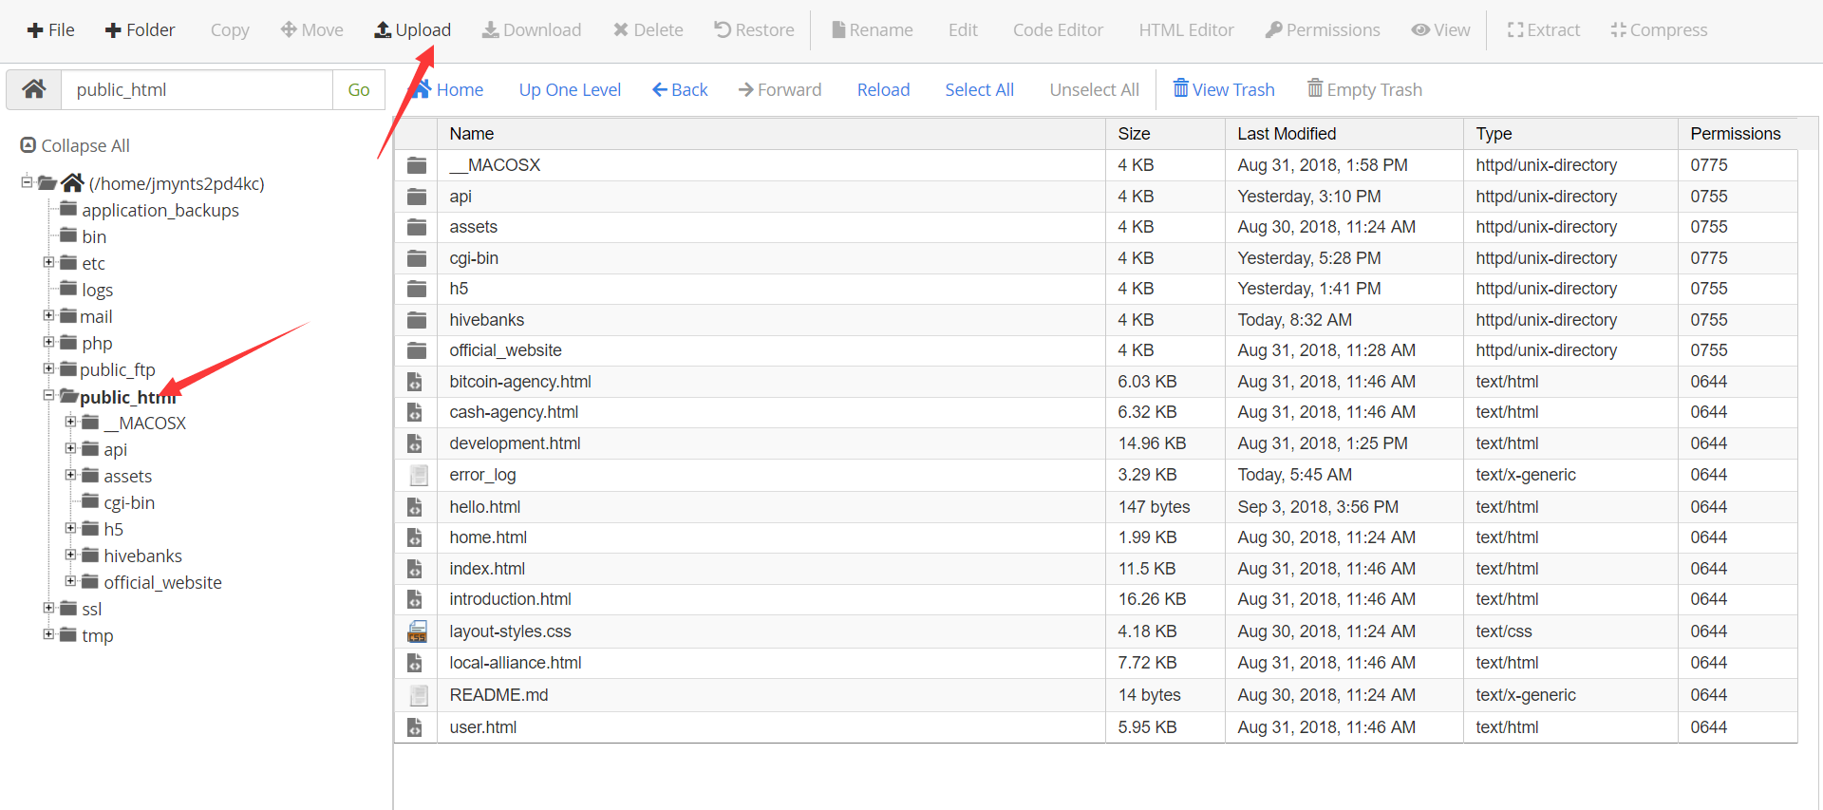

Click uplad to enter the file upload page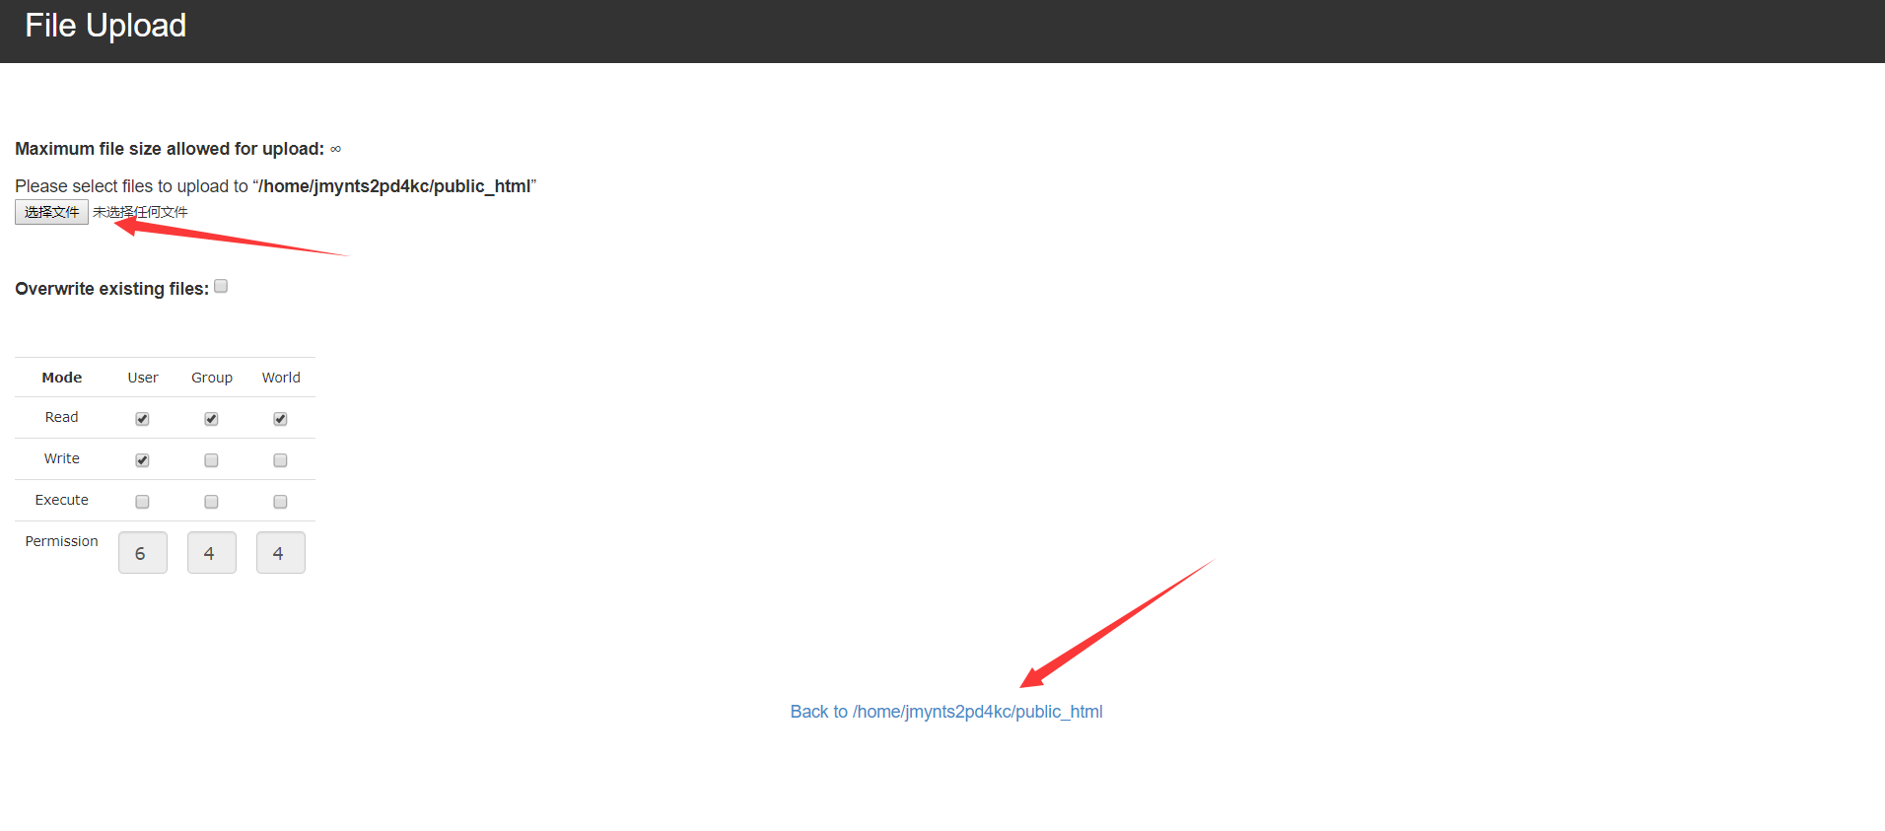

Compress the folder of the selected system file upload, click upload finished Back to/home/jmynts2pd4kc/public_html can see compressed files in the file directory, right-click on the selected to unzip the diagram below.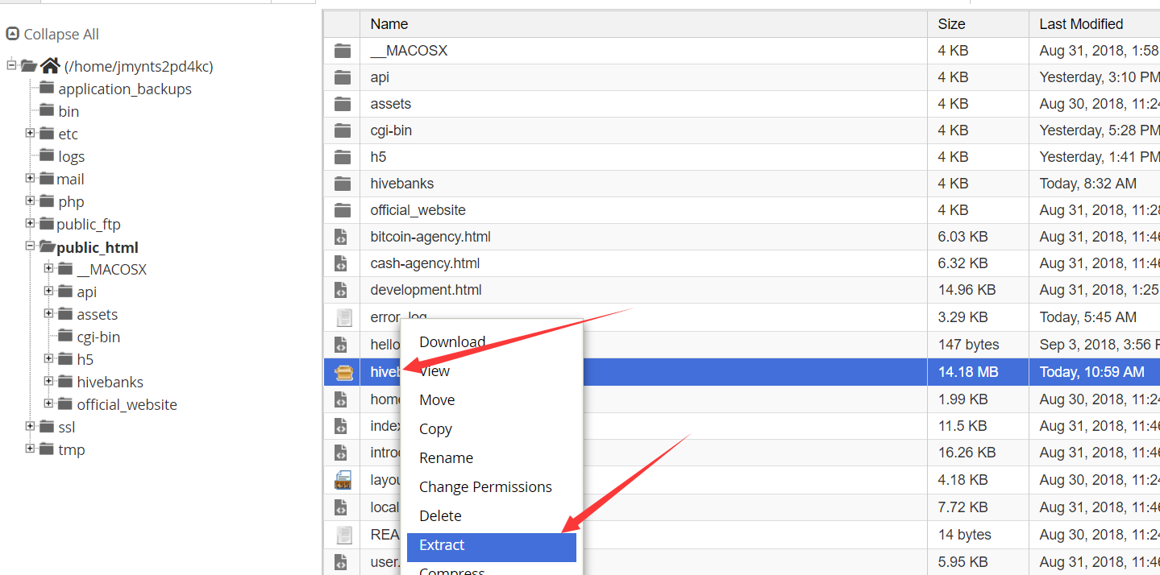

Open the following directory in the directory file to upload the front-end configuration files, errcode.json and config_url.json to the directory folder below.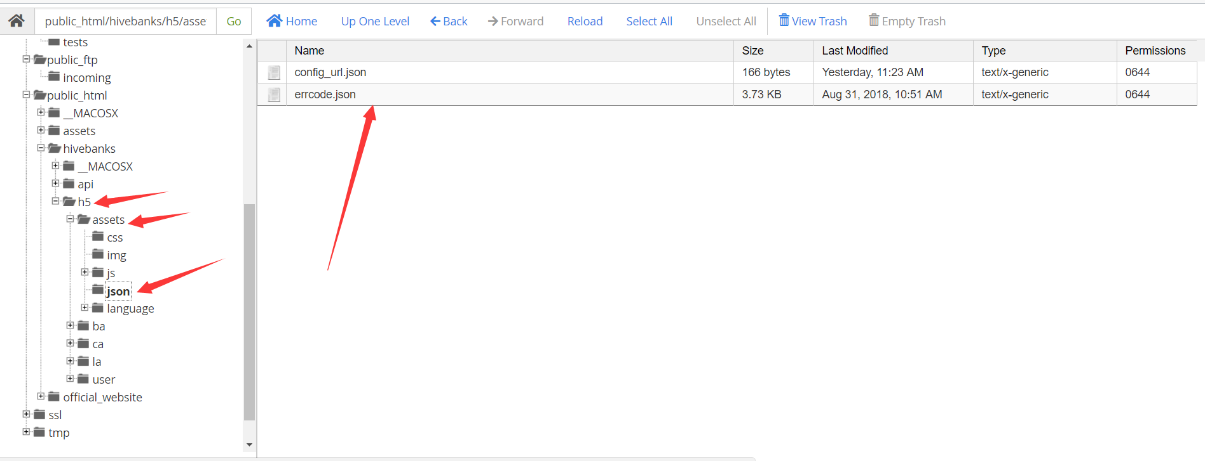

Upload the configuration file, in the following four configuration files, after the configuration uploaded to the current directory.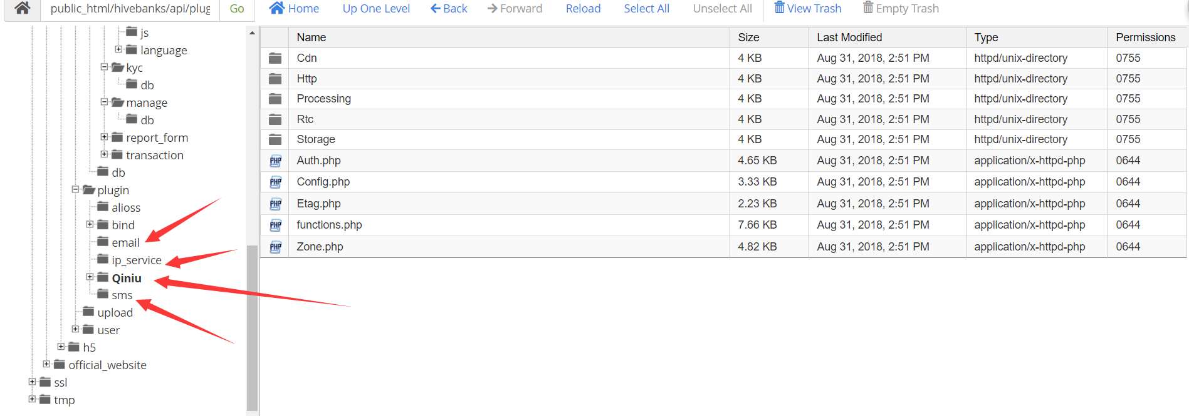

Note: folder uploads must be compressed, otherwise upload fails. Individual file uploads are not required. Don't close the back of the godaddy page right now, there are a few things you need to configure to set up your banking system

**4：After completing the above operations, set up the digital bank.**

4.1：Enter the configuration domain name into the bank setup page

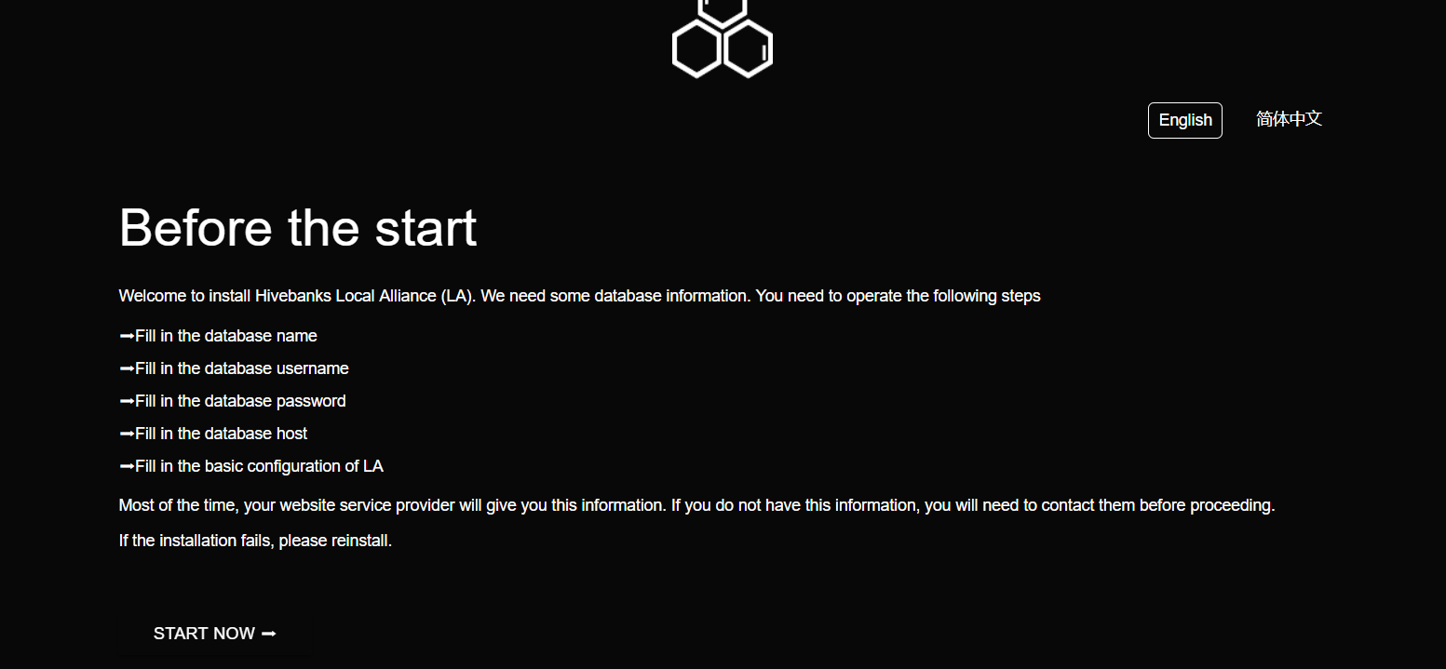

4.2: click the above limit to start the installation. The following page is displayed for data filling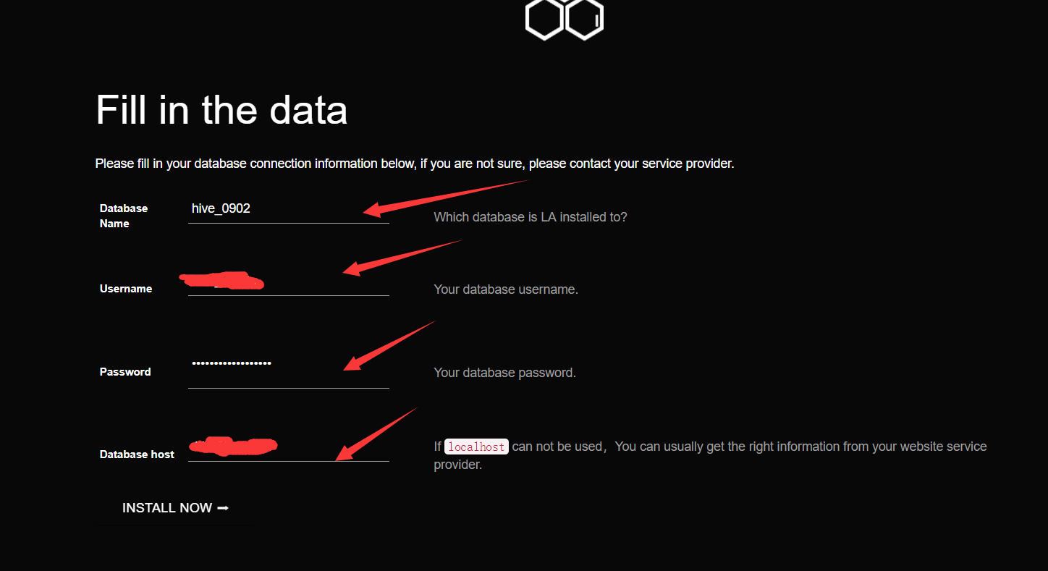

4.3: after filling the information, click to start the installation. Due to the particularity of the godaddy server, we cannot directly create it through the code. You need to manually create the database and the database link file.

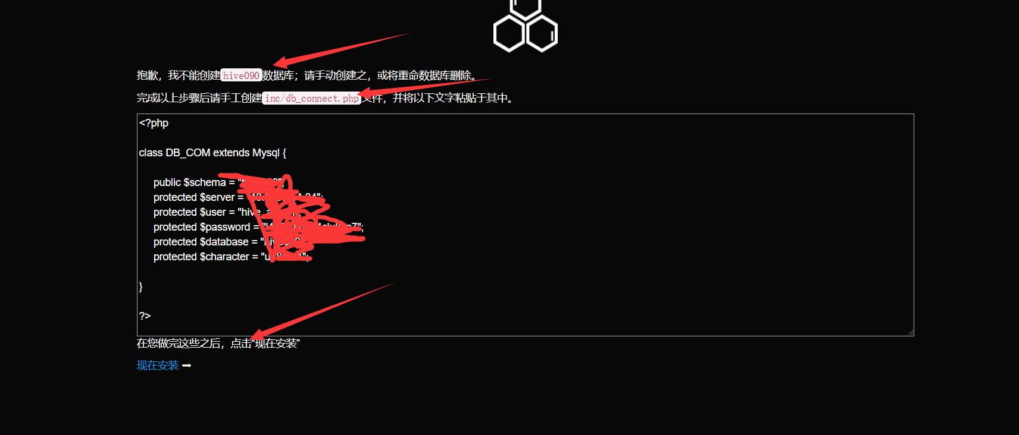

4.4: open the godaddy file management interface, find the inc folder, and create a new folder named db_connect.php. Right - click to edit, as shown below.

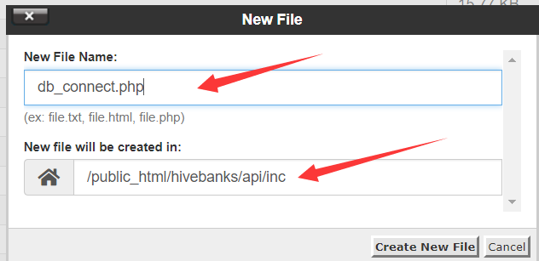

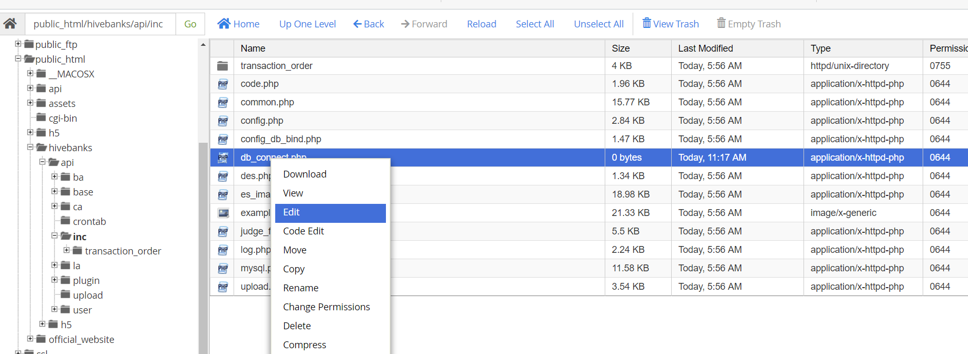

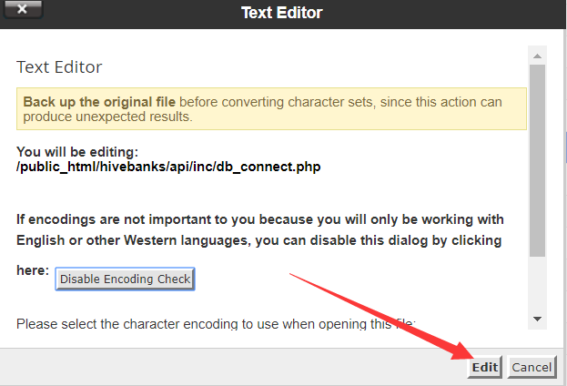

In the edit screen, write the PHP shown below.

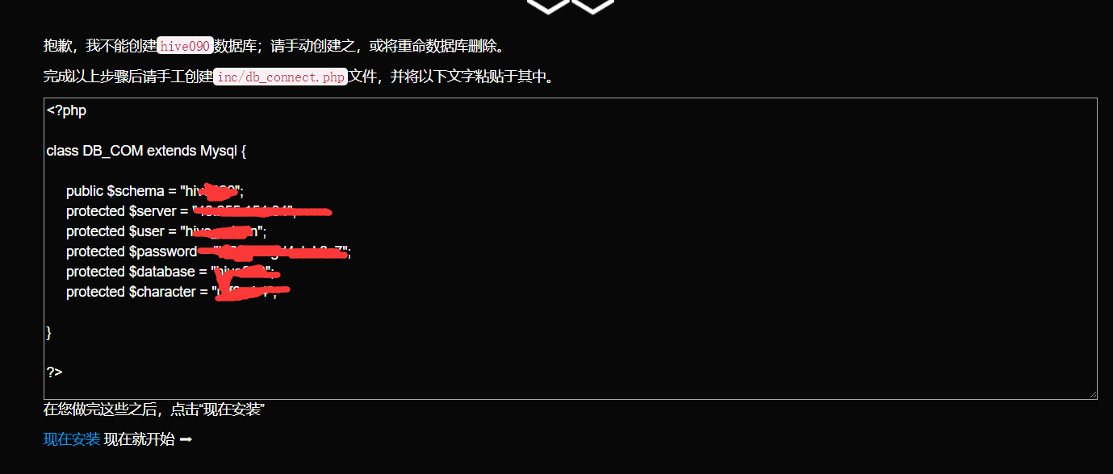

After writing, click Save_Changes and click Close to complete the file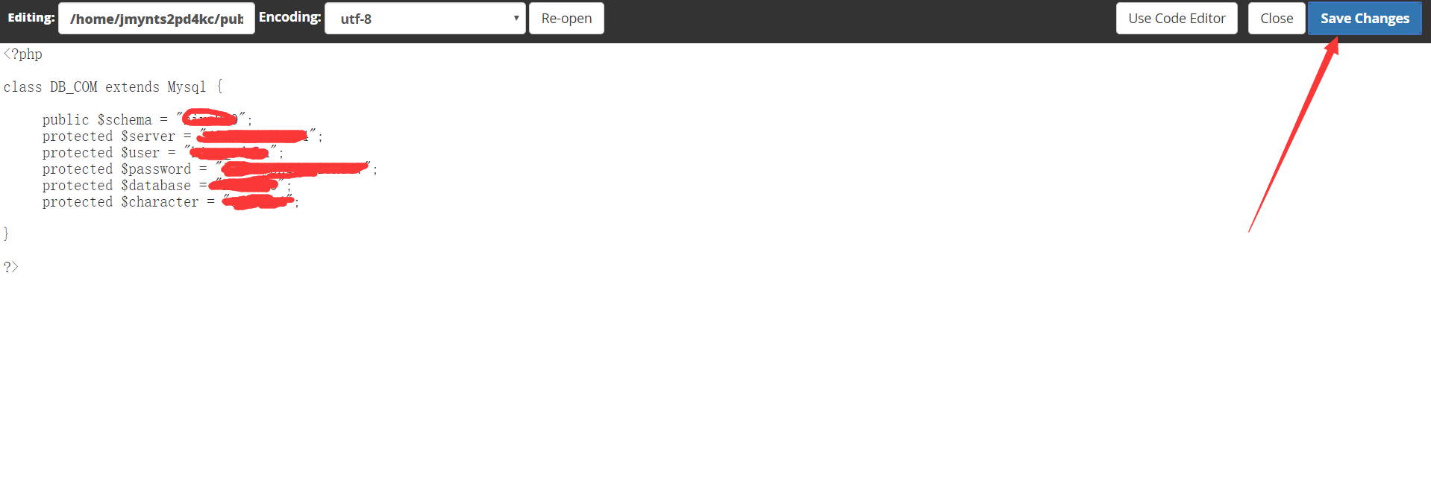

4.5: after the above operations, we create the database. Go back to my admin screen and click the cPanel administrator to manage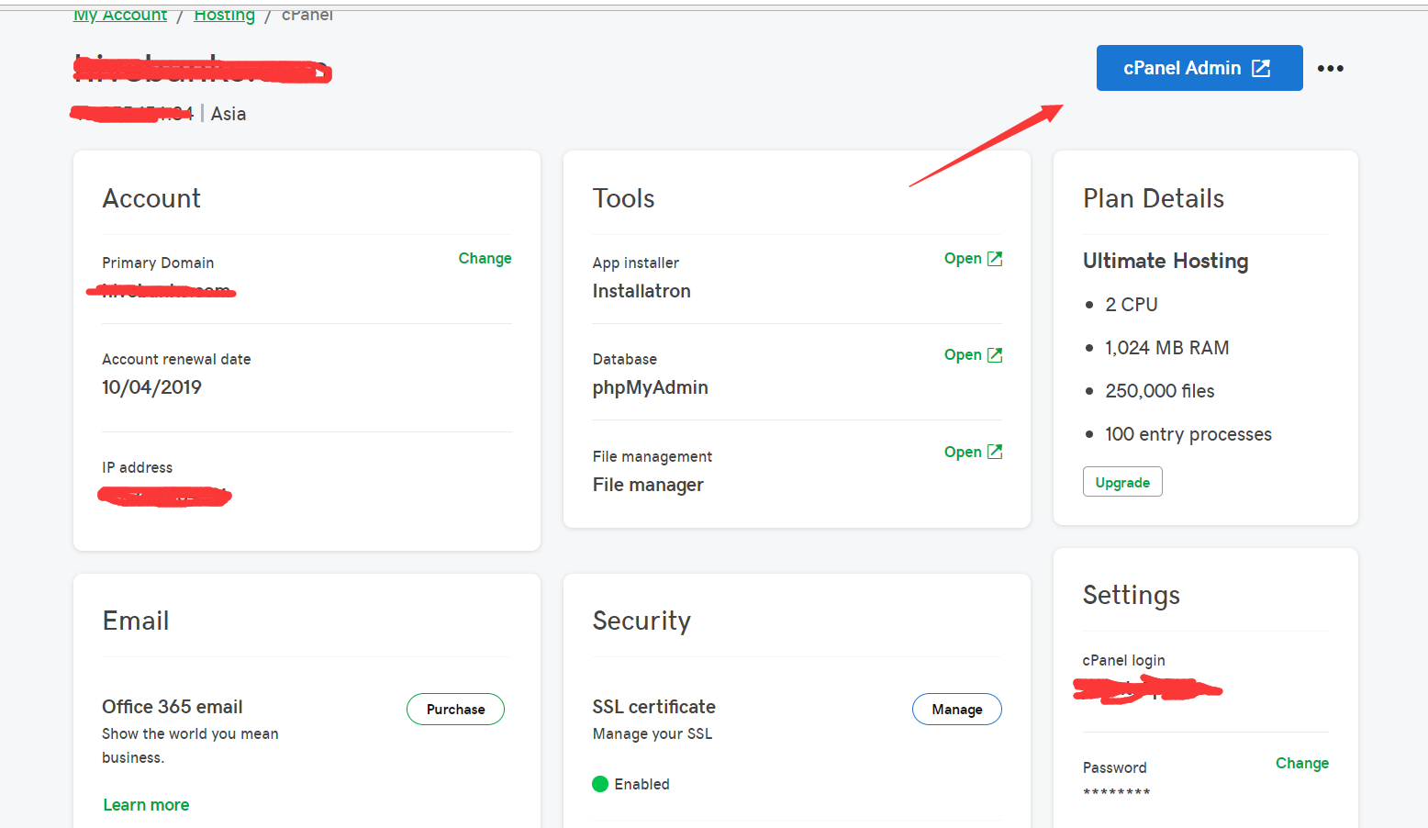

4.6: find the database indicated by the red arrow at the bottom of the administration page. Click enter management.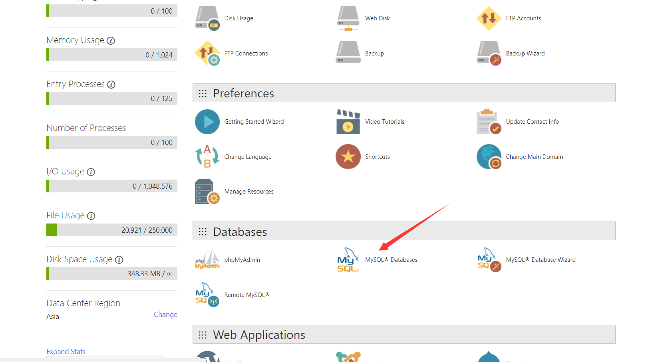

4.7: fill the database name in the red arrow input box below. Click create to create the database. Click Go Back on the jump page to return to the front interface.

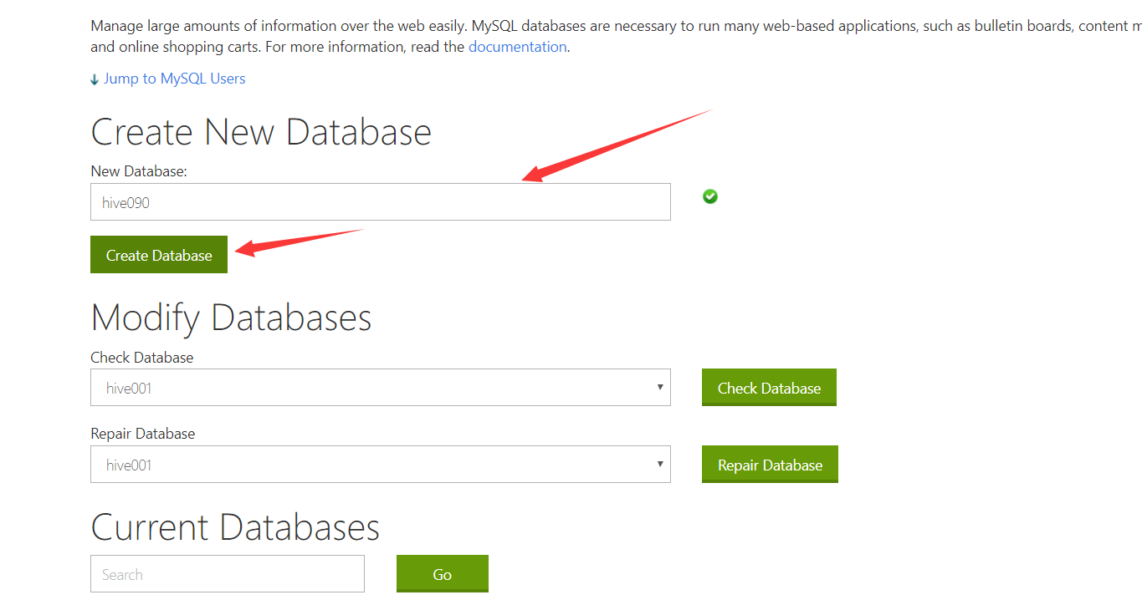

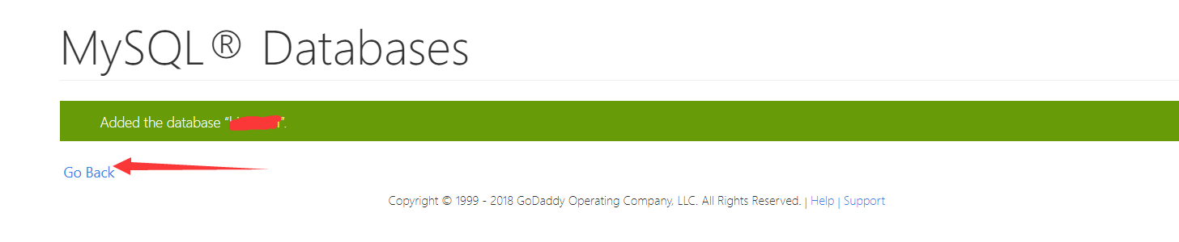

4.8: enter the red arrow box below to fill in the database user name, password and confirm password. In the add user to database, select the new data and enter the user name, which is written when the banking system is created. Click create user. If it exists, just bind the database to the user

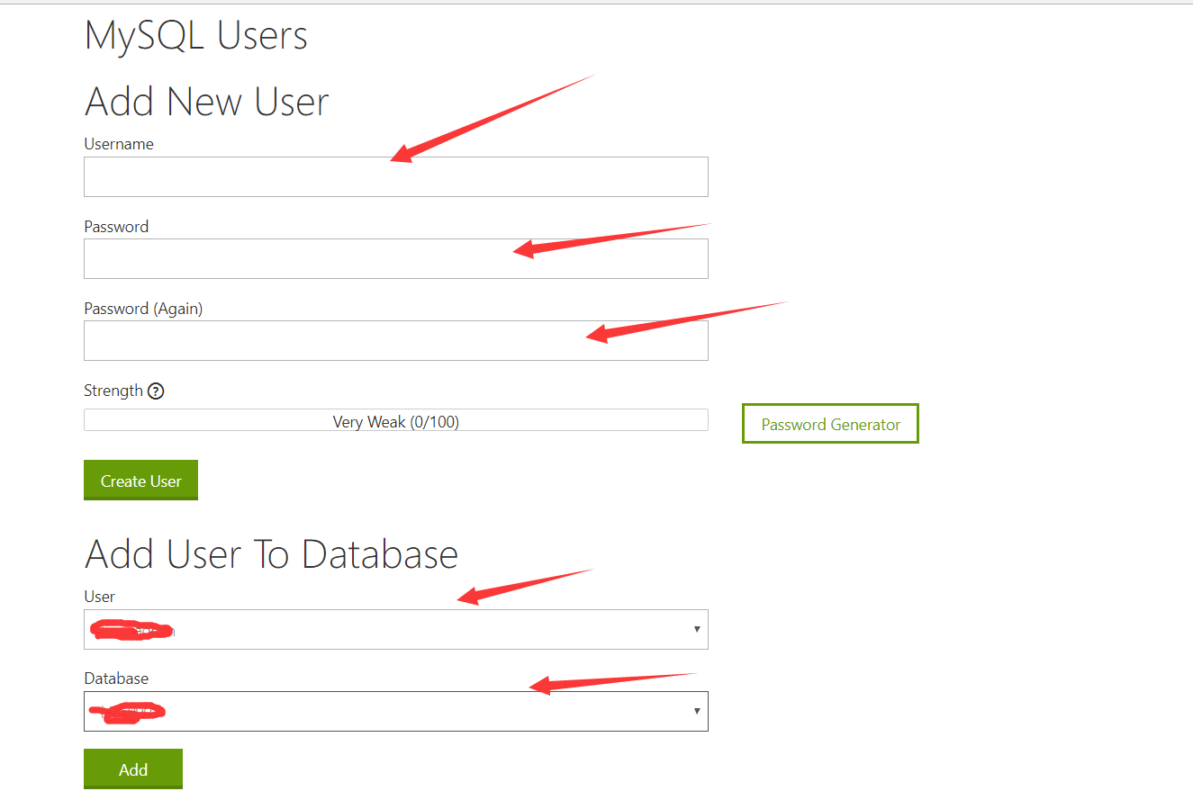

4.9: select database permissions as shown below. Choose according to your needs

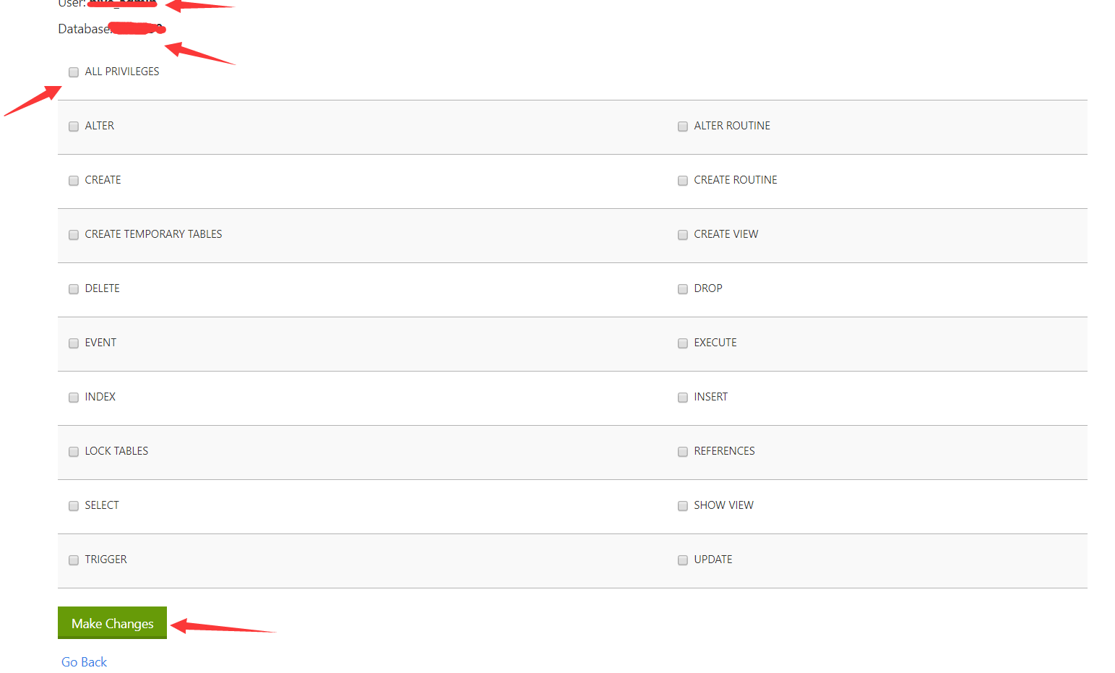

4.10：Return to the main interface and enter database management

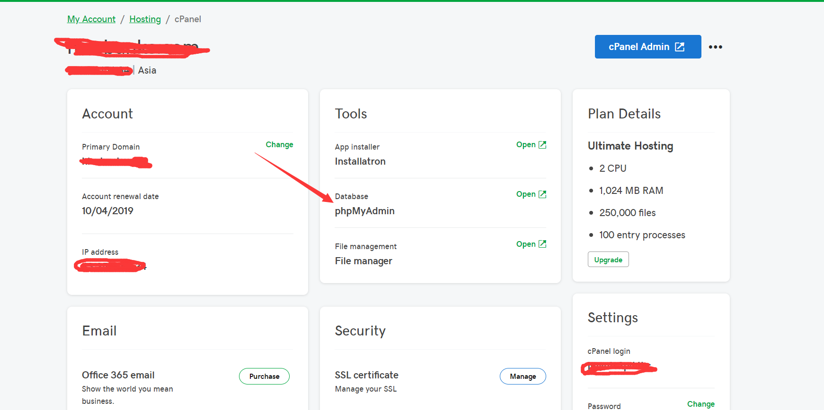

4.11：Database management interface, display current existing database, find the database just created.

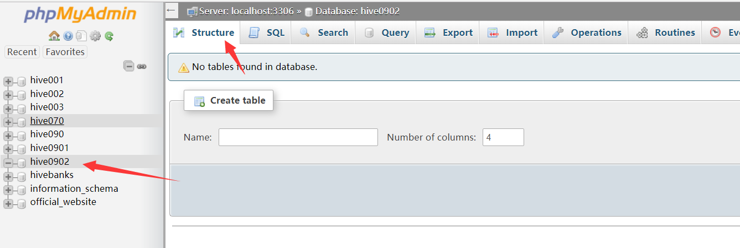

4.12：Create a table. To create or select a data import manually, we introduce the import data table.

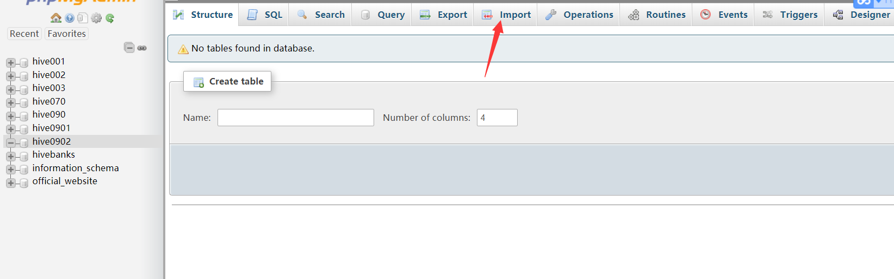

4.13：According to the prompt, the downloaded database's.sql file is compressed into a suitable format, and then uploaded. Select the character set, and select the correct format of the uploaded file. After completion, click execution to complete the creation of the database table

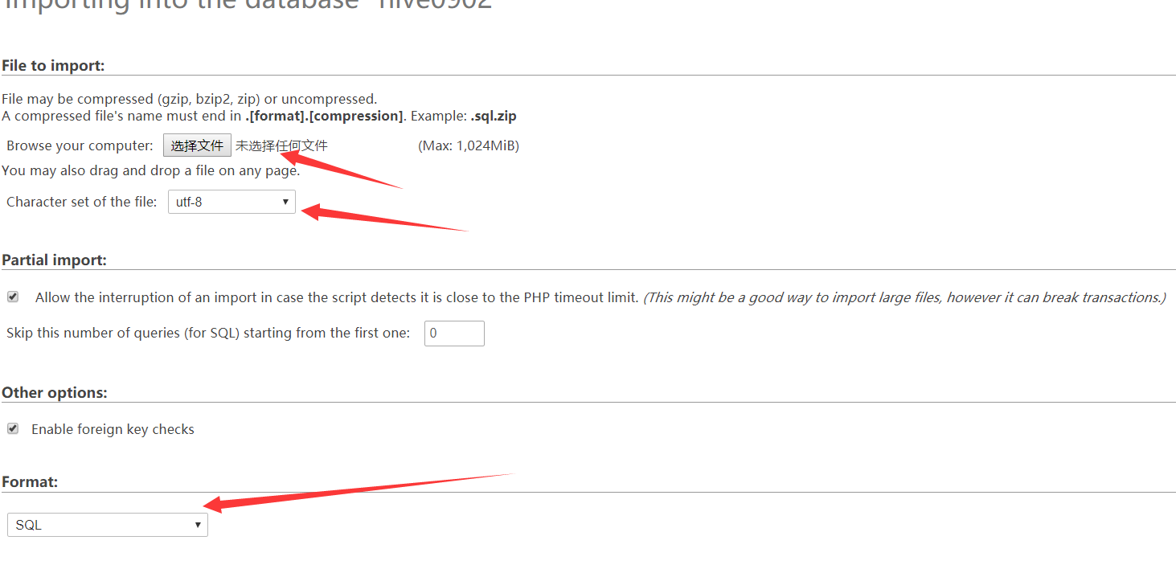

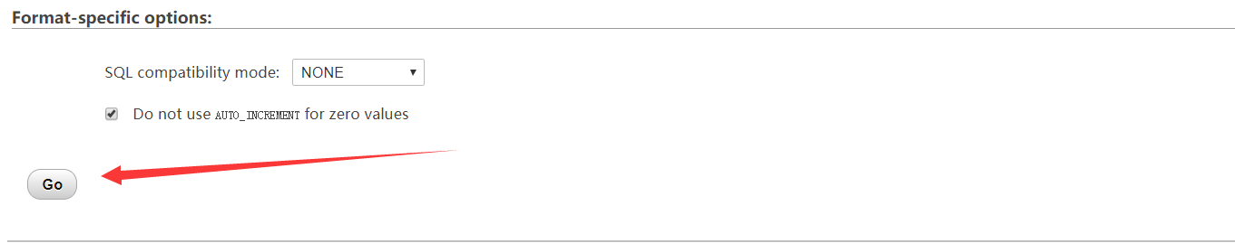

4.14 When the creation is complete, it is shown in the following figure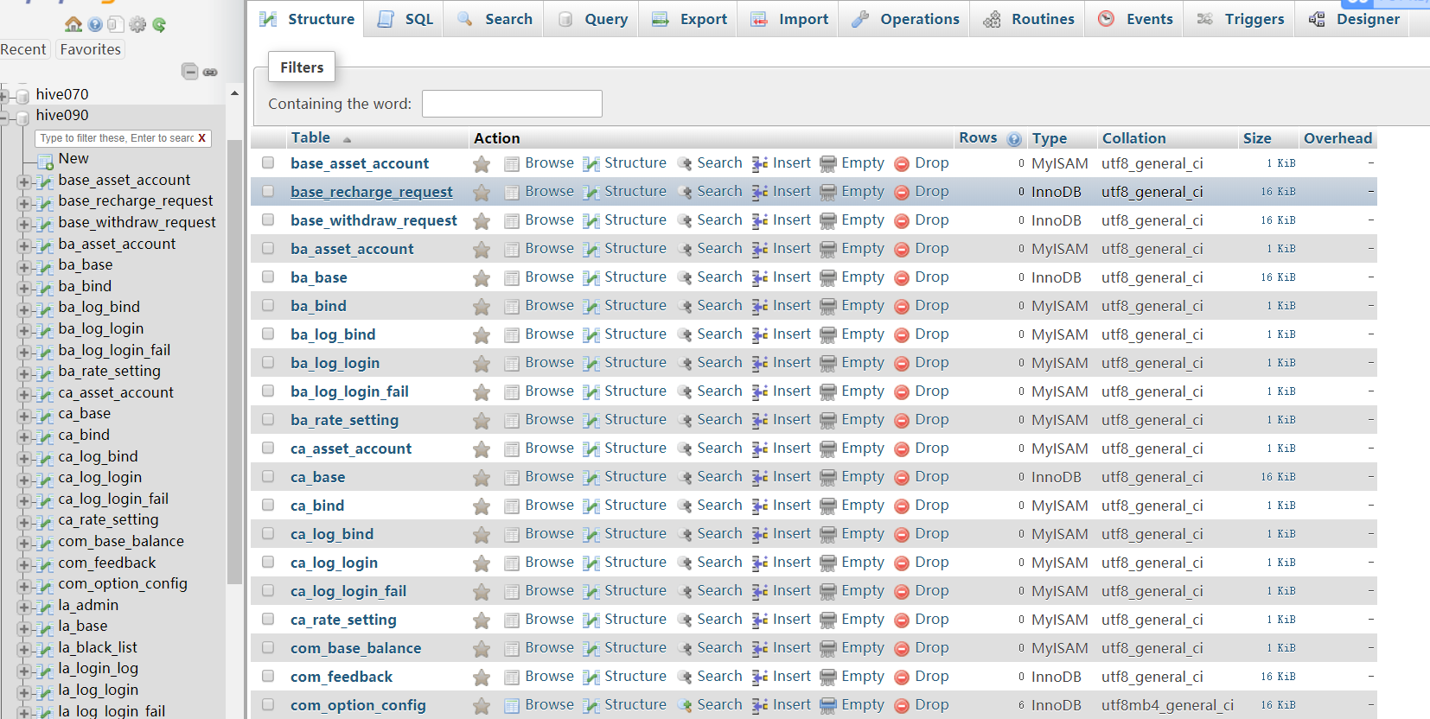

**5：Complete the above operation and return to the setup page of the banking system. Click install now. Enter the background management information registration page.**

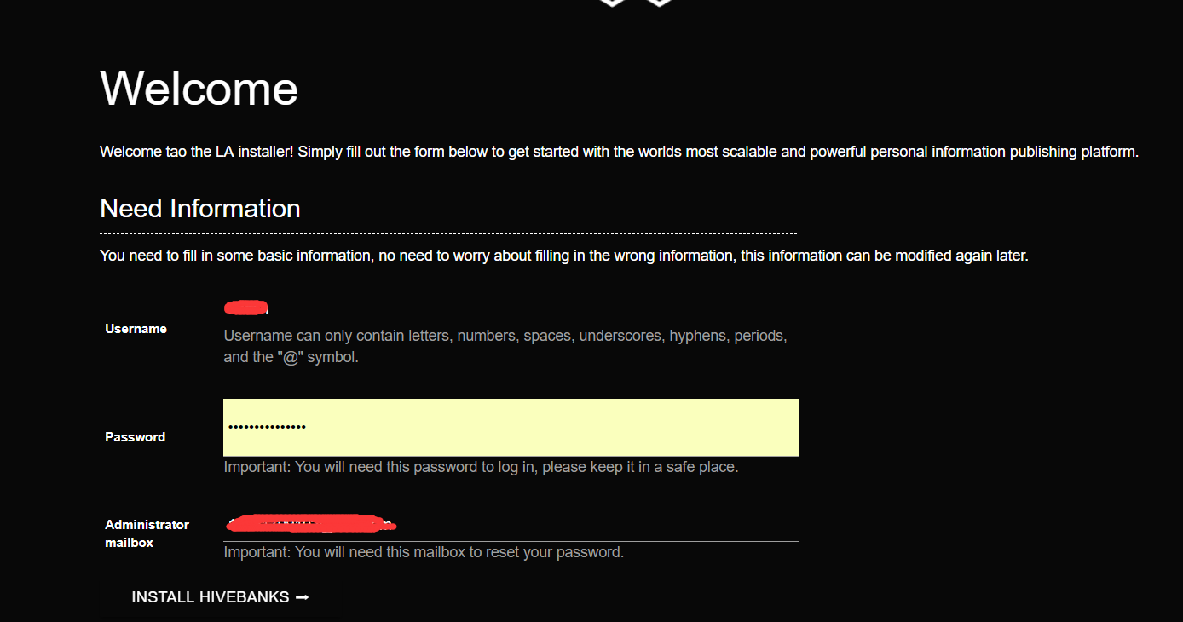

The administrator's mailbox must be filled. If the database password is lost, the database may be lost.

**6：The information is set up for the last configuration of the banking system, and the url before and after can be viewed in the json file when the file is uploaded earlier.**

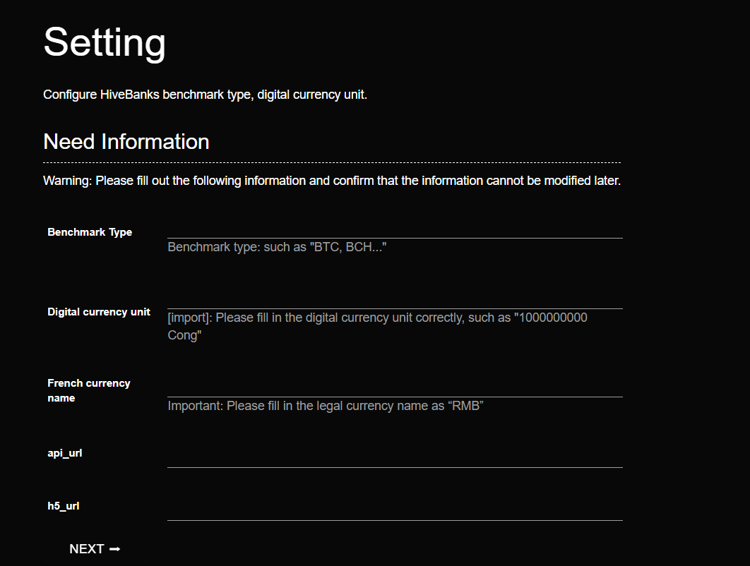

**7：When the following screen appears, congratulations now that your banking system has been set up.**

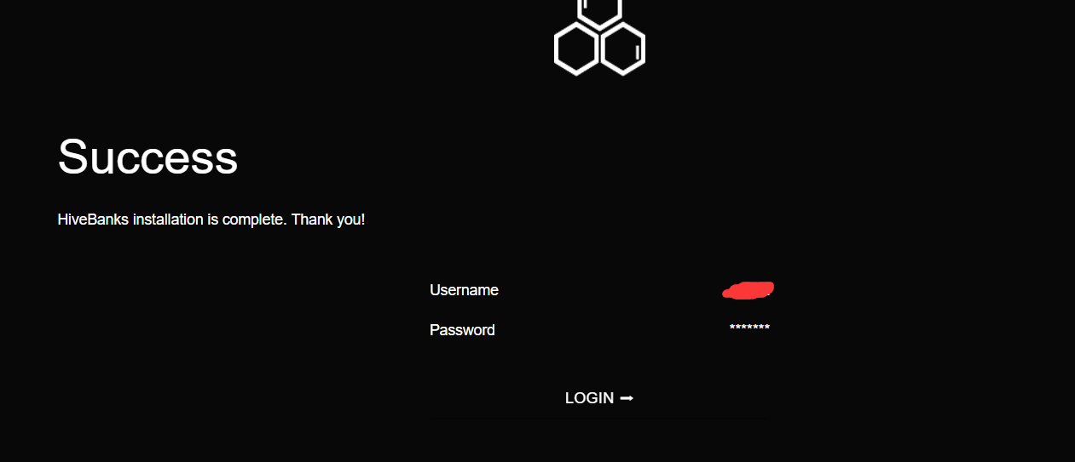

**Godaddy** **The introduction to version banking system creation ends here. Thank you for your use!**