

**M2 - MIAGE 2IS - Innovative Information Systems**

**Innovative Data Management**

**Term project – Project IDM**

**Professors**: THEVENIN Jean-Marc,

ALIGON Julien

**Students:** KIM Phuong Pham, JIN Xutong

Toulouse, 2019

Table of Contents

1. Analysis of Data Stored in a Text Form 3

1.1 PIG: Count the number of people with income <= 50K and> 50K 3

1.1.1 By Age 3

1.1.2 By Sex 3

1.1.3 By Workclass 4

1.2 MapReduce: Count the number of people with income <= 50K and> 50K 4

1.1.1 By Age 4

1.1.2 By Sex 4

1.1.3 By Workclass 4

1.3 Sqoop and Hive 5

1.3.1 Import data from MySQL to HDFS 5

1.3.2 By Age 6

1.3.2 By Sex 6

1.3.2 By Workclass 7

2. Discovering Neo4j 7

2.1 Load the Movie Database 7

2.2 Count the Number of Actors and Movies in the Database 8

2.3 Queries in Cypher 9

2.3.1 View actors who played directly with Tom Cruise 9

2.3.2 Number of actors who played directly with Tom Cruise 9

2.3.3 View actors who have played with actors who have already played with Tom Cruise 10

2.3.5 Show for each director the number of actors he directed in movies 10

2.3.6 Show for each director the average number of actors he directed by movie 11

# 1. Analysis of Data Stored in a Text Form

First of all, we converted our dataset into csv file. To simplify our dataset, we modified “income” column: Replaced string “<=50k” by integer “1”, and string “>50k” by integer “2”.

## 1.1 PIG: Count the number of people with income <= 50K and> 50K

* Copy file from local

hadoop fs -copyFromLocal adult.data /user/Phuong/DB_Adult/adult.data

* Load datafile into table “ad”, separate data by “,” and specify the schema by “(age: int,…)”

ad = load '/user/Phuong/DB_Adult/adult.data' using PigStorage(',') as (age:int,workclass:chararray,fnlwgt:int,education:chararray,education_num:int,marital_status:chararray,occupation:chararray,relationship:chararray,race:chararray,sex:chararray,capital_gain:int,capital_loss:int,hours_per_week:int,native_country:chararray,income:int);

### 1.1.1 By Age

* Sort data table by age and income, then store it as “ad_by_age”

ad_by_age = group ad by (age,income);

* Traverse “ad_by_age”, un-nest bags, group data by age, income (1 means <=50, 2 means >50), and count income number. Name this table as “ad_by_age_count”

ad_by_age_count = foreach ad_by_age generate FLATTEN(group) as (age,income),COUNT(ad.income) as income_c;

* Data storage

store ad_by_age_count into '/user/Phuong/DB_Adult/income_by_age'



### 1.1.2 By Sex

* Sort data table by sex and income, then store it as “ad_by_sex”

ad_by_sex = group ad by (sex,income);

* Traverse “ad_by_sex”, un-nest bags, group data by sex, income and count income number. Name this table as “ad_by_sex_count”

ad_by_sex_count = foreach ad_by_sex generate FLATTEN(group) as (sex,income),COUNT(ad.income) as income_c;

* Data storage

store ad_by_sex_count into '/user/Phuong/DB_Adult/income_by_sex'



### 1.1.3 By Workclass

* Sort data table by workclass and income, then store it as “ad_by_workclass”

ad_by_workclass = group ad by workclass,income);

* Traverse “ad_by_workclass”, un-nest bags, group data by workclass, income and count income number. Name this table as “ad_by_workclass_count”

ad_by_workclass_count = foreach ad_by_workclass generate FLATTEN(group) as (workclass,income),COUNT(ad.income) as income_c;

* Data storage

store ad_by_workclass_count into '/user/Phuong/DB_Adult/income_by_workclass'



## 1.2 MapReduce: Count the number of people with income <= 50K and> 50K

### 1.1.1 By Age

Mapper: - Input: Text, Output: Map<Text, Int>

* Read a line and split it into words
* Identify the column (col 1: Age, col 14: Income)
* For each line:
  + If income <=50: Write a line to output <”Age,class 1”, 1)
  + If income >50: Write a line to output <”Age,class 2”, 1)

Reducer: Input (Text key, Iterable<Int> values), output (Map<Text, Int>)

* With each key: sum (count) the number of values and write to output

Code Result

 

### 1.1.2 By Sex

The same logic with “by age” function but in the mapper, split into Male, Class1; Male, Class 2 and Female, Class1; Female, Class2

Code Result

 

### 1.1.3 By Workclass

Mapper: - Input: Text, Output: Map<Text, Text>

* Read a line and split it into words
* Identify the column (col 2: Workclass, col 14: Income)
* For each line:
  + Write the couple of (key,value) = (workclass, income)

Reducer: Input (Text key, Iterable<Text> values), output (Map<Text, Text>)

* Define a Map<income_class, count_number of this class)
* For each income_class in the array values: count the number of people in this class in the Map.
* With each key: Workclass, print out the map of Income_class and its numbers of people.

Code Result

 

## 1.3 Sqoop and Hive

### 1.3.1 Import data from MySQL to HDFS

* Import csv file into etu-web2/phpMyAdmin database
* Testing in Hadoop until find the unbusy port

[cloudera@quickstart ~]$ nc -zv localhost 3307

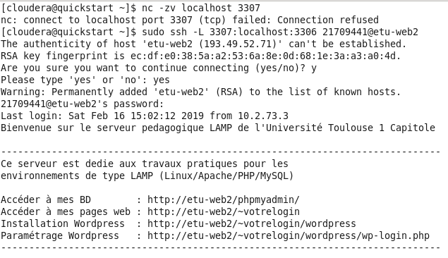

Figure 1 Free Port:3307

* Open a tunnel between the port 3307 of the PC and the MySQL server

[cloudera@quickstart ~]$ sudo ssh -L 3307:localhost:3306 21709441@etu-web2

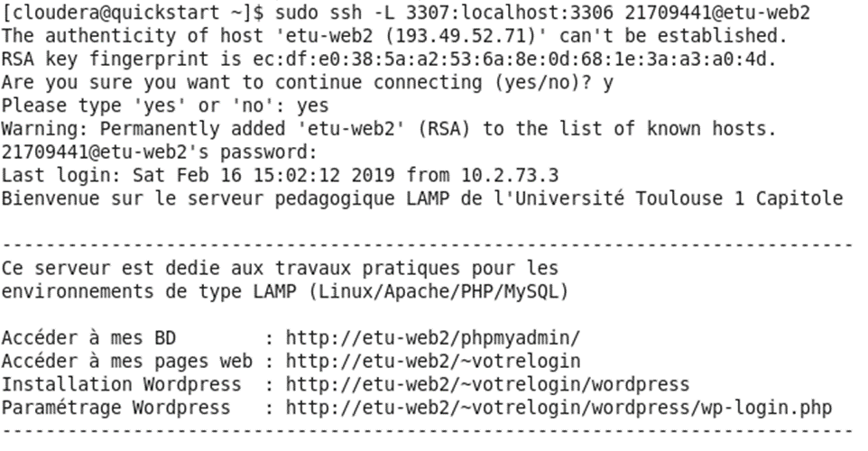

Figure 2 Open the Tunnel

* import data from MySQL into Hive

[cloudera@quickstart ~]$ sqoop import --connect jdbc:mysql://localhost:3307/db_21709441 --username 21709441 --password S00AO4 --table adult --hive-import

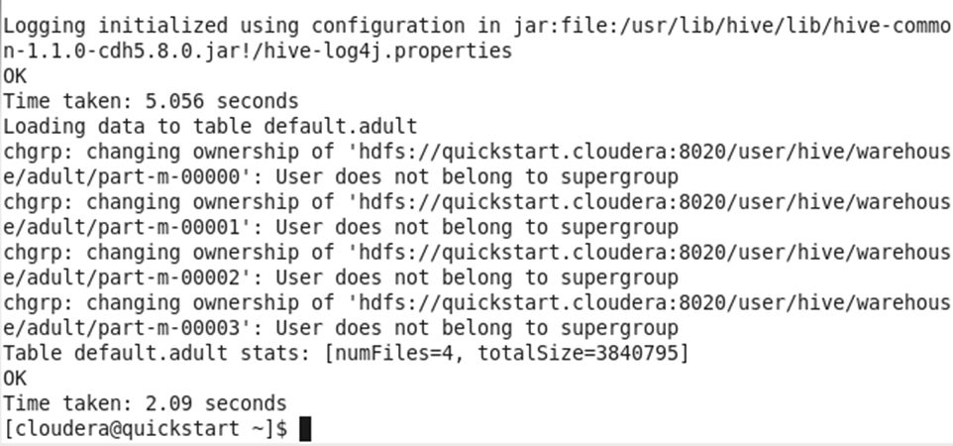

Figure 3 Data Importing

### 1.3.2 By Age

select count(*) as numAge, age, income as income_class

from adult

group by age,income

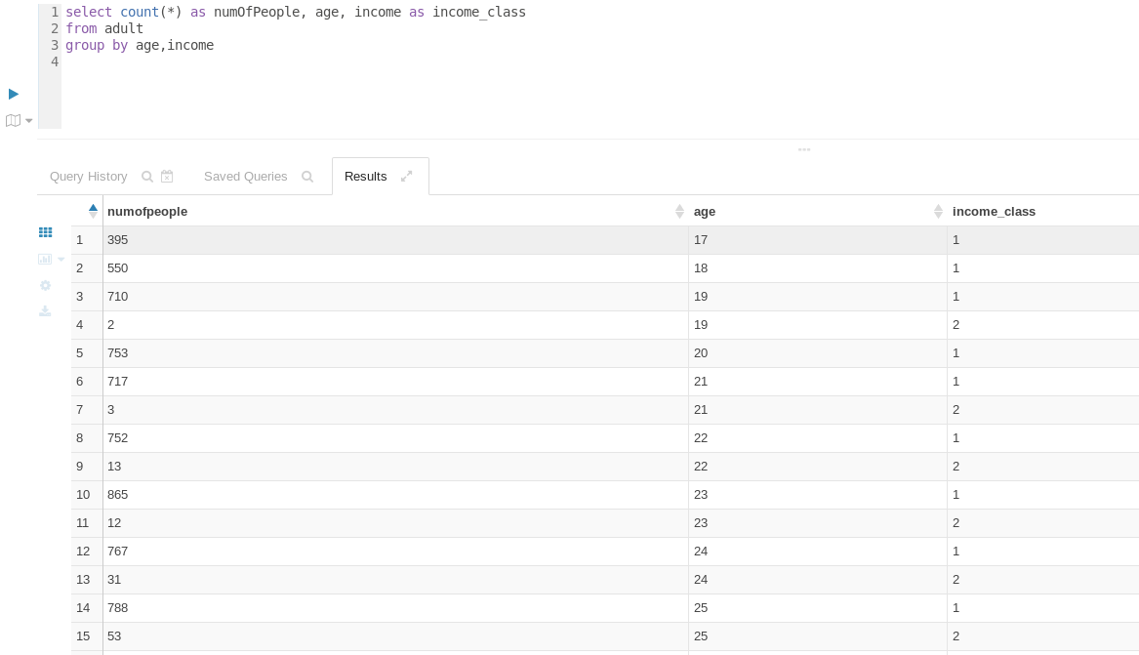

Figure 4 Hive: Income by Age

### 1.3.2 By Sex

select count(*) as numSex, sex, income as income_class

from adult

group by sex,income

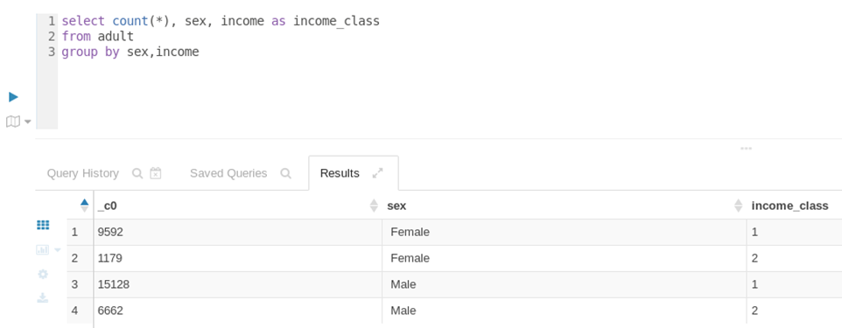

Figure 5 Hive: Income by Sex

### 1.3.2 By Workclass

select count(*) as numWorkclass, workclass, income as income_class

from adult

group by workclass,income

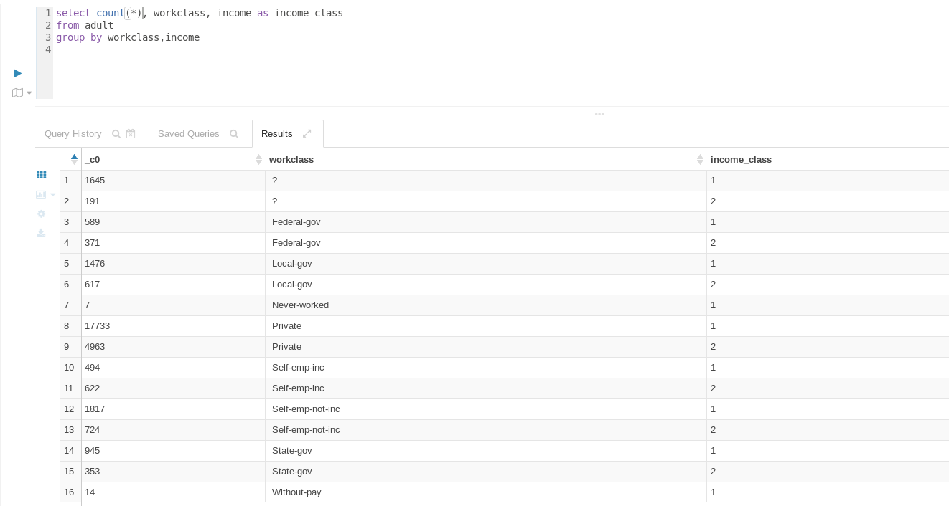

Figure 6 Income by Workclass

# 2. Discovering Neo4j

## 2.1 Load the Movie Database

:play movie graph

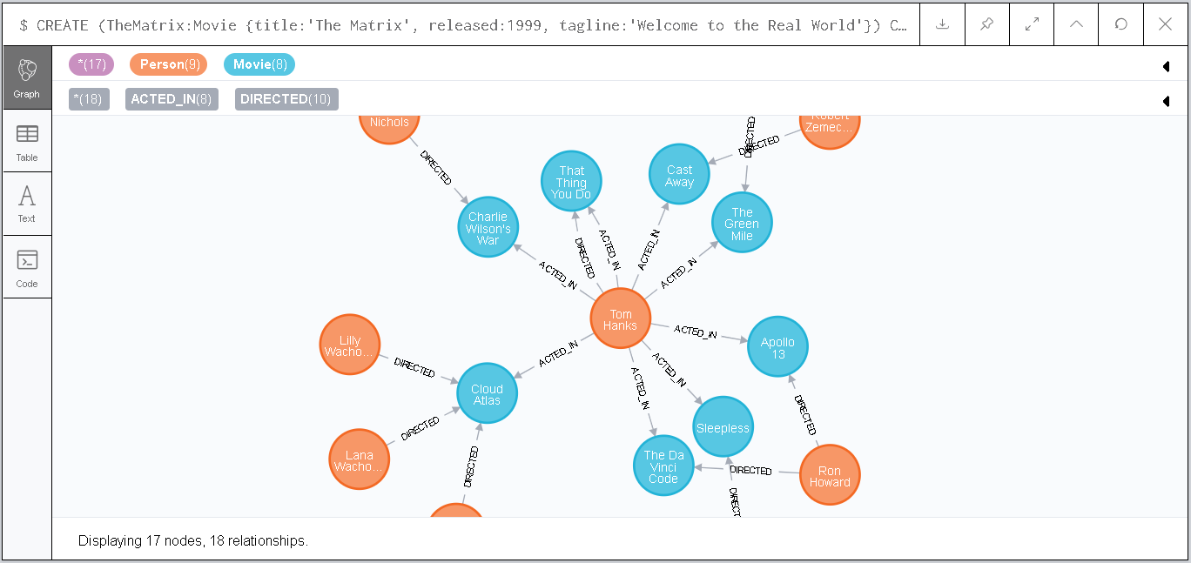

Figure 7 The Movie Database

## 2.2 Count the Number of Actors and Movies in the Database

MATCH (movie:Movie) RETURN COUNT(DISTINCT(movie))

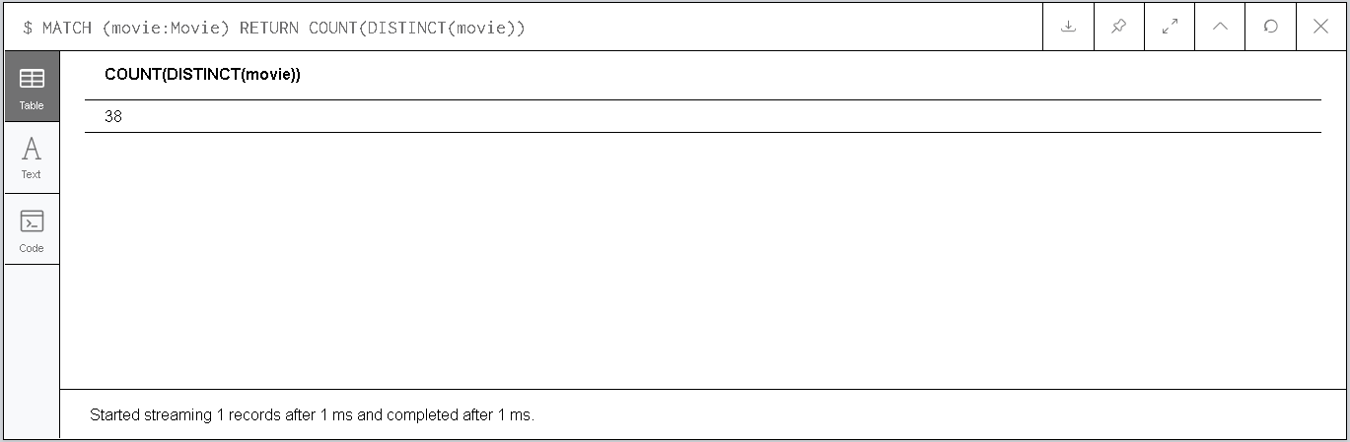

Figure 8 Number of Movies

MATCH (actor:Person)-[r:ACTED_IN]->() RETURN COUNT(DISTINCT(actor.name))

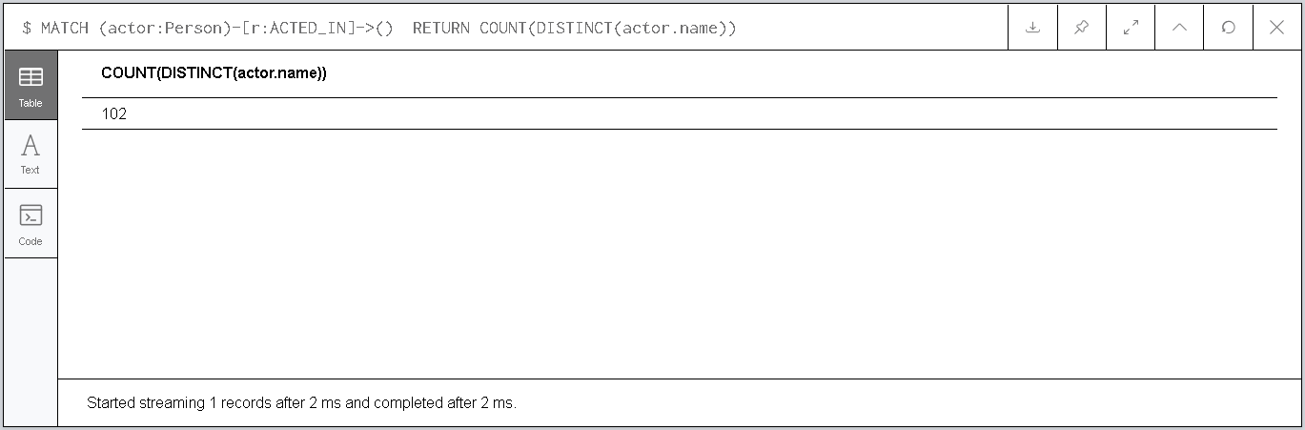

Figure 9 Number of Actors

## 2.3 Queries in Cypher

### 2.3.1 View actors who played directly with Tom Cruise

MATCH (TomC:Person {name:"Tom Cruise"})-[:ACTED_IN]->(m)<-[:ACTED_IN]-(coActors)

WHERE TomC <> coActors

RETURN DISTINCT(coActors)

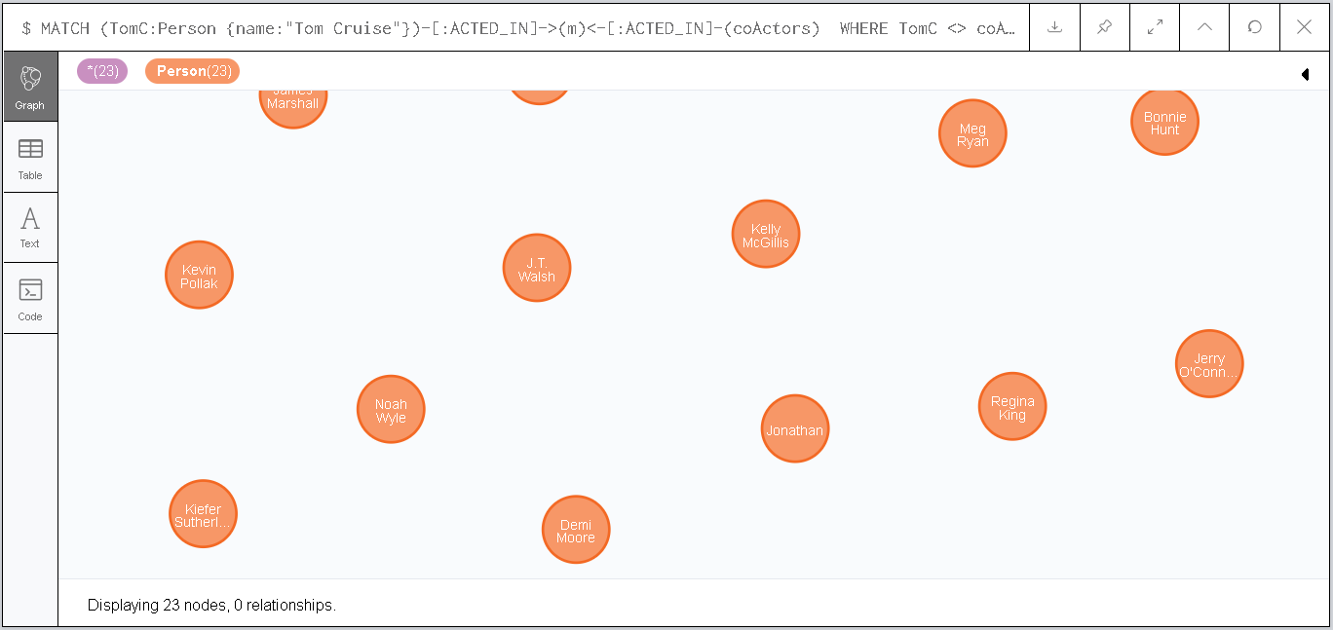

Figure 10 Co-actors of Tom Cruise

### 2.3.2 Number of actors who played directly with Tom Cruise

MATCH (TomC:Person {name:"Tom Cruise"})-[:ACTED_IN]->(m)<-[:ACTED_IN]-(coActors)

WHERE TomC <> coActors

RETURN COUNT(DISTINCT(coActors))

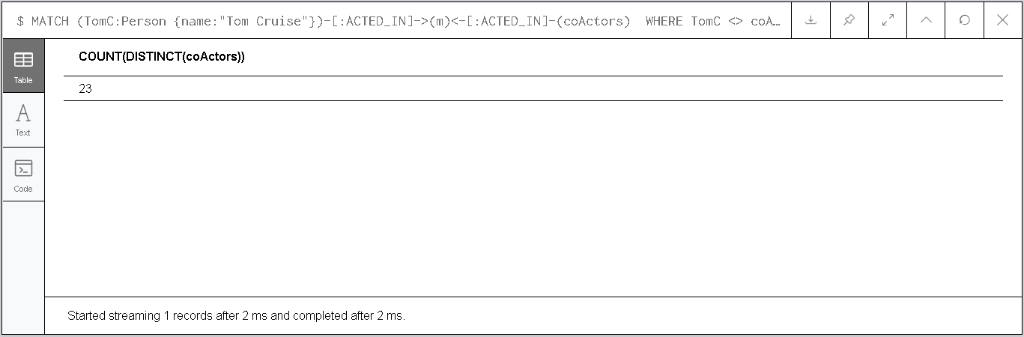

Figure 11 Number of Co-actors of Tome Cruise

### 2.3.3 View actors who have played with actors who have already played with Tom Cruise

MATCH (TomC:Person {name:"Tom Cruise"})-[:ACTED_IN]->(m)<-[:ACTED_IN]-(coActors), (coActors)-[:ACTE D_IN]->(m2)<-[:ACTED_IN]-(cocoActors)

WHERE TomC <> cocoActors

RETURN DISTINCT(cocoActors)

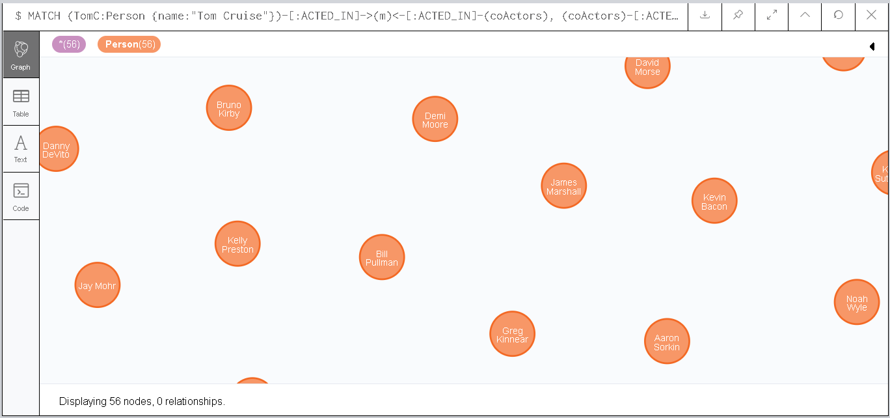

Figure 12 Co-coactors of Tom Cruise

### 2.3.5 Show for each director the number of actors he directed in movies

MATCH (director:Person)-[:DIRECTED]->() <-[:ACTED_IN]-(Actors) RETURN director.name,COUNT(DISTINCT(Actors))

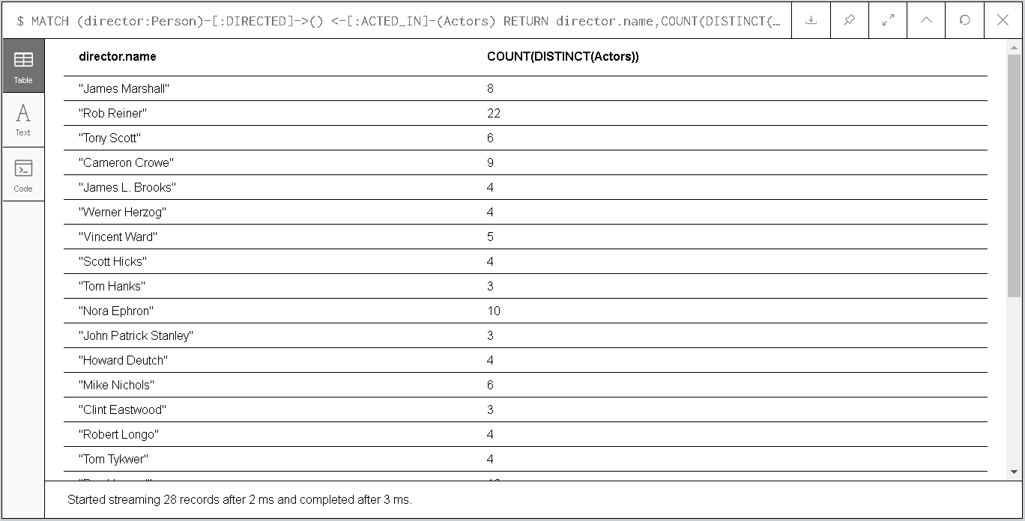

Figure 13 Number of Actors Directed by Each Director

### 2.3.6 Show for each director the average number of actors he directed by movie

MATCH (director:Person)-[:DIRECTED]->(movie:Movie)

WITH director, movie

MATCH (director:Person)-[:DIRECTED]->(movie)<-[:ACTED_IN]-(actors:Person)

WITH director,movie,COUNT(actors) AS numAct

RETURN director.name, numAct/COUNT(movie) AS avgActMov

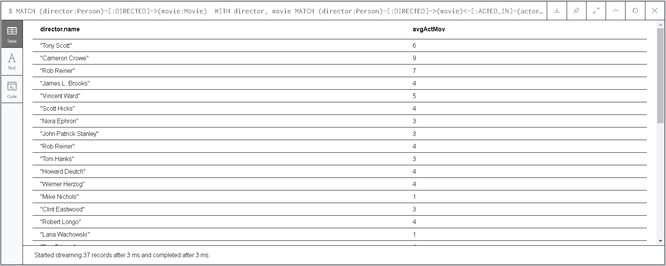

Figure 14 For Each Director, Average Number of Actors Directed by Movie