**Resume**

**Example DB:**

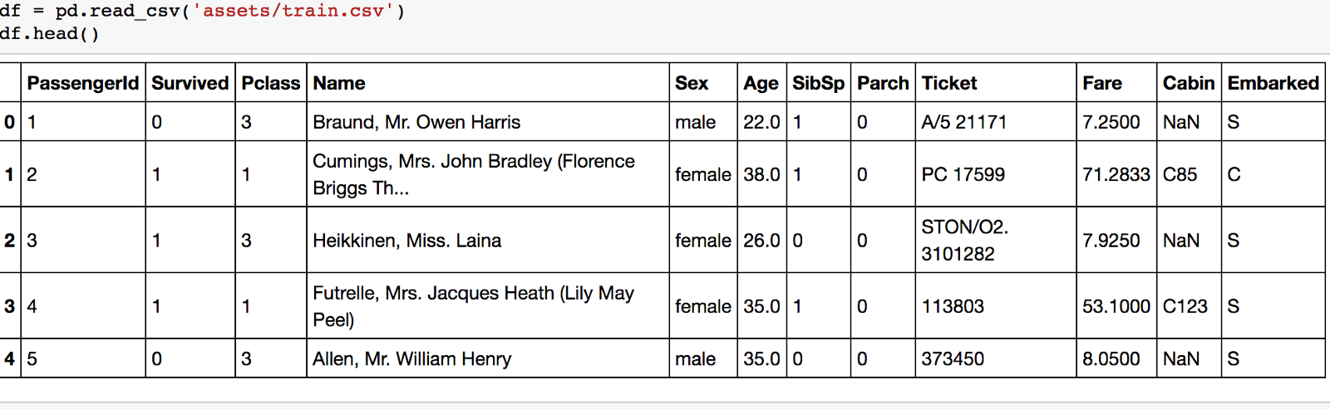

**Objects:**

* TrainingValue: Abstract class
* NumericalTrainingValue: Implement TrainingValue which is numerical
* TextualTrainingValue: Implement TrainingValue which is textual
* TrainingChar: Represent a character (column header) in the DB including (charID, charName, typeChar)
* TrainigRow: Represent a row in the DB including rowID, Map<TrainingChar,TrainingValue>



* TrainingDataSet: Represent a extracted Dataset from the DB including name (of this dataset), List<TrainingRow> extracted according to List<TrainingChar> chosen
* SingCharacteristicTree: A tree of 2 elements (1 character – 1 target) then use it for statistic the probability of survivor of 1 character

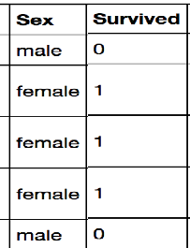

**Classes:**

DAO:

* To connect with database
* Extract the DB:
  + ExtractTrainingRow(int rowId, List<TrainingChar> chars)
  + ExtractTrainingDataset()

TrainingValue, NumericalTrainingValue, TextualTrainingValue, TrainingChar, TrainingRow

TrainingDataSet:

* HashSet<String> distinctValues(TrainingChar c): Create a list of distinct value for each column (character)
* List<SingleCharacteristicTree> createSingleCharTree(): Create a list of every SingleTree for each character (column) and calculate the probability of each value to find out which one mostly influence the survivor.