**20001711-NGUYỄN THÀNH LUÂN**

**Slide 5**

**Slide 6**

**Slide 7**

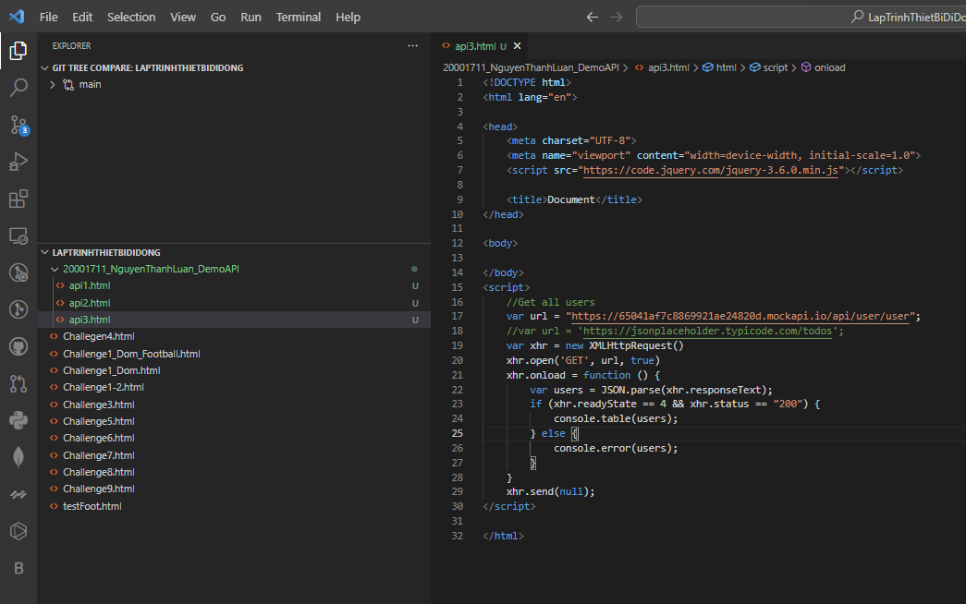

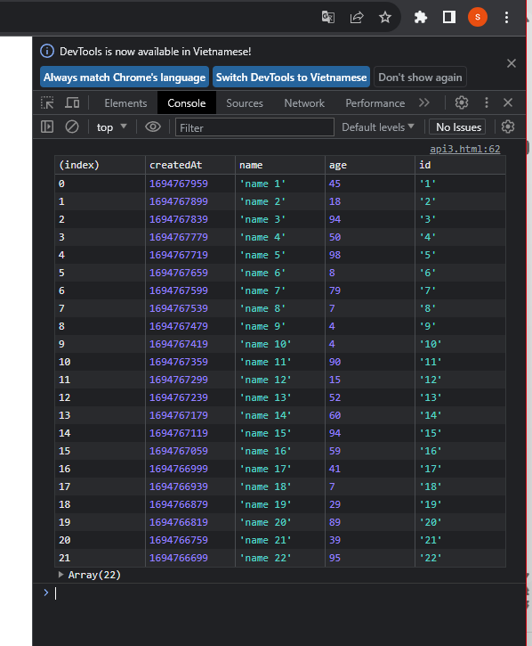

**Slide 9**

**Slide 10**

**Slide 11**

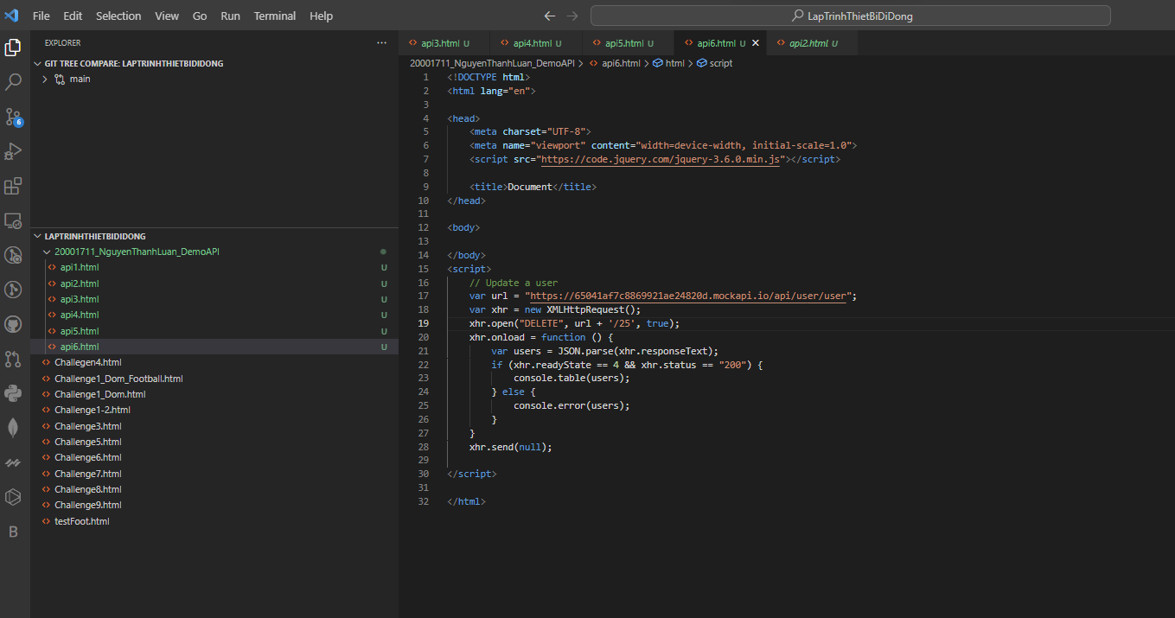

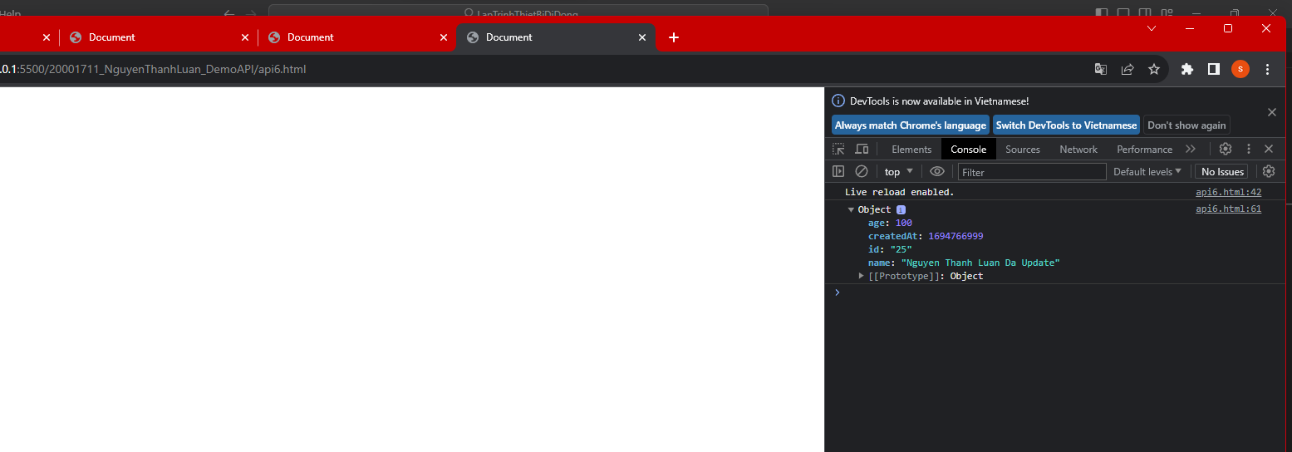

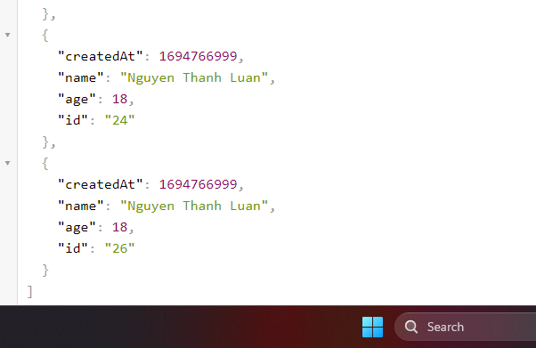

**PROMISE**

