HANOI UNIVERSITY OF SCIENCE AND TECHNOLOGY

School of Information and Communications Technology

Software Requirement Specification

Version 1.1

AIMS

Subject: Software Design and Construction

Nguyen Duc Hiep

MSSV: 20200213

*Hanoi,* *10/2023*

*<All notations inside the angle bracket are not part of this document, for its purpose is for extra instruction. When using this document, please erase all these notations and/or replace them with corresponding content as instructed. >*

*<This document, written by Prof. NGUYEN Thi Thu Trang, is used as a case study for student with related courses. Any modifications and/or utilization without the consent of the author is strictly forbidden>*

Table of contents

Table of contents 1

1 Introduction 2

1.1 Objective 2

1.2 Scope 2

1.3 Glossary 2

1.4 References 2

2 Overall requirements 3

2.1 Actors 3

2.2 General use case diagram 3

2.3 Lower-level use case diagrams 4

2.4 Business processes 4

2.4.1 Activity Diagram Place Order 4

2.4.2 Activity Diagram Place Rush Order 5

2.4.3 Activity Diagram Pay Order 5

3 Detail requirements 6

3.1 Specification of Use case UC001 - “Place order” 6

3.2 Specification of Use case UC002 - “Pay order” 8

3.3 Specification of Use case UC003 – “Place Rush Order” 10

4 Supplementary specification 13

4.1 Functionality 13

4.2 Usability 13

4.3 Reliability 13

4.4 Performance 13

4.5 Maintainability 13

4.6 Design Constraints 13

# Introduction

## Objective

This document presents the detailed description for User management subsystem, user group and their usable function at run time. This document also describes the objectives and features of the system, interfaces and constraints of the system in response to external action.

This document is for stakeholders and related software developers.

## Scope

<Describe the problem statement here>

## Glossary

*<Listing and explaining the terms appearing in the software’s profession and this documents. Any assumption of the reader’s prior knowledge or experience on the subject is ill advised>*

## References

*<Listing the referenced material used in this documents, including the one related to the project>*

# Overall requirements

## Actors

Software has 3 actors: customer, admin, VNPay

## General use case diagram

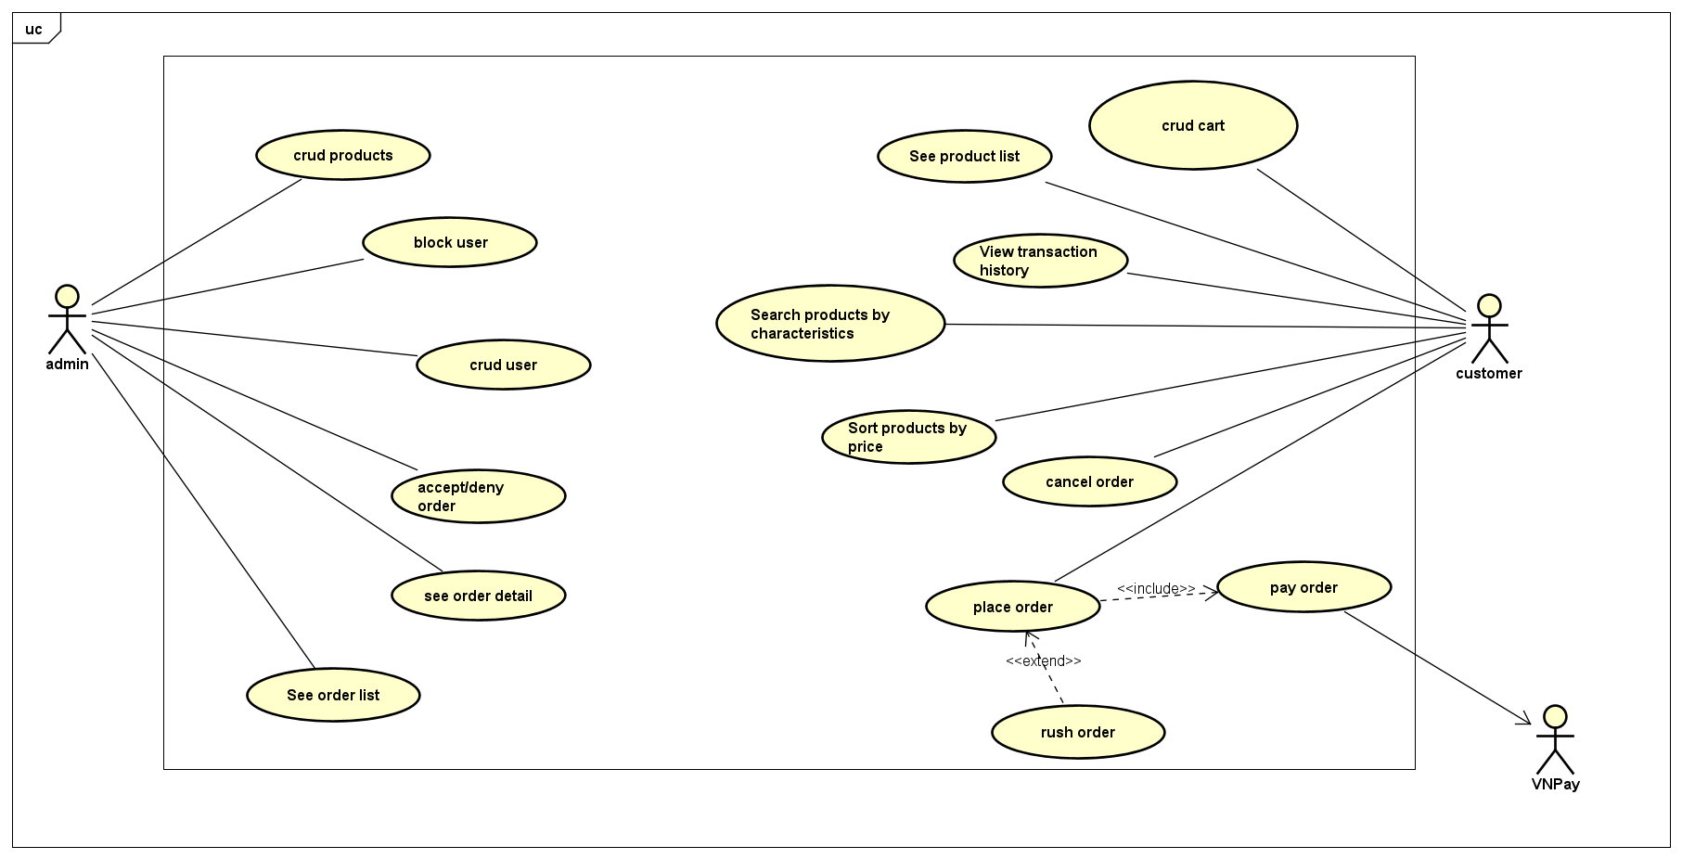

## Lower-level use case diagrams

## Business processes

### Activity Diagram Place Order

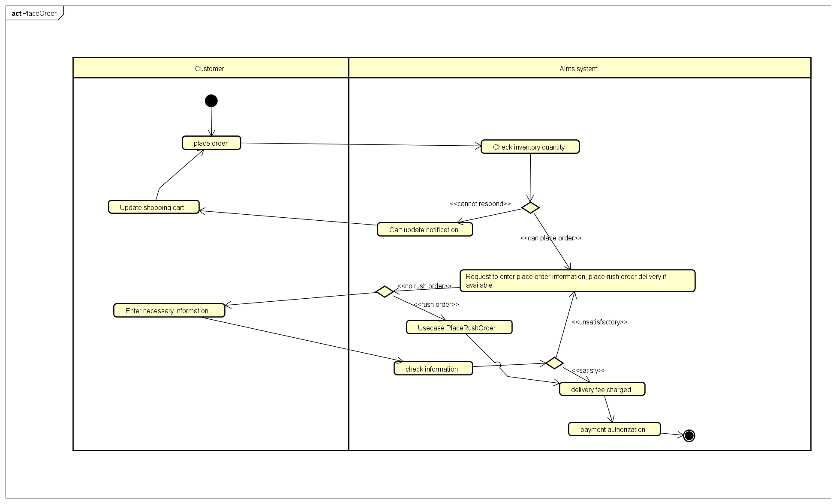

### Activity Diagram Place Rush Order

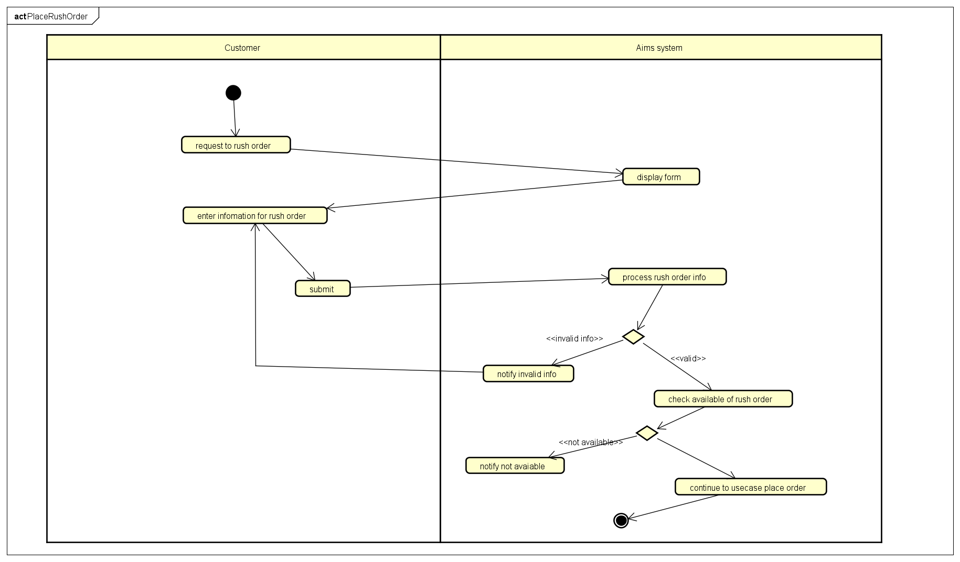

### Activity Diagram Pay Order

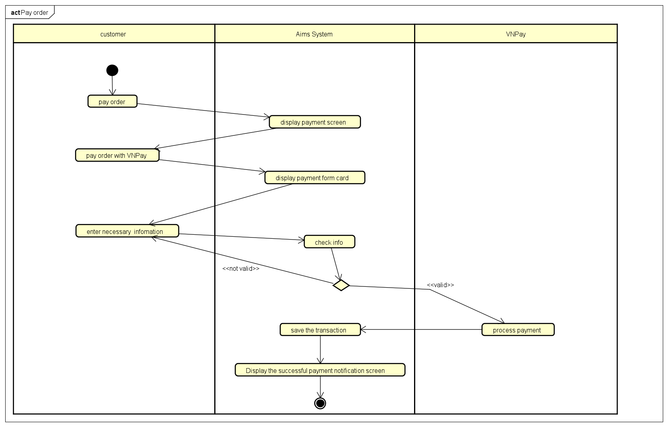

### Activity Diagram See Media List and Search Medias by title

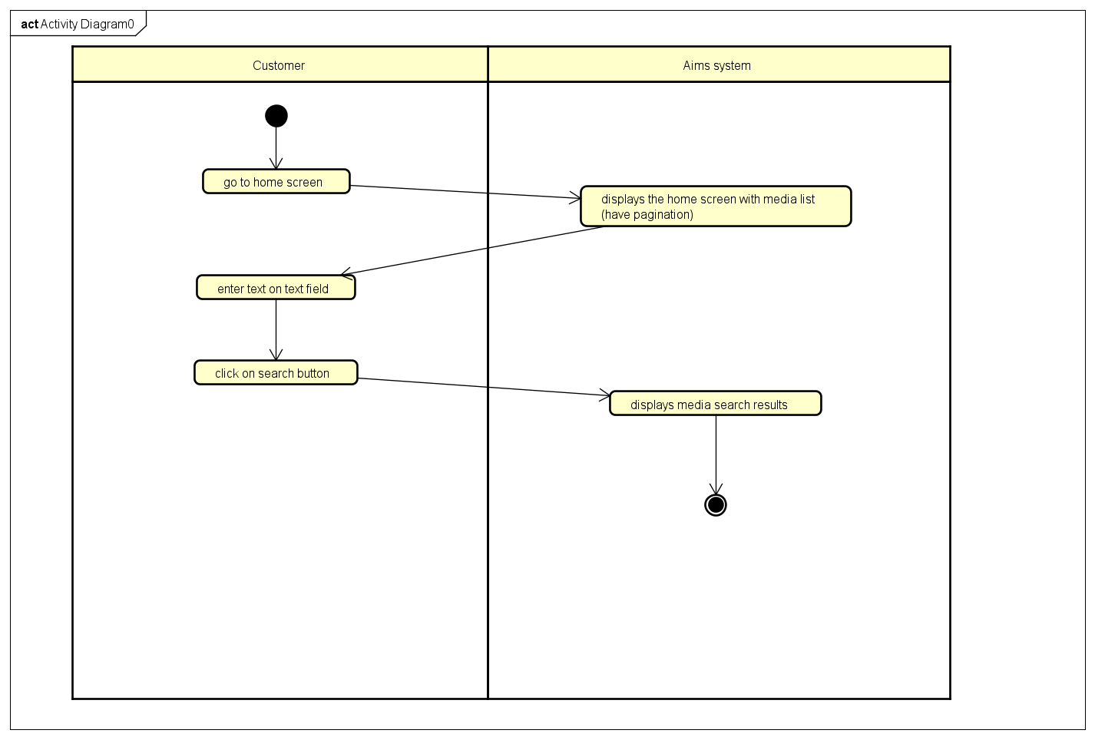

# Detail requirements

Details of the use cases given in following sections are specified below.

## Specification of Use case UC001 - “Place order”

1. **Use case code**

UC001

1. **Brief Description**

This use case describes the interaction between customer and AIMS system when customer wishes to place order

1. **Actors**

Customer

1. **Preconditions**

The customer is at the shopping cart interface

1. **Basic Flow of Events**

Step 1. The system displays the shopping cart interface

Step 2. Customer chooses to place an order

Step 3. The system checks the quantity of inventory

Step 4. The system requires entering delivery information

Step 5. Customers enter necessary information

Step 6. The system checks information

Step 7. The system calculates the delivery fee and authorizes payment

1. **Alternative flows**

Table N-Alternative flows of events for UC Place order

|  |  |  |  |  |
| --- | --- | --- | --- | --- |
| **No** | **Location** | **Condition** | **Action** | **Resume location** |
|  | At Step 3 | If inventory is insufficient | * The system asks the customer to update the shopping cart, and displays the inventory quantity for each unresponsive product | Resumes at Step 1 |
|  | At Step 6 | If the information is inappropriate or incomplete | * The system requires the customer to re-enter any information that is not satisfied | Resumes at Step 5 |
| 3. | At step 5 | If the user chooses to place a rush order | * The AIMS software inserts use case “Place Rush Order” | Resumes at step 1 use case “Place Rush Order” |

1. **Input data**

Table A-Input data of delevery infomation

|  |  |  |  |  |  |
| --- | --- | --- | --- | --- | --- |
| **No** | **Data fields** | **Description** | **Mandatory** | **Valid condition** | **Example** |
|  | Receiver name | Required | Yes | String, max: 255 | Nguyen Duc Hiep |
|  | Phone number | required | Yes | 10 digits | 0366 125 502 |
|  | Province | Choose from a list | Yes |  | Ha Noi |
|  | Address | required | Yes |  | Giap Bat, Hoang Mai, Ha Noi |
|  | Shipping instructions | nullable | No |  |  |

1. **Output data**

Table B-Output data of …

|  |  |  |  |  |
| --- | --- | --- | --- | --- |
| **No** | **Data fields** | **Description** | **Display format** | **Example** |
|  | Title | Title of a media product |  | DVD Phim Vượt  ngục |
|  | Price | Price of the corresponding media products | * Comma for thousands separator * Positive integer * Right alignment | 123,000 |
|  | Quantity | Quantity of the corresponding media | * Positive integer * Right alignment | 2 |
|  | Amoount | Total money of the corresponding media | * Comma for thousands separator * Positive integer * Right alignment | 246,000 |
|  | Subtotal before VAT | Total price of products in the cart before VAT | * Comma for thousands separator * Positive integer * Right alignment | 2,106,000 |
|  | Subtotal | Total price of products in the cart with VAT | 2,316,600 |
|  | Shipping fee |  |  | 30 |
|  | Total |  |  | 2,346,600 |
|  | Currency |  |  | VND |
|  | Name |  |  | Nguyen Duc Hiep |
|  | Phone number |  |  | 0366 125 502 |
|  | Province |  |  | Hanoi |
|  | Address |  |  | Giap Bat, Hoang Mai, Ha Noi |
|  | Shipping instructions |  |  |  |

1. **Postconditions**

## Specification of Use case UC002 - “Pay order”

1. **Use case code**

UC002

1. **Brief Description**

This use case describes the interaction between customer, VNPay and AIMS system when customer wishes to pay

1. **Actors**

Customer, VNPay

1. **Preconditions**

The customer placed an order successfully

1. **Basic Flow of Events**

Step 1. Customer chooses to pay

Step 2. The system displays the payment interface

Step 3. Customers choose to pay via VNPay service

Step 4. The system returns the payment interface of VNPay

Step 5. Customer fills in information and clicks agree to payment

Step 6. The system checks credit card information

Step 7. The system updates the paid order status, saves the order to the database, notifies of success and displays transaction information

1. **Alternative flows**

Table N-Alternative flows of events for UC Place order

|  |  |  |  |  |
| --- | --- | --- | --- | --- |
| **No** | **Location** | **Condition** | **Action** | **Resume location** |
|  | At Step 6 | If the credit card information is invalid | * The system notifies payment failure | Resumes at Step 2 |

1. **Input data**

Table A-Input data of …

|  |  |  |  |  |  |
| --- | --- | --- | --- | --- | --- |
| **No** | **Data fields** | **Description** | **Mandatory** | **Valid condition** | **Example** |
|  | Card holder name |  | Yes | Maximum of 50 character | Nguyen Duc Hiep |
|  | Card number |  | Yes | 16 digits | 1234 3456 7896 7899 |
| 1. R | Expiration Date |  | Yes | Consist of month and last 2 digits of year only | 10/23 |
|  | Security code |  | Yes | 3 digits | 123 |

1. **Output data**

Table B-Output data of …

|  |  |  |  |  |
| --- | --- | --- | --- | --- |
| **No** | **Data fields** | **Description** | **Display format** | **Example** |
|  | Transaction ID |  |  |  |
|  | Card holder name |  |  | Nguyen Duc Hiep |
|  | Amount |  | Right alignment | 1.200.000 VNĐ |
|  | Transaction Content |  |  |  |
|  | Transaction Date |  | Dd/mm/yyyy | 07/10/2023 |

1. **Postconditions**

## Specification of Use case UC003 – “Place Rush Order”

**1. Use case code**

UC003

**2. Brief Description**

This use case describes the interaction between customer and AIMS system when customer wishes to place rush order

**3. Actors**

Customer

**4. Preconditions**

The actor request to place rush order in the “Place Order” Use case.

**5. Basic Flow of Events**

Step 1. The system displays the rush order’s information form

Step 2. Customers enter rush order’s information

Step 3. Customer confirms information

Step 4. The system processes rush order’s information

Step 5. Product inspection system supports rush order

Step 6. Move to the charging section of use case place order

**6. Alternative flows**

Table N-Alternative flows of events for UC Place order

|  |  |  |  |  |
| --- | --- | --- | --- | --- |
| **No** | **Location** | **Condition** | **Action** | **Resume location** |
|  | At Step 4 | If the information is not valid | * The AIMS software notifies that the information is invalid | Resumes at Step 2 |
|  | At step 5 | If there is a product that does not support rush order | * The AIMS software notifies that there is a product that does not support rush order | Resumes at Step 2 |

**7.Input data**

Table A-Input data of …

|  |  |  |  |  |  |
| --- | --- | --- | --- | --- | --- |
| **No** | **Data fields** | **Description** | **Mandatory** | **Valid condition** | **Example** |
|  | time |  | Yes | Not blank |  |
|  | Rush order instructions | nullable |  |  |  |

**8.Output data**

Table B-Output data of …

|  |  |  |  |  |
| --- | --- | --- | --- | --- |
| **No** | **Data fields** | **Description** | **Display format** | **Example** |
|  | Title | Title of a media product |  |  |
|  | Price | Price of the corresponding media products | * Comma for thousands separator * Positive integer * Right alignment | 123,000 |
|  | Quantity | Quantity of the corresponding media | * Positive integer * Right alignment | 2 |
|  | time | Arrival date of the product(s) | * DD/MM/YYYY |  |
|  | Amoount | Total money of the corresponding media | * Comma for thousands separator * Positive integer * Right alignment | 246,000 |
|  | Subtotal before VAT | Total price of products in the cart before VAT | * Comma for thousands separator * Positive integer * Right alignment | 2,106,000 |
|  | Subtotal | Total price of products in the cart with VAT | 2,316,600 |
|  | Rush order instructions |  |  |  |

**9.Postconditions**

## Specification of Usecase UC004 - “See Media List”

**1. Use case code**

UC004

**2. Brief Description**

This use case describes the interaction between customer and AIMS system when customer go to home screen

**3. Actors**

Customer

**4. Preconditions**

Customer is at the home page

**5. Basic Flow of Events**

Step 1. Go to home screen

Step 2. Select pages in pagination

## Specification of Use case UC005 – “Search Medias by title”

**1. Use case code**

UC005

**2. Brief Description**

This use case describes the interaction between customer and AIMS system when customer want to search medias by title

**3. Actors**

Customer

**4. Preconditions**

Customer is at the home page

**5. Basic Flow of Events**

Step 1. Go to home screen

Step 2. Enter text in text field input

Step 3. Click on search button

**6. Alternative flows**

**7.Input data**

Table A-Input data of text field input

|  |  |  |  |  |  |
| --- | --- | --- | --- | --- | --- |
| **No** | **Data fields** | **Description** | **Mandatory** | **Valid condition** | **Example** |
| 1 | title |  | No |  | book |

**8.Output data**

**9.Postconditions**

# Supplementary specification

*<Presenting other requirements if necessary, including non-functional requirements such as performance, reliability, usability, and supportability; or other technical requirements such as database system, used technology…>*

## Functionality

<List of the functional requirements that are general to many use cases. E.g. Among the flow of events of use case, in all the steps that interacts with the database system, if there are errors in the connection or operation processes, there need to be a corresponding error notifications so that the actor knows that the error is related to the database system rather than the user>

## Usability

<Requirements that relate to, or affect, the usability of the software. Examples include ease-of-use requirements or training requirements that specify how readily the software can be used by its actors>

## Reliability

<Any requirements concerning the reliability of the software. Quantitative measures such as mean time between failure or defects per thousand lines of code should be stated>

## Performance

<The performance characteristics of the software. Include specific response times. Reference related use cases by name>

## Maintainability

<Any requirements that will enhance the supportability or maintainability of the software being built>

## Design Constraints

<Any design constraints on the software being built>