Appendix: End-to-End Execution Example of AutoRSP

This appendix presents a fully reproducible end-to-end execution example of AutoRSP, illustrating the complete pipeline from raw robotic code input to a verified Robot Skill Primitive (RSP) class output. The example uses the turtlebot3_example dataset (consistent with the main paper) and includes runtime logs, workflow visualizations, and intermediate outputs to ensure full transparency and replicability for reviewers.

A. The step-by-step output from the LangGraph web interface is captured in the following screenshot:
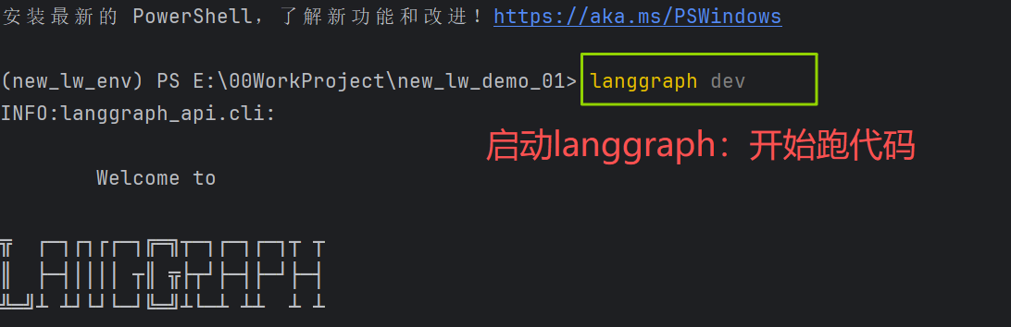
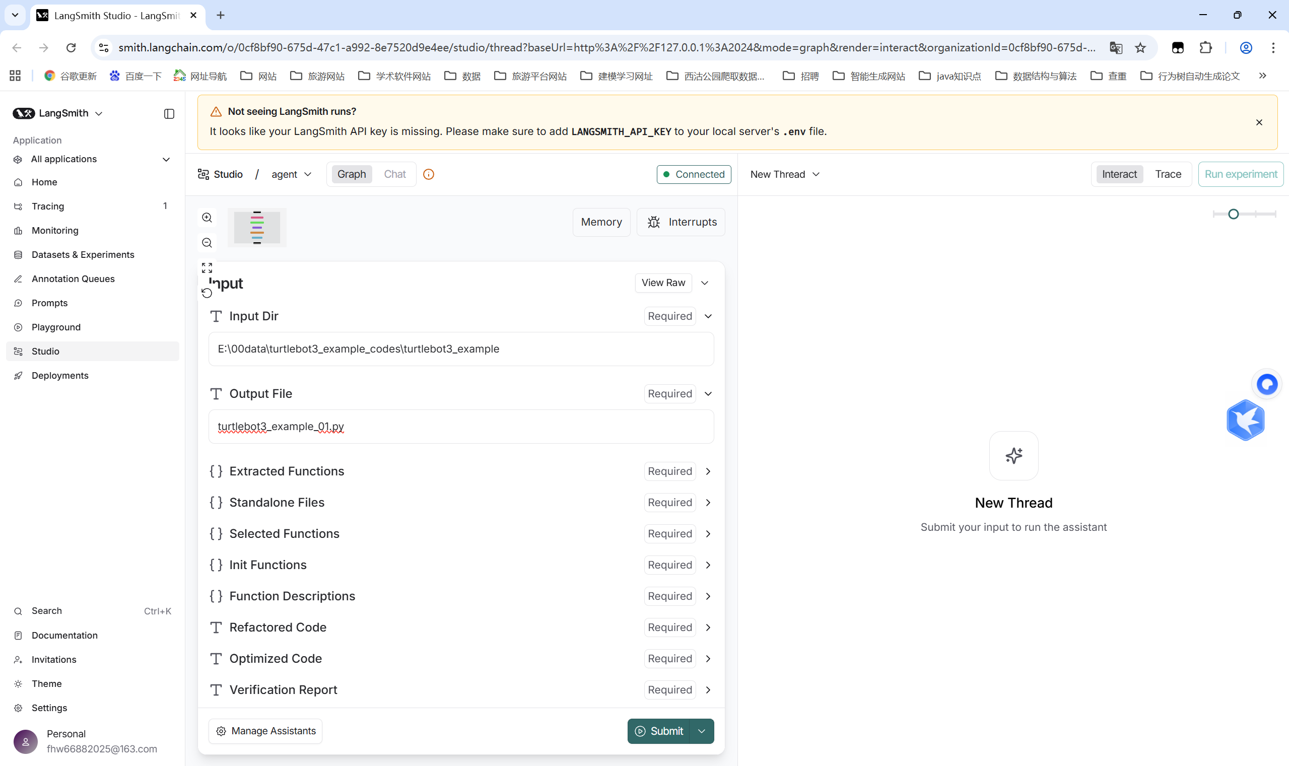
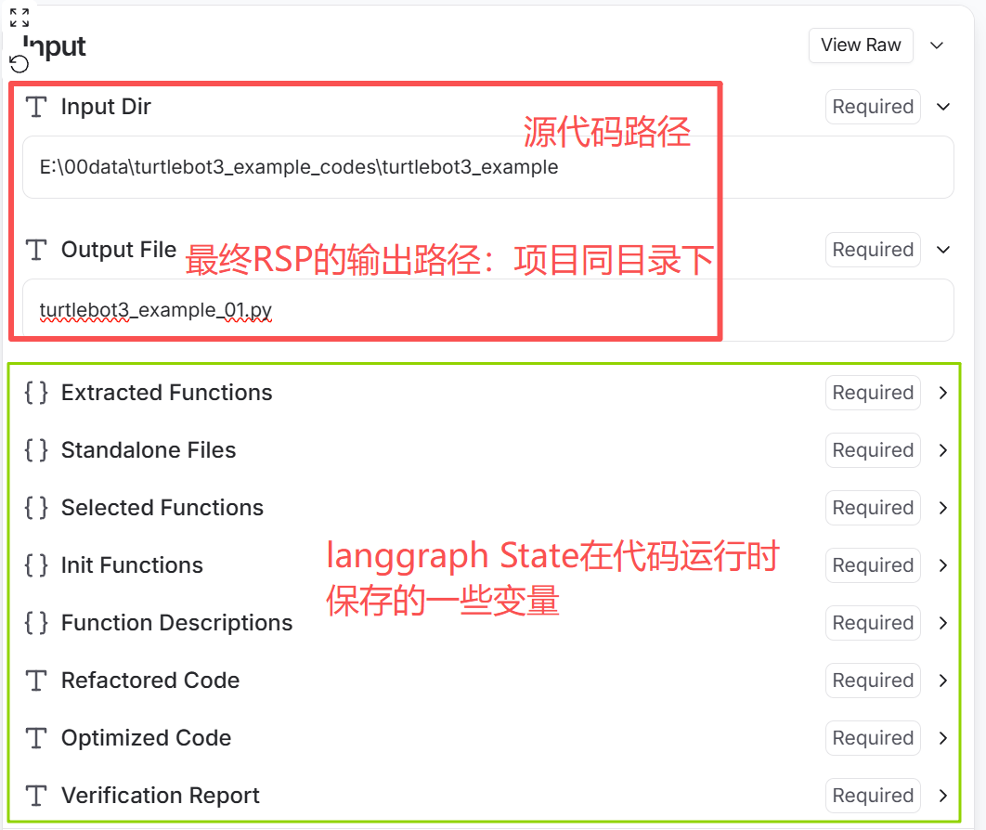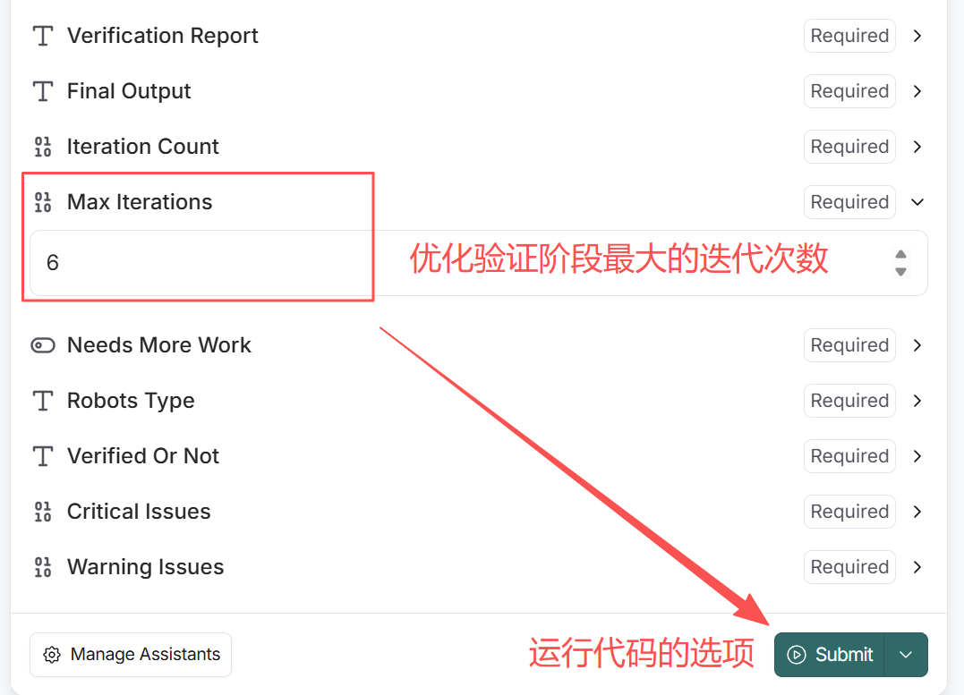
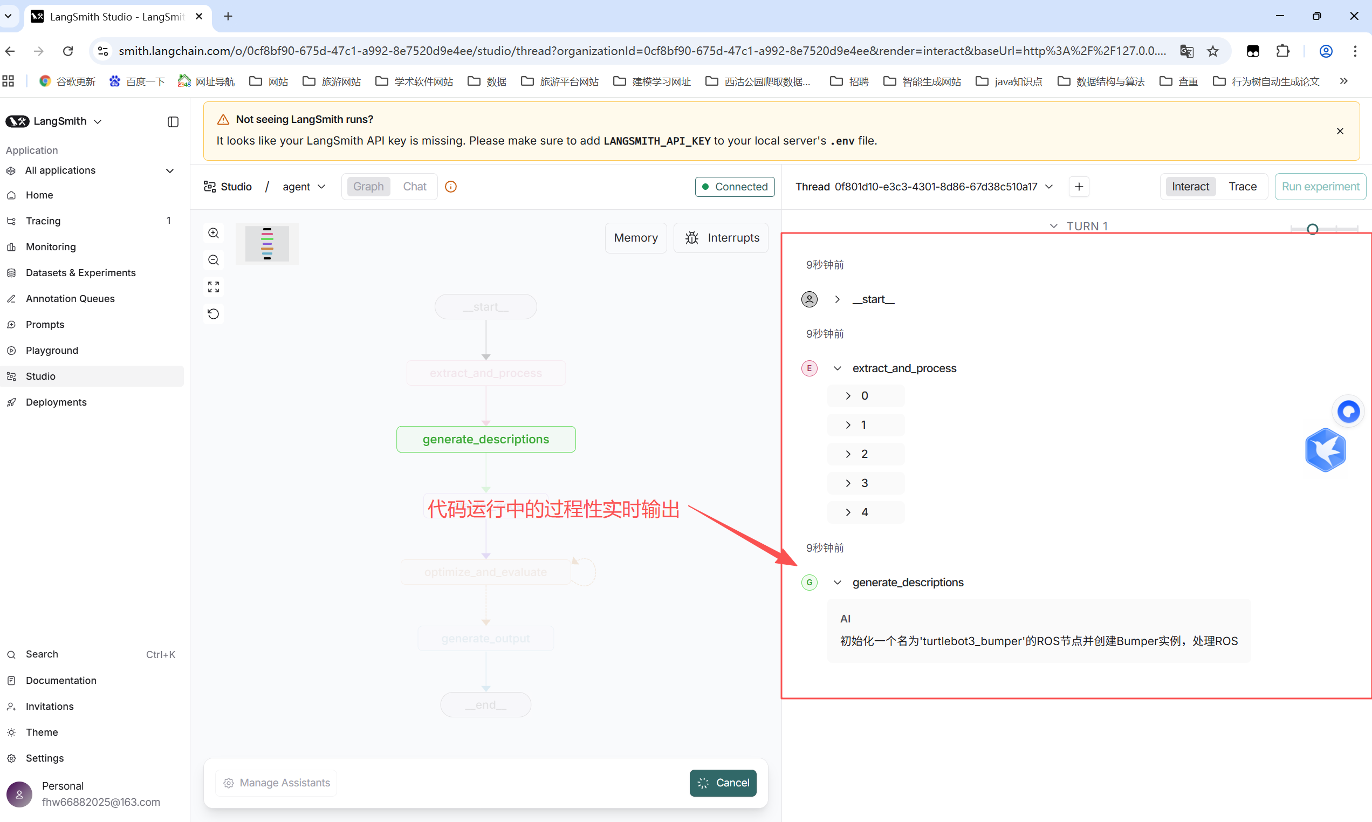
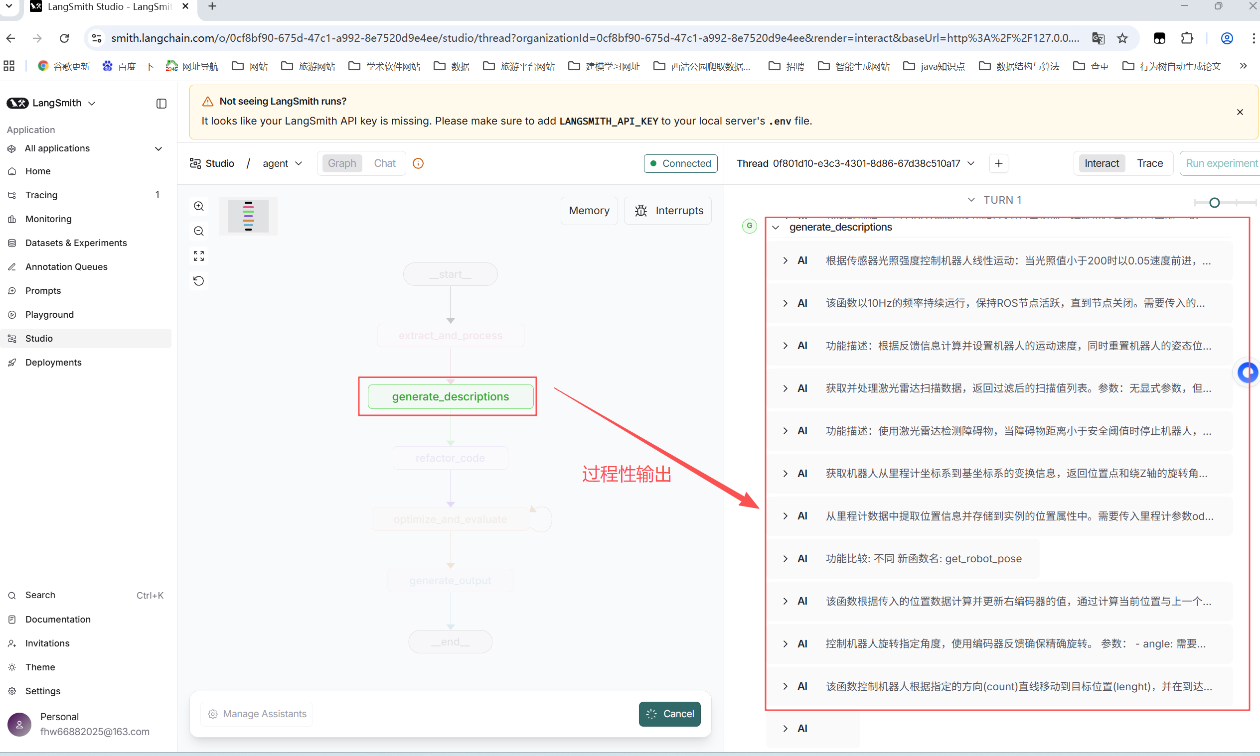
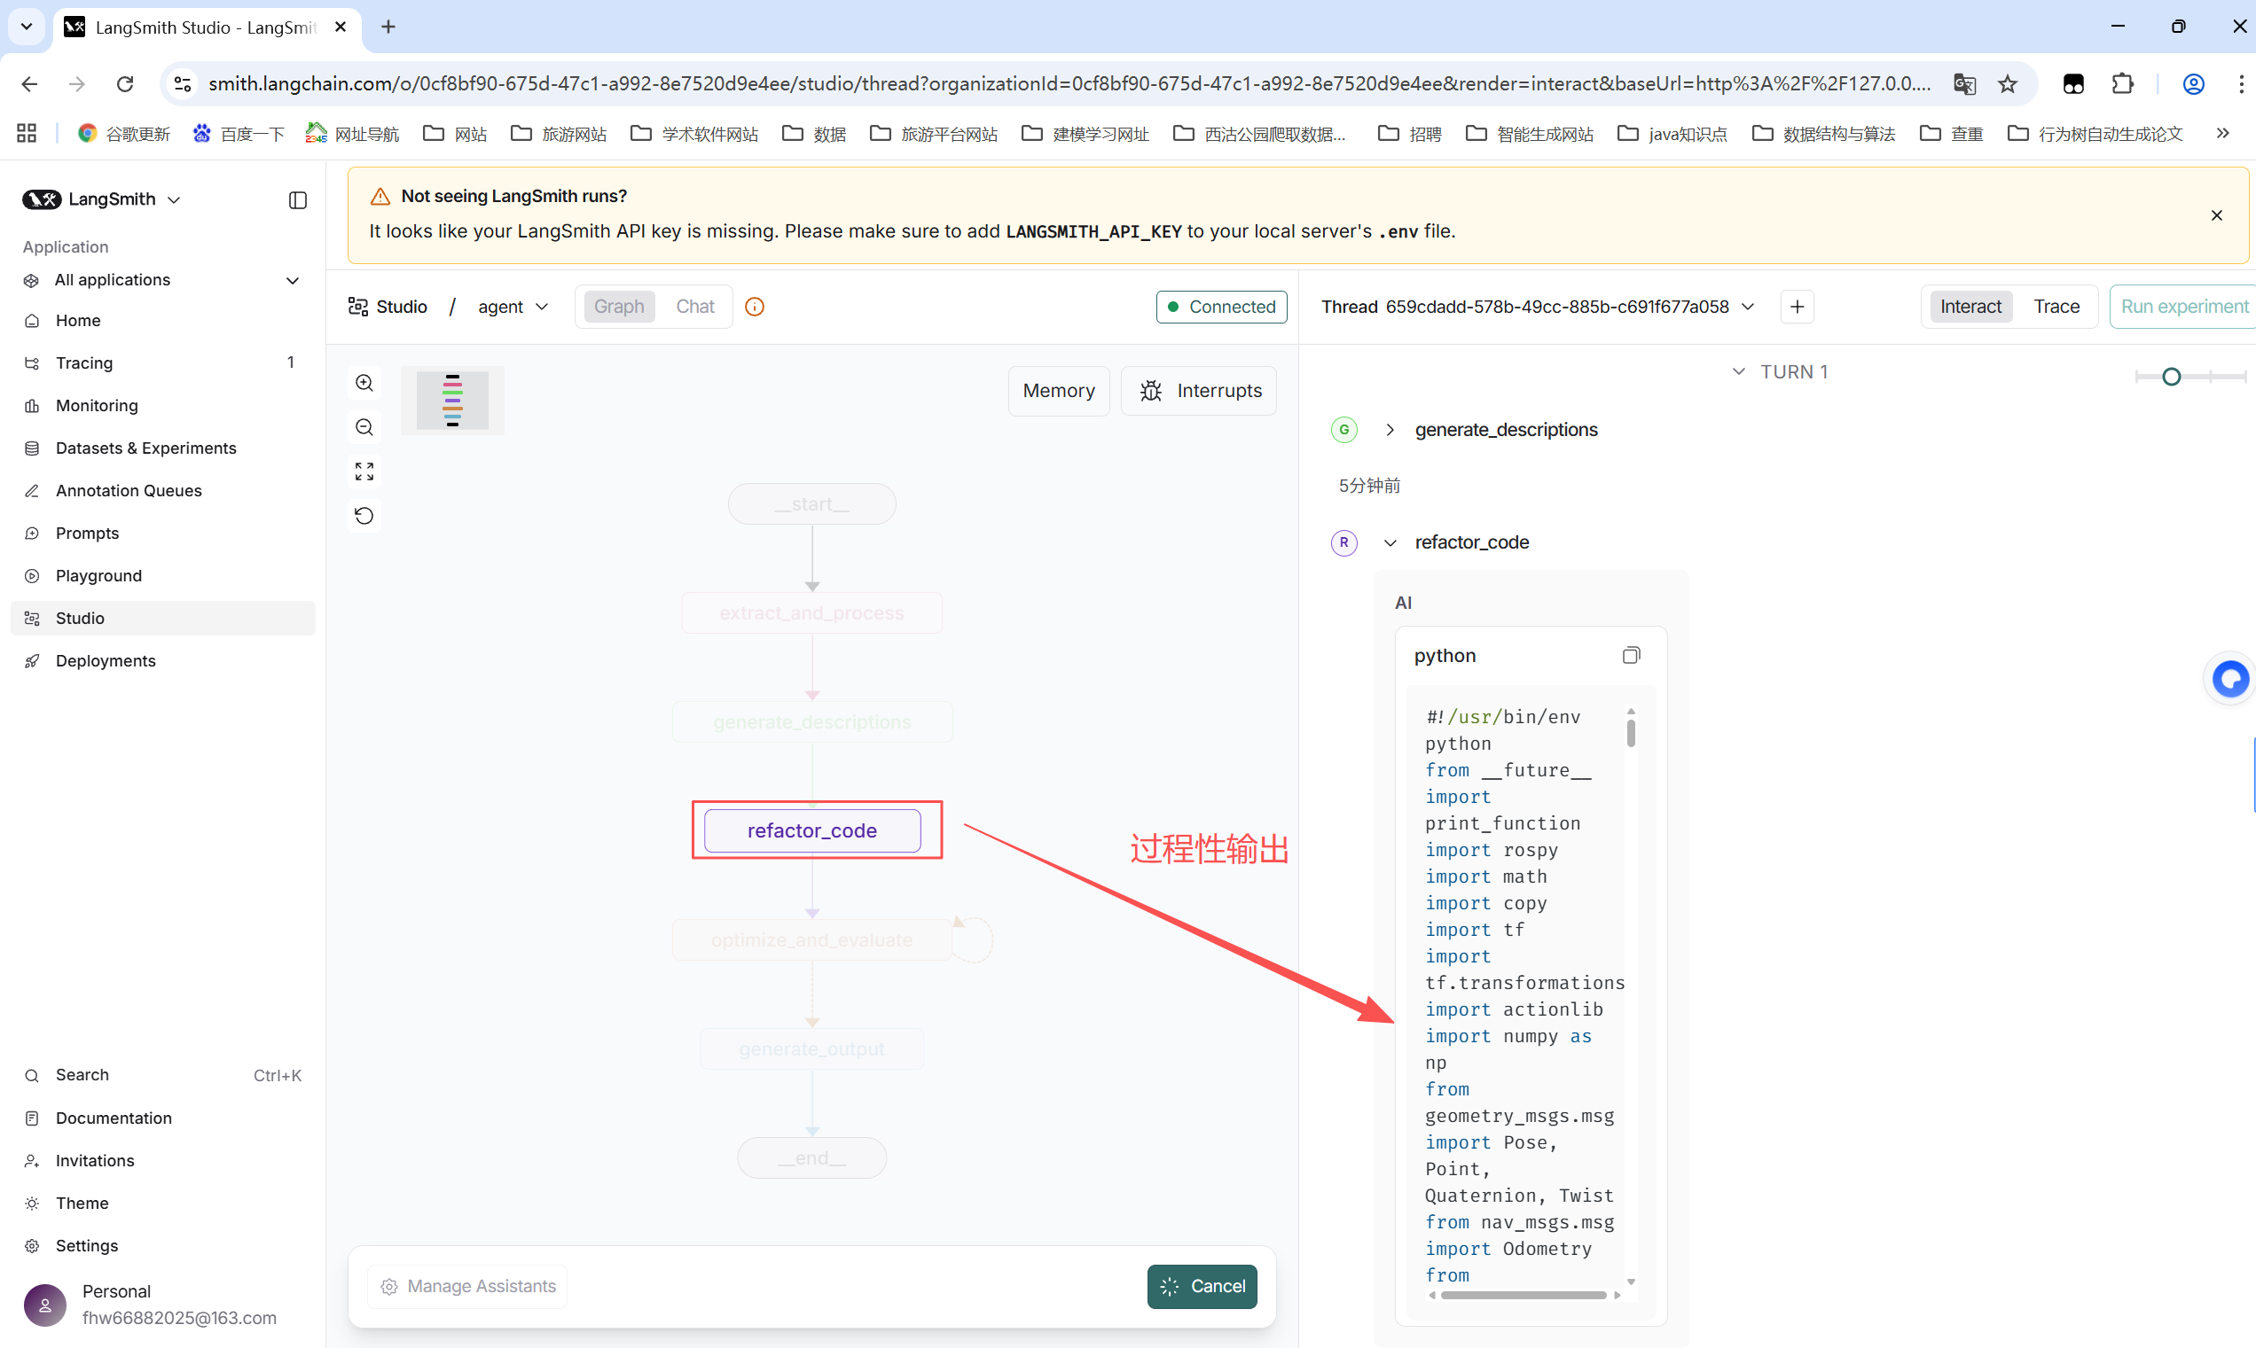
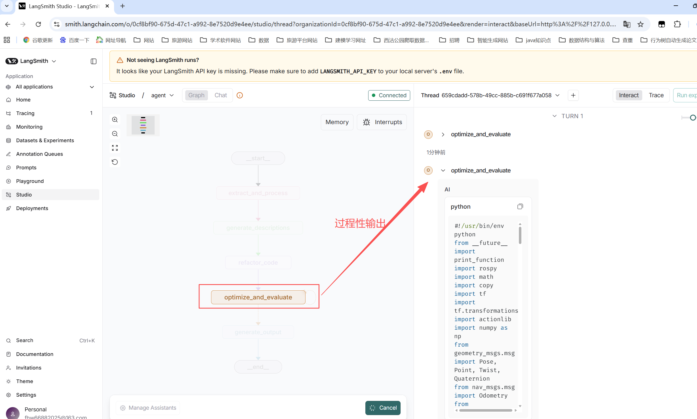

B.The runtime log output from the PyCharm Integrated Development Environment (IDE) terminal during code execution is presented below.
