Software Architecture Final Project

Class diagram for Library System Services

Customer Service

Book Command Service

Book Query Service

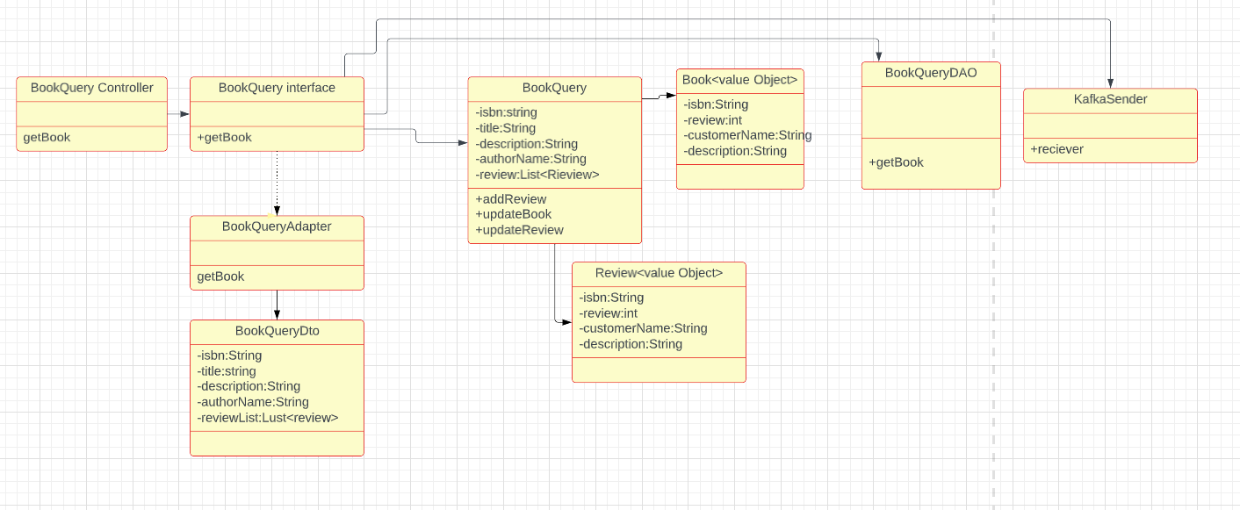

Review Service

Borrowing Service

