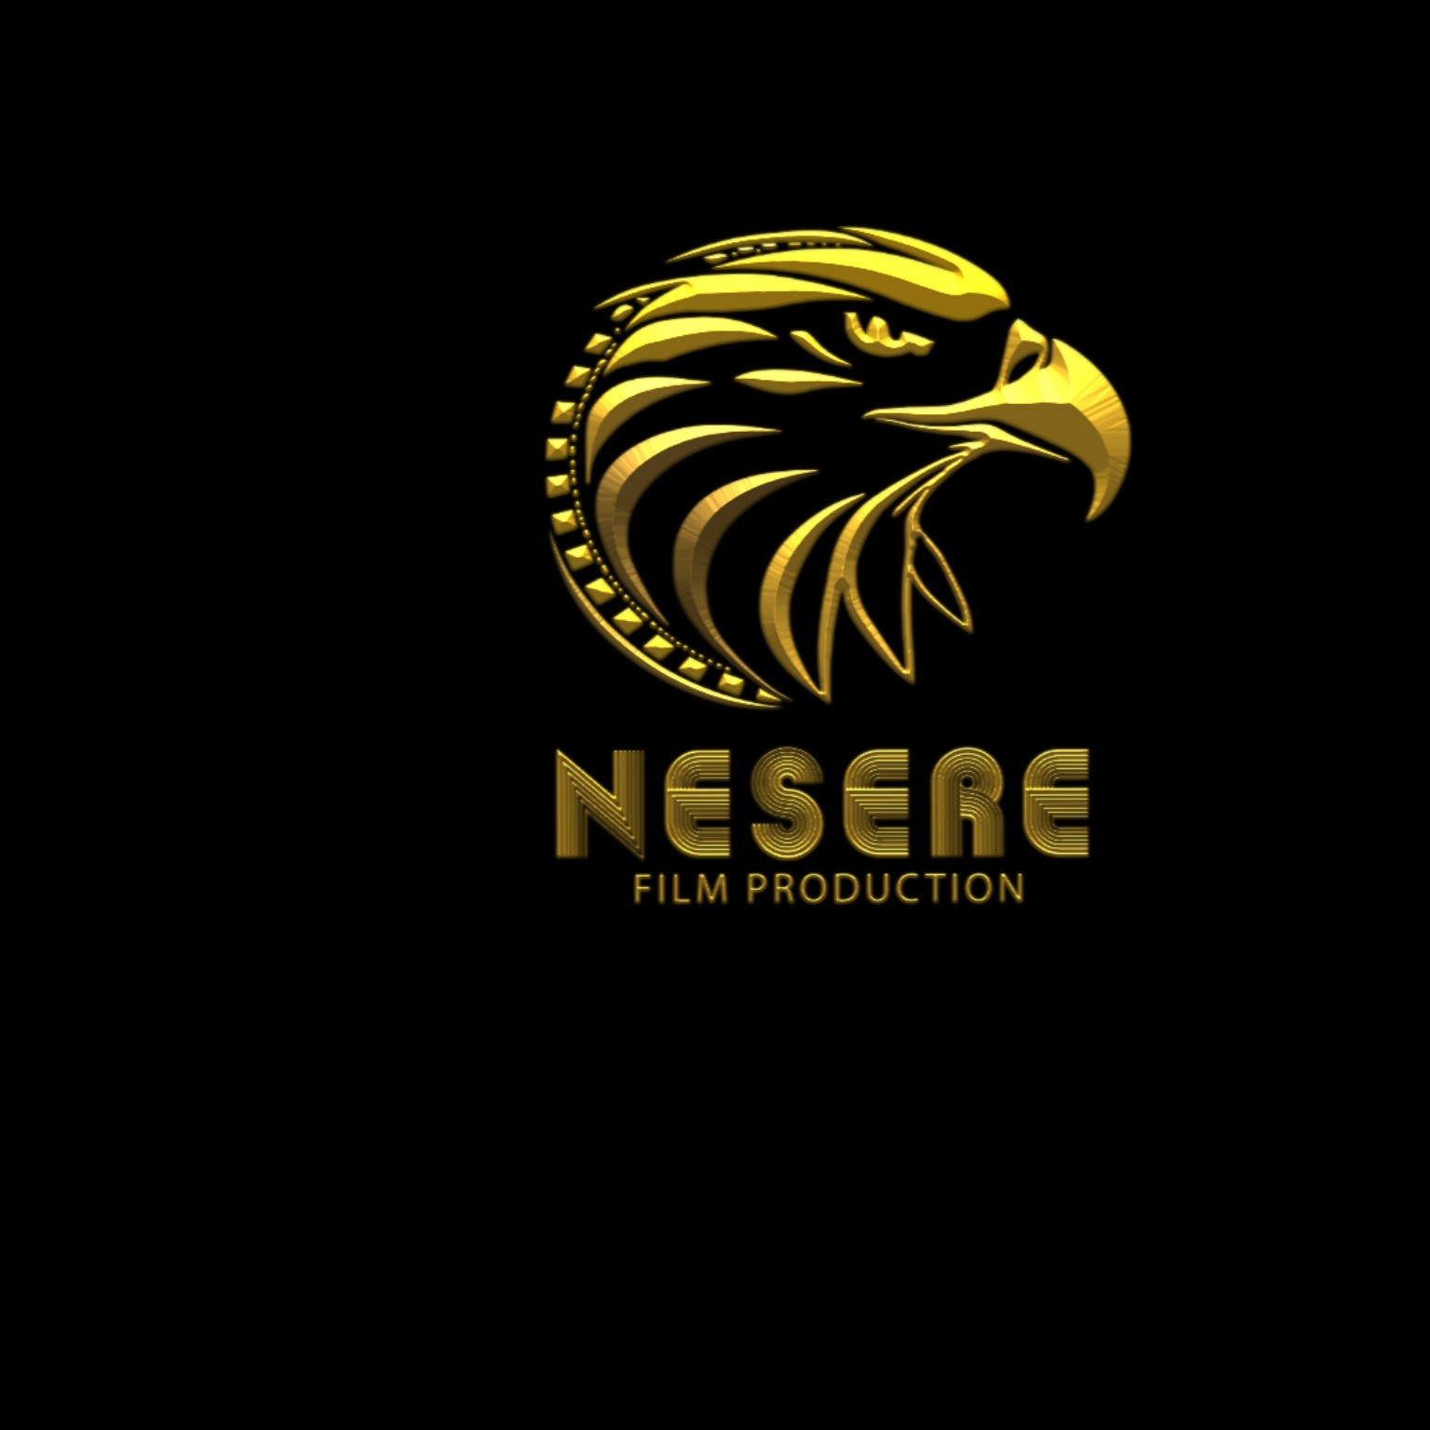
NESERE FILM PRODUCTION
Creative Media & Digital Services Management System
FULL SYSTEM REQUIREMENTS DOCUMENT
Brand Color Base: BLACK • GOLD • WHITE

1. Introduction
This document defines the requirements for the NESERE Film Production website and digital services management system. The system is for a creative visual media company based in Addis Ababa, Ethiopia, offering film production, TV commercials, YouTube and podcast production, social media management, wedding and event coverage, post-production, graphics design, web development, and advertisement/boosting services.

2. Project Objectives
- Create a professional online presence for NESERE Film Production.
- Present all company services, packages, portfolio projects, and contact channels.
- Allow customers to request services and submit project/booking information online.
- Allow administrators to manage services, packages, customers, requests, quotations, projects, and website content.
- Provide a responsive experience on desktop, laptop, tablet, and mobile.
- Use a premium cinematic design based on the NESERE logo.

3. Brand & Color Requirements
The supplied NESERE eagle logo is the main visual reference. The complete website should use the following color base:
Color | HEX | Main Use | Design Role
Black | #0B0B0B | Backgrounds, header, footer | Primary brand color
Gold | #D4AF37 | Buttons, icons, headings | Primary accent
Light Gold | #F2D16B | Hover, badges, highlights | Secondary accent
White | #FFFFFF | Main text | Contrast/readability
Design style: Luxury + Cinematic + Modern + Professional + Minimal.

4. Services
- Film & Video Production — cinematic films, documentaries, narrative video content.
- TV Commercials — TV advertisements, brand campaigns, and promotional videos.
- YouTube Video & Podcast Production — recording, production, editing, thumbnails, and publishing-ready content.
- Social Media Management — content planning, graphics, short-form video, page management, and campaign packages.
- Wedding & Event Coverage — wedding, corporate, cultural, and special-event photo/video coverage.
- Post Production & Editing — video editing, color correction/grading, sound editing, motion graphics, and finishing.
- Graphics Design — branding, posters, social media graphics, thumbnails, and promotional materials.
- Web Development — responsive business websites, landing pages, and web-based systems.
- Advertisement & Boosting Service — digital advertising, campaign setup, targeting, and performance support.

5. Main Website Pages

Home
- NESERE logo and navigation
- Hero/banner section
- Featured services
- Featured portfolio
- Why choose NESERE
- Testimonials
- Call-to-action
- Contact and footer

About Us
- Company profile and story
- Mission, vision, and core values
- Team information
- Company strengths and experience

Services
- Service listing
- Individual service details
- Packages/prices where applicable
- Request Service button

Portfolio / Gallery
- Films
- TV commercials
- Weddings and events
- Graphics
- Social media projects
- Web projects
- Images and videos

Packages
- Basic, Standard, Gold, and Custom packages
- Features, price, duration, deliverables, request button

Service Request / Booking
- Customer information
- Service/project type
- Preferred date and location
- Budget
- Description
- File/reference upload

Contact Us
- Phone
- Email
- Addis Ababa location
- Map
- Contact form
- Social media links

Login / Register
- Customer registration
- Login/logout
- Password reset
- Secure sessions

6. Customer Functional Requirements
- Register and log in securely.
- Browse and search services.
- View packages and portfolio.
- Submit a service request or booking.
- Upload project references/files.
- View request status.
- View quotations and accept/reject them.
- Send messages to NESERE.
- Receive notifications.
- Submit ratings/reviews after completion.

7. Admin Dashboard Requirements
- Secure admin login.
- Dashboard: customers, requests, pending requests, active projects, completed projects, and revenue.
- Add/edit/delete/activate/deactivate services.
- Manage packages and prices.
- View, approve, reject, and update requests.
- Assign projects and update project status.
- Create and send quotations.
- Manage customers and messages.
- Manage portfolio projects, images, and videos.
- Manage testimonials/reviews.
- Manage website content and social links.
- View reports and statistics.

8. Booking / Project Workflow
1. Customer registers/logs in.
2. Customer selects a service.
3. Customer submits project/booking requirements.
4. Admin reviews the request.
5. Admin prepares a quotation.
6. Customer accepts or rejects quotation.
7. Approved project is scheduled.
8. Project becomes In Progress.
9. Project is completed and delivered.
10. Customer submits a review.
Recommended status: Pending → Reviewed → Quotation Sent → Approved → In Progress → Completed / Rejected.

9. Database Requirements
- users — customer accounts and authentication.
- admins — administrator accounts and roles.
- services — main service information.
- service_packages — packages, prices, features, duration.
- service_requests — customer booking/service requests.
- customers — customer profile information.
- projects — portfolio and active/completed projects.
- project_images — project media files.
- quotations — quotes sent to customers.
- payments — payment records/status.
- messages — customer-admin communication.
- reviews — customer ratings/testimonials.
- notifications — system notifications.
- social_media_links — company social links.

10. Important Database Fields

Services
- service_id
- service_name
- description
- image
- price
- status
- created_at

Service Requests
- request_id
- customer_id
- service_id
- project_title
- description
- location
- preferred_date
- budget
- attachment
- status
- created_at

Users
- user_id
- full_name
- email
- phone
- password_hash
- role
- status
- created_at

11. Non-Functional Requirements

Security
- Secure password hashing.
- Admin authentication and role-based access.
- SQL injection, XSS, and CSRF protection.
- Safe file-upload validation.
- Secure sessions and logout.

Performance
- Optimized images/media.
- Efficient database queries.
- Fast page loading.
- Pagination for large lists.

Usability
- Simple navigation.
- Clear calls-to-action.
- Readable typography and contrast.
- Responsive desktop/tablet/mobile design.

12. Recommended Technology
- Frontend: HTML5, CSS3, JavaScript, Bootstrap.
- Backend: PHP.
- Database: MySQL.
- Development: XAMPP.
- Code Editor: Visual Studio Code.
- Version Control: Git/GitHub.
- Design: Responsive Black + Gold cinematic UI.

13. Main Navigation
NESERE
├── Home
├── About Us
├── Services
│ ├── Film & Video Production
│ ├── TV Commercials
│ ├── YouTube & Podcast Production
│ ├── Social Media Management
│ ├── Wedding & Event Coverage
│ ├── Post Production & Editing
│ ├── Graphics Design
│ ├── Web Development
│ └── Advertisement & Boosting Service
├── Portfolio
├── Packages
├── Blog / News
├── Contact
└── Login

14. Homepage Visual Requirements
- Use the supplied NESERE eagle logo prominently in the header.
- Black must be the dominant background.
- Gold must be used for buttons, icons, active navigation, headings, borders, and highlights.
- White/light gray should be used for readable text.
- Hero section should have a cinematic premium appearance.
- Use professional imagery with dark backgrounds and gold accents.
- Use strong CTAs such as Request a Service, Get a Quote, or Contact Us.
- Keep typography, cards, spacing, and buttons consistent.

15. Future Enhancements
- Online payment gateway integration.
- WhatsApp/Telegram integration.
- Email and SMS notifications.
- Advanced project management.
- Customer invoice generation.
- Online appointment/calendar scheduling.
- Analytics and advertising campaign reports.
- Amharic and English language support.

16. Acceptance Criteria
- All nine services are visible and manageable.
- Customer can register, log in, and submit a request.
- Admin can manage service requests.
- Admin can manage services, packages, portfolio, and customers.
- Customer can view request status and quotation.
- Website works on desktop and mobile.
- Brand colors consistently follow NESERE Black + Gold identity.
- Database correctly stores users, services, requests, projects, quotations, and reviews.
- Forms have validation and clear success/error messages.
- System is ready for deployment after final security and server testing.

17. Conclusion
The NESERE Film Production system combines a premium cinematic company website with a practical service-request and project-management workflow. The Black + Gold visual identity derived from the supplied NESERE logo should remain consistent throughout the homepage, services, portfolio, customer area, and admin dashboard.

