KMS configuration on AWS

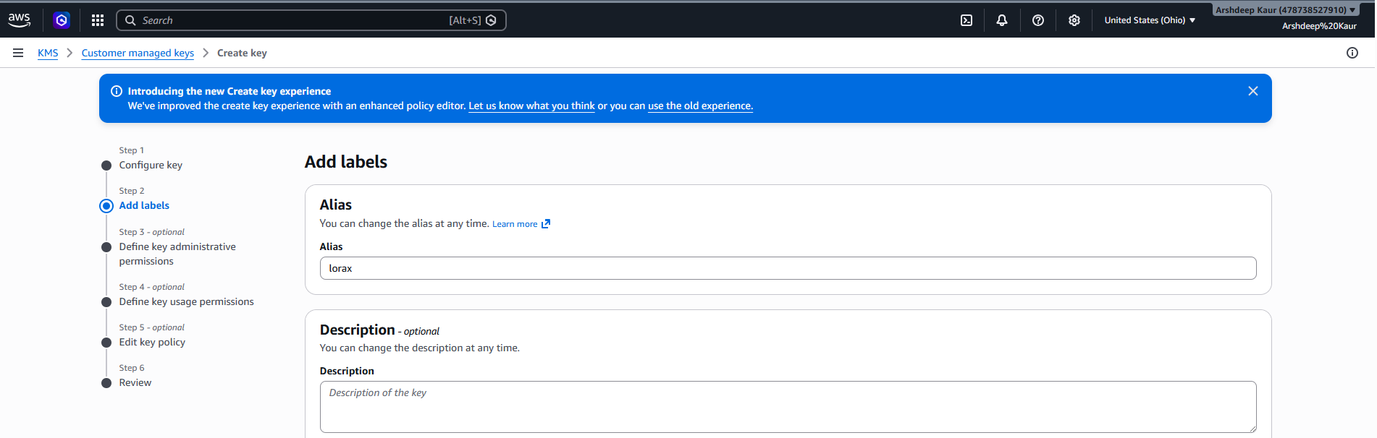
Screenshot 1: KMS key creation: Add Labels step. During key creation, an alias of “lorax” was assigned to the key. The alias acts as a human-readable identifier that makes it easier to reference the key across AWS services. This step is important for our capstone tool because the alias is one of the fields our Boto3 scanner will retrieve when listing and identifying customer managed keys.

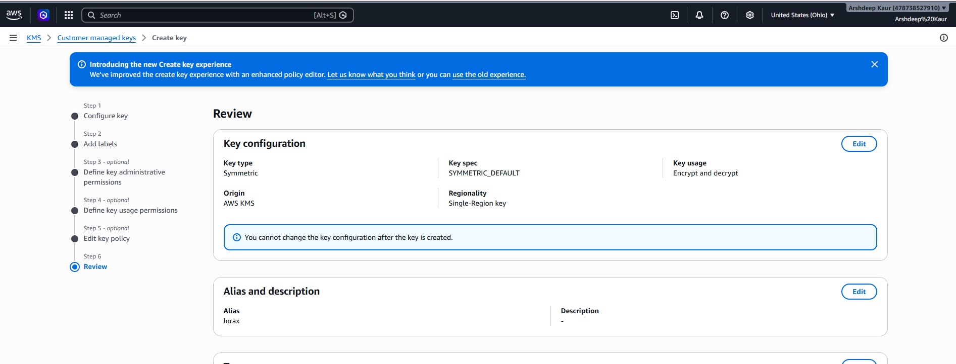
Screenshot 2: KMS key creation: Review page. This final review step summarizes the full key configuration before creation. The key type is Symmetric, the key spec is SYMMETRIC_DEFAULT, and the key usage is set to Encrypt and Decrypt. The origin is AWS KMS, meaning the key material is fully managed by AWS, and the regionality is set to Single-Region. This configuration represents a standard, correctly scoped encryption key. Our scanner will use these fields as evidence when evaluating key configurations.

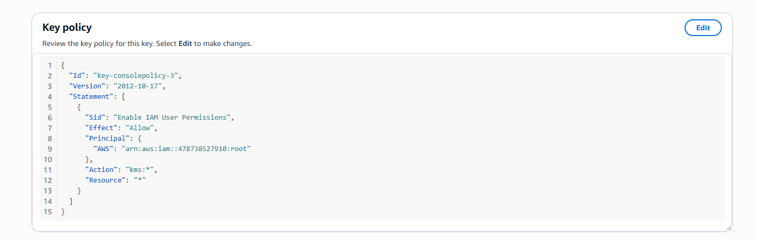
Screenshot 3: KMS key creation: Key Policy (JSON view). The key policy defines who has permission to manage and use the key. In this case the policy grants the AWS account root user full access via the Action field set to “kms:*” and Resource set to “*”. While this is a default policy generated by AWS, our capstone tool will flag overly permissive policies – particularly those granting kms:* to broad principals – as a potential misconfiguration. This screenshot demonstrates what policy evidence our scanner will extract and evaluate.

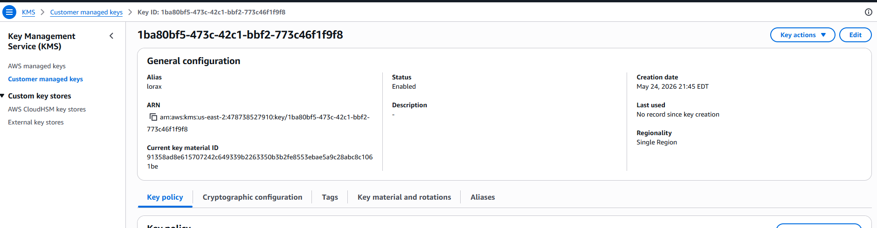
Screenshot 4: KMS key: General Configuration view (post-creation). This shows the successfully created KMS key with alias “lorax”. Key details visible include the Key ID, ARN, creation date (May 24, 2026), status (Enabled), and regionality (Single Region). The “Last used” field shows no record since creation, meaning the key has not yet been used for any encryption or decryption operations. This is what our Boto3 scanner will replicate using the describe_key() API call to collect evidence such as status, creation date, and key age for each customer managed key.

Security Groups Configuration on AWS

Inbound
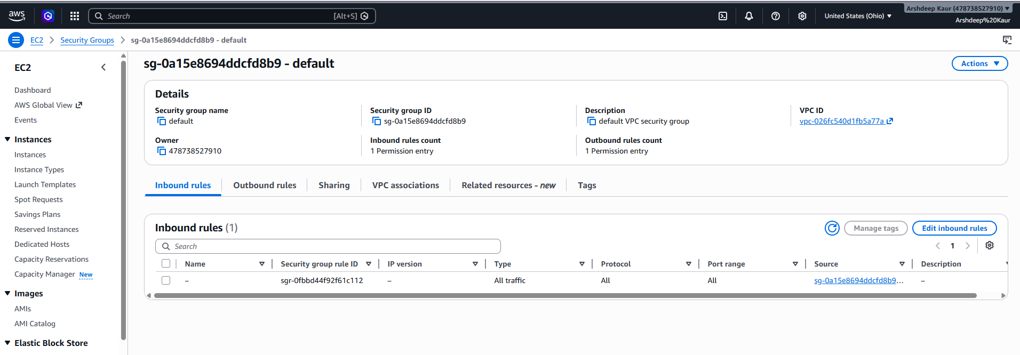
Screenshot 5: Default Security Group: Inbound Rules. This shows the inbound rules for the AWS default security group (sg-0a15e8694ddcfd8b9). There is one inbound rule allowing all traffic from within the same security group as the source. While this rule is intentional for internal communication, the key observation here is the source being another security group rather than an open IP range – which is considered acceptable. Our scanner will evaluate inbound rules to identify cases where traffic is allowed from 0.0.0.0/0 on sensitive ports, which represents a high severity misconfiguration.

Outbound
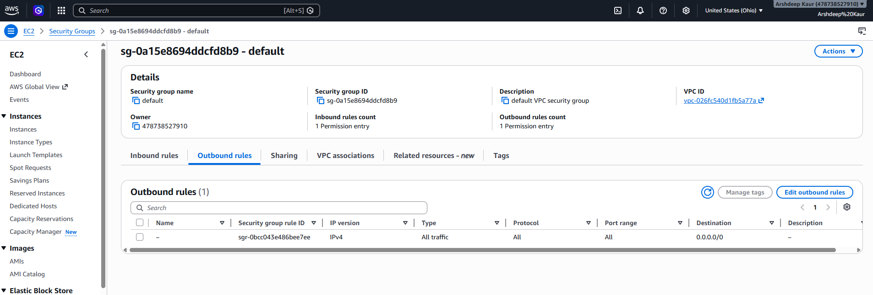
Screenshot 6: Default Security Group: Outbound Rules. This shows the outbound rule for the default security group, which allows all traffic to any destination (0.0.0.0/0) on all ports and protocols. This is a common default configuration in AWS and represents a potential misconfiguration. Our capstone scanner will flag unrestricted outbound rules as a low-to-medium severity finding, since they can allow data to be sent to any external destination without restriction.

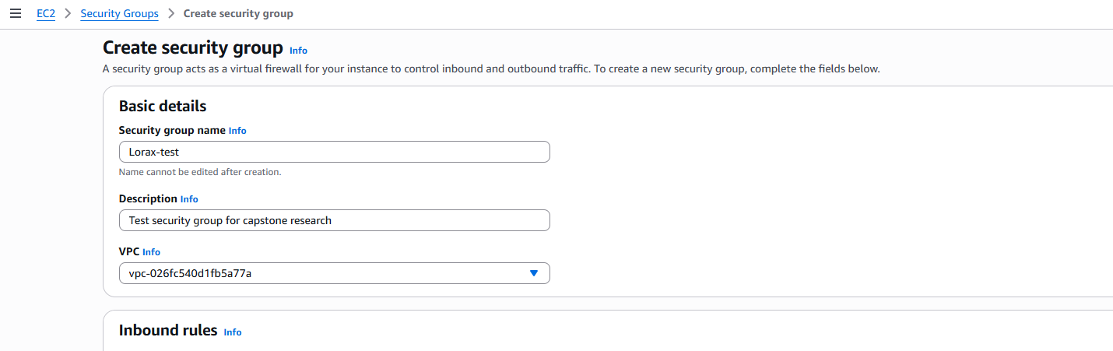
Screenshot 7: Create Security Group: Basic Details. A new test security group named “Lorax-test” was created with the description “Test security group for capstone research” and assigned to the default VPC. This test resource was created specifically to simulate a misconfigured environment that our Boto3 scanner can detect and flag. Creating a named, intentional test group allows us to validate that our scanner correctly identifies security groups with overly permissive rules.

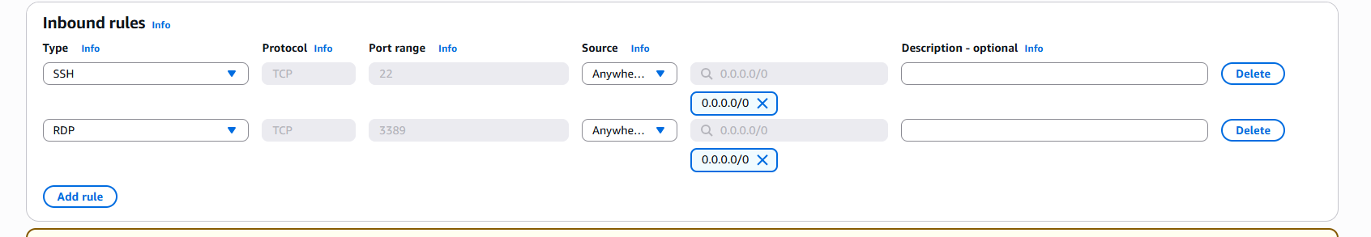
Screenshot 8: Lorax-test Security Group: Intentionally Misconfigured Inbound Rules. This screenshot shows two deliberately bad inbound rules added to the test security group: SSH on port 22 and RDP on port 3389, both with the source set to 0.0.0.0/0 (open to the entire internet). These are textbook high severity misconfigurations. Exposing SSH allows anyone on the internet to attempt remote login to a server, while open RDP is a common attack vector for ransomware and brute force attacks. Our scanner will flag both of these as high severity findings and map them to CIS Controls and NIST guidelines recommending restricted administrative access.

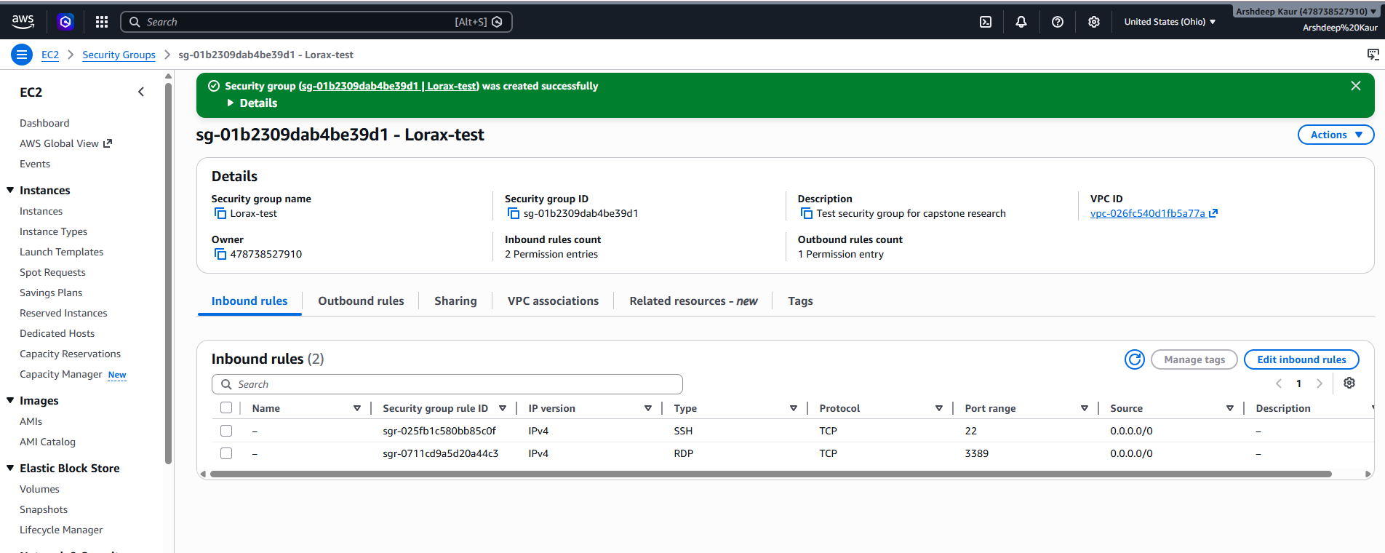
Screenshot 9: Lorax-test Security Group – Successfully Created with Misconfigured Rules. The security group was created successfully (green confirmation banner visible). The details panel shows the group name, ID (sg-01b2309dab4be39d1), description, and VPC association. The inbound rules section confirms 2 permission entries – SSH on port 22 and RDP on port 3389 – both sourced from 0.0.0.0/0. This is the final view our Boto3 scanner will encounter when scanning security groups. The scanner will call describe_security_groups(), iterate through each rule, and produce a structured finding for any rule that exposes sensitive ports to the open internet.

