Game Design Document

Fill up the Following document

1. Write the title of your project.

Stardew Run

1. What is the goal of the game?

To collect as many points possible before dying.

1. Write a brief story of your game?

Astraea is trying to escape from the dark elf.

1. Which are the playing characters of this game?

* Playing characters are the ones which respond to the user based on the input from the user
* Cars, monkeys, dinos, wizards etc, are the playing characters in the game.

|  |  |  |
| --- | --- | --- |
| Number | Character Name | What can this character do? |
| 1 | Astraea | Run and Jump |
| 2 |  |  |
| 3 |  |  |
| 4 |  |  |
| 5 |  |  |
| 6 |  |  |
| 7 |  |  |
| 8 |  |  |

1. Which are the Non Playing Characters of this game?

* Non Playing characters are the ones which don't have an action or a behaviour when the user interacts with the game.
* Hurdles, stones, bananas, coins, etc are non playing characters in the game.

|  |  |  |
| --- | --- | --- |
| Number | Character Name | What can this character do? |
| 1 | Blocks | Stop Astraea from moving ahead |
| 2 | Coins | Collects points when touched |
| 3 | Hearts | Keeps count of lives. |
| 4 |  |  |
| 5 |  |  |
| 6 |  |  |
| 7 |  |  |
| 8 |  |  |

Draw your imagination of this game. What does this game look like?

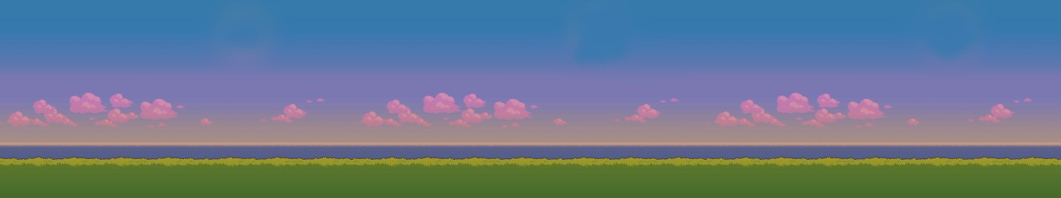

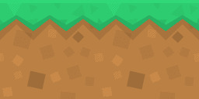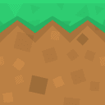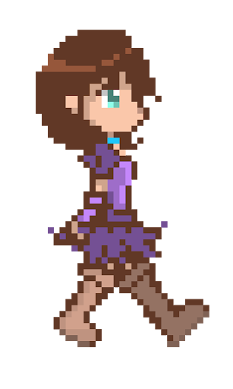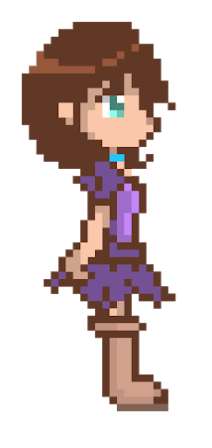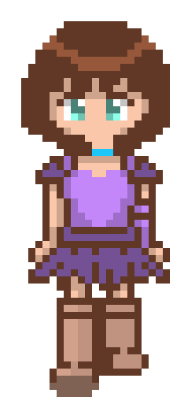

How do you plan to make your game engaging?

By making it more difficult as the game progresses.