Milestone-3
Project Title: Automated Fingerprint Minutiae Extractor
Project Description: This project is an automated biometric system designed to extract and identify key features, known as minutiae (specifically Ridge Endings and Bifurcations), from raw fingerprint images. The goal is to convert complex, noisy fingerprint images into a simple, searchable "feature template" (a list of coordinate points) suitable for identification or verification systems. The project emphasizes a robust image processing pipeline to handle synthetic noise and artifacts typical of fingerprint datasets.
Dataset Name: FVC2000 DB4_B
Link: Kaggle: Fingerprint Dataset for FVC2000_DB4_B
GitHub Link: https://github.com/hiyaa21/Fingerprint-Minutiae-Extractor
Dataset Description:
Source: Fingerprint Verification Competition (FVC) 2000.
Generation: Synthetic dataset generated by SFinGe (Synthetic Fingerprint Generator).
Structure: 80 total images (8 impressions each of 10 virtual fingers).
Attributes:
- dataset_FVC2000_DB4_B: Main dataset folder.
- dataset: Subfolder containing the data.
- np_data: Folder containing NumPy data files (img_real.npy, img_train.npy, label_real.npy, label_train.npy).
- real_data: Folder containing real fingerprint images (00000.bmp to 00009.bmp).
- train_data: Folder containing training fingerprint images (00000_00.bmp, 00000_01.bmp, etc.).
Project Pipeline (Final): Our finalized pipeline consists of 7 sequential stages, including a sophisticated 3-stage pruning process to handle noise.
- Image Enhancement: cv2.equalizeHist to improve contrast.
- Binarization: cv2.adaptiveThreshold to create a black-and-white image.
- Noise Cleaning: cv2.morphologyEx (Opening & Closing) to remove salt-and-pepper noise.
- Skeletonization: cv2.ximgproc. thinning (Zhang-Suen algorithm) to reduce ridges to 1-pixel width.
- Pruning Stage 1 (Islands): cv2.connectedComponentsWithStats to remove disconnected ridge fragments.
- Minutiae Extraction: Crossing Number (CN) method to detect raw endings and bifurcations.
- Pruning Stage 2 (Spurs): Distance-based removal of close Red-Blue pairs.
- Pruning Stage 3 (Clusters): Distance-based removal of close Blue-Blue pairs.
Visual Pipeline Overview:
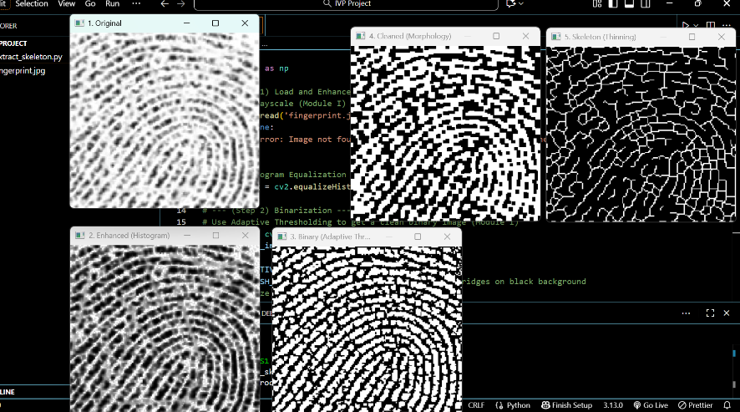
Preprocessing stages: (1) Original, (2) Enhanced, (3) Binary, (4) Cleaned, and (5) Initial Skeleton.
Preprocessing Tasks and Description
- Histogram Equalization: Stretches contrast to handle "smudgy" synthetic prints.
- Adaptive Thresholding: handles uneven illumination by calculating thresholds for small 11x11 pixel neighbourhoods.
- Morphological Operations: Cleans basic sensor noise before thinning.
- Skeletonization: Essential for converting thick ridges into analysable centrelines.
Errors Felt & Solutions (The Journey):
Error 1: The "Cloud of Dots" (False Positives)
Phase: Milestone 1
- Issue: After initial skeletonization, the extraction step detected hundreds of false minutiae, creating a useless "cloud" of red and blue dots.
- Cause: The skeleton contained hundreds of tiny, disconnected "islands" of noise.
Solution (Evolution):
- Initial Approach: We first attempted to use cv2.findContours to trace the outline of every artifact and filter them by arc length. While this worked partially, it was computationally expensive and treated lines as shapes.
- Final Approach: We switched to cv2.connectedComponentsWithStats. This method proved superior as it directly identified disconnected components and allowed us to filter strictly by pixel area (removing any component < 30 pixels).
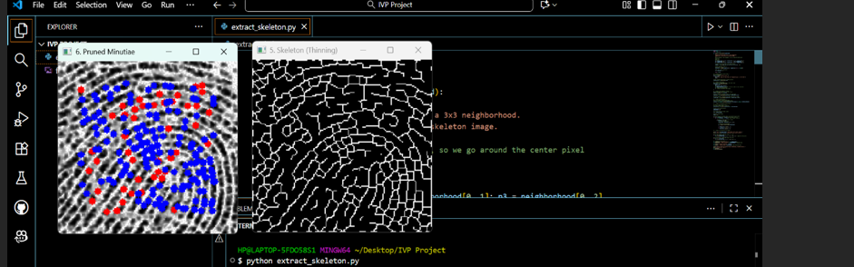

Figure 2: The initial result showing the massive number of false positives caused by a noisy skeleton.
Error 2: The "Spur" Noise
Phase: Milestone 2
- Issue: Even after removing islands, we saw many pairs of Red (Ending) and Blue (Bifurcation) dots very close together.
- Cause: "Hairy" ridges or small bumps on the ridge edge created short branches called "spurs" during thinning.
- Solution: Implemented Spur Pruning. We calculated the Euclidean distance between every red dot and every blue dot. If distance < 15px, we removed both, as they likely represented a spur.
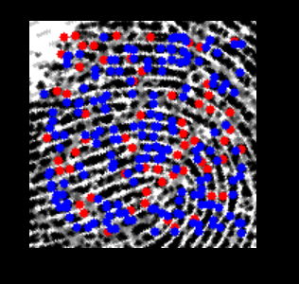
Figure 3: The result after initial pruning still shows "spurs" (close Red-Blue pairs) and "clusters" (dense blue groups).
Error 3: The "Blue Cluster" Noise
Phase: Milestone 3
- Issue: The spur pruning worked for red dots, but we still had a massive "cloud" of Blue dots (Bifurcations) in certain areas.
- Cause: "Blotchy" areas in the synthetic dataset thinned down into messy "webs" of lines, creating clusters of many bifurcations.
- Solution: Implemented Cluster Pruning. We compared every blue dot against every other blue dot. If distance < 10px, we removed both, successfully clearing the final noise artifacts.
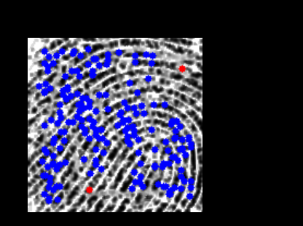
Investigation: The Canny Edge Detection Experiment
Phase: Methodology Comparison
- Objective: We investigated using Canny Edge Detection as an alternative to morphological thinning for skeletonization.
- Result: The approach failed and was rejected.
- Reasoning: Canny is an Edge Detector, meaning it finds the boundaries of a ridge. This produces two lines (left and right edges) for every single ridge, rather than one centreline.
- Impact: As seen in the figure below, this "double edge" effect creates a chaotic map where every ridge appears as a loop, generating thousands of false bifurcations and endings where the edges touch. This confirmed that morphological Thinning is the only viable approach for minutiae extraction.
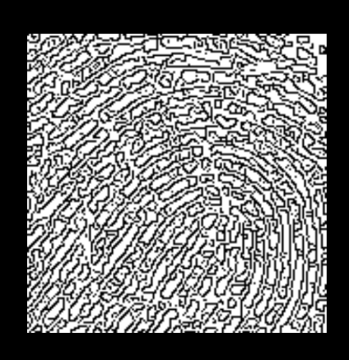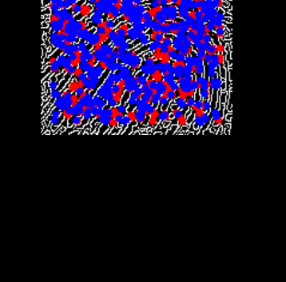
Figure 4: Output of Canny Edge Detection. Note the double lines for every ridge, which makes centreline analysis impossible.
Results:
The final system successfully processes the entire FVC2000 DB4_B dataset. We utilized a comparison matrix to track the effectiveness of our pruning stages.
Quantitative Analysis (Comparison Matrix)
The table below presents a summary of results from our automated batch processing. It tracks the count of minutiae at three critical stages: Raw (Noisy), Spur-Pruned, and Final (Clean).
Note: Canny Edge Detection results are not included in this numeric table because the output was structurally invalid (double-edges), making point-counting irrelevant compared to the centreline
centreline method.
Image Name | Raw Endings (Noisy) | Raw Bifurcations (Noisy) | Spur-Pruned Endings | Spur-Pruned Bifurcations | Final Endings (Clean) | Final Bifurcations (Clean)
00000.bmp | 48 | 225 | 3 | 180 | 3 | 20
00001.bmp | 28 | 186 | 3 | 161 | 3 | 20
00002.bmp | 27 | 177 | 3 | 153 | 3 | 12
00003.bmp | 12 | 93 | 0 | 81 | 0 | 13
00004.bmp | 19 | 262 | 1 | 244 | 1 | 12
00005.bmp | 34 | 286 | 0 | 252 | 0 | 12
00006.bmp | 12 | 299 | 1 | 288 | 1 | 19
00007.bmp | 27 | 272 | 1 | 246 | 1 | 10
00008.bmp | 40 | 269 | 1 | 230 | 1 | 8
00009.bmp | 74 | 162 | 1 | 89 | 1 | 16
00000_00.bmp | 48 | 236 | 2 | 190 | 2 | 17
00000_01.bmp | 71 | 80 | 16 | 25 | 16 | 10
00000_02.bmp | 72 | 127 | 13 | 68 | 13 | 12
00000_03.bmp | 73 | 124 | 8 | 59 | 8 | 12
00000_04.bmp | 68 | 179 | 4 | 115 | 4 | 16
00000_05.bmp | 73 | 128 | 6 | 61 | 6 | 13
00000_06.bmp | 62 | 168 | 3 | 109 | 3 | 22
00000_07.bmp | 58 | 129 | 5 | 76 | 5 | 15
00000_08.bmp | 37 | 274 | 0 | 237 | 0 | 22
00000_09.bmp | 52 | 161 | 1 | 110 | 1 | 16

Criteria for Good Fingerprint Minutiae Extraction
The data above demonstrates the criteria we used to define "success" for our extraction algorithm:
- Drastic Reduction in False Positives:
  - Raw Stage (The Problem): We see counts in the hundreds (e.g., 225 Bifurcations). This is physically impossible for a single fingerprint and indicates extreme noise.
  - Final Stage (The Solution): The counts drop to reasonable numbers (e.g., 20 Bifurcations). A standard fingerprint typically has between 20-50 valid minutiae. Our final numbers align with this biological reality.
- Specific Noise Targeting:
  - Spur-Pruned Columns: Notice that the "Endings" count drops significantly here (e.g., from 48 to 3). This confirms that most "Raw Endings" were just tips of noisy spurs. By removing them, we cleaned up the ridge endings.
  - Final Columns: Notice the massive drop in "Bifurcations" (e.g., from 180 to 20). This confirms that our "Cluster Pruning" successfully removed the "webs" of false bifurcations that Spur Pruning missed.
- Stability:
  - A good algorithm produces a sparse, stable set of points. The final low numbers indicate that we have stripped away the artifacts and are left with only the distinct, high-confidence features needed for matching.

Final Visual Results:
Here are examples of the final output after all three pruning stages (Island, Spur, and Cluster) have been applied. The remaining minutiae are sparse and accurately placed on real ridge features.
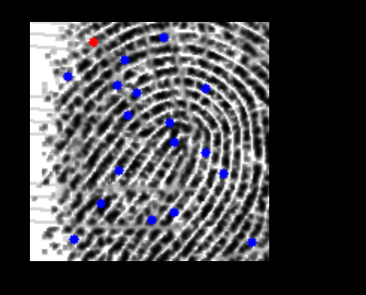
Figure 4: A clean final output showing accurately detected Ridge Endings (Red) and Bifurcations (Blue).
References:
- Jain, A. K., Hong, L., & Bolle, R. (1997). On-line fingerprint verification. IEEE Transactions on Pattern Analysis and Machine Intelligence. (Primary reference for the pipeline structure).
- Maltoni, D., et al. (2009). Handbook of Fingerprint Recognition. Springer. (Reference for Crossing Number and Thinning concepts).
- OpenCV Documentation: For connectedComponentsWithStats and ximgproc usage.
Conclusion:
This project successfully demonstrates that a robust fingerprint feature extractor cannot rely on simple detection alone. The core challenge lies in noise management. By implementing a multi-stage pruning pipeline that targets specific noise morphologies (Islands, Spurs, and Clusters), we achieved a system that extracts reliable biometric features from low-quality synthetic data.

