SIP Management System
Database Design Documentation
ER Diagram, Schema Reference, and Sample Queries
Node.js / Express · MySQL · Next.js

1. Project Overview
The SIP Management System lets a user create and track Systematic Investment Plans (SIPs) against a catalog of stocks. Creating a SIP auto-generates its installment schedule; paying an installment records a transaction against a bank account and (optionally) rounds the payment up into a linked savings goal. The schema was designed around the seven core entities required by the project brief (User, User_Phone, Bank_Account, Stock, SIP_Plan, Installments, SIP_Transaction), extended with a Goal / Goal_Member pair to support student-friendly savings-goal and split-with-friends features.
Core design principles:
- Third normal form (3NF) throughout — no repeating groups, every non-key column depends only on its table’s primary key.
- Every relationship is enforced with a real foreign key constraint, not just application logic.
- Cascading deletes (ON DELETE CASCADE) remove a user’s dependent rows automatically; nullable FKs (ON DELETE SET NULL) are used where a link is optional, e.g. SIP_Plan.Goal_ID.
- One AFTER UPDATE trigger encodes business logic (auto-completing a SIP) directly in the database, so it fires regardless of which client updates the row.

2. Entity-Relationship Diagram
Boxes are color-coded by role: indigo for core account tables, purple for the goals subsystem, green for reference data, amber for scheduling, and red for money movement. A dashed edge marks an optional (nullable) foreign key.
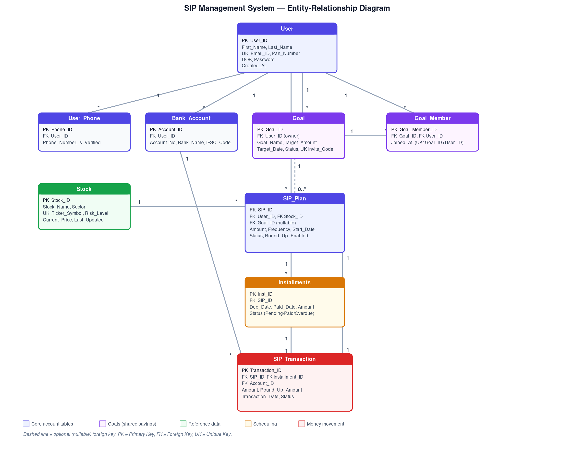

3. Schema Reference
All nine tables, in the order they should be created (parent tables before the child tables that reference them).

3.1 User
One row per registered student/investor. Root of every other table.
Column | Type | Key | Notes
User_ID | INT, AUTO_INCREMENT | PK | Surrogate key
First_Name / Last_Name | VARCHAR(100) |  | Required
Email_ID | VARCHAR(150) | UK | Unique; used as login
Pan_Number | VARCHAR(20) | UK | Unique; used for password-reset identity check
DOB | DATE
Password | VARCHAR(255) |  | bcrypt hash, never plaintext
Created_At | TIMESTAMP |  | Defaults to CURRENT_TIMESTAMP

3.2 User_Phone
A user may register multiple phone numbers; each is OTP-verifiable.
Column | Type | Key | Notes
Phone_ID | INT, AUTO_INCREMENT | PK
User_ID | INT | FK → User | ON DELETE CASCADE
Phone_Number | VARCHAR(20)
Is_Verified | TINYINT(1) |  | Default 0; set to 1 after OTP verification

3.3 Bank_Account
Bank accounts a user can pay installments from.
Column | Type | Key | Notes
Account_ID | INT, AUTO_INCREMENT | PK
User_ID | INT | FK → User | ON DELETE CASCADE
Account_No / Bank_Name / IFSC_Code | VARCHAR

3.4 Stock
Reference catalog of investable stocks (30 NSE-listed stocks seeded).
Column | Type | Key | Notes
Stock_ID | INT, AUTO_INCREMENT | PK
Stock_Name / Sector | VARCHAR
Ticker_Symbol | VARCHAR(20) | UK | e.g. "RELIANCE"
Risk_Level | ENUM('Low','Medium','High') |  | Drives the risk-appetite quiz recommendations
Current_Price | DECIMAL(12,2) |  | Refreshed every 15 min from Yahoo Finance
Last_Updated | DATETIME |  | Nullable; set on each price refresh

3.5 Goal
A savings target (e.g. "New Laptop") a SIP can be linked to.
Column | Type | Key | Notes
Goal_ID | INT, AUTO_INCREMENT | PK
User_ID | INT | FK → User | Owner; ON DELETE CASCADE
Goal_Name / Target_Amount / Target_Date | VARCHAR / DECIMAL / DATE |  | Target_Date optional
Status | ENUM('Active','Achieved','Archived') |  | Default Active
Invite_Code | VARCHAR(8) | UK | Nullable; 6-char code friends use to join a shared goal

3.6 Goal_Member
Join table: which users (other than the owner) have joined a shared goal.
Column | Type | Key | Notes
Goal_Member_ID | INT, AUTO_INCREMENT | PK
Goal_ID | INT | FK → Goal | ON DELETE CASCADE
User_ID | INT | FK → User | ON DELETE CASCADE
Joined_At | TIMESTAMP |  | Default CURRENT_TIMESTAMP
(Goal_ID, User_ID) | — | UK | Composite unique key — a user can join a goal only once

3.7 SIP_Plan
One row per Systematic Investment Plan a user has created.
Column | Type | Key | Notes
SIP_ID | INT, AUTO_INCREMENT | PK
User_ID | INT | FK → User | ON DELETE CASCADE
Stock_ID | INT | FK → Stock | Which stock this SIP invests in
Goal_ID | INT | FK → Goal | Nullable; ON DELETE SET NULL
Amount | DECIMAL(12,2) |  | Per-installment amount
Frequency | ENUM('Monthly','Quarterly') |  | Default Monthly
Start_Date | DATE
Status | ENUM('Active','Paused','Cancelled','Completed') |  | Default Active
Round_Up_Enabled | TINYINT(1) |  | Default 0; rounds payments up into the linked goal

3.8 Installments
Auto-generated schedule of individual payments for a SIP (12 for Monthly, 4 for Quarterly).
Column | Type | Key | Notes
Inst_ID | INT, AUTO_INCREMENT | PK
SIP_ID | INT | FK → SIP_Plan | ON DELETE CASCADE
Due_Date / Paid_Date | DATE |  | Paid_Date nullable until paid
Amount | DECIMAL(12,2)
Status | ENUM('Pending','Paid','Overdue') |  | Default Pending; flipped to Overdue by an hourly job

3.9 SIP_Transaction
A successful (or attempted) payment against one installment.
Column | Type | Key | Notes
Transaction_ID | INT, AUTO_INCREMENT | PK
SIP_ID | INT | FK → SIP_Plan | ON DELETE CASCADE
Installment_ID | INT | FK → Installments | ON DELETE CASCADE
Account_ID | INT | FK → Bank_Account | Which account paid
Amount | DECIMAL(12,2) |  | Installment amount charged
Round_Up_Amount | DECIMAL(10,2) |  | Default 0; extra credited to the linked goal
Transaction_Date | DATETIME |  | Default CURRENT_TIMESTAMP
Status | ENUM('Success','Failed','Pending') |  | Default Success

4. Normalization Notes
1NF — every column holds a single atomic value (e.g. a user’s phone numbers live in their own User_Phone rows rather than a comma-separated list on User).
2NF — every table uses a single-column surrogate primary key, so there are no partial-key dependencies to worry about.
3NF — non-key attributes depend only on the primary key, not on each other. For example, Installments.Amount is stored per-installment (not derived by joining back to SIP_Plan.Amount) because an installment’s amount is fixed at creation time and must stay accurate even if the SIP’s Amount is edited later — this is a deliberate, documented denormalization for correctness, not a normalization gap.
The Goal / Goal_Member split follows the same logic as a classic many-to-many join table: a goal can have many members, and a user can belong to many shared goals, so the relationship is modeled as its own table with a composite unique key rather than a repeating-group column.

5. Database Trigger
trg_installment_paid_check_completion — fires AFTER UPDATE on Installments. When an installment flips to ‘Paid’, it checks whether every installment for that SIP is now Paid, and if so marks the SIP itself ‘Completed’. Because this lives in the database rather than the Express layer, the SIP’s status stays correct even if a row were updated directly with SQL.
DELIMITER $$
CREATE TRIGGER trg_installment_paid_check_completion
AFTER UPDATE ON Installments
FOR EACH ROW
BEGIN
IF NEW.Status = 'Paid' AND (OLD.Status IS NULL OR OLD.Status <> 'Paid') THEN
IF NOT EXISTS (
SELECT 1 FROM Installments
WHERE SIP_ID = NEW.SIP_ID AND Status <> 'Paid'
) THEN
UPDATE SIP_Plan
SET Status = 'Completed'
WHERE SIP_ID = NEW.SIP_ID AND Status = 'Active';
END IF;
END IF;
END$$
DELIMITER ;

6. Sample SQL Queries
6.1 Total invested and active SIP count for a user (dashboard stats)
SELECT
(SELECT COALESCE(SUM(st.Amount), 0)
FROM SIP_Transaction st JOIN SIP_Plan sp ON st.SIP_ID = sp.SIP_ID
WHERE sp.User_ID = ? AND st.Status = 'Success') AS TotalInvested,
(SELECT COUNT(*) FROM SIP_Plan
WHERE User_ID = ? AND Status = 'Active') AS ActiveSips;
6.2 Installments actually due (ignores future-dated ones)
SELECT i.Inst_ID, i.Due_Date, i.Amount, s.Stock_Name
FROM Installments i
JOIN SIP_Plan sp ON i.SIP_ID = sp.SIP_ID
JOIN Stock s ON sp.Stock_ID = s.Stock_ID
WHERE sp.User_ID = ? AND i.Status IN ('Pending','Overdue')
AND i.Due_Date <= CURDATE()
ORDER BY i.Due_Date ASC;
6.3 Portfolio breakdown by sector (aggregate + GROUP BY)
SELECT s.Sector, SUM(st.Amount) AS Total
FROM SIP_Transaction st
JOIN SIP_Plan sp ON st.SIP_ID = sp.SIP_ID
JOIN Stock s ON sp.Stock_ID = s.Stock_ID
WHERE sp.User_ID = ? AND st.Status = 'Success'
GROUP BY s.Sector
ORDER BY Total DESC;
6.4 Goal progress, including round-up contributions (LEFT JOIN + aggregate)
SELECT g.Goal_ID, g.Goal_Name, g.Target_Amount,
COALESCE(SUM(CASE WHEN st.Status = 'Success'
THEN st.Amount + st.Round_Up_Amount ELSE 0 END), 0) AS Invested,
COUNT(DISTINCT sp.SIP_ID) AS LinkedSips
FROM Goal g
LEFT JOIN SIP_Plan sp ON sp.Goal_ID = g.Goal_ID
LEFT JOIN SIP_Transaction st ON st.SIP_ID = sp.SIP_ID
WHERE g.User_ID = ?
GROUP BY g.Goal_ID;
6.5 Consecutive on-time payment streak, in months (self-contained subquery)
SELECT DISTINCT DATE_FORMAT(st.Transaction_Date, '%Y-%m') AS PaidMonth
FROM SIP_Transaction st
JOIN SIP_Plan sp ON st.SIP_ID = sp.SIP_ID
WHERE sp.User_ID = ? AND st.Status = 'Success'
ORDER BY PaidMonth ASC;
-- Consumed by the app to compute current/longest streaks in JS,
-- since MySQL has no built-in "longest consecutive run" aggregate.
6.6 Contributor breakdown for a shared goal (multi-user aggregate)
SELECT u.User_ID, u.First_Name, u.Last_Name,
COALESCE(SUM(st.Amount + st.Round_Up_Amount), 0) AS Contributed
FROM SIP_Plan sp
JOIN User u ON sp.User_ID = u.User_ID
LEFT JOIN SIP_Transaction st ON st.SIP_ID = sp.SIP_ID AND st.Status = 'Success'
WHERE sp.Goal_ID = ?
GROUP BY u.User_ID
ORDER BY Contributed DESC;

End of document.

