**Upgrade R to the latest version**

**install.packages**("installr");

**library**(installr)

updateR()

**Intsall Other packages**

install.packages(c(‘DMwR’, ‘performanceEstimation’, ‘UBL’))

**Check if the following packages are installed**

"operators" %in% rownames(installed.packages())

"class" %in% rownames(installed.packages())

"fields" %in% rownames(installed.packages())

"ROCR" %in% rownames(installed.packages())

"DmwR" %in% rownames(installed.packages())

"Hmisc" %in% rownames(installed.packages())

(IN HMISC IF IT PROMPTS SOMETHING ABOUT COMPILATION CLICK “NO”)

**Run this in R console (not RStudio) or CMD**

* Download tar file from <https://www.dcc.fc.up.pt/~rpribeiro/uba/>
* CD to the directory of the tar file
* install.packages("uba_0.7.7.tar.gz",repos=NULL,dependencies=T)
* might put type=’source’ above

**RPY2 ON PYTHON**

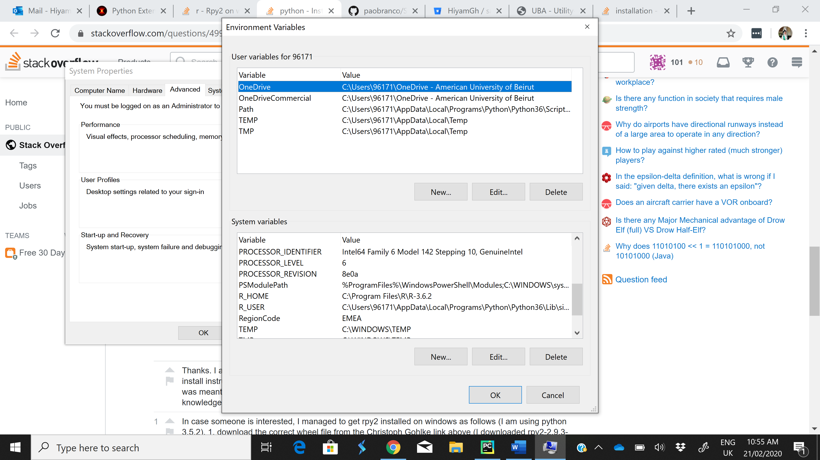

* Download the correct wheel from <https://www.lfd.uci.edu/~gohlke/pythonlibs/#rpy2>
* Add R_USER to SYSTEM VARIABLE:
  + C:\Users\96171\AppData\Local\Programs\Python\Python36\Lib\site-packages\rpy2
* ADD R_HOME TO SYSTEM VARIABLE
  + C:\Program Files\R\R-3.6.2
* CD to the download directory
* pip install rpy2‑2.9.3‑cp35‑cp35m‑win_amd64.whl
* (IF YOU HAVE PYTHON 3.6 USE WHEEL WITH CP36, IF YOU HAVE PYTHON 3.7 USE WHEEL CP37, ETC)