WEEK 1 TASK

Data Acquisition, Cleaning, and Exploratory Analysis

Dataset: Breast Cancer Wisconsin (Diagnostic)

Name: Hiya Saini
Tools: Python, Pandas, NumPy, Matplotlib, scikit-learn
Dataset Source: UCI Machine Learning Repository

Week 1 Internship Submission

Summary
This report documents an end-to-end data preparation and exploratory data analysis workflow using the Breast Cancer Wisconsin (Diagnostic) dataset. The project covers public dataset acquisition, initial inspection, data-quality checks, controlled cleaning, descriptive statistics, visualisation, and interpretation of analytical findings. The original dataset contains 569 observations and 30 real-valued features derived from digitized fine needle aspirate images of breast masses. The target variable contains benign and malignant diagnoses.
The original public dataset is already free of missing values and duplicate records. To demonstrate the required cleaning process realistically and transparently, a small controlled amount of missingness and five duplicate rows were introduced into a working copy. These modifications were not applied to the source dataset. The working copy was then cleaned using duplicate removal and median imputation for numerical variables. Exploratory analysis was performed on the resulting cleaned data using six visualisations.

2. Objectives
- Acquire and document a publicly available dataset.
- Inspect the dataset structure, dimensions, data types, missing values, and duplicates.
- Demonstrate practical data-cleaning techniques using Pandas.
- Use descriptive statistics to understand the numerical variables.
- Create at least three meaningful visualisations and interpret them.
- Identify important relationships and patterns that could support future analysis.
- Produce a reproducible Python notebook and script.

3. Dataset Description
The selected dataset is the Breast Cancer Wisconsin (Diagnostic) dataset maintained by the UCI Machine Learning Repository. UCI describes it as a multivariate classification dataset containing 569 instances and 30 real-valued features. The features are computed from digitized images of fine needle aspirates and describe characteristics of cell nuclei. The target diagnosis has two classes: malignant and benign.
Dataset Property | Value
Dataset | Breast Cancer Wisconsin (Diagnostic)
Source | UCI Machine Learning Repository
Instances | 569
Predictive Features | 30
Task | Binary classification
Feature Type | Real-valued numerical features
Target Classes | Benign and malignant
Missing Values in Source | No
License | CC BY 4.0
DOI | 10.24432/C5DW2B

4. Data Acquisition
The official dataset is available through the UCI Machine Learning Repository. UCI also provides a Python import pattern using the ucimlrepo package. For this report, scikit-learn's bundled representation of the same public WDBC dataset was used for reproducible local execution, while the official UCI source and citation are documented in the project files.
Example acquisition code:
from sklearn.datasets import load_breast_cancer
data = load_breast_cancer(as_frame=True)
df = data.frame.copy()
df["diagnosis"] = df["target"].map({
0: "malignant",
1: "benign"
})
df.drop(columns=["target"], inplace=True)
Official UCI API-style alternative: fetch_ucirepo(id=17). The project README and notebook include the corresponding import example.

5. Initial Data Inspection
The initial dataset contains 569 rows and 30 predictive features, plus the diagnosis field used as the target. All predictive variables are numerical.
Initial checks performed:
- df.head() and df.info() for structure and data types.
- df.describe() for summary statistics.
- df.isna().sum() for missing-value detection.
- df.duplicated().sum() for duplicate detection.
- Value counts for the diagnosis target.
Inspection | Result
Rows | 569
Predictive features | 30
Target column | diagnosis
Missing cells in source | 0
Duplicate rows in source | 0

6. Data Cleaning and Preprocessing

6.1 Why a controlled working copy was used
The UCI source reports no missing values for this dataset, and the local source representation also contains no duplicates. Because the internship task specifically asks for a simulation of data preparation, a controlled working copy was created. Seventeen numerical values were set to missing across three columns, and five exact duplicate rows were appended. This allows the cleaning workflow to be demonstrated without changing or misrepresenting the original public dataset.

6.2 Missing-value handling
Missing values were checked with isna().sum(). In the working copy, missing values occurred in mean radius (6), mean texture (6), and mean area (5). Median imputation was selected because these continuous measurements can contain extreme observations and the median is less sensitive to outliers than the mean. The imputation values were calculated from the working data after duplicate removal.
Column | Missing Before | Imputation Method
mean radius | 6 | Median
mean texture | 6 | Median
mean area | 5 | Median

6.3 Duplicate handling
The working copy contained 5 duplicate rows. These were removed using drop_duplicates(), producing a dataset with no duplicate rows.

6.4 Data-type validation
The numerical predictors were retained as numeric columns. The diagnosis field was converted to a categorical variable because it represents the two target classes rather than a continuous quantity.

6.5 Cleaning code
working = working.drop_duplicates().reset_index(drop=True)
for col in working.select_dtypes(include=np.number).columns:
if working[col].isna().any():
working[col] = working[col].fillna(
working[col].median()
)
working["diagnosis"] = working["diagnosis"].astype("category")
After cleaning: 569 rows, 0 missing cells, and 0 duplicate rows.

7. Exploratory Data Analysis
EDA was performed to understand class balance, distributions, potential outliers, pairwise relationships, and correlations among selected numerical features. The analysis focuses on variables that describe the size and shape of cell nuclei.
Feature | Mean | Std. Dev. | Minimum | Maximum
mean radius | 14.14 | 3.51 | 6.98 | 28.11
mean texture | 19.27 | 4.28 | 9.71 | 39.28
mean perimeter | 91.97 | 24.30 | 43.79 | 188.50
mean area | 654.96 | 350.07 | 143.50 | 2501.00

8. Visualizations and Interpretation
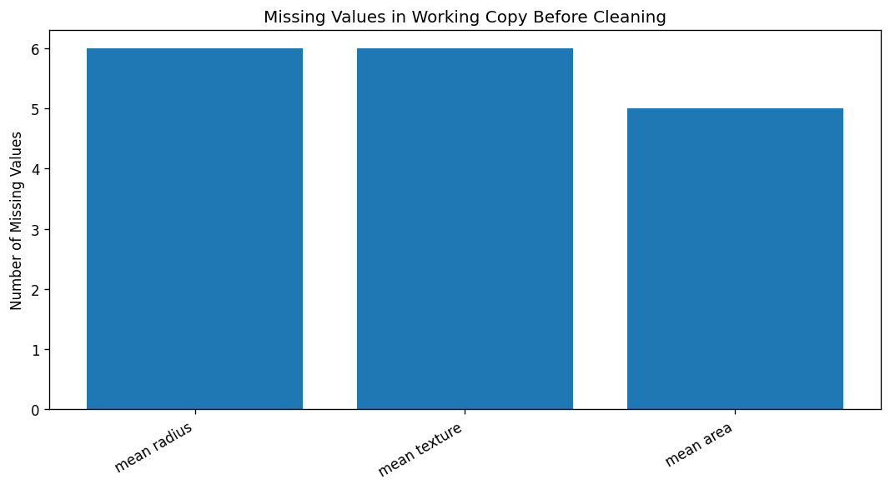

Figure 1. Missing Values Before Cleaning
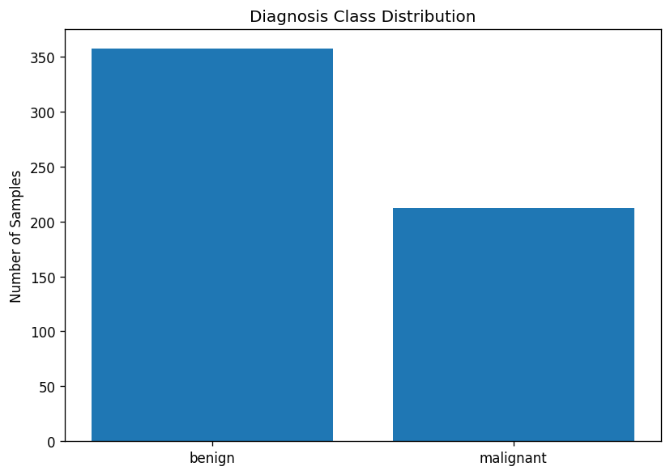
The controlled working copy contains missing observations in three numerical variables. This visualization makes the data-quality issue visible before imputation. The original UCI source does not contain missing values; the missingness shown here was intentionally introduced for the cleaning simulation.

Figure 2. Diagnosis Class Distribution
The cleaned dataset contains 357 benign observations (62.7%) and 212 malignant observations (37.3%). The classes are not perfectly balanced, so future predictive model evaluation should consider class distribution.
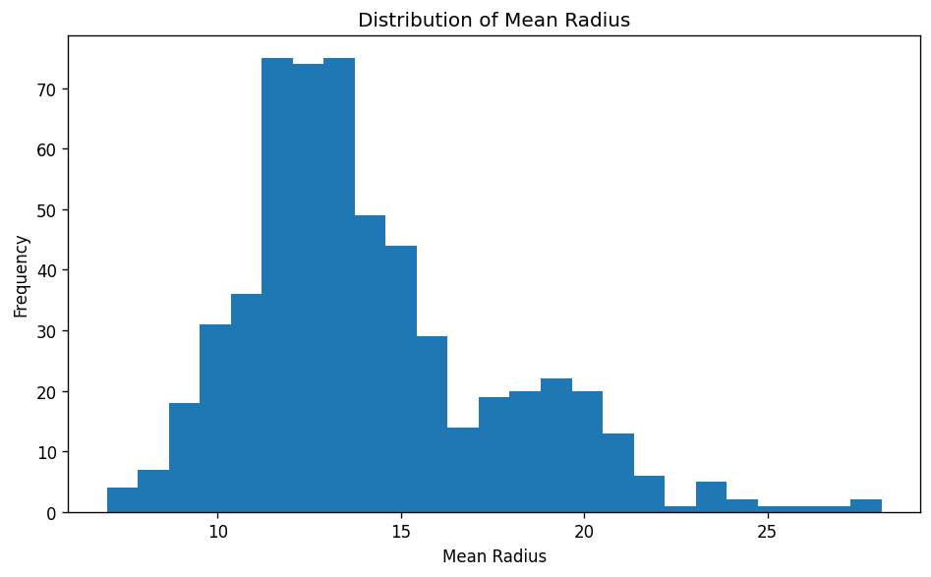

Figure 3. Distribution of Mean Radius
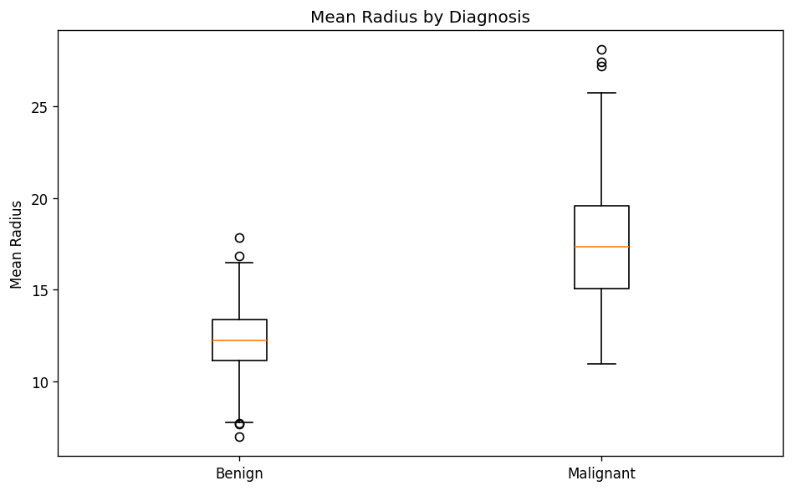
Mean radius has a broad numerical range. The distribution is not perfectly symmetric and contains observations at both lower and higher radius values. This suggests combining summary statistics with distribution plots rather than relying only on the mean.

Figure 4. Mean Radius by Diagnosis
The box plot shows that malignant observations generally have higher mean-radius values than benign observations. The malignant group also spans a wider range, suggesting that radius may be informative for distinguishing the two classes. The presence of extreme values is not automatically treated as an error because they may represent genuine biological variation.
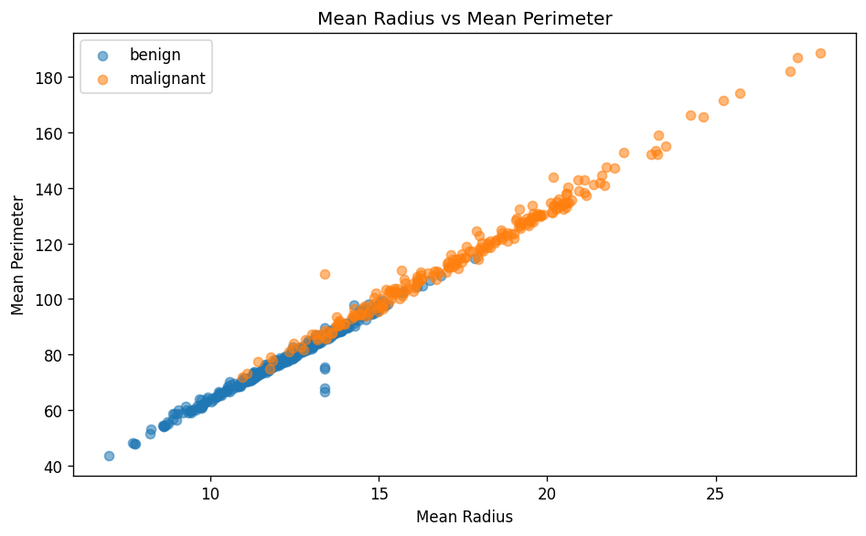

Figure 5. Mean Radius vs Mean Perimeter
A strong positive relationship is visible between mean radius and mean perimeter. As the measured radius of the cell nucleus increases, its perimeter generally increases as well. The separation of the two diagnosis groups also suggests that size-related features may carry useful predictive signal.
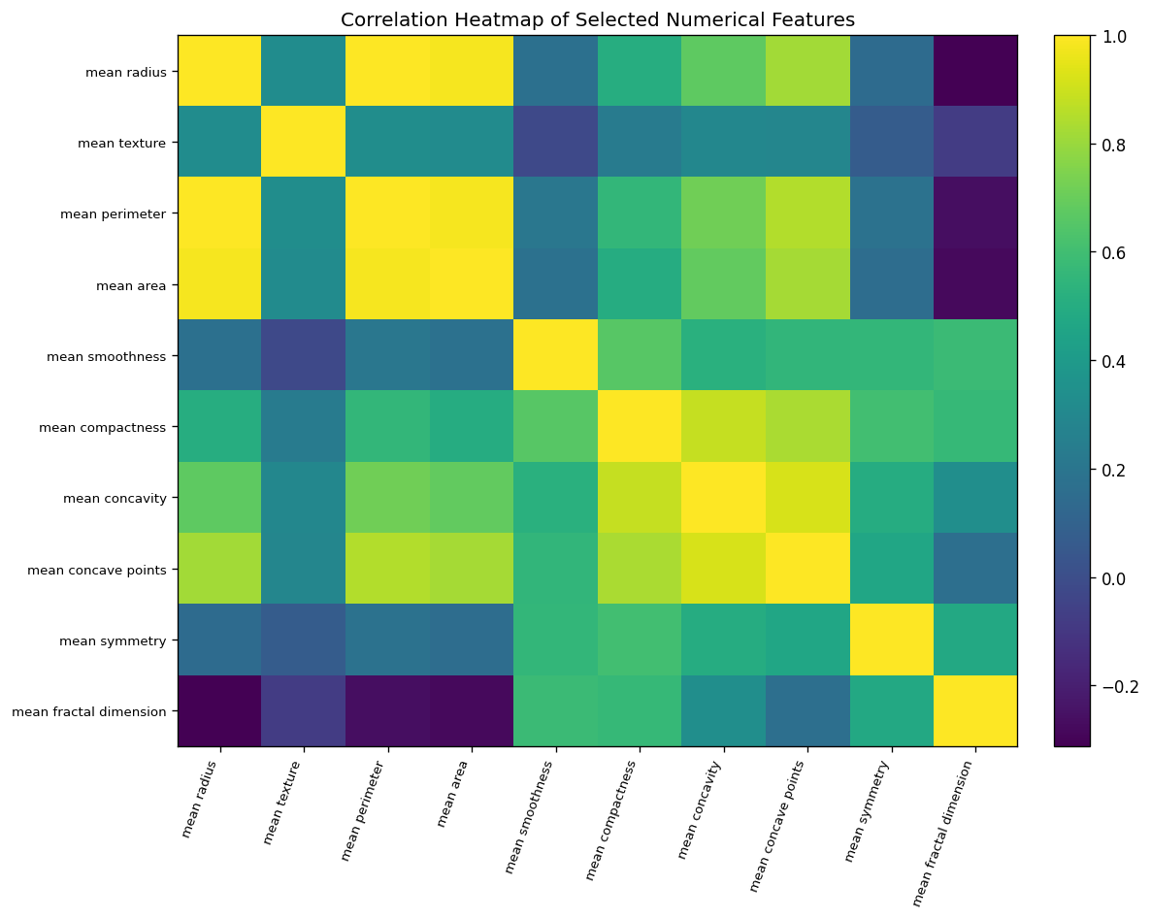

Figure 6. Correlation Heatmap of Selected Features
The heatmap shows substantial positive correlations among several size-related measurements. This indicates multicollinearity: multiple features may encode overlapping information about nucleus size. In a later machine-learning stage, feature selection, dimensionality reduction, or regularized models could be considered.

9. Analytical Findings
- mean radius and mean perimeter correlate approximately 0.996.
- mean perimeter and mean area correlate approximately 0.981.
- mean radius and mean area correlate approximately 0.980.
- mean concavity and mean concave points correlate approximately 0.921.
- mean compactness and mean concavity correlate approximately 0.883.
- mean perimeter and mean concave points correlate approximately 0.851.
- mean compactness and mean concave points correlate approximately 0.831.
- mean area and mean concave points correlate approximately 0.822.
The largest selected-feature correlation is between mean radius and mean perimeter, with a coefficient of approximately 0.996. This reinforces the observation that several geometric measurements are closely related. The class-level means also show a clear difference in size-related measurements. For example, mean radius averages approximately 12.17 for benign observations and 17.45 for malignant observations. Mean perimeter averages approximately 78.08 for benign and 115.37 for malignant observations.

10. Limitations and Further Analysis
- The controlled missingness and duplicate rows were introduced only to simulate a cleaning scenario; they are not claims about the original UCI source.
- The project is focused on data preparation and EDA, not on building a clinical prediction system.
- Correlation does not imply causation and should not be interpreted as clinical evidence.
- The target classes are moderately imbalanced, which should be considered in future model evaluation.

11. Conclusion
This Week 1 project successfully demonstrates the core data preparation lifecycle: acquiring a public dataset, inspecting its structure, identifying data-quality issues, cleaning a working copy, generating descriptive statistics, visualising distributions and relationships, and converting observations into analytical insights. The cleaning process used transparent rules: duplicate rows were removed, numerical missing values in the simulated working copy were imputed using medians, and the diagnosis field was validated as categorical. The EDA indicates that size-related measurements such as radius, perimeter, and area are strongly related and that malignant observations tend to show larger values for several of these measurements. The accompanying notebook and Python script make the workflow reproducible and provide a strong foundation for future machine-learning analysis.

