1. Introduction
Data visualization is an important part of data analysis because it converts large and complex datasets into visual patterns that can be understood quickly. The purpose of this project is to apply advanced visualization and storytelling techniques to the Netflix Movies and TV Shows dataset. Rather than presenting isolated charts, the analysis develops a connected narrative around the growth, content types, geographical distribution, genres, audience ratings, and relationships within Netflix's catalogue.
The project is designed for a non-technical audience. Therefore, each visualization is accompanied by a clear explanation of what is being shown, why the particular chart was selected, the main insight, and how that insight contributes to the overall story.

2. Objectives
- Understand and prepare the Netflix dataset for visualization.
- Identify important trends, patterns, differences, and anomalies in the data.
- Develop at least five sophisticated visualizations using Python visualization libraries.
- Use captions, annotations, and narrative explanations to communicate findings clearly.
- Translate analytical findings into potential business implications.
- Build a coherent visual story that can be understood by a non-technical audience.

3. Dataset Description
The analysis uses the publicly available Netflix Movies and TV Shows dataset. The dataset contains information about titles available on Netflix, including title, content type, director, cast, country, date added, release year, rating, duration, genres, and description.
Important variables used in the analysis include:
- show_id – unique identifier for each title.
- type – identifies whether the title is a Movie or TV Show.
- title – name of the title.
- country – country or countries associated with the title.
- release_year – year in which the title was released.
- rating – maturity/content rating.
- duration – movie duration or number of seasons for TV Shows.
- listed_in – genres/categories associated with the title.

4. Data Cleaning and Preprocessing
Initial missing-value analysis identified missing values in several columns. The following counts were observed before cleaning:
Column | Missing Values | Treatment
show_id | 0 | No action
type | 0 | No action
title | 0 | No action
director | 2634 | Replaced with Unknown
cast | 825 | Replaced with Unknown
country | 831 | Replaced with Unknown
date_added | 10 | Replaced with Unknown
release_year | 0 | No action
rating | 4 | Replaced with Unknown
duration | 3 | Replaced with Unknown
listed_in | 0 | No action
description | 0 | No action
Missing categorical values are replaced with the label 'Unknown' instead of deleting entire records. This preserves useful information from otherwise valid records. For multi-valued fields such as country and listed_in, the values are separated and exploded when required for frequency-based visualisations.

5. Tools and Technologies
- Python – programming and analysis.
- Pandas – data loading, cleaning, grouping, and transformation.
- NumPy – numerical operations.
- Matplotlib – customizable static visualizations.
- Seaborn – statistical and advanced visualizations.
- Plotly – optional interactive visualizations.
- Kaggle Notebook – dataset access and execution environment.

6. Data Story Framework
The visual narrative follows a logical progression. It begins with the broad question of how Netflix's content catalogue has changed over time, then compares Movies and TV Shows, explores where content comes from, examines genre preferences, studies audience ratings, and finally combines dimensions in an advanced heatmap.
- Growth → How has Netflix's content changed over time?
- Content Type → Is the catalogue dominated by Movies or TV Shows?
- Geography → Which countries contribute the most content?
- Genres → What categories dominate the catalogue?
- Audience → Which ratings and audience segments are most common?
- Relationships → How do genres and content types interact?

7. Visualisation 1 – Growth of Netflix Content Over Time
Chart type: Line chart
A line chart is appropriate because release year is a time-based variable. The chart should show the number of titles associated with each release year. The main purpose is to reveal long-term growth, periods of rapid expansion, and unusual changes.
Storytelling contribution: This visualisation establishes the opening of the story by showing how the scale of the Netflix catalogue has changed over time.
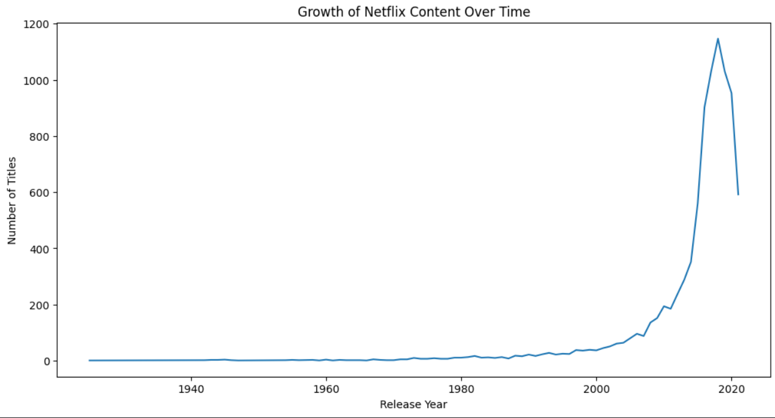
Python output: yearly_content = df.groupby('release_year').size()

8. Visualisation 2 – Movies vs TV Shows
Chart type: Bar chart
A bar chart provides a direct comparison between the two content types. It allows the audience to quickly identify which type forms the larger share of the catalogue.
Storytelling contribution: This visualization narrows the story from overall growth to the composition of the catalogue.

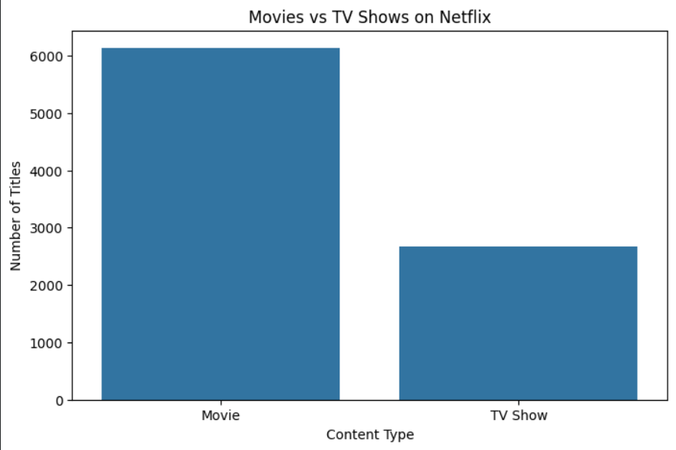
Python output: df['type'].value_counts()

9. Visualisation 3 – Top Countries by Netflix Content
Chart type: Horizontal bar chart
Country names can be long, so a horizontal bar chart improves readability. Because one title can contain multiple countries, the country field should be split and exploded before counting.
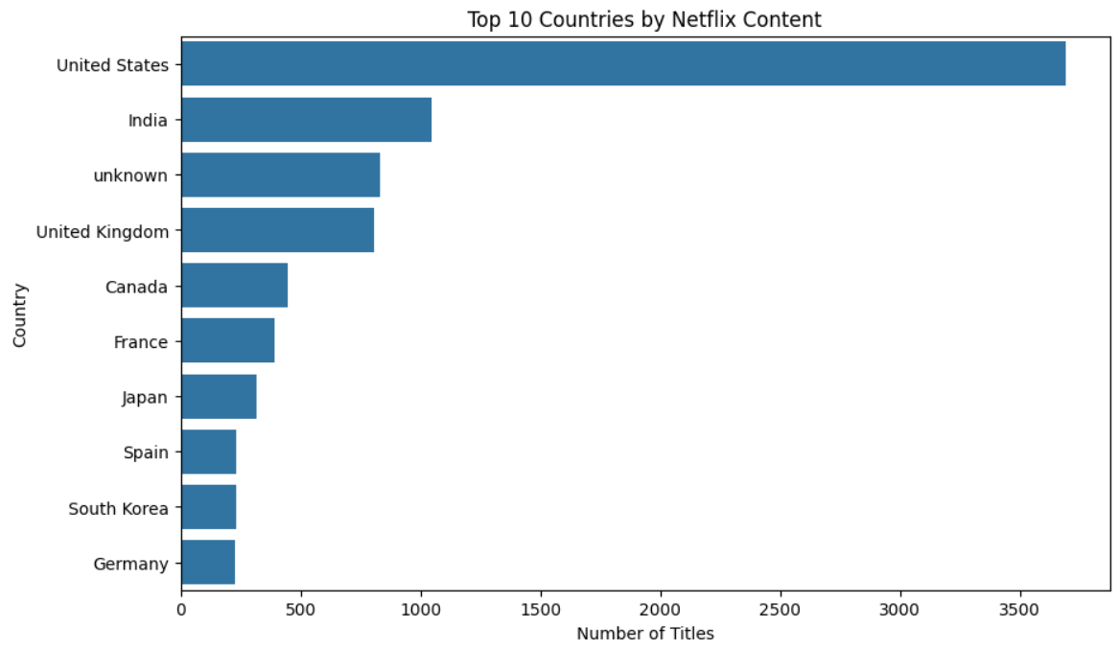
Storytelling contribution: The geographic view adds an international dimension to the story and helps identify major content-producing markets.

Python approach: df['country'].str.split(', ').explode().value_counts().head(10)

10. Visualisation 4 – Top Netflix Genres
Chart type: Horizontal bar chart
The listed_in field contains one or more genres for a title. Splitting and exploding the field allows genre frequencies to be calculated. A ranked bar chart clearly communicates which genres dominate.
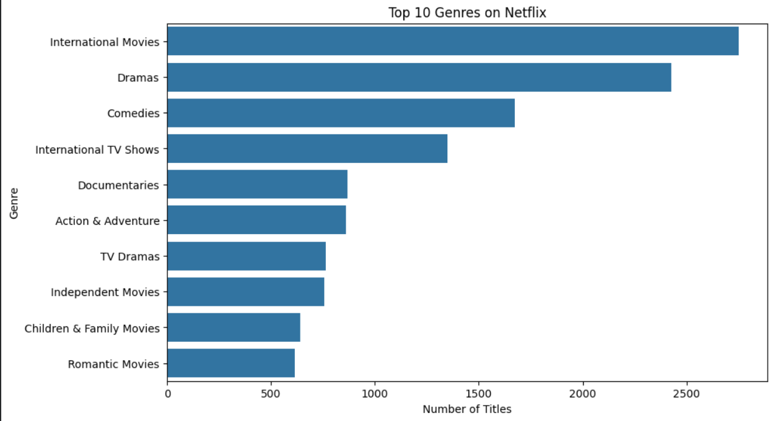
Storytelling contribution: The genre analysis moves the narrative from where Netflix content comes from to what kinds of entertainment are most common.
Python approach: df['listed_in'].str.split(', ').explode().value_counts().head(10)

11. Visualization 5 – Content Rating Distribution
Chart type: Bar chart
A rating distribution chart communicates the maturity levels represented in the catalogue. Rotating category labels may improve readability.
Storytelling contribution: Ratings provide an audience perspective and show how Netflix serves different age and viewing groups.

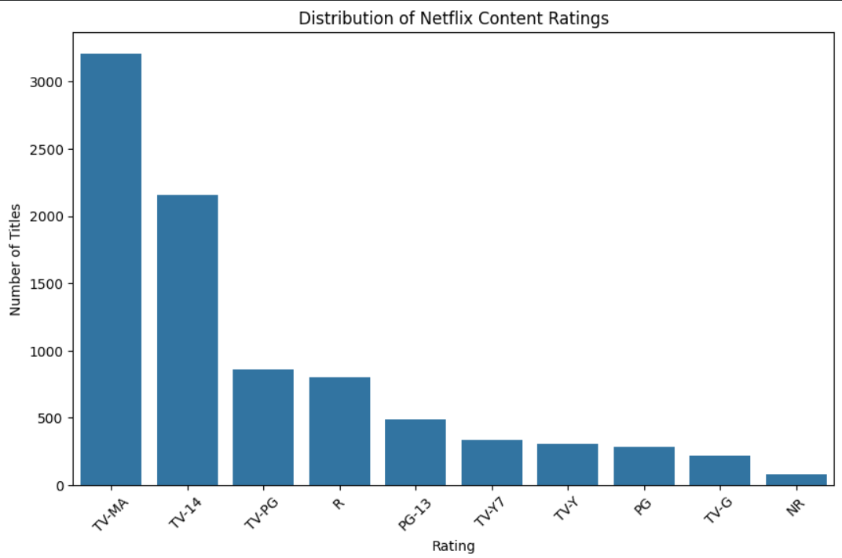
Python output: df['rating'].value_counts().head(10)

12. Visualization 6 – Genre vs Content Type Heatmap
Chart type: Heatmap
A heatmap is useful for comparing two categorical dimensions simultaneously. Rows represent the most common genres and columns represent Movies and TV Shows. Cell values show the number of titles.
Storytelling contribution: This advanced visualization combines two dimensions and helps reveal which genres are more strongly associated with Movies or TV Shows.

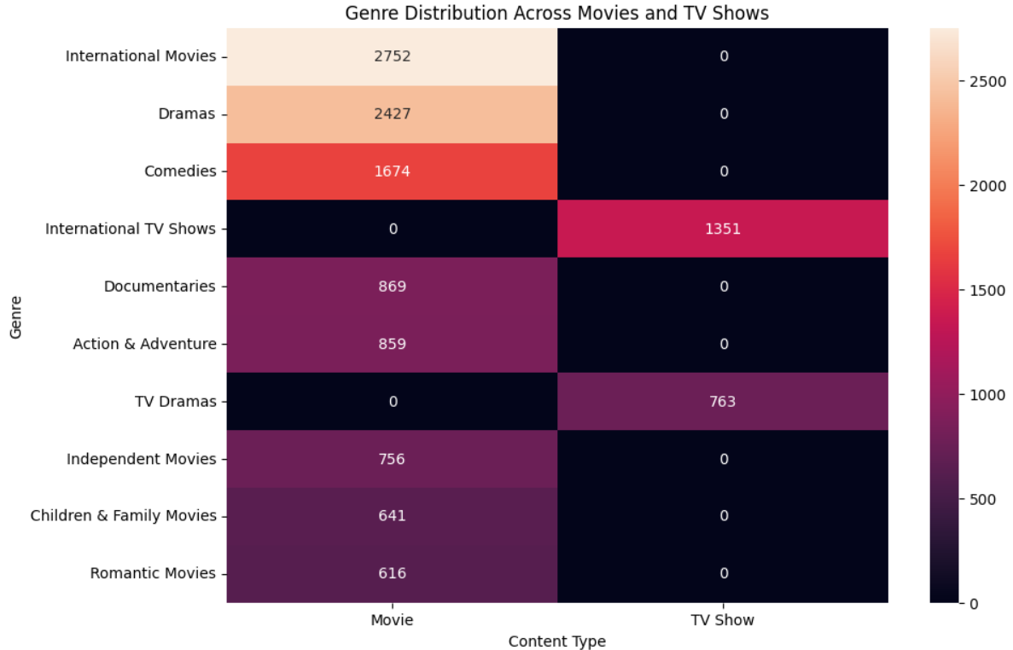
13. Visualization Annotation Strategy
Annotations should be used selectively to direct the reader's attention to the most important observation rather than decorating every part of a graph. Examples include highlighting a year with unusually high content, labelling the largest category, or adding an arrow to an important change.
- Use descriptive titles that communicate the question being answered.
- Label axes with meaningful units or counts.
- Use data labels when they improve interpretation.
- Add arrows or callouts to important peaks, gaps, or anomalies.
- Place a short figure caption below every visualization.
- Explain the insight in plain language immediately after the figure.

14. Overall Data Story
The overall narrative should connect the visualizations rather than treating them as separate exercises. The story begins by examining the development of Netflix's content catalogue over time. It then establishes the balance between Movies and TV Shows, explores the global sources of content, identifies dominant genres, and examines the ratings that characterize the audience being served. Finally, the heatmap brings the analysis together by showing how genres differ between Movies and TV Shows.
After the charts are generated, this section should be updated with the strongest numerical findings. For example, mention the largest content type, the leading country, the dominant genre, and the most common rating.

15. Potential Business Implications
Content Investment: Understanding content growth and the balance between Movies and TV Shows can help evaluate how a streaming platform allocates content-production and acquisition resources.
International Strategy: The country analysis can identify major content-producing markets and indicate opportunities for localized productions and regional expansion.
Audience Segmentation: Rating patterns provide a broad view of the age and maturity segments represented in the catalogue.
Genre Strategy: Genre frequencies can support decisions about content acquisition, diversification, and identification of potentially underserved categories.
Catalogue Management: Combining genre, content type, country, and rating information can support better organization and discovery of content.

16. Key Findings
- [Finding 1 – overall content trend]
- [Finding 2 – Movies vs TV Shows]
- [Finding 3 – leading content-producing country/countries]
- [Finding 4 – dominant genre(s)]
- [Finding 5 – dominant rating/audience category]
- [Finding 6 – important relationship observed in the heatmap]

17. Conclusion
This project demonstrates how Python can be used not only to create attractive charts but also to communicate a meaningful data-driven story. The combination of time-series analysis, categorical comparisons, geographic analysis, genre analysis, rating analysis, and a heatmap provides multiple perspectives on the Netflix catalogue.
The final conclusions should be based on the actual numerical results produced from the dataset. Present the strongest insights in simple language so a non-technical reader can understand what happened, why it matters, and what decisions the findings could inform.

18. Core Python Code Used
import pandas as pd
import numpy as np
import matplotlib.pyplot as plt
import seaborn as sns
df = pd.read_csv('/kaggle/input/netflix-shows/netflix_titles.csv')
# Missing-value treatment
for col in ['director', 'cast', 'country', 'date_added', 'rating', 'duration']:
df[col] = df[col].fillna('Unknown')
# Basic exploration
print(df.shape)
print(df.info())
print(df.isnull().sum())
# Content type
print(df['type'].value_counts())
# Release-year trend
yearly_content = df.groupby('release_year').size()
# Countries
country_list = df['country'].str.split(', ').explode()
country_counts = country_list.value_counts().head(10)
# Genres
genre_list = df['listed_in'].str.split(', ').explode()
genre_counts = genre_list.value_counts().head(10)
# Ratings
rating_counts = df['rating'].value_counts().head(10)
# Genre x type heatmap
temp = df[['type', 'listed_in']].dropna().copy()
temp['genre'] = temp['listed_in'].str.split(', ')
temp = temp.explode('genre')
heatmap_data = pd.crosstab(temp['genre'], temp['type'])
top_genres = heatmap_data.sum(axis=1).nlargest(10).index
heatmap_data = heatmap_data.loc[top_genres]

