1. Introduction
Statistical analysis plays an important role in identifying meaningful patterns, relationships, and differences within a dataset. In this project, statistical analysis and hypothesis testing techniques were applied to the Breast Cancer Wisconsin Diagnostic Dataset using Python.
The main objective of this analysis was to investigate whether important tumor measurements differ between benign and malignant tumors and whether different tumor characteristics are statistically associated with each other.
Python libraries including Pandas, NumPy, SciPy, Statsmodels, Matplotlib, and Seaborn were used throughout the analysis. Three major statistical tests were performed: an independent two-sample t-test, a chi-square test of independence, and a one-way ANOVA. Since the ANOVA result was statistically significant, Tukey's HSD post-hoc test was also performed to determine which specific groups differed.
In addition, a 95% confidence interval was calculated for the difference in mean tumor radius between malignant and benign tumors. Appropriate visualizations were created to support and explain the statistical findings.
2. Objectives
The main objectives of this project were:
- To understand and prepare the breast cancer dataset for statistical analysis.
- To formulate meaningful statistical hypotheses.
- To compare the mean tumor radius between benign and malignant tumors.
- To determine whether tumor radius category is associated with tumor diagnosis.
- To compare mean tumor perimeter across different tumor-radius groups.
- To perform t-test, chi-square, and ANOVA statistical tests using Python.
- To perform post-hoc analysis using Tukey's HSD test.
- To calculate and interpret a 95% confidence interval.
- To create appropriate visualizations supporting the statistical analysis.
- To interpret statistical results using p-values and confidence intervals.
- To draw meaningful scientific conclusions from the analysis.
3. Dataset Description
The Breast Cancer Wisconsin Diagnostic Dataset was used for this statistical analysis. The dataset contains measurements computed from digitized images of fine needle aspiration (FNA) of breast masses. Each observation represents a tumor case and contains numerical measurements describing different characteristics of the tumor.
The dataset contains 569 observations and 31 columns. The features include measurements such as mean radius, mean texture, mean perimeter, mean area, smoothness, compactness, concavity, concave points, symmetry, and fractal dimension.
The target variable used in this analysis was diagnosis, which classifies tumors as either benign or malignant.
The dataset contained:
- 357 benign cases
- 212 malignant cases
The cleaned dataset prepared during Week 1 was reused for this analysis. This provided continuity between the data acquisition and cleaning performed in Week 1, visualization performed in Week 2, and statistical analysis performed in Week 3.
Important Variables Used
Variable | Description
diagnosis | Classification of the tumor as benign or malignant
mean radius | Average radius of the tumor
mean perimeter | Average perimeter of the tumor
radius_category | Tumor radius categorized as Low Radius or High Radius
radius_group | Tumor radius divided into Small, Medium, and Large groups

4. Tools and Technologies Used
The following tools and Python libraries were used:
Python- The primary programming language used for data processing and statistical analysis.
Pandas- Used for loading, cleaning, filtering, and manipulating the dataset.
NumPy- Used for numerical calculations and handling missing or invalid values.
SciPy- Used for performing statistical tests such as:
- Independent t-test
- Chi-square test
- One-way ANOVA
- Confidence interval calculations
Statsmodels- Used to perform Tukey's HSD post-hoc test.
Matplotlib- Used for creating statistical visualizations.
Seaborn- Used for creating enhanced statistical plots such as boxplots, histograms, and count plots.
Jupyter Notebook- Used as the development environment for conducting and documenting the analysis.
5. Methodology
The statistical analysis was performed through the following steps.
Step 1 – Data Preparation
The cleaned dataset obtained during Week 1 was loaded using Pandas. Relevant variables were selected for each statistical test. Missing and invalid values were removed before performing the statistical analysis.
Step 2 – Exploratory Analysis
Basic statistical summaries and visualizations were used to understand the distribution of tumor measurements and identify differences between diagnosis groups.
Step 3 – Hypothesis Formulation
Three research questions were formulated and corresponding null and alternative hypotheses were defined.
Step 4 – Statistical Testing
Three major statistical tests were performed:
- Independent two-sample t-test
- Chi-square test of independence
- One-way ANOVA
Step 5 – Post-Hoc Testing
Since the ANOVA produced a statistically significant result, Tukey's HSD test was performed to identify which specific groups differed from one another.
Step 6 – Confidence Interval
A 95% confidence interval was calculated for the difference in mean tumor radius between malignant and benign tumors.
Step 7 – Interpretation
All statistical tests were evaluated at a significance level of:
α = 0.05
The following decision rule was used:
- p < 0.05 → Reject the null hypothesis
- p ≥ 0.05 → Fail to reject the null hypothesis
6. Hypothesis Formulation
6.1 Hypothesis 1 – Independent Two-Sample T-Test
Research Question
Is the mean tumor radius significantly different between malignant and benign tumors?
Null Hypothesis (H₀)
There is no significant difference in mean tumor radius between malignant and benign tumors.
Alternative Hypothesis (H₁)
There is a significant difference in mean tumor radius between malignant and benign tumors.
6.2 Hypothesis 2 – Chi-Square Test
Research Question
Is tumor radius category associated with tumor diagnosis?
Null Hypothesis (H₀)
Tumor radius category and diagnosis are independent.
Alternative Hypothesis (H₁)
Tumor radius category and diagnosis are significantly associated.
6.3 Hypothesis 3 – One-Way ANOVA
Research Question
Does mean tumor perimeter differ significantly among Small, Medium, and Large tumor-radius groups?
Null Hypothesis (H₀)
The mean tumor perimeter is the same across all three radius groups.
Alternative Hypothesis (H₁)
At least one radius group has a significantly different mean tumor perimeter.
7. Statistical Analysis and Results
7.1 Independent Two-Sample T-Test
Objective- The first hypothesis investigated whether the mean tumor radius differs significantly between malignant and benign tumors.
A Welch's independent two-sample t-test was used. This test is appropriate for comparing the means of two independent groups and does not require the assumption that both groups have equal variances.
Descriptive Results
Diagnosis | Number of Cases | Mean Tumor Radius
Malignant | 212 | 17.4628
Benign | 357 | 12.1465
The malignant group had a considerably higher average tumor radius than the benign group.
Result
The independent t-test produced a statistically significant result at the 5% significance level.
Therefore:
Decision: Reject H₀
Interpretation
There is a statistically significant difference in mean tumor radius between malignant and benign tumors.
The results indicate that malignant tumors in this dataset tend to have a larger mean radius than benign tumors.
Visualization
Figure 1: Comparison of Mean Tumor Radius by Diagnosis

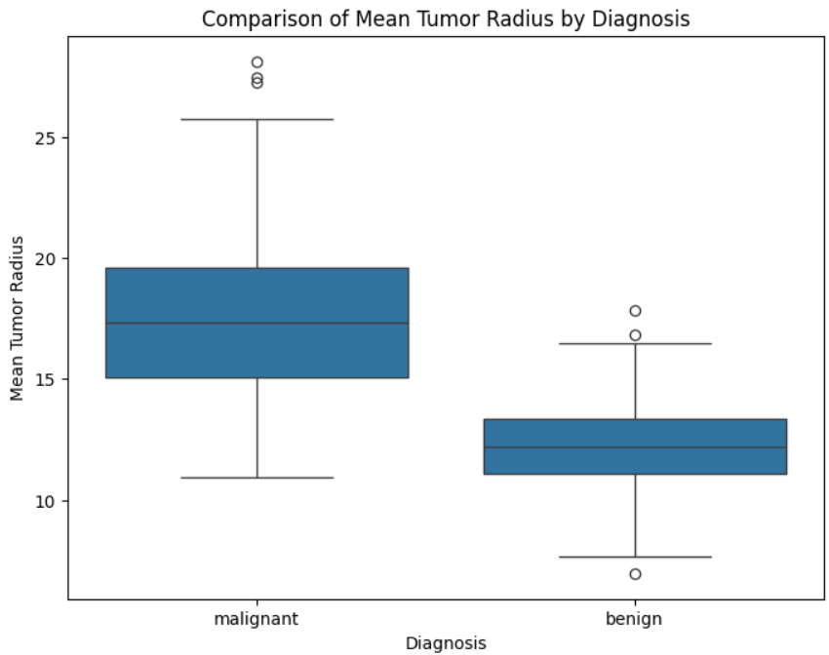

Figure 2: Distribution of Tumor Radius by Diagnosis
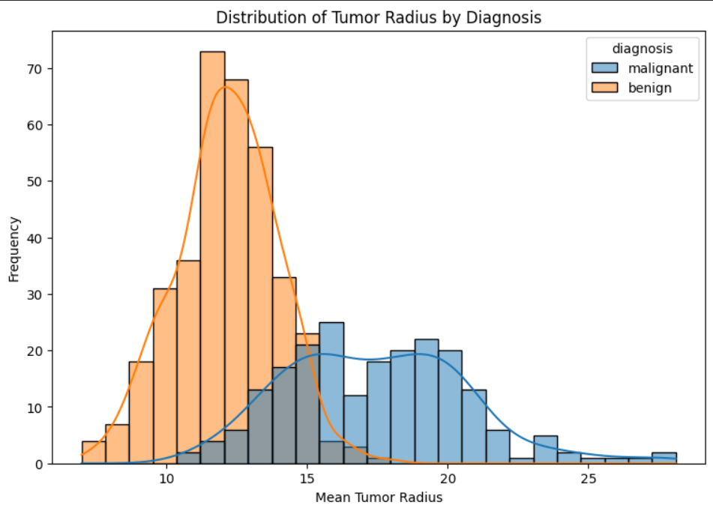

7.2 Chi-Square Test of Independence
Objective
The second hypothesis examined whether tumor radius category and diagnosis are statistically associated.
Since the chi-square test requires categorical variables, the continuous mean radius variable was converted into two categories:
- Low Radius
- High Radius
The median tumor radius was used as the dividing point.
Results
Statistic | Value
Chi-square statistic | 236.528
Degrees of freedom | 1
p-value | < 0.001
The exact calculated p-value was approximately:
2.2479 × 10⁻⁵³
Decision
Since:
p < 0.05
the null hypothesis was rejected.
Interpretation
The chi-square test revealed a statistically significant association between tumor radius category and diagnosis:
χ² = 236.528, df = 1, p < 0.001
Therefore, tumor radius category and diagnosis are not independent in the analyzed dataset.
This indicates that the category of tumor radius is strongly associated with whether the tumor is classified as benign or malignant.
Visualization
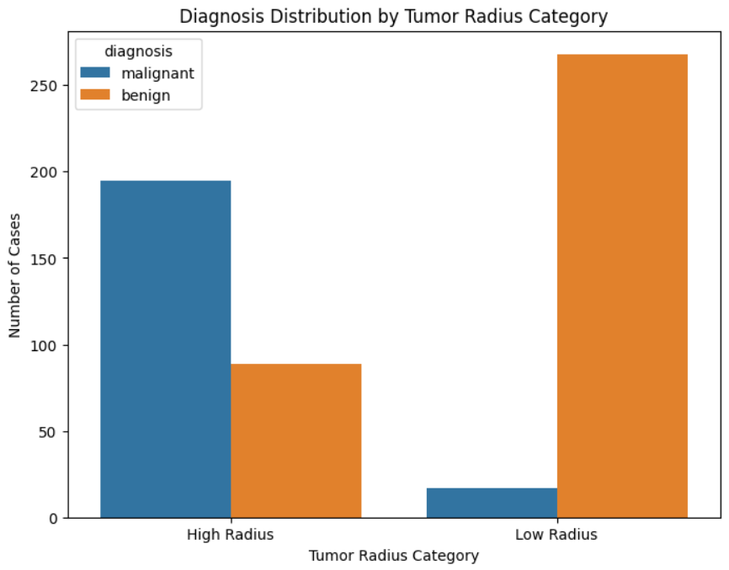
Figure 3: Diagnosis Distribution by Tumor Radius Category

7.3 One-Way ANOVA
Objective
The third hypothesis investigated whether mean tumor perimeter differs significantly among three tumor-radius groups:
- Small
- Medium
- Large
The continuous mean radius variable was divided into three groups using tertiles.
Mean Tumor Perimeter
Radius Group | Mean Tumor Perimeter
Small | 69.306859
Medium | 86.687287
Large | 119.976632
The mean perimeter increased substantially from the Small group to the Large group.
Result
The ANOVA test produced a statistically significant result.
Decision: Reject H₀
Interpretation
There is a statistically significant difference in mean tumor perimeter among the Small, Medium, and Large tumor-radius groups.
This means that at least one of the three groups has a different mean tumor perimeter.

7.4 Tukey HSD Post-Hoc Test
Purpose
Although ANOVA establishes that at least one group differs from another, it does not identify exactly which groups are significantly different.
Therefore, a Tukey HSD post-hoc test was performed.
Results
Group 1 | Group 2 | Mean Difference | p-adjusted | Reject H₀
Large | Medium | -33.2893 | < 0.001 | Yes
Large | Small | -50.6698 | < 0.001 | Yes
Medium | Small | -17.3804 | < 0.001 | Yes
Interpretation
All three pairwise comparisons were statistically significant.
Therefore:
- Large and Medium groups differ significantly.
- Large and Small groups differ significantly.
- Medium and Small groups differ significantly.
The negative mean differences result from the order of the groups in the comparison. The descriptive statistics show that the Large radius group has the highest mean perimeter, followed by the Medium group and then the Small group.
Overall, the Tukey HSD results confirm that all three tumor-radius groups have significantly different mean tumour perimeter values.
8. Confidence Interval Analysis
A 95% confidence interval was calculated to estimate the difference in mean tumor radius between malignant and benign tumors.
Results
Mean Difference: 5.3163
95% Confidence Interval: 4.8452 to 5.7874
Interpretation
The estimated difference in mean tumor radius between malignant and benign tumors was 5.3163 units.
The 95% confidence interval ranged from 4.8452 to 5.7874.
Since the entire confidence interval is above zero, zero is not a plausible value for the true difference between the two groups at the 95% confidence level.
Therefore, the confidence interval supports the conclusion obtained from the independent t-test that the mean tumor radius differs significantly between malignant and benign tumors.
Visualization
Figure 4: 95% Confidence Interval for Difference in Mean Tumor Radius

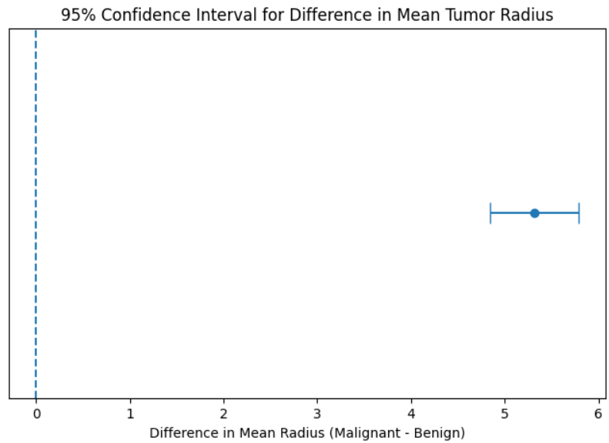

9. Overall Statistical Findings
The statistical analysis revealed significant relationships among tumor characteristics and diagnosis.
The independent two-sample t-test showed a statistically significant difference in mean tumor radius between malignant and benign tumors. The malignant group had a higher average tumor radius than the benign group.
The chi-square test demonstrated a statistically significant association between tumor radius category and diagnosis. This indicates that tumor radius category and diagnosis are not independent in the analyzed dataset.
The one-way ANOVA showed that mean tumor perimeter differed significantly across the Small, Medium, and Large tumor-radius groups.
The Tukey HSD post-hoc test further confirmed that all three radius groups differed significantly from one another.
Finally, the 95% confidence interval for the difference in mean tumor radius was 4.8452 to 5.7874, which did not contain zero. This provides additional evidence of a significant difference between malignant and benign tumors.
10. Scientific Implications
The findings indicate that tumor size-related measurements provide useful information for understanding differences between benign and malignant tumor cases in this dataset.
The significant difference in mean tumor radius suggests that tumor radius is an important characteristic when analyzing tumor measurements. The significant association between radius category and diagnosis further supports the relationship between tumor size and tumor classification.
The ANOVA analysis also demonstrated that larger tumor-radius groups have significantly different tumor perimeter values. The increasing mean perimeter across the Small, Medium, and Large groups indicates a strong relationship between tumor radius and perimeter.
These findings can be useful during exploratory medical data analysis and can help identify potentially important features for future machine learning models.
However, statistical significance alone does not mean that these measurements can independently provide a clinical diagnosis. Medical decisions require appropriate clinical evaluation and validation.
11. Limitations
The analysis has several limitations:
- The analysis was performed using a single dataset, so the results may not generalize to every population.
- Statistical association does not necessarily imply causation.
- The radius categories used for the chi-square analysis were created using the dataset median and do not necessarily represent clinical thresholds.
- The Small, Medium, and Large groups used for ANOVA were created using tertiles and are analytical categories rather than clinical categories.
- The analysis focused on selected tumor measurements rather than all possible clinical and patient-related factors.
- The statistical results demonstrate relationships within the dataset but should not be interpreted as a standalone diagnostic method.
12. Conclusion
This project demonstrated the application of statistical analysis and hypothesis testing techniques to the Breast Cancer Wisconsin Diagnostic Dataset using Python.
Three major statistical tests were performed. The independent two-sample t-test identified a statistically significant difference in mean tumor radius between malignant and benign tumors. The chi-square test revealed a statistically significant association between tumor radius category and diagnosis.
The one-way ANOVA demonstrated that mean tumor perimeter differed significantly among the Small, Medium, and Large tumor-radius groups. Since the ANOVA result was significant, Tukey's HSD post-hoc test was performed and showed that all three groups differed significantly from one another.
The 95% confidence interval for the difference in mean tumor radius was 4.8452 to 5.7874, which did not include zero and therefore supported the t-test conclusion.
Overall, the project demonstrates how hypothesis testing, p-values, confidence intervals, and statistical visualization can be used to identify meaningful patterns in a real-world dataset. The analysis also provides a strong statistical foundation for further machine learning and predictive analysis.
13. Key Results Summary
Analysis | Key Result | Decision
Independent T-Test | Significant difference in mean tumor radius | Reject H₀
Chi-Square Test | χ² = 236.528, p < 0.001 | Reject H₀
One-Way ANOVA | Significant difference in mean perimeter | Reject H₀
Tukey HSD | All three groups significantly differ | Reject H₀ for all comparisons
95% CI | 4.8452 to 5.7874 | Does not contain 0

