Design and Evaluation of an Object-Oriented Internship Management System
Hiya Shah, Manyata Rao
SVKM's NMIMS MPSTME, Mumbai, India
Source code and UML: https://github.com/hiyashah18/InternshipManagementSystemOOP
Abstract: Internship placement in colleges is still often run through e-mail threads, spreadsheets and notice boards: students cannot see every opening, companies cannot track their applicants, and nobody holds a single, trustworthy record of who applied where and with what result. We present IMS, the Internship Management System, a Java web application that manages students, companies, internship postings, applications and selection status for three kinds of user: students, company representatives and an administrator. The design is deliberately object-oriented: an abstract User hierarchy whose subclasses supply their own dashboards and menus, generic interfaces for management and search, a checked exception hierarchy, a generic file-based data store, and a service layer behind a web server built on the JDK itself, so that no external library, framework or database is needed. Because no real placement data was available, the system seeds a small fictional data set on first run (6 users, 2 companies, 5 internships and 1 application). We executed all 18 documented test cases against a running instance and all 18 passed; each page answers in about 1 ms or less on the sample data. In a service-layer benchmark, keyword search over 10,000 internships takes about 1.2 ms, but every write rewrites the whole data file, so posting one internship grows from 1.4 ms (100 records) to 15.9 ms (10,000 records); this, together with unsalted password hashes and the absence of an automated unit-test suite, is the main limitation we identify. The system is 1,860 lines of Java in 30 files.
Keywords: object-oriented design, internship management, Java, web application, file handling, exception handling, UML

I. INTRODUCTION
Placement of students in internships is an activity that nobody notices until it goes wrong. A student misses an opening because it was posted in one chat group and not another; a company receives applications by e-mail and loses track of who was shortlisted; a coordinator cannot say how many students applied or how many were accepted. The same applicant may apply to the same opening twice, or to an opening that closed last week, and nobody finds out. A single shared record that every party reads and updates removes most of these problems.
This paper reports the design, implementation and evaluation of IMS (the Internship Management System), built with its core rooted in object-oriented programming: a local web application in which companies register and post internships, students search for them and apply, companies accept or reject applicants, and an administrator oversees all records. The project demonstrates classes, encapsulation, inheritance, polymorphism, abstraction, interfaces, collections, exception handling, file handling, generics and packages.
Our contributions are:
- A complete object-oriented model and web application of the internship workflow in 1,860 lines of Java (including comments) in 30 files, with no runtime dependencies (Sections IV and VI).
- A role-based design in which three user types share one abstract base class and supply their own menus and dashboards, while generic interfaces and one generic data store serve all four record types (Section IV).
- A documented verification and measurement study: the 18 documented test cases were executed against a running instance, page response times were measured, and the cost of the file-based persistence was measured at up to 10,000 internships (Sections VII and VIII), together with an explicit list of the limitations we found (Section IX and the final list of open issues).
The rest of the paper is organised as follows. Section II reviews related work. Section III lists the requirements, Section IV describes the design, Section V the sample data, Section VI the implementation, Section VII testing, Section VIII the results, Section IX discusses them, and Section X concludes.
II. RELATED WORK
Web-based internship management has been reported before. Abdullah et al. [1] describe a web system at a university campus that replaces a paper-heavy manual process by matching industry requirements with student qualifications to generate placements, and report good usability from testing. Husin et al. [2] present a prototype for the industrial-training unit of a computing school that replaces the scattered use of shared storage and a chat application, and evaluate it through user-satisfaction testing. IMS differs in emphasis: it is a deliberately small, dependency-free system whose purpose is to show an object-oriented design, so students search by keyword and location and companies decide, without automatic matching, and we evaluate correctness against documented test cases and performance by measurement. We did not run a user study.
The object-oriented concepts we rely on (classes, encapsulation, inheritance, polymorphism and abstraction) follow the standard treatments of Booch et al. [3] and Meyer [4]. Bloch [5] guides our use of checked exceptions, interfaces and generics, and also warns against Java serialization, which our persistence layer uses (Section VI). The UML notation follows Fowler [6].
Three security references frame the limitations in Section IX. The OWASP Password Storage Cheat Sheet [7] recommends a slow, salted key-derivation function (Argon2id first, with PBKDF2 and others as alternatives) and a unique salt for every password; the NIST digital identity guidelines [8] set a minimum length for user-chosen passwords; and the OWASP guidance on cross-site scripting [9] recommends encoding untrusted data on output, which is the approach our Html.esc method takes.
III. REQUIREMENTS
The requirements were distilled into six functional requirements (F1–F6), eleven object-oriented requirements (O1–O11) and a short list of non-functional requirements; Appendix A traces each of them to classes and test cases.
Functional: F1: register and log in as a student, a company representative or an administrator. F2: let a company post internships with title, location, stipend, duration and description, and close them. F3: let a student search the open internships by keyword and by location. F4: let a student apply, while blocking duplicate applications and applications to closed or non-existent internships. F5: let a company review the applicants of its own internships, accept or reject them, and let the student see the status. F6: let an administrator view all users, companies, internships and applications and remove students and internships.
Object-oriented: O1: classes and objects; O2: encapsulation; O3: inheritance; O4: polymorphism; O5: abstraction; O6: interfaces; O7: collections; O8: exception handling; O9: file handling; O10: generics; O11: packages.
Non-functional: The system runs offline with no external library, framework or database (JDK 8 or newer, as documented by the project), validates all input, stores passwords only as hashes, keeps its data across restarts, answers each page in under one second on the sample data, and never shows a stack trace to the user on invalid input.
IV. SYSTEM DESIGN
A. Architecture
IMS is organised in six packages (Table I). WebServer is the single entry point: it receives each HTTP request, identifies the user from a session cookie, checks the role required by the page, calls the services and renders the page through Html. The four services (UserService, CompanyService, InternshipService and ApplicationService) hold the records in memory and write them through a DataStore. The web layer is therefore a thin client of the same service code that the verification in Sections VII and VIII exercises directly.
TABLE I
PACKAGES AND THEIR RESPONSIBILITIES (FILES / LINES OF JAVA).
Package | Contents
model (8 / 345) | abstract User; Student, CompanyRepresentative, Administrator; Company, Internship, Application; enum ApplicationStatus
exception (7 / 69) | checked InternshipSystemException and six subclasses
service (7 / 487) | interfaces Applicable, Manageable<T>, Searchable<T>; UserService, CompanyService, InternshipService, ApplicationService
util (5 / 181) | DataStore<T>, Validator, PasswordUtil, IdGenerator, SampleData
web (2 / 730) | WebServer (routing, sessions, role checks), Html (page templates, escaping)
main (1 / 48) | Main (loads data, seeds samples, starts the server)

B. Domain model and OOP concepts
The domain model has three user classes and three record classes (the full UML class diagrams are in Appendix C, Figs. 10–12): User (abstract), Student, CompanyRepresentative, Administrator, Company, Internship and Application, plus the enumeration ApplicationStatus with the values PENDING, ACCEPTED and REJECTED. An Internship stores the name of its company next to the company identifier so that it can be displayed and searched without a lookup, and it can only be changed through setters that validate their input; for example, the stipend must lie between 0 and 1,000,000 rupees per month and the duration between 1 and 24 months.
User is abstract and holds what every account has: identifier, name, e-mail address and password hash. It declares three abstract methods, getRole(), getDashboardTitle() and getMenuLinks(), and one overridable method, describe(). The three subclasses implement them differently: a student sees Dashboard, Browse Internships and My Applications; a company representative sees Dashboard, My Internships and Post Internship; the administrator sees Dashboard and Manage Records. The web layer calls these methods through a User reference, so it contains no per-role menu code (runtime polymorphism). InternshipService offers two methods called search, one taking a keyword and one taking a keyword and a location (overloading, compile-time polymorphism). Table II maps every required OOP concept to its place in the code.
TABLE II
MAPPING OF THE REQUIRED OOP CONCEPTS TO THE IMPLEMENTATION.
Concept | Where it appears
Classes, objects (O1) | Student, Company, Internship, Application, Administrator
Encapsulation (O2) | private fields and validating setters in all model classes
Inheritance (O3) | Student, CompanyRepresentative, Administrator extend User; all exceptions extend InternshipSystemException
Polymorphism (O4) | overridden getMenuLinks, getDashboardTitle, describe; overloaded InternshipService.search
Abstraction (O5) | abstract class User with three abstract methods
Interfaces (O6) | Searchable<T>, Manageable<T>, Applicable
Collections (O7) | ArrayList, LinkedHashMap (a HashMap), HashMap for sessions, Iterator
Exceptions (O8) | InternshipSystemException hierarchy (7 checked types); try/catch in WebServer, Main, DataStore; try-with-resources
File handling (O9) | DataStore reads and writes data/*.dat with object streams
Generics (O10) | DataStore<T extends Serializable>, Searchable<T>, Manageable<T>
Packages (O11) | six packages (Table I)

C. Services and interfaces
Three interfaces separate what a service offers from how it is stored. Manageable<T> declares add, remove, findById and getAll and is implemented by the user, company and internship services; Searchable<T> declares a keyword search and is implemented by InternshipService; Applicable declares apply(studentId, internshipId) and is implemented by ApplicationService. Each service keeps its records in a LinkedHashMap keyed by identifier (insertion order is preserved for display), loads them from its DataStore in the constructor and saves the complete list after every change. A keyword search is case-insensitive, covers title, company, location and description of the open internships only, and may be restricted by a location substring.
D. Lifecycles and integrity rules
An application is created as PENDING and can be set to ACCEPTED or REJECTED by the company that owns the internship; an internship is created open and can be closed by its owner (the model has no operation that reopens it). The services enforce the following rules, most of which are exercised by a test case in Section VII (the ownership checks and the removal of an internship are not): a student has at most one application per internship; applications are accepted only for existing, open internships (otherwise InternshipNotFoundException or InternshipClosedException); only the owning company may close an internship or decide on its applications; an e-mail address can be registered once; removing a student removes that student's applications, and removing an internship removes its applications. All failures are checked exceptions derived from InternshipSystemException; the other types cover authentication, duplicate applications, invalid input and data-file errors (Appendix C, Fig. 12).
E. User interface
The interface is a set of server-rendered HTML pages with a navigation bar that depends on the role (Figs. 1–8). After login the server sets an HttpOnly session cookie that maps to the user; a page that needs a role the user does not have redirects to the dashboard with an error banner. Success and error messages travel as a msg or err parameter of the redirect URL and are shown in a banner. User-supplied text is escaped by Html.esc before it is written into a page. The server runs on one thread, so the in-memory collections need no locking.
V. SAMPLE DATA
Nature: All data is fictional. No real student, company or placement data was used. On the very first start, SampleData.loadIfEmpty creates the records in Table III so that the demonstration is never empty; it does nothing when any user already exists. The demonstration accounts are listed on the login page (Fig. 1) and in the README.
TABLE III
SAMPLE DATA CREATED ON THE FIRST RUN.
Entity | Count | Content
Administrators | 1 | System Admin
Students | 3 | three students (B.Tech Computer Engineering, B.Sc Information Technology, BCA) with skills
Company reps | 2 | one for each company
Companies | 2 | TechNova Solutions (Software, Mumbai); GreenLeaf Analytics (Data Analytics, Pune)
Internships | 5 | three at TechNova, two at GreenLeaf; Mumbai 2, Pune 1, Remote 2; stipends of ₹8,000–15,000 per month; durations of 2–6 months
Applications | 1 | one student applied to the Java Developer Intern posting (PENDING)

Limitations: The data set is tiny and was written by hand, and it contains no closed internships, no rejected applications and no long descriptions. It is enough to demonstrate every screen but it supports conclusions about the program's behaviour on a small, clean input, not about a real placement season. For the larger-scale measurements in Section VIII-C the benchmark generates its own synthetic internships with a fixed random seed.
VI. IMPLEMENTATION
The system comprises 30 Java source files (31 types including one nested class; 1,860 lines including comments) and is compiled with a single javac command over the six source folders, so the build is a plain javac script that works offline. The launchers run.bat and run.sh compile the sources into out/ and start main.Main on port 8080, or on a port given as an argument. No external code, including a test framework, is used.
Persistence: DataStore<T extends Serializable> saves a List<T> with an ObjectOutputStream and loads it with an ObjectInputStream; it is instantiated once for each of four record types (users.dat, companies.dat, internships.dat, applications.dat). A missing file means a first run and yields an empty list. I/O errors and unreadable files raise a DataStorageException whose message names the file and tells the user to delete it to reset the data. Every change rewrites the complete file of the affected record type.
Accounts and validation: Validator centralises input checks (non-empty text, an e-mail pattern, a minimum password length of four characters, integer ranges and integer parsing) and throws InvalidInputException with a message that is shown to the user. Passwords are stored as hexadecimal SHA-256 hashes computed by PasswordUtil; the hash is not salted. Identifiers are a prefix followed by six hexadecimal characters of a random UUID (for example STU-3FA9C2); the generator does not check for collisions.
Request handling: WebServer registers one handler for all paths and dispatches on the path in a switch. A helper method checks the role (and the HTTP method for state-changing pages) before each handler runs; unauthenticated requests are redirected to the login page. Unexpected exceptions produce an error page that shows only the exception message, and the stack trace goes to the server console.
Notable decisions: The company name is copied into each internship so that search needs no join. Ownership is checked in the service (not only in the page) so that a company cannot close or review another company's records even if it sends the request by hand. The Main class passes the services to the server by constructor injection, which keeps the services usable without a web server and is what allows the benchmark in Section VIII-C to call them directly.
VII. TESTING AND VALIDATION
Test cases: The project documents 18 manual test cases (Table IV). For this study we executed every case against a freshly started instance with the sample data, using a scripted HTTP client that logs in as the relevant user, sends the same form requests as the browser and checks the redirect target, the message and the page content. Case 18 was executed by stopping the server and starting it again. All 18 cases passed. The script was written for this study; it is not yet part of the repository.
What was not done: The project has no automated unit-test suite (no JUnit tests), no line-coverage figure and no load test of the web layer. The cases are example-based and cover the main success and failure paths of each requirement; they do not show that no other input can break the system. The screenshots (Figs. 1–8) were taken separately in a browser and show the same screens that the script exercised.

TABLE IV
FUNCTIONAL TEST CASES AND OBSERVED RESULTS (18 OF 18 PASSED).
# | Test | Expected result | Observed result
1 | Log in with a wrong password | Error "Incorrect email or password." | Redirect to login with that message
2 | Student logs in with valid credentials | Student dashboard opens | Redirect to /dashboard; "Student Dashboard" shown
3 | Search "java" | Only matching internships are listed | Java Developer Intern listed; Data Analyst Intern not listed
4 | Filter by location "pune" | Only Pune internships are listed | Only Data Analyst Intern listed
5 | Apply to an open internship | Application saved as PENDING | "Application submitted successfully."; PENDING shown under My Applications
6 | Apply to the same internship twice | DuplicateApplicationException message shown | "You have already applied for this internship."
7 | Apply to a non-existent internship | InternshipNotFoundException message shown | "This internship does not exist."
8 | Student opens the admin page | Redirected to dashboard with an error | Redirect to /dashboard: "You do not have access to that page."
9 | Company posts internship with stipend "abc" | "Stipend must be a whole number." | Same message
10 | Company posts internship with duration 99 | "Duration must be between 1 and 24." | "Duration (months) must be between 1 and 24." (wording differs from the documented text, see the list of open issues)
11 | Company accepts an applicant | Status changes to ACCEPTED | ACCEPTED shown to the student
12 | Company closes an internship | Status CLOSED, hidden from student search | CLOSED in the company list; absent from the student search
13 | Register with an invalid email | "Please enter a valid email address." | Same message
14 | Register with an existing email | "An account with this email already exists." | Same message
15 | Register with a 2-character password | "Password must be at least 4 characters long." | Same message
16 | Register with HTML in the name | Shown as plain text, not executed | Dashboard contains the escaped text; no script element
17 | Admin removes a student | Student and their applications are deleted | "Student removed."; the student and the student's application no longer appear
18 | Restart the server | All users, internships and applications are still there | New account, ACCEPTED status, CLOSED state and the removal survived the restart

VIII. RESULTS
A. Application output
Figs. 1–8 show the screens of the running system with the sample data: the login page with the demonstration accounts; the student dashboard with its counters; the internship browser with keyword and location filters, where an internship the student already applied to carries an Already applied badge instead of an Apply button; the list of the student's applications with status; the company's internship list with applicant counts and Applicants and Close actions; the form for posting an internship; the administrator dashboard; and the administrator's record list with Remove buttons for students and internships.

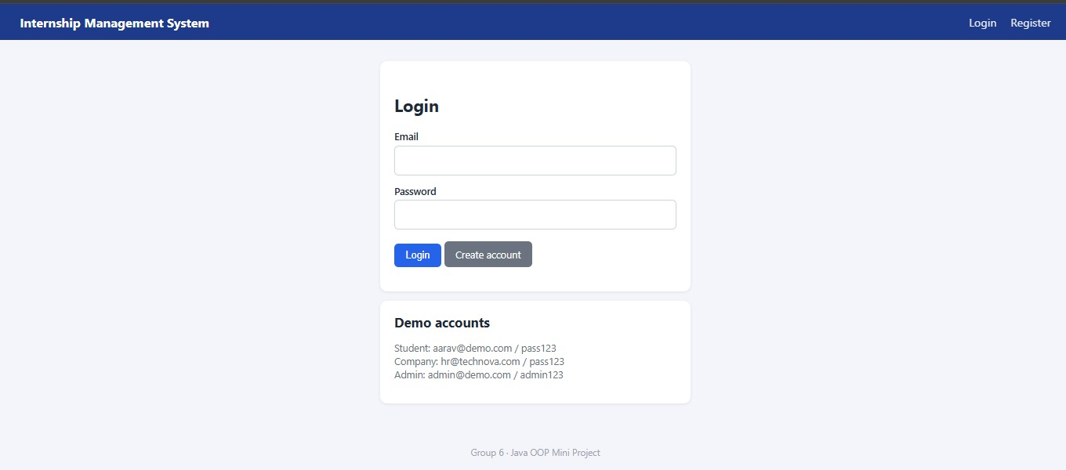
Fig. 1. Login page with the demonstration accounts.
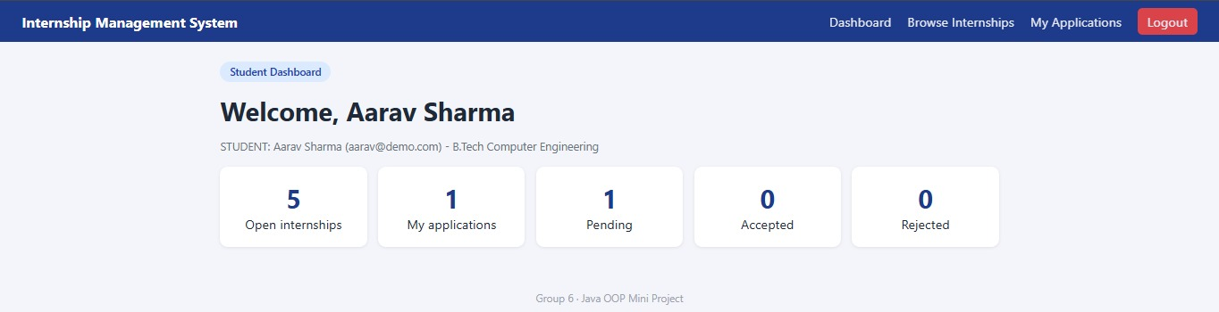
Fig. 2. Student dashboard (open internships, own applications by status).
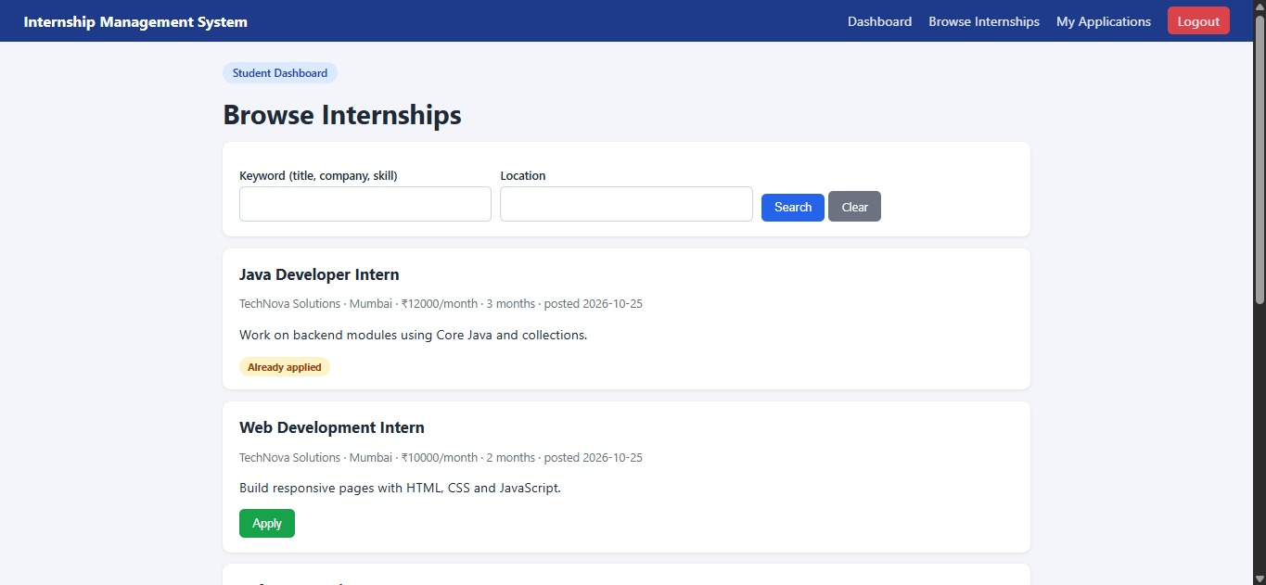
Fig. 3. Student browsing internships with keyword and location filters.
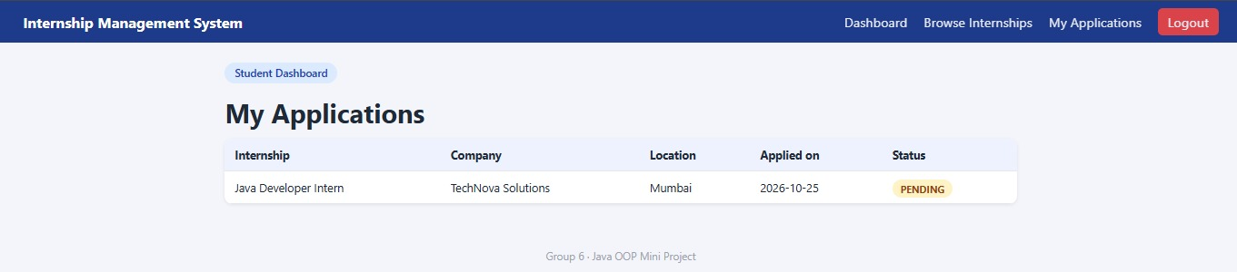
Fig. 4. Student's applications with status.
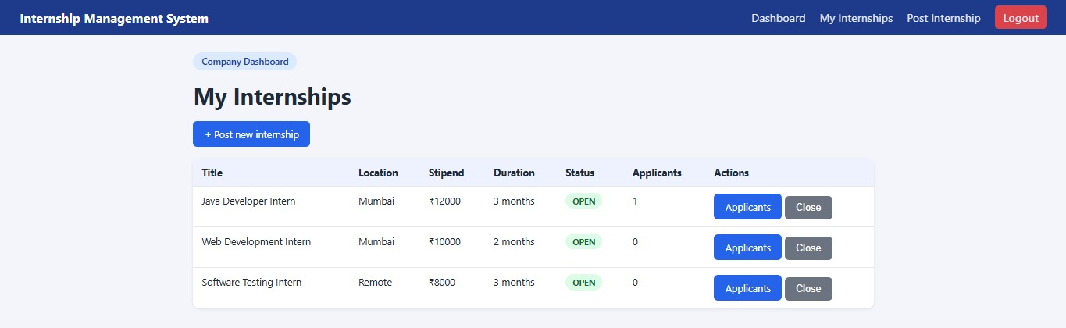
Fig. 5. Company's internship list with applicant counts and actions.
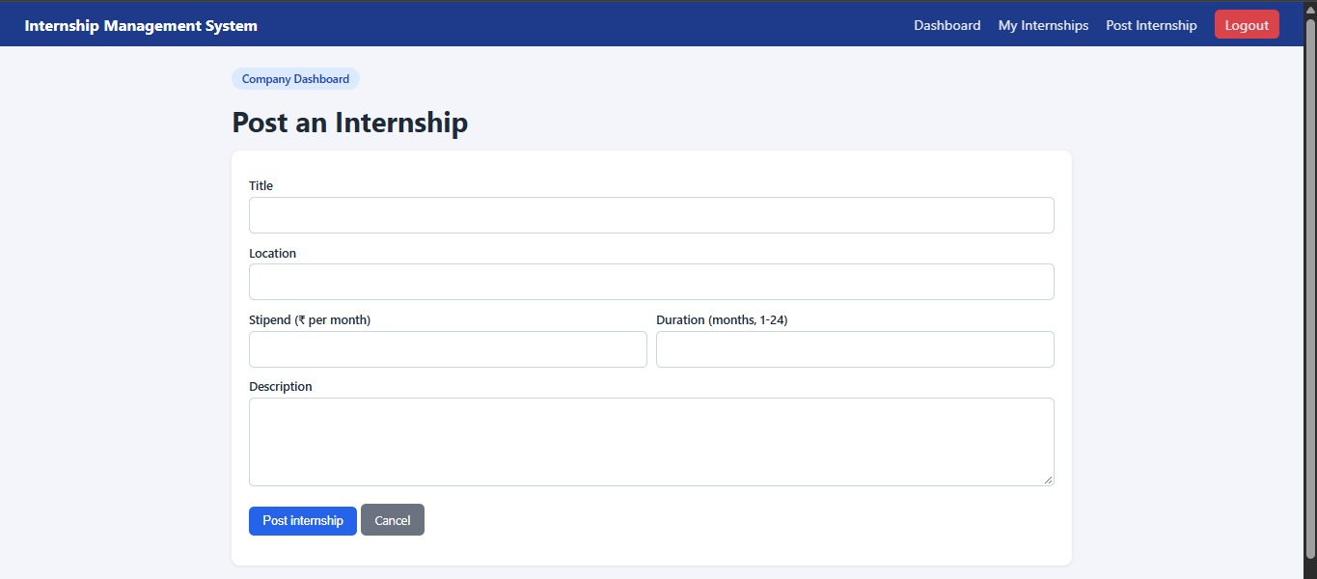
Fig. 6. Form for posting an internship (validated on the server).
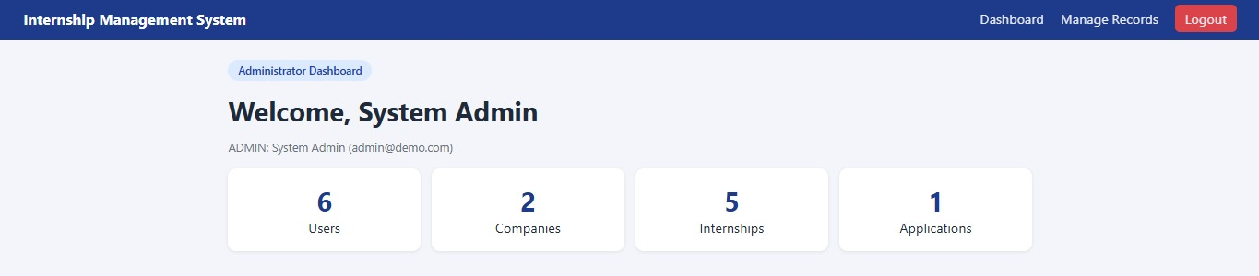
Fig. 7. Administrator dashboard.
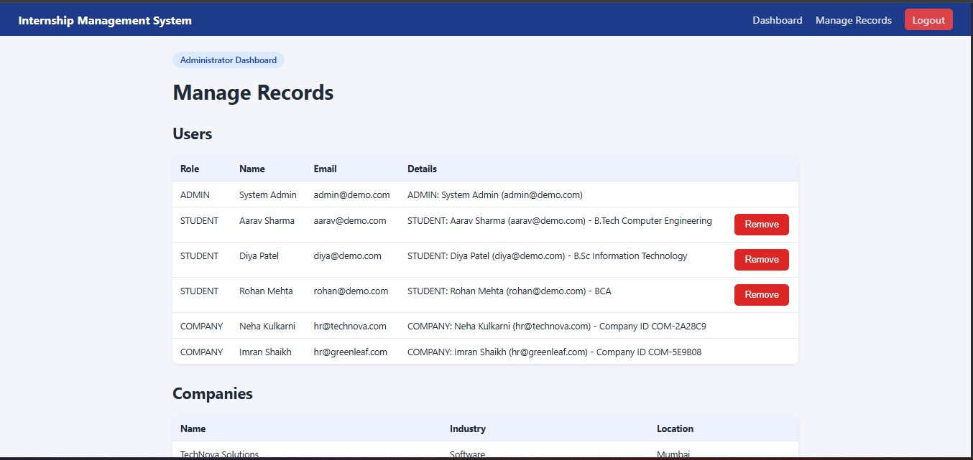
Fig. 8. Administrator's record list (users, with Remove for students).

B. Interactive performance
A scripted client on the same machine (a cloud container with two virtual CPUs of an Intel Xeon at 2.3 GHz, OpenJDK 21) requested each page 200 times after logging in as a student, with the sample data loaded. Table V shows the median and the 95th percentile of the response time. All pages answer in about 1 ms or less; a single login request, which includes the SHA-256 hash and the creation of the session, took 6.7 ms. The one-second non-functional target is therefore met by a wide margin on the sample data.
TABLE V
RESPONSE TIME OF THE PAGES ON THE SAMPLE DATA (200 REQUESTS EACH, MILLISECONDS).
Page | Median | 95th pct.
Dashboard | 1.07 | 2.86
Browse internships (no filter) | 0.85 | 1.23
Browse, keyword "java" and location "mumbai" | 0.69 | 0.93
My applications | 0.67 | 0.93

C. Scalability of the service layer
To see how the in-memory collections and the file persistence behave when there is more data, a benchmark program calls the services directly (without the web layer) with 100, 1,000, 5,000 and 10,000 internships generated with a fixed random seed, of the five titles and five locations used in the sample data. For each size it posts all internships, measures the median of 200 keyword searches and of 200 keyword-plus-location searches, reloads the internship file, and then submits up to 2,000 applications from distinct students. Table VI and Fig. 9 show the results of one run for each size.

TABLE VI
SERVICE-LAYER MEASUREMENTS BY NUMBER OF STORED INTERNSHIPS (ONE RUN PER SIZE; MILLISECONDS UNLESS NOTED).
Internships | Post (mean) | Search, keyword (median) | Search, keyword + location (median) | Reload file | File (KB) | Apply (mean; applications stored) | Heap (MB)
100 | 1.40 | 0.060 | 0.052 | 15.1 | 10 | 0.71 (100) | 3
1,000 | 1.84 | 0.106 | 0.122 | 30.3 | 97 | 1.69 (1,000) | 3
5,000 | 7.93 | 0.485 | 0.555 | 50.4 | 492 | 2.49 (2,000) | 5
10,000 | 15.88 | 1.182 | 1.279 | 103.4 | 985 | 2.70 (2,000) | 8

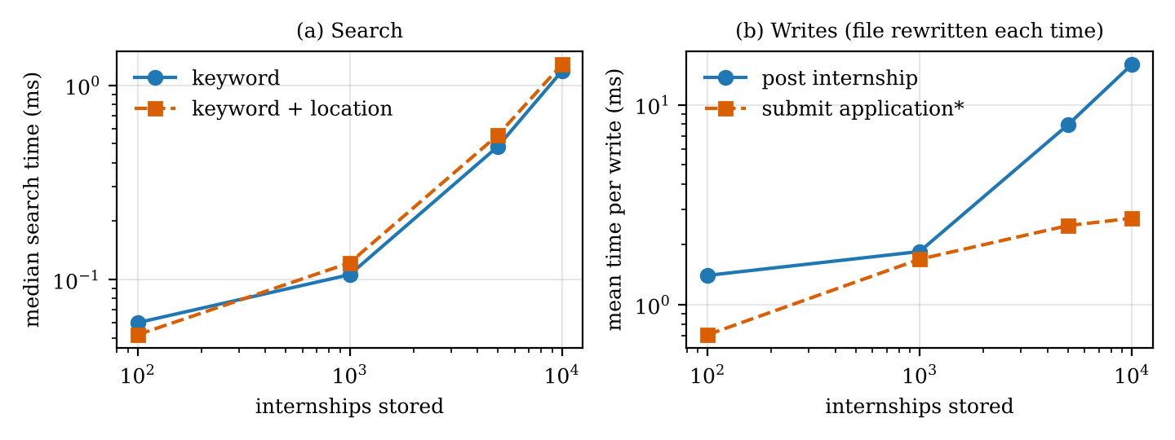
Fig. 9. (a) Median search time and (b) mean time per write against the number of stored internships (log scales). The application writes rewrite a file of 100 to 2,000 applications.

Searching is a linear scan and stays cheap: the median search takes 0.06 ms with 100 internships and 1.18 ms with 10,000, and doubling the number of internships from 5,000 to 10,000 multiplies the time by 2.4. Writing is the limit. Because every change serialises the complete list again, the mean time to post one internship grows from 1.4 ms at 100 internships to 15.9 ms at 10,000, so building a data set of 10,000 internships one posting at a time took 158.8 s (0.14 s for 100, 1.8 s for 1,000 and 39.7 s for 5,000): the total cost of the writes grows roughly with the square of the number of records. Submitting an application also scans all existing applications to detect a duplicate, and its time grows from 0.7 ms to 2.7 ms as the number of stored applications grows from 100 to 2,000. Memory is not a concern: the heap in use after a collection was 3–8 MB, and the internship file occupied about 100 bytes per internship (985 KB for 10,000).
A single posting taking 16 ms is still unnoticeable to a user, and a college placement season is likely to involve hundreds of postings rather than ten thousand, so the interactive target is not at risk for the intended use; the measurement shows where the design would break first if the system were used at a much larger scale.
IX. DISCUSSION
What the results mean. Three messages are robust. First, the object-oriented structure keeps each requirement in one small place: the role-specific part of the interface lives in three short subclasses of User, input rules live in Validator, every failure is a InternshipSystemException that the web layer turns into a banner, and all 18 documented test cases pass. Second, the in-memory design is fast for reads at this scale: pages answer in about 1 ms and a keyword search over 10,000 internships takes about 1.2 ms. Third, the whole-file persistence is the scalability limit, as Section VIII-C shows, and it also leaves a durability gap: a file is overwritten in place, so a crash during a write could leave an unreadable file (we did not test this).
Implications for design. Because the services depend on DataStore only through its load and save methods, a database-backed store (for example through JDBC) could replace it with changes confined to the util package and the four service constructors; we have not tried this. Saving only the changed record would remove the quadratic write cost. The password handling should move to a salted, deliberately slow key-derivation function as recommended in [7], and the minimum length should follow [8]; sessions need an expiry time and the forms need an anti-forgery token (see the list of open issues).
Threats to validity. Construct: a passing test case shows that the documented behaviour occurs for the input we chose, not that the behaviour is right for every input; the documented expected results were written by the same team. Internal: the test script and the benchmark ran against the code as it is in the repository and use a fixed random seed, but each benchmark size was run once, and the smallest sizes are influenced by JVM warm-up. External: the sample data is tiny and fictional, the benchmark data is synthetic with five titles and five locations, no real users took part, and the performance figures come from one machine, not from a student's laptop. Measurement: response times were measured by a client on the same machine over the loopback interface, so they exclude network delay; heap use was sampled once after a garbage collection and is not a peak. No usability evaluation was carried out, so nothing in this paper says that the pages are easy to use.
X. CONCLUSION AND FUTURE WORK
We built IMS, an object-oriented web application for managing internships, with three user roles, generic interfaces, a checked exception hierarchy and a file-based generic data store, and without external libraries. All 18 documented test cases pass, pages answer in about a millisecond on the sample data, and search over 10,000 internships takes about 1.2 ms, while the cost of each write grows with the amount of stored data. Future work includes automated unit tests with a coverage measurement, a database back end, salted password hashing with a stronger password policy, session expiry and anti-forgery tokens, HTTPS, e-mail notification of status changes, resume upload, interview scheduling, student profile editing and password reset, and a usability study with real students and company representatives.
KNOWN INCONSISTENCIES AND OPEN ISSUES
We list the points where the evidence is weaker than the headline results suggest.
- No automated test suite. Correctness evidence comes from 18 example-based cases executed by a script that is not in the repository; no line coverage was measured.
- Documentation mismatch. The README documents the message for test case 10 as "Duration must be between 1 and 24."; the program shows "Duration (months) must be between 1 and 24." The behaviour is correct; the documented text should be updated.
- Weak password handling. Passwords are hashed with one round of unsalted SHA-256 and the minimum length is four characters; this does not follow the recommendations in [7] and [8].
- Session and request security. Sessions never expire (they end only on logout), the cookie has no Secure or SameSite attribute, the forms carry no anti-forgery token, logout is a GET request, and the server speaks plain HTTP.
- File persistence. Data is stored with Java object serialization, which Bloch [5] advises against, and each save overwrites the whole file in place; the write cost grows with the data (Section VIII-C) and a crash during a write could corrupt a file.
- Identifiers. Identifiers have six hexadecimal characters and are not checked for collisions.
- Untested rules. The ownership checks (a company closing or reviewing another company's records) and the removal of an internship with its applications are implemented but have no test case.
- Single thread. The server handles one request at a time; concurrent use was not tested.
- No real-world validation. All data is fictional and no user study was done.
- Scalability figures. Each benchmark size was run once on one machine, so the figures show the trend, not precise values.
- Account management gaps. There is no way to edit a profile, reset a password, remove a company or company representative, or reopen a closed internship.
- References. Bibliographic details of references [1], [2], [7] and [9] were checked against the publisher, repository or web pages; we did not read each work in full, and our statements about them are limited to their subject matter.
REFERENCES
[1] F. S. Abdullah, A. A. Seman, N. Ibrahim, N. A. Majid, N. M. A. Wahab, M. S. Mustafa, and N. F. M. Sani, "Web-based application of the internship management system," Journal of Computing Research and Innovation, vol. 2, no. 3, pp. 46–51, 2017.
[2] M. Z. Husin, P. R. Ganes, and N. Puteh, "A web-based industrial training management system: A case study of the School of Computing," Journal of Digital System Development, vol. 2, no. 2, pp. 64–78, Oct. 2024, doi: 10.32890/jdsd2024.2.2.5.
[3] G. Booch, R. A. Maksimchuk, M. W. Engle, B. J. Young, J. Conallen, and K. A. Houston, Object-Oriented Analysis and Design with Applications, 3rd ed. Addison-Wesley, 2007.
[4] B. Meyer, Object-Oriented Software Construction, 2nd ed. Prentice Hall, 1997.
[5] J. Bloch, Effective Java, 3rd ed. Addison-Wesley, 2018.
[6] M. Fowler, UML Distilled: A Brief Guide to the Standard Object Modeling Language, 3rd ed. Addison-Wesley, 2003.
[7] OWASP, "Password Storage Cheat Sheet," OWASP Cheat Sheet Series. [Online]. Available: https://cheatsheetseries.owasp.org/cheatsheets/Password_Storage_Cheat_Sheet.html
[8] P. A. Grassi et al., "Digital identity guidelines: Authentication and lifecycle management," NIST Special Publication 800-63B, Jun. 2017, doi: 10.6028/NIST.SP.800-63b.
[9] OWASP, "Cross Site Scripting Prevention Cheat Sheet," OWASP Cheat Sheet Series. [Online]. Available: https://cheatsheetseries.owasp.org/cheatsheets/Cross_Site_Scripting_Prevention_Cheat_Sheet.html

APPENDIX A — TRACEABILITY MATRIX
TABLE VII
REQUIREMENTS TRACED TO CLASSES AND TEST CASES (TC = TEST CASE NUMBER OF TABLE IV).
Req | Main classes | Test cases | Section
F1 | UserService, User, Student, CompanyRepresentative, Administrator, Validator, PasswordUtil, WebServer (login, register) | TC1, TC2, TC13, TC14, TC15, TC16 | IV-B, IV-E
F2 | InternshipService (post, close), Internship, Company, CompanyService | TC9, TC10, TC12 | IV-B, IV-D
F3 | InternshipService (overloaded search), Searchable<T> | TC3, TC4, TC12 | IV-C
F4 | ApplicationService (apply), Applicable, DuplicateApplicationException, InternshipClosedException, InternshipNotFoundException | TC5, TC6, TC7 | IV-C, IV-D
F5 | ApplicationService (updateStatus), ApplicationStatus, WebServer (applicants, decide) | TC11 | IV-D
F6 | WebServer (admin pages), ApplicationService (removeByStudent, removeByInternship), Manageable<T> | TC8, TC17 | IV-D, IV-E
O1–O2 | model classes; Validator | TC9, TC10, TC13, TC15 | IV-B
O3–O5 | User and its three subclasses; exception hierarchy | TC2, TC8 (role-specific pages) | IV-B
O6, O10 | Searchable<T>, Manageable<T>, Applicable; DataStore<T> | TC3, TC4, TC18 | IV-C
O7 | LinkedHashMap, ArrayList, HashMap (sessions), Iterator | TC5, TC17 | IV-C
O8 | InternshipSystemException hierarchy; WebServer error handling | TC1, TC6, TC7, TC9, TC10 | IV-D
O9 | DataStore (object streams) | TC18 | VI
O11 | six packages | build (compile) | IV-A

APPENDIX B — HOW TO RUN
Requirements: JDK 8 or newer (as documented; we ran it on JDK 21). On Windows run run.bat; on Linux or macOS run sh run.sh; both compile the sources and start the server, and then the application is opened at http://localhost:8080. A different port is given as an argument, for example run.bat 9090 or sh run.sh 9090. The sources can also be compiled by hand with one javac command over the six source folders (the command is given in the README) and started with java -cp out main.Main; the program must be started from the project folder so that the data/ folder is found. The demonstration accounts are aarav@demo.com / pass123 (student), hr@technova.com / pass123 (company) and admin@demo.com / admin123 (administrator). To reset the data, stop the server and delete the .dat files in data/. The README of the repository describes these steps.
APPENDIX C — UML DIAGRAMS
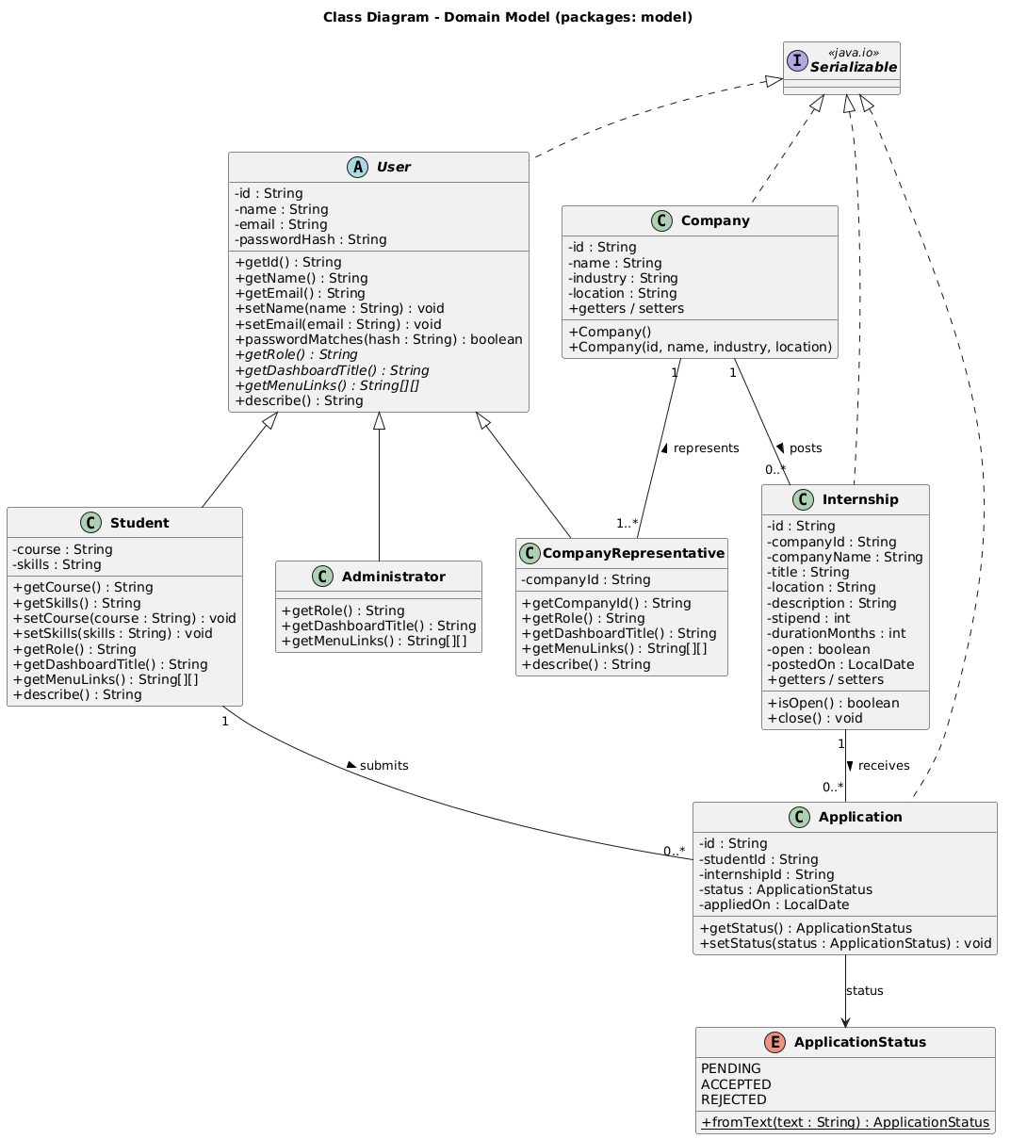
Fig. 10. Domain model: users, records and the status enumeration.
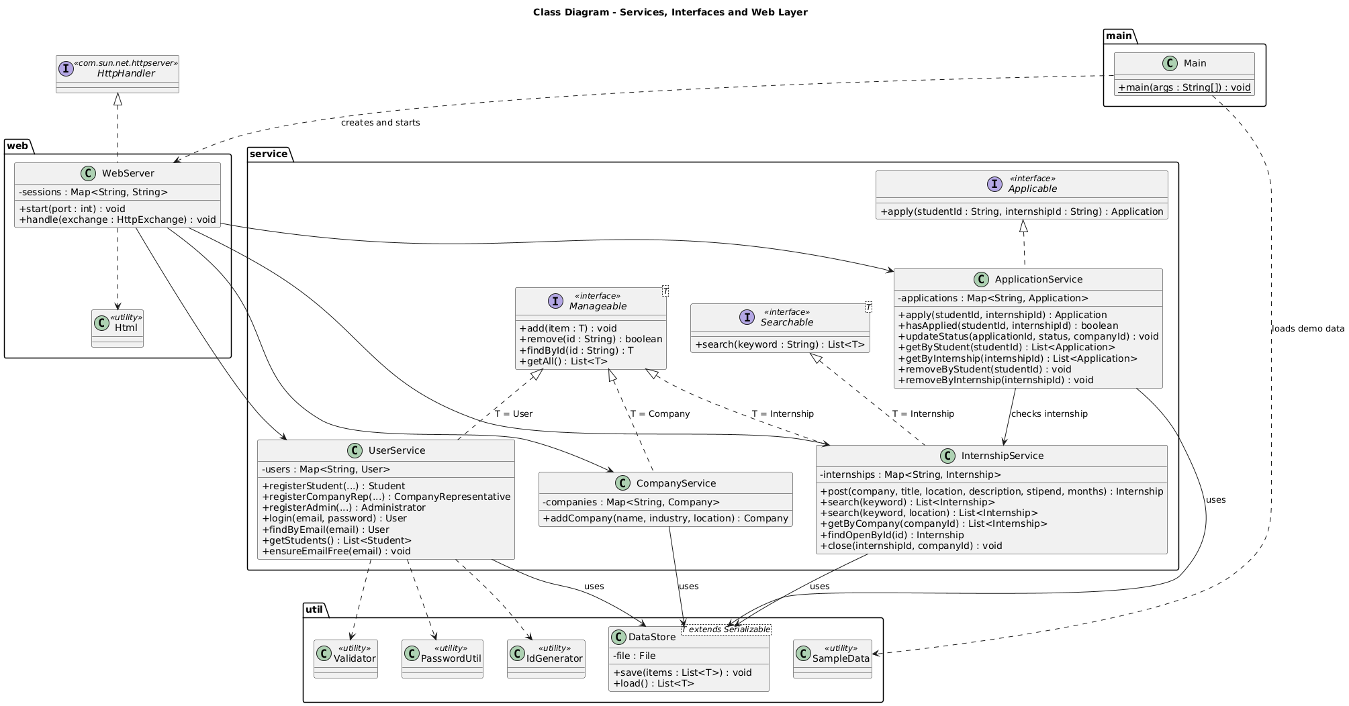
Fig. 11. Services, interfaces and the web layer.
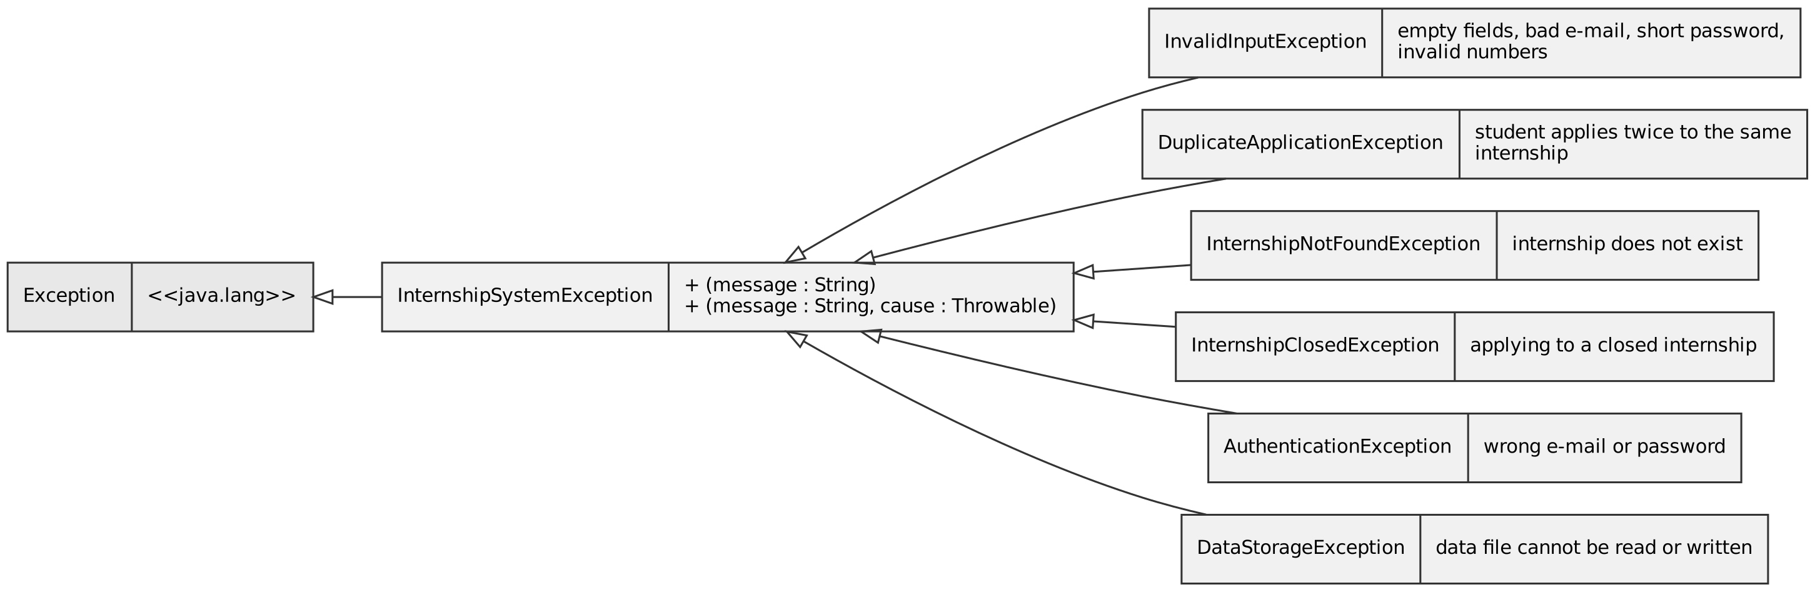
Fig. 12. Exception hierarchy.
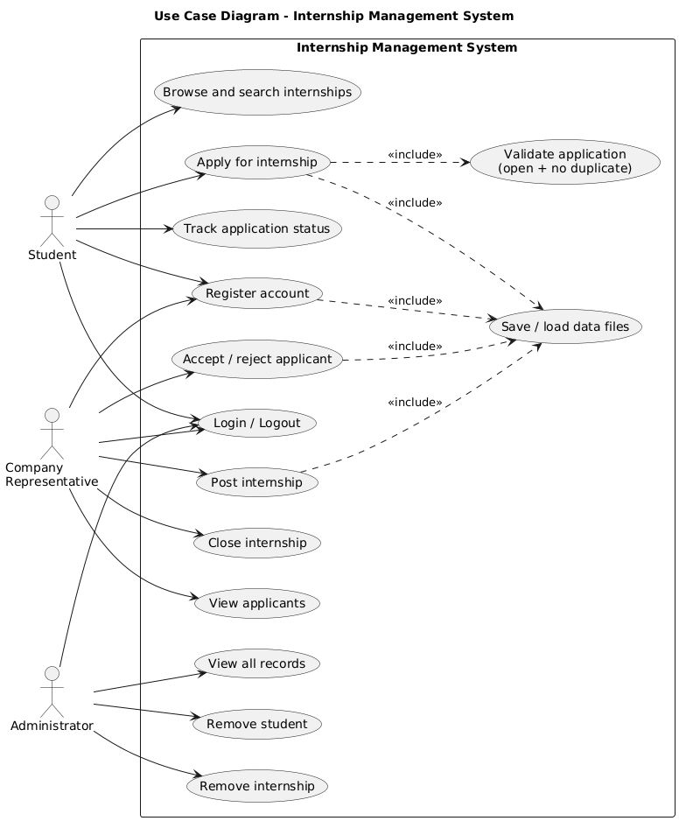
Fig. 13. Use case diagram.
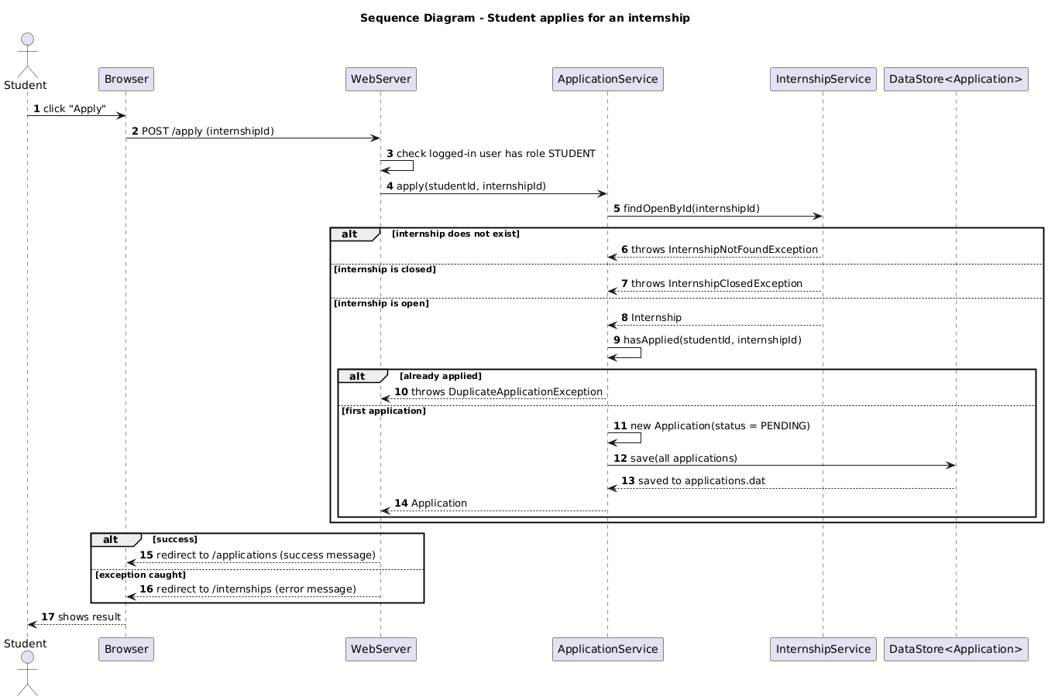
Fig. 14. Sequence of a student applying for an internship.
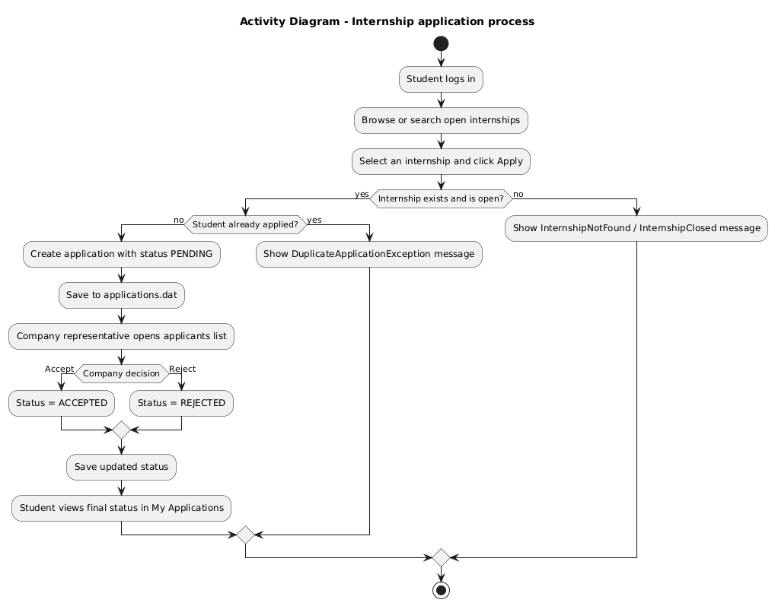
Fig. 15. Activity diagram of the application process.

