iBudget
Software Project
Management Plan

Approvals: | L. Assayah | _____________ | date: | _____________
 | C. Leung | _____________ | date: | _____________
 | Q. Pham | _____________ | date: | _____________
 | V. Velev | _____________ | date: | _____________
 | J. Reimels | _____________ | date: | _____________

Revision History

Date | Author | Version | Reason
2/12/12 | V.Velev | 1.0 | First Draft
2/12/12 | Q.Pham | 1.0 | Draft Schedule
2/12/12 | V.Velev | 1.1 | Added Budget and Resource Allocation section.
2/12/12 | V.Dineva | 1.1 | Risk Management Contribution
2/12/12 | Q.Pham | 1.1 | Risk Management Contribution
2/13/12 | Q.Pham | 1.2 | Add TOC and Reference Section. Modify Schedule.

Table of Contents

1. Introduction 3
1.1. Project overview 3
1.2. Project deliverables 3
1.3. Evolution of the SPMP 3
1.4. Project deliverables 3
1.5. Acronyms 3
2. Project Organization 3
2.1. Process Model 3
2.2. Organizational Structure 4
2.3. Project Responsibilities 4
3. Management Process 5
3.1. Management objectives and priorities 5
3.2. Assumptions, Dependencies and Constraints 5
None. 5
3.3. Risk management 5
3.4. Monitoring and controlling mechanism 6
3.5. Staffing Plan 6
4. Technical Process 7
4.1. Methods, tools and techniques 7
4.2. Software Documentation 7
5. Resources and schedule 7
5.1. Resources 7
5.2. Budget and resource allocation 7
5.3. Schedule 8
6. References 10

Introduction

Project overview

iBudget is planned as a personal financial management software tool that produces as an output a thorough and simple analysis of one’s financial statements. The user should be able to use iBudget to easily and efficiently attain an overview of his or her finances as well as create a budget.

Project deliverables

At the end of the school semester, the team shall deliver a working software program as well as all the necessary documentation.

Evolution of the SPMP

This document shall be maintained on a weekly basis by the project leader. It is subject to configuration management by means of the SCMP.

Project deliverables

Source code for the iBudget project and all necessary documentation.

Acronyms

QA – quality assurance
SCMP – Software Configuration Management Plan
SPMP – Software Project Management Plan
SRS – Software Requirements Specification
SDD – Software Design Document
STP – Software Test Plan

Project Organization

Process Model

The project will be executed using a Waterfall with Feedback model. This sequential approach will consist of the following phases: Inception, Requirements, Implementation, Testing, and Maintenance. Each phase will allow the team to go back to a previous phase (e.g. go back to Requirements from Implementation to redefine the project.)

Organizational Structure

The team will consist of members with designated roles. The roles are team leader, the configuration management leader, the quality assurance leader, the requirements management leader, the design leader, and the implementation leader. These roles are shown in figure 2.2.

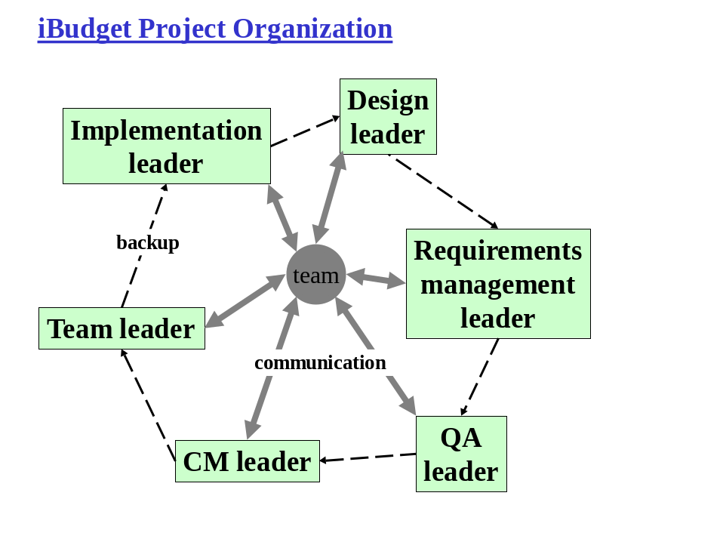
Figure 2.2: iBudget Project Organization

Project Responsibilities

The responsibilities of the participants in the project are shown in table 2.3.

Member | Team Leader | CM Leader | QA Leader | Requirements Management Leader | Design Leader | Implementation Leader
Document Responsibility | SPMP | SCMP | SQAP  STP | SRS | SDD | Code Base
Table 2.3: Project Responsibilities

Being responsible for the document includes the following:
- Making sure the document is completed in time.
- Keeping the document up-to-date throughout the project life cycle

Management Process

Management objectives and priorities

The highest management priority shall be the completion of the project on time before the end of the school semester. This also includes that the project be on schedule. The second priority shall be meeting a degree of quality as specified by the quality parameters. The third priority shall be to include as many features as were planned throughout the project lifecycle.

Assumptions, Dependencies and Constraints

None.

Risk management

# | Risk Title | Likelihood to Occur  1-10 | Impact  1-10 | Retirement Cost  1-10 | Priority | Retirement or Mitigation Plan | Responsible Engineer | Target Completion Date
1 | Requirements Inflation | 3 | 8 | 2 | 48 | Add additional features depending on time. | All | 04/02
2 | Poor Productivity | 7 | 10 | 10 | 40 | Keep developers engaged and motivated. | Project Leader | 04/30
3 | Shorfalls in 3rd party software | 4 | 3 | 6 | 336 | Analyze software capabilities in advance. | TBD | 02/30
4 | Insufficient time | 8 | 9 | 5 | 30 | Follow schedule. | Project Leader | 04/30
5 | Unforeseen software defects | 7 | 7 | 5 | 45 | Allocate enough time for defect resolution. | All | 04/16

Risk #1: Overpromising and underdelivering on specified requirements will result in the failure of the project. The team has decided on a basic feature set and will add additional functionality depending on time left in the semester.

Risk#2: Time constraints and other personal/professional responsibilities can result in poor productivity. The team leader is responsible for keeping other team members engaged.

Risk#3: Functionality of 3rd party tools might not suffice. The team should analyze each tool in advance.

Risk#4: The team is required to finish the project by the end of the school semester. The team leader is responsible for making sure that all deadlines are met.

Risk#5: Software defects are inevitable. All developers should allocate enough time to debug their code and resolve any uncovered defects.

Monitoring and controlling mechanism

There will be a weekly project meeting on Mondays from 5PM to 6PM. The team will discuss all issues pertaining to the project at that time. Further discussion will take place via email or telephone. In case the need arises for addition meetings, the team will schedule one or more on a week-by-week basis depending on the availability of all team members.

Each team member’s progress will be tracked by the team leader. Each member is responsible to submitting a weekly report to the team leader, indicating the tasks he or she has worked on throughout the week as well as the tasks planned for the following week. The team member must also specify an estimated time needed to complete planned tasks as well as the actual time spent on already completed tasks.

Staffing Plan

Team member roles are specified as in Table 3.5.

Name | Team Leader | CM Leader | QA Leader | Requirement Management Leader | Design Leader | Implementation Leader
Vladimir Velev | X
Jonathan Reimels |  | X
Vanya Dineva |  |  | X
Laurene Assayah |  |  |  | X
Churk Leung |  |  |  |  | X
Quan Pham |  |  |  |  |  | X
Table 3.5: iBudget Staffing Plan

Technical Process

The SRS will describe the technical process in detail. This section describes aspect of the process which are not explicitly stated in the SRS.

Methods, tools and techniques

The iBudget project will use Apache server, MySQL, and will be implemented in PHP.

Software Documentation

Refer to the SQAP.

Resources and schedule

Resources

TBD

Budget and resource allocation

Estimate before beginning requirement analysis.

Estimate LOC:

FP = (∑UFP_i)*GCF
UFP_i = 3 (EI) + 4 (EO) + 3 (EIN) + 7 (ILF) + 5 (ELF) = 22
GCF = 0.65 + 0.01 * 42 = 1.07
FP = 23.54

LOC = 23.54 * (600 LOC/FP) = 14 KLOC

COCOMOI:

Effort Applied (E) = 3.0 * (14)^1.12 = 57 man-months
Development Time (D) = 2.5 * (57)^0.38 = 11 months
People required (P) = 57/11 = 6

Schedule

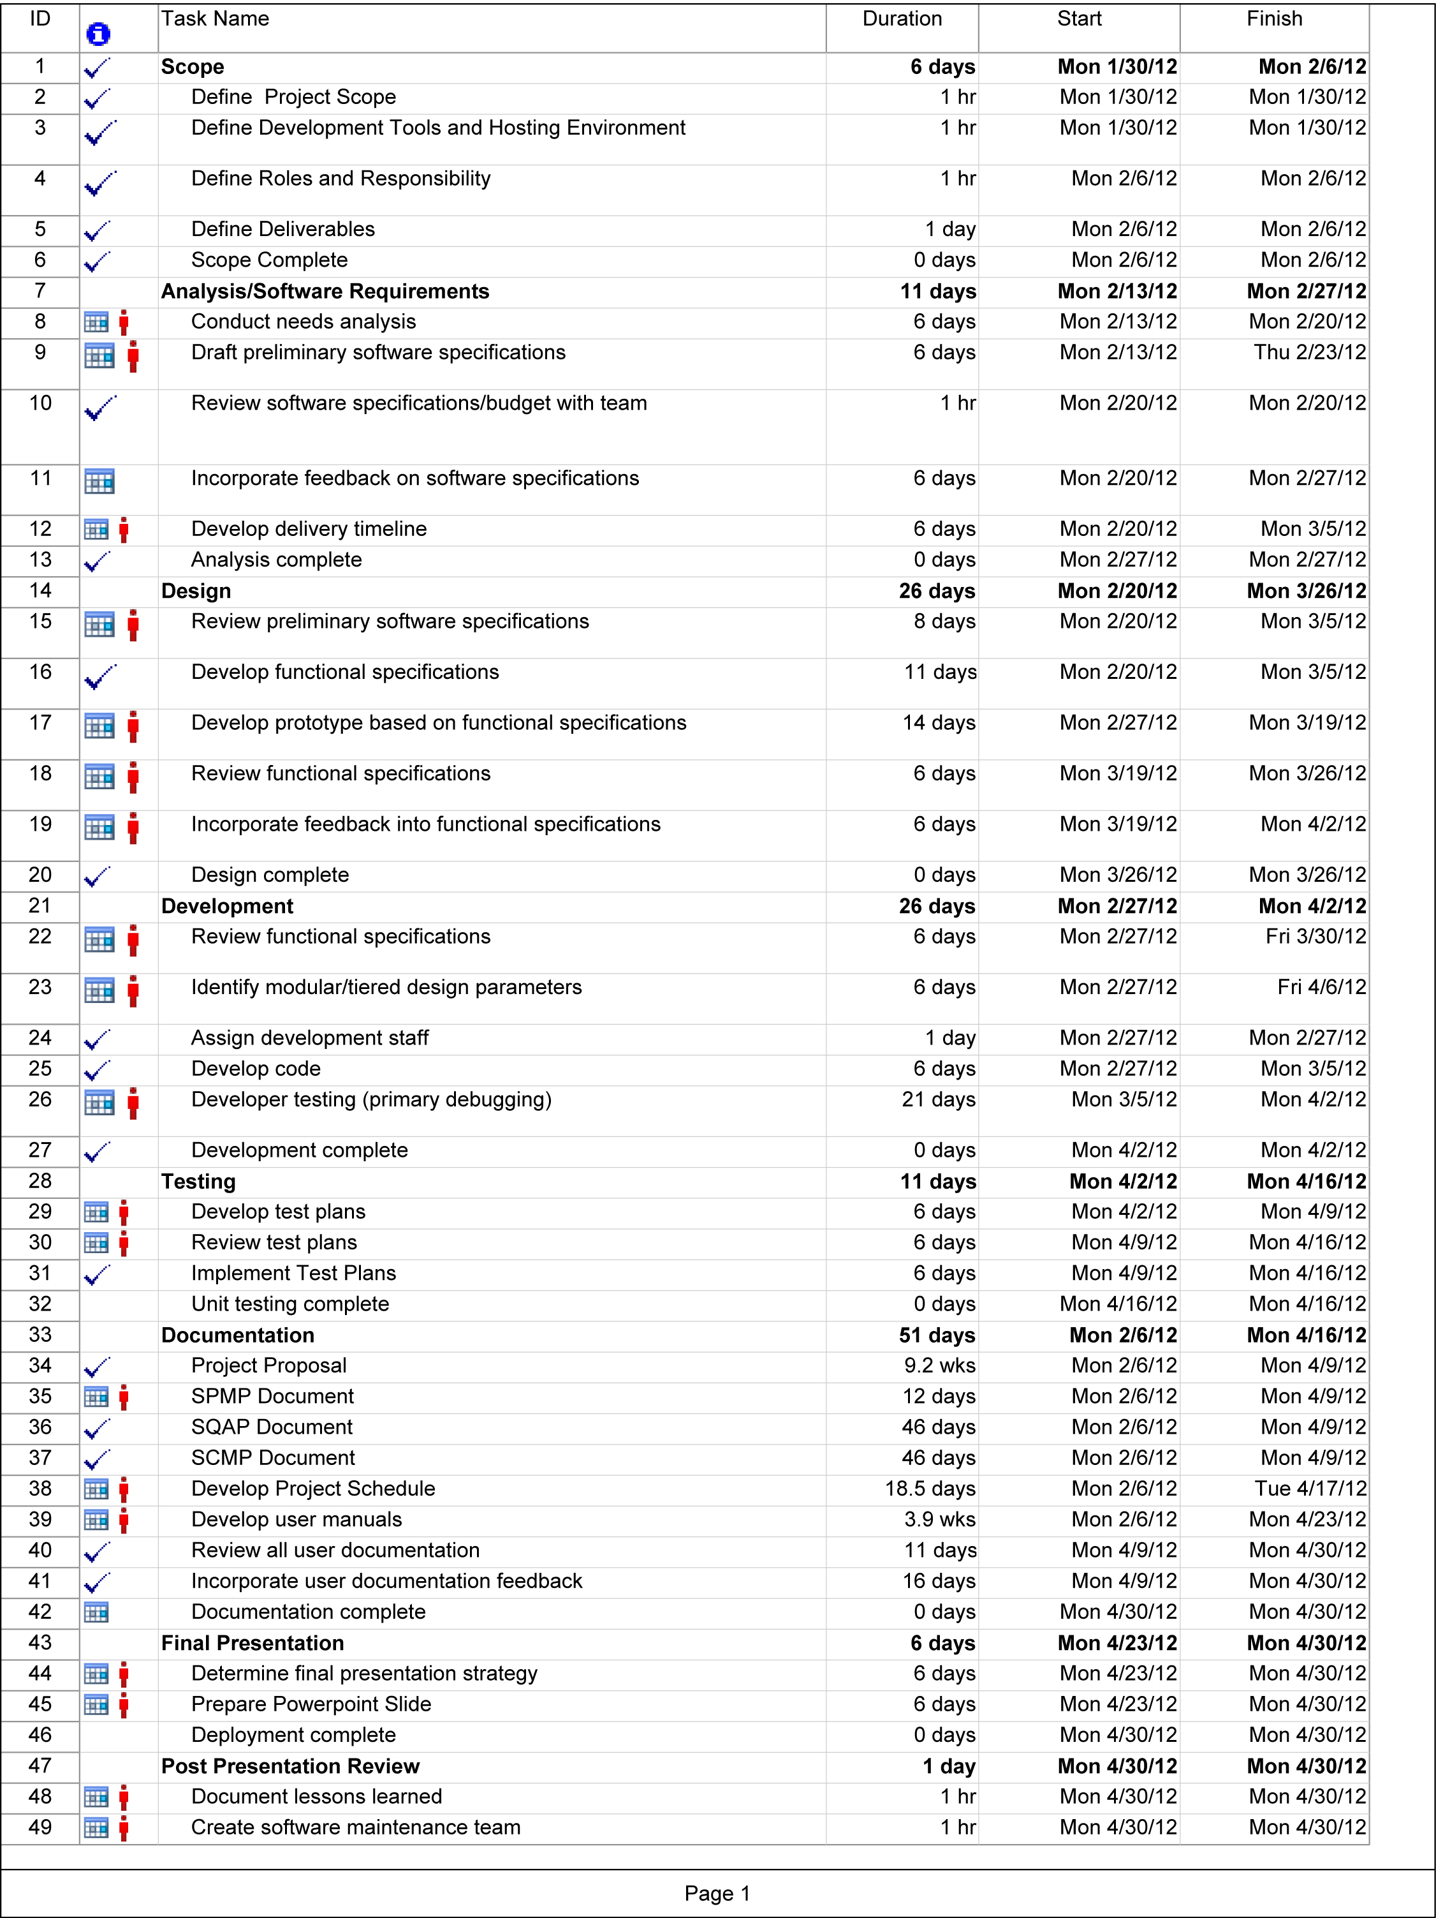
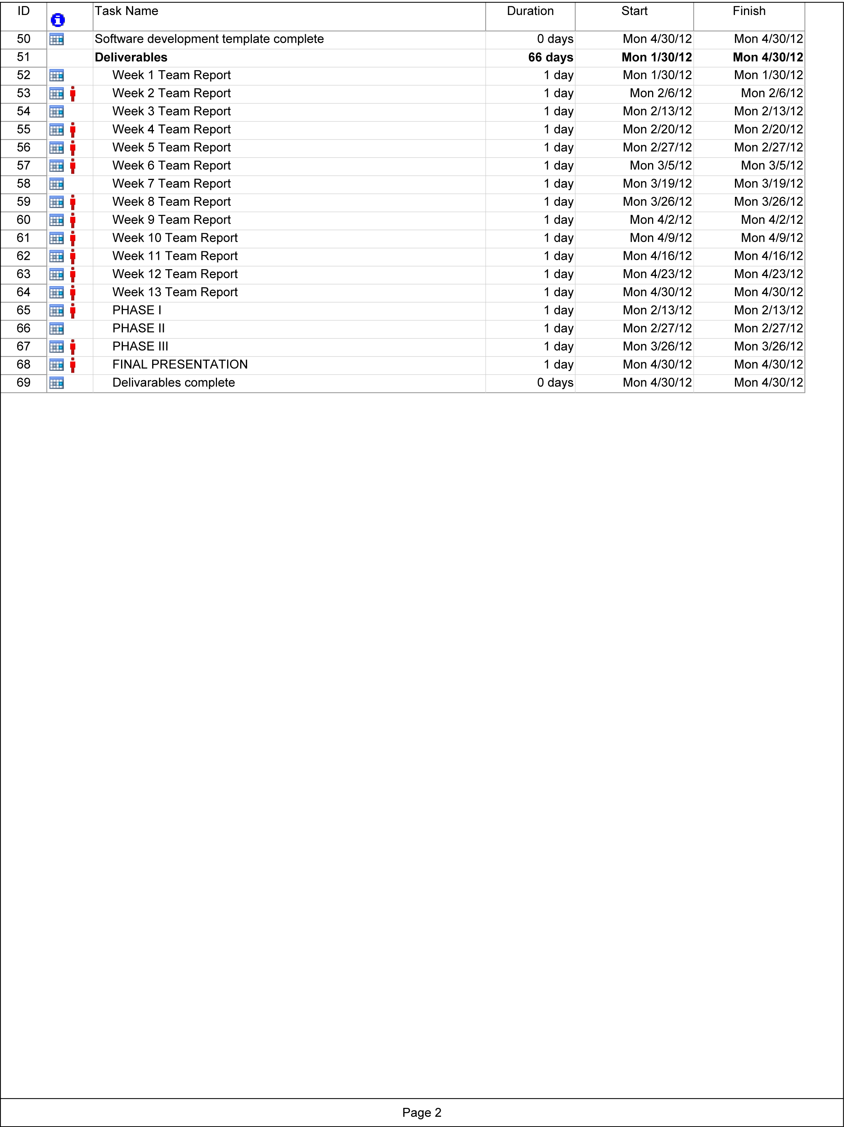

References

- Software Engineering: Modern Approaches / Eric J. Braude, Michael E. Bernstein, 2nd Ed. Wiley, 2011.

