### **🔹 Basic Level Questions**

1. What is hypothesis testing? Why is it important in data analysis?

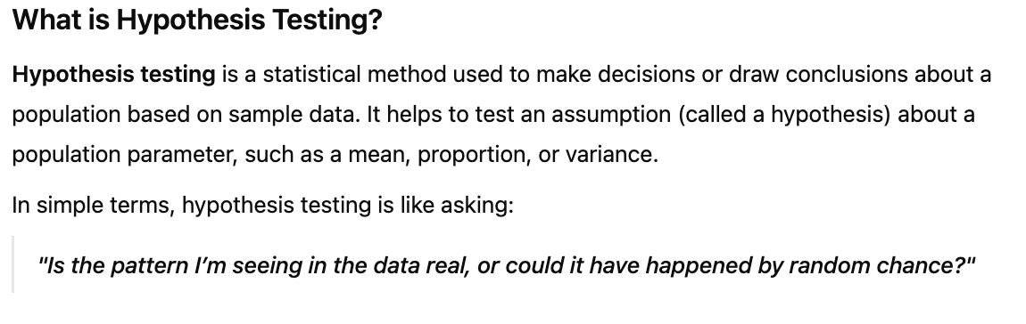

1. What are null and alternative hypotheses? Give examples.

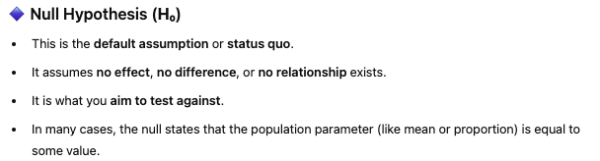

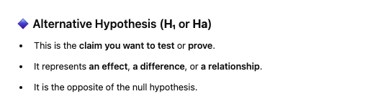

1. What is a p-value, and how do you interpret it?

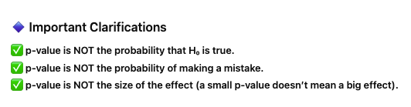

1. What is the significance level (α)? How do you choose it?
2. What are Type I and Type II errors? How do they differ?

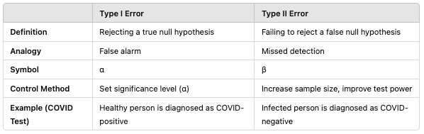

1. What is a one-tailed test vs. a two-tailed test? When would you use each?

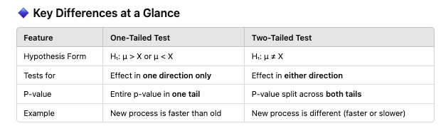

1. Can you explain the basic steps of performing a hypothesis test?

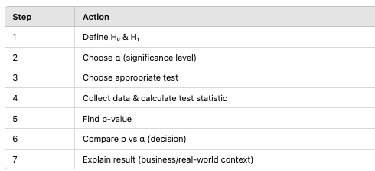

### **🔹 Intermediate Level Questions**

1. How do you decide which statistical test to use in hypothesis testing?
2. What is a t-test? When do you use it?
3. What is a z-test? How is it different from a t-test?
4. What are paired and unpaired t-tests? Examples?
5. Explain ANOVA — when would you use it instead of a t-test?
6. What is a chi-square test used for? Explain with an example.

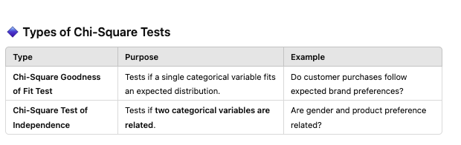

1. What assumptions are necessary for performing a t-test? What if those assumptions are violated?

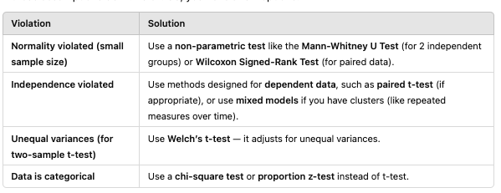

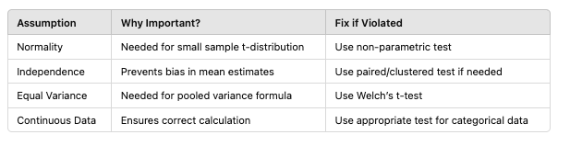

1. What does it mean if a test result is statistically significant but not practically significant?
2. What is the relationship between confidence intervals and hypothesis testing?

### **🔹 Advanced Level Questions**

1. How do you handle multiple hypothesis testing? What is the Bonferroni correction?
2. What is a non-parametric test? When would you use one instead of a parametric test?
3. Explain power of a test. How do you calculate it?
4. What factors affect the power of a hypothesis test?
5. What is Levene’s Test, and why is it important before ANOVA?
6. What is the difference between statistical significance and effect size?
7. Explain the concept of p-hacking and how to avoid it.
8. What is the difference between a hypothesis test and confidence interval approach to inference?
9. In A/B testing, what hypothesis test would you use to compare conversion rates between two groups?
10. How do you ensure your sample size is adequate for hypothesis testing?

### **🔹 Scenario-Based Questions (Real-World)**

1. You run an A/B test and get a p-value of 0.08. What does that mean, and what should you do?
2. In a clinical trial, you want to test if a new drug is better than the current one. Formulate null and alternative hypotheses and choose an appropriate test.
3. You are analyzing customer satisfaction scores (ordinal data) across 3 different branches of a store. What test will you use?
4. Your manager asks you to compare the average transaction amounts between two stores. Which test would you use, and why?
5. Your sample size is very small (n < 30), and you don’t know if the data is normally distributed. What test will you use?