TRIGGER EVENTS
Company Lead Finder
Summary of this week, and what Contour can give the tool
For Levi Young · From Al-khair Pama, AI Engineer · 24 October 2026
The Lead Finder is Contour’s first AI project. Every week it will find companies that fit Contour’s work and show signs they may need a new office. It sends them to you first, then to sales through HubSpot.
This file is the background. The questions for you are in the second file, QUESTIONS. Anything marked TBC is to be confirmed.

1. What we agreed this week
We met on 20, 21 and 23 October. These five decisions shape the tool.
- The Lead Finder comes first. Meeting prep is on hold until it’s running. (23 Oct)
- Claude does the research, not HubSpot’s built-in AI (Breeze). Breeze can’t research in depth and gives us little control over sources. (23 Oct)
- The tool looks outside HubSpot. HubSpot doesn’t show when a company is about to move. Contact history doesn’t help either, because a big fitout happens only once every 5 to 10 years. (23 Oct)
- It runs on its own server (DigitalOcean) with its own database. The database remembers every company, so sales never gets the same lead twice. (20 and 23 Oct)
- Results come by email and in HubSpot. Nobody needs a new login. (21 Oct)

2. How it will work
Once a week, without anyone pressing a button, the tool runs five steps for Melbourne, Adelaide and Perth.
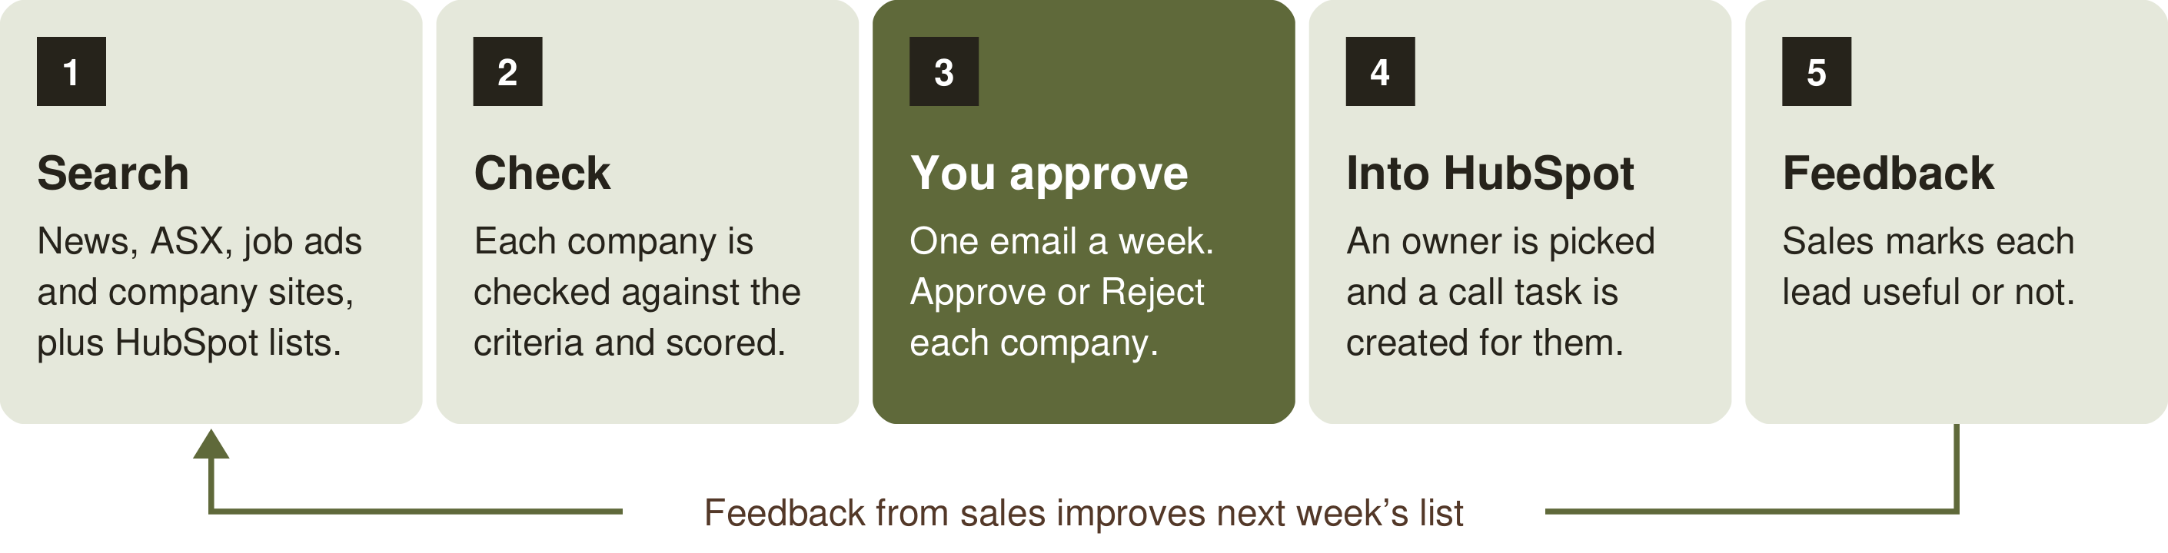
The check uses the company criteria in section 4, and the score puts newer, stronger signs first. Companies you approve are marked “AI suggested” in HubSpot. Nothing goes into HubSpot without your approval.

What a lead looks like
A made-up example of one company on the weekly list:
ABC Logistics, Perth
What happened Won a $200M contract last week. Hiring 120 office staff. (Link to the news story.)
Why it fits About 300 staff in Perth, in logistics. Result: Pass.
Estimated office 3,000 m², so a fitout of at least $4.5M.
Who to contact Head of Property or CFO
In HubSpot Not yet. New company.
Approve Reject

3. Claude’s view: what Contour can give the tool
You asked for Claude’s view on what Contour should provide to make the tool as deep as possible. I gave Claude our notes from this week. This is its answer, and I agree with it.
Searching the web is the easy part. What Claude can’t find is what Contour already knows.

Any AI tool can find a news story about a contract win. It can’t know which companies turned into good projects for Contour, what was happening at the time, or which signs turned out to matter. That knowledge is what will make this tool better than a general search.
The three things that would help most, in order:
- Past projects, won and lost. 10 to 20 past projects, with what was happening at each company when it first spoke to Contour. This shows the tool what a real lead looks like. It also gives us a fair test: would the tool have spotted those companies a year before they called?
- Numbers for each trigger. “Fast growth” and “big contract” have to become numbers before a program can use them. For example, 20% more staff in a year, or a contract over $50M. These are only examples, not Contour’s figures. Without real numbers the tool guesses, and the weekly list will be uneven.
- Lease data. A lease ending is the strongest trigger, and it’s rarely in the news. Property Daily has this data. You’ve sent me the logins, so I’m now checking what it includes and whether Property Daily lets a program read it.
Smaller things also help: which HubSpot lists to check, which competitors to watch, and what the team knows but hasn’t written down. They’re all in QUESTIONS.

4. Company criteria: our draft
Contour’s deal criteria (Option 2, Q4 2026) judge a project after Contour has met the client. The tool works earlier, before anyone calls, and it only has public information. So it needs company criteria: the parts of the deal criteria it can check from the outside.
You mentioned an official company criteria document on 20 Oct. If there is one, please send it and I’ll use it instead. Until then, this draft is what I’ll build on.
A company must pass two tests: it fits, and it has a trigger. Together they decide the result.
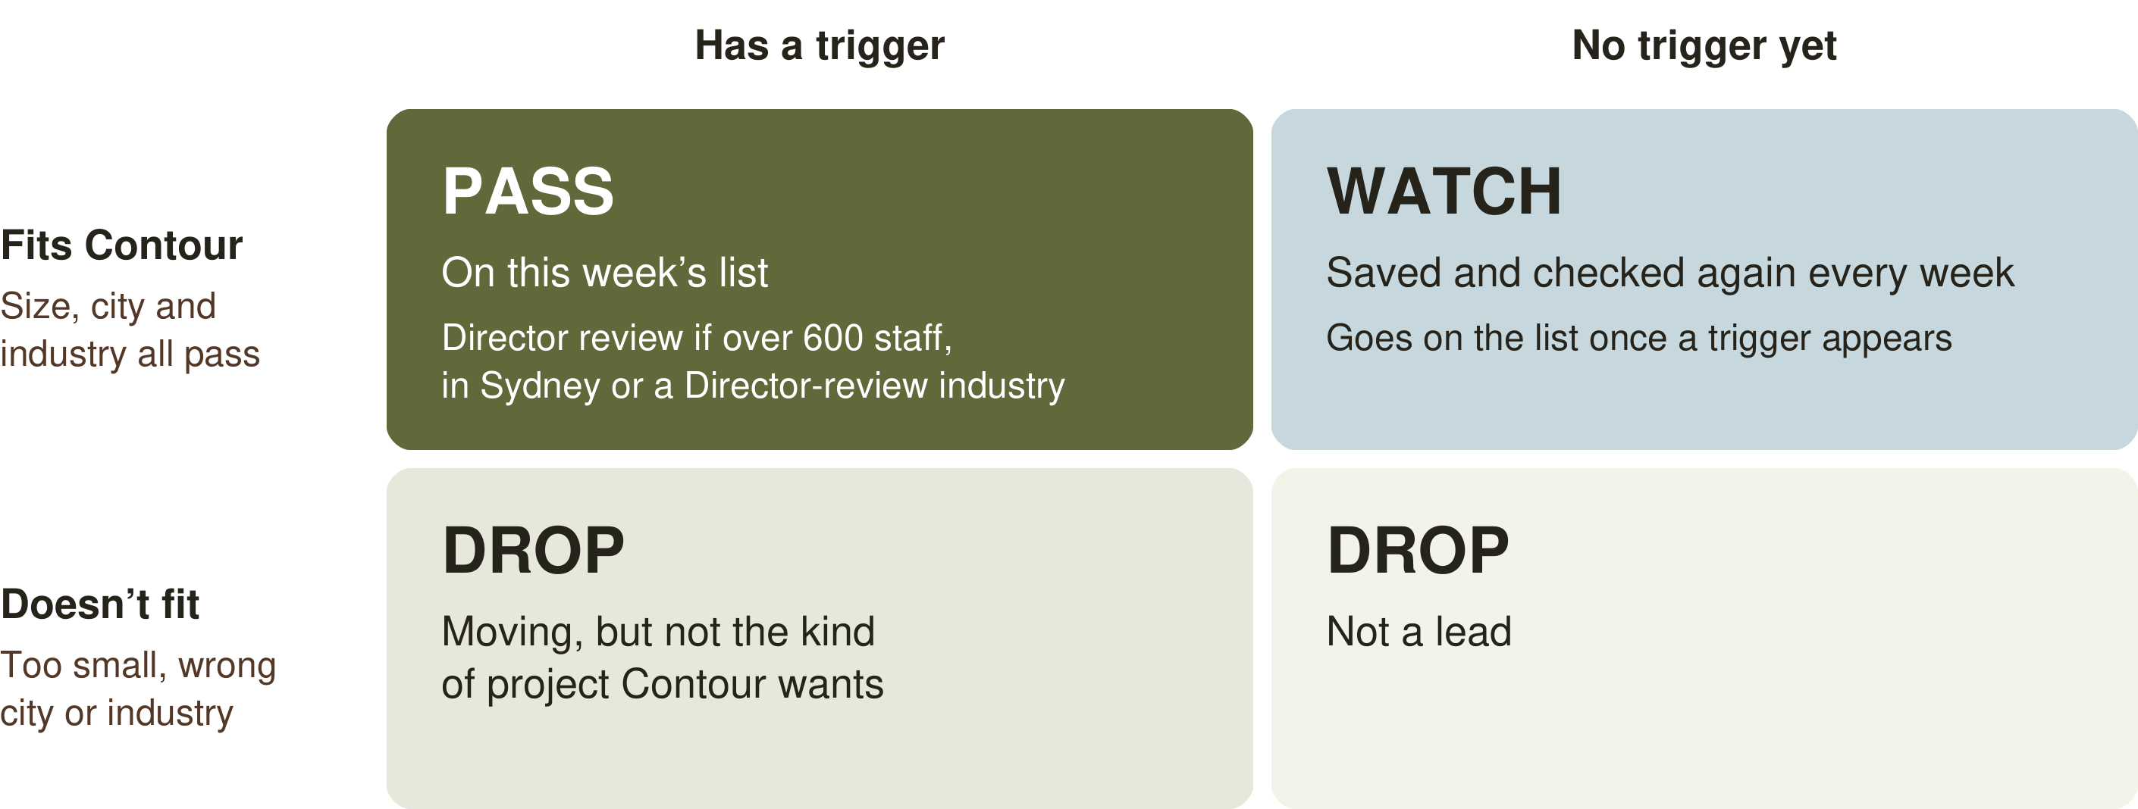
Director review covers companies over 600 staff (a possible Whale Pipeline project), in Sydney, or in these industries from the deal criteria: government, education, industry-associated consultants, legal (especially tier 1), premium banking and financial services, real estate agencies, standard not-for-profits, hospitals and direct healthcare providers.
Never suggested: companies already sent, companies with an open deal or active project in HubSpot, and anyone on a do-not-contact list.

Test 1: it fits
Rule | Passes if | Source
Staff | 100 to 600 staff in that city | Deal criteria and 23 Oct meeting
Office size | 1,000 to 6,000 m², estimated at 10 m² per person | Deal criteria
City | Melbourne, Adelaide or Perth | Deal criteria
Industry | The office matters to how they work: teamwork, clients, hiring | Deal criteria
Decides locally | Decisions are made in Australia, not by an overseas head office | Deal criteria (procurement)
Healthy | Not in administration, and not cutting staff | Our proposal (TBC)
Office-based | Most staff work in an office, not on sites or in shops | Our proposal (TBC)

Test 2: it has a trigger
A trigger is a sign the company may need a new office within 3 years.
Type | Triggers | Source
Main | A lease ending. A merger or takeover where one side has an older office. A big new contract needing about 100 more office staff. Fast growth. | You, 23 Oct
Other | Merging several offices into one. A return to office. A restructure. | Deal criteria
Weak | A new CEO or culture change. A hiring push to attract talent. These only add to the score. | Deal criteria

Timing matters too. The best window is probably 1 to 3 years before a move. Any closer and a consultant is likely already hired (TBC).

How the 11 deal rules carry over
Five deal rules can be checked directly from public information. Four can only be judged from clues. Two need a conversation, so sales checks them after the first call.
Deal rule | What the tool checks | Check
Size ($1.5M to $10M) | 100 to 600 staff in that city | Direct
Location | An office in Melbourne, Adelaide or Perth | Direct
Industry | Industry type. Director-review industries are flagged. | Direct
Procurement | Australian head office, or decisions made locally | Direct
Timing (within 3 years) | Date of the trigger, or a lease ending in 1 to 3 years | Direct
Need | A trigger from the list above | Clues
Likelihood (over 50%) | A strong source, or more than one trigger | Clues
Competition | No news of a fitout firm already appointed | Clues
Other red flags | A healthy company with no open deal in HubSpot | Clues
Decision makers | Suggests a role to contact, like CFO | Sales
Early engagement | Can’t be seen from outside | Sales

The numbers line up. 100 staff × 10 m² is 1,000 m², and at $1,500 per m² that’s $1.5M, the bottom of the deal range. 600 staff × 10 m² is 6,000 m², the top of the range. So the 600-staff Director limit matches the deal criteria.

What the tool works out for each company
Estimate | How
Office size | Staff × 10 m²
Fitout value | Office size × $1,500 per m², the minimum rate in the deal criteria. For example, 300 staff → 3,000 m² → at least $4.5M.
Move window | From the trigger date or the lease end date
Who to contact | A role, like CFO or Head of Property. Names can come later.
How sure it is | Every fact is marked confirmed, estimated or guessed, with a source link

5. Tools and hosting
Version 1 needs four tools. Property Daily is sorted. The other three need a yes from you, in QUESTIONS section 1.
Tool | What it does | Status
Claude API | Does the research and writes each lead card | Not set up yet
HubSpot | Holds the leads. Its workflows pick an owner, create call tasks and notify sales. | Not set up yet  View only today
DigitalOcean | Runs the weekly program and its database | Needs your OK
Property Daily | Lease end dates, the strongest trigger | Done  Logins received. Checking its terms.

More tools later, one step at a time
We’re building this in steps, so the tool list will grow with the project. Version 1 starts with the four tools above. I’ll put others forward one at a time. Each one comes to you with its cost and the reason, once a test shows we need it. Starting small keeps the cost down and makes problems easier to find.
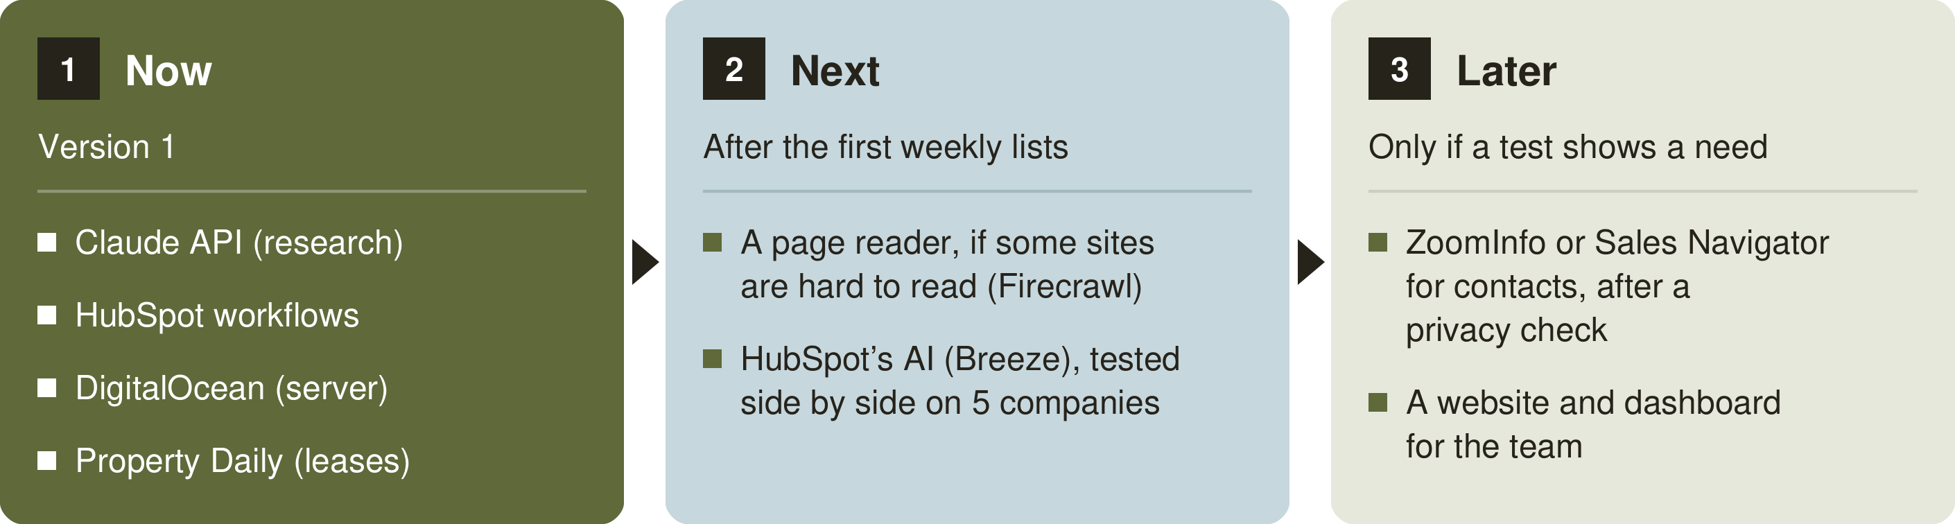

Claude API
- The Claude API lets a program use Claude, instead of a person typing in the chat window. It’s separate from the Claude chat plan, set up in the Claude Console and billed by use.
- The Console has a monthly spending limit on its Billing page. If the tool reaches it, it stops until the next month, so it can’t overspend.

DigitalOcean and hosting
- I’ll open the account with my Contour email and add you or IT as a team member, so Contour always has access. I’ll send you the invoice each month for reimbursement. Billing can move to a company card later.
- No other hosting is needed. If we later build a website for the team, for example to search past leads or see a dashboard, it can run on the same account.
- DigitalOcean has a Sydney data centre, so the tool and its data can stay in Australia.

Data
The tool sends Claude company names and public information. It doesn’t need client contacts or deal notes. Claude runs on Anthropic’s servers, so I’d like your OK before any HubSpot data goes in (QUESTIONS section 1).

6. Next steps
Who | What
You | Answer QUESTIONS, starting with section 1 and the top 5.
You | Arrange HubSpot access and the Claude API account.
Me | Open DigitalOcean once you’re happy with it. Check Property Daily’s terms.
Me | Run a test by hand: search the last 30 days in all three cities, check each company against the criteria, and count the real leads. This shows the idea works before we build.
Me | Build version 1 and send you the first weekly list. The timing depends on when the accounts are ready.
Happy to go through any of this on a call if that’s quicker.
Al-khair

