Can we predict canopy temperature of cotton using weather variables?

Hiz jamali

11 October 2018

## Introduction

Canopy temperature (Tc) is a direct measurement of the energy release by a plant in surface energy flux and an indirect but important indicator for the water status of a plant via its inverse relation to transpiration and stomatal conductance (Jones, 1999). Indeed, continuous measurements of canopy temperature can help identify crop stress (Jackson, 1982; Peñuelas et al., 1992; Patel et al., 2001) and the need for irrigation to optimise growth and yield in crops, since the closure of stomata increases canopy temperature (Brown and Escombe, 1905, reviewed by Guilioni et al., 2008). Continuous measurement of canopy temperature is an important indicator of plant water status of crops and the ability to predict canopy temperature will assist in the implementation of this technology for guiding crop irrigation scheduling. By noting that canopy temperature is related to its environmental weather variables which change over time of the day and have different effect or contribution to canopy temperature, this paper presents a simple probabilistic model to predict canopy temperature by using weather variables which can be obtained from weather model predictions. These models can be used to predict canopy temperature into the near future that can be linked to strategies utilising continuous canopy temperature sensing for irrigation scheduling in cropping systems.

## Materials and methods

This study utilises canopy temperature data from 4 sensors collected in either fully irrigated or partially irrigated cotton experiments at Narrabri, New South Wales, Australia. The data were leaf surface temperatures measured by wireless, infrared canopy temperature sensor (ArduCrop, CSIRO, Canberra, ACT, Australia) positioned at approximately 20 – 30 cm above the crop canopy during the season. Data was collected at 5 minutes intervals from 21 December 2015 0:00 to 22 March 2016 23:45. However, weather data was collected only at hourly scale from the Australian Bureau of Meteorology (<http://bom.gov.au>). Canopy temperature data was averaged to 15 minute time intervals.

Data was downloaded from the collection " Cotton Canopy Temperature" from CSIRO’s Data Access Portal using this link:

<https://doi.org/10.25919/5badc8df1cd5f>

## Data visualization

### Weather

Weather data included the varibales shown in table below:

## datetime Year Day Hour maxAT minAT maxST minST maxRH minRH WS  
## 1 1/01/2015 1:00 2015 1 100 20.20 18.68 26.81 26.08 55.73 48.15 0.056  
## 2 1/01/2015 2:00 2015 1 200 19.69 19.18 26.13 25.52 62.37 50.04 0.242  
## 3 1/01/2015 3:00 2015 1 300 20.61 18.98 25.56 25.07 71.30 61.28 0.144  
## 4 1/01/2015 4:00 2015 1 400 23.68 20.50 25.14 24.80 73.70 66.22 5.482  
## 5 1/01/2015 5:00 2015 1 500 23.61 23.07 24.85 24.67 67.74 66.15 5.696  
## 6 1/01/2015 6:00 2015 1 600 23.91 22.73 24.75 24.55 68.82 65.50 5.559  
## WD MaxWS solar_rad rain tot_rain  
## 1 SE (134°) 5.85 0.000 0 142  
## 2 ESE (108°) 6.93 0.000 0 142  
## 3 E (91°) 7.20 0.000 0 142  
## 4 NE (55°) 15.30 0.000 0 142  
## 5 NE (52°) 13.14 0.001 0 142  
## 6 NE (40°) 14.22 0.177 0 142

### Canopy temperature

Canopy temperature files were in csv format with three columns and a header as shown below:

## # A tibble: 6 x 3  
## ID datetime canopytemp  
## <chr> <dttm> <dbl>  
## 1 2015_ACRI_LW_3 2015-12-22 08:35:00 25.4  
## 2 2015_ACRI_LW_3 2015-12-22 08:40:00 25.4  
## 3 2015_ACRI_LW_3 2015-12-22 08:55:00 27.2  
## 4 2015_ACRI_LW_3 2015-12-22 09:00:00 30.5  
## 5 2015_ACRI_LW_3 2015-12-22 09:05:00 30.3  
## 6 2015_ACRI_LW_3 2015-12-22 09:10:00 30.1

### Combining weather and canopy temperature data

To create a new dataframe with only required data, the columns ID, datetime, Year, Day, Hour and canopytemp were selecetd from the sensor_extract df abd columns Year, Day, Hour, meanAT, meanRH, WS, solar_rad and rain were selected from weather df as below:

## # A tibble: 6 x 11  
## ID datetime Year Day Hour canopytemp meanAT meanRH  
## <chr> <dttm> <dbl> <dbl> <int> <dbl> <dbl> <dbl>  
## 1 2015_ACR~ 2015-12-22 08:45:00 2015 356 8 25.4 26.5 50.1  
## 2 2015_ACR~ 2015-12-22 09:00:00 2015 356 9 28.8 27.9 46.6  
## 3 2015_ACR~ 2015-12-22 09:15:00 2015 356 9 30.2 27.9 46.6  
## 4 2015_ACR~ 2015-12-22 09:30:00 2015 356 9 29.9 27.9 46.6  
## 5 2015_ACR~ 2015-12-22 09:45:00 2015 356 9 33.1 27.9 46.6  
## 6 2015_ACR~ 2015-12-22 10:00:00 2015 356 10 33.7 29.5 43.4  
## # ... with 3 more variables: WS <dbl>, solar_rad <dbl>, rain <dbl>

### Plotting canopy temperature data

To get an idea of the quality fo data and potential relationships between weather variables and canopy temperature 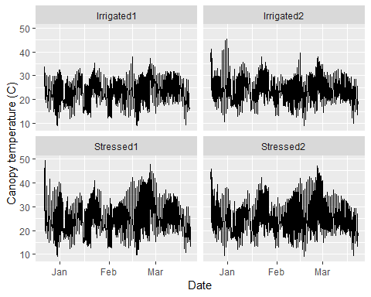 ### Box plot

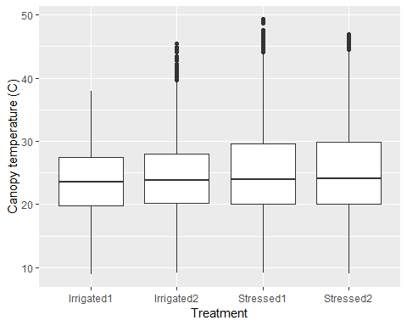

Above figures show that: 1) Higher canopy temperature values in December are likely because of smaller canopy resulting in feedback from background soil which is hotter that plants. This data should be excluded for any future analyses.

1. Canopy temperature is higher in stressed plants compared with irrigated plants especially in late February and March which may influence the relationship between weather variables and canopy temperature.

### Plotting weather data

### Air temperature

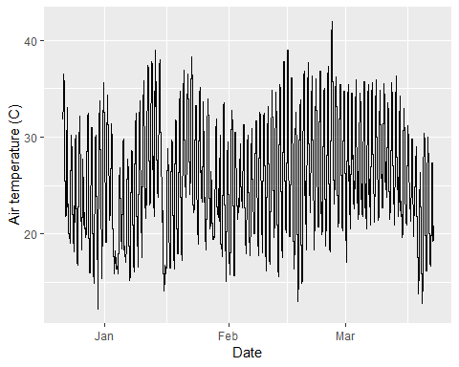 ### Regressions: Air temperature vs canopy temperture

The figures below confirm that at higher air temperatures the canopy temperature of irrigated plants remained < 40 degrees while stressed plants heated up to 45 degrees. It might be necessary to build separate prediction models for stressed and well watered crops for accurate prediction.

## Warning: Removed 28 rows containing missing values (geom_point).

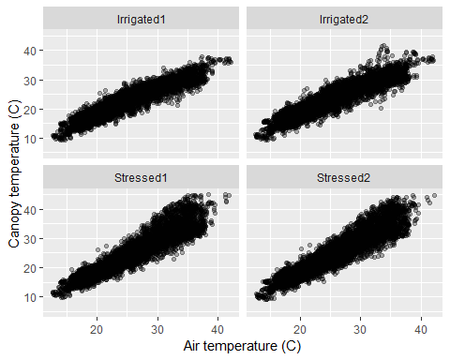

### Regressions: meanRH vs canopy temperture

There seems a negative correlation between relative humidity and canopy temperature. This is expected as higher humidity results in reduced evapotranspiration and affecting plants ability to cool down. RH is a good candidate for predictive model.

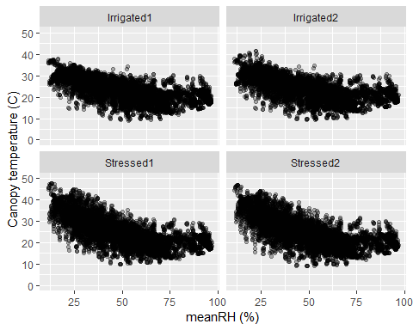

### Regressions: Wind speed vs canopy temperture

Wind speed does not seem a strong candidate for canopy temperature prediction model 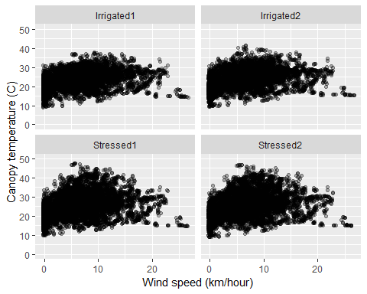 ### Regressions: Solar radiation vs canopy temperture Solar radiation seems to have a similar relationship as air temperature. The slope of the regression is flatter for irrigated crops and steeper for stressed crops because of latter’s inability to cool due to lacl of water availability. However, given air temperature is driven by solar radiation, it may or may not be work including both soalr radiation and air temperature in the model. 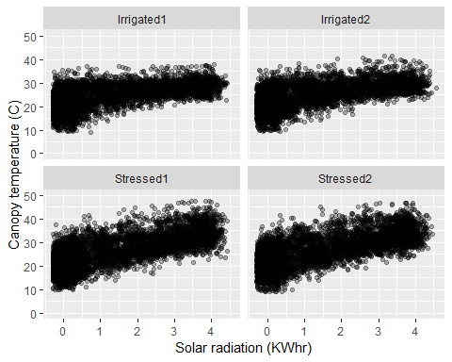

### Regressions: Solar radiation vs canopy temperture

Does solar radiation drive air temperature? Of course it does. 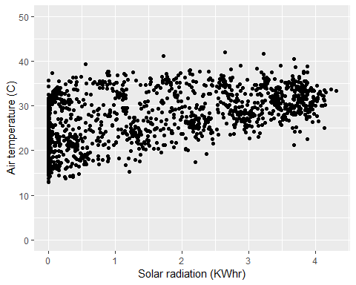

## Statistical Analyses

1. Best variables for predicting canopy temperature
2. Do we different models to predict canopy temperature of irrigated and water stressed crop?

### lm

## Analysis of Variance Table  
##   
## Response: canopytemp  
## Df Sum Sq Mean Sq F value Pr(>F)   
## meanAT 1 1070701 1070701 181946 < 2.2e-16 ***  
## ID 3 16083 5361 911 < 2.2e-16 ***  
## Residuals 35104 206577 6   
## ---  
## Signif. codes: 0 '***' 0.001 '**' 0.01 '*' 0.05 '.' 0.1 ' ' 1

##   
## Call:  
## lm(formula = canopytemp ~ meanAT + ID, data = canopy_weather)  
##   
## Residuals:  
## Min 1Q Median 3Q Max   
## -11.288 -1.475 -0.027 1.278 19.357   
##   
## Coefficients:  
## Estimate Std. Error t value Pr(>|t|)   
## (Intercept) -1.521678 0.064120 -23.73 <2e-16 ***  
## meanAT 0.975252 0.002287 426.48 <2e-16 ***  
## IDIrrigated2 0.570461 0.036676 15.55 <2e-16 ***  
## IDStressed1 1.560346 0.036757 42.45 <2e-16 ***  
## IDStressed2 1.599923 0.036672 43.63 <2e-16 ***  
## ---  
## Signif. codes: 0 '***' 0.001 '**' 0.01 '*' 0.05 '.' 0.1 ' ' 1  
##   
## Residual standard error: 2.426 on 35104 degrees of freedom  
## Multiple R-squared: 0.8403, Adjusted R-squared: 0.8403   
## F-statistic: 4.617e+04 on 4 and 35104 DF, p-value: < 2.2e-16

### lmer

## Type III Analysis of Variance Table with Satterthwaite's method  
## Sum Sq Mean Sq NumDF DenDF F value Pr(>F)   
## meanAT 323631 323631 1 35101 82067.4 < 2.2e-16 ***  
## meanRH 16824 16824 1 35101 4266.3 < 2.2e-16 ***  
## solar_rad 30768 30768 1 35101 7802.3 < 2.2e-16 ***  
## WS 8674 8674 1 35101 2199.5 < 2.2e-16 ***  
## ---  
## Signif. codes: 0 '***' 0.001 '**' 0.01 '*' 0.05 '.' 0.1 ' ' 1

## Linear mixed model fit by REML. t-tests use Satterthwaite's method [  
## lmerModLmerTest]  
## Formula: canopytemp ~ meanAT + meanRH + solar_rad + WS + (1 | ID)  
## Data: canopy_weather  
##   
## REML criterion at convergence: 147871.7  
##   
## Scaled residuals:   
## Min 1Q Median 3Q Max   
## -4.3886 -0.5963 -0.0414 0.5159 8.9859   
##   
## Random effects:  
## Groups Name Variance Std.Dev.  
## ID (Intercept) 0.6191 0.7868   
## Residual 3.9435 1.9858   
## Number of obs: 35109, groups: ID, 4  
##   
## Fixed effects:  
## Estimate Std. Error df t value Pr(>|t|)   
## (Intercept) -5.357e+00 4.117e-01 3.595e+00 -13.01 0.000375 ***  
## meanAT 9.894e-01 3.454e-03 3.510e+04 286.47 < 2e-16 ***  
## meanRH 5.625e-02 8.611e-04 3.510e+04 65.32 < 2e-16 ***  
## solar_rad 8.781e-01 9.941e-03 3.510e+04 88.33 < 2e-16 ***  
## WS 1.003e-01 2.138e-03 3.510e+04 46.90 < 2e-16 ***  
## ---  
## Signif. codes: 0 '***' 0.001 '**' 0.01 '*' 0.05 '.' 0.1 ' ' 1  
##   
## Correlation of Fixed Effects:  
## (Intr) meanAT meanRH slr_rd  
## meanAT -0.280   
## meanRH -0.262 0.733   
## solar_rad 0.069 -0.399 -0.010   
## WS -0.031 0.004 0.028 -0.267

