HW2

1.副函式:

function xNew = myFindNextPos2(A,x,delt)

x_dot = zeros(size(x))

xNew = x_dot;

x_dot = A*x

xNew = x + x_dot*delt;

return;

end

2.主函式:

基本設定:

clc;clear;

n=1+0+5+3+0+3+0+6+1;

a = fix(n/10);

b = rem(n,10);

HW2-1:測試控制器

A = [0, 1;-a, b]

B= [ 0 1];

s = conv([1 2*a-(a+b)*i],[1 2*a+(a+b)*i])%設定極點

k1 = s(3)+A(2,1);

k2 = s(2)+A(2,2);

K = [k1 k2];

A_BK = A - B'*K

delt = 0.0008;

x1 = [2 2]'%起點1

x1arr1 = [0,0,0,0]'; x1arr2 = x1arr1; x1arr1(1) = x1(1);

x1arr2(1) = x1(2);

x2 = [-2 -2]'%起點2

x2arr1 = [0,0,0,0]'; x2arr2 = x1arr1; x2arr1(1) = x2(1);

x2arr2(1) = x2(2);

for i=1:10000

xN1 = myFindNextPos2(A_BK,x1,delt);

xN2 = myFindNextPos2(A_BK,x2,delt);

x1arr1(i+1) = xN1(1);

x1arr2(i+1) = xN1(2);

x2arr1(i+1) = xN2(1);

x2arr2(i+1) = xN2(2);

x1 = xN1;

x2 = xN2;

end

figure(1);

plot(x1arr1,x1arr2,'b',x2arr1,x2arr2,'r');

hold on;

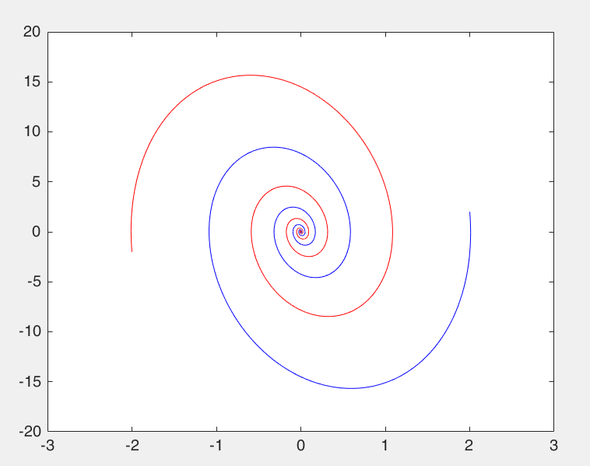

HW2-2: 設計控制器

A = [1 -2*a b];

B = [1 -4];

G = tf(B,A);

s = conv(conv([1 a+1],[1 a+2]),[1 a+3]);

%整理後tmp = [a0 b0 b1]

tmp = ([1 1 0;-2 -4 1;9 0 -4]\[s(2)+2;s(3)-9;s(4)])

S = [tmp(2) tmp(3)];

R = [1 tmp(1)];

C = tf(S,R)

num = conv(B,S)

den = conv(A,R)+conv([0 1],conv(B,S))

sys = tf(num,den)

rlocus(sys)

[A,B,C,D] = tf2ss(num,den)

delt = 0.0008;

x1 = [2 2 2]'%起點1

x1arr1 = [0,0,0,0]'; %x

x1arr2 = x1arr1; %y

x1arr3 = x1arr1; %z

x1arr1(1) = x1(1);

x1arr2(1) = x1(2);

x1arr3(1) = x1(3);

x2 = [-2 -2 -2]'%起點2

x2arr1 = [0,0,0,0]'; %x

x2arr2 = x2arr1; %y

x2arr3 = x2arr1; %z

x2arr1(1) = x2(1);

x2arr2(1) = x2(2);

x2arr3(1) = x2(3);

for i=1:5000

xN1 = myFindNextPos2(A,x1,delt);

xN2 = myFindNextPos2(A,x2,delt);

x1arr1(i+1) = xN1(1);

x1arr2(i+1) = xN1(2);

x1arr3(i+1) = xN1(3);

x2arr1(i+1) = xN2(1);

x2arr2(i+1) = xN2(2);

x2arr3(i+1) = xN2(3);

x1 = xN1;

x2 = xN2;

end

figure(1);

plot3(x1arr1,x1arr2,x1arr3,'b',x2arr1,x2arr2,x2arr3,'r');

hold on;

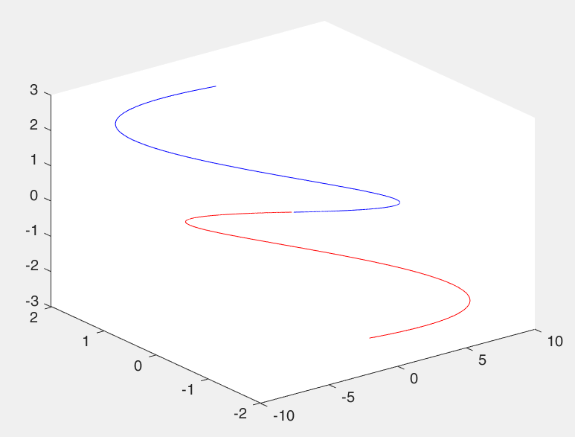

HW2-3: J (cost function)

A = [0, 1;-a, b];

B= [ 0 1];

Q = eye(2);

R = 1;

syms p11 p12 p22;

P = [p11 p12;p12 p22];

A_t = A'

B_t = B'

eq = A_t*P + P*A - P*B_t*R*B*P + Q

[p11,p12,p22] = solve(eq);

for i = 1:4

P = double([p11(i) p12(i);p12(i) p22(i)])

K = inv(R).*(B*P)

end

[k,p] = lqr(A,B',Q,R)

J = [2 2]*P*[2 2]'

[K1,P1] = lqr(A,B,Q,R)

x1 = [2 2]'

x2 = x1

x3 = x1

delt = 0.008

%optimal solution控制

J_init1 = x1'*P1*x1

%P2控制隨意帶入(需找可使系統穩定的控制器)

P2 = [1.81,9;9,10];

K2 = inv(R)*B'*P2

J_init2 = x2'*P2*x2

%P3控制隨意帶入(需找可使系統穩定的控制器)

P3 = [1,0;0,15];

K3 = inv(R)*B'*P3

J_init3 = x3'*P3*x3

A_BK = A-B*K1

A_BK2 = A-B*K2

A_BK3 = A-B*K3

for i=1:4000

t(i) = i;

xN1 = myFindNextPos2(A_BK,x1,delt);

xN2 = myFindNextPos2(A_BK2,x2,delt);

xN3 = myFindNextPos2(A_BK3,x3,delt);

x1 = xN1;

x2 = xN2;

x3 = xN3;

%最佳化

J(i) = J_init1 - x1'*P1*x1

%隨意設

J2(i) = J_init2 - x2'*P2*x2

J3(i) = J_init3 - x3'*P3*x3

end

figure(1);

plot(t,J,'b',t,J2,'r',t,J3,'g');

legend('optimal solution','K2 = [0.9 10]','K3 = [0 13]')

有四組solution:

p = k =

21.8708 0.4142 0.4142 18.1010

0.4142 18.1010

p = k =

-3.8708 0.4142 0.4142 -0.1010

0.4142 -0.1010

p = k =

-3.4235 -2.4142 -2.4142 17.7847

-2.4142 17.7847

p = k =

21.4235 -2.4142 -2.4142 0.2153

-2.4142 0.2153

其中 p11>0 & p22>0

所以solution 為

p = k =

21.8708 0.4142 0.4142 18.1010

0.4142 18.1010

以lqr驗證得到相同解

P1 = K1=

21.8708 0.4142 0.4142 18.1010

0.4142 18.1010

