**HW5**

**1)**

x1_dot = x2

x2_dot = x3

x3_dot = alpha(x1^2*sinx2 + x2^2*sinx3)+(x1+x3^2)*cosx3 + u(t) +d(t)

alpha = 1 ± 0.1

|d(t)| <=0.2

**使用線性回饋的sliding mode control 修正**

假設 s = A*x3 + B*x2 + C*x3 (A,B可以決定狀態彎曲程度)

本處另 B=4、 C=20 ( 固定A = 1 )

可以使系統打在(D^2+4*D+20)*x1=0的平面後進行收斂，並且由於此平面的eigen value為 -2±4i ，所以會以旋轉向原點收斂。

當 s_dot >1

k = K;

當 s_dot <-1

k = -K;

當 1>=s_dot>=-1

k = K*s;

ux = A*( x3_dot) - (B*( x2_dot) + C*( x1_dot) +k);

但是由於系統有震盪誤差，所以當K的值沒有大於可以收斂邊緣很多的話，會不易觀測出系統跑入平面的感覺，這是因為收斂不夠快，無法快速壓制誤差。

經測試: 550<x<1730 or 3985<x:收斂 3985>x>1730 or 550>x:發散

|  |  |  |
| --- | --- | --- |
|  | K = 550 | K = 5000 |
| 狀態空間 |  |  |
| 能量因子隨時間變化 |  |  |
| 狀態收斂 |  |  |

**主程式:**

%% main code

% k:const.

K = 5000;

delt = 0.0001;

totTime = 10;

totalStep = totTime/delt ;

tarr= [0 : 1 : totalStep]*delt;

x = [0 4 0]'

xarr1 = zeros(totalStep+1,1);xarr2 = xarr1;xarr3 = xarr1;

xarr1(1) = x(1);xarr2(1) = x(2);xarr3(1) = x(3);

x_1 = xarr1(1);x_2 = xarr2(1);x_3 = xarr3(1);

Bx = [0;0;1];

for i=1:totalStep

%get random of alpha, the range is 1~1.1

alpha = 1 + rand*0.1;

tmp1 = (alpha*x_1*sin(x_2)+cos(x_3));

tmp2 = (alpha*x_2*sin(x_3));

tmp3 = (x_3^2*cos(x_3));

Ax = [ 0 1 0;

0 0 1;

tmp1 tmp2 tmp3

];

A = 1;

B = 4;

C = 20;

s = A*x_3 + B*x_2 + C*x_1;

if s>0

if s>=1

k = K;

else

k = K*s;

end

else

if s<=-1

k = -1*K;

else

k = K*s;

end

end

ss(i+1) = s;

kk(i+1) = k;

ux = A*(tmp1*x_1 + tmp2*x_2 + tmp3*x_3) - (B*(x_3) + C*(x_2) +k);

if ux>2200

ux = 2200;

elseif ux<-2200

ux = -2200;

end

uu(i+1) = ux;

xNew = zeros(size(x));

ut = Bx*ux;

dt = 0.4*rand()-0.2;

x_dot = Ax*x + ut + dt;

xNew = x + x_dot*delt;

xN = xNew;

xarr1(i+1) = xN(1);xarr2(i+1) = xN(2);xarr3(i+1) = xN(3);

x = xN;

x_1 = xN(1);x_2 = xN(2);x_3 = xN(3);

end

figure(1);plot(tarr,xarr1,'-r',tarr,xarr2,'-g',tarr,xarr3,'-b');legend('x1','x2','x3');

xlabel('Time');ylabel('x');

figure(2)

plot3(xarr1,xarr2,xarr3,'-b');hold on;

plot3(xarr1(1),xarr2(1),xarr3(1),'o',xarr1(i+1),xarr2(i+1),xarr3(i+1),'x');

xlabel('x1');ylabel('x2');zlabel('x3');

figure(3)

subplot(3,1,1);

plot(tarr,uu,'-b');

xlabel('Time');ylabel('u');

subplot(3,1,2);

plot(tarr,kk,'-b');

xlabel('Time');ylabel('k');

subplot(3,1,3);

one = ones(1,totalStep+1);

minusone = -1*ones(1,totalStep+1);

plot(tarr,ss,'-b',tarr,one,'g',tarr,minusone,'g');

legend('s','up layer','low layer');

xlabel('Time');ylabel('s');

figure(4)

subplot(3,1,1);

plot(xarr1,xarr2,'-b');hold on;

plot(xarr1(1),xarr2(1),'o',xarr1(i+1),xarr2(i+1),'x');

xlabel('x1');ylabel('x2');

subplot(3,1,2);

plot(xarr2,xarr3,'-b');hold on;

plot(xarr2(1),xarr3(1),'o',xarr2(i+1),xarr3(i+1),'x');

xlabel('x2');ylabel('x3');

subplot(3,1,3);

plot(xarr1,xarr3,'-b');hold on;

plot(xarr1(1),xarr3(1),'o',xarr1(i+1),xarr3(i+1),'x');

xlabel('x1');ylabel('x3');

**2)**

在in time疊代運算，資料會與前面時間資料積分。

在on time的初始M_hat 設定為 0去計算誤差值，並且疊代運算，資料會與上一筆質量資料有關。

會取最後一筆資料作為估算值:

m1 = 1.8898

m2 = 1.8800

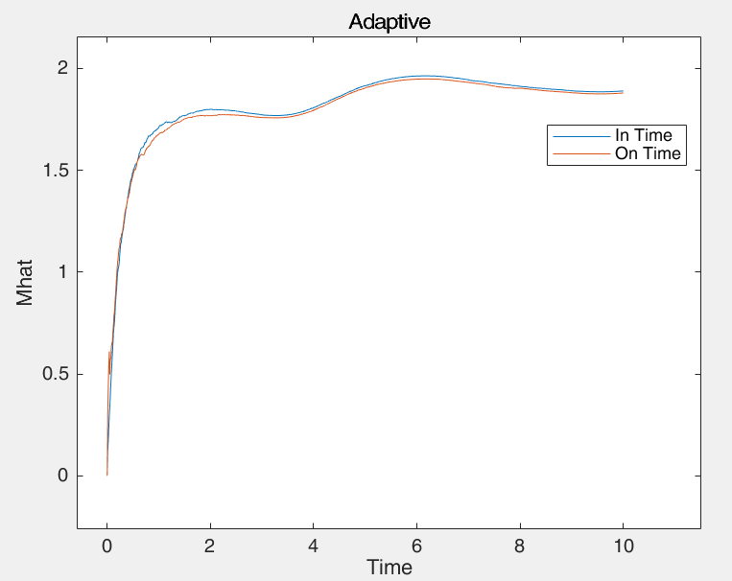

**主程式:**

%% main code

%Set M0 = 2

m0 = 2;

delt = 0.01;

totTime = 10;

totalStep = totTime/delt ;

tarr= [0 : 1 : totalStep]*delt;

%% off line

uarr = sin(tarr);

nTot = length(uarr);

darr = 0.1*rand(1,nTot);

yarr = uarr/m0 + darr;

UY_integral = zeros(1,totalStep+1);

YY_integral = zeros(1,totalStep+1);

for i = 2:totalStep+1

UY_integral(i) = UY_integral(i-1) + uarr(i)*yarr(i)*delt;

YY_integral(i) = YY_integral(i-1) + yarr(i)*yarr(i)*delt;

m1(i) = UY_integral(i)/YY_integral(i);

end

%% on line

uarr = sin(tarr);

nTot = length(uarr);

darr = 0.1*rand(1,nTot);

yarr = uarr/m0 + darr;

YY_integral = zeros(1,totalStep+1);

m2 = zeros(1,totalStep+1);

m2(1) = 0;

for i = 2:totalStep+1

YY_integral(i) = YY_integral(i-1) + yarr(i)*yarr(i)*delt;

error = (-uarr(i)+m2(i-1)*yarr(i));

m_dot = -error*yarr(i)/YY_integral(i);

m2(i) = m2(i-1) + m_dot*delt;

end

figure(1);

plot(tarr,m1);

hold on;

plot(tarr,m2);

title("Adaptive");

xlabel('Time');ylabel('Mhat');

legend("In Time","On Time");

m1(totalStep+1)

m2(totalStep+1)

**3)**

資料作圖顯示:

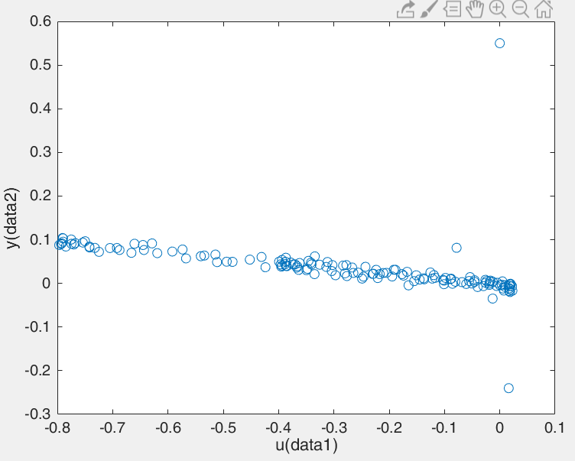

由於Theta = ${[ \sum{φ\left(k-1\right)φ^{T}\left(k-1\right) ]}}^{-1}*\sum{y(k)φ(k-1)}$

運算時使用的 $φ$ 是

$$φ=[y\left(k-1\right) y\left(k-2\right) u\left(k-1\right) u(k-2)]'$$

對時間用k資料進行推移運算，並進行sigma加總起來

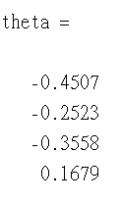

**主程式:**

%% main code.

[u, y] = textread('hw6Data.txt', '%f%f');

len = length(u);

plot(u,y,'o');

xlabel("u(data1)")

ylabel("y(data2)")

tmp = 0;

tmp2 = 0;

for i=4:len

phi = zeros(4,1);

phi(1) = y(i-1);

phi(2) = y(i-2);

phi(3) = u(i-1);

phi(4) = u(i-2);

tmp = tmp + phi*phi';

tmp2 = tmp2 + y(i)*phi;

end

tmp3 = inv(tmp);

%[-a1 -a2 b1 b2]

theta = tmp3*tmp2