**1-a**

a-A a-B

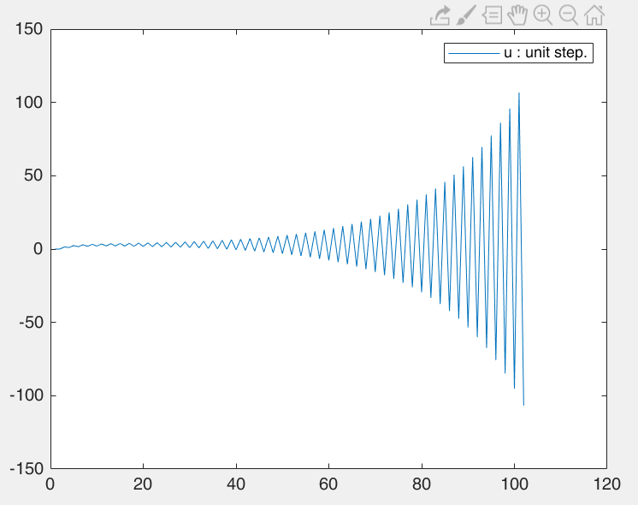 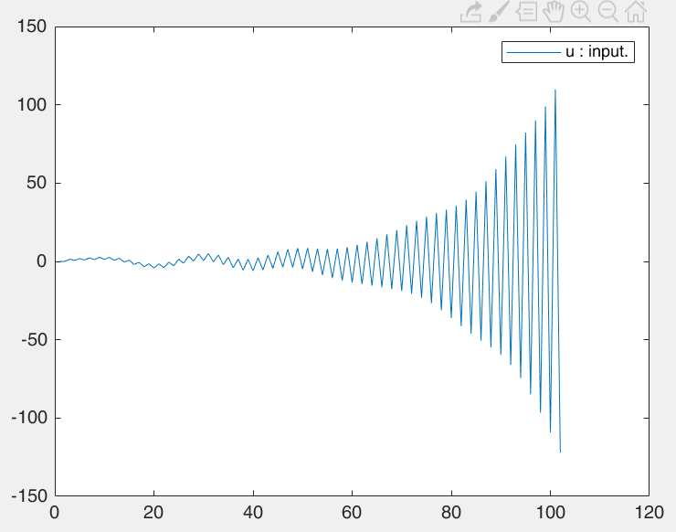

使用G = $\frac{0.9z+0.6}{z^{2}+0.3z-0.8}$ = $\frac{Y}{U}$

可得y(k+1) = -0.3y(k) + 0.8y(k-1) + 0.9u(k) + 0.6u(k-1)

加入輸出前的誤差向d = 0.01 ~ - 0.01

Code:

%% 1-a

y(1) = 0;y(2) = 0;

u(1) = 0;u(2) = 0;

delt = 0.1;

totTime = 10;

totalStep = totTime/delt ;

tarr= [0 : 1 : totalStep]*delt;

for i=1:totalStep

k = i+2;

u(k) = 100;

%u(k) = sin(6*k/20) + 0.5*sin(6*k/15+3.2) + 0.2*sin(2.57*k/15+1.63);

d = 0.02*(rand-0.5);

y(k) = -0.3*y(k-1) + 0.8*y(k-2) + 0.9*u(k-1) + 0.6*u(k-2) + d;

end

plot(y)

legend('u : input.')

**1-b**

b-A

設定:

$$φ=[y\left(k-1\right);y\left(k-2\right);u\left(k-1\right);u\left(k-2\right)]$$

$$θ=[-a_{1};-a_{2};b_{1};b_{2}]$$

由於

$$φ=[y\left(k-1\right);y\left(k-2\right);u\left(k-1\right);u\left(k-2\right)]$$

所以 $φ*φ^{T}=[y\left(k-1\right)*y\left(k-1\right) y\left(k-1\right)*y\left(k-2\right) y\left(k-1\right)*u\left(k-1\right) y\left(k-1\right)*u(k-2)$

$$y\left(k-2\right)*y\left(k-1\right) y\left(k-2\right)*y\left(k-2\right) y\left(k-2\right)*u\left(k-1\right) y\left(k-2\right)*u(k-2)$$

$$u\left(k-1\right)*y\left(k-1\right) u\left(k-1\right)*y\left(k-2\right) u\left(k-1\right)*u\left(k-1\right) u\left(k-1\right)*u(k-2)$$

$$u\left(k-1\right)*y\left(k-1\right) u\left(k-1\right)*y\left(k-2\right) u\left(k-1\right)*u\left(k-1\right) u\left(k-1\right)*u(k-2)$$

$$]$$

在原先假設中u(0)=u(1)=1且y(0)=y(1)=0

如果u(k)設為unit step input則u(k)=1

在inverse $(\sum{\left(φ*φ^{T}\right))=}$ inf 造成theta的預測回歸線無法正確得到

所以在初始假設中我將u(0)=u(1)=0且y(0)=y(1)=0

如果u(k)設為unit step input則u(k)=1

在 $\sum{\left(φ*φ^{T}\right)}$ 後，會造成後2行的數值些許差異

所以進行inverse $(\sum{\left(φ*φ^{T}\right))}$ 不會為inf

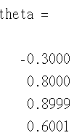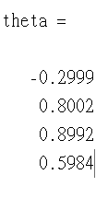得到結果:

(u=1) (u=100)

此外設定100步是因為此系統為發散系統，所以跑太多部會發散，所以也不能取得正確數值；但在有限步數，如果可以使 $\sum{\left(φ*φ^{T}\right)}$ 後2行的數值差異變大則理論上可以得到比較準確結果，其中一種方法就是將u>>u(0)=0。

b-B

$$u\left(k\right)=\sin\left(\frac{6k}{20}\right)+0.5\sin\left(\frac{6k}{15}+3.2\right)+0.2sin⁡(\frac{2.57k}{13}+1.63)$$

所以不會造成b-A的 $\sum{\left(φ*φ^{T}\right)}$ 後2行的數值相同，進而產生

inverse $(\sum{\left(φ*φ^{T}\right))=}$ inf 的問題，可以直接得到正確的theta

Code:

%% 1-b

len = length(u);

tmp = 0;

tmp2 = 0;

for i=4:len

phi = zeros(4,1);

phi(1) = y(i-1);

phi(2) = y(i-2);

phi(3) = u(i-1);

phi(4) = u(i-2);

tmp = tmp + phi*phi';

tmp4(:,:,i) = tmp;

tmp2 = tmp2 + y(i)*phi;

end

tmp3 = inv(tmp);

%[-a1 -a2 b1 b2]

theta = tmp3*tmp2

a1 = -theta(1);

a2 = -theta(2);

b1 = theta(3);

b2 = theta(4);

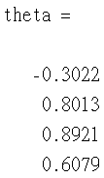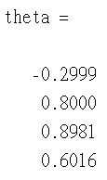得到結果:

(原本) (震幅為1)

震幅為1改為:

u(k) = 0.3*sin(6*k/20) + 0.5*sin(6*k/15+3.2) + 0.2*sin(2.57*k/15+1.63);

b-C



(b-B) (b-A)

皆取兩者震幅為1的結果

觀測結果大致可以發現b-A結果比較準確

**1-c**

使用pole asignment方式設計閉迴路

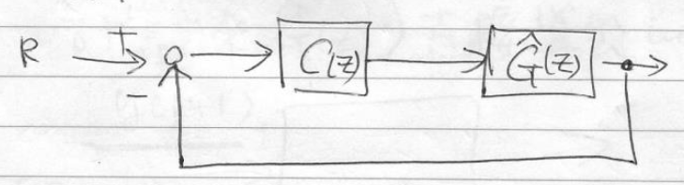

設定 $C= \frac{β_{0}z+β_{1}}{z+α}$， $G =\frac{b_{1}z+b_{2}}{z^{2}+a_{1}z+a2}$

G帶入b題結果:

$$a_{1}=-θ(1)$$

$$a_{2}=-θ(2)$$

$$b_{1}= θ(3)$$

$$b_{2}= θ(4)$$

進行pole assignment，取分母部分:

$z^{3}+\left(α+a_{1}+β_{0}b_{1}\right)z^{2}+\left(αa_{1}+a_{2}+β_{1}b_{1}+β_{0}b_{2}\right)z+{(αa_{2}+β}_{1}b_{2})$ = 0

放入z = $0.5±0.5i,0.82$:

$z^{3}+1.82z^{2}+1.07z+0.205$ = 0

計算三元一次方程式取得 $α, β_{0},β_{1}$

結果:

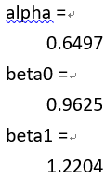 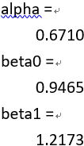

(c-A) (c-B)

(c-A) 200到1000後誤差最大為0.3126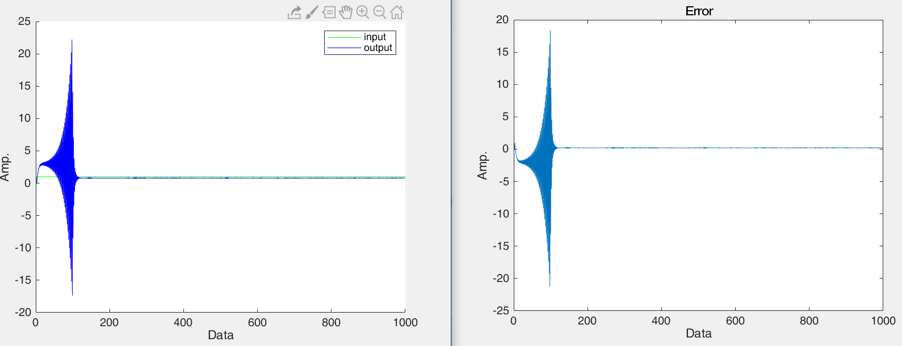

(c-B) 200到1000後誤差最大為0.3424

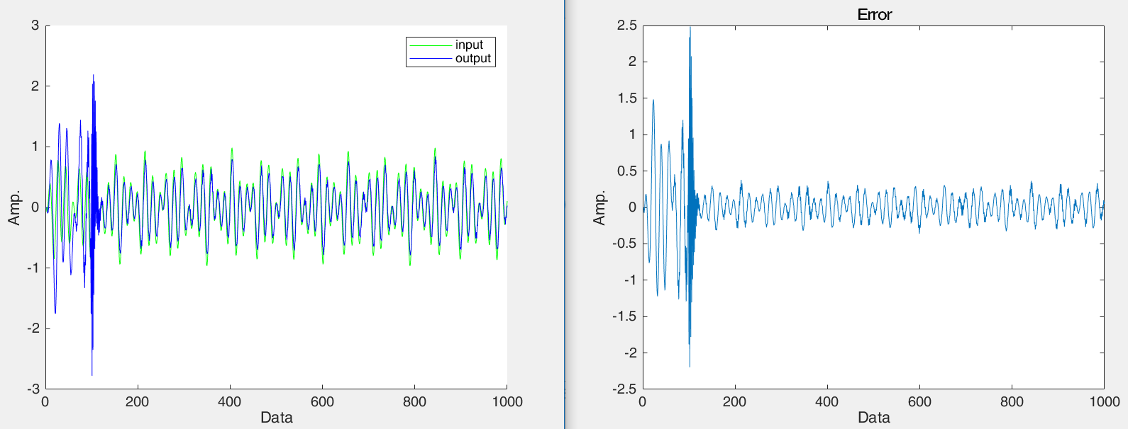

Code:

%% 1-c

syms alpha beta0 beta1

sol1 = alpha + a1 + beta0*b1 - 1.82;

sol2 = alpha*a1 + a2 + beta1*b1 + beta0*b2 - 1.07;

sol3 = alpha*a2 + beta1*b2 - 0.205;

[alpha beta0 beta1] = solve(sol1,sol2,sol3);

Alpha = double(alpha)

Beta0 = double(beta0)

Beta1 = double(beta1)

r=u;

%開路等校

for k=totalStep:1000

%r(k) = 1;

r(k) = (0.3*sin(6*k/20) + 0.5*sin(6*k/15+3.2) + 0.2*sin(2.57*k/15+1.63))*1;

d = 0.02*(rand-0.5);

y(k) = -(Alpha+a1+Beta0*b1)*y(k-1) - (Alpha*a1+a2+Beta1*b1+Beta0*b2)*y(k-2) - (Alpha*a2+Beta1*b2)*y(k-3) + (Beta0*b1)*r(k-1) + (Beta1*b1+Beta0*b2)*r(k-2) + (Beta1*b2)*r(k-3) + d;

end

%閉路等校

% for k=totalStep:1000

% %r(k+1) = 1;

% r(k+1)=(0.3*sin(6*k/20) + 0.5*sin(6*k/15+3.2) + 0.2*sin(2.57*k/15+1.63))*1;

% e(k)=r(k)-y(k);

% u(k)=(-Alpha*u(k-1)+Beta0*e(k)+Beta1*e(k-1));

% d = 0.02*(rand-0.5);

% y(k+1)=-a1*y(k)-a2*y(k-1)+b1*u(k)+b2*u(k-1)+d;

% end

figure()

%plot(y,'r')

hold on;

plot(r,'g')

plot(y,'b')

figure()

plot(r-y)

**1-d**

前900步持續改變G,C的值，進行On Line控制

後600步固定G,C的值，不隨時間改變

明顯可以看出A的震幅比B的震幅小很多

|  |  |  |
| --- | --- | --- |
|  | A | B |
| 數據 |  |  |
| 誤差 |  |  |

Code:

%% 1-d: STC on line

y(1) = 0;y(2) = 0;

u(1) = 0;u(2) = 0;

delt = 0.1;

totTime = 150;

totalStep = totTime/delt ;

tarr= [0 : 1 : totalStep]*delt;

for i=1:totalStep

k = i+2;

r(k) = 1;

%r(k) = 0.3*sin(6*k/20) + 0.5*sin(6*k/15+3.2) + 0.2*sin(2.57*k/15+1.63);

d = 0.01*(rand-0.5);

if i<6

y(k) = -0.3*y(k-1) + 0.8*y(k-2) + 0.9*r(k-1) + 0.6*r(k-2) + d;

u(k) = r(k);

else

r(k+1) = 1;

%r(k+1)=(0.3*sin(6*k/20) + 0.5*sin(6*k/15+3.2) + 0.2*sin(2.57*k/15+1.63))*1;

e(k-1)=r(k-1)-y(k-1);

u(k-1)=(-Alpha*u(k-2)+Beta0*e(k-1)+Beta1*e(k-2));

d = 0.02*(rand-0.5);

y(k)=-a1*y(k-1)-a2*y(k-2)+b1*u(k-1)+b2*u(k-2)+d;

end

if i>4 && i<900

theta = findtheta(u,y);

a1 = -theta(1);

a2 = -theta(2);

b1 = theta(3);

b2 = theta(4);

syms alpha beta0 beta1;

sol1 = alpha + a1 + beta0*b1 - 1.82;

sol2 = alpha*a1 + a2 + beta1*b1 + beta0*b2 - 1.07;

sol3 = alpha*a2 + beta1*b2 - 0.205;

[alpha beta0 beta1] = solve(sol1,sol2,sol3);

Alpha = double(alpha);

Beta0 = double(beta0);

Beta1 = double(beta1);

end

end

plot(y)

legend('u : input.')

function [theta]=findtheta(u,y)

len = length(u);

tmp = 0;

tmp2 = 0;

for i=4:len

phi = zeros(4,1);

phi(1) = y(i-1);

phi(2) = y(i-2);

phi(3) = u(i-1);

phi(4) = u(i-2);

tmp = tmp + phi*phi';

tmp2 = tmp2 + y(i)*phi;

end

tmp3 = inv(tmp);

%[-a1 -a2 b1 b2]

theta = tmp3*tmp2;

end

**2**

基本設定:

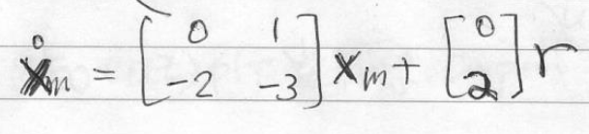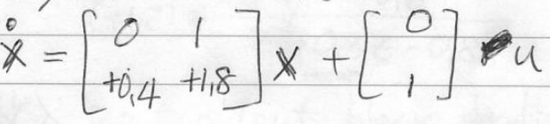

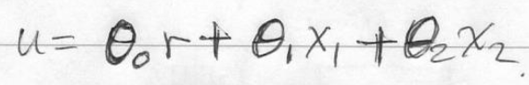

設定:

gama1 = 1;

gama2 = 1;

gama3 = 5;

Q = [1 0;0 40];

結果(檢查收斂情況):

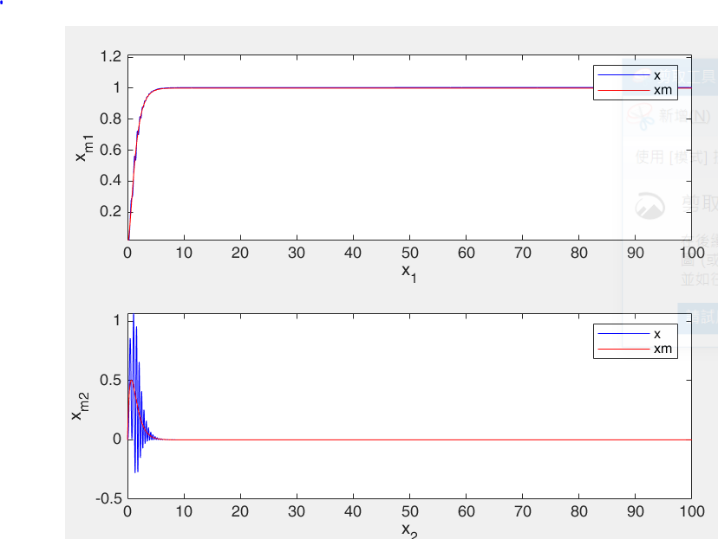 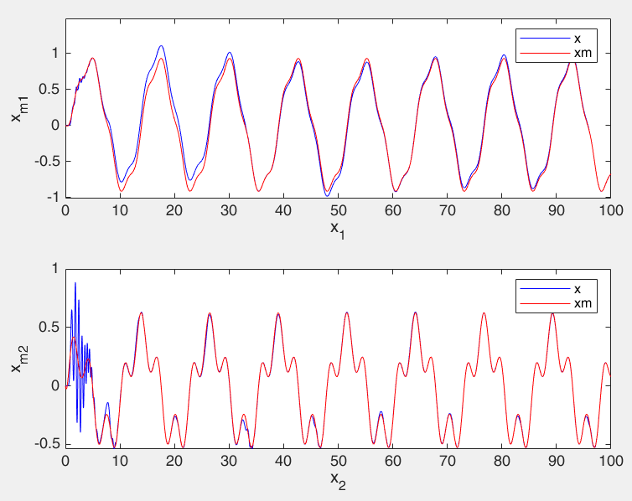

clc;clear;

%% main code.

%MRAC

delt = 0.01;

totTime = 100;

totalStep = totTime/delt ;

tarr= [0 : 1 : totalStep]*delt;

x = [0;0];

xm = [0;0];

%

am1=-2; am2=-3; a1=0.4; a2=1.8;

bm = 2;b = 1;

Am = [ 0 1;

am1 am2];

A = [ 0 1;

a1 a2];

Bm = [0;bm];

B = [0;b];

gama1 = 1;

gama2 = 0.5;

gama3 = 4;

Q=[1 0;0 1000];

P = lyap(Am,Q)

theta(:,1)=[0;0;0];

xarr1 = zeros(totalStep+1,1);xarr2 = xarr1;

xmarr1 = xarr1;xmarr2 = xmarr1;

earr1 = xarr1;earr2 = earr1;

xarr1(1) = x(1);xarr2(1) = x(2);

x_1 = xarr1(1);x_2 = xarr2(1);

xmarr1(1) = xm(1);xmarr2(1) = xm(2);

xm_1 = xmarr1(1);xm_2 = xmarr2(1);

for i=1:totalStep

k = i;

%r(k+1) = 1;

r(k+1)=sin(0.5*k*delt)+0.3*cos(2*k*delt+4);

u(k+1) = theta(1,k)*r(k) + theta(2,k)*x_1 + theta(3,k)*x_2;

%Xm (Mode)

xm_dot = Am*xm + Bm*r(k);

xmN = xm + xm_dot*delt;

xmarr1(i+1) = xmN(1);xmarr2(i+1) = xmN(2);

xm = xmN;

xm_1 = xmN(1);xm_2 = xmN(2);

%X

x_dot = A*x + B*u(k);

xN = x + x_dot*delt;

xarr1(i+1) = xN(1);xarr2(i+1) = xN(2);

x = xN;

x_1 = xN(1);x_2 = xN(2);

%E

e_1 = xm_1-x_1;

e_2 = xm_2-x_2;

%cal

zeta = 0.5*(P(1,2)*e_1+P(2,2)*e_2);

theta(1,k+1) = theta(1,k) + delt*(zeta*r(k))/(b*gama1);

theta(2,k+1) = theta(2,k) + delt*(zeta*x_1)/(b*gama2);

theta(3,k+1) = theta(3,k) + delt*(zeta*x_2)/(b*gama3);

end

figure(1)

subplot(2,1,1)

plot(tarr,xarr1,'b',tarr,xmarr1,'r')

xlabel('x_1');ylabel('x_m_1');

legend('x','xm')

subplot(2,1,2)

plot(tarr,xarr2,'b',tarr,xmarr2,'r')

xlabel('x_2');ylabel('x_m_2');

legend('x','xm')

figure(2)

plot(tarr,xmarr1-xarr1,'b',tarr,xmarr2-xarr2,'r')

xlabel('Time');ylabel('Error');

legend('e1','e2')

figure(3)

plot(tarr,u,'b',tarr,r,'r')

xlabel('Time');ylabel('Input');

legend('u','r')

figure(4)

plot(tarr,theta(1,:),'b',tarr,theta(2,:),'r',tarr,theta(3,:),'g')

xlabel('Time');ylabel('Theta');

legend('theta0','theta1','theta2')